
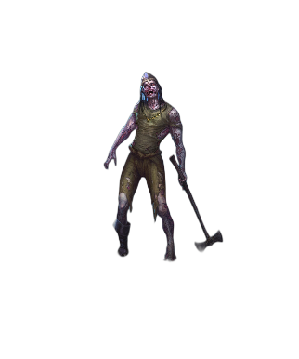
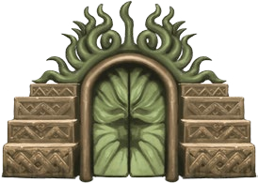
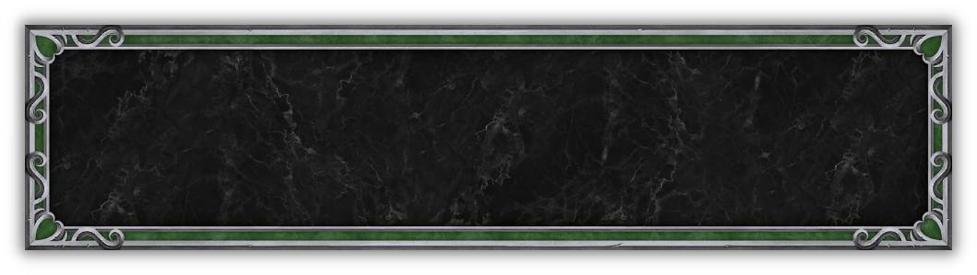
COOPERATIVE SCENARIO
Sigil of the Abyss

Author: Allan Finnich
The undead have been focusing their attention to activate an old Necropolis relic – The Sigil of the Abyss. If activated the land will be enveloped by darkness, and turning its inhabitants undead. The Sigil of the Abyss can only be destroyed by the combined power of a collective of other relics. Old warring factions must now unite and find the relics to avoid the impending threat from Necropolis and defeat them once and for all.

SCENARIO LENGTH
This scenario comprises of two parts and is played over a total of 12 rounds.
- Part 1 has a duration of 4 rounds.
- Part 2 has a duration of 8 rounds.

PLAYER SETUP PART 1
Starting Resources: 15 , 4 , 1 
Starting Income: 15 , 2 , 0 
Starting Units: 2  Units of choice as Few
Town Buildings:  Dwelling

PART 1 – FINDING THE RELICS
VICTORY CONDITIONS PART 1
Find the faction specific relic.

DEFEAT CONDITIONS PART 1
One or more factions do not find the at the end of the 4th round.

MAP SETUP PART 1
In part 1 each faction travels on their own land and is not connected to the other factions.
Castle  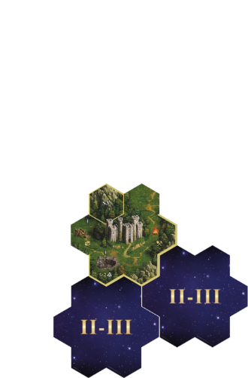  Tiles used are S3, F6 + F9.  Undiscovered tiles are either F6 or F9. | Rampart  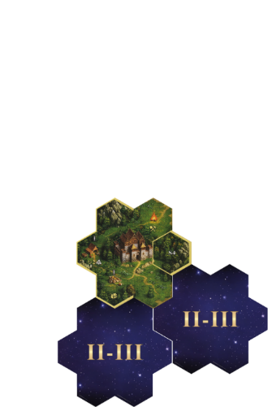  Tiles used are S4, F11 + F12.  Undiscovered tiles are either F11 or F12.
Fortress  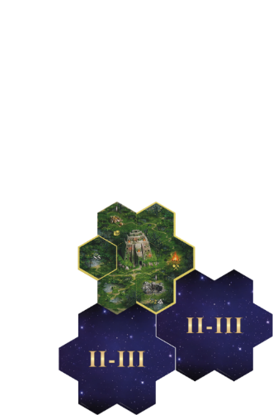  Tiles used are S5, F14 and F15.  Undiscovered tiles are either F14 or F15. | Inferno  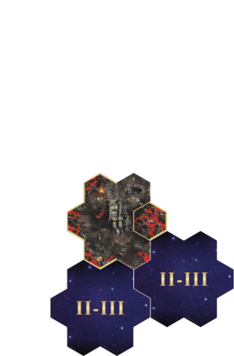  Tiles used are S6, F17 and F18.  Undiscovered tiles are either F17 or F18.

TIMED EVENTS PART 1
If there are timed events they are described in each of the faction quests.

ADDITIONAL RULES PART 1
Before this part:
- Remove the following from the Artifact deck: Centaurs Axe, Vial of Lifeblood and Tunic of the Cyclops King.
- Have the Necropolis faction army within reach.
During this part:
- Ignore all yellow borders on Starting Tiles
- You can use your Build Token to
  - give your resources to another player,
or
  - enter your settlement’s marketplace where resources can be traded at the same rates as trading posts
- Permanent bonuses and artifacts gained as reward in 4th round can only be used from the beginning of the 5th round.

CASTLE – “Sigil of Light”
Just as you thought there was no hope you get word from a messenger that the relic Sigil of Light is on the way to your lands. It is transported by a protected convoy from distant lands, and the convoy will rest at the Observation tower near your castle. You must reach the convoy to procure the relic by trade. The local bandits have heard of the riches you may carry so be ready for raids!
Objectives
- Bring 5  and 3  to the Observation Tower at the end of the 4th round
- Survive the raids. See Surviving the raids
Surviving the raids: Bandits raid you at the end of your turn in 2nd and 4th round.
- 2nd round: Roll two attack die. If the outcome is
- $±$1 and $±$1: You are ambushed by 2  neutral units
- 0 and 0: You are ambushed by 2  neutral units
- $±$1 and 0: You are ambushed by 1  neutral unit
- 4th round: Roll one attack dice. If the outcome is
- 0: You are ambushed by 2  neutral units
- $±$1: You are ambushed by 2  and 1  neutral units.
Combat rounds while defending against raids do not cost .
If the hero is raided while in town, then this is an attack on said town. If Citadel has been built, add walls and Arrow Tower. If defeated pay 5  to bribe the bandits to let you live.
Reward
- Relic: The Sigil of Light
- Get a free War Machine of choice or search Spell (3) twice
- Permanent bonus: You may give an ally a Moral token at any time. The token can only be used in the round in which it was given.

RAMPART – “Essence of Nature”
A local druid knows the location of the relic Essence of Nature. However, he can’t tell you its location as he has fallen ill due to corruption of nearby mines. Restore him to health by cleansing the mines, so he can reveal the location of the Essence of Nature.
Objectives
- Cleanse two corrupt mines. See Cleansing mines.
- Retrieve the Essence of Nature from druid at the Witch Hut after the cleansing of the mines at the end of the 4th round.
Cleansing mines: When engaging a Mine controlled by
- level I Neutral Units: Resolve combat against level II Neutral Unit. Hero gains  accordingly.
- level III Neutral Units: Draw 1  and 1  Neutral Units and roll one attack dice. Add the corresponding  tier unit as Pack from the Necropolis faction:
  - -1: Skeletons
  - 0 : Zombies
  - +1: Wraiths
Combat rounds while Cleansing mines costs  as normal.

Reward
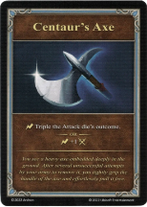
- Relic: Essence of Nature
- Gain the artifact Centaur’s axe to your Hand or gain an additional Magic Arrow to your Hand
- Permanent bonus: Once every round you may at any time choose an ally who receives an additional .


FORTRESS – “Heart of the Swamp”
The Heart of the Swamp relic has been lost for generations, but a scholar foretells it is at the bottom of a local swamp. The undead have heard of this legend and a young Lizard bowman has recently observed small search parties of undead combing the local swamps for the relic. It is only a matter of time before the undead finds the relic. You must act now!
Important: After all of the  of the main hero is spend place a 2nd hero on Fortress starting town for free as a scout. The scout has a maximum of 2  per round and can activate any field, except those that requires engaging in any form of combat.
Objectives
- Determine the strength of the search parties at both local swamps by scouting them. To scout the local swamps, activate the local swamp fields (F14 + F15 ignore borders) by visiting them with the scout. See Strength of search party.
- Defeat the undead search parties with main hero at the local swamps to obtain the relic. Visit the local swamp fields to engage the search party. A search party can only be engaged when the scout has determined their strength. Combat with search parties does not cost .
- Bring the relic to the local scholar before the end of 4th round.
Strength of search party: Roll two attack die for each local swamp. The roll determines the strength of the search party:
- -1 = 1 ,
- 0 = 2 ,
- +1 = 1 
Draw neutral units matching the roll and set aside for when the main hero engages.

Reward
- Relic: The Heart of the Swamp
- Gain an empowered Attack or an empowered Power Statistics card
- Permanent bonus: Your hero gains an expert point which any ally can spend with your permission at any time once every round.

INFERNO – “Flame of Redemption”
The Flame of Redemption once flamed high but has long since been extinguished since the mischief Inferno came to this land. It must be reignited so its properties can be used in the fight against the undead threat, and to do this requires the Blood Stone from the local Star Axis.
Objectives
- Retrieve the Blood Stone from a Star Axis. See Retrieving the Blood Stone. Resolve the field as normal after the battle.
- Bring the Blood Stone to the Tree of Knowledge. See Reigniting the Flame of Redemption.
Retrieving the Blood Stone: Shuffle the  units from the Necropolis faction and draw two Undead units. Fight the 2  units drawn. First drawn  unit is Pack the other is Few.  unit as Few respawns again as Few instantly from its position when defeated on the battlefield. Combat rounds do not cost .
Reigniting the Flame of Redemption: To reignite the flame of redemption within the blood stone you must either sacrifice a unit (Few or Pack) from your army or pay 3 , 1 .

Reward
- Relic: The Flame of Redemption
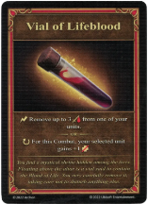
- Gain the artifact Vial of Lifeblood or Tunic of the Cyclops King
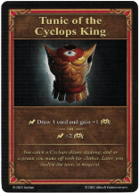

Remove the unchosen artifact from the deck
- Permanent bonus: Once per round Inferno player may reinforce another player during combat by gating in an Inferno  unit of choice (must be in Inferno player army) to the battlefield. If the gated unit is defeated in combat, it is no longer in the Inferno players army and must be recruited again.


PART 2 – DESTROYING THE SIGIL OF THE ABYSS
The relics from each faction has been procured and the time to strike against the Undead and destroy the Sigil of the Abyss is now! To destroy the Sigil of the Abyss the Undead foothold must be taken. The foothold is, however, only accessible via two Undead gates from which patrols are regularly are sent to find and defeat the this newly formed alliance. The factions must team up and formulate a plan of attack to take the Undead foothold…

VICTORY CONDITIONS PART 2
Destroy the Sigil of the Abyss by defeating the Undead foothold, i.e. all players must win their final battle.

DEFEAT CONDITIONS PART 2
Less than 3 faction heroes are present on the map tile with the Undead foothold (Necropolis town) by the end of the 12th round.
One or more players does not win their battle against the Undead foothold in 12th round.

MAP SETUP PART 2
Required map tiles: S1, F1, F2, F3, F10, F13, F16
Undiscovered Far (II-III) map tiles must be from the pool of F3, F10, F13, F16. Players decide where each tile with their faction settlement is placed and oriented.
Random: 5 x Near (IV-V) map tiles from the pool of map tiles N1 – N12.
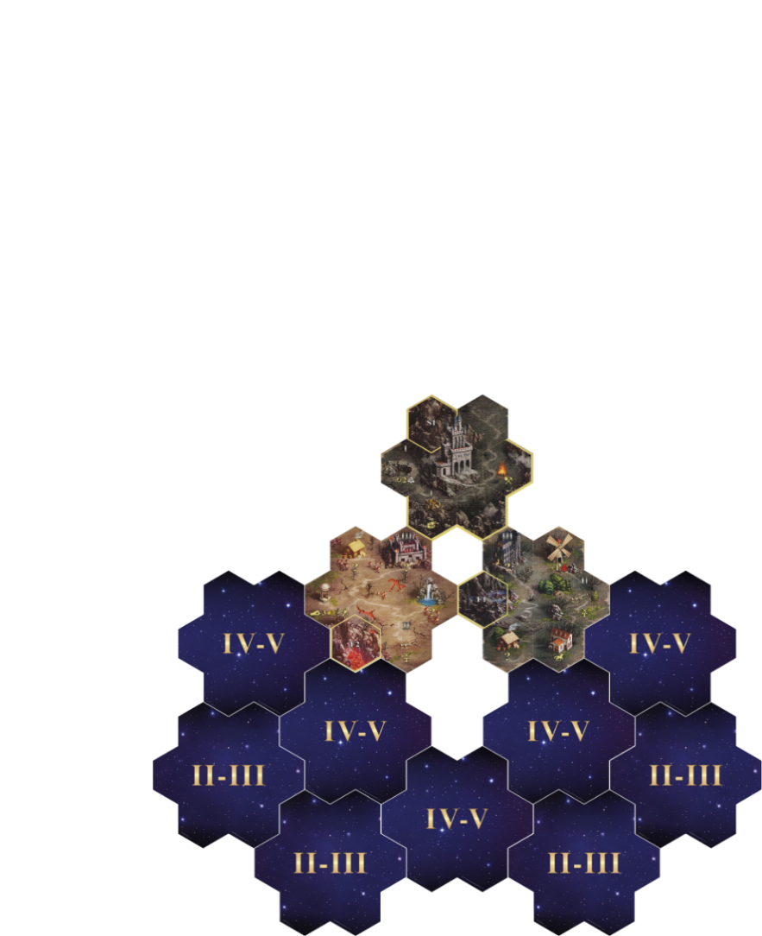

TIMED EVENTS PART 2
- 7th Round: Increased efficiency from mines. Move income marker for  and  one up at the very beginning of the round.
- 9th Round: Increased efficiency from mines. Move income marker for ,  and  one up at the very beginning of the round.
- 7th and 9th Rounds: Remove all black cubes from every Windmill, Water wheel, Mystical Garden, and Obelisks.
- 7th, 9th and 11th Rounds: Patrols from both undead gates set out, one from each. Use either Necropolis factions’ heroes or cubes to symbolise patrols. Starts from settlements on map tiles F2 and F3, respectively. Patrols cannot emerge from defeated gates.

ADDITIONAL RULES PART 2
Before this part:
- Resource gains from mines from part 1 are kept.
- Only the main hero is transferred from part 1.
- Army of the Undead gates: Create 2 decks both consisting of 3  and 2 . Shuffle and set aside beside each Undead gate.

During this part:
- Castle, Rampart, Fortress and Inferno settlements are equivalent to their respective starting towns from part 1.
- When a player visits an Obelisk, that player then rolls either one Treasure dice or one Resource dice and resolves the outcome.
- Secondary heroes cannot be recruited.
- Patrol movement: When one or more patrols are on the map roll an attack dice for each patrol at the very end of the round. Move each patrol according to their roll (cannot be rerolled):
  - +1 = moves 2 fields
  - 0 = moves 1 field
  - -1 = does not move.
Patrols move toward closest hero. If two or more heroes are equidistant to the patrol, then move the patrol to the closest hero to the left from the patrol’s perspective.

- Patrol strength: When combatting patrols its strength is equal to that of the main hero.
- Fighting patrols: Combat with patrols does not cost .
When attacking patrols and they are defeated then resolve the field after combat if it is unvisited.
If attacked by patrols the defending hero must still deploy its army first on the battlefield.
If retreating from combat with a patrol move the hero to the last visited field.
If a patrol follows a hero to one of the players settlements, then this is an attack on said settlement. If Citadel has been built, then add walls and Arrow Tower. If defeated, then the player must pay 5  to deploy 3 units of choice from another players army and continue the combat.
If patrols are attacked while still in an Undead gate then combat against the patrol is skipped and the Undead gate is attacked instead.
- Attacking the Undead gates: When attacking an Undead gate you engage its corresponding army in combat. For the combat you gain +1  but a total max. of 3 . Combat costs  as normal.
Defeated units of the Army of the Undead gate return instantly to their respective deck of neutral units during combat.
You cannot retreat or surrender.
- Taking the Undead foothold: The Undead foothold can only be attacked when all heroes are on the map tile. When the Undead foothold is attacked the final battle begins and no more movement on the map is allowed.
- Ignore all yellow borders and visitable fields on the map tile with the Necropolis town (S1).
- Final battle: For each of the , , , and Neutral Units: Return the defeated units to the deck and shuffle. Roll one attack dice. The roll determines the combination of tiers of the defending units:
  - -1 = 1 , 2 , 1  +
Ghost Dragon as Pack
  - 0 = 1 , 2 , 1  +
Dread Knights as Pack
  - +1 = 1 , 2 , +
Dread Knights as Few
and
Ghost Dragon as Few
Ghost Dragon and Dread Knights are the  tier units from the Necropolis faction.
If only 3 out of 4 players is on tile with Undead foothold at the end of 12th round, the last player is instantly teleported to the Undead foothold.
- The Undead foothold is attacked from all sides meaning that every faction must defeat the defences at their side to take the Undead foothold. All sides have siege walls and an Arrow Tower.

