**Portfolio Web Page**

Contents

Document Description 2

Change Log 2

User Stories 3

Wireframes 3

Style Guide 3

Code guidelines 3

HTML 3

CSS 3

Visual aid 3

Grid Layout 3

Fonts 4

Color Palette 4

# Document Description

This document describes the business requirements that need to be implemented for completing a portfolio page for describing oneself.

# Change Log

|  |  |  |  |  |
| --- | --- | --- | --- | --- |
| S. No. | Update | Version | Updated By | Updated On |
| 1. | Created the document for functional specifications for the portfolio page | 1.0 | Allan Jungoy | 17th Sept’20 |
| 2. | Webpage design brainstorming | 1.1 | Allan Jungoy | 19th Sept’20 |
| 3. | Started coding for the webpage design plan. | 1.2 | Allan Jungoy | 19th Sept’20 |
| 4. | Researched for codes to be used for the for the webpage. Encountered difficulties aligning the columns and rows using CSS grid | 1.3 | Allan Jungoy | 20th Sept’20 |
| 5. | Decided to adopt other easier options like combining flexbox and CSS-grid. | 1.4 | Allan Jungoy | 20th Sept’20 |
| 6. | Changed plan to a new design with combined flexbox and CSS-grid | 1.5 | Allan Jungoy | 23th Sept’20 |
| 7. | Gathered information from internet such as google, youtube videos etc…to for the codes to use for the project. | 1.6 | Allan Jungoy | 25th Sept’20 |
| 8. | Working on the colors, font-family, font-size to use for the project. | 1.7 | Allan Jungoy | 26th Sept’20 |
| 9. | Started to finalizing the project for submission | 1.8 | Allan Jungoy | 27th Sept’20 |
| 10. | Created documentation  For the project prior for submission. | 1.9 | Allan Jungoy | 27th Sept’20 |

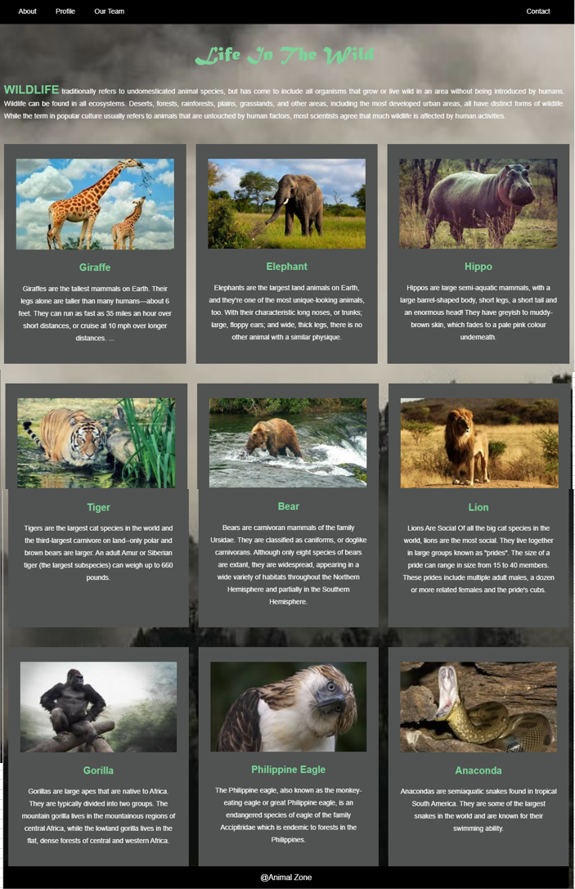

# User Stories

|  |  |  |  |
| --- | --- | --- | --- |
| User Story ID | As a (user) | I want to (task) | So that I can (result) |
| 1 | As a person who visits the portfolio page | Should be able to see an about section | So that I can know more about the person who had developed his / her portfolio |
| 2 | As a person who visits the portfolio page | Should be able to see the picture of the person who has developed this page | So that I can get more information about him / her |
|  |  |  |  |

# Wireframes

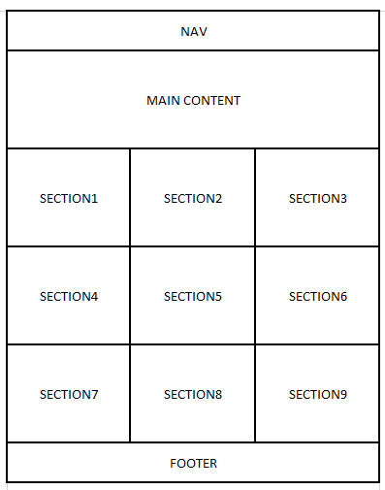

# Style Guide

***Refer to the*** [***lonely planet style guide***](https://rizzo.lonelyplanet.com/styleguide/design-elements/colours) ***for example***

This guide defines the standards that will be followed by developing the web page.

## Code guidelines

This section defines the coding standards that will be followed during the development of the web page

### HTML

* Always Doctype Header
* Use a new line for all elements
* Wrap long lines
* For attribute values use double quotes and no single quotes

### CSS

* Use meaningful selector names
* Try and reuse classes
* Try and avoid type selectors for qualification
* Do not use units for 0 values
* Avoid hacks

## Visual aid

This section defines the standards for the look and feel of the page

### Grid Layout – Provide Example

***Please refer to the link*** [***https://rizzo.lonelyplanet.com/styleguide/css-utilities/proportional-grid***](https://rizzo.lonelyplanet.com/styleguide/css-utilities/proportional-grid) ***for example***

### Fonts

Define the fonts that you will use on the page

* Headings: Matura MT Script Capitals
* Paragraphs: Arial
* Footer: Arial

### Color Palette

* Colors: rgb 80,83,81
* Sub colors: white, black, green.