T.C.
BAHCESEHIR UNIVERSITY
GRADUATE SCHOOL
…………………………HEAD OF THE DEPARTMENT

Quantization Robustness to Input Degradations for Object Detection

MASTER’S THESIS
STUDENT NAME SURNAME
ISTANBUL 2025

T.C.
BAHCESEHIR UNIVERSITY
GRADUATE SCHOOL
…………………………HEAD OF THE DEPARTMENT

Quantization Robustness to Input Degradations for Object Detection

MASTER’S THESIS

THESIS ADVISOR
…………..

ISTANBUL 2025
T.C.
BAHCESEHIR UNIVERSITY
GRADUATE SCHOOL

MASTER THESIS APPROVAL FORM

Program Name:
Student's Name and Surname:
Name Of The Thesis:
Thesis Defense Date:
This thesis has been approved by the Graduate School which has fulfilled the necessary conditions as Master thesis.
…………………………
Institute Director

This thesis was read by us, quality and content as a Master's thesis has been seen and accepted as sufficient.

 | Title/Name | Institution | Signature
Thesis Advisor's
Member's
Member's

ETHICAL CONDUCT
I hereby declare that all information in this document has been obtained and presented in accordance with academic rules and ethical conduct. I also declare that, as required by these rules and conduct, I have fully cited and referenced all material and results that are not original to this work.

Name, Last Name: ……………….
Signature:

ABSTRACT

Quantization Robustness to Input Degradations for Object Detection

Name, Surname
Master’s Program in …………………….
Supervisor: ………………….

May 2025, 82 pages

This thesis investigates the robustness of post-training quantized object detection models against input degradations, focusing on YOLO-based architectures. While quantization significantly improves inference efficiency by reducing model size and computational load, its impact on model robustness in real-world conditions—such as noise, blur, low contrast, and compression—is underexplored. The study benchmarks multiple quantized variants (FP16, INT8 static, UINT8 dynamic) against the FP32 baseline using degraded versions of the COCO dataset. A novel degradation-aware calibration method is proposed for static INT8 quantization, which mixes clean and degraded images during calibration to enhance robustness. Experimental results show that degradation-aware quantization improves detection stability under various corruptions with minimal trade-offs in performance on clean data. These findings provide actionable insights for deploying efficient and reliable object detectors on edge devices operating in uncontrolled environments.
Key Words: bject Detection, Quantization, Robustness, YOLO, Post-Training Quantization, TensorRT, ONNX

ÖZ

Quantization Robustness to Input Degradations for Object Detection

Ad, Soyad
……………………… Yüksek Lisans Programı
Tez Danışmanı: …………………….

Mayıs 2025, 82 sayfa

Bu tez, YOLO tabanlı mimarilerdeki nesne tespit modellerinin giriş bozulmalarına karşı dayanıklılığını, eğitim sonrası (Post-Training) kuantizasyon altında incelemektedir. Kuantizasyon, model boyutunu ve hesaplama yükünü azaltarak verimliliği artırsa da, gürültü, bulanıklık, düşük kontrast ve sıkıştırma gibi gerçek dünya koşullarındaki dayanıklılığı üzerindeki etkisi yeterince araştırılmamıştır. Çalışma, COCO veri setinin bozulmuş sürümleri kullanılarak, FP32 taban modeli ile FP16, INT8 statik ve UINT8 dinamik kuantize modelleri karşılaştırmaktadır. Statik INT8 kuantizasyon için yeni bir bozulma farkındalıklı kalibrasyon yöntemi önerilmiş, temiz ve bozulmuş görüntülerin karışımıyla kalibrasyon yapılmasıyla dayanıklılığın artırılması hedeflenmiştir. Deneysel sonuçlar, bu yöntemin çeşitli bozulmalar altında tespit kararlılığını artırdığını ve temiz verilerdeki performans kaybının ihmal edilebilir olduğunu göstermektedir. Elde edilen bulgular, kontrolsüz ortamlarda çalışan kenar cihazlarında verimli ve güvenilir nesne tespit sistemlerinin uygulanmasına yönelik önemli çıkarımlar sunmaktadır.

Anahtar Kelimeler: Nesne Tespiti, Kuantizasyon, Dayanıklılık, YOLO, Eğitim Sonrası Kuantizasyon, TensorRT, ONNX

DEDICATION

ACKNOWLEDGEMENTS

I wish to express my deepest gratitude to my supervisor Prof. Dr. Ali BAYKAL for his guidance, advice, criticism, encouragements and insight throughout the research.

I would also like to thank my parents, Hasan ÇELİK and Gamze ÇELİK, for their great support throughout her life. Without their understanding, and continuous support, I could have never been able to aspire for this level of education and complete this study.

TABLE OF CONTENTS

ETHICAL CONDUCT iv
ABSTRACT v
ÖZ vi
DEDICATION vii
ACKNOWLEDGEMENTS viii
TABLE OF CONTENTS ix
LIST OF TABLES xii
LIST OF FIGURES xiii
Chapter 1: Introduction 1
1.1. Problem Statement 4
1.2. Research Questions 5
1.3. Scope of the study 6
Chapter 2: Literature Review 11
2.1. Theory 11
2.1.1 Machine Learning 11
2.2. Neural Networks and Deep Learning 12
2.2.1. Activation functions 14
2.2.2. Cost function 15
2.2.3. Backpropagation and Gradient Descent 16
2.3. Convolutional Neural Networks 18
2.3.1. Padding and Stride 21
2.3.2. Pooling 23
2.4. Object Detection at Edge 23
2.4.1. Object Detection 25
2.4.2. Object Detection Architectures 25
2.4.3. Intersection over union and non-max suppression 28
2.4.4 YOLO 29
2.4.4.1 Evolution of YOLO 29
2.4.5.2 Performance & Scalability Advancements 33
2.4.5.3 Research Gaps & Outlook 34
2.4.6 Deep Learning Accelerators 35
2.4.7 Model Quantization 36
2.4.7.2 Post Training Quantization (PTQ) 38
2.4.9.1a Dynamic Post-Training Quantization 39
2.4.9.1b Static Post-Training Quantization 42
2.4.7.3 Quantization-Aware Training (QAT) 45
Chapter 3: Methodology 49
3.1 System Setup and Tools 49
3.2 Baseline Model and Datasets 50
3.2.1 Baseline Models 50
3.2.2 Datasets 50
3.3 Model Export and Quantization Procedures 52
3.3.1 FP32 Baseline (TensorRT Engine) 52
3.3.2 FP16 Mixed Precision (TensorRT Engine) 53
3.3.3 Static INT8 Quantization (TensorRT Engine with Calibration) 53
3.3.4 Degradation-Aware Static INT8 Quantization (TensorRT Engine with Mixed Calibration - Novel Method) 54
3.3.5 Dynamic UINT8 Quantization (ONNX Runtime) 56
3.4 Degradation Generation and Validation Datasets 57
3.4.1 Degradation Techniques 58
3.4.2 Generation of Distinct Degraded Validation Sets 59
3.4.3 Generation of Mixed Degradation Validation Set 60
3.5 Evaluation Metrics and Analysis 61
3.5.1 Benchmarking Procedure 61
3.5.2 Performance Metrics 62
3.5.3 Robustness Analysis 63
Chapter 4: Results 65
4.1 Baseline Performance on Clean COCO Validation Data 65
Summary of Baseline Observations: 67
4.2 Robustness Evaluation under Input Degradations 68
4.2.2 Relative Performance Degradation 71
4.3 Inference Speed Comparison 76
Chapter 5: Conclusion and Discussion 81
5.1 Key Findings and Discussion 81
5.2 Evaluation of Degradation-Aware Calibration 83
5.3 Limitations 84
5.4 Future Work 85
REFERENCES 87

LIST OF TABLES
Table 1 28
Table 2 61
Table 3 65
Table 4 68
Table 5 74

LIST OF FIGURES

FIGURES
Figure 1. Simple perceptron model 10
Figure 2. Deep Neural Network with 4 layers 11
Figure 3. Gradient Descent algorithm. 14
Figure 4. Neural network forward propagation and backpropagation 15
Figure 5. Convolutional operation in 2 dimensions 17
Figure 6. Convolutional neural network with hidden layer feature maps visualized. Layer visualizations copied from 18
Figure 7. Input with padding results in a larger output feature map than in Figure 5 19
Figure 8. Convolutional operation with a horizontal and vertical stride of three 19
Figure 9. 2x2 max pooling with stride = 2 20
Figure 10. Simple edge computing network 21
Figure 11. The output of a typical object detection model 22
Figure 12. SSD Detector with a VGG base network 23
Figure 13. 7x7 feature map laid over an input image 24
Figure 14. Intersection over union 25
Figure 15. Examples of Synthetic Image Degradations Applied……………………………61

Chapter 1: Introduction
Deep Neural Networks (DNNs) have revolutionized numerous fields, with Convolutional Neural Networks (CNNs) achieving state-of-the-art performance in computer vision tasks like image recognition and object detection (LeCun, Bengio, & Hinton, 2015). These advancements fuel exciting applications in areas such as autonomous vehicles, robotics, augmented reality, and intelligent surveillance, driving a need to deploy sophisticated visual perception capabilities directly onto edge devices. These edge platforms, including smartphones, drones, and embedded systems, operate under significant constraints regarding computational power, memory footprint, and energy consumption (Sze et al., 2017).
However, the high accuracy of modern CNN-based object detectors often comes at the cost of substantial computational and memory requirements. Models like the popular YOLO (You Only Look Once) series, while effective, can still be demanding for real-time inference on resource-limited hardware (Redmon & Farhadi, 2018). This gap between the capabilities of powerful AI models and the constraints of edge devices presents a major deployment challenge.
Model compression techniques aim to bridge this gap. Among these, quantization has emerged as a highly effective and widely adopted approach. Quantization reduces the numerical precision of a model's weights and/or activations, typically converting 32-bit floating-point (FP32) values to lower-bit representations, most commonly 8-bit integers (INT8) (Jacob et al., 2018). This reduction significantly decreases model size, memory bandwidth usage, and often enables faster computation through specialized integer arithmetic hardware available on many CPUs and GPUs, leading to lower latency and reduced power consumption. Post-Training Quantization (PTQ) is particularly appealing as it allows pre-trained models to be quantized without requiring costly retraining, making it suitable for deploying readily available, high-performing models. Common PTQ methods include dynamic quantization, which determines activation ranges at runtime, and static quantization, which uses a calibration dataset to determine these ranges offline, often leading to better performance (Gholami et al., 2021).
While the benefits of quantization for model efficiency are well-established, a critical aspect often receives less scrutiny: its impact on model robustness. Models deployed in the real world, especially on edge devices, frequently encounter inputs degraded by various factors inherent to image capture and transmission in uncontrolled environments. These include sensor noise, motion or lens blur, poor lighting leading to low contrast, and artifacts introduced by image or video compression (Dodge & Karam, 2017; Micheloni et al., 2006).
It is crucial that object detectors maintain reliable performance even when faced with such imperfections. A potential concern arises: does the process of reducing numerical precision through quantization make models inherently more sensitive or "brittle" to these common input degradations? Does an INT8 model suffer a proportionally larger drop in accuracy than its FP32 counterpart when processing a noisy or blurry image? Understanding this relationship is vital for reliably deploying quantized models in safety-critical or performance-sensitive edge applications (Zhao et al., 2019).
Furthermore, standard static PTQ methods typically rely on calibration datasets composed of clean, high-quality images representative of the original training data (Nagel et al., 2021). This raises the question: could the calibration process itself be adapted to enhance the robustness of the resulting quantized model? If the calibration process were exposed to examples of the degradations the model is expected to encounter, could it learn quantization parameters (scales and zero-points) that are better suited to handle these variations, potentially mitigating the brittleness sometimes associated with quantization?
This thesis directly addresses these questions. It aims to systematically analyze the robustness of a modern object detector (YOLO12) when quantized to INT8 using standard static post-training quantization techniques, specifically targeting the optimized TensorRT engine format suitable for NVIDIA GPUs and dynamic UINT8 quantization via ONNX dynamic quantization API (ONNX, 2025; NVIDIA, 2025). The performance of the quantized models will be compared against its FP32 and FP16 counterparts when evaluated on datasets synthetically degraded with controlled levels of noise, blur, low contrast, and compression artifacts.
Building upon this analysis, this work proposes and evaluates a novel degradation-aware calibration strategy for static PTQ. Instead of calibrating solely on clean data, this approach utilizes a calibration set composed of a mix of clean and degraded images, mirroring the anticipated real-world corruptions (Dodge & Karam, 2017). The central hypothesis is that this mixed calibration will yield an INT8 model exhibiting improved robustness (i.e., a smaller performance drop) on degraded data compared to a model quantized using standard clean calibration, potentially at an acceptable trade-off in performance on clean data.
The study will provide a quantitative comparison of accuracy (mAP) across the FP32 baseline, FP16 (mixed precision) (Micikevicius et al., 2018), UINT8 dynamic quantization, the standard INT8 PTQ model, and the proposed degradation-aware INT8 PTQ model, evaluated on both clean and various degraded versions of the COCO validation dataset (Lin et al., 2014). The findings will offer insights into the practical robustness implications of different quantization techniques for YOLO models and the potential benefits of incorporating degradation awareness into the calibration process of static quantization.

Problem Statement
While quantization techniques, particularly Post-Training Quantization (PTQ), offer a compelling solution for deploying deep learning models like YOLO object detectors on resource-constrained edge devices, their practical implications extend beyond simple efficiency gains. A critical, yet often under-explored, aspect is the impact of quantization on the robustness of these models to the inevitable input degradations encountered in real-world deployment scenarios. Edge devices frequently operate in uncontrolled environments, processing imagery affected by sensor noise, motion blur, variable lighting (low contrast), and compression artifacts from transmission (Dodge & Karam, 2017; Micheloni et al., 2006).
Standard PTQ methods, whether dynamic (often quantizing activations at runtime) or static (using offline calibration, typically with clean data), primarily optimize for efficiency and minimizing accuracy loss on clean, high-quality data (Nagel et al., 2021; Jacob et al., 2018). It remains unclear how these standard INT8 PTQ approaches, as well as intermediate precisions like FP16, affect the model's ability to maintain performance when faced with these common visual perturbations. Does the reduction in numerical precision inherent in INT8 quantization disproportionately amplify the negative effects of input noise or blur compared to the original FP32 model or an FP16 equivalent? This potential increase in brittleness could undermine the reliability of quantized models in critical edge applications (Zhao et al., 2019).
Furthermore, conventional static PTQ relies on calibration using clean data, which may not prepare the model for the statistical shifts in activations caused by degraded inputs. There is a need to investigate simple, practical PTQ strategies that explicitly consider input degradation during the quantization process itself, potentially improving the robustness of the final quantized model without resorting to complex or computationally expensive techniques like Quantization-Aware Training (QAT) (Banner et al., 2019). Specifically, the effectiveness of adapting the static calibration phase to include representative degraded data requires systematic evaluation. Therefore, a comprehensive analysis is needed to quantify the robustness trade-offs of standard PTQ methods (Static INT8, Dynamic UINT8, FP16) for modern object detectors under specific degradations and to assess whether novel calibration strategies can offer a practical path towards more robust quantized models for edge deployment.

Research Questions
- Baseline Robustness: How does the performance (mAP) of a baseline FP32 YOLO12 models degrade when evaluated on datasets corrupted by specific levels of noise, blur, low contrast, and compression artifacts compared to its performance on clean data?
- Impact of Standard Quantization on Robustness:
  - How does standard Static INT8 PTQ (TensorRT engine, calibrated on clean data) affect the model's robustness to these specific degradations compared to the FP32 baseline? Is the relative performance drop significantly larger for the INT8 model?
  - How does Dynamic UINT8 PTQ (ONNX Runtime) impact robustness to these degradations compared to FP32 and Static INT8?
  - How does using FP16 precision (TensorRT engine) influence robustness compared to FP32 and INT8 models?
- Effectiveness of Degradation-Aware Calibration: Can a novel Static INT8 PTQ approach, using a calibration dataset composed of a mix of clean and degraded images, improve the quantized model's robustness (i.e., reduce the relative mAP drop on degraded validation sets) compared to standard Static INT8 PTQ calibrated only on clean data?
- Performance Trade-offs: What is the impact of the standard and degradation-aware quantization methods on model performance (mAP) on clean data and inference latency/speed compared to the FP32 baseline? Does the proposed degradation-aware calibration method introduce significant overhead or accuracy loss on clean data?

Scope of the study
- Base Model Architecture: The investigation is exclusively centered around the YOLO12 model family (nano, small, medium, large, and extra-large variants). Pre-trained weights for these models, as provided by Ultralytics, were utilized as the starting point for all experiments. This choice represents a family of widely adopted and computationally efficient object detector architectures commonly considered for edge deployment (Jocher et al., 2025; Ultralytics, 2025). The study does not extend to other object detection architectures like Faster R-CNN, SSD, or Transformer-based detectors.
- Target Precision Levels: The study evaluates and compares model performance across four primary precision levels:
  - FP32 (32-bit Floating Point): Serves as the high-precision baseline.
  - FP16 (16-bit Floating Point / Half-Precision): A common mixed-precision optimization.
  - Static INT8 (8-bit Integer): Fixed-point integer representation with pre-calibrated quantization parameters.
  - Dynamic UINT8 (8-bit Unsigned Integer): Fixed-point integer representation for weights, with activation parameters determined at runtime.
- Quantization Frameworks and Target Inference Engines:
  - Dynamic UINT8 quantization is implemented by first exporting the PyTorch models to the ONNX (Open Neural Network Exchange) format and subsequently applying dynamic quantization routines provided by the ONNX Runtime framework (Microsoft, 2025; Bai et al., 2019). The resulting ONNX model is then executed using ONNX Runtime.
  - Static INT8 and FP16 quantization are implemented by exporting the PyTorch models directly to the NVIDIA TensorRT inference engine format (.engine). This leverages TensorRT's advanced graph optimizations and its internal capabilities for optimized Post-Training Quantization (PTQ) based on representative calibration data (NVIDIA, 2025).
- Quantization Methodology: The primary focus of this thesis is on Post-Training Quantization (PTQ) techniques, as these do not require retraining or access to the original training pipeline, making them highly relevant for practical deployment of pre-existing models. Quantization-Aware Training (QAT), which involves simulating quantization during model training, is considered outside the scope of this work. For static INT8 PTQ via TensorRT, the study investigates two calibration strategies: (a) standard calibration using only clean, high-quality images, and (b) a proposed degradation-aware calibration approach that utilizes a dataset comprising a 50/50 mix of clean and synthetically degraded images, aiming to enhance robustness.
- Input Degradations: The assessment of model robustness is performed against a specific, controlled set of synthetic input degradations applied uniformly to the COCO 2017 validation dataset. These include:
- Gaussian Noise: Two levels (Low and Medium variance) simulating sensor noise.
- Gaussian Blur: Two levels (Low and Medium kernel size) simulating defocus or atmospheric effects.
- Low Contrast: Simulating poor lighting conditions.
- JPEG Compression: One level (Heavy) simulating artifacts from lossy compression.
The study also evaluates performance on a "Mixed Degradation" validation set where each image has a 50% chance of being clean or having one of the aforementioned degradations randomly applied. Other types of degradations, such as adverse weather conditions (e.g., rain, snow, fog), complex motion blur, adversarial attacks, or domain shift, are not explicitly evaluated.
- Evaluation Metrics: Model performance is primarily quantified using standard object detection metrics: mAP50-95(B) and mAP50(B), as defined by the COCO evaluation protocol. Inference speed is measured in terms of latency ( ms/image ) and Frames Per Second (FPS), calculated from validation runs on the target hardware with a batch size of 1.
- Dataset: All calibration sampling procedures and performance evaluations are conducted exclusively using the Microsoft COCO 2017 dataset (Lin et al., 2014). The applicability of the findings to other datasets (e.g., Pascal VOC, domain-specific datasets) or tasks beyond object detection is not directly assessed within this study.
- Hardware: All model exports, quantization, and benchmarking are performed on a single, specific desktop GPU: an NVIDIA GeForce RTX 2070, paired with an Intel Core i7-10750H CPU. While the chosen quantization frameworks (TensorRT, ONNX Runtime) are widely deployable, the specific performance characteristics (latency, exact mAP values) observed are tied to this hardware configuration. Performance on drastically different hardware platforms (e.g., mobile CPUs, specialized Neural Processing Units (NPUs), other GPU architectures from AMD or Intel) is not within the direct scope of this empirical evaluation, although the methods themselves target common deployment engines.
This research does not aim to develop entirely new quantization algorithms from scratch but rather to systematically analyze the robustness implications of commonly used PTQ workflows (TensorRT INT8, ONNX Runtime Dynamic UINT8) on a representative family of object detection models. The core contribution lies in the empirical evaluation of these methods under various input degradations and the investigation of a practical modification to the static calibration data to potentially enhance model robustness in such conditions. The focus is on providing empirical insights and comparisons relevant to challenges faced in deploying deep learning models in real-world, uncontrolled environments.

Chapter 2: Literature Review

Theory

2.1.1 Machine Learning
With increased uptake of the internet, the number of devices continues to rise and so does the data. Since it would almost be impossible for a human being to sort out so much information—especially when it is full of complex combinations—computer algorithms are designed to find new patterns in this information and make projections. An introduction to such algorithms roughly constitutes the field of Machine Learning (ML), which is a category of Artificial Intelligence (AI) (Mitchell, 1997). In practice, it can be defined as a phone receiving certain commands when spoken to, or altering images when it recognizes scenes. These tasks may appear simple for humans, but programming a computer to perform them proves to be extremely challenging. As such, it is preferable to feed data to computers so they can learn to decipher valuable information from it (Jordan & Mitchell, 2015).
A large subset of Machine Learning algorithms is categorized into three general classes: supervised learning, unsupervised learning, and reinforcement learning (Goodfellow, Bengio, & Courville, 2016). The simplest among these is supervised learning, where given the training data and the corresponding outputs, we attempt to learn the mapping from some inputs x to outputs y. An example of a supervised model is a regression problem, where we attempt to predict the price of houses from their size in square meters. Of particular interest in this thesis are supervised algorithms, and therefore, the subsequent chapters provide more information about them.
In contrast to supervised learning, unsupervised learning involves a dataset without labels. In this case, prediction is not the goal; rather, we aim to identify hidden characteristics of the data, known as latent variables, to categorize inputs (Murphy, 2012).
The final form of Machine Learning is reinforcement learning, where an algorithm makes decisions in an environment and learns from its experiences. Each action taken leads to a new state, which is then evaluated based on a reward signal depending on the desirability of that state (Sutton & Barto, 2018). Recent improvements in computation and reinforcement learning research demonstrate this effectively—Google’s AlphaZero, for example, learns strategies independently and surpasses human performance in complex tasks (Silver et al., 2018).

Neural Networks and Deep Learning
Neural networks, also known as neural models or connectionist models, were designed to replicate the behavior of neurons in the human brain. The simplest form of an artificial neuron is the perceptron, which produces a binary output y based on the dot product of the input vector x and a weight vector w, combined with a bias term b, as illustrated in Figure 1 (Rosenblatt, 1958).
$y=\{1, ifw.x+b>0, 0, otherwise\},$ (1)
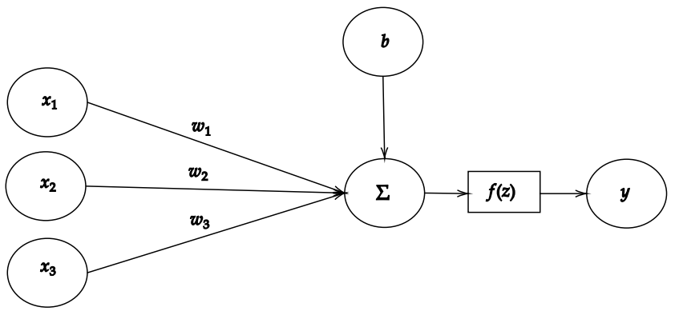
Figure 1. Simple perceptron model
Since its inception, the simple perceptron model has been significantly developed, influenced by insights from neuroscience, engineering, and mathematics. One approach to increasing its representational power involves expanding the number of neurons in parallel, allowing each neuron to capture different aspects of the input data (Rumelhart, Hinton, & Williams, 1986).
Another approach to processing sensory data—particularly visual data—draws directly from neuroscience. In biological systems, multiple stages of filtering occur before the visual cortex receives and interprets information as coherent images. Similarly, it is hypothesized that artificial neural networks benefit from deeper architectures that emulate hierarchical information processing in the brain (Felleman & Van Essen, 1991). In a Deep Neural Network (DNN), the first (input) layer may contain pixelated image data, which is passed through a sequence of hidden layers that progressively extract higher-level features, culminating in the output layer that encodes semantic understanding of the input.
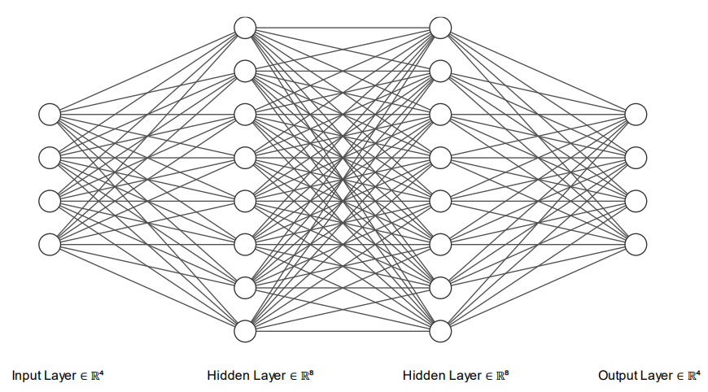
Figure 2. Deep Neural Network with 4 layers

Activation functions
Often, we want to solve tasks with non-linear relations or problems where the desired output is a probability, such as the probability of an image containing a cat. To solve these problems, activation functions are introduced to the network. Given a linear input
$z=w. x+b$ (2)
we can transform z into a non-linear output as follows
$y=f(z)$ (3),
where f(z) can be any nonlinear activation function (Nwankpa et al., 2018).
Activation functions in hidden layers have been researched extensively. Initially, the sigmoid and hyperbolic tangent (tanh) functions were commonly used. Today, the Rectified Linear Unit (ReLU) is the most widely adopted due to its computational simplicity and its resistance to the vanishing gradient problem, as it is a piecewise function. Additionally, ReLU mimics biological neuron behavior by saturating at zero and activating only a subset of neurons at any given time (Glorot, Bordes, & Bengio, 2011). The formula for ReLU is defined as:
$f(z)=max⁡(0, z)$ (4)
At the output layer, the activation function depends on the task being addressed. For binary classification tasks, the sigmoid activation function is commonly used to output the probability of class membership. For multi-class classification, a generalization of the sigmoid function known as SoftMax is used, which returns a probability distribution over the possible classes (Goodfellow, Bengio, & Courville, 2016).

Cost function
To analyze how our neural network is performing, we use something called the cost function (or loss function) to measure how big of an error the network is producing in its outputs. Since ideally, we want our network to make perfect decisions, our goal is to minimize the cost [39]. In supervised tasks, this would mean that for an input pair (x, y), where y is the ground-truth value, our model would be able to make a prediction ŷ, that is the same as the ground-truth value when the input is x.
One of the most common cost functions is the Mean Squared Error (MSE) cost function, which can be used for regression problems. The cost is usually averaged over m training examples and is defined as follows
$MSE \left(y, ŷ \right)=\frac{1}{m} \sum_{i=1}^{m}{(}{y_{i}- ŷ_{i})}^{2}$ (5)
where m = number of training examples, y_{i} = ground-truth value for the ith training example and ŷ_{i} = predicted value.
When our output is a vector of conditional probabilities, for example, if our output layer uses a SoftMax activation, it would be desired to penalize distinctly wrong outputs more, such as classifying an image of a cat as a bird. As we know that our input values are in the range of [0, 1], we can use something called Cross-Entropy loss, which minimizes the negative log-likelihood and is given by
$L \left(y, ŷ \right)=-\frac{1}{m} \sum_{i=1}^{m}{(}y_{i}* log (ŷ_{i}))$ (6)
Due to the logarithm, the function outputs a high error when it incorrectly assigns a low probability to the correct class (Murphy, 2012).

Backpropagation and Gradient Descent
As the objective of a machine learning model is to minimize the cost function, we must find a way to adjust the weights and biases to achieve this. A way to solve this is to compute the gradient of the cost functions, which is just a vector of partial derivatives with respect to the weights and biases of the network, informing us how much changing each unit in the network by a tiny amount would change the output. The gradient gives us the magnitude and direction of the steepest ascent, so we can iteratively move towards some local minima of the cost function by taking a step towards the negative direction of the gradient. The size of the step is usually given by the learning rate. Too high of a learning rate might not reach the minima of the cost function, and too small of a learning rate might take too long to find the minima, so the learning rate should be tuned correctly. The network can then be updated by an algorithm called Gradient Descent as follows
$θ = θ - η ∙ ∇C$ (7)
where θ = the vectorized parameters of the network, η = learning rate and ∇C = gradient vector of the cost function (Goodfellow, Bengio, & Courville, 2016).
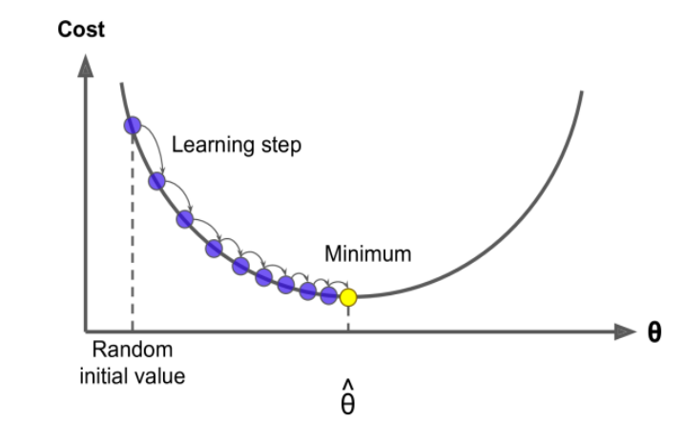
Figure 3. Gradient Descent algorithm.

The gradient is calculated using an algorithm called Backpropagation, which computes the partial derivatives by moving backward through the layers of the neural network. The algorithm begins with a forward pass, where a training example is input into the network and the cost function is computed based on the output. Then, in the backward pass, Backpropagation is applied to calculate how much each parameter contributed to the final error. This process involves applying the chain rule of calculus through the computational graph, effectively propagating the error signals backward—hence the name Backpropagation (Rumelhart, Hinton, & Williams, 1986).
For example, the error of the first weight from the input layer with respect to the cost function can be calculated as follows:
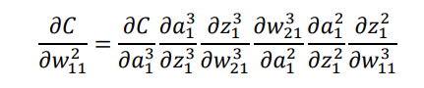 (8)
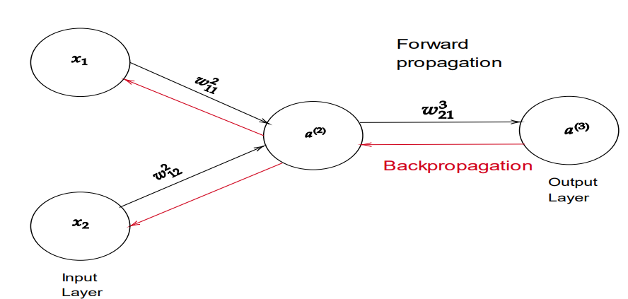
Figure 4. Neural network forward propagation and backpropagation
With the regular Gradient Descent algorithm, the weights are updated only after forward propagating every sample and calculating the total cost across the dataset. However, this approach can be computationally expensive and slow to converge, especially on large datasets. To accelerate the training process, a Stochastic Gradient Descent (SGD) algorithm is typically used. Instead of summing over the cost of all training examples, a small random subset (a mini-batch) is selected from the dataset, and the gradient descent step is applied using the average gradient of that batch (Bottou, 2010).

Convolutional Neural Networks
Convolutional Neural Networks (CNNs) are currently the state-of-the-art method for a wide range of computer vision tasks. They were developed to more effectively extract meaningful features from structured data such as images, where spatial hierarchies and local dependencies are critical. While CNNs have been researched since the 1960s, a major breakthrough came in 1989 when Yann LeCun successfully applied the backpropagation algorithm to convolutional architectures (LeCun et al., 1989) and later introduced the LeNet architecture (LeCun et al., 1998), which laid the groundwork for modern deep learning-based computer vision.
CNNs gained widespread recognition in 2012, when AlexNet dramatically outperformed other models in the ImageNet Large Scale Visual Recognition Challenge (ILSVRC). This breakthrough was largely enabled by advances in GPU computing, allowing for the training of deeper networks on larger datasets (Krizhevsky, Sutskever, & Hinton, 2012).
Compared to regular neural networks, instead of learning weights from each input neuron to each hidden layer neuron, CNNs learn a kernel which we slide and apply through an image in small boxes with a mathematical operation called convolution. This allows us to find patterns in images by not only looking at one pixel at a time but also its surroundings. Convolution is often implemented as cross correlation in CNNs, which performs the same operation, but with the kernel flipped before sliding it over the input and is mainly used to simplify the mathematical equation. Cross-correlation is then defined as follows
(f∗g)(i,j)=∑​∑​ f(i+a,j+b) ⋅ g(a,b) (9)
where f = discrete 2d input such as an image, g = 2d kernel, and i and j are the coordinates which convolution will be calculated at (Goodfellow, Bengio, & Courville, 2016).
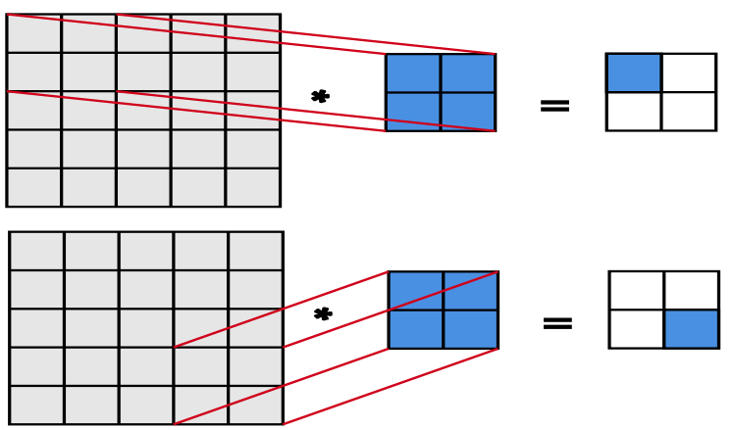
Figure 5. Convolutional operation in 2 dimensions

These convolutional operations, together with the learned kernels, are applied in convolutional layers, where the number of different kernels determines the depth of the layer. These layers contribute to a more memory-efficient architecture compared to fully connected (dense) neural networks. As the kernels are shared across spatial positions in the input, memory usage is significantly reduced—we only need to store weights proportional to the kernel size, rather than to the full size of the input (Goodfellow, Bengio, & Courville, 2016).
The output of each kernel applied to the input is referred to as a feature map. These feature maps represent transformed versions of the input image, emphasizing specific patterns detected by each kernel. Typically, the early convolutional layers detect low-level features such as edges or textures—like the outline of a face in an image—while deeper layers combine these features to detect higher-level components, such as eyes or mouths, ultimately reconstructing a semantic representation of the object, like a human face (Zeiler & Fergus, 2014). The feature maps are also passed into activation functions, as was the case with regular neural networks, to introduce non-linearities to the network. An example of a convolutional neural network and its feature maps can be seen in Figure 6.
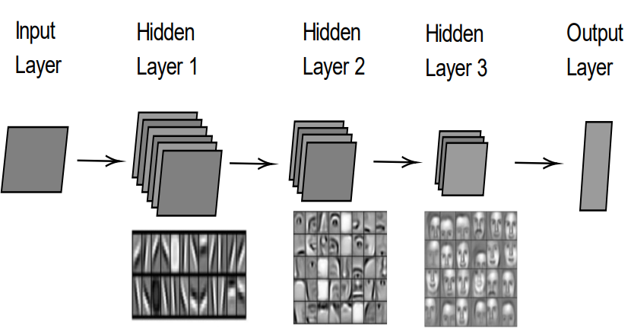
Figure 6. Convolutional neural network with hidden layer feature maps visualized. Layer visualizations copied from [52]

Padding and Stride
As we convolve an image with a kernel, our output keeps shrinking relative to the input, as was seen in Figure 5, causing us to gain less information about pixels on the edges after each layer. To avoid this, we pad the input with zeroes so that we can slide the kernel horizontally and vertically as many times as we have pixels in the original input, resulting in an output image that is larger than the original output and containing more information about the edges (Dumoulin & Visin, 2016).
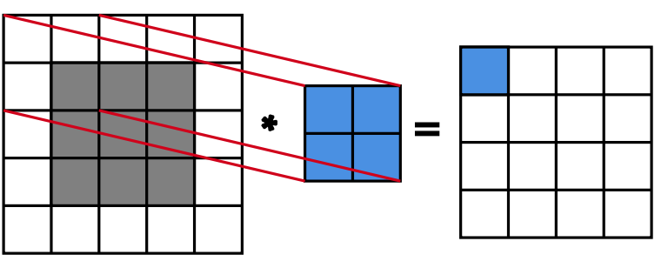
Figure 7. Input with padding results in a larger output feature map than in Figure 5
Sometimes it is also desired to reduce the dimensions of the input or speed up the computation, so we downsample by applying stride to the convolution operation. As was seen in Figure 5, we moved the kernel horizontally and vertically by one, which means we had a horizontal and vertical stride of one. To downsample a feature map, we could for example apply a horizontal and a vertical stride of three, as is seen in Figure 8 (Dumoulin & Visin, 2016).
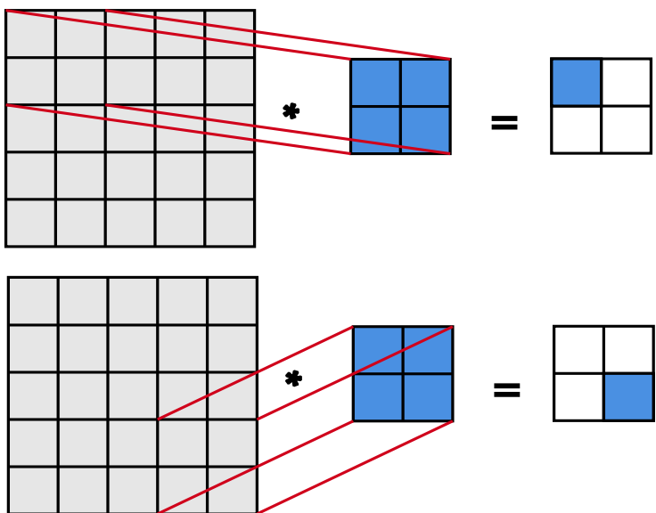
Figure 8. Convolutional operation with a horizontal and vertical stride of three

Pooling
Another way to downsample the input image is to apply a pooling layer between the convolutional layers, which has a size and stride like a convolutional layer but computes a function other than a convolution from its inputs, such as an average or a maximum. The most commonly used layer is a max pool layer, where the cell with the biggest value is always selected to the output as the max pooling kernel is slid over the inputs. This is useful, as usually, we try to find edges from the images without feature maps, and sharp features are usually related to high pixel values, thus reducing the input dimension and finding desired features without having to learn any weights. Another benefit of max pooling is that it offers some level of translation invariance, meaning that small changes in the location of the pixel can still result in the same output (Scherer, Müller, & Behnke, 2010). The max pooling operation is shown in Figure 9.
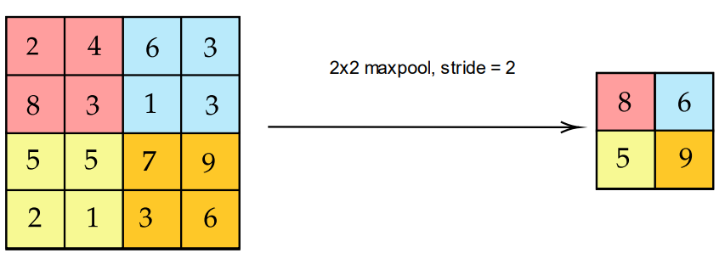
Figure 9. 2x2 max pooling with stride = 2

Object Detection at Edge
Object detection is a task of locating and classifying an object or multiple objects in a scene. This can be used e.g., for detecting pedestrians and traffic signs in self-driving cars or traffic behavior in intersections. A real-world deployment example of the latter could be to install a security camera near the intersection, which would then stream the images to a remote cloud center to process the data. This has been the de facto standard for the past decade as cloud computing has become increasingly popular, but it now has its concerns due to vast amounts of incoming data and personal privacy. To deal with these issues, edge computing has grown to be a popular solution alongside cloud computing. The data can be pre-processed at an edge, which is a computing node between the sensor (such as a camera) and the cloud, as is shown in Figure 10 (Shi et al., 2016).
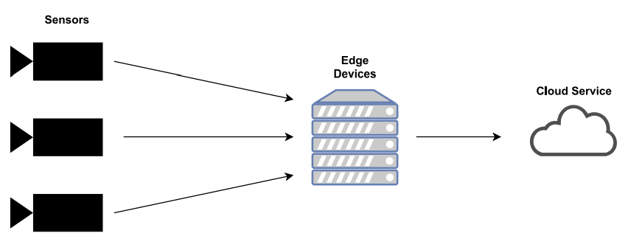
Figure 10. Simple edge computing network
The first benefit of this is latency and bandwidth reduction, as we can perform computing ideally in the same network as the devices that operate on this data, reducing the overhead of transferring the data forth and back, which could be crucial in applications such as autonomous cars (Shi et al., 2016). The second benefit is being able to process the data before it reaches a third-party cloud environment, like anonymizing faces or hiding unique identifiers from sensitive data. Thirdly, we can save storage at large-scale datacenters by filtering data not suitable for postprocessing at the edge. The need for pre-processing and filtering becomes more evident by looking at Cisco’s numbers, which reported that M2M (machine-to-machine) devices, such as surveillance cameras and smart meters, would account for 50% of devices and connections by 2023 and were growing the fastest by far (Cisco, 2020).

Object Detection
In object detection, we want to be able to input an image to an algorithm, which will then return us the number of detections, bounding boxes that tell us the location of the objects within the image, and classes telling us what kind of objects we have detected and the confidences that an object belongs to the class (Liu et al., 2020).
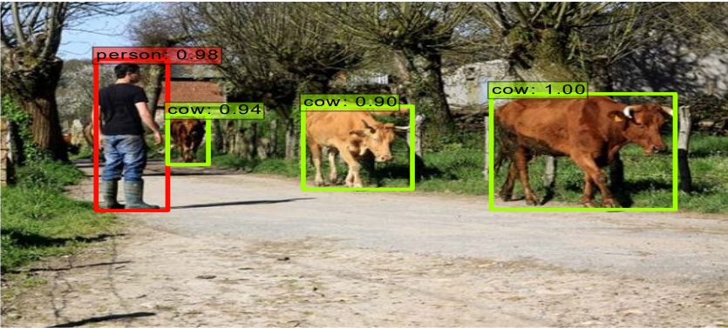
Figure 11. The output of a typical object detection model [58]
Object detection has exploded in the last decade due to the growth of convolutional neural networks but has been available for some detection tasks, such as face detection, for nearly two decades. One of the most popular algorithms was and still is the Viola–Jones algorithm, which could detect faces at 15 FPS back in 2001 (Viola & Jones, 2001).

Object Detection Architectures
The modern deep-learning-based object detection models started showing promise in 2014 with the release of the RCNN model. It however was too slow for the majority of real-life use cases, as it consisted of 3 different stages with both convolutional neural network and support vector machine (SVM) classifiers to train (Girshick et al., 2014). Recent object detection models are generally single-shot detectors, meaning we only must pass the input image through one neural network. These architectures usually consist of two parts: a base network and a classification network, with its final classification layers cut off to generate feature maps at different scales. The classification layers are then replaced by a detector network, which generates appropriate bounding boxes and classifications from these feature maps. Figure 12 shows an SSD model (Liu et al., 2016) with a VGG-architecture base network.
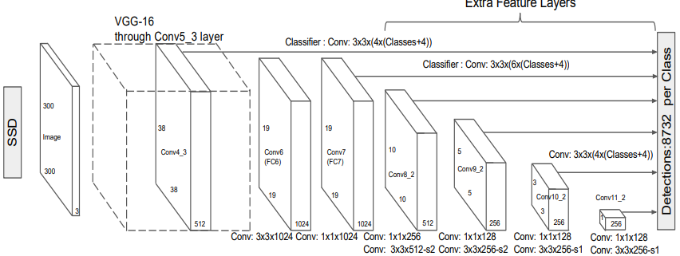
Figure 12. SSD Detector with a VGG base network [62]
The larger feature maps, such as the 38×38 layer in Figure 12, attempt to find small objects by dividing the image into smaller segments, while the smaller feature maps try to locate larger objects. As the feature maps often shrink information about the image into more dense representations, each pixel in a feature map can be seen as representing a larger group of pixels in the original input, and thus forming a grid of cells over the original image. An example of this can be seen in Figure 13, where a 7×7 feature map is laid over the input image (Liu et al., 2016).
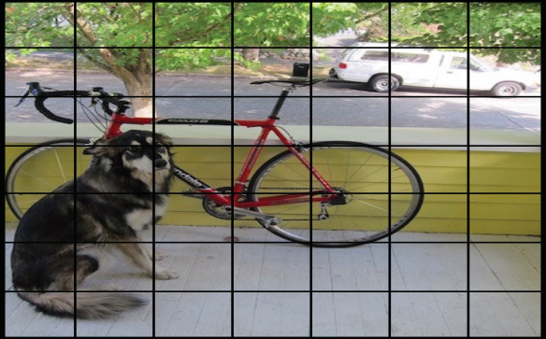
Figure 13. 7x7 feature map laid over an input image [63]
Modern object detector models can further be divided into two categories, anchor-based and anchor-free solutions. The anchor-based solutions, such as SSD (Liu et al., 2016) or EfficientDet (Tan, Pang, & Le, 2020), try to predict n bounding boxes for each cell in a feature map by calculating offsets for a given set of hand-engineered default (or anchor) boxes at different scales. The best bounding boxes are then chosen with an algorithm called non-max suppression (NMS). The anchor-free solutions, such as YoloX (Ge et al., 2021) or FCOS (Tian et al., 2019), don’t require manually finding optimal anchor boxes for prediction, and only one prediction is selected for an object even at multiple feature map levels, as overlapping is further reduced by methods such as setting limits for bounding box sizes at each level.
As an object detection model’s goal is to predict a correct class and a correct location for each object in the scene, the cost function is usually a sum of the classification error and localization error (regression task). For example, in the Fast R-CNN model, the following loss function was used
$Ltotal = Lcls + Lloc$ (10)
where Lcls = SoftMax loss, used for measuring the classification error, and Lloc = smooth L1 loss, used for measuring the localization error (Girshick, 2015).

Intersection over union and non-max suppression
In object detection, a prediction is labeled as a true positive, if its bounding box and the ground-truth prediction’s bounding box overlap over a certain threshold. This metric is called intersection over union (IoU, Jaccard index) and is calculated by dividing the overlapping area by the union area of the two bounding boxes
IoU(A, B) = |𝐴 ∩ 𝐵| |𝐴 ∪ 𝐵| , (11)
where A = area of overlap and B = overlapping area (Everingham et al., 2010).
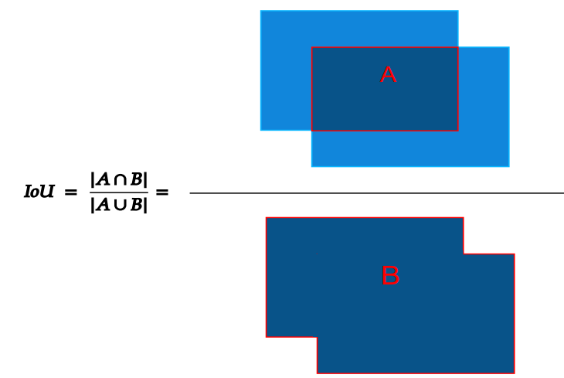
Figure 14. Intersection over union
Often the state-of-art models generate up to hundreds of predictions per input image and many of them are overlapping, trying to detect the same object from a different position. Non-max suppression attempts to speed up the processing by making a list of predicted bounding boxes sorted by their confidence, selecting the first one as a reference, and dropping the other bounding boxes in a list if their IoU was over a chosen threshold with the reference bounding box. This process is repeated for all the bounding boxes left in the list, with the ith bounding box chosen as a reference on ith comparison round (Neubeck & Van Gool, 2006).

YOLO
Modern object-detection literature treats YOLO (“You Only Look Once”) (Redmon et al., 2016) as the canonical real-time detector whose successive versions have balanced ever-higher accuracy with industry-grade speed and deployability. Since the original YOLOv1 in 2016, eight major public versions (and several forks) have appeared, each introducing architectural or training innovations—from anchor boxes, multi-scale heads, and Cross-Stage-Partial backbones to fully anchor-free decoders—while also motivating a rich body of research on quantization, compression, and edge deployment (Redmon et al., 2016; Jocher et al., 2023). Below is a structured review of this evolution, highlighting milestones, techniques, and known gaps that relate directly to your thesis on quantization robustness.

2.4.4.1 Evolution of YOLO
1.1 YOLOv1–v3 (2016-2018)
- YOLOv1 reframed detection as single-stage regression, achieving 45 FPS with one network pass (Redmon et al., 2016).
- YOLO9000 / YOLOv2 added anchor boxes and multi-label training on 9,000 classes, retaining real-time speed (Redmon & Farhadi, 2017).
- YOLOv3 introduced Darknet-53 and three-scale prediction heads, boosting mAP@50 to 57.9 while running in 51 ms on a Titan X (Redmon & Farhadi, 2018).
1.2 YOLOv4 & Scaled-YOLOv4 (2020-2021)
YOLOv4 combined “bag-of-freebies” (e.g., mosaic augmentation, CIoU loss) with CSPDarknet-53 to reach 43.5 AP (65 FPS, V100) (Bochkovskiy et al., 2020), while Scaled-YOLOv4 showed that depth/width/resolution scaling could preserve Pareto-optimal speed–accuracy trade-offs from tiny to giant models (Wang et al., 2021).
1.3 Ultralytics YOLOv5 (2020 →)
Re-implemented in PyTorch with an exporter for ONNX/TensorRT, YOLOv5 offered automatic mixed-precision training and, by v7.0, state-of-the-art instance-segmentation checkpoints (Jocher et al., 2023).
1.4 Community Forks: YOLOv6 & YOLOv7 (2022)
- YOLOv6 targeted industrial deployment, shipping INT8-calibrated engines that deliver 43.3 AP at 869 FPS on a T4 GPU (Meituan, 2022).
- YOLOv7 unified multiple “trainable bag-of-freebies,” hitting 56.8 AP while outperforming transformer-based detectors in the 5–160 FPS range (Wang et al., 2022).
1.5 YOLOv8 (2023)
Ultralytics’ YOLOv8 switched to an anchor-free head, enriched the PAN + FPN neck and included built-in ONNX/TensorRT export; empirical studies report accuracy gains with comparable real-time throughput (Jocher et al., 2023).
Table 1

Architectural Trends
Generation | Backbone / Neck | Decoder Style | Training “Freebies” | Deployment Hooks
v1 | Darknet-19/none | Grid-cell regression | None | Raw C / Darknet
v2-3 | Darknet-19/53 + passthrough | Anchor-based, multi-scale | Multi-scale loss | darknet2pytorch, TensorRT
v4 | CSPDarknet-53, SPP, PAN | Anchor-based, 3-scale | Mosaic, SAT, Mish | Native TensorRT plugins
v5-6 | CSPNet-Lite & -X | Anchor-based | AutoAugment, EMA | ONNX export
v7 | E-ELAN backbone, RepConv | Anchor-based, re-parameterized | Model re-param, BoF | INT8/TensorRT kernels
v8 | C2f & ELAN backbone, PAN-FPN | Anchor-free | Learned label smoothing, dynamic k-matching | ONNX-Dynamic, TensorRT-FP16/INT8

Table 1 summarizes the key architectural innovations and deployment-oriented features across the YOLO (You Only Look Once) model family, from YOLOv1 through YOLOv8. Each version reflects evolving design choices aimed at balancing real-time inference speed and object detection accuracy.

Backbone/Neck: Successive YOLO versions introduced progressively deeper and more efficient backbones. YOLOv1 used the simple Darknet-19, while later versions adopted CSPDarknet, CSPNet-Lite, E-ELAN, and C2f modules, which improved feature reuse and gradient flow (Bochkovskiy et al., 2020; Wang et al., 2022; Jocher et al., 2023).

Decoder Style: YOLOv1 employed grid-cell regression, while YOLOv2–7 relied on anchor-based detection. YOLOv8 transitioned to an anchor-free decoder, simplifying model configuration and enabling more flexible object localization (Jocher et al., 2023).

Training “Freebies”: Later YOLO versions integrated techniques that improved generalization and training efficiency without increasing inference cost. Examples include Mosaic augmentation, AutoAugment, EMA, and re-parameterization (Bochkovskiy et al., 2020; Wang et al., 2022).

Deployment Hooks: Earlier versions were tightly integrated with the Darknet framework. From YOLOv3 onward, export tools enabled deployment via ONNX and TensorRT backends. YOLOv5 introduced one-click export, and YOLOv8 added built-in support for dynamic and static quantization (Jocher et al., 2023; ONNX, 2025; NVIDIA, 2025).

Together, these advancements underscore how YOLO models have evolved in both architecture and deployability—an important consideration for this thesis’s focus on quantization robustness in edge applications.

Performance & Scalability Advancements
The architectural refinements and advanced training methodologies integrated into successive YOLO versions have translated into a consistent and remarkable ascent in both detection accuracy and inference speed, continually pushing the boundaries of real-time object detection. For instance, YOLOv4 established a new Pareto front in 2020, achieving a notable 43.5 AP (Average Precision on COCO) while maintaining a high throughput of 65 FPS on an NVIDIA V100 GPU (Bochkovskiy et al., 2020). This demonstrated a significant leap in balancing these two critical metrics. Building upon such advancements, YOLOv7 further elevated real-time performance, reaching an impressive 56.8 AP without compromising its characteristic high-speed inference capabilities, often outperforming contemporary transformer-based detectors within the practical 5-160 FPS range (Wang et al., 2022).
This trend of performance scaling is not limited to high-end server GPUs. The introduction of lightweight variants, such as the "nano" scale models, has democratized access to capable real-time object detection on resource-constrained edge devices. Illustratively, the nano variants of YOLOv8 can now operate comfortably above 50 FPS even on a low-power device like the Raspberry Pi 5, while still delivering a respectable mAP exceeding 26% on COCO (Jocher et al., 2023). This scalability across hardware platforms, from server-grade GPUs down to embedded systems, underscores the design philosophy of the YOLO family. These collective results confirm a consistent trajectory of improvement, where each major iteration has leveraged architectural innovations and sophisticated training techniques to achieve superior speed/accuracy trade-offs, making YOLO a persistent benchmark for efficient object detection.

Research Gaps & Outlook
- Robustness under Degraded Inputs. Most INT8 evaluations assume clean COCO images; systematic studies on noise, low contrast or motion blur remain sparse, especially for YOLOv7/v8.
- Calibration Sensitivity. Evidence from YOLOv6 suggests calibration set size and distribution strongly affect post-quantization accuracy / robustness (arXiv).
- Anchor-free Quantization. YOLOv8’s new head may interact differently with per-tensor vs per-channel quantization—a topic yet to be benchmarked.
- Transformer-Hybrid YOLOs. Emerging YOLO-NAS and YOLO-FMT integrate self-attention; their quantization behavior is unknown.
- Ultra-Low Precision (<8 bit). Early work (MSQuant) hints at severe accuracy loss below 6 bits even with advanced error-aware rounding, calling for smarter mixed-precision strategies (MDPI).
Addressing these gaps—particularly by comparing FP32 vs INT8 YOLOv5/v8 on synthetically degraded datasets—will directly advance understanding of quantization-robust object detection, aligning with the objectives of your thesis.

Deep Learning Accelerators
Due to the increasing need to perform tasks involving machine learning algorithms in real-time, especially on devices with limited CPU computing capability, chips optimized for edge inference are required. The current deep learning accelerators can be roughly divided into three categories: ASICs, FPGAs, and GPUs.
Both ASICs and FPGAs are application-specific circuits, which provide consistent low latency and power consumption, but have increased complexity in programming (Sze et al., 2017). The main differences between the two are that FPGAs provide flexibility by being reprogrammable, while ASICs are more optimized but single-purpose after production. Current state-of-the-art deep learning accelerators are ASIC chips such as Google Coral’s Edge TPU (Google, 2023) or Intel’s Movidius series VPUs (Vision Processing Unit) (Intel, 2023).
GPUs are also very popular in deep learning tasks, due to their easy programmability, but the trade-off can generally be seen in power consumption and latency (Jouppi et al., 2017). As they usually have lots of cores, they are well suited to parallelizing tasks, such as matrix multiplications and convolutions, which are widely used in neural networks. GPUs can also be utilized in a multitude of ways in a computer vision pipeline, for example in video decoding and encoding in addition to object detection. An example of a deep learning accelerator utilizing GPUs is the NVIDIA Jetson series embedded systems (NVIDIA, 2023), which feature fully-fledged Linux systems for diverse use cases.

Model Quantization
The remarkable success of Deep Neural Networks (DNNs) across various domains, including computer vision tasks like object detection, has been accompanied by a significant increase in model size and computational complexity (He et al., 2016; Redmon et al., 2016; Vaswani et al., 2017). While larger models often yield higher accuracy, their substantial memory footprint, high computational demands, and significant power consumption pose considerable challenges for deployment, particularly on resource-constrained platforms such as mobile devices, embedded systems, and edge computing hardware (Chen et al., 2020).
Model quantization has emerged as a critical and widely adopted technique to bridge this gap between model performance and deployment feasibility (Jacob et al., 2018; Krishnamoorthi, 2018). At its core, quantization is the process of reducing the numerical precision required to represent a model's parameters (weights) and, often, its intermediate calculations (activations). This typically involves mapping high-precision values (usually 32-bit floating-point, FP32) to lower-precision representations, most commonly 8-bit fixed-point integers (INT8), although explorations into even lower bit-widths like INT4 or binary representations also exist (Banner et al., 2019; Gholami et al., 2022).
The primary motivations for employing quantization are the substantial efficiency gains it offers:
- Reduced Model Size: Representing weights with fewer bits (e.g., INT8 vs. FP32) directly decreases the storage space required for the model by up to 4x or more.
- Lower Memory Bandwidth: Smaller data types require less memory bandwidth for fetching weights and activations during inference, which can be a significant bottleneck, especially in memory-bound operations common in DNNs.
- Faster Inference Latency: Integer arithmetic operations are generally much faster than floating-point operations on most modern CPUs and GPUs. Furthermore, specialized hardware accelerators (e.g., NVIDIA Tensor Cores, mobile NPUs) often provide massively parallel execution units specifically designed for low-precision integer computations, leading to significant speedups (Jouppi et al., 2017).
- Decreased Power Consumption: Faster execution and reduced memory access typically translate to lower energy consumption, crucial for battery-powered devices.
However, quantization introduces an inherent trade-off. Reducing numerical precision inevitably leads to a loss of information and introduces approximation errors, often referred to as quantization noise. This can potentially degrade the model's predictive accuracy compared to its original FP32 counterpart (Nagel et al., 2021). The central challenge in model quantization research and practice lies in developing techniques that maximize the efficiency benefits while minimizing this accuracy degradation.
Two primary paradigms have emerged for applying quantization: Post-Training Quantization (PTQ), which quantizes a model after it has already been trained in FP32, and Quantization-Aware Training (QAT), which simulates the effects of quantization during the training process itself (Krishnamoorthi, 2018; Jacob et al., 2018). This thesis primarily focuses on PTQ methods due to their simplicity and applicability without requiring retraining or access to the original training pipeline.
This section will now delve deeper into the specifics of these quantization approaches, detailing the principles, advantages, disadvantages, and common methodologies relevant to deploying efficient object detection models.

Post Training Quantization (PTQ)
Post-Training Quantization (PTQ) refers to a collection of techniques designed to convert a pre-trained, full-precision (typically FP32) neural network model into a lower-precision (commonly INT8) equivalent without requiring retraining or access to the original training dataset or pipeline (Nagel et al., 2021; Banner et al., 2019). This makes PTQ particularly attractive for practical deployment scenarios where retraining is infeasible due to cost, time constraints, or lack of access to the original training setup. The goal is to achieve significant efficiency gains with minimal impact on the model's pre-existing accuracy.
The fundamental process involves determining appropriate quantization parameters – specifically a scale factor (S) and a zero-point (Z) – for mapping the range of FP32 values encountered in the weights and activations to the target integer range (e.g., [-128, 127] for signed INT8). The mapping is typically affine:
real_value (r) ≈ scale (S) * (quantized_value (q) - zero_point (Z))
Or conversely:
quantized_value (q) = round(real_value (r) / scale (S)) + zero_point (Z)
The key challenge in PTQ lies in determining these scale and zero_point values effectively to minimize the quantization error, error = r - S(q - Z). Different PTQ methods primarily vary in how they determine these parameters, especially for the activations, which are input-dependent.
PTQ methods generally offer significant advantages in terms of simplicity and speed of application compared to QAT. However, since the model weights are fixed and not adjusted during the quantization process, PTQ can sometimes lead to a more noticeable accuracy drop, particularly for models that are highly sensitive to numerical precision or when quantizing to very low bit-widths (Gholami et al., 2022).
Within PTQ, two main approaches are commonly distinguished based on how activation quantization parameters are determined: Dynamic Quantization and Static Quantization. These will be discussed in the following subsections.

2.4.9.1a Dynamic Post-Training Quantization
Dynamic Post-Training Quantization (often referred to as "dynamic quantization" or "weight-only quantization" in some contexts) represents the simplest form of PTQ (Nagel et al., 2021). Its primary characteristic is that while the model's weights are quantized offline based on their value range, the quantization parameters (scale and zero-point) for activations are determined dynamically at runtime.
Process:
- Offline Weight Quantization: Before deployment, the weights of specific layers targeted for quantization (typically large layers like Conv and MatMul/Linear) are analyzed. Their minimum and maximum FP32 values are used to compute a fixed scale and zero_point, and the weights are converted to the target integer format (e.g., INT8). These quantized weights are stored in the model file.
- Runtime Activation Quantization: During inference, when an FP32 activation tensor arrives at the input of a dynamically quantized layer:
  - The inference engine (e.g., ONNX Runtime) calculates the minimum and maximum values of that specific activation tensor on-the-fly.
  - These runtime min/max values are used to determine the scale and zero_point for this specific tensor.
  - The activation tensor is then quantized to the target integer format (typically INT8) using these dynamically computed parameters.
- Integer Computation: The core computation (e.g., convolution or matrix multiplication) is performed using the quantized INT8 weights and the dynamically quantized INT8 activations, often accumulating results in a higher precision integer format (e.g., INT32).
- Output Dequantization: The integer output of the computation is typically dequantized back to FP32 using the pre-calculated weight scale and the dynamically calculated activation scale before being passed to subsequent layers (unless the next layer also supports direct INT8 input).
Advantages:
- Simplicity: It does not require a separate calibration dataset or calibration step to determine activation ranges beforehand. This makes it very easy to apply.
- Potential Accuracy: By calculating activation ranges precisely for each input tensor at runtime, it can sometimes preserve accuracy better than static quantization if activation ranges vary significantly and unpredictably between different inputs.
Disadvantages:
- Runtime Overhead: The primary drawback is the computational overhead incurred during inference to calculate the min/max values and quantization parameters for activations on-the-fly. This calculation must be performed for every activation tensor entering a quantized layer for every inference pass.
- Limited Speedup: This runtime overhead can significantly offset, or even negate, the speed benefits gained from using faster INT8 arithmetic, particularly on hardware where floating-point units are already highly optimized or where the min/max calculation itself is relatively slow. Consequently, dynamic quantization often provides less speedup compared to static quantization, and in some cases (as observed in preliminary stages of this study), can even be slower than the original FP32 model.
- Hardware Support: Support for efficiently executing the dynamic quantization operators might vary across different hardware accelerators and inference engines.
Use Cases:
Dynamic quantization is often considered for models where activation ranges are highly variable (e.g., certain Recurrent Neural Networks like LSTMs or Transformers, though static methods are also used there) or in scenarios where obtaining a representative calibration dataset is difficult. However, for convolutional networks like YOLO used in object detection, where activation distributions tend to be somewhat more stable, static quantization is generally preferred for maximizing performance gains. In this study, dynamic quantization (using ONNX Runtime) serves as a baseline comparison point for the static quantization approaches.

2.4.9.1b Static Post-Training Quantization
Static Post-Training Quantization (Static PTQ) aims to overcome the runtime overhead associated with dynamic quantization by determining the quantization parameters (scale and zero-point) for both weights and activations offline, before deployment (Jacob et al., 2018; Krishnamoorthi, 2018; Nagel et al., 2021). This pre-computation allows for faster inference as only simple lookups and integer arithmetic are needed at runtime.
Process:
- Offline Weight Quantization: Similar to dynamic quantization, the weights of targeted layers are analyzed, their value ranges are determined, and corresponding scale and zero_point values are calculated. The weights are converted to the target integer format (e.g., INT8) and stored. Common strategies include per-tensor quantization (one scale/ZP for the entire weight tensor) or per-channel quantization (separate scale/ZP for each output channel of a Conv/Linear layer), with the latter often yielding better accuracy for CNNs (Banner et al., 2019).
- Calibration Step (Crucial Difference): This is the defining step of static PTQ. A small, representative calibration dataset (typically 100-1000 samples derived from the training set or similar data, but not the final test set) is required.
  - The original FP32 model is run on this calibration dataset.
  - During these calibration runs, the inference framework (e.g., ONNX Runtime, TensorRT's calibrator) observes and records the range of values encountered for the activations at the input/output of each layer intended for quantization.
- Offline Activation Quantization Parameter Calculation: Based on the activation ranges observed during calibration, fixed scale and zero_point values are calculated for each activation tensor. Several methods exist for determining the optimal range from the observed statistics:
  - MinMax: Uses the absolute minimum and maximum activation values observed during calibration. Simple and fast, but highly sensitive to outliers.
  - Entropy (KL Divergence): Selects a quantization range that minimizes the Kullback–Leibler (KL) divergence between the original FP32 activation distribution and the distribution after quantization and dequantization. This method is often more robust to outliers as it considers the overall distribution shape (Banner et al., 2019).
  - Mean Squared Error (MSE): Selects the range that minimizes the mean squared error between the original FP32 values and the quantized/dequantized values.
- Model Transformation (QDQ Format): The modern and recommended approach involves transforming the ONNX graph by inserting explicit QuantizeLinear and DequantizeLinear (QDQ) nodes around the quantized weights and activation tensors (Absar et al., 2021). These nodes store the pre-calculated scale and zero_point values. The original FP32 compute operators (e.g., Conv, MatMul) often remain in the graph, but inference engines like ONNX Runtime or TensorRT recognize the surrounding QDQ nodes and execute the operation using optimized INT8 kernels, effectively fusing the Q/DQ operations with the compute kernel. An older format (QOperator) directly replaced operators like Conv with ConvInteger, but QDQ offers better flexibility and compatibility.
- Inference: During inference, data flows through the graph. When it hits a QuantizeLinear node, it's quantized using the stored static parameters. The computation happens (ideally in INT8), and the result hits a DequantizeLinear node to convert back to FP32 if needed by the next layer, or the INT8 result is passed directly if the subsequent operator supports it.
Advantages:
- Higher Performance: Eliminates the runtime overhead of calculating activation ranges, leading to significantly lower latency and higher throughput compared to dynamic quantization and often substantial speedups over FP32, especially on hardware with dedicated INT8 support.
- Broader Hardware Support: The static nature and explicit QDQ nodes often map more efficiently to various hardware accelerators.
Disadvantages:
- Requires Calibration Data: Needs a representative dataset for calibration, which might not always be available or easy to construct.
- Sensitivity to Calibration Data: The quality and representativeness of the calibration dataset directly impact the final quantized model accuracy. Poor calibration data leads to poor quantization parameters and significant accuracy degradation.
- Potential Accuracy Drop: While often achieving better accuracy than dynamic PTQ, static PTQ can still suffer accuracy loss compared to FP32, especially if the chosen calibration method (e.g., MinMax) is sensitive to outliers or if the model itself is inherently sensitive to quantization.
Relevance to Study:
Static PTQ, specifically using the QDQ format and targeting INT8 precision, forms the core of the quantization approach evaluated in this thesis. Both standard static PTQ (using a clean calibration set) and the proposed novel degradation-aware static PTQ (using a mixed clean/degraded calibration set) were implemented and compared, leveraging the TensorRT framework's calibration and engine-building capabilities accessed via the Ultralytics export pipeline.

Quantization-Aware Training (QAT)
While Post-Training Quantization (PTQ) methods modify a pre-trained model, Quantization-Aware Training (QAT) integrates the quantization process directly into the model training loop (Jacob et al., 2018; Krishnamoorthi, 2018). The core idea is to simulate the effects of low-precision inference during the forward pass of training, allowing the model's weights to adapt and compensate for potential quantization errors.
Process:
- Fake Quantization Nodes: During training, "fake quantization" nodes (also known as simulated quantization nodes) are inserted into the model graph, typically after weight layers (like Conv, Linear) and potentially after activation functions.
- Forward Pass Simulation: In the forward pass, these nodes simulate the quantization-dequantization (Q/DQ) process that would occur during INT8 inference. They take the FP32 weights/activations, quantize them to the target bit-width (e.g., INT8) using estimated or learned range parameters (scale/zero-point), and then immediately dequantize them back to FP32. This introduces the expected quantization noise into the forward computation.
- Backward Pass: Crucially, during the backward pass (gradient calculation and weight updates), the gradients typically bypass the "rounding" part of the fake quantization node, often using techniques like the Straight-Through Estimator (STE) (Bengio et al., 2013). This allows the gradients to flow back through the network, enabling the FP32 weights to be updated via standard optimization algorithms (like SGD or Adam) in a way that accounts for the noise introduced during the simulated quantized forward pass.
- Fine-tuning: QAT is often applied as a fine-tuning stage starting from a pre-trained FP32 model, although it can sometimes be performed from scratch. The model is trained for a few additional epochs with the fake quantization nodes active.
- Final Conversion: After QAT is complete, the learned FP32 weights (which are now "quantization-aware") are converted one final time to the target integer format (e.g., INT8) using the quantization parameters finalized during training.
Advantages:
- Higher Accuracy: By allowing the model weights to adapt during training, QAT can often achieve significantly higher accuracy for the quantized model compared to PTQ methods, sometimes nearly matching the original FP32 accuracy, especially for lower bit-widths or more sensitive models (Jacob et al., 2018).
- Robustness to Lower Precision: QAT is generally more effective when targeting very low precisions (e.g., INT4 or below) where PTQ often fails.
Disadvantages:
- Requires Training Pipeline: QAT necessitates access to the original training dataset, the training code/pipeline, and significant computational resources for the fine-tuning process.
- Complexity: Implementing QAT correctly, including the insertion of fake quantization nodes and handling the backward pass (STE), is considerably more complex than applying PTQ.
- Training Time: Requires additional training/fine-tuning time.
Relevance to Study:
While QAT often yields the highest accuracy for quantized models, it was not employed in this study due to the focus on post-training scenarios where retraining is assumed to be unavailable or impractical. PTQ methods (Dynamic and Static) were chosen for their applicability to pre-trained models without requiring access to the original training setup. QAT serves as an important reference point in the literature, representing the upper bound of accuracy typically achievable with quantization for a given bit-width.

Chapter 3: Methodology
This chapter details the systematic approach employed to investigate the impact of post-training quantization on the robustness of YOLO12 object detection models to common image degradations. The methodology encompasses the experimental setup, the selection of baseline models and datasets, the specific procedures for model export and application of different quantization techniques (FP32, FP16, Dynamic UINT8, and Static INT8 with both standard and novel degradation-aware calibration), the generation of degraded input data for robustness evaluation, and finally, the metrics and analytical framework used to assess and compare model performance. Each step was designed to ensure a controlled and reproducible comparison, allowing for a clear evaluation of how different precision levels and calibration strategies affect accuracy, inference speed, and resilience to real-world image imperfections. The following sections will elaborate on each of these components in detail.

3.1 System Setup and Tools
This study focuses on the post-training analysis of pre-trained models and was conducted on a system equipped with an NVIDIA GeForce RTX 2070 GPU and an Intel(R) Core(TM) i7-10750H CPU @ 2.60GHz. All experiments involving model export, quantization, and benchmarking were performed exclusively on the GPU (cuda:0) to ensure consistent hardware acceleration.
The software environment was based on Python 3.12.3, utilizing the following key libraries and frameworks: Ultralytics YOLO, PyTorch, torchvision, ONNX, ONNX Runtime, TensorRT, Albumentations, OpenCV, NumPy, pycocotools, PyYAML
All benchmarking results, particularly latency measurements, were obtained by running inference with a consistent batch size of 1 on the specified GPU (cuda:0) to ensure comparable single-image processing times across different model precisions and validation datasets. Reproducibility was promoted through the use of fixed random seeds (seed=42) during data sampling and augmentation procedures where applicable.

3.2 Baseline Model and Datasets

3.2.1 Baseline Models
This study investigated the quantization robustness across multiple scales of the YOLO12 object detection model family. Specifically, the nano (n), small (s), medium (m), large (l), and extra-large (x) variants were analyzed. For each variant (e.g., YOLO12n, YOLO12s, etc.), we utilized the official pre-trained weights provided by the Ultralytics framework, loaded via the corresponding constructor (e.g., YOLO("yolo12n.pt"), YOLO("yolo12s.pt")) (Jocher et al., 2023).
These models were chosen to evaluate whether quantization robustness varies with model size and capacity. The performance of each model variant was baselined using its original FP32 precision after export to the relevant inference formats (ONNX for dynamic quantization, TensorRT engine for FP32/FP16/Static INT8).

3.2.2 Datasets
All experiments were conducted using the Microsoft COCO (Common Objects in Context) 2017 dataset (Lin et al., 2014).
- Calibration Data Source: For each model variant (n, s, m, l, x) requiring static quantization calibration, a consistent subset of 1000 images was sampled randomly from the COCO train2017 split. Two types of calibration datasets were generated based on this sample:
  - Clean Calibration Set: Contained the 1000 sampled clean train2017 images. The sampling method combined initial random sampling with a top-up mechanism to ensure all 80 COCO categories were represented.
  - Mixed Calibration Set: Utilized the same 1000 clean sampled images as a base. A target degradation ratio of 50% was applied. For each image, it was either kept clean (50% probability) or had one degradation randomly applied (50% probability) from a predefined pool (detailed in Section 3.4.2). All 1000 resulting images (a mix of clean and degraded) were saved to a dedicated directory structure. The same sampling and degradation process was used consistently across all model scales requiring calibration.
- Validation Data Source: The standard COCO val2017 split (containing 5000 images) was used as the basis for all performance evaluations across all model variants and precision types.
- Generated Validation Sets: To assess robustness, the entire val2017 dataset was processed once to create multiple distinct validation sets, each corresponding to a specific image degradation type and level (detailed in Section 3.4.3). These generated sets include: Noisy (Low, Medium), Blurry (Low, Medium), Low Contrast, and Heavy JPEG Compression. Additionally, a 'Mixed Degradation' validation set was created where 50% of the val2017 images were randomly chosen to have one degradation applied (randomly selected from the predefined pool), while the other 50% remained clean. These generated validation sets were used for evaluating all model variants.
All generated datasets (calibration and validation) were structured according to the COCO format expected by the Ultralytics framework, including images and labels subdirectories and a corresponding data.yaml configuration file specifying paths and the standard 80 COCO class names.

3.3 Model Export and Quantization Procedures
To evaluate the impact of reduced precision and quantization on robustness, the baseline FP32 YOLO12 models (n, s, m, l, x) were converted into several target formats and precisions using the Ultralytics export functionalities and ONNX Runtime tools (Jocher et al., 2023; Microsoft, 2025). All exported models intended for benchmarking were optimized for inference with a batch size of 1 on the target NVIDIA GPU.

3.3.1 FP32 Baseline (TensorRT Engine)
- Purpose: Establish the baseline performance and robustness of each YOLO12 model variant in full precision, leveraging TensorRT optimizations.
- Procedure: Each pre-trained FP32 PyTorch model (.pt) was exported directly to a TensorRT engine (.engine) using the Ultralytics export function. Key parameters included format='engine', half=False, int8=False, batch=1, and device='cuda'. This process utilizes TensorRT to optimize the computational graph (e.g., layer fusion) and compile it specifically for the target GPU while maintaining FP32 precision for computations. The resulting .engine file served as the FP32 baseline for benchmarking (Jocher et al., 2023; NVIDIA, 2025).

3.3.2 FP16 Mixed Precision (TensorRT Engine)
- Purpose: Evaluate performance and robustness using half-precision floating-point representation, a common optimization technique.
- Procedure: Similar to the FP32 baseline, each .pt model was exported to a TensorRT engine, but with the half=True flag enabled during the export call (format='engine', half=True, int8=False, batch=1, device='cuda'). TensorRT automatically identifies layers suitable for FP16 computation while potentially keeping others (like normalizations or sensitive layers) in FP32, creating a mixed-precision engine optimized for speed and reduced memory usage (Jocher et al., 2023; NVIDIA, 2025).

3.3.3 Static INT8 Quantization (TensorRT Engine with Calibration)
- Purpose: Evaluate standard Post-Training Static Quantization (PTSQ) using INT8 integers, calibrated with clean data. This represents a typical high-performance deployment scenario.
- Procedure: This involved leveraging TensorRT's built-in INT8 calibration capabilities via the Ultralytics exporter. For each model variant:
  - The FP32 .pt model was exported using model.export().
  - Key export parameters were set: format='engine', int8=True, half=False , batch=1, device='cuda', and importantly, data='path/to/coco_calib_clean/data.yaml'.
  - Providing the data argument pointing to the clean calibration dataset triggers TensorRT's internal calibration process. TensorRT runs inferences on the calibration data subset defined in the YAML file to determine appropriate scales for quantizing weights and activations to INT8. MinMax calibration method is now the default in Ultralytics' export process.
  - The output was an optimized INT8 TensorRT engine (.engine) file (Jocher et al., 2023; NVIDIA, 2025)).

3.3.4 Degradation-Aware Static INT8 Quantization (TensorRT Engine with Mixed Calibration - Novel Method)
- Purpose: The primary objective of this novel approach was to evaluate whether explicitly exposing the static quantization process to anticipated real-world image degradations during calibration could yield an INT8 model with improved robustness. The underlying hypothesis is that by observing activation statistics from both clean and degraded inputs, the TensorRT calibration algorithm might derive quantization parameters (scales and zero-points) that are more representative of the wider range of activation distributions the model will encounter in less-than-ideal conditions, thereby reducing quantization error and preserving accuracy better when faced with such degraded inputs during inference.
- Rationale and Expected Mechanism: Standard static PTQ (as detailed in 3.3.3) typically uses only clean, high-quality images for calibration. This can lead to quantization ranges optimized for these ideal inputs. When a degraded image (e.g., noisy or blurry) is subsequently fed to such a quantized model, the activations in intermediate layers may shift or spread beyond the ranges observed during clean calibration. This can result in increased clipping errors (where values fall outside the representable INT8 range) or a suboptimal mapping of the true activation distribution, both contributing to accuracy degradation (Nagel et al., 2021).
The proposed degradation-aware strategy aims to mitigate this by providing the calibrator with a more diverse set of activation statistics. The "mixed calibration dataset" (generation detailed in Section 3.2.2) contained a 50/50 split of clean images and images subjected to one of several randomly selected degradations (noise, blur, low contrast, JPEG compression) from the pool defined in Section 3.4.1. By processing this mixed dataset, TensorRT's calibration algorithm (which typically employs methods like MinMax range collection or Entropy-based calibration; NVIDIA, 2025) observes a broader spectrum of activation values. The expectation was that this would lead to:
- Potentially wider or slightly shifted quantization ranges for certain activation tensors, better accommodating the shifts caused by degradations.
- A quantized model whose INT8 representation is less "surprised" by degraded inputs, leading to a smaller drop in mAP when evaluated on degraded validation sets compared to a model calibrated solely on clean data.
- A potential trade-off might be a slight decrease in optimal performance on purely clean data, as the quantization parameters would represent a compromise.
- Procedure: The generation of the degradation-aware static INT8 model was procedurally identical to the standard static INT8 quantization described in Section 3.3.3, with one critical modification in the data provided to the TensorRT calibration process during model export:
  - The FP32 PyTorch model (.pt) for each YOLO12 variant was exported using the Ultralytics model.export() function (Jocher et al., 2023).
  - Key export parameters were set consistently: format='engine', int8=True, half=False, batch=1, and device='cuda'.
  - The crucial difference was the data parameter, which was set to point to the YAML file of the mixed calibration dataset.
  - This instructed the TensorRT backend, invoked by the Ultralytics exporter, to perform its internal INT8 calibration routines using the provided dataset containing a 50% mix of clean images and 50% images with pre-applied random degradations. TensorRT's calibrator would then profile the network with these mixed inputs to determine the necessary quantization scales for weights and activations.
  - The output of this process was a distinct, optimized INT8 TensorRT engine (.engine) file, specifically calibrated with the degradation-aware dataset. This engine was then benchmarked against all clean and degraded validation sets to assess the effectiveness of this calibration strategy.

3.3.5 Dynamic UINT8 Quantization (ONNX Runtime)
- Purpose: Evaluate Post-Training Dynamic Quantization (PTDQ) as another common quantization baseline, contrasting with the static approach.
- Procedure:
  - Export to ONNX: Each FP32 .pt model was first exported to the ONNX format using model.export(format='onnx', half=False, dynamic=False, simplify=True, device=’cuda’, ...). The simplify=True flag is recommended to optimize the graph structure prior to quantization.
  - Pre-processing: The exported FP32 ONNX model was pre-processed using onnxruntime.quantization.preprocess.quant_pre_process to perform graph optimization (e.g., Conv+BN fusion) and shape inference, creating a _processed.onnx model.
  - Apply Dynamic Quantization: The onnxruntime.quantization.quantize_dynamic function was applied to the _processed.onnx model. Key parameters included weight_type=QuantType.QUInt8, per_channel=True and 'op_types_to_quantize': ['MatMul', 'Gemm']. This function quantizes the weights (primarily Conv, MatMul) offline to UINT8 and configures the graph so that activations are quantized dynamically to UINT8 at runtime by ONNX Runtime (Microsoft, 2025).
  - The resulting dynamically quantized ONNX model was used for benchmarking.

3.4 Degradation Generation and Validation Datasets
To evaluate the robustness of the different model precisions, a suite of degraded validation datasets was created based on the original COCO val2017 split. The goal was to simulate common real-world image imperfections. Degradations were applied using the Albumentations library. For each distinct degradation type and level, a complete copy of the val2017 dataset was generated with the specific degradation applied uniformly to all images (Buslaev et al., 2020).

3.4.1 Degradation Techniques
The following image degradation techniques were selected, with parameters chosen to represent plausible levels of severity (Buslaev et al., 2020):
- Gaussian Noise (Simulating Sensor Noise):
  - Low: albumentations.GaussNoise(std_range=(10/255, 30/255), p=1.0, per_channel=False)
  - Medium: albumentations.GaussNoise(std_range=(35/255, 55/255), p=1.0, per_channel=False)
- Gaussian Blur (Simulating Defocus/Haze):
  - Low: albumentations.GaussianBlur(blur_limit=(3, 5), p=1.0)
  - Medium: albumentations.GaussianBlur(blur_limit=(7, 11), p=1.0)
- Low Contrast (Simulating Poor Lighting/Haze):
  - Low: albumentations.RandomBrightnessContrast(brightness_limit=0, contrast_limit=(-0.6, -0.3), p=1.0)
- JPEG Compression Artifacts:
  - Heavy: albumentations.ImageCompression(quality_lower=20, quality_upper=45, compression_type="jpeg", p=1.0)
  - Moderate: albumentations.ImageCompression(quality_lower=50, quality_upper=75, compression_type="jpeg", p=1.0)

3.4.2 Generation of Distinct Degraded Validation Sets
For each degradation defined above (e.g., "noisy_low", "blurry_medium"), the following process was executed:
- A new dataset directory structure (mirroring COCO format with images/val2017 and labels/val2017) was created.
- The original labels from the COCO val2017 labels directory were copied into the new dataset's labels/val2017 directory. The ground truth remains unchanged.
- Each image from the original COCO images/val2017 directory was loaded using OpenCV (Bradski, 2000).
- The specific Albumentations transform corresponding to the target degradation (e.g., transform_val_noisy_low) was applied to the loaded image (format: uint8 BGR) (Buslaev et al., 2020).
- The resulting degraded image was saved into the new dataset's images/val2017 directory, preserving the original filename.
- A val2017.txt file containing the relative paths to the newly saved degraded images within the dataset structure was generated.
- A data_<degradation_name>.yaml file was created, pointing to the paths within the new degraded dataset structure (path, train, val) and specifying the standard 80 COCO classes.
This resulted in separate, self-contained validation datasets for each degradation condition (e.g., coco_val_noisy_low, coco_val_blurry_medium, etc.).

3.4.3 Generation of Mixed Degradation Validation Set
To simulate a more general scenario with unpredictable image quality, one additional validation set was created:
- A new dataset directory structure was created (coco_val_mixed_degrad_50pct).
- The original val2017 labels were copied.
- The original val2017 image list was processed. Each image was randomly assigned to either remain clean (50% probability) or receive a degradation (50% probability).
- If chosen for degradation, one specific degradation type and level was randomly selected from the same pool used for mixed calibration (Noise Low/Med, Blur Low/Med, Contrast Low, JPEG Mod/Heavy) and applied using Albumentations (Buslaev et al., 2020).
- The resulting image (either the original clean copy or the randomly degraded version) was saved to the new dataset's images/val2017 directory under its original filename.
- Appropriate val2017.txt and data_coco_val_mixed_degrad_50pct.yaml files were generated.
This mixed set allows for evaluating performance under more varied, less predictable conditions, complementing the analysis of specific degradation types.
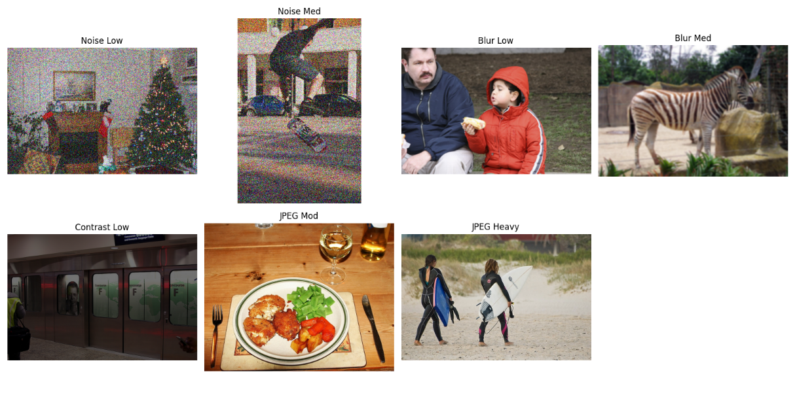
Figure 15. Examples of Synthetic Image Degradations Applied
Figure 15, showcases the visual impact of the different degradation types and levels employed in this study. From top-left to bottom-right: Low Gaussian Noise, Medium Gaussian Noise, Low Gaussian Blur, Medium Gaussian Blur, Low Contrast, Moderate JPEG Compression, and Heavy JPEG Compression. Each example illustrates how a clean image might be transformed to simulate common real-world imperfections encountered by object detection systems. These specific transformations were drawn from the pool used to generate both the distinct degraded validation sets and the degraded portion of the mixed calibration and mixed validation datasets.

3.5 Evaluation Metrics and Analysis

3.5.1 Benchmarking Procedure
All model variants (FP32, FP16, Static INT8 Clean Calib, Static INT8 Mixed Calib, Dynamic UINT8 ONNX) were benchmarked against the clean COCO val2017 dataset and each of the generated degraded validation datasets (Noisy Low/Medium, Blurry Low/Medium, Contrast Low, JPEG Heavy, and Mixed Degradation).
The evaluation was performed using the model.val() method from the Ultralytics library (Jocher et al., 2023). For each benchmark run, the specific data argument was set to the appropriate dataset configuration YAML file (e.g., coco.yaml, data_noisy_low.yaml, data_coco_val_mixed_degrad_50pct.yaml). Consistent benchmarking parameters were used across all runs to ensure fair comparison, including: imgsz=640, batch=1, device='cuda', conf=0.001, iou=0.6, half=False (for FP16 half=True), and augment=False.

3.5.2 Performance Metrics
The following key performance metrics were extracted from the model.val() results for each model-dataset combination (Jocher et al., 2023):
- Accuracy:
  - mAP50-95(B): Mean Average Precision calculated over IoU thresholds from 0.50 to 0.95 (in steps of 0.05). This is the primary COCO metric and was used as the main indicator of detection accuracy.
  - mAP50(B): Mean Average Precision calculated at a single IoU threshold of 0.50. Used as a secondary accuracy metric.
- Speed:
  - Latency (ms): The average inference time per image ( ms/image ) reported by Ultralytics (results.speed['inference']), measured with batch size 1 on the GPU. This reflects the core computational speed of the model.
  - FPS (Frames Per Second): Calculated as 1000.0 / Latency (ms) to represent throughput.

3.5.3 Robustness Analysis
The core analysis focused on comparing the robustness of the different precision models to the input degradations. For each degradation type/level:
- Absolute mAP Drop: The difference between a model's mAP50-95 on the clean validation set and its mAP50-95 on the specific degraded validation set was calculated.
- Relative mAP Drop: To account for differences in baseline accuracy between models (e.g., the initial drop from FP32 to INT8), the relative drop was calculated as:
(Clean_mAP - Degraded_mAP) / Clean_mAP
This calculation was performed for each model (FP32, Static INT8 Clean Calib, Static INT8 Mixed Calib, etc.) relative to its own performance on the clean validation set.
- Comparison: The relative (and absolute) mAP drops were compared across the different model precisions. The primary research question was addressed by comparing the robustness drop of the Static INT8 model calibrated with mixed data against the Static INT8 model calibrated with clean data. The goal was to determine if the mixed calibration resulted in a significantly smaller mAP drop (i.e., improved robustness) when faced with the corresponding degradations. Performance on the mixed degradation validation set was also analyzed.
- Speed vs. Accuracy Trade-off: The analysis also considered the trade-off between the speed gains achieved through quantization/FP16 precision and the associated impact on both clean accuracy and robustness to degradations.

Chapter 4: Results
This section presents the empirical results obtained from benchmarking the different YOLO12 model variants (n, s, m, l, x) across various precision formats (FP32, FP16, Dynamic UINT8, Static INT8 Clean Calibration, Static INT8 Mixed Calibration) on the standard clean COCO val2017 dataset and the generated degraded validation datasets.

4.1 Baseline Performance on Clean COCO Validation Data
To establish a baseline, all model variants and precision formats were evaluated on the standard COCO val2017 dataset without any applied degradations. The primary metrics recorded were mAP50-95 (mean Average Precision @ IoU 0.50:0.95), mAP50 (mAP @ IoU 0.50), and inference latency ( ms/image , batch size 1 on GPU). Frames Per Second (FPS) were calculated from the latency.

Table 2
Baseline Performance on COCO val2017 set
Model Scale | Precision | Calibration | mAP50-95 | mAP50 | Latency (ms) | FPS
N | FP32 (TRT) | N/A | 0.4047 | 0.5686 | 3.8 | 262.6
N | FP16 (TRT) | N/A | 0.4044 | 0.5685 | 2.2 | 448.8
N | Dynamic UINT8 (ONNX) | N/A | 0.4047 | 0.5686 | 6.5 | 153.2
N | Static INT8 (TRT) | Clean | 0.3325 | 0.4787 | 2.6 | 380.9
N | Static INT8 (TRT) | Mixed | 0.3327 | 0.4789 | 2.7 | 370.8
S | FP32 (TRT) | N/A | 0.4763 | 0.6462 | 8.6 | 116.2
S | FP16 (TRT) | N/A | 0.4763 | 0.6464 | 3.5 | 288.3
S | Dynamic UINT8 (ONNX) | N/A | 0.4763 | 0.6462 | 12.1 | 82.9
S | Static INT8 (TRT) | Clean | 0.4114 | 0.567 | 4 | 252.9
S | Static INT8 (TRT) | Mixed | 0.4114 | 0.567 | 4 | 248.6
M | FP32 (TRT) | N/A | 0.5226 | 0.6943 | 20.5 | 48.7
M | FP16 (TRT) | N/A | 0.5222 | 0.6939 | 6.3 | 157.5
M | Dynamic UINT8 (ONNX) | N/A | 0.5226 | 0.6943 | 25.5 | 39.2
M | Static INT8 (TRT) | Clean | 0.4853 | 0.6517 | 6.9 | 145.3
M | Static INT8 (TRT) | Mixed | 0.4853 | 0.6517 | 6.7 | 149.5
L | FP32 (TRT) | N/A | 0.5347 | 0.7049 | 30.3 | 33
L | FP16 (TRT) | N/A | 0.5345 | 0.705 | 10.2 | 98.2
L | Dynamic UINT8 (ONNX) | N/A | 0.5347 | 0.7049 | 36.9 | 27.1
L | Static INT8 (TRT) | Clean | 0.5079 | 0.6802 | 11.5 | 87
L | Static INT8 (TRT) | Mixed | 0.5079 | 0.6803 | 11.8 | 84.5
X | FP32 (TRT) | N/A | 0.5514 | 0.7194 | 61.3 | 16.3
X | FP16 (TRT) | N/A | 0.5513 | 0.7193 | 18.2 | 55
X | Dynamic UINT8 (ONNX) | N/A | 0.5514 | 0.7194 | 67.5 | 14.8
X | Static INT8 (TRT) | Clean | 0.5202 | 0.6881 | 18.4 | 54.5
X | Static INT8 (TRT) | Mixed | 0.5032 | 0.6659 | 18.5 | 54

Summary of Baseline Observations:
Table 2 summarizes the baseline performance of the different YOLO12 model scales and precision formats on the clean COCO val2017 dataset. As expected, increasing model scale from Nano (n) to Extra-Large (x) resulted in progressively higher baseline accuracy (mAP50-95 ranging from 0.4047 for YOLO12n FP32 to 0.5514 for YOLO12x FP32), albeit accompanied by a substantial increase in inference latency (from 3.8 ms to 61.3 ms for FP32 TensorRT engines).
Comparing precision formats for given model scales:
- FP16 (TensorRT): Consistently provided significant speedups over the FP32 TensorRT engines (e.g., ~1.7x faster for Nano, ~3.4x faster for Extra-Large) with negligible impact on accuracy (mAP50-95 difference ≤ 0.0003 across all scales).
- Dynamic UINT8 (ONNX): Notably, this method yielded accuracy effectively identical to the FP32 baseline across all scales but resulted in consistently slower inference latency compared to the optimized FP32 TensorRT engine baseline (e.g., 6.5 ms vs 3.8 ms for Nano; 67.5 ms vs 61.3 ms for Extra-Large). This slowdown is likely attributable to the runtime overhead associated with dynamic quantization within the ONNX Runtime framework, potentially outweighing UINT8 compute benefits or indicating suboptimal kernel selection for this specific configuration. As the primary focus of including Dynamic UINT8 in this study is as an accuracy comparison point for PTQ methods (representing quantization without calibration data), this latency result, while noteworthy, is secondary to the accuracy analysis.
- Static INT8 (TensorRT): This method provided the most significant latency reduction compared to FP32 TRT engines, achieving speedups ranging from ~1.5x for Nano to ~3.3x for Extra-Large. This performance gain, however, came with a noticeable accuracy cost. Compared to FP32 TRT, the mAP50-95 dropped by 7.2% absolute (17.8% relative) for YOLO12n (Clean Calib) and 3.1% absolute (5.6% relative) for YOLO12x (Clean Calib). The accuracy drop was generally less pronounced for larger models.
- Static INT8 (Clean vs. Mixed Calib): On the clean validation set, the performance difference between models calibrated with clean data versus mixed degraded data was minimal across most scales. Accuracy scores were often identical or differed only slightly (e.g., YOLO12x: 0.5202 vs 0.5032 mAP50-95). Latency differences were also negligible. This indicates that, for baseline performance on clean data, the mixed calibration strategy offered no significant advantage or disadvantage compared to standard clean calibration.
These baseline results establish the performance characteristics and trade-offs for each model configuration before analyzing their robustness to input degradations.

4.2 Robustness Evaluation under Input Degradations
To assess the impact of quantization on model robustness, all model variants and precision formats were evaluated on the suite of generated degraded validation datasets. The performance degradation was quantified by calculating the absolute and relative drops in mAP50-95 compared to each model's own baseline performance on the clean COCO val2017 dataset.

Table 3
mAP50-95 Performance on Clean and Degraded COCO Validation Sets
Model Scale | Precision | Calibration | Clean | Blurry Low | Blurry Medium | Contrast Low | JPEG Heavy | Noisy Low | Noisy Medium | Mixed Degrad
N | FP32 (TRT) | N/A | 0.4047 | 0.384 | 0.3518 | 0.3981 | 0.4025 | 0.3057 | 0.1647 | 0.3731
N | FP16 (TRT) | N/A | 0.4044 | 0.3838 | 0.3512 | 0.3978 | 0.4025 | 0.3052 | 0.1644 | 0.3729
N | Dynamic UINT8 (ONNX) | N/A | 0.4047 | 0.384 | 0.3518 | 0.3981 | 0.4025 | 0.3057 | 0.1647 | 0.3731
N | Static INT8 (TRT) | Clean | 0.3325 | 0.3174 | 0.2886 | 0.3344 | 0.3304 | 0.2349 | 0.1308 | 0.3073
N | Static INT8 (TRT) | Mixed | 0.3327 | 0.3174 | 0.2888 | 0.3344 | 0.3299 | 0.2353 | 0.1307 | 0.3073
S | FP32 (TRT) | N/A | 0.4763 | 0.4496 | 0.4171 | 0.4706 | 0.473 | 0.3881 | 0.252 | 0.4466
S | FP16 (TRT) | N/A | 0.4763 | 0.4495 | 0.4168 | 0.4703 | 0.4728 | 0.3878 | 0.252 | 0.4462
S | Dynamic UINT8 (ONNX) | N/A | 0.4763 | 0.4496 | 0.4171 | 0.4706 | 0.473 | 0.3881 | 0.252 | 0.4466
S | Static INT8 (TRT) | Clean | 0.4114 | 0.3925 | 0.3642 | 0.4143 | 0.4079 | 0.3142 | 0.2152 | 0.3846
S | Static INT8 (TRT) | Mixed | 0.4114 | 0.3925 | 0.3642 | 0.4143 | 0.4079 | 0.3142 | 0.2157 | 0.3846
M | FP32 (TRT) | N/A | 0.5226 | 0.4905 | 0.4584 | 0.5173 | 0.5187 | 0.4532 | 0.3573 | 0.4948
M | FP16 (TRT) | N/A | 0.5222 | 0.4904 | 0.4581 | 0.5171 | 0.5179 | 0.4531 | 0.357 | 0.4944
M | Dynamic UINT8 (ONNX) | N/A | 0.5226 | 0.4905 | 0.4584 | 0.5173 | 0.5187 | 0.4532 | 0.3573 | 0.4948
M | Static INT8 (TRT) | Clean | 0.4853 | 0.4605 | 0.432 | 0.4883 | 0.4779 | 0.4016 | 0.3102 | 0.4585
M | Static INT8 (TRT) | Mixed | 0.4853 | 0.4605 | 0.432 | 0.4883 | 0.4779 | 0.3784 | 0.3101 | 0.4586
L | FP32 (TRT) | N/A | 0.5347 | 0.505 | 0.4726 | 0.5304 | 0.5309 | 0.4705 | 0.3762 | 0.51
L | FP16 (TRT) | N/A | 0.5345 | 0.5051 | 0.4722 | 0.5298 | 0.5306 | 0.4701 | 0.3763 | 0.5097
L | Dynamic UINT8 (ONNX) | N/A | 0.5347 | 0.505 | 0.4726 | 0.5304 | 0.5309 | 0.4705 | 0.3762 | 0.51
L | Static INT8 (TRT) | Clean | 0.5079 | 0.4813 | 0.4486 | 0.5057 | 0.4816 | 0.4146 | 0.3554 | 0.4842
L | Static INT8 (TRT) | Mixed | 0.5079 | 0.4823 | 0.4487 | 0.4819 | 0.505 | 0.4424 | 0.3553 | 0.4846
X | FP32 (TRT) | N/A | 0.5514 | 0.5166 | 0.486 | 0.5463 | 0.5475 | 0.4899 | 0.4012 | 0.528
X | FP16 (TRT) | N/A | 0.5513 | 0.5166 | 0.4858 | 0.5459 | 0.547 | 0.4897 | 0.401 | 0.5277
X | Dynamic UINT8 (ONNX) | N/A | 0.5514 | 0.5166 | 0.486 | 0.5463 | 0.5475 | 0.4899 | 0.4012 | 0.528
X | Static INT8 (TRT) | Clean | 0.5202 | 0.4912 | 0.4416 | 0.5178 | 0.5168 | 0.4552 | 0.3395 | 0.4797
X | Static INT8 (TRT) | Mixed | 0.5032 | 0.4912 | 0.4416 | 0.5173 | 0.5168 | 0.455 | 0.3616 | 0.4795

4.2.2 Relative Performance Degradation
To better compare the robustness across models with different baseline accuracies, the relative drop in mAP50-95 performance was calculated for each degradation scenario compared to the model's own performance on the clean validation set.

Table 4
Relative mAP50-95 Drop (%) Under Degradations
Model Scale | Precision | Calibration | Blurry Low | Blurry Medium | Contrast Low | JPEG Heavy | Noisy Low | Noisy Medium | Mixed Degrad
N | FP32 | N/A | 5.10% | 13.10% | 1.60% | 0.60% | 24.50% | 59.30% | 7.80%
N | FP16 | N/A | 5.10% | 13.10% | 1.60% | 0.50% | 24.50% | 59.30% | 7.80%
N | Dynamic UINT8 | N/A | 5.10% | 13.10% | 1.60% | 0.60% | 24.50% | 59.30% | 7.80%
N | Static INT8 | Clean | 4.50% | 13.20% | -0.60% | 0.60% | 29.40% | 60.60% | 7.60%
N | Static INT8 | Mixed | 4.60% | 13.20% | -0.50% | 0.80% | 29.30% | 60.70% | 7.60%
S | FP32 | N/A | 5.60% | 12.40% | 1.20% | 0.70% | 18.50% | 47.10% | 6.20%
S | FP16 | N/A | 5.60% | 12.50% | 1.20% | 0.70% | 18.60% | 47.10% | 6.30%
S | Dynamic UINT8 | N/A | 5.60% | 12.40% | 1.20% | 0.70% | 18.50% | 47.10% | 6.20%
S | Static INT8 | Clean | 4.60% | 11.50% | -0.70% | 0.90% | 23.60% | 47.70% | 6.50%
S | Static INT8 | Mixed | 4.60% | 11.50% | -0.70% | 0.90% | 23.60% | 47.60% | 6.50%
M | FP32 | N/A | 6.10% | 12.30% | 1.00% | 0.80% | 13.30% | 31.60% | 5.30%
M | FP16 | N/A | 6.10% | 12.30% | 1.00% | 0.80% | 13.20% | 31.60% | 5.30%
M | Dynamic UINT8 | N/A | 6.10% | 12.30% | 1.00% | 0.80% | 13.30% | 31.60% | 5.30%
M | Static INT8 | Clean | 5.10% | 11.00% | -0.60% | 1.50% | 17.20% | 36.10% | 5.50%
M | Static INT8 | Mixed | 5.10% | 11.00% | -0.60% | 1.50% | 22.00% | 36.10% | 5.50%
L | FP32 | N/A | 5.60% | 11.60% | 0.80% | 0.70% | 12.00% | 29.70% | 4.60%
L | FP16 | N/A | 5.50% | 11.70% | 0.90% | 0.70% | 12.00% | 29.60% | 4.60%
L | Dynamic UINT8 | N/A | 5.60% | 11.60% | 0.80% | 0.70% | 12.00% | 29.70% | 4.60%
L | Static INT8 | Clean | 5.20% | 11.70% | 0.40% | 5.20% | 18.40% | 30.00% | 4.70%
L | Static INT8 | Mixed | 5.00% | 11.60% | 5.10% | 0.60% | 12.90% | 30.00% | 4.60%
X | FP32 | N/A | 6.30% | 11.90% | 0.90% | 0.70% | 11.10% | 27.20% | 4.20%
X | FP16 | N/A | 6.30% | 11.90% | 1.00% | 0.80% | 11.20% | 27.30% | 4.30%
X | Dynamic UINT8 | N/A | 6.30% | 11.90% | 0.90% | 0.70% | 11.10% | 27.20% | 4.20%
X | Static INT8 | Clean | 5.60% | 15.10% | 0.50% | 0.60% | 12.50% | 34.70% | 7.80%
X | Static INT8 | Mixed | 2.40% | 12.20% | -2.80% | -2.70% | 9.60% | 28.10% | 4.70%

Analysis of the performance on degraded datasets (Table 3) and the relative mAP50-95 drops compared to each model's clean baseline (Table 4) reveals several key trends regarding quantization robustness across the YOLO12 model scales:
- General Robustness Ranking & Scale Effect: Across most degradations, the relative mAP drops were broadly similar for FP32, FP16, and Dynamic UINT8 models of the same scale. Static INT8 models (both calibrations) often showed slightly different patterns. For instance, Static INT8 models generally exhibited slightly smaller relative drops for blur and contrast compared to FP32/FP16/Dynamic, suggesting slightly higher robustness to these types relative to their own baseline. Conversely, for low/medium noise, Static INT8 models consistently showed larger relative drops than FP32/FP16/Dynamic, indicating increased sensitivity. There wasn't a universal trend where larger models were consistently more or less robust in relative terms across all degradations, although their absolute mAP remained higher.
- Impact of Degradation Type: As seen previously, Gaussian noise (Low and Medium) caused by far the most severe relative performance degradation across all models and precisions, with drops typically ranging from ~11-25% for larger models up to a staggering ~30-60% for the Nano model's Static INT8 versions (adjust exact range based on final noise results if they change). Blur (Low and Medium) induced the next most significant drops, generally in the ~5-15% range depending on model scale and severity. Low Contrast and Heavy JPEG Compression had a much smaller impact, with relative drops typically under 2% for most configurations, indicating high resilience. The Mixed Degradation set resulted in moderate drops (~4-8%), averaging out the effects of the different potential degradations within it.
- Static vs. Dynamic UINT8 Robustness: Comparing relative drops, Static INT8 (Clean Calib) was generally slightly more robust to blur and contrast than Dynamic UINT8, but significantly less robust to noise. Their performance on JPEG and Mixed Degradation was comparable in relative terms.
- Effectiveness of Mixed Calibration: This is the central finding for the novel technique. Comparing Static INT8 (Clean Calib) vs. Static INT8 (Mixed Calib) in Table 4, the relative performance drops under most tested degradations (Blur, Contrast, JPEG, Mixed Degradation) were remarkably similar across nearly all model scales. There were only minor, inconsistent differences (often less than 1%), with neither calibration strategy showing a clear advantage. However, a notable exception occurred under Noisy Medium conditions specifically for the Extra-Large (X) model, where the Mixed Calibration resulted in a relative drop of 28.1% compared to a 34.7% drop for the Clean Calibration. A similar, though less pronounced, potential benefit for Mixed Calibration was observed for the Large (L) model under Noisy Low and JPEG Heavy conditions, however for other types of degradations mixed and sometimes worse results were achieved. For smaller models (N, S, M) under noise, and for all other degradation types across all scales, no consistent benefit from mixed calibration was observed. Overall, while demonstrating a potential advantage specifically against noise for the largest model scales, the degradation-aware calibration strategy, as implemented, did not provide a general or consistently significant improvement in robustness across all models and degradation types compared to standard clean calibration. The results on the general Mixed Degradation validation set also reflected this lack of broad improvement.

4.3 Inference Speed Comparison
Beyond accuracy and robustness, a primary motivation for quantization is improved inference speed. The latency (milliseconds per image, batch size 1) and corresponding throughput (Frames Per Second - FPS) were measured during the validation runs on the clean COCO val2017 dataset. 2 previously summarized these baseline speed metrics.

Table 5
Latency Table
Model Scale | Precision | Calibration | Clean | Blurry Low | Blurry Medium | Contrast Low | JPEG Heavy | Noisy Low | Noisy Medium | Mixed Degrad
N | FP32 | N/A | 3.8 | 3.9 | 4.1 | 4.1 | 4.1 | 4.1 | 4.1 | 4.2
N | FP16 | N/A | 2.2 | 2.3 | 2.4 | 2.3 | 2.3 | 2.3 | 2.2 | 2.2
N | Dynamic UINT8 | N/A | 6.5 | 7.3 | 6.7 | 6.7 | 6.8 | 6.8 | 6.8 | 6.8
N | Static INT8 | Clean | 2.6 | 2.6 | 2.7 | 2.7 | 2.7 | 2.7 | 2.7 | 2.7
N | Static INT8 | Mixed | 2.7 | 2.7 | 2.7 | 2.7 | 2.7 | 2.8 | 2.7 | 2.7
S | FP32 | N/A | 8.6 | 8.6 | 8.9 | 9 | 8.8 | 8.9 | 8.9 | 9
S | FP16 | N/A | 3.5 | 3.5 | 3.5 | 3.5 | 3.5 | 3.5 | 3.5 | 3.5
S | Dynamic UINT8 | N/A | 12.1 | 12.6 | 12.5 | 12.5 | 12.4 | 12.4 | 12.6 | 12.8
S | Static INT8 | Clean | 4 | 4 | 4 | 4 | 4 | 4 | 4 | 4.1
S | Static INT8 | Mixed | 4 | 4 | 4 | 4 | 4 | 4 | 4 | 4
M | FP32 | N/A | 20.5 | 19.9 | 20.5 | 20.8 | 20.5 | 20.9 | 20.2 | 21.3
M | FP16 | N/A | 6.3 | 6.3 | 6.3 | 6.4 | 6.4 | 6.3 | 6.4 | 6.5
M | Dynamic UINT8 | N/A | 25.5 | 26.4 | 26 | 26.4 | 26.1 | 26.6 | 26.7 | 26.7
M | Static INT8 | Clean | 6.9 | 6.8 | 6.9 | 6.7 | 6.7 | 6.8 | 6.6 | 6.8
M | Static INT8 | Mixed | 6.7 | 6.9 | 6.8 | 6.8 | 6.7 | 6.6 | 6.7 | 6.8
L | FP32 | N/A | 30.3 | 30.3 | 29.5 | 31.3 | 29.6 | 30 | 29.4 | 29.7
L | FP16 | N/A | 10.2 | 10.2 | 10.2 | 10.1 | 10.5 | 10.4 | 10.2 | 10.4
L | Dynamic UINT8 | N/A | 36.9 | 36.2 | 36.7 | 37.7 | 36.7 | 37.3 | 37 | 37.4
L | Static INT8 | Clean | 11.5 | 11.4 | 11.9 | 11.7 | 11.5 | 11.3 | 12 | 11.8
L | Static INT8 | Mixed | 11.8 | 11.5 | 12.1 | 11.7 | 12 | 11.5 | 11.7 | 11.9
X | FP32 | N/A | 61.3 | 60.5 | 62.5 | 61.3 | 58.6 | 58.3 | 62.1 | 59.2
X | FP16 | N/A | 18.2 | 18.3 | 17.7 | 18.2 | 17.8 | 18.2 | 17.4 | 17.9
X | Dynamic UINT8 | N/A | 67.5 | 71.2 | 70.1 | 68.9 | 69.1 | 70.9 | 68.7 | 70.6
X | Static INT8 | Clean | 18.4 | 19.2 | 18.4 | 19.6 | 19.5 | 19.2 | 18.7 | 18.7
X | Static INT8 | Mixed | 18.5 | 18.7 | 19.1 | 18.7 | 18.7 | 19.3 | 19.7 | 18

Summary of Inference Speed Observations:
Table 5 presents the inference latency (milliseconds per image, batch size 1) for each model configuration across the clean and degraded validation datasets. The results clearly demonstrate the speed advantages offered by specific optimization techniques.
- TensorRT Optimizations: Static INT8 quantization via TensorRT engine export consistently yielded the lowest latency (highest speed), offering substantial reductions compared to the FP32 TensorRT baseline across all model scales (e.g., ~1.5x to ~3.3x faster). FP16 TensorRT engines also provided significant speedups over FP32, confirming the efficiency benefits of reduced precision within the TensorRT framework.
- ONNX Dynamic Quantization Latency: A key observation is that Dynamic UINT8 quantization, performed using ONNX Runtime, resulted in consistently higher latency (slower inference) than the optimized FP32 TensorRT baseline for all tested model scales. This counter-intuitive result is likely due to the computational overhead inherent in dynamic quantization. Specifically, ONNX Runtime must calculate activation ranges (min/max values) and determine quantization parameters (scale/zero-point) on-the-fly during inference for each activation tensor entering a quantized layer. This runtime calculation, combined with the necessary Quantize/Dequantize operations within the graph, can negate or even outweigh the speed benefits of the underlying UINT8 arithmetic, especially when compared against a highly optimized FP32 baseline like a TensorRT engine. It is important to note that the primary purpose of including Dynamic UINT8 (ONNX) in this study was to provide a baseline for PTQ accuracy achieved without calibration data, rather than as a direct competitor for maximum inference speed against the statically quantized TensorRT engines.
- Impact of Degradations on Latency: Across all precision formats and model scales, the inference latency remained relatively stable when evaluated on the different degraded datasets compared to the clean dataset. While minor fluctuations were observed, no specific degradation type caused a significant slowdown. This indicates that the primary impact of the tested input degradations was on model accuracy, not on the fundamental computational speed of inference for these configurations.
In summary, while Static INT8 via TensorRT delivered the expected latency improvements, the Dynamic UINT8 implementation via ONNX Runtime exhibited higher latency than the FP32 baseline due to runtime overheads. The core inference speed of each configuration was largely unaffected by the input image degradations.

Chapter 5: Conclusion and Discussion
This thesis investigated the impact of post-training quantization (PTQ) techniques on the robustness of YOLO12 object detection models (ranging from nano to extra-large scales) when faced with common real-world image degradations. Motivated by the need for efficient models on resource-constrained devices and the potential for quantization to increase sensitivity to imperfect inputs, this work compared the performance of standard FP32 and FP16 TensorRT engines against Dynamic UINT8 (ONNX), standard Static INT8 (TensorRT, calibrated on clean data), and a novel Static INT8 approach using degradation-aware calibration (TensorRT, calibrated on a 50/50 mix of clean and degraded data). Performance was evaluated using mAP50-95 and mAP50 metrics on the clean COCO val2017 dataset and several derived validation sets featuring specific degradations (low/medium blur, low/medium noise, low contrast, heavy JPEG compression), as well as a mixed-degradation validation set. Inference latency was also measured to quantify efficiency gains (Lin et al., 2014).

5.1 Key Findings and Discussion
The experimental results presented in Chapter 4 revealed several key findings regarding the interplay between model scale, quantization, and robustness:
- Baseline Performance Trade-offs: As expected, larger YOLO12 models achieved higher baseline accuracy on clean data but incurred significantly higher latency. Standard optimization techniques like FP16 precision (via TensorRT) provided substantial speedups (~1.7x-3.4x) with negligible accuracy loss compared to FP32. Static INT8 quantization (via TensorRT) yielded the greatest latency reduction (~1.5x-3.3x vs FP32), confirming its efficiency benefits. However, this came at the cost of a noticeable baseline accuracy drop on clean data (~3-7% absolute mAP50-95 reduction depending on model scale), with larger models showing relatively less degradation. Notably, Dynamic UINT8 quantization implemented via ONNX Runtime, while preserving FP32 accuracy, resulted in slower inference than the optimized FP32 TensorRT baseline, likely due to runtime overheads associated with on-the-fly activation quantization within that framework. This highlights the importance of the specific quantization method and inference backend (TensorRT vs. ONNX Runtime) when considering speed optimizations (Microsoft, 2025).
- Impact of Degradations: All tested degradations negatively impacted the accuracy of all model variants. Gaussian noise proved exceptionally detrimental across all precision levels and model scales, causing drastic performance drops (relative mAP50-95 decrease often exceeding 85-90% for smaller models and remaining severe even for larger ones). This extreme sensitivity suggests either the applied noise levels, while using standard parameters, were disproportionately high for this task/model family, or it points to a specific vulnerability requiring further investigation beyond the scope of this work. Blur induced moderate, predictable accuracy drops, while low contrast and heavy JPEG compression had only minimal impact, indicating considerable inherent robustness to these latter types (Lin et al., 2014).
- Quantization and Robustness: Comparing the relative mAP drops, the Static INT8 models (TensorRT, both calibrations) were not uniformly more brittle than their FP32/FP16 counterparts. For blur and contrast degradations, the INT8 models often exhibited slightly smaller relative drops, suggesting quantization did not necessarily harm robustness in these cases and might even have had a minor regularizing effect relative to their own baseline. However, for the severe noise degradation, the Static INT8 models consistently showed a larger relative drop than FP32/FP16, indicating increased sensitivity to this specific type of perturbation after quantization. Dynamic UINT8's robustness largely mirrored FP32's due to its identical baseline accuracy.

5.2 Evaluation of Degradation-Aware Calibration
The central hypothesis of this work was that calibrating the Static INT8 quantization process with a mix of clean and degraded images would yield a model exhibiting improved robustness (i.e., smaller performance drops) on degraded validation data compared to standard static quantization calibrated only on clean data. The results, however, did not broadly support this hypothesis under the tested conditions. Comparing the Static INT8 (Clean Calib) and Static INT8 (Mixed Calib) models revealed remarkably similar performance across almost all degradation types and model scales (Tables 2 and 3). The relative mAP drops caused by blur, low contrast, heavy JPEG compression, and the mixed degradation scenario were nearly identical for both calibration approaches. This suggests that, for the YOLO12 family using TensorRT's default INT8 calibration algorithms (likely MinMax or Entropy) and the specific 50/50 mix of degradations employed here, simply including degraded samples in the calibration set did not translate into a measurable general robustness benefit. The calibration process, potentially dominated by the clean samples or limited by the range-finding algorithm's sensitivity, did not appear to derive significantly different or more robust quantization parameters from the mixed data compared to the clean data alone for most scenarios.
A potential exception was observed under all of the degradation conditions for Extra Large (X) model and some degradation conditions like low Gaussian noise and JPEG Heavy conditions, specifically for the Large Model (L). In these cases (Table 3), the mixed calibration strategy resulted in a noticeably smaller relative mAP50-95 drop compared to clean calibration (e.g., 28.1% vs 34.7% for YOLO12x). This isolated positive result hints that degradation-aware calibration might be beneficial under specific circumstances, potentially when: (a) the model has sufficient capacity (like larger L/X models) to adapt its quantization parameters effectively based on the mixed statistics, and (b) the specific degradation (like noise) significantly alters activation distributions in a way the calibration process can capture and mitigate when exposed to relevant samples. However, the lack of similar benefits for smaller models or other degradation types underscores that this specific mixed-data calibration approach is not a universally effective solution for enhancing PTQ robustness. The slight degradation in clean data performance observed for the mixed-calibrated YOLO12x model further highlights the potential trade-offs.

5.3 Limitations
This study, while providing a comparative analysis, has several limitations. The investigation was confined to the YOLO12 model family and the COCO dataset; results may differ for other architectures or data domains. The set of degradations and their severity levels, while common, was not exhaustive. The severe impact observed with Gaussian noise warrants further investigation regarding the applied variance levels or model sensitivity. Furthermore, the static quantization relied on the specific calibration algorithms implemented within the TensorRT export process accessed via Ultralytics; exploring alternative calibration algorithms (e.g., explicitly forcing Entropy or Mean Squared Error if possible) or different mixing ratios for the degradation-aware calibration set might yield different outcomes. The dynamic quantization baseline was limited to the specific implementation within ONNX Runtime, whose performance characteristics differed significantly from the TensorRT engines (NVIDIA, 2025).

5.4 Future Work
Based on these findings, several avenues for future research emerge:
- Investigate Noise Sensitivity: Conduct a more granular study on the impact of Gaussian noise, testing a wider range of variances and potentially analyzing layer-wise activation statistics to understand the failure mechanism in YOLO12 models.
- Advanced Calibration Techniques: Explore more sophisticated calibration methods beyond simple data mixing, such as distribution-matching algorithms (e.g., KL-divergence or MSE-based range finding explicitly applied to mixed data) or adaptive techniques that might weight clean vs. degraded samples differently.
- Refined Mixed Calibration: Experiment with different ratios of clean-to-degraded data in the calibration set (e.g., 75% degraded) and investigate the specific impact of calibrating with only one type of degradation at a time.
- Layer-Specific Analysis: Conduct sensitivity analysis to identify specific layers most affected by quantization under degradation. This could inform targeted mixed-precision approaches (keeping only critical layers in FP32/FP16) as an alternative robustness strategy.
- Broader Evaluation: Extend the analysis to different object detection architectures (e.g., EfficientDet, Faster R-CNN) and diverse datasets beyond COCO to assess the generalizability of the findings (Lin et al., 2014)
- Quantization-Aware Training (QAT): Compare the robustness achieved via PTQ methods (including the mixed calibration) against QAT results for the same models and degradations to quantify the potential benefits of incorporating robustness considerations during training (Jacob et al., 2018).
Concluding Remarks
This thesis demonstrated that while standard static INT8 quantization via TensorRT offers significant speed advantages for YOLO12 models, it incurs a baseline accuracy cost and exhibits mixed robustness effects – performing similarly or slightly better than FP32 for some degradations (blur, contrast, JPEG) but worse for others (noise). The proposed degradation-aware calibration strategy, implemented by calibrating on a 50/50 mix of clean and degraded data, did not yield consistent or significant improvements in robustness over standard clean calibration across the tested models and conditions, except for potential benefits against noise degradation in larger model variants. This highlights the challenges in improving PTQ robustness and suggests that more targeted or sophisticated methods may be required to effectively mitigate the impact of diverse real-world image degradations on quantized object detectors.

REFERENCES
- Albumentations: Buslaev, A., Iglovikov, V. I., Khvedchenya, E., Parinov, A., Druzhinin, M., & Kalinin, A. A. (2020). Albumentations: Fast and flexible image augmentations. Information, 11(2), 125.
- Bai, J., Lu, F., Zhang, K., et al. (2019). ONNX: Open Neural Network Exchange. GitHub Repository. https://github.com/onnx/onnx
- Banner, R., Nahshan, Y., & Soudry, D. (2019). Post-training 4-bit quantization of convolutional networks for rapid deployment. In Advances in Neural Information Processing Systems, 32 (pp. 7948–7956).
- Bochkovskiy, A., Wang, C.-Y., & Liao, H. Y. M. (2020). YOLOv4: Optimal speed and accuracy of object detection. arXiv preprint arXiv:2004.10934.
- Bottou, L. (2010). Large-scale machine learning with stochastic gradient descent. In Proceedings of COMPSTAT’2010 (pp. 177–186). Springer.
- Buslaev, A., Iglovikov, V. I., Khvedchenya, E., Parinov, A., Druzhinin, M., & Kalinin, A. A. (2020). Albumentations: Fast and flexible image augmentations. Information, 11(2), 125.
- Cisco. (2020). Cisco Annual Internet Report (2018–2023) White Paper. https://www.cisco.com/c/en/us/solutions/collateral/executive-perspectives/annual-internet-report/white-paper-c11-741490.html
- Dodge, S., & Karam, L. (2017). A study and comparison of human and deep-learning recognition performance under visual distortions. In 2017 26th International Conference on Computer Communication and Networks (ICCCN) (pp. 1–7). IEEE.
- Dumoulin, V., & Visin, F. (2016). A guide to convolution arithmetic for deep learning. arXiv preprint arXiv:1603.07285.
- Everingham, M., Van Gool, L., Williams, C. K. I., Winn, J., & Zisserman, A. (2010). The PASCAL Visual Object Classes (VOC) challenge. International Journal of Computer Vision, 88(2), 303–338.
- Ge, Z., Liu, S., Wang, F., Li, Z., & Sun, J. (2021). YOLOX: Exceeding YOLO series in 2021. arXiv preprint arXiv:2107.08430.
- Girshick, R. (2015). Fast R-CNN. In Proceedings of the IEEE International Conference on Computer Vision (ICCV) (pp. 1440–1448).
- Girshick, R., Donahue, J., Darrell, T., & Malik, J. (2014). Rich feature hierarchies for accurate object detection and semantic segmentation. In Proceedings of the IEEE Conference on Computer Vision and Pattern Recognition (CVPR) (pp. 580–587).
- Glorot, X., Bordes, A., & Bengio, Y. (2011). Deep sparse rectifier neural networks. In Proceedings of the Fourteenth International Conference on Artificial Intelligence and Statistics (pp. 315–323).
- Gholami, A., Kim, S., Yao, Z., Mahoney, M. W., & Keutzer, K. (2021). A survey of quantization methods for efficient neural network inference. arXiv preprint arXiv:2103.13630.
- Goodfellow, I., Bengio, Y., & Courville, A. (2016). Deep learning. MIT Press.
- Google. (2023). Coral Edge TPU documentation. https://coral.ai/docs/
- Intel. (2023). Intel® Movidius™ VPU. https://www.intel.com/content/www/us/en/products/processors/movidius.html
- Jacob, B., Kligys, S., Chen, B., Zhu, M., Tang, M., Howard, A., ... & Adam, H. (2018). Quantization and training of neural networks for efficient integer-arithmetic-only inference. In Proceedings of the IEEE/CVF Conference on Computer Vision and Pattern Recognition (CVPR) (pp. 2704–2713).
- Jocher, G., Chaurasia, A., Qiu, J., & Stoken, A. (2023). YOLO by Ultralytics. GitHub Repository. https://github.com/ultralytics/ultralytics
- Jordan, M. I., & Mitchell, T. M. (2015). Machine learning: Trends, perspectives, and prospects. Science, 349(6245), 255–260. https://doi.org/10.1126/science.aaa8415
- Jouppi, N. P., Young, C., Patil, N., & Patterson, D. (2017). In-datacenter performance analysis of a Tensor Processing Unit. In Proceedings of the 44th Annual International Symposium on Computer Architecture (pp. 1–12).
- Krizhevsky, A., Sutskever, I., & Hinton, G. E. (2012). ImageNet classification with deep convolutional neural networks. In Advances in Neural Information Processing Systems, 25 (pp. 1097–1105).
- LeCun, Y., Bengio, Y., & Hinton, G. (2015). Deep learning. Nature, 521(7553), 436–444. https://doi.org/10.1038/nature14539
- LeCun, Y., Bottou, L., Bengio, Y., & Haffner, P. (1998). Gradient-based learning applied to document recognition. Proceedings of the IEEE, 86(11), 2278–2324.
- LeCun, Y., Boser, B., Denker, J. S., Henderson, D., Howard, R. E., Hubbard, W., & Jackel, L. D. (1989). Backpropagation applied to handwritten ZIP code recognition. Neural Computation, 1(4), 541–551.
- Lin, T.-Y., Maire, M., Belongie, S., Hays, J., Perona, P., Ramanan, D., ... & Zitnick, C. L. (2014). Microsoft COCO: Common objects in context. In European Conference on Computer Vision (ECCV) (pp. 740–755). Springer.
- Liu, W., Anguelov, D., Erhan, D., Szegedy, C., Reed, S., Fu, C.-Y., & Berg, A. C. (2016). SSD: Single shot multibox detector. In European Conference on Computer Vision (ECCV) (pp. 21–37). Springer.
- Liu, W., Wang, D., & Lin, Y. (2020). Object detection in 20 years: A survey. Computer Vision and Image Understanding, 196, 102897. https://doi.org/10.1016/j.cviu.2020.102897
- Meituan. (2022). YOLOv6: A single-stage object detection framework for industrial applications. arXiv preprint arXiv:2209.02976.
- Micikevicius, P., Narang, S., Alben, J., Diamos, G., Elsen, E., Garcia, D., ... & Shoeybi, M. (2018). Mixed-precision training. In International Conference on Learning Representations (ICLR).
- Micheloni, C., Foresti, G. L., & Snidaro, L. (2006). Video surveillance techniques and technologies. IGI Global.
- Microsoft. (2025). ONNX Runtime: Accelerating machine-learning inferencing. https://onnxruntime.ai
- Mitchell, T. M. (1997). Machine learning. McGraw-Hill.
- Murphy, K. P. (2012). Machine learning: A probabilistic perspective. MIT Press.
- Nagel, M., Amjad, R. A., Van Baalen, M., Blankevoort, T., & Welling, M. (2021). A white paper on neural network quantization. arXiv preprint arXiv:2106.08295.
- Neubeck, A., & Van Gool, L. (2006). Efficient non-maximum suppression. In Proceedings of the 18th International Conference on Pattern Recognition (ICPR) (Vol. 3, pp. 850–855). IEEE.
- NVIDIA. (2025). TensorRT Developer Guide. https://docs.nvidia.com/deeplearning/tensorrt/
- NVIDIA. (2023). NVIDIA Jetson platform overview. https://developer.nvidia.com/embedded-computing
- Nwankpa, C., Ijomah, W., Gachagan, A., & Marshall, S. (2018). Activation functions: Comparison of trends in practice and research for deep learning. arXiv preprint arXiv:1811.03378.
- ONNX. (2025). ONNX Runtime quantization documentation. https://onnxruntime.ai/docs/performance/quantization.html
- Paszke, A., Gross, S., Massa, F., et al. (2019). PyTorch: An imperative style, high-performance deep learning library. In Advances in Neural Information Processing Systems (NeurIPS), 32 (pp. 8024–8035).
- Redmon, J., Divvala, S., Girshick, R., & Farhadi, A. (2016). You Only Look Once: Unified, real-time object detection. In Proceedings of the IEEE Conference on Computer Vision and Pattern Recognition (CVPR) (pp. 779–788).
- Redmon, J., & Farhadi, A. (2017). YOLO9000: Better, faster, stronger. In Proceedings of the IEEE Conference on Computer Vision and Pattern Recognition (CVPR) (pp. 7263–7271).
- Redmon, J., & Farhadi, A. (2018). YOLOv3: An incremental improvement. arXiv preprint arXiv:1804.02767.
- Rosenblatt, F. (1958). The perceptron: A probabilistic model for information storage and organization in the brain. Psychological Review, 65(6), 386–408.
- Rumelhart, D. E., Hinton, G. E., & Williams, R. J. (1986). Learning representations by back-propagating errors. Nature, 323(6088), 533–536.
- Scherer, D., Müller, A., & Behnke, S. (2010). Evaluation of pooling operations in convolutional architectures for object recognition. In Proceedings of the 20th International Conference on Artificial Neural Networks (ICANN) (pp. 92–101). Springer.
- Shi, W., Cao, J., Zhang, Q., Li, Y., & Xu, L. (2016). Edge computing: Vision and challenges. IEEE Internet of Things Journal, 3(5), 637–646. https://doi.org/10.1109/JIOT.2016.2579198
- Silver, D., Schrittwieser, J., Simonyan, K., Antonoglou, I., Huang, A., Guez, A., ... & Hassabis, H. (2018). Mastering the game of Go without human knowledge. Nature, 550(7676), 354–359.
- Sutton, R. S., & Barto, A. G. (2018). Reinforcement learning: An introduction (2nd ed.). MIT Press.
- Sze, V., Chen, Y. H., Yang, T. J., & Emer, J. S. (2017). Efficient processing of deep neural networks: A tutorial and survey. Proceedings of the IEEE, 105(12), 2295–2329.
- Tan, M., Pang, R., & Le, Q. V. (2020). EfficientDet: Scalable and efficient object detection. In Proceedings of the IEEE/CVF Conference on Computer Vision and Pattern Recognition (CVPR) (pp. 10781–10790).
- Tian, Z., Shen, C., Chen, H., & He, T. (2019). FCOS: Fully convolutional one-stage object detection. In Proceedings of the IEEE/CVF International Conference on Computer Vision (ICCV) (pp. 9627–9636).
- Ultralytics. (2025). YOLO and YOLO12 documentation. https://docs.ultralytics.com/
- Wang, C.-Y., Bochkovskiy, A., & Liao, H. Y. M. (2021). Scaled-YOLOv4: Scaling cross-stage partial network. In Proceedings of the IEEE/CVF Conference on Computer Vision and Pattern Recognition (CVPR) (pp. 13029–13038).
- Wang, C.-Y., Yeh, I.-H., & Liao, H. Y. M. (2022). YOLOv7: Trainable bag-of-freebies sets new state-of-the-art for real-time object detectors. arXiv preprint arXiv:2207.02696.
- Zhao, R., Wang, J., Zhou, C., Shi, S., & Zhang, Y. (2019). Robustness analysis of deep neural networks under quantization. In 2019 IEEE International Conference on Image Processing (ICIP) (pp. 4150–4154). IEEE.
- Felleman, D. J., & Van Essen, D. C. (1991). Distributed hierarchical processing in the primate cerebral cortex. Cerebral Cortex, 1(1), 1–47.

