Documentation

Data Preparation
Dataset:https://www.kaggle.com/api/v1/datasets/download/akshaydattatraykhare/car-details-dataset

Data Ingestion

import pandas as pd
import numpy as np
import matplotlib.pyplot as plt
import seaborn as sns

#Load CSV
DATA_PATH="./data/CAR DETAILS FROM CAR DEKHO.csv"
df = pd.read_csv(DATA_PATH)

print("DATASET TOPOLOGY AUDIT")
print("Dataset Shape:", df.shape)
print("\nColumn Information & Data Types:")
print(df.info())
print("\nFirst 5 rows:")
print(df.head())

DATASET TOPOLOGY AUDIT
Dataset Shape: (4340, 8)

Column Information & Data Types:
<class 'pandas.DataFrame'>
RangeIndex: 4340 entries, 0 to 4339
Data columns (total 8 columns):
# Column Non-Null Count Dtype
--- ------ -------------- -----
0 name 4340 non-null str
1 year 4340 non-null int64
2 selling_price 4340 non-null int64
3 km_driven 4340 non-null int64
4 fuel 4340 non-null str
5 seller_type 4340 non-null str
6 transmission 4340 non-null str
7 owner 4340 non-null str
dtypes: int64(3), str(5)
memory usage: 515.2 KB
None

First 5 rows:
name year selling_price km_driven fuel \
0 Maruti 800 AC 2007 60000 70000 Petrol
1 Maruti Wagon R LXI Minor 2007 135000 50000 Petrol
2 Hyundai Verna 1.6 SX 2012 600000 100000 Diesel
3 Datsun RediGO T Option 2017 250000 46000 Petrol
4 Honda Amaze VX i-DTEC 2014 450000 141000 Diesel

seller_type transmission owner
0 Individual Manual First Owner
1 Individual Manual First Owner
2 Individual Manual First Owner
3 Individual Manual First Owner
4 Individual Manual Second Owner

Data Ingestion

import pandas as pd
import numpy as np
import matplotlib.pyplot as plt
import seaborn as sns

#Load CSV
DATA_PATH="./data/CAR DETAILS FROM CAR DEKHO.csv"
df = pd.read_csv(DATA_PATH)

print("DATASET TOPOLOGY AUDIT")
print("Dataset Shape:", df.shape)
print("\nColumn Information & Data Types:")
print(df.info())
print("\nFirst 5 rows:")
print(df.head())

OUTPUT
DATASET TOPOLOGY AUDIT
Dataset Shape: (4340, 8)

Column Information & Data Types:
<class 'pandas.DataFrame'>
RangeIndex: 4340 entries, 0 to 4339
Data columns (total 8 columns):
# Column Non-Null Count Dtype
--- ------ -------------- -----
0 name 4340 non-null str
1 year 4340 non-null int64
2 selling_price 4340 non-null int64
3 km_driven 4340 non-null int64
4 fuel 4340 non-null str
5 seller_type 4340 non-null str
6 transmission 4340 non-null str
7 owner 4340 non-null str
dtypes: int64(3), str(5)
memory usage: 515.2 KB
None

First 5 rows:
name year selling_price km_driven fuel \
0 Maruti 800 AC 2007 60000 70000 Petrol
1 Maruti Wagon R LXI Minor 2007 135000 50000 Petrol
2 Hyundai Verna 1.6 SX 2012 600000 100000 Diesel
3 Datsun RediGO T Option 2017 250000 46000 Petrol
4 Honda Amaze VX i-DTEC 2014 450000 141000 Diesel

seller_type transmission owner
0 Individual Manual First Owner
1 Individual Manual First Owner
2 Individual Manual First Owner
3 Individual Manual First Owner
4 Individual Manual Second Owner

Exploratory Data Analysis

fig, axes = plt.subplots(1,2,figsize=(14,5))

# Plot raw right-skewed price distribution
sns.histplot(df["selling_price"],kde=True,ax=axes[0], color="orange")
axes[0].set_title("Raw Price (Severe Positive Skew)")
axes[0].set_xlabel("Price")

# Plot log-transformed price distribution
sns.histplot(np.log(df["selling_price"]), kde=True, ax=axes[1], color="blue")
axes[1].set_title("Log-Transformed Price (Gaussian Stabilized)")
axes[1].set_xlabel("log(Price)")

plt.tight_layout()
plt.show()

# Extract target and apply log transform to protect backpropagation gradient updates
y = np.log(df["selling_price"])

OUTPUT
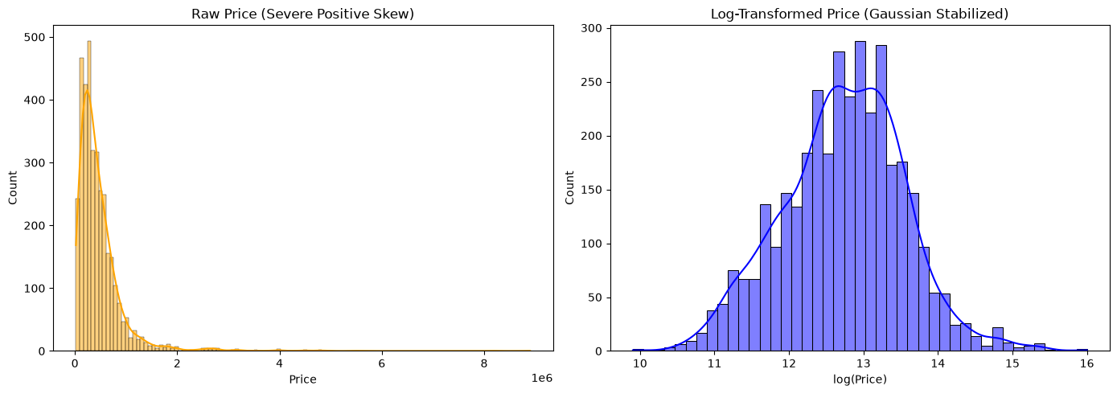

Feature Engineering & Preprocessing Pipeline

from sklearn.model_selection import train_test_split
from sklearn.preprocessing import OneHotEncoder, StandardScaler
from sklearn.compose import ColumnTransformer

# Feature Engineering
CURRENT_YEAR = 2024
df["brand"] = df["name"].apply(lambda x: x.split()[0])
df["vehicle_age"] = CURRENT_YEAR - df["year"]
df["km_per_year"] = df["km_driven"] / (df["vehicle_age"] + 1)

# Group uncommon brands into "Other" to keep things manageable
top_brands = df["brand"].value_counts().nlargest(10).index
df["brand"] = df["brand"].apply(lambda b: b if b in top_brands else "Other")

categorical_features = ["brand","fuel","seller_type","transmission","owner"]
numeric_features = ["vehicle_age","km_driven","km_per_year"]

X = df[categorical_features + numeric_features]

# Train/Test Split (80% Train, 20% Holdout Test)
X_train, X_test, y_train, y_test = train_test_split(X,y,test_size=0.2, random_state=42)

# Robust Column Transformer Pipeline
preprocessor = ColumnTransformer(
transformers=[
("num", StandardScaler(), numeric_features),
("cat", OneHotEncoder(handle_unknown="ignore", sparse_output=False), categorical_features)
]
)

# Fit and transform
X_train_processed = preprocessor.fit_transform(X_train)
X_test_processed = preprocessor.transform(X_test)

print("Preprocessed Input Tensor Dimensions:")
print("Training Features:", X_train_processed.shape)
print("Testing Features:",X_test_processed.shape)

OUTPUT
Preprocessed Input Tensor Dimensions:
Training Features: (2860, 29)
Testing Features: (716, 29)

Neural Regressor Experiments
Evaluates Activation Functions (ReLU vs GELU vs Sigmoid) and Weight Initialization Pairing (He vs Xavier)

