**University of Management and Technology**

**Department of Computer Science**

**Deep Learning and Neural Networks – V2**

**Project Report**

**Allaudin Ali Ahmad**

**F2020266458**

**Submitted to: Dr Muhammad Nadeem Ashraf**

**ECG Heartbeat Classification Project Report**

**Introduction**

This project focuses on developing deep learning models to classify ECG heartbeats as normal or abnormal. The goal is to assist in the automatic diagnosis of cardiac anomalies, potentially improving healthcare services.

**Dataset**

* The ECG Heartbeat dataset used in this project is publicly available and consists of two classes: "Normal" and "Abnormal."
* The dataset contains a total of **14552** samples, with **4046** "Normal" and **10506** "Abnormal" heartbeats.

**Exploratory Data Analysis**

A preliminary analysis revealed the class distribution. Sample ECG signals from both categories were visualized to understand the data characteristics.

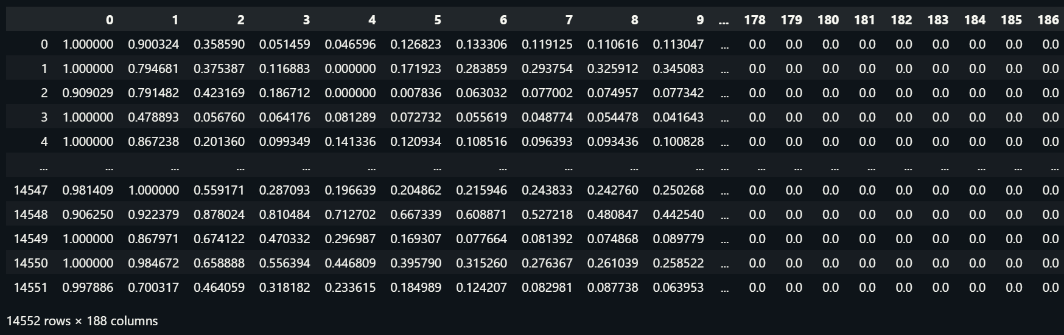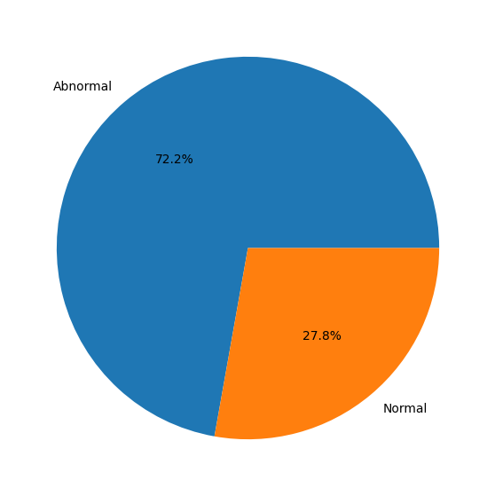

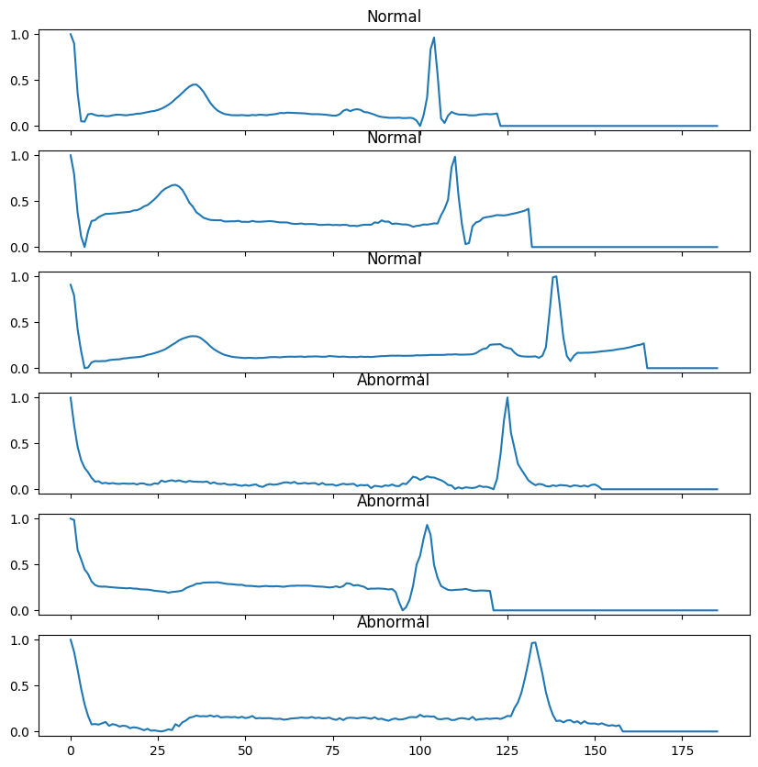

**Pre-processing**

The data was split into training and test sets (80-20 ratio), ensuring stratified sampling. The data was reshaped to match the input requirements of the models.

**Model Development**

**CNN Model**

A Convolutional Neural Network (CNN) was built with Conv1D, BatchNormalization, MaxPooling1D, Flatten, Dense layers, and a sigmoid activation function for binary classification. The CNN model is suitable for time-series data like ECG signals due to its ability to extract spatial hierarchies of features.

**Transformer Model**

A Transformer model was created using a custom Transformer encoder and Dense layers for classification. The input layer (Input(shape=(x_train.shape[1],1))) was defined to match the dimensions of the processed ECG data.

**Transformer Encoder**

* **MultiHeadAttention:** Captures complex patterns in ECG signals, allowing the model to focus on different sequence parts simultaneously.
* **Dropout and LayerNormalization:** Regularize the model and stabilize the learning process.
* **Conv1D Layers:** Extract local features from the ECG signals, crucial for interpreting heart rhythms.
* **Residual Connections:** Help avoid the vanishing gradient problem, maintaining the flow of gradients.

**Training and Validation**

The models were compiled and trained with validation splits to monitor performance and prevent overfitting. The CNN was trained for 100 epochs, while the Transformer was trained for 10 epochs with focal loss to address class imbalance.

**Focal Loss Implementation**

To tackle class imbalance, the Transformer model used focal loss with alpha=0.33 and gamma=2.5, balancing the focus between classes.

**Model Evaluation**

The models were evaluated on the test set, with the CNN showing excellent performance across metrics. The Transformer model, after focal loss adjustment, showed improved recall for the minority class but a decrease in overall accuracy.

**Issues Faced and Solutions**

1. **Class Imbalance:** Addressed using focal loss in the Transformer model.
2. **Model Performance:** The Transformer was fine-tuned with focal loss parameters and architecture adjustments.

**Final Model Performance**

1. **CNN Model Performance**

The CNN model exhibited outstanding performance, as evidenced by the precision, recall, and F1-score metrics:

**Class 0.0 (Normal):** Achieved a high precision of 0.99 and recall of 0.94, indicating excellent ability to correctly identify and classify normal heartbeats.

**Class 1.0 (Abnormal):** Demonstrated a precision of 0.98 and a perfect recall of 1.00, showing exceptional effectiveness in detecting abnormal heartbeats.

**Overall Accuracy:** The model achieved an impressive overall accuracy of 98%, reflecting its robustness and reliability in classifying heartbeats.

These metrics suggest that the CNN model not only effectively distinguishes between normal and abnormal heartbeats but also maintains a high level of accuracy across both classes.

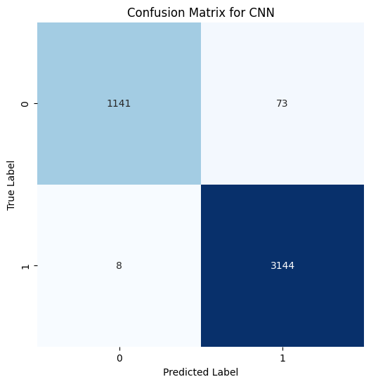

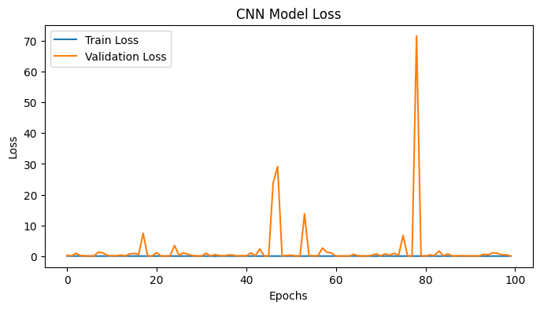

1. **Transformer (TF) Model Performance**

The Transformer model, after implementing focal loss to address class imbalance, showed the following performance:

**Class 0.0 (Normal):** The model had a precision of 0.38 and a recall of 0.67. While the recall improved significantly compared to earlier iterations, indicating better identification of normal heartbeats, precision remained relatively low.

**Class 1.0 (Abnormal):** Showed a precision of 0.82 and a recall of 0.58. The model's ability to identify abnormal heartbeats was moderately effective but not as proficient as the CNN model.

**Overall Accuracy:** The Transformer model achieved an accuracy of 61%, which is lower compared to the CNN model. This reflects challenges in balancing sensitivity and specificity, especially in the presence of class imbalance.

The performance metrics indicate that while the Transformer model made strides in addressing class imbalance, particularly in improving the detection of normal heartbeats (Class 0.0), it still lagged behind the CNN model in overall accuracy and consistency across classes.

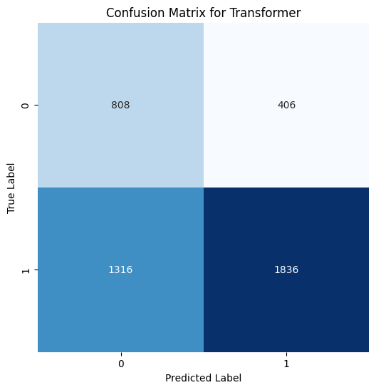

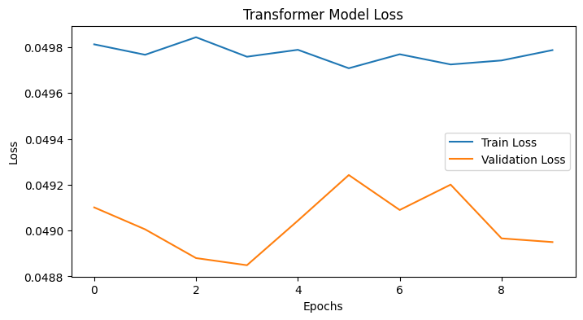

**Further Work**

* Fine-tuning focal loss parameters or exploring other imbalance handling methods.
* Experimenting with different architectures and hyperparameters for the Transformer.
* Utilizing cross-validation for robust model evaluation.
* Investigating the CNN's overfitting and considering ensemble techniques.

**Conclusion**

In summary, the CNN model outperformed the Transformer in classifying ECG heartbeats, demonstrating high precision and recall across both classes. The Transformer model, despite improvements with focal loss, showed a need for further optimization to enhance its predictive accuracy and balance. The project underscores the importance of model selection and tuning in handling complex tasks such as medical diagnosis through ECG signal analysis.