Project Documentation of Quarantine&Chill

By

Alex Jackson

20161119

An Assignment Submitted in Partial Fulfilment of The Requirements

For the Course Ctpr490: Information Science Adv. Project

Instructor: Mr. Damion Mitchell

Date: May 7, 2020

Contents

System Overview 3

Installing & Setup 4

Creating/Joining a Room 6

Joining a Room 6

Creating a Random Room 6

Main Room Functionalities 7

Playing Videos 8

Play or Pause videos (For all viewers) 9

Sync with Host 9

Switch to Host 10

Change Between Video Players 11

Changing video content 12

Changing a YouTube video 12

Changing a MP4/HTML5 video 13

The Chatroom 14

Viewing online users 15

Invite user to room 15

Video Chat Controls 16

Analytics (Google) 17

System Overview

Quarantine&Chill is an online application that allows for people to connect, during the COVID-19 pandemic, by watching videos online simultaneously. The platform also allows users to send messages to each other and video chat; on the same interface. The system is embedded with two types of video players which enables them to watch a variety of videos. From YouTube videos, videos on movie sites and other social media platforms such as Facebook.

Installing & Setup

Steps

1. Install node.js by entering <https://nodejs.org/en/> in your browser.

2. Go through setup menu.

3. After instillation open command prompt and enter node – version to verify if you have node.

4. After type cd (to change directory and paste the directory of the Node.js folder)

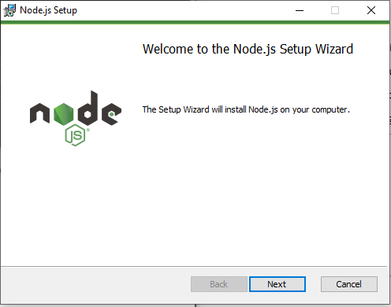

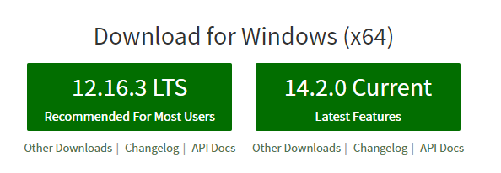

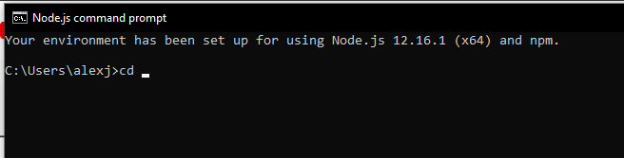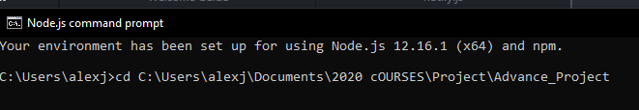

5. To install dependences, in the control panel, type ”npm I”

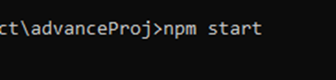6. To run the program type npm start

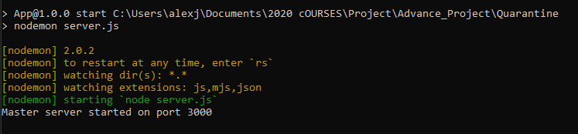7. To run test cases/function, type npm test

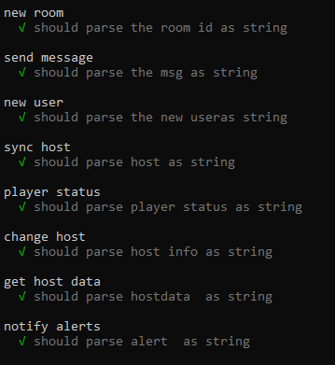

Creating/Joining a Room

# Joining a Room

**

1. Upon entering the home page, enter your name and the room name you would like to create. If you want to join a room someone created, enter the room name of that room.

# Creating a Random Room

If creating a room, you may click the random button to create a room with a random room name.

Main Room Functionalities

The system comprises of two video players, a YouTube Player and a MP4/HTML5 player. The control system is placed below. Which allows users to:

1. Play or Pause the video
2. Sync with Host
3. Switch to Host
4. Change between video players
5. Changing video content.

# Playing Videos

## A screenshot of a cell phone Description automatically generatedA screenshot of a cell phone Description automatically generatedPlay or Pause videos (For all viewers)

1. To start or stop the video, click the Play/Pause button.

## A screenshot of a cell phone Description automatically generatedSync with Host

**Steps**

1. When viewing, If the user lags or speeds up the video, A warning will be displayed.
2. The user can press the sync button to watch at the time frame of the host.

## Switch to Host

**Steps**

1. Another user can become the host by, clicking the “Make me the host!” button.
2. The user will be notified that “*username* is now the host”.
3. The host label will be changed to display the username of the new host.

## Change Between Video Players

**Step**

1. To switch between these players, click the player button.

## Changing video content

### A picture containing table Description automatically generatedChanging a YouTube video

**Steps**

1. visit YouTube and open a video of your choice.

2. Copy the video link from the navigation bar or the YouTube video itself.

3. Paste it into the change area section of the system.

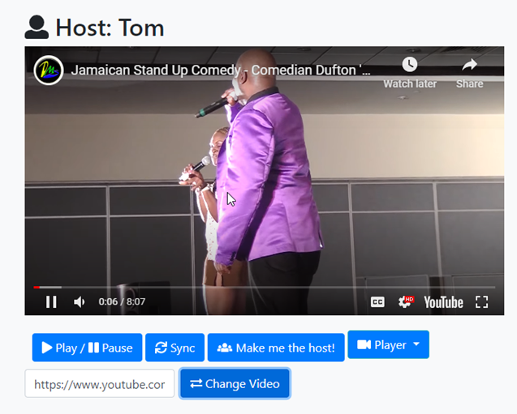4. Click the change video button.

### Changing a MP4/HTML5 video

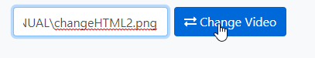

**Steps**

1.Find a movie streaming website.  
2. Copy the video address

3. paste the video address in the change player section

4. click the change player button.

# The Chatroom

The system allows users to chat while watching videos.

1. To chat simply type your message and hit enter to send.

# Viewing online users

**Steps**

1. In top right-hand side of the room. There is a list of users who are in the room
2. When a person enters the room, a popup will show, who has entered the room

# Invite user to room

**Steps**

1. In the top right-hand side of the page, there is an invite button.

2. Upon clicking, a popup will appear with an invite link.

3. The invite link be copied and send to friends.

# Video Chat Controls

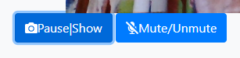

**Steps**

1. For users to stop showing their video to others.

2. User should press the mute to stop their audio from being transmitted.

Analytics (Google)

The systems uses, the google analytics for the analytics section of the page.

