**Overview**

The course will take you through two key analytical concepts to help you understand any business situation and help you choose the correct techniques to analyze your data.

1. Cross Industry Standard Process for Data Mining (CRISP-DM)
2. Predictive Methodology Map

**CRISP-DM**

This framework was originally developed by data miners in order to generalize the common approaches to defining and analyzing a problem. In this course, we will call CRISP-DM the "Problem Solving Framework".

The framework is made up of 6 steps:

1. Business Issue Understanding
2. Data Understanding
3. Data Preparation
4. Analysis/Modeling
5. Validation
6. Presentation/Visualization

[[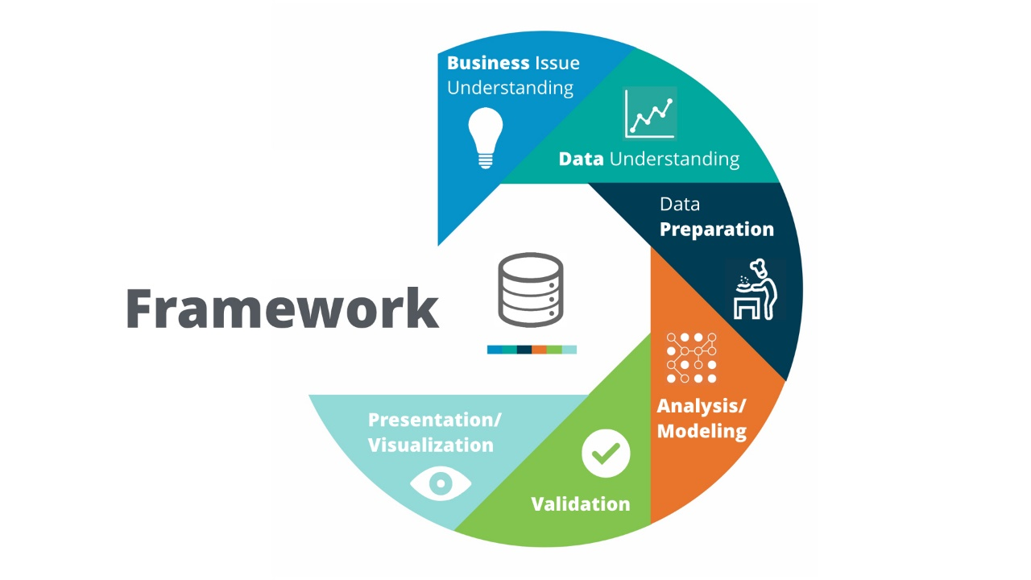](https://classroom.udacity.com/nanodegrees/nd008t/parts/9cd2f005-f9b1-4953-ba02-ad65805b2a4a/modules/fc4c1ffe-01f6-4c11-b38b-646ecf1d3c59/lessons/db69445f-9d16-4f99-9efb-2b4cc2dd51a2/concepts/b5f0b3d5-6c0d-4ab6-8870-01c93c3747b9)](https://classroom.udacity.com/nanodegrees/nd008t/parts/9cd2f005-f9b1-4953-ba02-ad65805b2a4a/modules/fc4c1ffe-01f6-4c11-b38b-646ecf1d3c59/lessons/db69445f-9d16-4f99-9efb-2b4cc2dd51a2/concepts/b5f0b3d5-6c0d-4ab6-8870-01c93c3747b9)

[This framework is based upon the CRISP-DM framework: Cross Industry Standard Process for Data Mining](https://classroom.udacity.com/nanodegrees/nd008t/parts/9cd2f005-f9b1-4953-ba02-ad65805b2a4a/modules/fc4c1ffe-01f6-4c11-b38b-646ecf1d3c59/lessons/db69445f-9d16-4f99-9efb-2b4cc2dd51a2/concepts/b5f0b3d5-6c0d-4ab6-8870-01c93c3747b9)

**Methodology Map**

The methodology map is a guide to determine the appropriate analytical technique(s) to solve a particular business question or problem.

The map outlines two main scenarios for a business problem:

1. Data analysis
2. Predictive analysis

Data analysis refers to the more standard approaches of blending together data and reporting on trends and statistics and helps answer business questions that involve understanding more about the dataset such as "On average, how many people order coffee and a donut per transaction in my store in any given week?"

Predictive analysis will help businesses predict future behavior based on existing data such as "Given the average coffee order, how much coffee can I expect to sell next week if I were to add a new brand of coffee?"

It's highly suggested you download and print this map to help you figure out what kind of analytical techniques you should use given any business problem you may work on in your career.

[[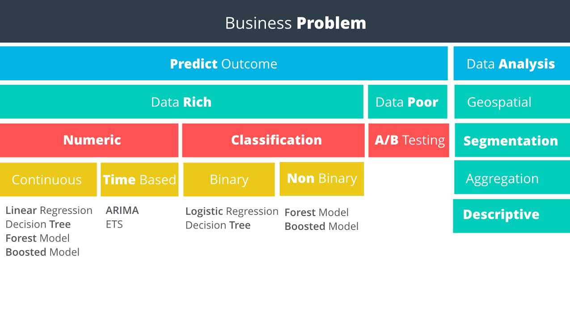](https://classroom.udacity.com/nanodegrees/nd008t/parts/9cd2f005-f9b1-4953-ba02-ad65805b2a4a/modules/fc4c1ffe-01f6-4c11-b38b-646ecf1d3c59/lessons/db69445f-9d16-4f99-9efb-2b4cc2dd51a2/concepts/b5f0b3d5-6c0d-4ab6-8870-01c93c3747b9)](https://classroom.udacity.com/nanodegrees/nd008t/parts/9cd2f005-f9b1-4953-ba02-ad65805b2a4a/modules/fc4c1ffe-01f6-4c11-b38b-646ecf1d3c59/lessons/db69445f-9d16-4f99-9efb-2b4cc2dd51a2/concepts/b5f0b3d5-6c0d-4ab6-8870-01c93c3747b9)

[Analyst Methodology Map](https://classroom.udacity.com/nanodegrees/nd008t/parts/9cd2f005-f9b1-4953-ba02-ad65805b2a4a/modules/fc4c1ffe-01f6-4c11-b38b-646ecf1d3c59/lessons/db69445f-9d16-4f99-9efb-2b4cc2dd51a2/concepts/b5f0b3d5-6c0d-4ab6-8870-01c93c3747b9)

**Linear Regression**

You will then learn how to create linear regression models to help you predict numerical data such as sales. You'll dive deep into these concepts:

1. Linear relationship
2. Multiple-R squared and p-values
3. Significant coefficients
4. Modeling categorical variables