|  |  |  |
| --- | --- | --- |
| **Tasks** | **Estimate time(hrs)** | **Actual time(hrs)** |
| Background(Research) | 6.5 | 11 |
| Analysis & Design | 9 | 15 |
| Implementation | 9 | 45 |
| Testing | 9 | 10 |
| Documentation | 11.5 | 30 |

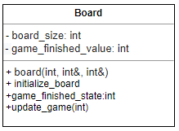

Figure …: UML diagram for the class Board

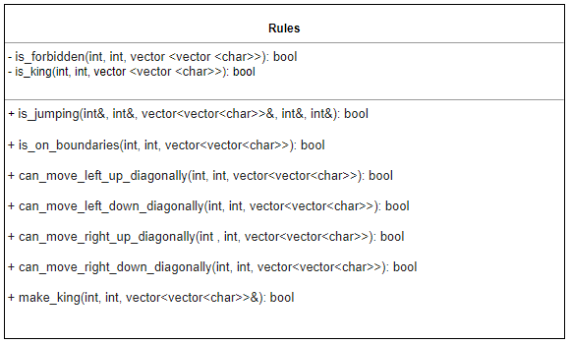

Figure …: UML diagram for the class Rules