

# MIPS模拟器设计

---自然选择前进四

编号666666

## 目录

MIPS模拟器实验报告 3

小组基本信息： 3

使用手册： 3

打开文件： 4

保存文件： 5

新建文件： 6

汇编： 6

反汇编： 8

运行： 8

逐条运行： 8

全部运行： 9

清空： 10

内存查看： 11

运行实例： 12

软件流程图： 16

任务分工： 17

代码： 17

附录： 18

Mai.h： 18

Mainwindow.h： 18

main.cpp 20

Mainwindow.cpp： 20

Run.cpp: 32

mainwindow.ui 38

Mai.cpp: 39

# MIPS模拟器实验报告

## 小组基本信息：

组名：自然选择前进四

项目负责经理：钱旭峰

其他组员：沈旭东、王海容、黄一伦

## 使用手册：

我们采用了界面操作，界面简单易懂，操作方便

如下图：

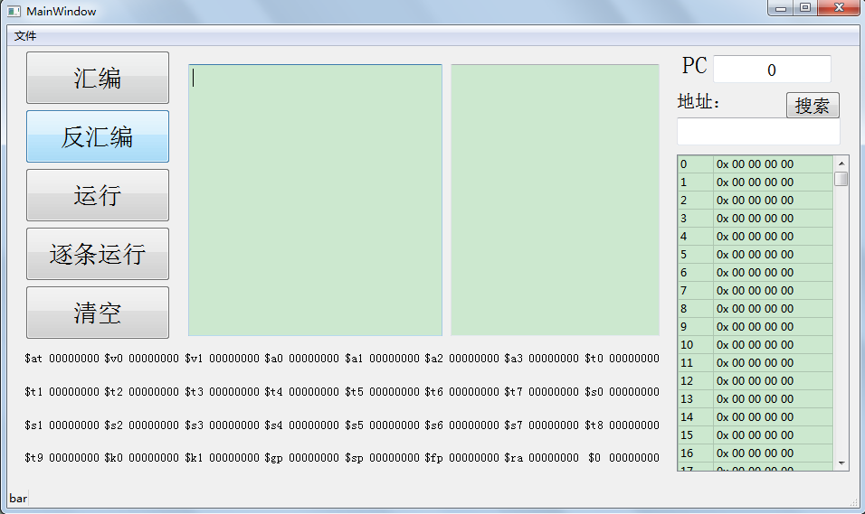

接下来我将为您详细讲解操作细节：

我们的软件支持文件的打开与保存

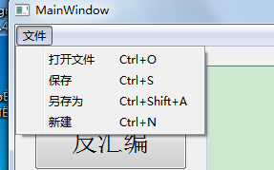

### 打开文件：

按打开文件的按钮会跳出如下对话框：

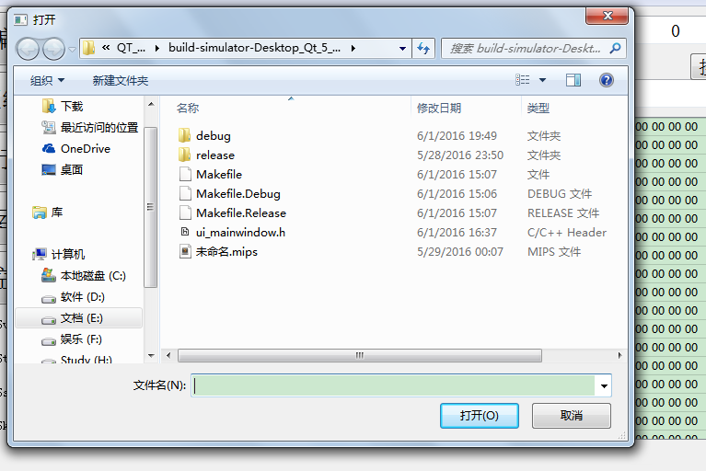

### 保存文件：

您可以选择保存的地址与文件名进行文件的保存

如果你按下保存按钮，若您曾经将这份文件保存过，则您在文本框的内容会保存到原地址

若您没有曾经将这份文件保存过，则系统将自动调用另存为函数

效果如另存为

当您按下另存为按钮，软件会弹出这样的窗口：

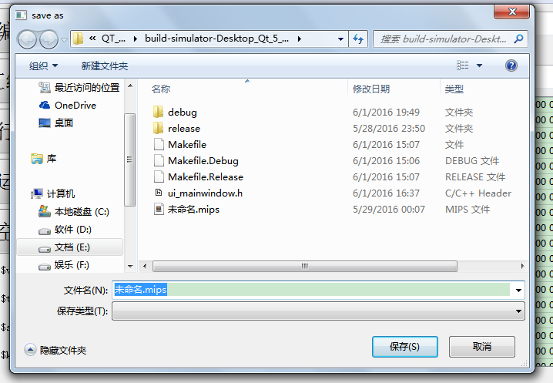

您可以选择保存的地址与文件名进行保存

### 新建文件：

当你按下新建文件按钮，软件会自动将光标移动到文本框，准备接受输入

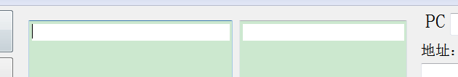

### 汇编：

您可以在文本框中输入您想要输入的MIPS指令

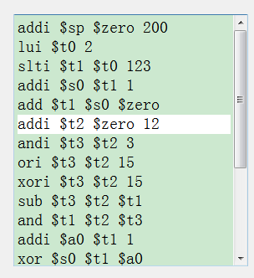

可以见到在您选中的那一行会高亮显示，方便查看

当你按下“汇编”按钮，在二进制文本框中会显示16进制的指令：

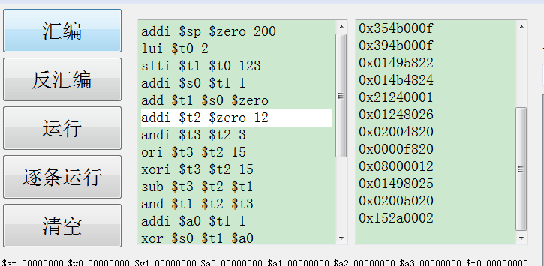

当您的指令输入错误时，软件会提醒您输入有误：



### 反汇编：

您可以将文本框中的MIPS指令清空，按下反汇编按钮，软件会把二进制指令反汇编成MIPS指令：

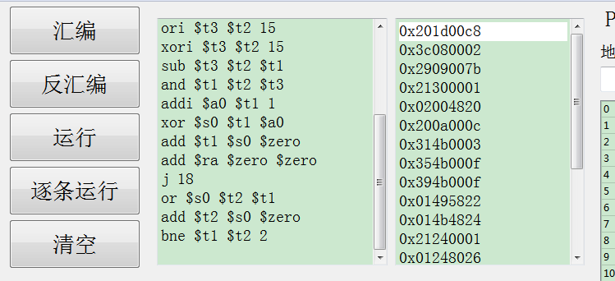

您可以试着检测正确性，一定会发现我们的软件永远不会出错

### 运行：

我们的软件可以模拟运行您的指令分为：逐条运行 和 一次性运行

### 逐条运行：

我们的软件支持逐条运行，您可以按下逐条运行的按钮来让软件运行下一条指令：

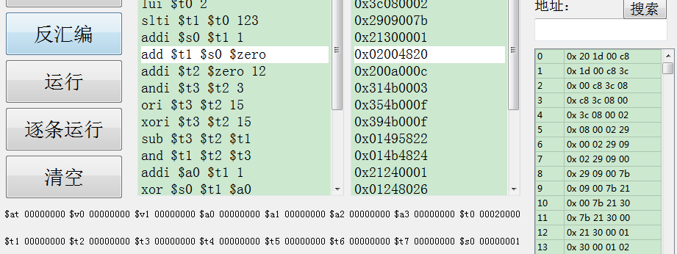

当您按下逐条运行的按钮，您会发现文本框的高亮行会提醒您当前运行的指令，您也会发现右侧的内存框的内容已经变化，

下面的32个寄存器的内容也根据您的指令而改变（如$s0,$t0）

PC寄存器也相应的改变：

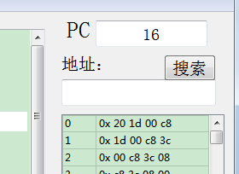

### 全部运行：

当您按下“运行”按钮，您的程序会一次性运行到底：

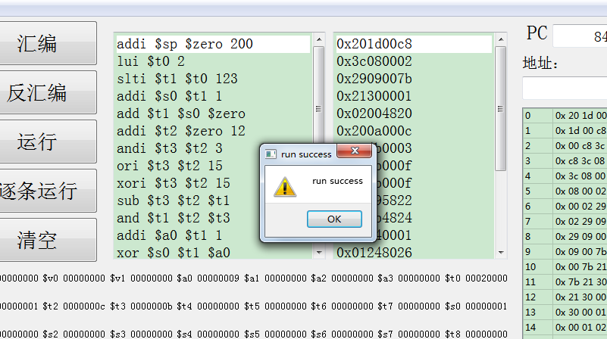

软件会提醒您程序运行成功

当您没有任何输入时，按下运行按钮，软件会提醒您文本框为空：

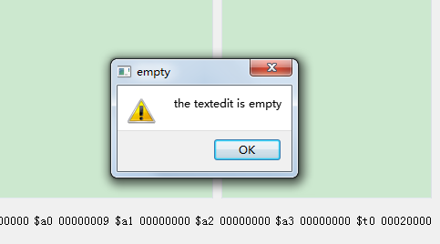

### 清空：

当你按下“清空”按钮：

则软件会初始化，内存，32个寄存器，两个文本框都会清空

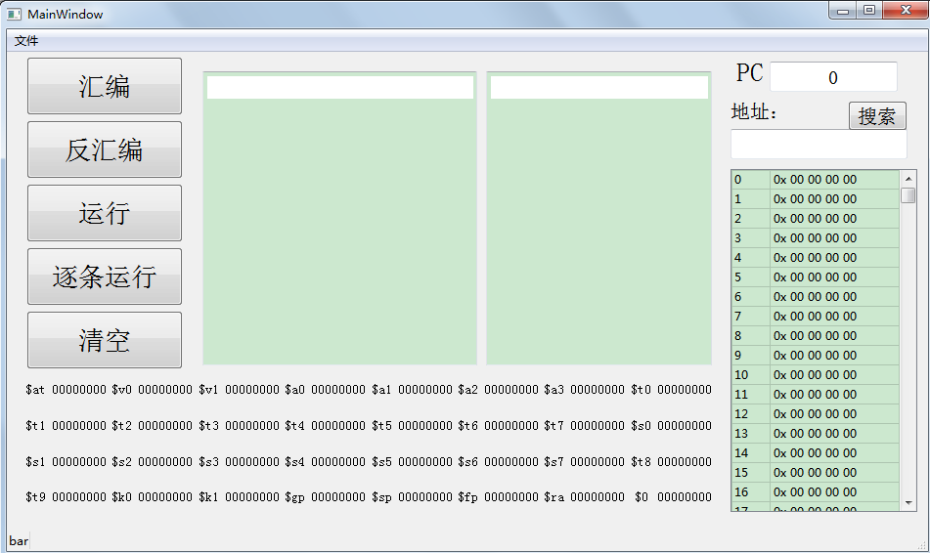

### 内存查看：

我们的软件暂时开辟了1024*8 即1K的内存，以字节寻址

您可以在地址框中输入您想要查看的内存地址，按下“搜索”按钮

内存框会调到您想要的内存：

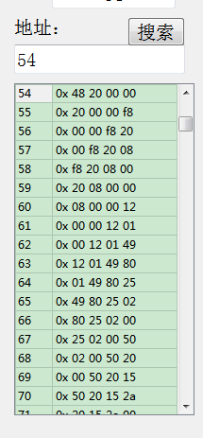

## 运行实例：

我们的软件支持22条指令，包括

add

sub

slt

and

or

nor

xor

addi

slti

andi

ori

xori

lw

sw

lb

sb

lui

beq

bne

j

jal

jr

我将以下面的MIPS代码作为测试实例：

addi $sp $zero 200

lui $t0 2

slti $t1 $t0 123

addi $s0 $t1 1

add $t1 $s0 $zero

addi $t2 $zero 12

andi $t3 $t2 3

ori $t3 $t2 15

xori $t3 $t2 15

sub $t3 $t2 $t1

and $t1 $t2 $t3

addi $a0 $t1 1

xor $s0 $t1 $a0

add $t1 $s0 $zero

add $ra $zero $zero

j 18

or $s0 $t2 $t1

add $t2 $s0 $zero

bne $t1 $t2 2

先清空所有：

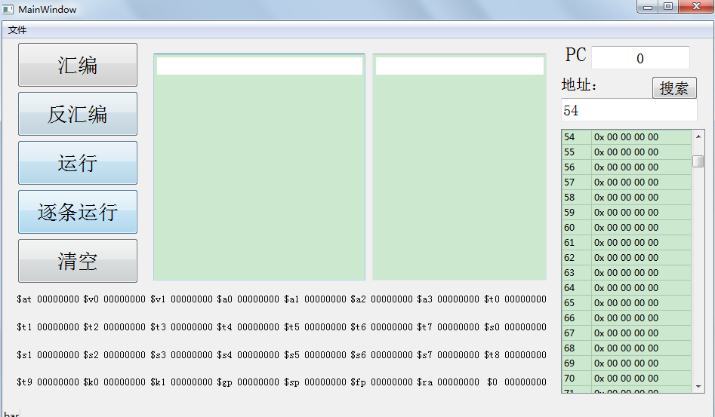

打开文件读入MIPS：

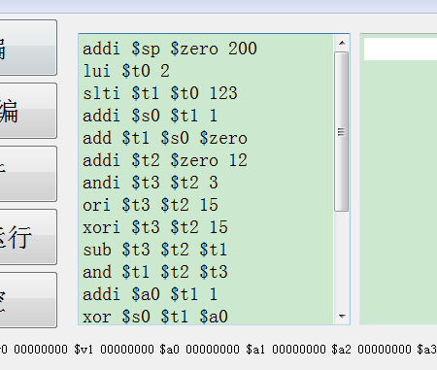

汇编之后：

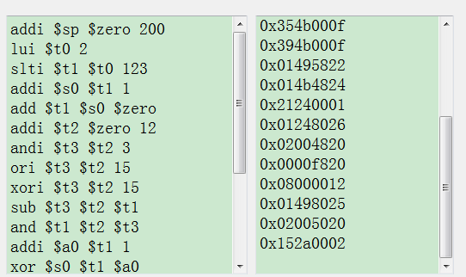

我们现在尝试着逐条运行：

运行第一条：

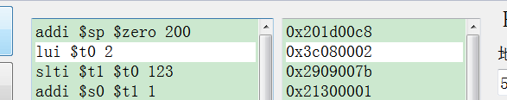

可见$sp已经改变：



我们不断的逐条运行

现在我们将要运行如下指令：

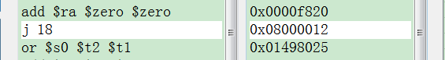

按下逐条运行：

我们看见程序直接跳到了最后一行

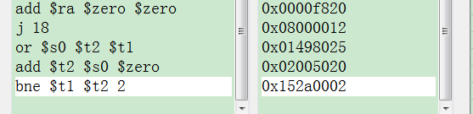

可见程序运行正确

此时我们的32个寄存器也相应的变化：

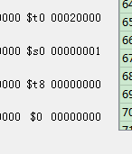

PC也相应变化



## 

## 软件流程图：

**使用者输入**

**文件系统**

**内存，寄存器改变**

**MIPS指令**

**内存，寄存器改变**

**汇编**

**16进制指令**

**运行**

**全部运行**

**逐条运行**

## 任务分工：

沈旭东：MIPS指令的汇编与反汇编内核

王海荣：汇编与反汇编内核与界面的接口

黄一伦：MISP运行内核

钱旭峰：内存寄存器类的实现，界面设计和实现，运行接口,内存管理

## 代码：

mai.h 汇编反汇编头文件

mainwindow.h 主界面头文件

mai.cpp 汇编反汇编实现文件

main.cpp 主函数文件

mainwindow.cpp 主界面实现文件

run.cpp 运行实现文件

mainwindow.ui 主界面界面文件

## 附录：

### Mai.h：

#ifndef MAI_H

#define MAI_H

#endif // MAI_H

QString dodo(QString instring);

QString odod(QString instring);

### Mainwindow.h：

#ifndef MAINWINDOW_H

#define MAINWINDOW_H

#include <QMainWindow>

#include<iostream>

#include <QString>

#include<string>

#include<QLabel>

namespace Ui {

class MainWindow;

}

class MainWindow : public QMainWindow

{

Q_OBJECT

public:

explicit MainWindow(QWidget *parent = 0);

~*MainWindow*();

private:

Ui::MainWindow *ui;

bool issaved;

QString curfile;

unsigned char memory[1024];

unsigned int PC;

unsigned int Register[32];

QString IR;

int INS;

unsigned int lineindex;

void update();

QLabel *bar;

bool flag;

void showMessage(const QString& message);

unsigned int add;

QString changeR(unsigned int N);

public:

QString change(int N);

void gotoline( int line );

void setIR();

bool MainWindow_ins(unsigned int IR);

void MainWindow_add(unsigned int IR);

void MainWindow_sub(unsigned int IR);

void MainWindow_slt(unsigned int IR);

void MainWindow_and(unsigned int IR);

void MainWindow_or(unsigned int IR);

void MainWindow_nor(unsigned int IR);

void MainWindow_xor(unsigned int IR);

void MainWindow_addi(unsigned int IR);

void MainWindow_slti(unsigned int IR);

void MainWindow_andi(unsigned int IR);

void MainWindow_ori(unsigned int IR);

void MainWindow_xori(unsigned int IR);

void MainWindow_lw(unsigned int IR);

void MainWindow_sw(unsigned int IR);

void MainWindow_lb(unsigned int IR);

void MainWindow_sb(unsigned int IR);

void MainWindow_lui(unsigned int IR);

void MainWindow_beq(unsigned int IR);

void MainWindow_bne(unsigned int IR);

void MainWindow_j(unsigned int IR);

void MainWindow_jal(unsigned int IR);

void MainWindow_jr(unsigned int IR);

public slots:

void clearall();

void file_new(); //新建文件

void file_saveornot(); //修改过的文件是否保存

void file_save(); //保存文件

void file_saveas(); //文件另存为

bool savefile(const QString& fileName); //存储文件

void file_open(); //打开文件

bool file_load(const QString& fileName); //读取文件

void sousuo();

void on_assembler_clicked();

void on_disassembler_clicked();

void run();

void runall();

void highlightCurrentLine_1();

void highlightCurrentLine_2();

};

#endif // MAINWINDOW_H

### main.cpp

#include "mainwindow.h"

#include <QApplication>

int main(int argc, char *argv[])

{

QApplication a(argc, argv);

MainWindow w;

w.show();

return a.exec();

}

### Mainwindow.cpp：

#include "mainwindow.h"

#include "ui_mainwindow.h"

#include "mai.h"

#include <QtGui>

#include <fstream>

#include<string>

#include<QMessageBox>

#include<QFileDialog>

#include<Qcolor>

MainWindow::MainWindow(QWidget *parent) :QMainWindow(parent),ui(new Ui::MainWindow)

{

ui->setupUi(this);

issaved=0;

curfile="未命名.mips";

PC=0;

IR="";

INS=0;

flag=0;

add=0;

lineindex=0;

memset(memory, 0, 1024);

memset(Register,0,32*4);

bar=new QLabel("bar");

statusBar()->addWidget(bar);

bar->show();

ui->pc->setFocusPolicy(Qt::NoFocus);

ui->pc->setText(QString::number(PC));

connect(ui->save, SIGNAL(triggered(bool)),this,SLOT(file_save()));

connect(ui->saveas, SIGNAL(triggered(bool)),this,SLOT(file_saveas()));

connect(ui->open, SIGNAL(triggered(bool)),this,SLOT(file_open()));

connect(ui->file_new, SIGNAL(triggered(bool)),this,SLOT(file_new()));

connect(ui->search, SIGNAL(clicked(bool)),this,SLOT(sousuo()));

connect(ui->run, SIGNAL(clicked(bool)),this,SLOT(run()));

connect(ui->runall, SIGNAL(clicked(bool)),this,SLOT(runall()));

connect(ui->text1, SIGNAL(cursorPositionChanged()), this, SLOT(highlightCurrentLine_1()));

connect(ui->text2, SIGNAL(cursorPositionChanged()), this, SLOT(highlightCurrentLine_2()));

connect(ui->wim, SIGNAL(clicked(bool)),this,SLOT(clearall()) );

update();

}

MainWindow::~*MainWindow*()

{

delete ui;

}

void MainWindow::gotoline( int line )

{

QTextCursor tc = ui->text2->textCursor();

int position = ui->text2->document()->findBlockByNumber ( line-1 ).position();

tc.setPosition(position,QTextCursor::MoveAnchor);

ui->text2->setTextCursor( tc );

tc = ui->text1->textCursor();

position = ui->text1->document()->findBlockByNumber ( line-1 ).position();

tc.setPosition(position,QTextCursor::MoveAnchor);

ui->text1->setTextCursor( tc );

}

void MainWindow::sousuo()

{

int line=ui->addr->text().toInt();

if(line<0 || line>1019)

{

QMessageBox::warning(this,"error",tr("请输入正确地址"));

ui->addr->clear();

return;

}

ui->MEM->setCurrentCell(line,0);

return;

}

void MainWindow::clearall(){

memset(this->memory, 0, 1024);

memset(this->Register,0,32*4);

this->PC=0;

this->add=0;

this->IR="";

INS=0;

add=0;

flag=0;

issaved=0;

lineindex=0;

ui->text1->setPlainText("");

ui->text2->setPlainText("");

statusBar()->showMessage("");

update();

}

void MainWindow::showMessage(const QString& message)

{

bar->setText(message);

}

void MainWindow::update()

{

ui->pc->setText(QString::number(PC));

ui->pc->repaint();

ui->r0->setText(changeR(Register[0])); ui->r0->repaint();

ui->r1->setText(changeR(Register[1])); ui->r1->repaint();

ui->r2->setText(changeR(Register[2])); ui->r2->repaint();

ui->r3->setText(changeR(Register[3])); ui->r3->repaint();

ui->r4->setText(changeR(Register[4])); ui->r4->repaint();

ui->r5->setText(changeR(Register[5])); ui->r5->repaint();

ui->r6->setText(changeR(Register[6])); ui->r6->repaint();

ui->r7->setText(changeR(Register[7])); ui->r7->repaint();

ui->r8->setText(changeR(Register[8])); ui->r8->repaint();

ui->r9->setText(changeR(Register[9])); ui->r9->repaint();

ui->r10->setText(changeR(Register[10])); ui->r10->repaint();

ui->r11->setText(changeR(Register[11])); ui->r11->repaint();

ui->r12->setText(changeR(Register[12])); ui->r12->repaint();

ui->r13->setText(changeR(Register[13])); ui->r13->repaint();

ui->r14->setText(changeR(Register[14])); ui->r14->repaint();

ui->r15->setText(changeR(Register[15])); ui->r15->repaint();

ui->r16->setText(changeR(Register[16])); ui->r16->repaint();

ui->r17->setText(changeR(Register[17])); ui->r17->repaint();

ui->r18->setText(changeR(Register[18])); ui->r18->repaint();

ui->r19->setText(changeR(Register[19])); ui->r19->repaint();

ui->r20->setText(changeR(Register[20])); ui->r20->repaint();

ui->r21->setText(changeR(Register[21])); ui->r21->repaint();

ui->r22->setText(changeR(Register[22])); ui->r22->repaint();

ui->r23->setText(changeR(Register[23])); ui->r23->repaint();

ui->r24->setText(changeR(Register[24])); ui->r24->repaint();

ui->r25->setText(changeR(Register[25])); ui->r25->repaint();

ui->r26->setText(changeR(Register[26])); ui->r26->repaint();

ui->r27->setText(changeR(Register[27])); ui->r27->repaint();

ui->r28->setText(changeR(Register[28])); ui->r28->repaint();

ui->r29->setText(changeR(Register[29])); ui->r29->repaint();

ui->r30->setText(changeR(Register[30])); ui->r30->repaint();

ui->r31->setText(changeR(Register[31])); ui->r31->repaint();

ui->MEM->clear();

ui->MEM->setColumnCount(2);

ui->MEM->setRowCount(1020);

ui->MEM->setColumnWidth(0,40);

ui->MEM->setColumnWidth(1,100);

ui->MEM->verticalHeader()->*setVisible*(false); //隐藏列表头

ui->MEM->horizontalHeader()->*setVisible*(false); //隐藏列表头

ui->MEM->horizontalHeader()->setStretchLastSection(true); //设置充满表宽度

ui->MEM->setEditTriggers(QAbstractItemView::NoEditTriggers);

int cou;

int num;

for(cou = 0; cou < 1020; cou ++)

{

ui->MEM->setRowHeight(cou,20);

ui->MEM->setItem(cou, 0, new QTableWidgetItem(QString::number(cou)));

num=memory[cou]<<24 | memory[cou+1]<<16 |memory[cou+2]<<8 | memory[cou+3];

ui->MEM->setItem(cou, 1, new QTableWidgetItem(change(num)));

}

}

QString MainWindow::changeR(unsigned int N)

{

QString res=QString::number(N,16);

while(res.length()<8)

res.insert(0,"0");

while(res.length()>8)

res.remove(0,1);

return res;

}

QString MainWindow::change(int N)

{

QString res=QString::number(N,16);

while(res.length()<8)

res.insert(0,"0");

while(res.length()>8)

res.remove(0,1);

res.insert(2," ");

res.insert(5," ");

res.insert(8," ");

res.insert(0,"0x ");

return res;

}

void MainWindow::file_save()

{

if(issaved)

savefile(curfile);

else

file_saveas();

}

bool MainWindow::savefile(const QString& filename)

{

QFile file(filename);

if(!file.*open*(QFile::WriteOnly | QFile::Text))

{

QMessageBox::warning(this,"save file",tr("cannot save %1:\n %2").arg(filename).arg(file.errorString()));

return false;

}

QTextStream out(&file);

out<<ui->text1->toPlainText();

issaved=1;

curfile=QFileInfo(filename).canonicalFilePath();

setWindowTitle(curfile);

return true;

}

void MainWindow::file_saveas()

{

QString filename=QFileDialog::getSaveFileName(this,tr("save as"),curfile);

//获得文件名

if(!filename.isEmpty())

{

savefile(filename);

}

}

void MainWindow::file_saveornot()

{

if(ui->text1->document()->isModified())

{

QMessageBox box;

box.setWindowTitle("save or not ?");

box.setIcon(QMessageBox::Warning);

box.setText(curfile + " has not saved,save now?");

box.setStandardButtons(QMessageBox::Yes | QMessageBox::No);

if(box.*exec*()==QMessageBox::Yes)

file_save();

}

}

void MainWindow::file_new()

{

file_saveornot();

issaved=false;

curfile="未命名.mips";

ui->text1->clear();

ui->text2->clear();

ui->text1->*setVisible*(true);

ui->text2->*setVisible*(true);

}

void MainWindow::file_open()

{

file_saveornot();

QString filename=QFileDialog::getOpenFileName(this);

if(!filename.isEmpty())//如果文件名不为空

file_load(filename);

issaved=true;

ui->text1->*setVisible*(true);

}

bool MainWindow::file_load(const QString& filename)

{

QFile file(filename);

if(!file.*open*(QFile::ReadOnly | QFile::Text))

{

QMessageBox::warning(this,"open file",tr("cannot open %1:\n %2").arg(filename).arg(file.errorString()));

return false;

}

QTextStream in(&file);

ui->text1->setPlainText(in.readAll());

curfile = QFileInfo(filename).canonicalFilePath();

setWindowTitle(curfile);

return true;

}

void MainWindow::on_assembler_clicked()

{

QString q;

int linenum=ui->text1->document()->lineCount();

for(int i=0;i<linenum;i++)

{

QString str = ui->text1->document()->findBlockByLineNumber(i).text();

if(!str.isEmpty())

{

q =dodo(str);

if(!i)

ui->text2->setPlainText(q);

else

ui->text2->appendPlainText(q);

}

}

PC=0;

}

void MainWindow::on_disassembler_clicked()

{

int linenum=ui->text2->document()->lineCount();

QString q,p;

unsigned long ins;

bool ok;

for(int i=0;i<linenum;i++)

{

QString str = ui->text2->document()->findBlockByLineNumber(i).text();

q=str;

q.remove("0x");

p=q.mid(4,4);

q=q.mid(0,4);

ins=p.toInt(&ok,16);

memory[4*i+2]=ins>>8;

memory[4*i+3]=ins;

ins=q.toInt(&ok,16);

memory[4*i]=ins>>8;

memory[4*i+1]=ins;

if(!str.isEmpty())

{

QString q =odod(str);

if(!i)

ui->text1->setPlainText(q);

else

ui->text1->appendPlainText(q);

}

}

}

void MainWindow::run()

{

if(ui->text2->toPlainText()=="" && ui->text1->toPlainText()!="")

{

on_assembler_clicked();

on_disassembler_clicked();

flag=1;

}

else if(ui->text1->toPlainText()=="")

{

QMessageBox::warning(this,"empty",tr("the textedit is empty"));

return;

}

else if(flag==0)

{

on_disassembler_clicked();

flag=1;

}

unsigned int linenum=ui->text2->document()->lineCount();

if(lineindex==linenum)

{

lineindex=0;

flag=0;

statusBar()->showMessage("正在运行行号:"+QString::number(lineindex));

QMessageBox::warning(this,"end of running",tr("end of running"));

return;

}

INS=memory[PC]<<24 | memory[PC+1]<<16 |memory[PC+2]<<8 | memory[PC+3];

if(!MainWindow::MainWindow_ins(INS))

{

QMessageBox::warning(this,"run error",tr("cannot run %1").arg(IR));

return;

}

statusBar()->showMessage("正在运行行号:"+QString::number(lineindex+2));

lineindex=PC/4;

gotoline(lineindex+1);

update();

return;

}

void MainWindow::runall()

{

PC=0;

if(ui->text2->toPlainText()=="" && ui->text1->toPlainText()!="")

{

on_assembler_clicked();

on_disassembler_clicked();

flag=1;

}

else if(ui->text1->toPlainText()=="")

{

QMessageBox::warning(this,"empty",tr("the textedit is empty"));

return;

}

else if(flag==0)

{

on_disassembler_clicked();

flag=1;

}

unsigned int linenum=ui->text2->document()->lineCount();

lineindex=0;

while(lineindex<linenum)

{

INS=memory[PC]<<24 | memory[PC+1]<<16 |memory[PC+2]<<8 | memory[PC+3];

if(!MainWindow::MainWindow_ins(INS))

{

update();

QMessageBox::warning(this,"run error",tr("cannot run %1").arg(IR));

return;

}

statusBar()->showMessage("正在运行行号:"+QString::number(lineindex+2));

gotoline(lineindex+2);

lineindex=PC/4;

}

update();

QMessageBox::warning(this,"run success",tr("run success"));

flag=0;

return;

}

void MainWindow::highlightCurrentLine_1()

{

QList<QTextEdit::ExtraSelection> extraSelections;

if (!ui->text1->isReadOnly()) {

QTextEdit::ExtraSelection selection;

QColor lineColor = QColor(Qt::blue).lighter(200);

selection.format.setBackground(lineColor);

selection.format.setProperty(QTextFormat::FullWidthSelection, true);

selection.cursor = ui->text1->textCursor();

selection.cursor.clearSelection();

extraSelections.append(selection);

}

ui->text1->setExtraSelections(extraSelections);

}

void MainWindow::highlightCurrentLine_2()

{

QList<QTextEdit::ExtraSelection> extraSelections;

if (!ui->text2->isReadOnly()) {

QTextEdit::ExtraSelection selection;

QColor lineColor = QColor(Qt::blue).lighter(200);

selection.format.setBackground(lineColor);

selection.format.setProperty(QTextFormat::FullWidthSelection, true);

selection.cursor = ui->text2->textCursor();

selection.cursor.clearSelection();

extraSelections.append(selection);

}

ui->text2->setExtraSelections(extraSelections);

}

### Run.cpp:

#include "mainwindow.h"

void MainWindow::setIR(){

this->IR=this->memory[this->add+this->PC];

}

bool MainWindow::MainWindow_ins(unsigned int IR){

switch(IR>>26){

case 0x00:{

switch(IR&0x3f){

case 0x20:MainWindow::MainWindow_add(IR);break;

case 0x22:MainWindow::MainWindow_sub(IR);break;

case 0x24:MainWindow::MainWindow_and(IR);break;

case 0x25:MainWindow::MainWindow_or(IR);break;

case 0x27:MainWindow::MainWindow_nor(IR);break;

case 0x26:MainWindow::MainWindow_xor(IR);break;

case 0x2a:MainWindow::MainWindow_slt(IR);break;

case 0x08:MainWindow::MainWindow_jr(IR);break;

default:return false;//错误

}break;

}

case 0x08:MainWindow::MainWindow_addi(IR);break;

case 0x0a:MainWindow::MainWindow_slti(IR);break;

case 0x0c:MainWindow::MainWindow_andi(IR);break;

case 0x0d:MainWindow::MainWindow_ori(IR);break;

case 0x0e:MainWindow::MainWindow_xori(IR);break;

case 0x23:MainWindow::MainWindow_lw(IR);break;

case 0x2b:MainWindow::MainWindow_sw(IR);break;

case 0x20:MainWindow::MainWindow_lb(IR);break;

case 0x28:MainWindow::MainWindow_sb(IR);break;

case 0x0f:if(IR>>21&0x1f)return false;else MainWindow::MainWindow_lui(IR);break;

case 0x04:MainWindow::MainWindow_beq(IR);break;

case 0x05:MainWindow::MainWindow_bne(IR);break;

case 0x02:MainWindow::MainWindow_j(IR);break;

case 0x03:MainWindow::MainWindow_jal(IR);break;

default:return false;//错误

}

return true;

}

void MainWindow::MainWindow_add(unsigned int IR){

this->Register[(IR>>11)&0x1f]=this->Register[(IR>>21)&0x1f]+this->Register[(IR>>16)&0x1f];

this->PC+=4;

}

void MainWindow::MainWindow_sub(unsigned int IR){

this->Register[(IR>>11)&0x1f]=this->Register[(IR>>21)&0x1f]-this->Register[(IR>>16)&0x1f];

this->PC+=4;

}

void MainWindow::MainWindow_slt(unsigned int IR){

this->Register[(IR>>11)&0x1f]=this->Register[(IR>>21)&0x1f]<this->Register[(IR>>16)&0x1f]?1:0;

this->PC+=4;

}

void MainWindow::MainWindow_and(unsigned int IR){

this->Register[(IR>>11)&0x1f]=this->Register[(IR>>21)&0x1f]&this->Register[(IR>>16)&0x1f];

this->PC+=4;

}

void MainWindow::MainWindow_or(unsigned int IR){

this->Register[(IR>>11)&0x1f]=this->Register[(IR>>21)&0x1f]|this->Register[(IR>>16)&0x1f];

this->PC+=4;

}

void MainWindow::MainWindow_nor(unsigned int IR){

this->Register[(IR>>11)&0x1f]=~(this->Register[(IR>>21)&0x1f]|this->Register[(IR>>16)&0x1f]);

this->PC+=4;

}

void MainWindow::MainWindow_xor(unsigned int IR){

this->Register[(IR>>11)&0x1f]=this->Register[(IR>>21)&0x1f]^this->Register[(IR>>16)&0x1f];

this->PC+=4;

}

void MainWindow::MainWindow_addi(unsigned int IR){

unsigned int tmp,sign;

tmp=IR&0xffff;

sign=((tmp>>15)?0xffff:0x0000)<<16;

this->Register[(IR>>16)&0x1f]=this->Register[(IR>>21)&0x1f]+tmp+sign;

this->PC+=4;

}

void MainWindow::MainWindow_slti(unsigned int IR){

unsigned int tmp,sign;

tmp=IR&0xffff;

sign=(tmp>>15?0xffff:0x0000)<<16;

this->Register[(IR>>16)&0x1f]=this->Register[(IR>>21)&0x1f]<(tmp+sign)?1:0;

this->PC+=4;

}

void MainWindow::MainWindow_andi(unsigned int IR){

unsigned int tmp,sign;

tmp=IR&0xffff;

sign=(tmp>>15?0xffff:0x0000)<<16;

this->Register[(IR>>16)&0x1f]=this->Register[(IR>>21)&0x1f]&(tmp+sign);

this->PC+=4;

}

void MainWindow::MainWindow_ori(unsigned int IR){

unsigned int tmp,sign;

tmp=IR&0xffff;

sign=(tmp>>15?0xffff:0x0000)<<16;

this->Register[(IR>>16)&0x1f]=this->Register[(IR>>21)&0x1f]|(tmp+sign);

this->PC+=4;

}

void MainWindow::MainWindow_xori(unsigned int IR){

unsigned int tmp,sign;

tmp=IR&0xffff;

sign=(tmp>>15?0xffff:0x0000)<<16;

this->Register[(IR>>16)&0x1f]=this->Register[(IR>>21)&0x1f]^(tmp+sign);

this->PC+=4;

}

void MainWindow::MainWindow_lw(unsigned int IR){

unsigned int tmp,sign,res,address;

res=0;

tmp=IR&0xffff;

sign=(tmp>>15?0xffff:0x0000)<<16;

address=tmp+sign+this->Register[(IR>>21)&0x1f];

res+=(this->memory[address])&0xff;

res=((res<<8)+this->memory[address+1])&0xffff;

res=((res<<8)+this->memory[address+2])&0xfffffff;

res=((res<<8)+this->memory[address+3])&0xfffffffff;

this->Register[(IR>>16)&0x1f]=res;

this->PC+=4;

}

void MainWindow::MainWindow_sw(unsigned int IR){

unsigned int tmp,sign,address;

tmp=IR&0xffff;

sign=(tmp>>15?0xffff:0x0000)<<16;

address=tmp+sign+this->Register[(IR>>21)&0x1f];

this->memory[address]=Register[(IR>>16)&0x1f]>>24;

this->memory[address+1]=(Register[(IR>>16)&0x1f]>>16)&0xff;

this->memory[address+2]=(Register[(IR>>16)&0x1f]>>8)&0xff;

this->memory[address+3]=(Register[(IR>>16)&0x1f])&0xff;

this->PC+=4;

}

void MainWindow::MainWindow_lb(unsigned int IR){

unsigned int tmp,sign,res,address;

res=0;

tmp=IR&0xffff;

sign=(tmp>>15?0xffff:0x0000)<<16;

address=tmp+sign+this->Register[(IR>>21)&0x1f];

res+=this->memory[address+3];

sign=((res>>7)?0xffffff:0x000000)<<8;

this->Register[(IR>>16)&0x1f]=res+sign;

this->PC+=4;

}

void MainWindow::MainWindow_sb(unsigned int IR){

unsigned int tmp,res,sign,address;

res=Register[(IR>>16)&0xff];

tmp=IR&0xffff;

sign=(tmp>>15?0xffff:0x0000)<<16;

address=tmp+sign+this->Register[(IR>>21)&0x1f];

this->memory[address]=(res>>7)?0xff:0x00;

this->memory[address+1]=(res>>7)?0xff:0x00;

this->memory[address+2]=(res>>7)?0xff:0x00;

this->memory[address+3]=res;

this->PC+=4;

}

void MainWindow::MainWindow_lui(unsigned int IR){

this->Register[(IR>>16)&0x1f]=(IR&0xffff)<<16;

this->PC+=4;

}

void MainWindow::MainWindow_beq(unsigned int IR){

unsigned int tmp,sign,offset;

tmp=IR&0xffff;

sign=((tmp>>15)?0x3fff:0x0000)<<16;

offset=(tmp+sign)<<2;

this->PC=(this->Register[(IR>>16)&0x1f]==this->Register[(IR>>21)&0x1f])?this->PC+4+offset:this->PC+4;

}

void MainWindow::MainWindow_bne(unsigned int IR){

unsigned int tmp,sign,offset;

tmp=IR&0xffff;

sign=((tmp>>15)?0x3fff:0x0000)<<16;

offset=(tmp+sign)<<2;

this->PC=(this->Register[(IR>>16)&0x1f]!=this->Register[(IR>>21)&0x1f])?this->PC+4+offset:this->PC+4;

}

void MainWindow::MainWindow_j(unsigned int IR){

unsigned int address;

address=((this->PC)&0xf0000000)+(IR&0x3ffff)<<2;

this->PC=address;

}

void MainWindow::MainWindow_jal(unsigned int IR){

unsigned int address;

address=((this->PC)&0xf0000000)+(IR&0x3ffff)<<2;

this->memory[31]=this->PC+4;

this->PC=address;

}

void MainWindow::MainWindow_jr(unsigned int IR){

this->PC=this->Register[(IR>>21)&0x1f];

}

### mainwindow.ui

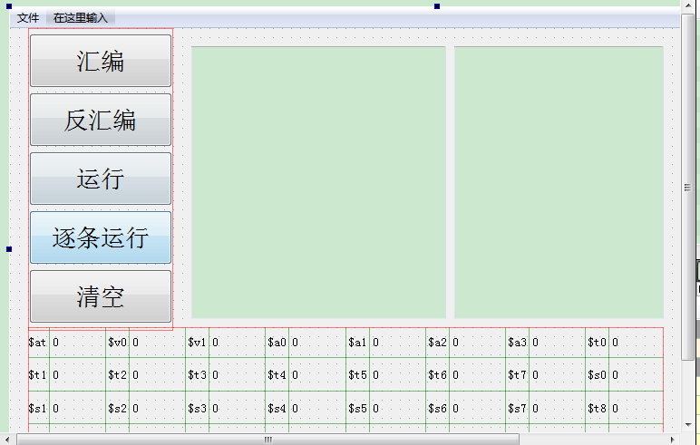

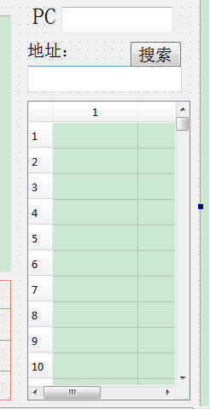

### Mai.cpp:

#include<iostream>

#include<string>

#include<cstring>

#include<QString>

#include"mai.h"

using namespace std;

typedef unsigned int bit32;

class instruction{

private:

bit32 binary_code;

char* str_code;

int str2bin_add(char* in){

int i = 0, r, p = 0;

bit32 binary = 0;

char *temp;

temp = (char*)calloc(7, 1);

while (in[p] != ' '){

temp[i] = in[p];

i++;

p++;

if (i > 6)break;

}

temp[i] = 0;

if ((r = read_register(temp)) == -1)return -1;

binary += bit32(r) << 11;

p++;

i = 0;

while (in[p] != ' '){

temp[i] = in[p];

i++;

p++;

if (i > 6)break;

}

temp[i] = 0;

if ((r = read_register(temp)) == -1)return -1;

binary += bit32(r) << 21;

p++;

i = 0;

while (in[p] != 0){

temp[i] = in[p];

i++;

p++;

if (i > 6)break;

}

temp[i] = 0;

if ((r = read_register(temp)) == -1)return -1;

binary += bit32(r) << 16;

binary += 0x20;

this->binary_code = binary;

binary_code2str_code();

return 0;

}

int str2bin_sub(char* in){

int i = 0, r, p = 0;

bit32 binary = 0;

char *temp;

temp = (char*)calloc(7, 1);

while (in[p] != ' '){

temp[i] = in[p];

i++;

p++;

if (i > 6)break;

}

temp[i] = 0;

if ((r = read_register(temp)) == -1)return -1;

binary += bit32(r) << 11;

p++;

i = 0;

while (in[p] != ' '){

temp[i] = in[p];

i++;

p++;

if (i > 6)break;

}

temp[i] = 0;

if ((r = read_register(temp)) == -1)return -1;

binary += bit32(r) << 21;

p++;

i = 0;

while (in[p] != 0){

temp[i] = in[p];

i++;

p++;

if (i > 6)break;

}

temp[i] = 0;

if ((r = read_register(temp)) == -1)return -1;

binary += bit32(r) << 16;

binary += 0x22;

this->binary_code = binary;

binary_code2str_code();

return 0;

}

int str2bin_slt(char* in){

int i = 0, r, p = 0;

bit32 binary = 0;

char *temp;

temp = (char*)calloc(7, 1);

while (in[p] != ' '){

temp[i] = in[p];

i++;

p++;

if (i > 6)break;

}

temp[i] = 0;

if ((r = read_register(temp)) == -1)return -1;

binary += bit32(r) << 11;

p++;

i = 0;

while (in[p] != ' '){

temp[i] = in[p];

i++;

p++;

if (i > 6)break;

}

temp[i] = 0;

if ((r = read_register(temp)) == -1)return -1;

binary += bit32(r) << 21;

p++;

i = 0;

while (in[p] != 0){

temp[i] = in[p];

i++;

p++;

if (i > 6)break;

}

temp[i] = 0;

if ((r = read_register(temp)) == -1)return -1;

binary += bit32(r) << 16;

binary += 0x2a;

this->binary_code = binary;

binary_code2str_code();

return 0;

}

int str2bin_and(char* in){

int i = 0, r, p = 0;

bit32 binary = 0;

char *temp;

temp = (char*)calloc(7, 1);

while (in[p] != ' '){

temp[i] = in[p];

i++;

p++;

if (i > 6)break;

}

temp[i] = 0;

if ((r = read_register(temp)) == -1)return -1;

binary += bit32(r) << 11;

p++;

i = 0;

while (in[p] != ' '){

temp[i] = in[p];

i++;

p++;

if (i > 6)break;

}

temp[i] = 0;

if ((r = read_register(temp)) == -1)return -1;

binary += bit32(r) << 21;

p++;

i = 0;

while (in[p] != 0){

temp[i] = in[p];

i++;

p++;

if (i > 6)break;

}

temp[i] = 0;

if ((r = read_register(temp)) == -1)return -1;

binary += bit32(r) << 16;

binary += 0x24;

this->binary_code = binary;

binary_code2str_code();

return 0;

}

int str2bin_or(char* in){

int i = 0, r, p = 0;

bit32 binary = 0;

char *temp;

temp = (char*)calloc(7, 1);

while (in[p] != ' '){

temp[i] = in[p];

i++;

p++;

if (i > 6)break;

}

temp[i] = 0;

if ((r = read_register(temp)) == -1)return -1;

binary += bit32(r) << 11;

p++;

i = 0;

while (in[p] != ' '){

temp[i] = in[p];

i++;

p++;

if (i > 6)break;

}

temp[i] = 0;

if ((r = read_register(temp)) == -1)return -1;

binary += bit32(r) << 21;

p++;

i = 0;

while (in[p] != 0){

temp[i] = in[p];

i++;

p++;

if (i > 6)break;

}

temp[i] = 0;

if ((r = read_register(temp)) == -1)return -1;

binary += bit32(r) << 16;

binary += 0x25;

this->binary_code = binary;

binary_code2str_code();

return 0;

}

int str2bin_nor(char* in){

int i = 0, r, p = 0;

bit32 binary = 0;

char *temp;

temp = (char*)calloc(7, 1);

while (in[p] != ' '){

temp[i] = in[p];

i++;

p++;

if (i > 6)break;

}

temp[i] = 0;

if ((r = read_register(temp)) == -1)return -1;

binary += bit32(r) << 11;

p++;

i = 0;

while (in[p] != ' '){

temp[i] = in[p];

i++;

p++;

if (i > 6)break;

}

temp[i] = 0;

if ((r = read_register(temp)) == -1)return -1;

binary += bit32(r) << 21;

p++;

i = 0;

while (in[p] != 0){

temp[i] = in[p];

i++;

p++;

if (i > 6)break;

}

temp[i] = 0;

if ((r = read_register(temp)) == -1)return -1;

binary += bit32(r) << 16;

binary += 0x27;

this->binary_code = binary;

binary_code2str_code();

return 0;

}

int str2bin_xor(char* in){

int i = 0, r, p = 0;

bit32 binary = 0;

char *temp;

temp = (char*)calloc(7, 1);

while (in[p] != ' '){

temp[i] = in[p];

i++;

p++;

if (i > 6)break;

}

temp[i] = 0;

if ((r = read_register(temp)) == -1)return -1;

binary += bit32(r) << 11;

p++;

i = 0;

while (in[p] != ' '){

temp[i] = in[p];

i++;

p++;

if (i > 6)break;

}

temp[i] = 0;

if ((r = read_register(temp)) == -1)return -1;

binary += bit32(r) << 21;

p++;

i = 0;

while (in[p] != 0){

temp[i] = in[p];

i++;

p++;

if (i > 6)break;

}

temp[i] = 0;

if ((r = read_register(temp)) == -1)return -1;

binary += bit32(r) << 16;

binary += 0x26;

this->binary_code = binary;

binary_code2str_code();

return 0;

}

int str2bin_addi(char* in){

int i = 0, r, p = 0;

bit32 binary = 0;

int immediate = 0;

char *temp;

temp = (char*)calloc(7, 1);

while (in[p] != ' '){

temp[i] = in[p];

i++;

p++;

if (i > 6)break;

}

temp[i] = 0;

if ((r = read_register(temp)) == -1)return -1;

binary += bit32(r) << 16;

p++;

i = 0;

while (in[p] != ' '){

temp[i] = in[p];

i++;

p++;

if (i > 6)break;

}

temp[i] = 0;

if ((r = read_register(temp)) == -1)return -1;

binary += bit32(r) << 21;

p++;

sscanf(in + p, "%d%c", &immediate);

binary += immediate & 0xffff;

binary += (0x8) << 26;

this->binary_code = binary;

binary_code2str_code();

return 0;

}

int str2bin_slti(char* in){

int i = 0, r, p = 0;

bit32 binary = 0;

int immediate = 0;

char *temp;

temp = (char*)calloc(7, 1);

while (in[p] != ' '){

temp[i] = in[p];

i++;

p++;

if (i > 6)break;

}

temp[i] = 0;

if ((r = read_register(temp)) == -1)return -1;

binary += bit32(r) << 16;

p++;

i = 0;

while (in[p] != ' '){

temp[i] = in[p];

i++;

p++;

if (i > 6)break;

}

temp[i] = 0;

if ((r = read_register(temp)) == -1)return -1;

binary += bit32(r) << 21;

p++;

sscanf(in + p, "%d", &immediate);

binary += immediate & 0xffff;

binary += (0xa) << 26;

this->binary_code = binary;

binary_code2str_code();

return 0;

}

int str2bin_andi(char* in){

int i = 0, r, p = 0;

bit32 binary = 0;

int immediate = 0;

char *temp;

temp = (char*)calloc(7, 1);

while (in[p] != ' '){

temp[i] = in[p];

i++;

p++;

if (i > 6)break;

}

temp[i] = 0;

if ((r = read_register(temp)) == -1)return -1;

binary += bit32(r) << 16;

p++;

i = 0;

while (in[p] != ' '){

temp[i] = in[p];

i++;

p++;

if (i > 6)break;

}

temp[i] = 0;

if ((r = read_register(temp)) == -1)return -1;

binary += bit32(r) << 21;

p++;

sscanf(in + p, "%d", &immediate);

binary += immediate & 0xffff;

binary += (0xc) << 26;

this->binary_code = binary;

binary_code2str_code();

return 0;

}

int str2bin_ori(char* in){

int i = 0, r, p = 0;

bit32 binary = 0;

int immediate = 0;

char *temp;

temp = (char*)calloc(7, 1);

while (in[p] != ' '){

temp[i] = in[p];

i++;

p++;

if (i > 6)break;

}

temp[i] = 0;

if ((r = read_register(temp)) == -1)return -1;

binary += bit32(r) << 16;

p++;

i = 0;

while (in[p] != ' '){

temp[i] = in[p];

i++;

p++;

if (i > 6)break;

}

temp[i] = 0;

if ((r = read_register(temp)) == -1)return -1;

binary += bit32(r) << 21;

p++;

sscanf(in + p, "%d", &immediate);

binary += immediate & 0xffff;

binary += (0xd) << 26;

this->binary_code = binary;

binary_code2str_code();

return 0;

}

int str2bin_xori(char* in){

int i = 0, r, p = 0;

bit32 binary = 0;

int immediate = 0;

char *temp;

temp = (char*)calloc(7, 1);

while (in[p] != ' '){

temp[i] = in[p];

i++;

p++;

if (i > 6)break;

}

temp[i] = 0;

if ((r = read_register(temp)) == -1)return -1;

binary += bit32(r) << 16;

p++;

i = 0;

while (in[p] != ' '){

temp[i] = in[p];

i++;

p++;

if (i > 6)break;

}

temp[i] = 0;

if ((r = read_register(temp)) == -1)return -1;

binary += bit32(r) << 21;

p++;

sscanf(in + p, "%d", &immediate);

binary += immediate & 0xffff;

binary += (0xe) << 26;

this->binary_code = binary;

binary_code2str_code();

return 0;

}

int str2bin_lw(char* in){

int i = 0, r, p = 0;

bit32 binary = 0;

int immediate = 0;

char *temp, *temp1;

temp = (char*)calloc(7, 1);

temp1 = (char*)calloc(7, 1);

while (in[p] != ' '){

temp[i] = in[p];

i++;

p++;

if (i > 6)break;

}

temp[i] = 0;

if ((r = read_register(temp)) == -1)return -1;

binary += bit32(r) << 16;

p++;

sscanf(in + p, "%d(%s", &immediate,temp1);

binary += immediate & 0xffff;

i = 0;

while (temp1[i] != ')'){

temp[i] = temp1[i];

i++;

if (i > 6)break;

}

if ((r = read_register(temp)) == -1)return -1;

binary += bit32(r) << 21;

binary += (0x23) << 26;

this->binary_code = binary;

binary_code2str_code();

return 0;

}

int str2bin_sw(char* in){

int i = 0, r, p = 0;

bit32 binary = 0;

int immediate = 0;

char *temp, *temp1;

temp = (char*)calloc(7, 1);

temp1 = (char*)calloc(7, 1);

while (in[p] != ' '){

temp[i] = in[p];

i++;

p++;

if (i > 6)break;

}

temp[i] = 0;

if ((r = read_register(temp)) == -1)return -1;

binary += bit32(r) << 16;

p++;

sscanf(in + p, "%d(%s", &immediate, temp1);

binary += immediate & 0xffff;

i = 0;

while (temp1[i] != ')'){

temp[i] = temp1[i];

i++;

if (i > 6)break;

}

if ((r = read_register(temp)) == -1)return -1;

binary += bit32(r) << 21;

binary += (0x2b) << 26;

this->binary_code = binary;

binary_code2str_code();

return 0;

}

int str2bin_lb(char* in){

int i = 0, r, p = 0;

bit32 binary = 0;

int immediate = 0;

char *temp, *temp1;

temp = (char*)calloc(7, 1);

temp1 = (char*)calloc(7, 1);

while (in[p] != ' '){

temp[i] = in[p];

i++;

p++;

if (i > 6)break;

}

temp[i] = 0;

if ((r = read_register(temp)) == -1)return -1;

binary += bit32(r) << 16;

p++;

sscanf(in + p, "%d(%s", &immediate, temp1);

binary += immediate & 0xffff;

i = 0;

while (temp1[i] != ')'){

temp[i] = temp1[i];

i++;

if (i > 6)break;

}

if ((r = read_register(temp)) == -1)return -1;

binary += bit32(r) << 21;

binary += (0x20) << 26;

this->binary_code = binary;

binary_code2str_code();

return 0;

}

int str2bin_sb(char* in){

int i = 0, r, p = 0;

bit32 binary = 0;

int immediate = 0;

char *temp, *temp1;

temp = (char*)calloc(7, 1);

temp1 = (char*)calloc(7, 1);

while (in[p] != ' '){

temp[i] = in[p];

i++;

p++;

if (i > 6)break;

}

temp[i] = 0;

if ((r = read_register(temp)) == -1)return -1;

binary += bit32(r) << 16;

p++;

sscanf(in + p, "%d(%s", &immediate, temp1);

binary += immediate & 0xffff;

i = 0;

while (temp1[i] != ')'){

temp[i] = temp1[i];

i++;

if (i > 6)break;

}

if ((r = read_register(temp)) == -1)return -1;

binary += bit32(r) << 21;

binary += (0x28) << 26;

this->binary_code = binary;

binary_code2str_code();

return 0;

}

int str2bin_lui(char* in){

int i = 0, r, p = 0;

bit32 binary = 0;

int immediate = 0;

char *temp;

temp = (char*)calloc(7, 1);

while (in[p] != ' '){

temp[i] = in[p];

i++;

p++;

if (i > 6)break;

}

temp[i] = 0;

if ((r = read_register(temp)) == -1)return -1;

binary += bit32(r) << 16;

p++;

sscanf(in + p, "%d", &immediate);

binary += immediate & 0xffff;

binary += (0xf) << 26;

this->binary_code = binary;

binary_code2str_code();

return 0;

}

int str2bin_beq(char* in){

int i = 0, r, p = 0;

bit32 binary = 0;

int immediate = 0;

char *temp;

temp = (char*)calloc(7, 1);

while (in[p] != ' '){

temp[i] = in[p];

i++;

p++;

if (i > 6)break;

}

temp[i] = 0;

if ((r = read_register(temp)) == -1)return -1;

binary += bit32(r) << 21;

p++;

i = 0;

while (in[p] != ' '){

temp[i] = in[p];

i++;

p++;

if (i > 6)break;

}

temp[i] = 0;

if ((r = read_register(temp)) == -1)return -1;

binary += bit32(r) << 16;

p++;

sscanf(in + p, "%d", &immediate);

binary += immediate & 0xffff;

binary += (0x4) << 26;

this->binary_code = binary;

binary_code2str_code();

return 0;

}

int str2bin_bne(char* in){

int i = 0, r, p = 0;

bit32 binary = 0;

int immediate = 0;

char *temp;

temp = (char*)calloc(7, 1);

while (in[p] != ' '){

temp[i] = in[p];

i++;

p++;

if (i > 6)break;

}

temp[i] = 0;

if ((r = read_register(temp)) == -1)return -1;

binary += bit32(r) << 21;

p++;

i = 0;

while (in[p] != ' '){

temp[i] = in[p];

i++;

p++;

if (i > 6)break;

}

temp[i] = 0;

if ((r = read_register(temp)) == -1)return -1;

binary += bit32(r) << 16;

p++;

sscanf(in + p, "%d", &immediate);

binary += immediate & 0xffff;

binary += (0x5) << 26;

this->binary_code = binary;

binary_code2str_code();

return 0;

}

int str2bin_j(char* in){

bit32 target, binary = 0;

sscanf(in, "%d", &target);

binary += target & 0x3fffff;

binary += (0x2) << 26;

this->binary_code = binary;

binary_code2str_code();

return 0;

}

int str2bin_jal(char* in){

bit32 target, binary = 0;

sscanf(in, "%d", &target);

binary += target & 0x3fffff;

binary += (0x3) << 26;

this->binary_code = binary;

binary_code2str_code();

return 0;

}

int str2bin_jr(char* in){

int i = 0, r, p = 0;

bit32 binary = 0;

int immediate = 0;

char *temp;

temp = (char*)calloc(7, 1);

while (in[p] != ' '){

temp[i] = in[p];

i++;

p++;

if (i > 6)break;

}

temp[i] = 0;

if ((r = read_register(temp)) == -1)return -1;

binary += bit32(r) << 21;

binary += 0x8;

this->binary_code = binary;

binary_code2str_code();

return 0;

}

void binary_code2str_code(){

char *str, *reg_1, *reg_2, *reg_3;

bit32 op, func, reg1, reg2, reg3, target, immediateu;

int immediate;

str = (char*)calloc(30, 1);

reg_1 = (char*)calloc(7, 1);

reg_2 = (char*)calloc(7, 1);

reg_3 = (char*)calloc(7, 1);

op = (this->binary_code) >> 26;

func = (this->binary_code) & 0x3f;

reg1 = ((this->binary_code) >> 21) & 0x1f;

reg2 = ((this->binary_code) >> 16) & 0x1f;

reg3 = ((this->binary_code) >> 11) & 0x1f;

reg_1 = get_register_name(reg1);

reg_2 = get_register_name(reg2);

reg_3 = get_register_name(reg3);

immediateu = (this->binary_code) & 0xffff;

immediate = (immediateu & 0x8000) ? -(0x10000-immediateu) : (immediateu & 0x7fff);

target = (this->binary_code) & 0x3ffffff;

switch (op){

case 0:

switch (func){

case 0x20:

sprintf(str, "add %s %s %s", reg_3, reg_1, reg_2); break;

case 0x22:

sprintf(str, "sub %s %s %s", reg_3, reg_1, reg_2); break;

case 0x2a:

sprintf(str, "slt %s %s %s", reg_3, reg_1, reg_2); break;

case 0x24:

sprintf(str, "and %s %s %s", reg_3, reg_1, reg_2); break;

case 0x25:

sprintf(str, "or %s %s %s", reg_3, reg_1, reg_2); break;

case 0x27:

sprintf(str, "nor %s %s %s", reg_3, reg_1, reg_2); break;

case 0x26:

sprintf(str, "xor %s %s %s", reg_3, reg_1, reg_2); break;

case 0x8:

sprintf(str, "jr %s", reg_1); break;

default:

sprintf(str, "hot hot hot"); break;

}break;

case 0x8:

sprintf(str, "addi %s %s %d", reg_2, reg_1, immediate); break;

case 0xa:

sprintf(str, "slti %s %s %d", reg_2, reg_1, immediate); break;

case 0xc:

sprintf(str, "andi %s %s %d", reg_2, reg_1, immediate); break;

case 0xd:

sprintf(str, "ori %s %s %d", reg_2, reg_1, immediate); break;

case 0xe:

sprintf(str, "xori %s %s %d", reg_2, reg_1, immediate); break;

case 0x4:

sprintf(str, "beq %s %s %d", reg_1, reg_2, immediate); break;

case 0x5:

sprintf(str, "bne %s %s %d", reg_1, reg_2, immediate); break;

case 0x23:

sprintf(str, "lw %s %d(%s)", reg_2, immediate, reg_1); break;

case 0x2b:

sprintf(str, "sw %s %d(%s)", reg_2, immediate, reg_1); break;

case 0x20:

sprintf(str, "lb %s %d(%s)", reg_2, immediate, reg_1); break;

case 0x28:

sprintf(str, "sb %s %d(%s)", reg_2, immediate, reg_1); break;

case 0xf:

sprintf(str, "lui %s %d", reg_2, immediate); break;

case 0x2:

sprintf(str, "j %d", target); break;

case 0x3:

sprintf(str, "jal %d", target); break;

default:

sprintf(str, "hot hot hot"); break;

}

this->str_code = str;

}

char* get_register_name(bit32 reg){

char* temp;

temp = (char*)calloc(7, 1);

switch (reg){

case 0:strcpy(temp, "$zero"); break;

case 1:strcpy(temp, "$at"); break;

case 2:strcpy(temp, "$v0"); break;

case 3:strcpy(temp, "$v1"); break;

case 4:strcpy(temp, "$a0"); break;

case 5:strcpy(temp, "$a1"); break;

case 6:strcpy(temp, "$a2"); break;

case 7:strcpy(temp, "$a3"); break;

case 8:strcpy(temp, "$t0"); break;

case 9:strcpy(temp, "$t1"); break;

case 10:strcpy(temp, "$t2"); break;

case 11:strcpy(temp, "$t3"); break;

case 12:strcpy(temp, "$t4"); break;

case 13:strcpy(temp, "$t5"); break;

case 14:strcpy(temp, "$t6"); break;

case 15:strcpy(temp, "$t7"); break;

case 16:strcpy(temp, "$s0"); break;

case 17:strcpy(temp, "$s1"); break;

case 18:strcpy(temp, "$s2"); break;

case 19:strcpy(temp, "$s3"); break;

case 20:strcpy(temp, "$s4"); break;

case 21:strcpy(temp, "$s5"); break;

case 22:strcpy(temp, "$s6"); break;

case 23:strcpy(temp, "$s7"); break;

case 24:strcpy(temp, "$t8"); break;

case 25:strcpy(temp, "$t9"); break;

case 26:strcpy(temp, "$k0"); break;

case 27:strcpy(temp, "$k1"); break;

case 28:strcpy(temp, "$gp"); break;

case 29:strcpy(temp, "$sp"); break;

case 30:strcpy(temp, "$fp"); break;

case 31:strcpy(temp, "$ra"); break;

default:strcpy(temp, "???"); break;

}

return temp;

}

int read_register(char* reg){

if (!strcmp(reg, "$0"))return 0;

else if (!strcmp(reg, "$1"))return 1;

else if (!strcmp(reg, "$2"))return 2;

else if (!strcmp(reg, "$3"))return 3;

else if (!strcmp(reg, "$4"))return 4;

else if (!strcmp(reg, "$5"))return 5;

else if (!strcmp(reg, "$6"))return 6;

else if (!strcmp(reg, "$7"))return 7;

else if (!strcmp(reg, "$8"))return 8;

else if (!strcmp(reg, "$9"))return 9;

else if (!strcmp(reg, "$10"))return 10;

else if (!strcmp(reg, "$11"))return 11;

else if (!strcmp(reg, "$12"))return 12;

else if (!strcmp(reg, "$13"))return 13;

else if (!strcmp(reg, "$14"))return 14;

else if (!strcmp(reg, "$15"))return 15;

else if (!strcmp(reg, "$16"))return 16;

else if (!strcmp(reg, "$17"))return 17;

else if (!strcmp(reg, "$18"))return 18;

else if (!strcmp(reg, "$19"))return 19;

else if (!strcmp(reg, "$20"))return 20;

else if (!strcmp(reg, "$21"))return 21;

else if (!strcmp(reg, "$22"))return 22;

else if (!strcmp(reg, "$23"))return 23;

else if (!strcmp(reg, "$24"))return 24;

else if (!strcmp(reg, "$25"))return 25;

else if (!strcmp(reg, "$26"))return 26;

else if (!strcmp(reg, "$27"))return 27;

else if (!strcmp(reg, "$28"))return 28;

else if (!strcmp(reg, "$29"))return 29;

else if (!strcmp(reg, "$30"))return 30;

else if (!strcmp(reg, "$31"))return 31;

else if (!strcmp(reg, "$zero"))return 0;

else if (!strcmp(reg, "$at"))return 1;

else if (!strcmp(reg, "$v0"))return 2;

else if (!strcmp(reg, "$v1"))return 3;

else if (!strcmp(reg, "$a0"))return 4;

else if (!strcmp(reg, "$a1"))return 5;

else if (!strcmp(reg, "$a2"))return 6;

else if (!strcmp(reg, "$a3"))return 7;

else if (!strcmp(reg, "$t0"))return 8;

else if (!strcmp(reg, "$t1"))return 9;

else if (!strcmp(reg, "$t2"))return 10;

else if (!strcmp(reg, "$t3"))return 11;

else if (!strcmp(reg, "$t4"))return 12;

else if (!strcmp(reg, "$t5"))return 13;

else if (!strcmp(reg, "$t6"))return 14;

else if (!strcmp(reg, "$t7"))return 15;

else if (!strcmp(reg, "$s0"))return 16;

else if (!strcmp(reg, "$s1"))return 17;

else if (!strcmp(reg, "$s2"))return 18;

else if (!strcmp(reg, "$s3"))return 19;

else if (!strcmp(reg, "$s4"))return 20;

else if (!strcmp(reg, "$s5"))return 21;

else if (!strcmp(reg, "$s6"))return 22;

else if (!strcmp(reg, "$s7"))return 23;

else if (!strcmp(reg, "$t8"))return 24;

else if (!strcmp(reg, "$t9"))return 25;

else if (!strcmp(reg, "$k0"))return 26;

else if (!strcmp(reg, "$k1"))return 27;

else if (!strcmp(reg, "$gp"))return 28;

else if (!strcmp(reg, "$sp"))return 29;

else if (!strcmp(reg, "$fp"))return 30;

else if (!strcmp(reg, "$ra"))return 31;

else return -1;

}

public:

instruction(){

binary_code = 0;

str_code = 0;

}

bit32 get_binary_code(){

return binary_code;

}

char* get_str_code(){

return str_code;

}

char* C_str_binary_code(){

char *temp;

int value[8];

temp = (char*)calloc(15, 1);

value[0] = ((this->binary_code) >> 28) & 0xf;

value[1] = ((this->binary_code) >> 24) & 0xf;

value[2] = ((this->binary_code) >> 20) & 0xf;

value[3] = ((this->binary_code) >> 16) & 0xf;

value[4] = ((this->binary_code) >> 12) & 0xf;

value[5] = ((this->binary_code) >> 8) & 0xf;

value[6] = ((this->binary_code) >> 4) & 0xf;

value[7] = (this->binary_code) & 0xf;

sprintf(temp, "0x%x%x%x%x%x%x%x%x", value[0], value[1], value[2], value[3], value[4], value[5], value[6], value[7]);

return temp;

}

int input_instruction_str(char* in){

int i = 0;

char *temp;

temp = (char*)calloc(6, 1);

while (in[i] != ' '){

temp[i] = in[i];

if (temp[i] >= 'A'&&temp[i] <= 'Z')

temp[i] += 32;

i++;

if (i > 5)break;

}

temp[i] = 0;

if (!strcmp(temp, "add"))return str2bin_add(in + 4);

else if (!strcmp(temp, "sub"))return str2bin_sub(in + 4);

else if (!strcmp(temp, "slt"))return str2bin_slt(in + 4);

else if (!strcmp(temp, "and"))return str2bin_and(in + 4);

else if (!strcmp(temp, "or"))return str2bin_or(in + 3);

else if (!strcmp(temp, "nor"))return str2bin_nor(in + 4);

else if (!strcmp(temp, "xor"))return str2bin_xor(in + 4);

else if (!strcmp(temp, "addi"))return str2bin_addi(in + 5);

else if (!strcmp(temp, "slti"))return str2bin_slti(in + 5);

else if (!strcmp(temp, "andi"))return str2bin_andi(in + 5);

else if (!strcmp(temp, "ori"))return str2bin_ori(in + 4);

else if (!strcmp(temp, "xori"))return str2bin_xori(in + 5);

else if (!strcmp(temp, "lw"))return str2bin_lw(in + 3);

else if (!strcmp(temp, "sw"))return str2bin_sw(in + 3);

else if (!strcmp(temp, "lb"))return str2bin_lb(in + 3);

else if (!strcmp(temp, "sb"))return str2bin_sb(in + 3);

else if (!strcmp(temp, "lui"))return str2bin_lui(in + 4);

else if (!strcmp(temp, "beq"))return str2bin_beq(in + 4);

else if (!strcmp(temp, "bne"))return str2bin_bne(in + 4);

else if (!strcmp(temp, "j"))return str2bin_j(in + 2);

else if (!strcmp(temp, "jal"))return str2bin_jal(in + 4);

else if (!strcmp(temp, "jr"))return str2bin_jr(in + 3);

else return -1;

}

int input_instruction_binary(bit32 code){

this->binary_code = code;

binary_code2str_code();

return 0;

}

};

QString dodo(QString instring){

instring = instring.simplified();

string o;

char*s=(char*)calloc(30, 1);

QByteArray ba = instring.toLatin1();

s=ba.data();

instruction t;

if (t.input_instruction_str(s) == -1){

o +="Wrong input!";

}

else

{

string ast=t.C_str_binary_code();

//string fn=t.get_str_code();;

o=ast;

}

QString qo = QString::fromStdString(o);

return qo;

}

QString odod(QString instring){

string o;

bool ok;

bit32 s=instring.toUInt(&ok,16);

instruction t;

if (t.input_instruction_binary(s) == -1){

o +="Wrong input!";

}

else

{

//string ast=t.C_str_binary_code();

string fn=t.get_str_code();;

o=fn;

}

QString qo = QString::fromStdString(o);

return qo;

}