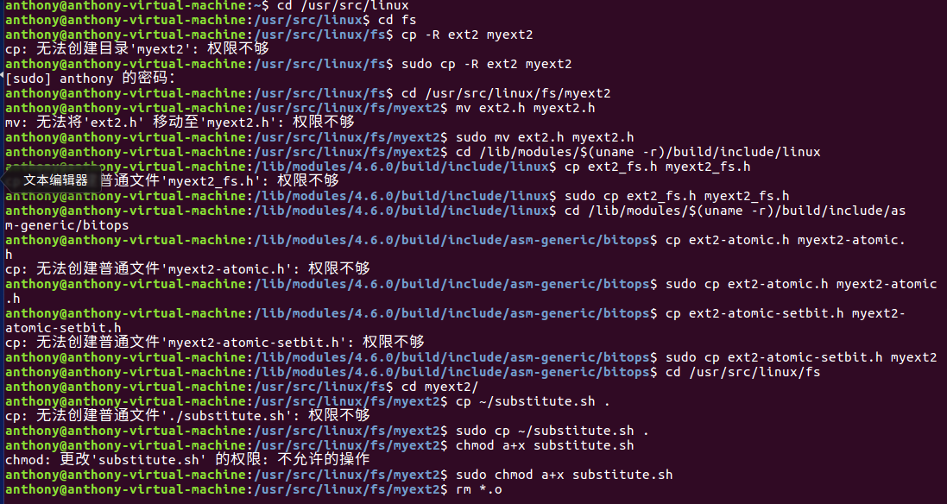

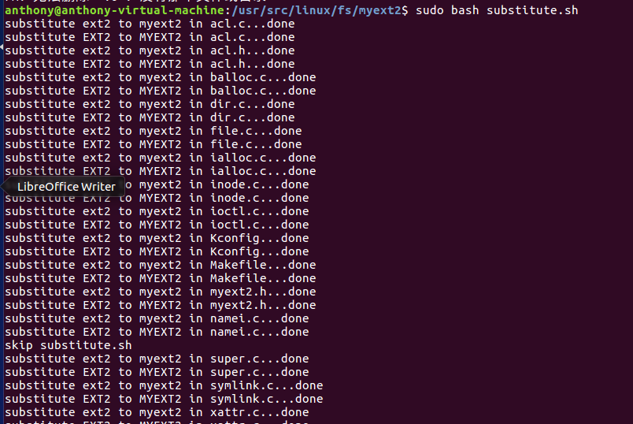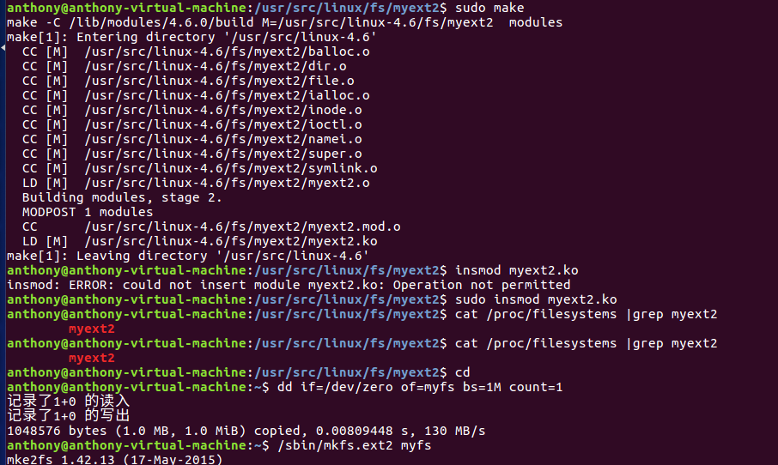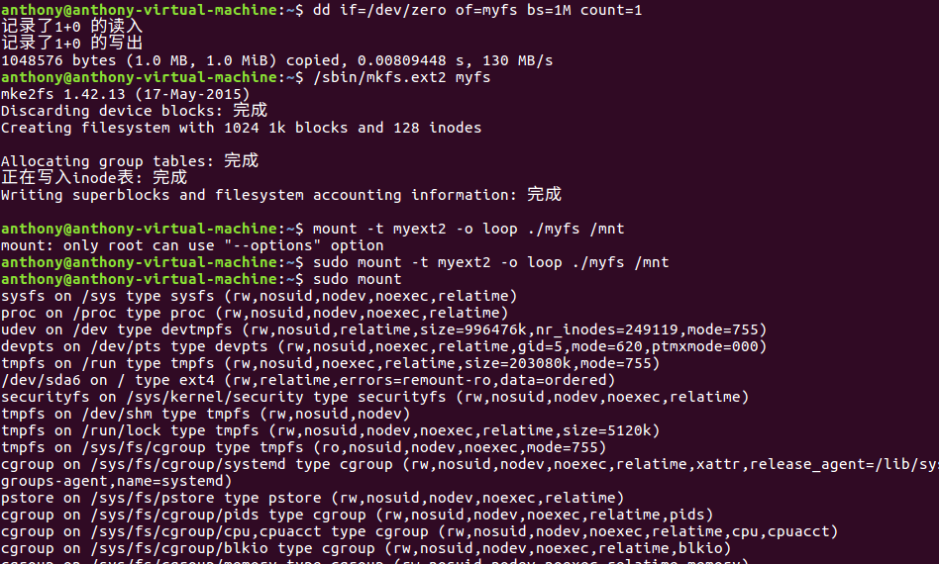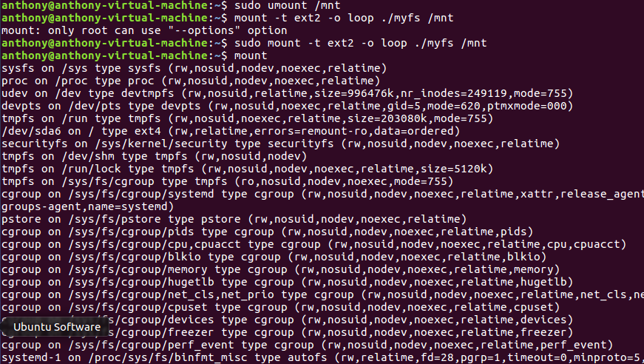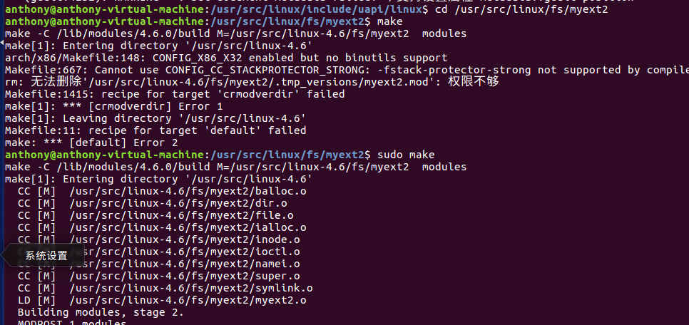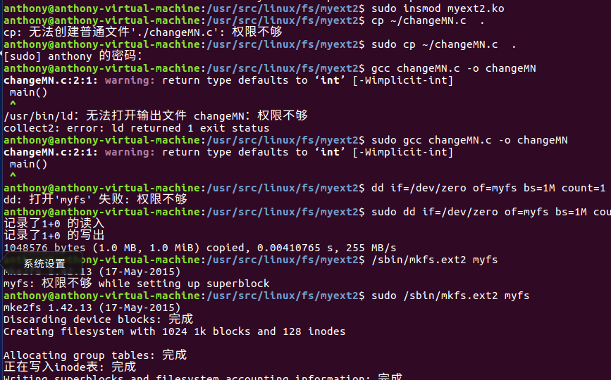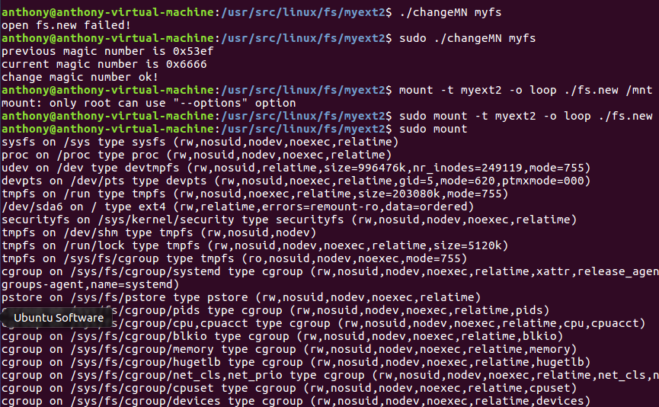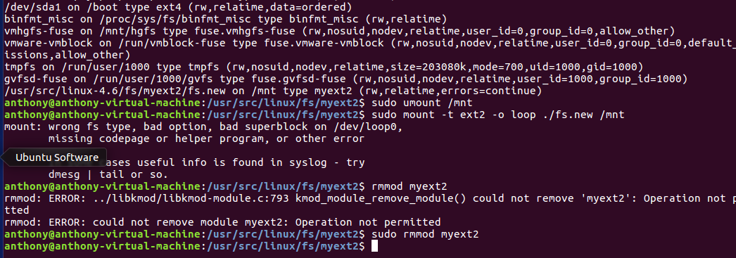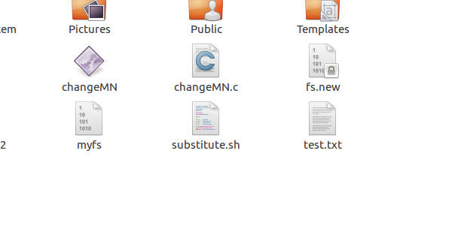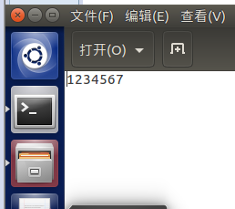

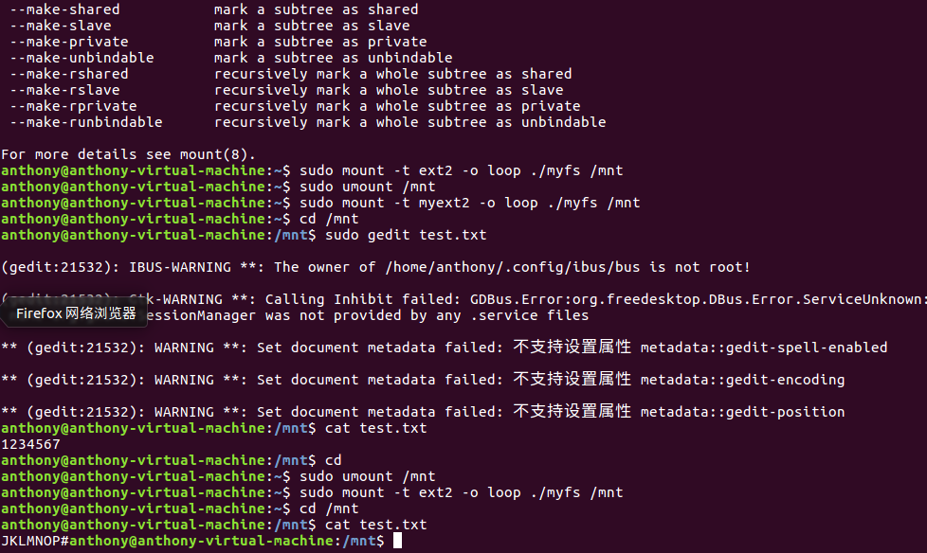

#include <linux/time.h>

#include <linux/pagemap.h>

#include <linux/dax.h>

#include <linux/quotaops.h>

#include "myext2.h"

#include "xattr.h"

#include "acl.h"

#include <linux/slab.h>

#include <linux/stat.h>

#include <linux/fcntl.h>

#include <linux/file.h>

#include <linux/uio.h>

#include <linux/fsnotify.h>

#include <linux/security.h>

#include <linux/export.h>

#include <linux/syscalls.h>

#include <linux/splice.h>

#include <linux/compat.h>

#include <linux/mount.h>

#include <linux/fs.h>

#include <asm/uaccess.h>

#include <asm/unistd.h>

typedef ssize_t (*io_fn_t)(struct file *, char __user *, size_t, loff_t *);

typedef ssize_t (*iter_fn_t)(struct kiocb *, struct iov_iter *);

#ifdef CONFIG_FS_DAX

/*

* The lock ordering for myext2 DAX fault paths is:

*

* mmap_sem (MM)

* sb_start_pagefault (vfs, freeze)

* myext2_inode_info->dax_sem

* address_space->i_mmap_rwsem or page_lock (mutually exclusive in DAX)

* myext2_inode_info->truncate_mutex

*

* The default page_lock and i_size verification done by non-DAX fault paths

* is sufficient because myext2 doesn't support hole punching.

*/

static ssize_t new_sync_write(struct file *filp, const char __user *buf, size_t len, loff_t *ppos)

{

struct iovec iov = { .iov_base = (void __user *)buf, .iov_len = len };

struct kiocb kiocb;

struct iov_iter iter;

ssize_t ret;

init_sync_kiocb(&kiocb, filp);

kiocb.ki_pos = *ppos;

iov_iter_init(&iter, WRITE, &iov, 1, len);

ret = filp->f_op->write_iter(&kiocb, &iter);

BUG_ON(ret == -EIOCBQUEUED);

if (ret > 0)

*ppos = kiocb.ki_pos;

return ret;

}

static ssize_t new_sync_read(struct file *filp, char __user *buf, size_t len, loff_t *ppos)

{

struct iovec iov = { .iov_base = buf, .iov_len = len };

struct kiocb kiocb;

struct iov_iter iter;

ssize_t ret;

init_sync_kiocb(&kiocb, filp);

kiocb.ki_pos = *ppos;

iov_iter_init(&iter, READ, &iov, 1, len);

ret = filp->f_op->read_iter(&kiocb, &iter);

BUG_ON(ret == -EIOCBQUEUED);

*ppos = kiocb.ki_pos;

return ret;

}

ssize_t new_sync_write_crypt(struct file *filp, const char __user *buf, size_t len, loff_t *ppos)

{

int i;

char* mybuf = buf;

for(i=0;i<len;i++)//在此处添加对长度为len的buf数据进行加密（简单移位密码，将每个字符值+25）

{

mybuf[i]+=25;

}

printk("haha encrypt %ld\n", len);

return new_sync_write(filp, mybuf, len, ppos);//调用默认的写函数，把加密数据写入

}

ssize_t new_sync_read_crypt(struct file *filp, char __user *buf, size_t len, loff_t *ppos)

{

int i;//先调用默认的读函数读取文件数据

ssize_t ret = new_sync_read(filp, buf, len, ppos);

//此处添加对文件的解密（简单移位解密，将每个字符值-25）

for(i=0;i<len;i++)

{

buf[i]-=25;

}

printk("haha encrypt %ld\n", len);

return ret;

}

const struct file_operations myext2_file_operations = {

.llseek = generic_file_llseek,

.read_iter = generic_file_read_iter,

.write_iter = generic_file_write_iter,

.unlocked_ioctl = myext2_ioctl,

.read =new_sync_read_crypt,

.write =new_sync_write_crypt,

#ifdef CONFIG_COMPAT

.compat_ioctl = myext2_compat_ioctl,

#endif

.mmap = myext2_file_mmap,

.open = dquot_file_open,

.release = myext2_release_file,

.fsync = myext2_fsync,

.splice_read = generic_file_splice_read,

.splice_write = iter_file_splice_write,

};