**STAT5120—Week 3 Homework, Allen Baumgarten**

1. Open the GPA/ACT data from CH03PR03.txt. This data set is the dataset from Chapter 1 on GPA vs. ACT, but includes observations on two additional variables, namely intelligence test scores (third column) and high school class rank percentile (fourth column). We want to know which of the three explanatory variables (ACT, intelligence test score, high school class rank percentile) can best be used to make a linear model for predicting GPA. So you will build and compare three simple linear regression models for

1. GPA vs. ACT

2. GPA vs. intelligence test score

3. GPA vs. class rank percentile

So for each of these three cases, do the following:

(a) obtain the linear model (lm(y ~ x)) and output (summary()) and compare the R2 values.

For Model 1, GPA vs. ACT Scores:

Coefficients:

Estimate Std. Error t value Pr(>|t|)

(Intercept) 2.11405 0.32089 6.588 1.3e-09 ***

ch03pr03[, 2] 0.03883 0.01277 3.040 0.00292 **

---

Signif. codes: 0 ‘***’ 0.001 ‘**’ 0.01 ‘*’ 0.05 ‘.’ 0.1 ‘ ’ 1

Residual standard error: 0.6231 on 118 degrees of freedom

Multiple R-squared: 0.07262, Adjusted R-squared: 0.06476

F-statistic: 9.24 on 1 and 118 DF, p-value: 0.002917

For Model 2, GPA vs. Intelligence Scores:

Coefficients:

Estimate Std. Error t value Pr(>|t|)

(Intercept) -1.873921 0.345709 -5.421 3.2e-07 ***

ch03pr03[, 3] 0.041944 0.002915 14.389 < 2e-16 ***

---

Signif. codes: 0 ‘***’ 0.001 ‘**’ 0.01 ‘*’ 0.05 ‘.’ 0.1 ‘ ’ 1

Residual standard error: 0.3899 on 118 degrees of freedom

Multiple R-squared: 0.637, Adjusted R-squared: 0.6339

F-statistic: 207 on 1 and 118 DF, p-value: < 2.2e-16

For Model 3, GPA vs. Class Rank Percentile:

Coefficients:

Estimate Std. Error t value Pr(>|t|)

(Intercept) 2.306901 0.185497 12.436 < 2e-16 ***

ch03pr03[, 4] 0.010417 0.002406 4.329 3.15e-05 ***

---

Signif. codes: 0 ‘***’ 0.001 ‘**’ 0.01 ‘*’ 0.05 ‘.’ 0.1 ‘ ’ 1

Residual standard error: 0.6011 on 118 degrees of freedom

Multiple R-squared: 0.1371, Adjusted R-squared: 0.1298

F-statistic: 18.74 on 1 and 118 DF, p-value: 3.153e-05

Comparing the R2 statistics, we find that Model 2 best accounts for the variation in y at ~64%:

Model 1 R2: 0.07262

Model 2 R2: 0.637

Model 3 R2: 0.1371

(b) make scatter plots that include the regression lines. Identify any potential outliers and influential observations. Decide whether or not to remove them before moving on.

Scatter plot for Model 1:

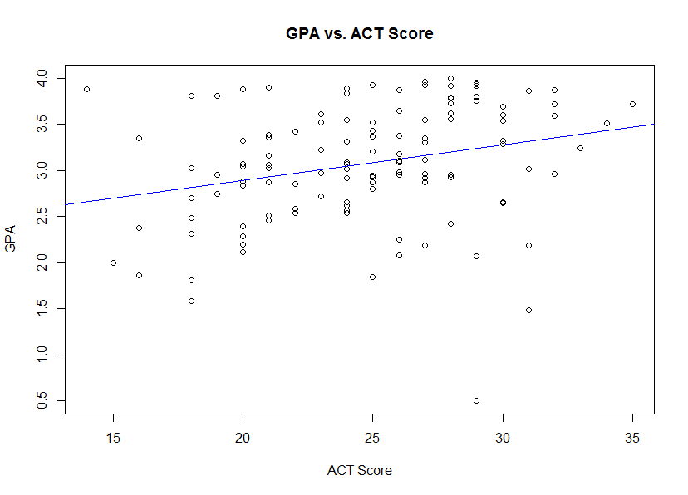

Scatter plot for Model 2:

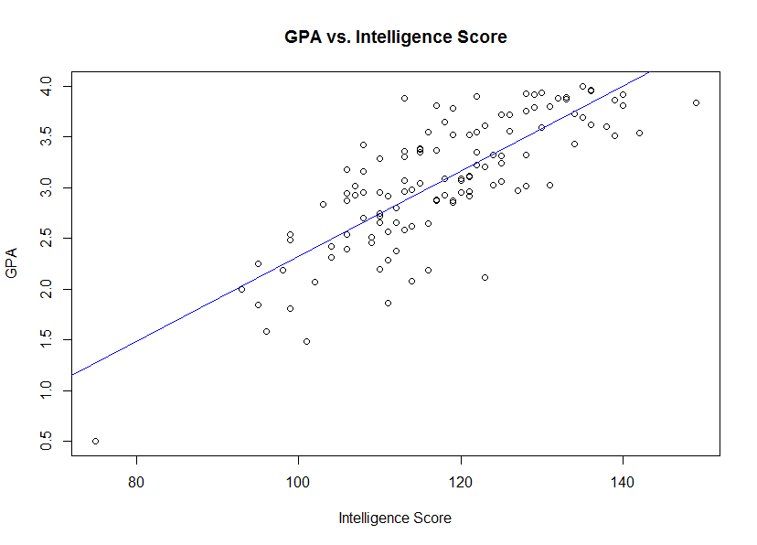

Scatter plot for Model 3:

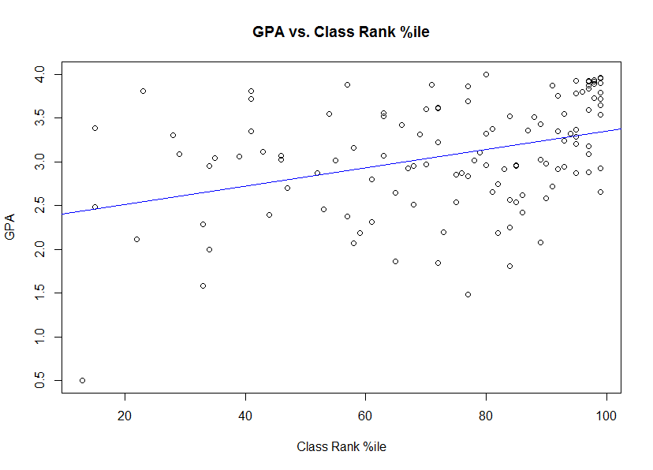

At least one outlier point was observed, viz., in Model 1 with an ACT Score of only 27 or 28 and a correspondingly low GPA score. There was also an outlier in Model 2 with a very low Intelligence score at around 75. Finally, there is a very low Class Rank score in Model 3 at around 10 to 15. Investigation of the dataset reveals that these three observed outliers are actually the same point (row 9) in the dataset. Concluding, I would elect to remove just one point, viz., the one with the low ACT score as per Model 1. This will mean in effect removing only one point from the dataset, leaving us with n = 119.

** R code was scripted to remove row 9 from the dataset based on instructions given in subquestion b above. Thus, subquestions c through h will be answered based on this new reduced dataset at n = 119 **

(c) check for normality of the residuals with Shapiro-Wilk tests (shapiro.test()). Based on reduced dataset, Shapiro-Wilks tests were run on the residuals of these three reduced models:

Test for Model 1 (GPA vs. ACT): W = 0.98454, p-value = 0.191

Test for Model 2 (GPA vs. Intell): W = 0.98973, p-value = 0.5172

Test for Model 3 (GPA vs. Class Rank): W = 0.97492, p-value = 0.02517

(d) make boxplots and histograms of the residuals to help check for normality. Boxplots constructed:

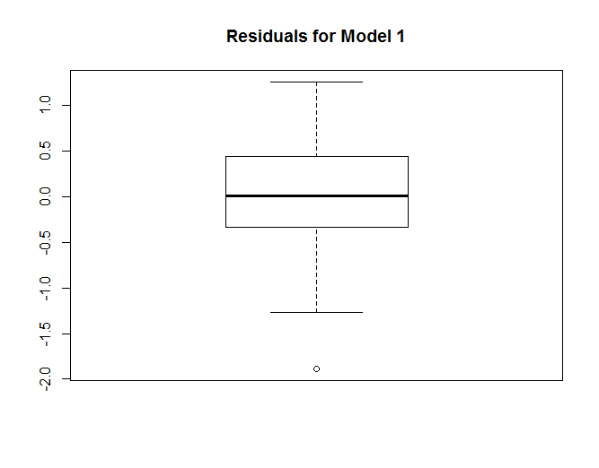

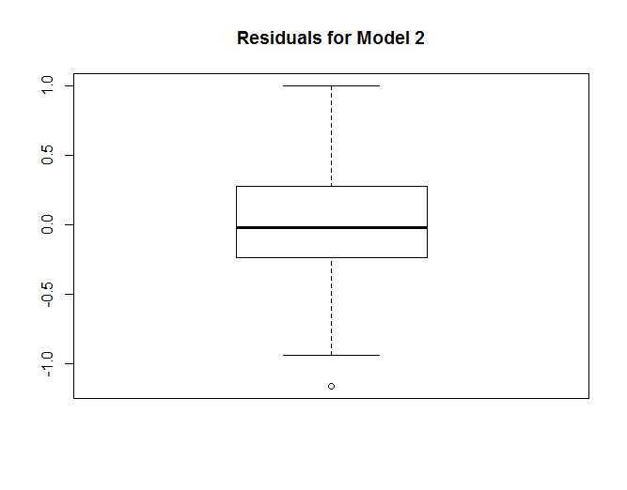

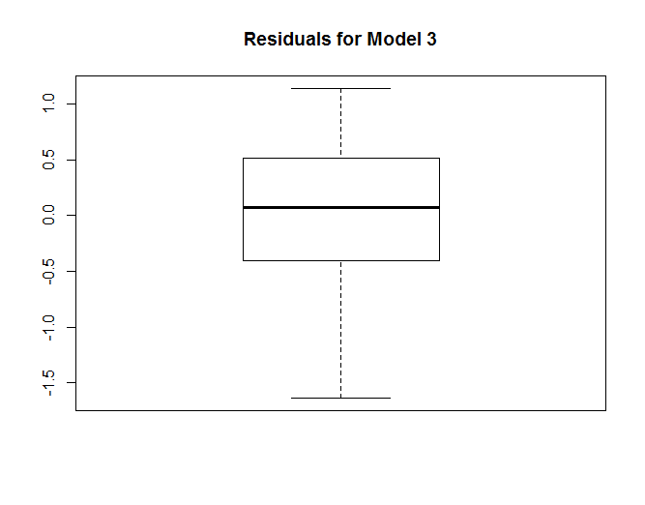

(e) make normal probability plots for the residuals (to check for normality). Normlity plots constructed:

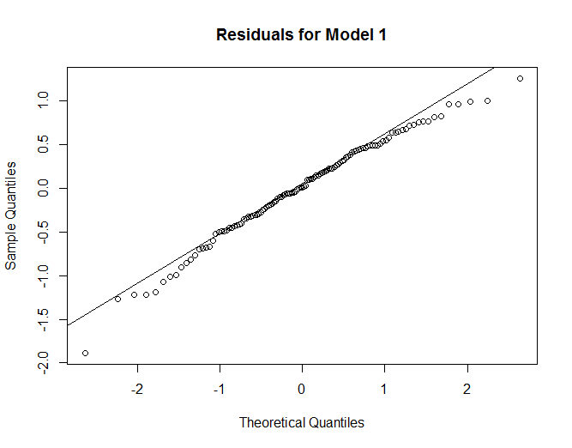

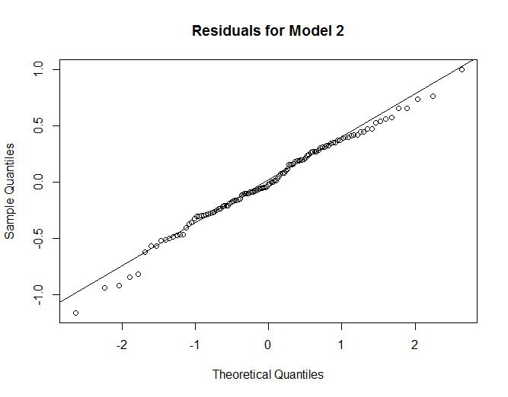

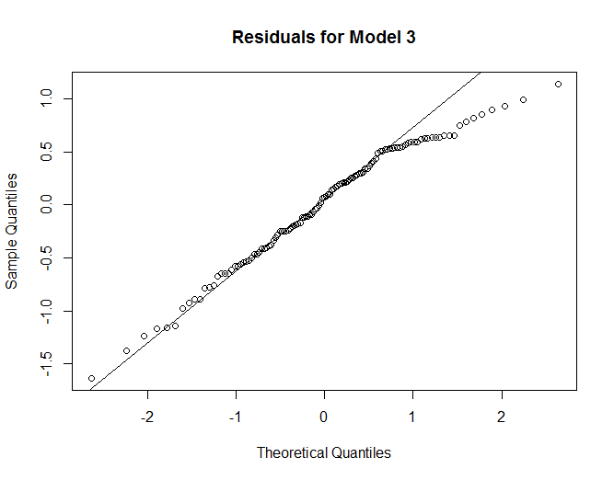

(f) Split the data set into two groups: students with ACT scores less than 26 and students with ACT scores at least 26. Run Levene's test for equality of variance of the residuals (leveneTest() requires the car package) on the response for these two groups. Remark on what you observe. The command subset() can be useful for splitting data sets. Cut data into two groups based on ACT Scores and then ran Levene’s test. A high p-value was observed, indicating we cannot (should not) reject the H0 that equal variance is present:

Levene's Test for Homogeneity of Variance (center = median)

Df F value Pr(>F)

group 1 0.1376 0.7114

(g) Repeat part (f) for the intelligence test score model, splitting at < 120 and 120. Do the residual variances for the two groups appear to differ? Partitioned data for Model 2 into two groups, <120 and 120>=. Performed a Levene’s test and the p-value was significant as shown below. The H0 would be that residual variances are equal and the HA is that we would reject H0. The significant p-value leads me to reject H0 in favor of HA:

Levene's Test for Homogeneity of Variance (center = median)

Df F value Pr(>F)

group 1 4.1622 0.04359 *

117

(g) plot the residuals vs. the predictor variable values to check for equality of variance. Constructed three scatter plots[1] to check for equality of variances in these three reduced models:

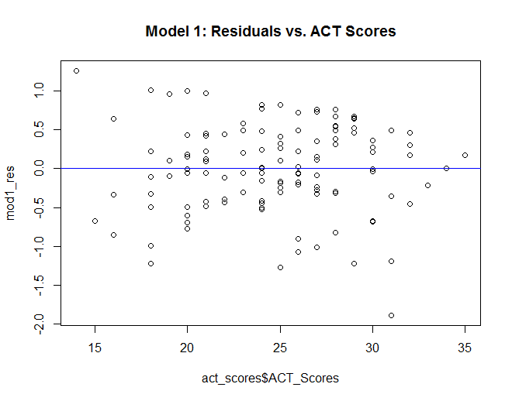

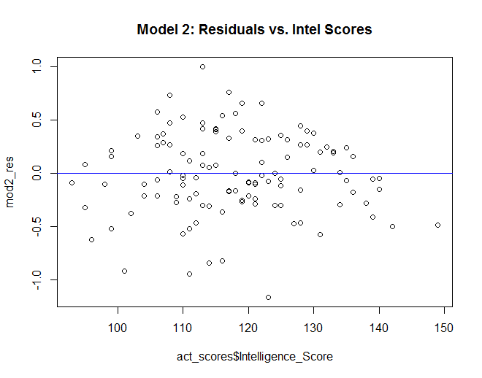

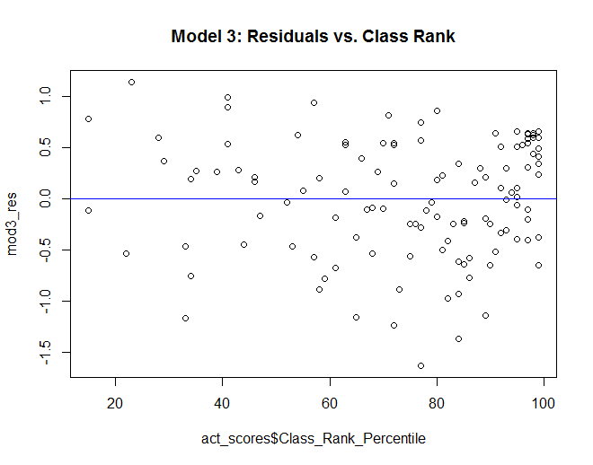

(h) Remark on which of the three explanatory variables seems to be the most useful in building a linear model for predicting first-year GPA. Residual plots for each of these models raise some concerns, prompting the need for either data transformations and/or perhaps curvilinear modeling. The residual plot for Model 1 shows the residuals appeargin “trend” down from the upper left quadrant to the lower right. The residual plot for Model 2 seems to show the residuals curving up from the left bottom, into the center, and then back down into the bottom right area of the graph. Residuals in Model 3 appear to have some tight clustering in the top right quadrant. I would recommend transforms, the inclusion of other variables, or non-linear models.

2. Adapted from ALSM 3.15. A chemist wanted to model the evolution of a solution concentration over time. To do this, she randomly assigned three solutions to measure after one hour, three solutions to measure after three hours, three to measure after five hours, three to measure after seven hours, and three to measure after nine hours. The data are in CH03PR15.

(a) Find the equation of the least-squares regression line. ŷ = 2.5753 + (-0.3240x)

(b) Run the F-test for lack of linear fit. Use the significance level α = 0.025. State your p-value and provide your conclusion. Utilized the anova() functionality in R on each of these 3 models. Low p-values would seem to indicate that we cannot reject H0 hypothesis that there is a linear fit for each of the three models. I would have to investigate, however, as to why findings in my residual plots seem to show some concerns as stated earlier.

Model 1:

Df Sum Sq Mean Sq F value Pr(>F)

act_scores$ACT_Scores 1 4.536 4.5364 14.2290 0.0002771 ***

Residuals 117 38.188 0.3264

Lack of fit 19 6.944 0.3655 1.1463 0.3195527

Pure Error 98 31.244 0.3188

---

Signif. codes: 0 ‘***’ 0.001 ‘**’ 0.01 ‘*’ 0.05 ‘.’ 0.1 ‘ ’ 1

Model 2:

Df Sum Sq Mean Sq F value Pr(>F)

act_scores$Intelligence_Score 1 25.4590 25.4590 195.4448 <2e-16 ***

Residuals 117 17.2651 0.1476

Lack of fit 43 7.6257 0.1773 1.3614 0.121

Pure Error 74 9.6394 0.1303

---

Signif. codes: 0 ‘***’ 0.001 ‘**’ 0.01 ‘*’ 0.05 ‘.’ 0.1 ‘ ’ 1

Model 3:

Df Sum Sq Mean Sq F value Pr(>F)

act_scores$Class_Rank_Percentile 1 4.135 4.1353 14.0469 0.0003938 ***

Residuals 117 38.589 0.3298

Lack of fit 55 20.336 0.3697 1.2559 0.1914652

Pure Error 62 18.253 0.2944

---

Signif. codes: 0 ‘***’ 0.001 ‘**’ 0.01 ‘*’ 0.05 ‘.’ 0.1 ‘ ’ 1

(c) When a lack-of-linear fit test indicates there is a lack of linear fit, does it suggest exactly what kind of function would be appropriate? Explain. The F-test does not specify which function would be appropriate per se, only that a linear one is not. It can, however, be used to explore other possibilities. Our text states, “The general linear test approach just explained can be used to test the appropriateness of other functions. Only the degrees of freedom for SSLF will need to be modified.”[2]

3. Adapted from ALSM 3.16. Use the data from the previous problem (CH03PR15).

(a) Make a scatterplot of the data, with concentration as the response variable. Based on the scatterplot, what kind of data transformation do you suggest to adjust for the non-constant variance and/or non-linearity?

Scatter plot constructed:

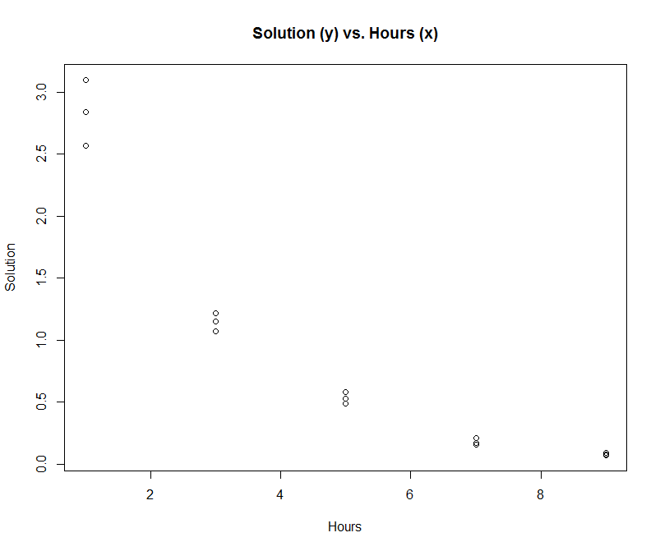

(b) Use the log-likelihood method in R we used for selecting the Box-Cox, and apply the transformation to the data. Then build a new regression model (using lm()) for the transformed data, make a fitted-line plot, and discuss how the new relationship compares with the old one.

Ran Box-Cox transformation (see R script in appendix [at the end of homework, not my intestinal track]) and fitted a new regression equation:

Coefficients:

Estimate Std. Error t value Pr(>|t|)

(Intercept) 1.0302214 0.0011764 875.73 < 2e-16 ***

chemistry$hours -0.0089532 0.0002048 -43.72 1.7e-15 ***

---

Signif. codes: 0 ‘***’ 0.001 ‘**’ 0.01 ‘*’ 0.05 ‘.’ 0.1 ‘ ’ 1

Residual standard error: 0.002243 on 13 degrees of freedom

Multiple R-squared: **0.9932**, Adjusted R-squared: 0.9927

F-statistic: 1911 on 1 and 13 DF, p-value: 1.701e-15

We see that this new transformed model takes on a very high R2 value of .99, making this a better-fitting model than with our non-transformed values earlier. A QQ plot below also shows a much better fit for the standardized residuals.

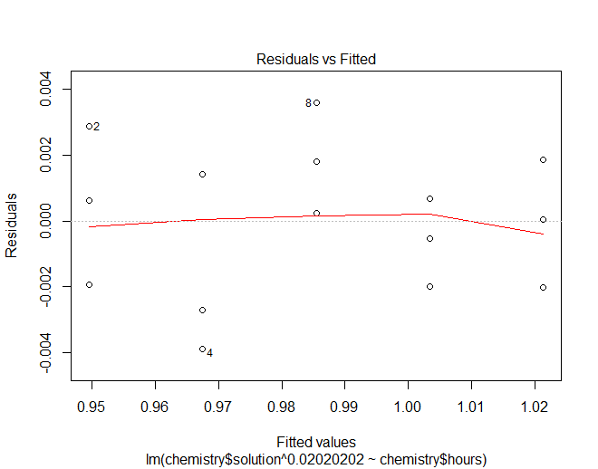

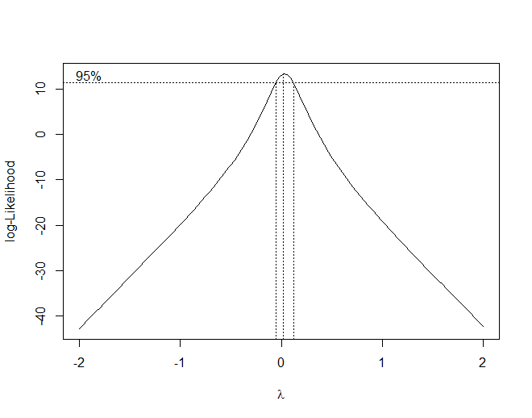

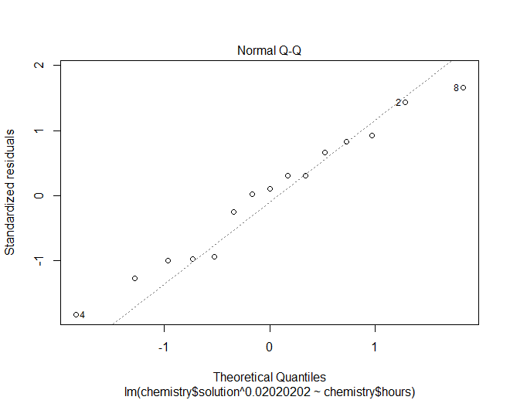

(c) Apply the log10 transformation and get the new regression line equation. Plot this model on a scatterplot of the transformed data. Compare the results of the Box-Cox transformation with those of the log10 transformation. Which do you like better and why?

Regressed on chemistry data transformed to log10:

Coefficients:

Estimate Std. Error t value Pr(>|t|)

(Intercept) 0.6022 0.1012 5.95 4.82e-05 ***

chemistry$hours_log10 -1.5532 0.1479 -10.50 1.02e-07 ***

---

Signif. codes: 0 ‘***’ 0.001 ‘**’ 0.01 ‘*’ 0.05 ‘.’ 0.1 ‘ ’ 1

Residual standard error: 0.1935 on 13 degrees of freedom

Multiple R-squared: **0.8945**, Adjusted R-squared: 0.8864

F-statistic: 110.3 on 1 and 13 DF, p-value: 1.017e-07

The Box-Cox transform results in a higher R2 value compared to our log10 transform. However, a scatter plot of the log10 transformed values shown below reveals that there remains a curvature to the data:

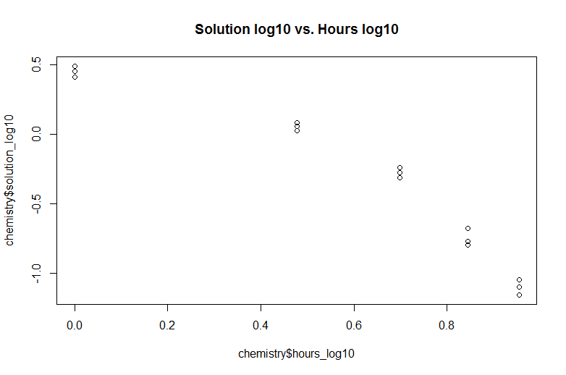

A scatter plot of the Box-Cox transformation shows a good linear fit:

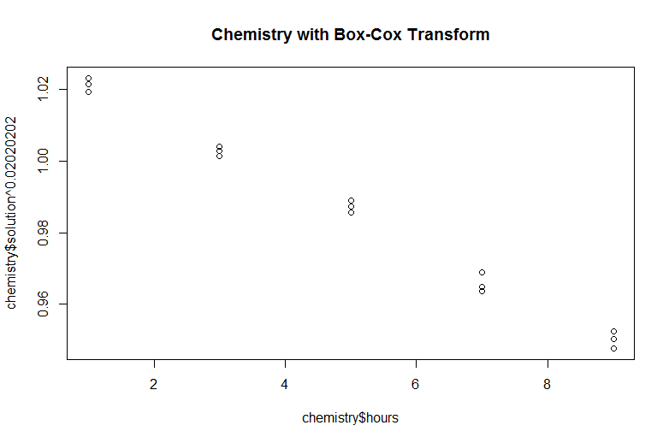

(d) Plot the residuals against the fitted values. Also make a normal probability plot. What do these plots indicate? These plots indicate that the residuals are fitted well, suggesting the Box-Cox transformation model fits the data well:

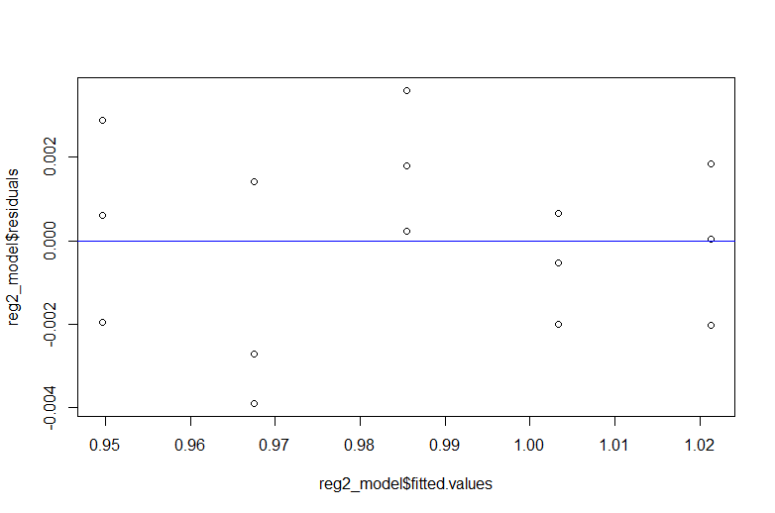

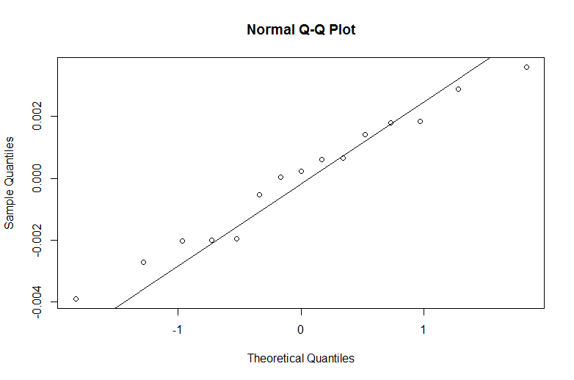

(e) Express your estimated regression functions in the original units. I am assuming that I am supposed to be converting back the transformed betas of the model I thought was the better of the two. In this case, I chose the Box-Cox model. Therefore, our y-intercept of would be expressed as 1.0302214^(1/.0202) = 4.366436 and our slope would be expressed as 0.0089532^(1/.0202) = -4.100024e-102

4. Adapted from ALSM 3.17. A marketing manager studied annual product sales figures over a ten year period. The data (years and sales in thousands of units) are in the file CH03PR17.

(a) Make a scatterplot. Is the linearity assumption reasonable? I am no Sir Ronald Fisher but I would tentatively conclude based on the scatter plot blow that there a linearity assumption between units (in thousands) and years is reasonable:

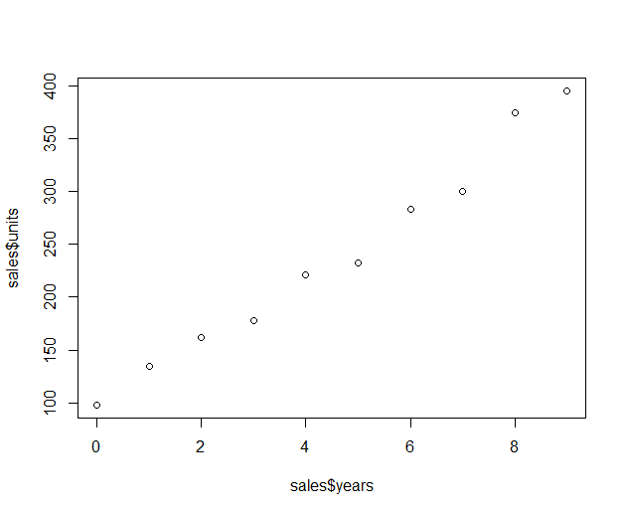

(b) Apply the maximum likelihood Box-Cox method (like we did in the Trees example) to get an appropriate power transformation of the response (sales). What is the value of SSE in this case? A regression model was generated on the Box-Cox transformed data, transformed at ^.050505:

Estimate Std. Error t value Pr(>|t|)

(Intercept) 10.50006 0.22092 47.53 4.25e-11 ***

boxcox_x 1.11723 0.04138 27.00 3.81e-09 ***

---

Signif. codes: 0 ‘***’ 0.001 ‘**’ 0.01 ‘*’ 0.05 ‘.’ 0.1 ‘ ’ 1

Residual standard error: 0.3759 on 8 degrees of freedom

Multiple R-squared: **0.9891**, Adjusted R-squared: 0.9878

F-statistic: 728.9 on 1 and 8 DF, p-value: 3.815e-09

Anova results showing the SSE:

Df Sum Sq Mean Sq F value Pr(>F)

boxcox_x 1 102.98 102.977 728.9 3.815e-09 ***

Residuals 8 1.13 0.141

---

Signif. codes: 0 ‘***’ 0.001 ‘**’ 0.01 ‘*’ 0.05 ‘.’ 0.1 ‘ ’ 1

(c) Try using the square-root transformation and get a new regression line.

Coefficients:

Estimate Std. Error t value Pr(>|t|)

(Intercept) 8.5410 0.7293 11.711 2.58e-06 ***

sales_years_sqr 3.3996 0.3438 9.888 9.23e-06 ***

---

Signif. codes: 0 ‘***’ 0.001 ‘**’ 0.01 ‘*’ 0.05 ‘.’ 0.1 ‘ ’ 1

Residual standard error: 0.9557 on 8 degrees of freedom

Multiple R-squared: **0.9244**, Adjusted R-squared: 0.9149

F-statistic: 97.78 on 1 and 8 DF, p-value: 9.229e-06

(d) Plot the regression line from the previous part on a scatterplot of the transformed data. Does this line seem to fit the transformed data well?

I would argue that the regression line does NOT fit that well: the line sits above the inside 7 points and below the outside 1 and 2, respectively. There seems to be a slight curvature to this data that a line does not fit:

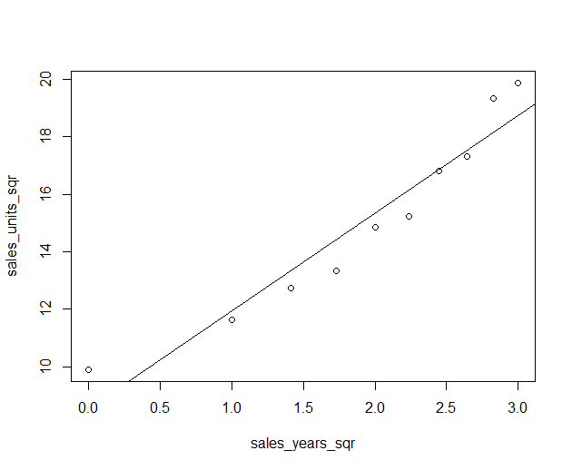

(e) Make a plot of the residuals vs. fits. Also make a normal probability plot. What do these plots indicate for your transformed data? These plots both confirm my suspicions about a curvature in the data points. (I love it when I’m right, which doesn’t happen often):

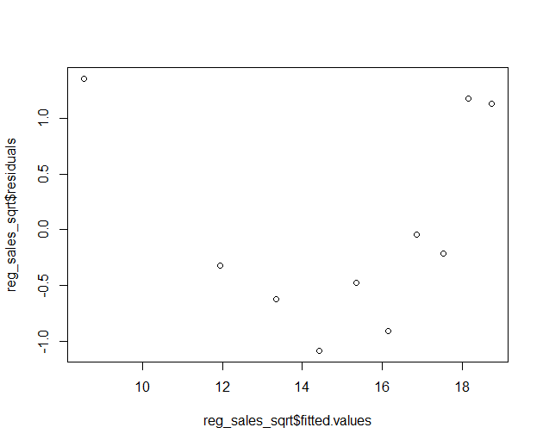

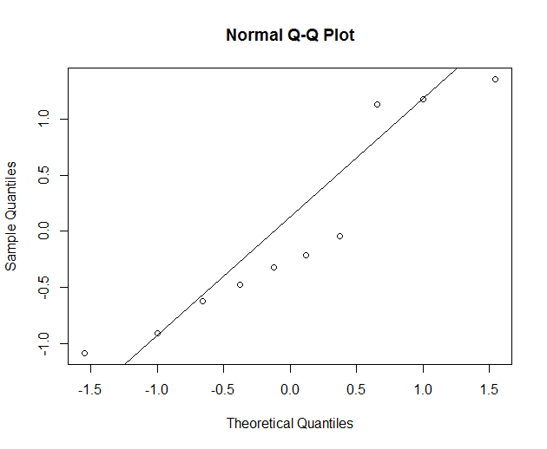

(f) Express the regression models in the original units. The y-intercept is 8.5410^2 = 72.94868 and the slope is 3.3996^2 = 11.55728

5. The Blaisdell Company wanted to use industry sales to predict its sales. Adjusted quarterly sales data for 1998 – 2002 are in the ALSM data set CH12TA02. The first column of data are observations of Blaisdell's sales, and the second column contain industry sales. The very first column, the one with the row numbers, is a time index: 1 means first quarter of 1998, 2 means 2nd quarter of 1998, etc.

(a) Make a scatter plot of company sales using industry sales as the predictor (with R of course). Describe the apparent relationship between the two variables. Loaded data for the Blaisdell Company per the text book, ch. 12, p. 489. Scatter plot constructed for a preliminary examination of the data:

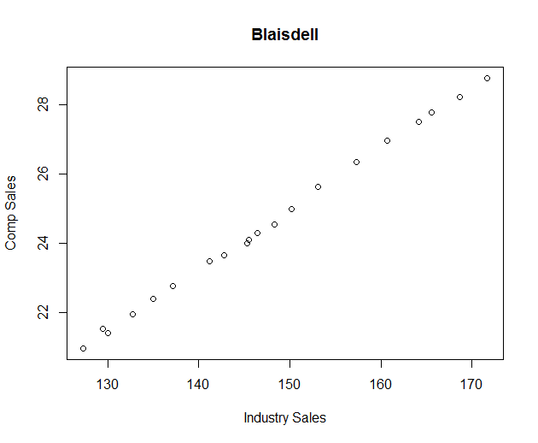

(b) Make a scatter plot of company sales versus the time index. You might have to create a new column for the time values or figure out how to reference the row numbers in R.

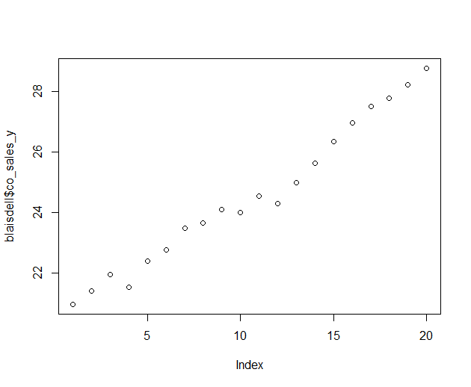

(c) Use R to run a Neumann-Durbin-Watson to check for autocorrelation of company sales over time:

H0 : = 0 The null hypothesis is that there is no autocorrelation

HA : 6 = 0 The alternative is that we reject the Null hypothesis

The Durbin-Watson test does show a relatively high degree of autocorrelation, as does our scatter above in subquestion b

lag Autocorrelation D-W Statistic p-value

1 0.6260046 0.7347256 0

Alternative hypothesis: rho != 0

(d) How would you suggest to proceed in modelling the relationship between these variables? A few remedial measures are possible,[3] including the addition of predictor variables and transformations. I would look for additional predictors first before transforming: if additional predictors are available, additional insights could be gained as opposed to performing data transforms alone which would not provide any insights.

6. Complete the following lack-of-fit ANOVA table:

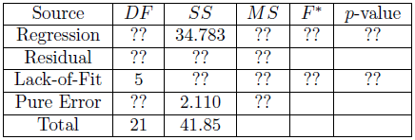

Table filled in:



APPENDIX: R SCRIPTS USED

**QUESTION 1:**

> library(xlsx)

> ch03pr03 <- read.xlsx("c:/Users/allen.baumgarten/Documents/CH03PR03.xlsx", sheetName = "Sheet1")

> ch03pr03_reg1 <- lm(ch03pr03[,1] ~ ch03pr03[,2])

> ch03pr03_reg2 <- lm(ch03pr03[,1] ~ ch03pr03[,3])

> ch03pr03_reg3 <- lm(ch03pr03[,1] ~ ch03pr03[,4])

> summary(ch03pr03_reg1 <- lm(ch03pr03[,1] ~ ch03pr03[,2]))

Call:

lm(formula = ch03pr03[, 1] ~ ch03pr03[, 2])

Residuals:

Min 1Q Median 3Q Max

-2.74004 -0.33827 0.04062 0.44064 1.22737

Coefficients:

Estimate Std. Error t value Pr(>|t|)

(Intercept) 2.11405 0.32089 6.588 1.3e-09 ***

ch03pr03[, 2] 0.03883 0.01277 3.040 0.00292 **

---

Signif. codes: 0 ‘***’ 0.001 ‘**’ 0.01 ‘*’ 0.05 ‘.’ 0.1 ‘ ’ 1

Residual standard error: 0.6231 on 118 degrees of freedom

Multiple R-squared: 0.07262, Adjusted R-squared: 0.06476

F-statistic: 9.24 on 1 and 118 DF, p-value: 0.002917

> summary(ch03pr03_reg2 <- lm(ch03pr03[,1] ~ ch03pr03[,3]))

Call:

lm(formula = ch03pr03[, 1] ~ ch03pr03[, 3])

Residuals:

Min 1Q Median 3Q Max

-1.1672 -0.2402 -0.0225 0.2977 1.0193

Coefficients:

Estimate Std. Error t value Pr(>|t|)

(Intercept) -1.873921 0.345709 -5.421 3.2e-07 ***

ch03pr03[, 3] 0.041944 0.002915 14.389 < 2e-16 ***

---

Signif. codes: 0 ‘***’ 0.001 ‘**’ 0.01 ‘*’ 0.05 ‘.’ 0.1 ‘ ’ 1

Residual standard error: 0.3899 on 118 degrees of freedom

Multiple R-squared: 0.637, Adjusted R-squared: 0.6339

F-statistic: 207 on 1 and 118 DF, p-value: < 2.2e-16

> summary(ch03pr03_reg3 <- lm(ch03pr03[,1] ~ ch03pr03[,4]))

Call:

lm(formula = ch03pr03[, 1] ~ ch03pr03[, 4])

Residuals:

Min 1Q Median 3Q Max

-1.94233 -0.40879 0.05516 0.48679 1.25950

Coefficients:

Estimate Std. Error t value Pr(>|t|)

(Intercept) 2.306901 0.185497 12.436 < 2e-16 ***

ch03pr03[, 4] 0.010417 0.002406 4.329 3.15e-05 ***

---

Signif. codes: 0 ‘***’ 0.001 ‘**’ 0.01 ‘*’ 0.05 ‘.’ 0.1 ‘ ’ 1

Residual standard error: 0.6011 on 118 degrees of freedom

Multiple R-squared: 0.1371, Adjusted R-squared: 0.1298

F-statistic: 18.74 on 1 and 118 DF, p-value: 3.153e-05

> plot(ch03pr03[,1] ~ ch03pr03[,2], main = "GPA vs. ACT Score", xlab="ACT Score", ylab="GPA")

> abline(ch03pr03_reg1, col="blue")

> plot(ch03pr03[,1] ~ ch03pr03[,3], main = "GPA vs. Intelligence Score", xlab="Intelligence Score", ylab="GPA")

> abline(ch03pr03_reg2, col="blue")

> plot(ch03pr03[,1] ~ ch03pr03[,4], main = "GPA vs. Class Rank %ile", xlab="Class Rank %ile", ylab="GPA")

> abline(ch03pr03_reg3, col="blue")

> nrow(ch03pr03)

[1] 120

> act_scores <- ch03pr03[-9,]

> nrow(act_scores)

[1] 119

####### 3 new reduced models are now built:

> summary(reg_mod1_gpa_act <- lm(act_scores$GPA ~ act_scores$ACT_Scores))

Call:

lm(formula = act_scores$GPA ~ act_scores$ACT_Scores)

Residuals:

Min 1Q Median 3Q Max

-1.88628 -0.33291 0.00723 0.43701 1.25781

Coefficients:

Estimate Std. Error t value Pr(>|t|)

(Intercept) 2.01358 0.29494 6.827 4.09e-10 ***

act_scores$ACT_Scores 0.04383 0.01176 3.728 0.000299 ***

---

Signif. codes: 0 ‘***’ 0.001 ‘**’ 0.01 ‘*’ 0.05 ‘.’ 0.1 ‘ ’ 1

Residual standard error: 0.5713 on 117 degrees of freedom

Multiple R-squared: 0.1062, Adjusted R-squared: 0.09854

F-statistic: 13.9 on 1 and 117 DF, p-value: 0.0002988

> summary(reg_mod2_gpa_intel <- lm(act_scores$GPA ~ act_scores$Intelligence_Score))

Call:

lm(formula = act_scores$GPA ~ act_scores$Intelligence_Score)

Residuals:

Min 1Q Median 3Q Max

-1.16390 -0.23990 -0.02005 0.27788 1.00167

Coefficients:

Estimate Std. Error t value Pr(>|t|)

(Intercept) -1.620511 0.360779 -4.492 1.67e-05 ***

act_scores$Intelligence_Score 0.039857 0.003034 13.135 < 2e-16 ***

---

Signif. codes: 0 ‘***’ 0.001 ‘**’ 0.01 ‘*’ 0.05 ‘.’ 0.1 ‘ ’ 1

Residual standard error: 0.3841 on 117 degrees of freedom

Multiple R-squared: 0.5959, Adjusted R-squared: 0.5924

F-statistic: 172.5 on 1 and 117 DF, p-value: < 2.2e-16

> summary(reg_mod3_gpa_class <- lm(act_scores$GPA ~ act_scores$Class_Rank_Percentile))

Call:

lm(formula = act_scores$GPA ~ act_scores$Class_Rank_Percentile)

Residuals:

Min 1Q Median 3Q Max

-1.63359 -0.40407 0.06992 0.51362 1.13967

Coefficients:

Estimate Std. Error t value Pr(>|t|)

(Intercept) 2.473276 0.183488 13.479 < 2e-16 ***

act_scores$Class_Rank_Percentile 0.008394 0.002370 3.541 0.000573 ***

---

Signif. codes: 0 ‘***’ 0.001 ‘**’ 0.01 ‘*’ 0.05 ‘.’ 0.1 ‘ ’ 1

Residual standard error: 0.5743 on 117 degrees of freedom

Multiple R-squared: 0.09679, Adjusted R-squared: 0.08907

F-statistic: 12.54 on 1 and 117 DF, p-value: 0.0005734

> mod1_res <- reg_mod1_gpa_act$residuals

> mod2_res <- reg_mod2_gpa_intel$residuals

> mod3_res <- reg_mod3_gpa_class$residuals

> shapiro.test(mod1_res)

Shapiro-Wilk normality test

data: mod1_res

W = 0.98454, p-value = 0.191

> shapiro.test(mod2_res)

Shapiro-Wilk normality test

data: mod2_res

W = 0.98973, p-value = 0.5172

> shapiro.test(mod3_res)

Shapiro-Wilk normality test

data: mod3_res

W = 0.97492, p-value = 0.02517

> qqnorm(mod1_res, main="Residuals for Model 1")

> qqline(mod1_res)

> qqnorm(mod2_res, main="Residuals for Model 2")

> qqline(mod2_res)

> qqnorm(mod3_res, main="Residuals for Model 3")

> qqline(mod3_res)

####### Cut data into 2 groups at less than 26 and 26 or greater:

> library(car)

> act_scores_26_cut <- cut(act_scores$ACT_Scores, c(-Inf,25.999,Inf), labels = c("<26","26>="))

> act_scores_26 <- cbind(act_scores,act_scores_26_cut)

> head(act_scores_26)

GPA ACT_Scores Intelligence_Score Class_Rank_Percentile act_scores_26_cut

1 3.897 21 122 99 <26

2 3.885 14 132 71 <26

3 3.778 28 119 95 26>=

4 2.540 22 99 75 <26

5 3.028 21 131 46 <26

6 3.865 31 139 77 26>=

> leveneTest(reg_mod1_gpa_act$residuals ~ act_scores_26$act_scores_26_cut)

Levene's Test for Homogeneity of Variance (center = median)

Df F value Pr(>F)

group 1 0.1376 0.7114

117

> act_scores_120_cut <- cut(act_scores$Intelligence_Score, c(-Inf,119.999,Inf), labels = c("<120","120>="))

> act_scores_120 <- cbind(act_scores,act_scores_120_cut)

> head(act_scores_120)

GPA ACT_Scores Intelligence_Score Class_Rank_Percentile act_scores_120_cut

1 3.897 21 122 99 120>=

2 3.885 14 132 71 120>=

3 3.778 28 119 95 <120

4 2.540 22 99 75 <120

5 3.028 21 131 46 120>=

6 3.865 31 139 77 120>=

> leveneTest(reg_mod2_gpa_intel$residuals ~ act_scores_120$act_scores_120_cut)

Levene's Test for Homogeneity of Variance (center = median)

Df F value Pr(>F)

group 1 4.1622 0.04359 *

117

---

Signif. codes: 0 ‘***’ 0.001 ‘**’ 0.01 ‘*’ 0.05 ‘.’ 0.1 ‘ ’ 1

**QUESTION 2:**

> solution <- c(.07, .09, .08, .16, .17, .21, .49, .58, .53, 1.22, 1.15, 1.07, 2.84, 2.57, 3.10)

> hours <- c(9, 9, 9, 7, 7, 7, 5, 5, 5, 3, 3, 3, 1, 1, 1)

> chemistry <- data.frame(solution,hours)

> chemistry

solution hours

1 0.07 9

2 0.09 9

3 0.08 9

4 0.16 7

5 0.17 7

6 0.21 7

7 0.49 5

8 0.58 5

9 0.53 5

10 1.22 3

11 1.15 3

12 1.07 3

13 2.84 1

14 2.57 1

15 3.10 1

> reg_chemistry <- lm(chemistry$solution ~ chemistry$hours)

> summary(reg_chemistry)

Call:

lm(formula = chemistry$solution ~ chemistry$hours)

Residuals:

Min 1Q Median 3Q Max

-0.5333 -0.4043 -0.1373 0.4157 0.8487

Coefficients:

Estimate Std. Error t value Pr(>|t|)

(Intercept) 2.5753 0.2487 10.354 1.20e-07 ***

chemistry$hours -0.3240 0.0433 -7.483 4.61e-06 ***

---

Signif. codes: 0 ‘***’ 0.001 ‘**’ 0.01 ‘*’ 0.05 ‘.’ 0.1 ‘ ’ 1

Residual standard error: 0.4743 on 13 degrees of freedom

Multiple R-squared: 0.8116, Adjusted R-squared: 0.7971

F-statistic: 55.99 on 1 and 13 DF, p-value: 4.611e-06

> install.packages("alr3")

> library(alr3)

> pureErrorAnova(reg_mod1_gpa_act)

Analysis of Variance Table

Response: act_scores$GPA

Df Sum Sq Mean Sq F value Pr(>F)

act_scores$ACT_Scores 1 4.536 4.5364 14.2290 0.0002771 ***

Residuals 117 38.188 0.3264

Lack of fit 19 6.944 0.3655 1.1463 0.3195527

Pure Error 98 31.244 0.3188

---

Signif. codes: 0 ‘***’ 0.001 ‘**’ 0.01 ‘*’ 0.05 ‘.’ 0.1 ‘ ’ 1

> pureErrorAnova(reg_mod2_gpa_intel)

Analysis of Variance Table

Response: act_scores$GPA

Df Sum Sq Mean Sq F value Pr(>F)

act_scores$Intelligence_Score 1 25.4590 25.4590 195.4448 <2e-16 ***

Residuals 117 17.2651 0.1476

Lack of fit 43 7.6257 0.1773 1.3614 0.121

Pure Error 74 9.6394 0.1303

---

Signif. codes: 0 ‘***’ 0.001 ‘**’ 0.01 ‘*’ 0.05 ‘.’ 0.1 ‘ ’ 1

> pureErrorAnova(reg_mod3_gpa_class)

Analysis of Variance Table

Response: act_scores$GPA

Df Sum Sq Mean Sq F value Pr(>F)

act_scores$Class_Rank_Percentile 1 4.135 4.1353 14.0469 0.0003938 ***

Residuals 117 38.589 0.3298

Lack of fit 55 20.336 0.3697 1.2559 0.1914652

Pure Error 62 18.253 0.2944

---

Signif. codes: 0 ‘***’ 0.001 ‘**’ 0.01 ‘*’ 0.05 ‘.’ 0.1 ‘ ’ 1

**QUESTION 3:**

> plot(chemistry$solution ~ chemistry$hours, main="Solution (y) vs. Hours (x)", xlab="Hours",ylab="Solution")

> library(MASS)

> trans <- boxcox(chemistry$solution ~ chemistry$hours)



> lambda <- trans$x

> loglh <- trans$y

> boxcox <- cbind(lambda, loglh)

> boxcox[order(-loglh),] # Using log-likelihood to optimize lambda

lambda loglh

[1,] 0.02020202 13.4557358

[2,] 0.06060606 13.2665123

> reg2_model <- lm(chemistry$solution^0.02020202 ~ chemistry$hours)

> summary(reg2_model)

Call:

lm(formula = chemistry$solution^0.02020202 ~ chemistry$hours)

Residuals:

Min 1Q Median 3Q Max

-0.0038939 -0.0019707 0.0002368 0.0016077 0.0036004

Coefficients:

Estimate Std. Error t value Pr(>|t|)

(Intercept) 1.0302214 0.0011764 875.73 < 2e-16 ***

chemistry$hours -0.0089532 0.0002048 -43.72 1.7e-15 ***

---

Signif. codes: 0 ‘***’ 0.001 ‘**’ 0.01 ‘*’ 0.05 ‘.’ 0.1 ‘ ’ 1

Residual standard error: 0.002243 on 13 degrees of freedom

Multiple R-squared: 0.9932, Adjusted R-squared: 0.9927

F-statistic: 1911 on 1 and 13 DF, p-value: 1.701e-15

> plot(reg2_model)

Hit <Return> to see next plot:





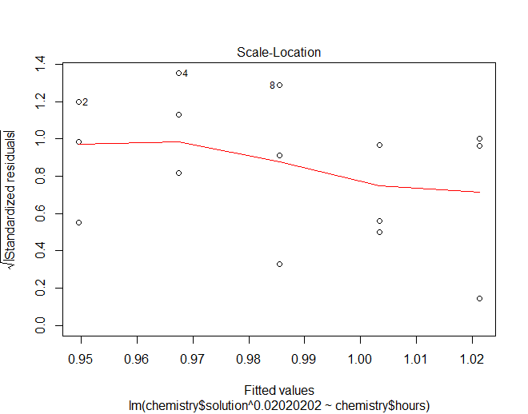

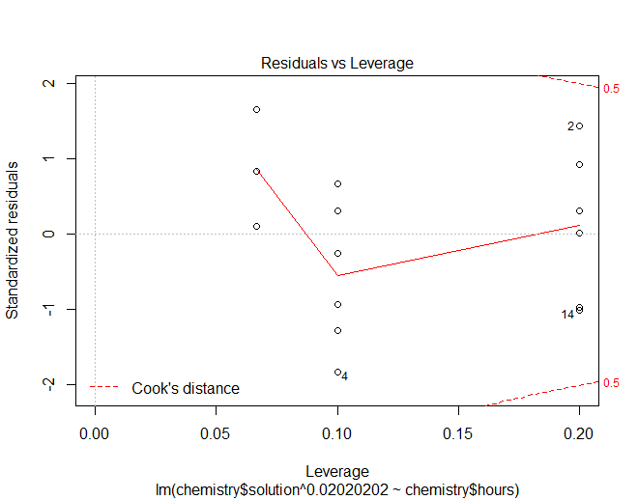

> chemistry$solution_log10 <- log10(chemistry$solution)

> chemistry$hours_log10 <- log10(chemistry$hours)

> summary(reg_chemistry_log10 <- lm(chemistry$solution_log10 ~ chemistry$hours_log10))

Call:

lm(formula = chemistry$solution_log10 ~ chemistry$hours_log10)

Residuals:

Min 1Q Median 3Q Max

-0.27494 -0.15732 -0.05912 0.18663 0.24690

Coefficients:

Estimate Std. Error t value Pr(>|t|)

(Intercept) 0.6022 0.1012 5.95 4.82e-05 ***

chemistry$hours_log10 -1.5532 0.1479 -10.50 1.02e-07 ***

---

Signif. codes: 0 ‘***’ 0.001 ‘**’ 0.01 ‘*’ 0.05 ‘.’ 0.1 ‘ ’ 1

Residual standard error: 0.1935 on 13 degrees of freedom

Multiple R-squared: 0.8945, Adjusted R-squared: 0.8864

F-statistic: 110.3 on 1 and 13 DF, p-value: 1.017e-07

> plot(reg2_model$residuals ~ reg2_model$fitted.values)

> qqnorm(reg2_model$residuals)

> qqline(reg2_model$residuals)

> plot(chemistry$solution_log10 ~ chemistry$hours_log10, main="Solution log10 vs. Hours log10")

> plot(chemistry$solution^0.02020202 ~ chemistry$hours, main="Chemistry with Box-Cox Transform")

> 1.0302214^(1/.0202)

[1] 4.366436

> -0.0089532^(1/.0202)

[1] -4.100024e-102

**QUESTION 4:**

> sales <- read.xlsx("C:/Users/allen.baumgarten/Documents/CH03PR17.xlsx",sheetName = "Sheet1")

> sales

units years

1 98 0

2 135 1

3 162 2

4 178 3

5 221 4

6 232 5

7 283 6

8 300 7

9 374 8

10 395 9

> plot(sales$units ~ sales$years)

> library(MASS)

> boxcox_data <- sales

> boxcox_y <- sales$units

> boxcox_x <- sales$years

> trans <- boxcox(boxcox_y ~ boxcox_x )

> lambda <- trans$x

> loglh <- trans$y

> boxcox <- cbind(lambda, loglh)

> boxcox[order(-loglh),] # Using log-likelihood to optimize lambda

> lambda_value <- 0.50505051 # input the minimizing x value that maximizes y

> boxcox_reg_model <- lm(dataset$y_variable^lambda_value ~ dataset$x_variable)

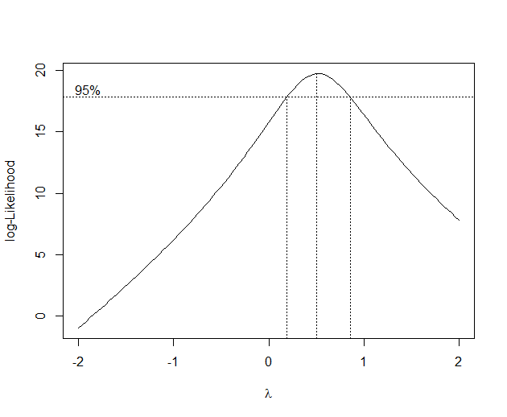

> boxcox_reg_model <- lm(boxcox_y^lambda_value ~ boxcox_x)

> summary(boxcox_reg_model)

Call:

lm(formula = boxcox_y^lambda_value ~ boxcox_x)

Residuals:

Min 1Q Median 3Q Max

-0.49396 -0.31557 0.01724 0.30425 0.48855

Coefficients:

Estimate Std. Error t value Pr(>|t|)

(Intercept) 10.50006 0.22092 47.53 4.25e-11 ***

boxcox_x 1.11723 0.04138 27.00 3.81e-09 ***

---

Signif. codes: 0 ‘***’ 0.001 ‘**’ 0.01 ‘*’ 0.05 ‘.’ 0.1 ‘ ’ 1

Residual standard error: 0.3759 on 8 degrees of freedom

Multiple R-squared: 0.9891, Adjusted R-squared: 0.9878

F-statistic: 728.9 on 1 and 8 DF, p-value: 3.815e-09

> pureErrorAnova(boxcox_reg_model)

Analysis of Variance Table

Response: boxcox_y^lambda_value

Df Sum Sq Mean Sq F value Pr(>F)

boxcox_x 1 102.98 102.977 728.9 3.815e-09 ***

Residuals 8 1.13 0.141

---

Signif. codes: 0 ‘***’ 0.001 ‘**’ 0.01 ‘*’ 0.05 ‘.’ 0.1 ‘ ’ 1

> sales_units_sqr <- sqrt(sales$units)

> sales_years_sqr <- sqrt(sales$years)

> summary(reg_sales_sqrt <- lm(sales_units_sqr ~ sales_years_sqr))

Call:

lm(formula = sales_units_sqr ~ sales_years_sqr)

Residuals:

Min 1Q Median 3Q Max

-1.0876 -0.5841 -0.2683 0.8397 1.3585

Coefficients:

Estimate Std. Error t value Pr(>|t|)

(Intercept) 8.5410 0.7293 11.711 2.58e-06 ***

sales_years_sqr 3.3996 0.3438 9.888 9.23e-06 ***

---

Signif. codes: 0 ‘***’ 0.001 ‘**’ 0.01 ‘*’ 0.05 ‘.’ 0.1 ‘ ’ 1

Residual standard error: 0.9557 on 8 degrees of freedom

Multiple R-squared: 0.9244, Adjusted R-squared: 0.9149

F-statistic: 97.78 on 1 and 8 DF, p-value: 9.229e-06

> plot(sales_units_sqr ~ sales_years_sqr)

> abline(reg_sales_sqrt)

> plot(reg_sales_sqrt$residuals ~ reg_sales_sqrt$fitted.values)

**QUESTION 5:**

> blaisdell <- read.xlsx("c:/Users/allen.baumgarten/Documents/CH12TA02.xlsx", sheetName = "Sheet1")

> blaisdell

co_sales_y ind_sales_x

1 20.96 127.3

2 21.40 130.0

3 21.96 132.7

4 21.52 129.4

5 22.39 135.0

6 22.76 137.1

7 23.48 141.2

8 23.66 142.8

9 24.10 145.5

10 24.01 145.3

11 24.54 148.3

12 24.30 146.4

13 25.00 150.2

14 25.64 153.1

15 26.36 157.3

16 26.98 160.7

17 27.52 164.2

18 27.78 165.6

19 28.24 168.7

20 28.78 171.7

> plot(blaisdell$co_sales_y ~ blaisdell$ind_sales_x, main="Blaisdell",ylab="Comp Sales",xlab="Industry Sales")

> plot(blaisdell$co_sales_y)

> summary(reg_blaisdell <- lm(blaisdell$co_sales_y ~ blaisdell$ind_sales_x))

Call:

lm(formula = blaisdell$co_sales_y ~ blaisdell$ind_sales_x)

Residuals:

Min 1Q Median 3Q Max

-0.149142 -0.054399 -0.000454 0.046425 0.163754

Coefficients:

Estimate Std. Error t value Pr(>|t|)

(Intercept) -1.454750 0.214146 -6.793 2.31e-06 ***

blaisdell$ind_sales_x 0.176283 0.001445 122.017 < 2e-16 ***

---

Signif. codes: 0 ‘***’ 0.001 ‘**’ 0.01 ‘*’ 0.05 ‘.’ 0.1 ‘ ’ 1

Residual standard error: 0.08606 on 18 degrees of freedom

Multiple R-squared: 0.9988, Adjusted R-squared: 0.9987

F-statistic: 1.489e+04 on 1 and 18 DF, p-value: < 2.2e-16

> library(car)

> durbinWatsonTest(reg_blaisdell)

lag Autocorrelation D-W Statistic p-value

1 0.6260046 0.7347256 0

Alternative hypothesis: rho != 0

1. All of which resembled probabilities of the Miami Dolphins’ wins/losses these past few decades (sorry).
2. Kutner, Michael H., Christopher J. Nachtsheim, John Neter, and William Li, *Applied Linear Statistical Models*, 5th ed., (McGraw Hill Education (India) Edition, 2013), 127.
3. Ibid., 490ff.