**Homework Week 4, STAT5120**

**Allen Baumgarten (Miami Heat Fan)**

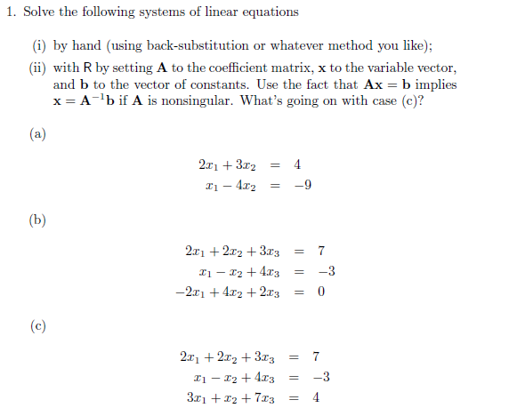

By hand:

Solve for X2 first 2X1 + 3X2 = 4

2(4X1 -9) +3X2 = 4

8X2 -18 +3X2 = 4

11X2 -18 = 4

11X2 = 22

11X2/11 = 22/11

X2 = 2

Solve for X1 next X1 – 4X2 = -9

X1 – 4(2) = -9

X1 = -9 + 8

X1 = 1

Coordinates for these two equations are (X1, X2) = (1,2)





Answer: tbd…

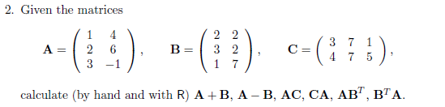

Answer: tbd…

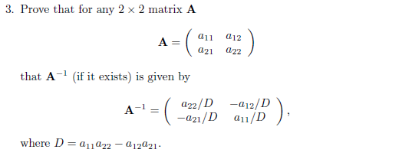

Answer: tbd…

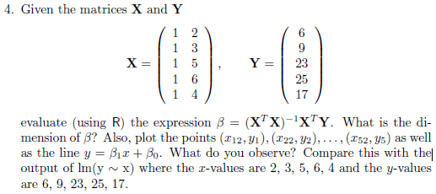

Answer: tbd…

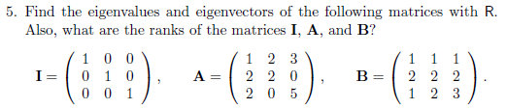

Answer: tbd…

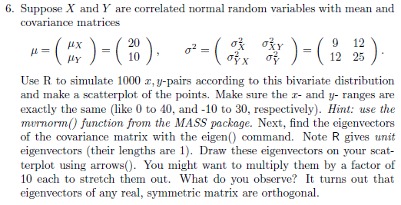

Answer: tbd…

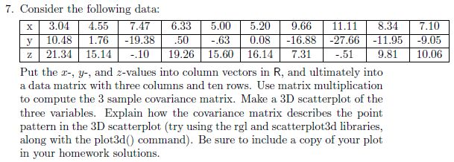

Answer: tbd…

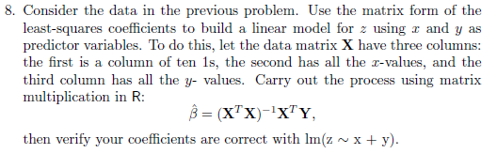

Answer: tbd…

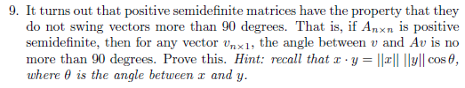

Answer: tbd…



Answer: tbd…

APPENDIX: R SCRIPTS USED