**STAT5120, Assignment 13, Allen Baumgarten (NOT an FSU fan)**

**Brief Description of the Data:**

The *infmort* dataset in the Faraway package contains four variables documenting infant mortalities (presumably counts of mortalities?) in five different major regions of the world. Per-capita income and oil exportation are two of these variables that may be related to infant mortality, or at least associated with it.

Our task will be to see if, at minimum, there is a statistically significant association between *region*, *oil* (export), and *income* with the counts of infant *mortalities* and if so, can the changes in these three variables be said to in some way ‘explain’ or ‘be associated with’ the increase(decrease) in infant mortalities. We must be cautious in assuming that any of these three variables explain what causes infant mortalities though it is a good bet that income levels would be associated with mortalities. Regions may also be associated with infant mortality as well if certain regions can be said to have more internal conflict or economic hardship than others, though again, this data may be too high of a level to make any strong inferences.

We will begin with a summary examination of the data itself by looking at univariate and bivariate relationships, both mathematically and graphically.

**Exploratory Data Analysis**

Statistical Summary

A statistical summary of the four *regions* reveals that Africa accounts for the most observations with Asia coming in with the second-most. The per-capita income levels are skewed to the right with a few regions with very high income such as the United States, Sweden, Denmark, and Germany. Thus, our *income* variable is decidedly skewed to the right. Moreover, the Americas, Asia, and Africa regions all seem to have similar income levels while Europe appears to have more varied income levels (see boxplot following).

Infant *mortalities* are also skewed with a median mortality (rate?) of 60.6 and a maximum of 650 in Saudi Arabia. This distribution is also skewed right with a couple of outliers to consider.

Bivariate relationships are also examined between income and mortality, respectively. A scatter plot of all mortalities vs. income shows clustering at the lower income levels and trails off to the right wit increases. At first glance, we do not appear to see a ‘clean’ straight (linear) relationship between these two numeric variables.

**region** **income** **mortality** **oil**

Africa: 34 Min.: 50.0 Min.: 9.60 oil exports: 9

Europe: 18 1st Qu.: 123.0 1st Qu.: 26.20 no oil exports: 96

Asia: 30 Median: 334.0 Median: 60.60

Americas: 23 Mean: 998.1 Mean: 89.05

3rd Qu.: 1191.0 3rd Qu.: 129.40

Max: 5596.0 Max.: 650.00

NA's: 4

Graphical Examination

A graphical examination of the data looked at per-capita income levels in total and by region.

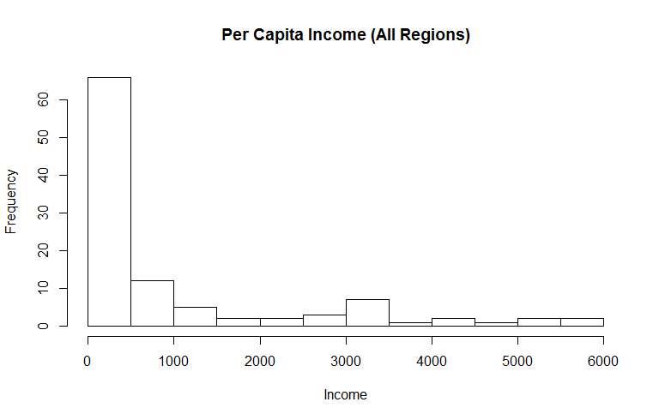

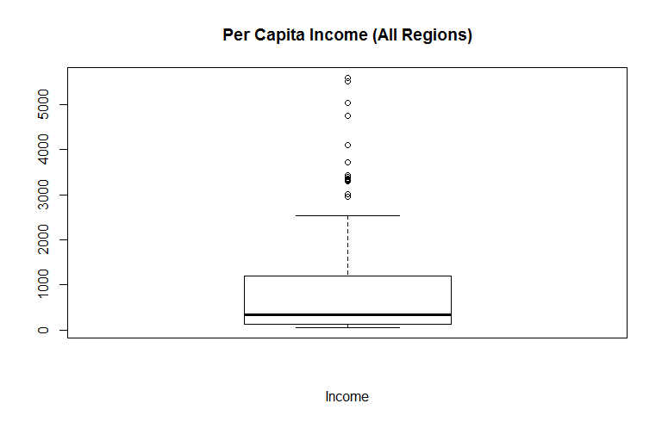

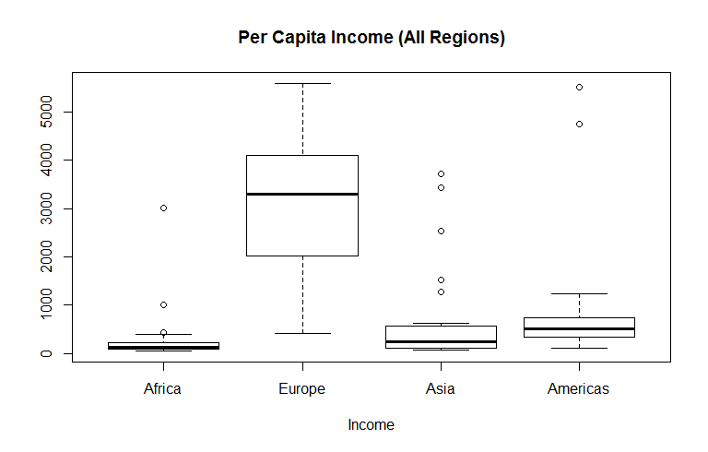

Infant mortality graphics:

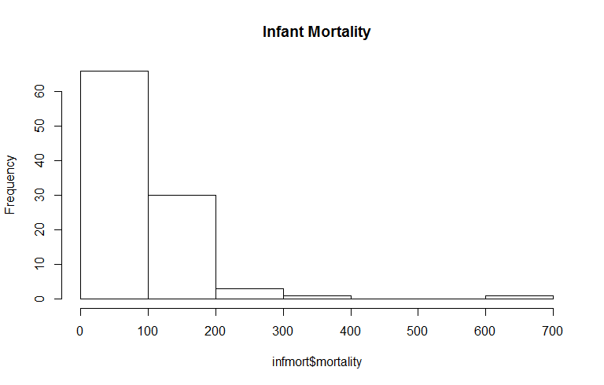

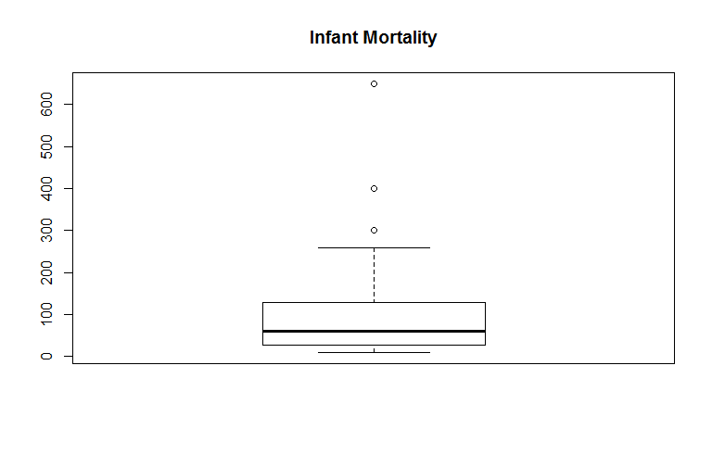

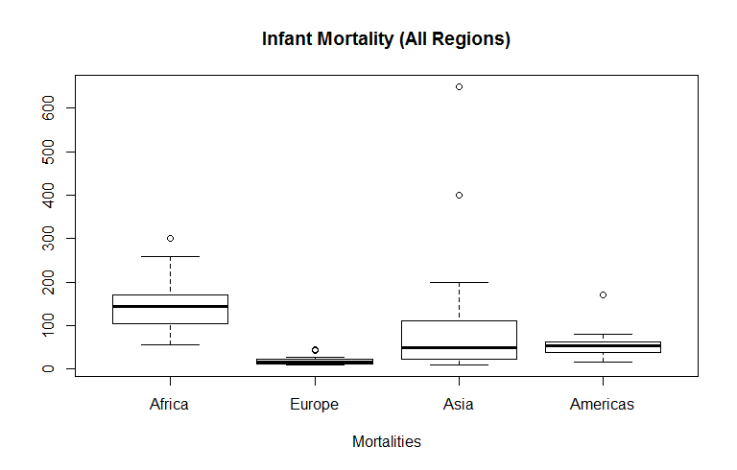

Bivariate graphics:

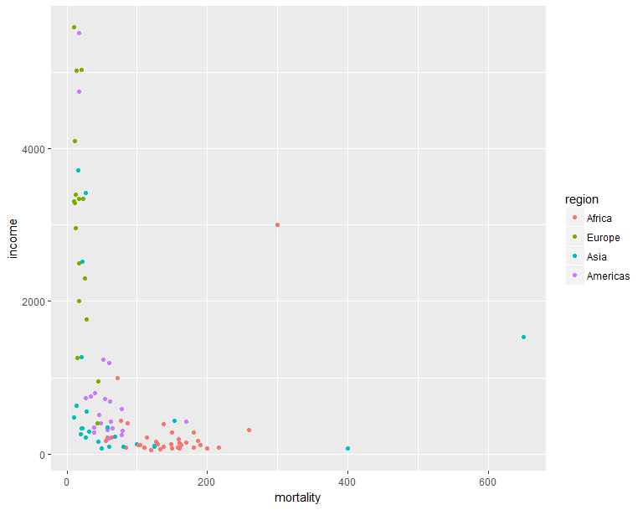

Potential outliers were removed through sub-setting (see R script) for the purpose of examining a better fit:

Libya Africa 3010 300.0 oil exports (row 26)

Saudi_Arabia Asia 1530 650.0 oil exports (row 28)

Afganistan Asia 75 400.0 no oil exports

This subset is shown below. We see that despite removing these three “outliers,” these two variables still appear to be non-linear:

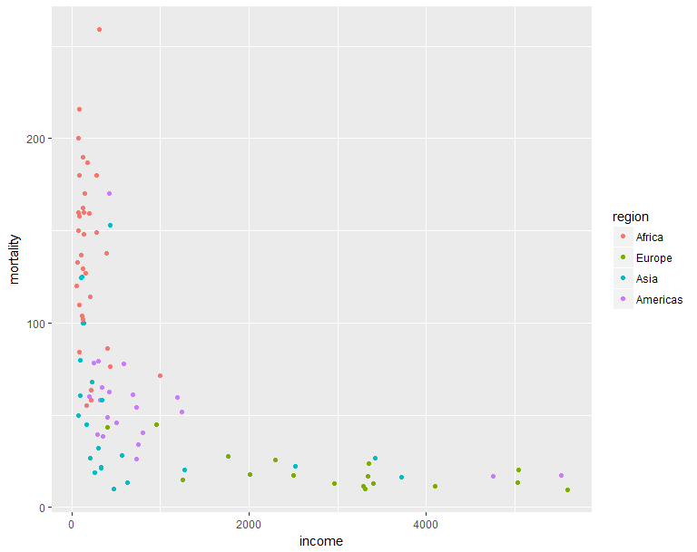

Taking the same reduced set and passing least squares lines through the data according which of the four regions they belong to was done to examine linear relationship. It would appear that Africa shows mortality almost “vertically” related to income with the exception of one additional “outlier,” viz., Africa, row 16:

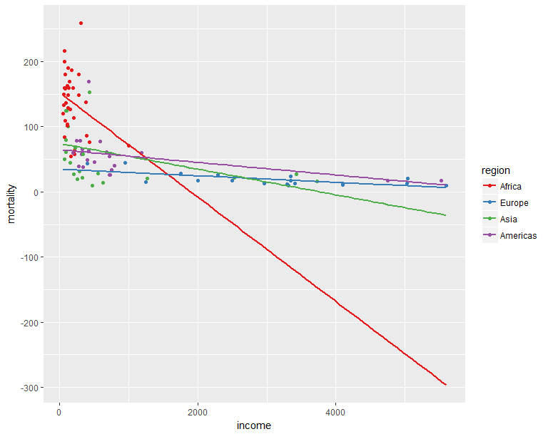

A reduced dataset was produced to examine the relationship of these two variables by removing row 16. These points with least squares fits are shown below:

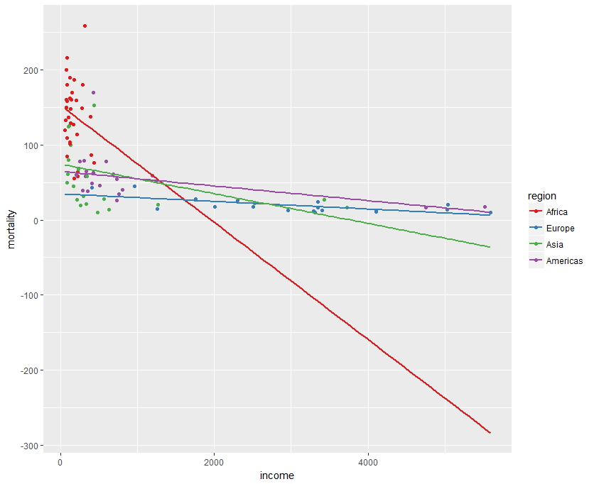

We see, finally, by examining mortality per the *oil* category, there appears to be much more variation in *mortality* in region with no oil exports:

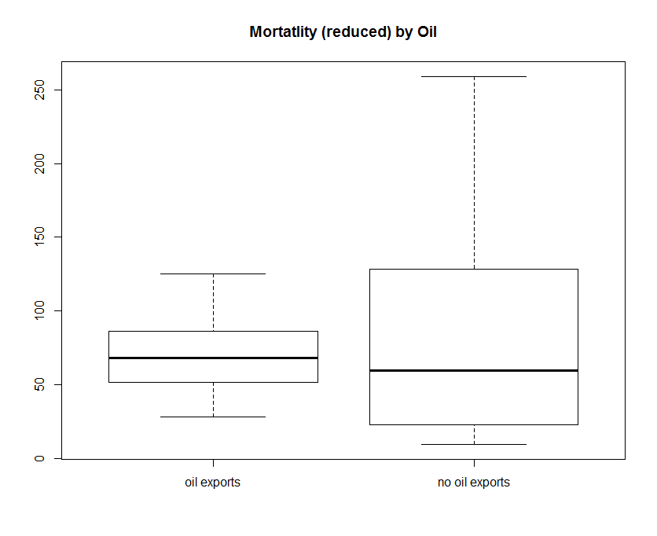

We examine also the spread of mortality by region with our reduced dataset and see that variation has been brought down some:

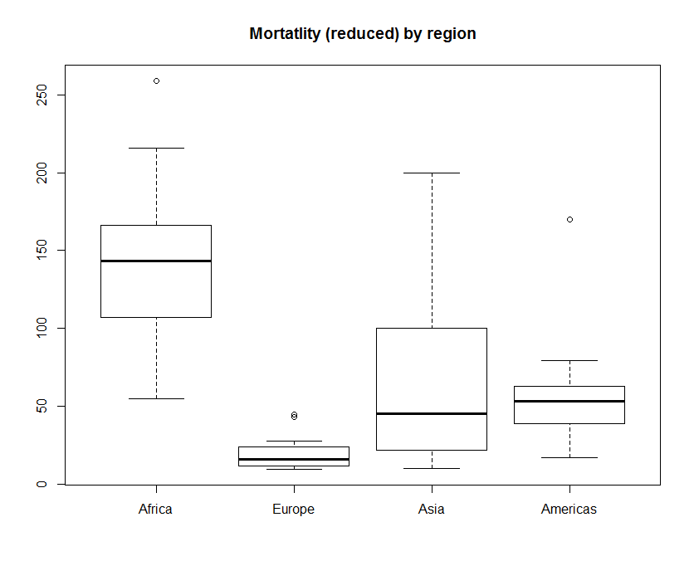

Having removed outliers to achieve a tighter set of representative observations, we fit a glm to investigate the effects of categories. We will use a backward-elimination approach by starting with all variables and then reducing them if necessary.

Our first blush at a model suggests that the *region* and *income* variables are significant while, perhaps surprisingly given the boxplot, the *oil* variable is not.

Deviance Residuals:

Min 1Q Median 3Q Max

-85.596 -23.411 -4.787 16.485 130.515

Coefficients:

Estimate Std. Error t value Pr(>|t|)

(Intercept) 125.414934 17.211361 7.287 1.12e-10 ***

infmort_reduced2$income -0.010945 0.003938 -2.779 **0.00662** **

infmort_reduced2$regionEurope -89.913820 16.241657 -5.536 **2.96e-07** ***

infmort_reduced2$regionAsia -72.161436 10.710814 -6.737 **1.43e-09** ***

infmort_reduced2$regionAmericas -75.069468 11.406600 -6.581 **2.92e-09** ***

infmort_reduced2$oilno oil exports 17.030434 16.791198 1.014 0.31315

---

Signif. codes: 0 ‘***’ 0.001 ‘**’ 0.01 ‘*’ 0.05 ‘.’ 0.1 ‘ ’ 1

(Dispersion parameter for gaussian family taken to be 1558.274)

Null deviance: 356627 on 96 degrees of freedom

Residual deviance: 141803 on 91 degrees of freedom

(4 observations deleted due to missingness)

AIC: 996.16

Number of Fisher Scoring iterations: 2

Re-running the model without oil at all produced a model with an AIC very close to our first model but because the AIC was slightly higher in our first model, albeit with the non-significant oil variable, we will use that one.

Deviance Residuals:

Min 1Q Median 3Q Max

-84.532 -23.326 -3.278 16.669 131.955

Coefficients:

Estimate Std. Error t value Pr(>|t|)

(Intercept) 141.358736 7.009508 20.167 < 2e-16 ***

infmort_reduced2$income -0.010811 0.003937 -2.746 0.00725 **

infmort_reduced2$regionEurope -89.236794 16.230465 -5.498 3.41e-07 ***

infmort_reduced2$regionAsia -72.524112 10.706513 -6.774 1.16e-09 ***

infmort_reduced2$regionAmericas -75.662828 11.393364 -6.641 2.14e-09 ***

---

Signif. codes: 0 ‘***’ 0.001 ‘**’ 0.01 ‘*’ 0.05 ‘.’ 0.1 ‘ ’ 1

(Dispersion parameter for gaussian family taken to be 1558.761)

Null deviance: 356627 on 96 degrees of freedom

Residual deviance: 143406 on 92 degrees of freedom

(4 observations deleted due to missingness)

AIC: 995.25

Number of Fisher Scoring iterations: 2

We examine the residuals for equal variance and see with our qq-plot that most of them follow a normal distribution though with some skew to the right:

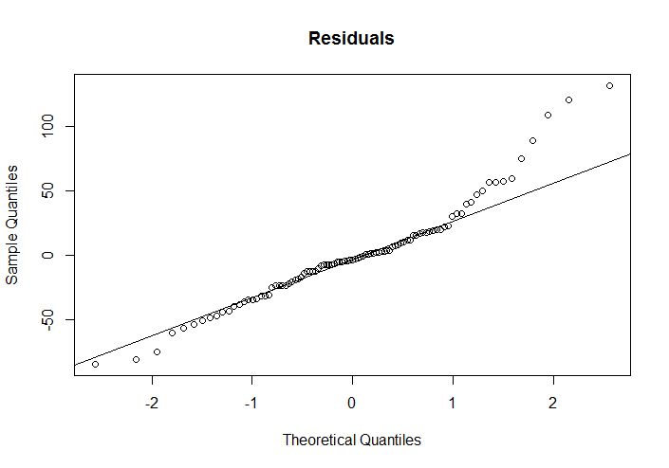

Our proposed model can be summarized as:

Mortality = 125.4 + -0.01(income) + -89.9(Europe) + -72.2(Asia) + -75.1(Americas)

We can thus interpret our model as saying that for every one-unit decrease in income by -.01, and all other variables held constant, mortality will increase accordingly. The categorical factors are all shown to have negative impacts as well with Europe’s impact being the greatest.

APPENDIX: R SCRIPTS

> summary(infmort)

region income mortality oil

Africa :34 Min. : 50.0 Min. : 9.60 oil exports : 9

Europe :18 1st Qu.: 123.0 1st Qu.: 26.20 no oil exports:96

Asia :30 Median : 334.0 Median : 60.60

Americas:23 Mean : 998.1 Mean : 89.05

3rd Qu.:1191.0 3rd Qu.:129.40

Max. :5596.0 Max. :650.00

NA's :4

> hist(infmort$income, main="Per Capita Income (All Regions)", xlab="Income")

> boxplot(infmort$income, main="Per Capita Income (All Regions)", xlab="Income")

> boxplot(infmort$income ~ infmort$region, main="Per Capita Income (All Regions)", xlab="Income")

> hist(infmort$mortality, main="Infant Mortality")

> boxplot(infmort$mortality, main="Infant Mortality")

> plot(infmort$mortality ~ infmort$income, main="Mortality vs. Income", xlab="income", ylab = "mortality")

> infmort_reduced <- infmort[-c(26,28,73),]

> ggplot(infmort_reduced, aes(x=income, y=mortality, colour=region)) + geom_point()

> sps <- ggplot(infmort_reduced2, aes(x=income, y=mortality, colour=region)) + geom_point() + scale_colour_brewer(palette="Set1")

> sps + geom_smooth(method=lm, se=FALSE, fullrange=TRUE)

> boxplot(infmort_reduced2$mortality ~ infmort_reduced2$oil, main="Mortatlity (reduced) by Oil")

> boxplot(infmort_reduced2$mortality ~ infmort_reduced2$region, main="Mortatlity (reduced) by region")

> lmod_infmort <- glm(infmort_reduced2$mortality ~ infmort_reduced2$income + infmort_reduced2$region + infmort_reduced2$oil, data=infmort_reduced2, family = gaussian())

> summary(lmod_infmort)

Call:

glm(formula = infmort_reduced2$mortality ~ infmort_reduced2$income + infmort_reduced2$region + infmort_reduced2$oil, family = gaussian(), data = infmort_reduced2)

Deviance Residuals:

Min 1Q Median 3Q Max

-85.596 -23.411 -4.787 16.485 130.515

Coefficients:

Estimate Std. Error t value Pr(>|t|)

(Intercept) 125.414934 17.211361 7.287 1.12e-10 ***

infmort_reduced2$income -0.010945 0.003938 -2.779 0.00662 **

infmort_reduced2$regionEurope -89.913820 16.241657 -5.536 2.96e-07 ***

infmort_reduced2$regionAsia -72.161436 10.710814 -6.737 1.43e-09 ***

infmort_reduced2$regionAmericas -75.069468 11.406600 -6.581 2.92e-09 ***

infmort_reduced2$oilno oil exports 17.030434 16.791198 1.014 0.31315

---

Signif. codes: 0 ‘***’ 0.001 ‘**’ 0.01 ‘*’ 0.05 ‘.’ 0.1 ‘ ’ 1

(Dispersion parameter for gaussian family taken to be 1558.274)

Null deviance: 356627 on 96 degrees of freedom

Residual deviance: 141803 on 91 degrees of freedom

(4 observations deleted due to missingness)

AIC: 996.16

Number of Fisher Scoring iterations: 2

> summary(lmod_infmort2 <- glm(infmort_reduced2$mortality ~ infmort_reduced2$income + infmort_reduced2$region, data=infmort_reduced2, family = gaussian()))

Call:

glm(formula = infmort_reduced2$mortality ~ infmort_reduced2$income +

infmort_reduced2$region, family = gaussian(), data = infmort_reduced2)

Deviance Residuals:

Min 1Q Median 3Q Max

-84.532 -23.326 -3.278 16.669 131.955

Coefficients:

Estimate Std. Error t value Pr(>|t|)

(Intercept) 141.358736 7.009508 20.167 < 2e-16 ***

infmort_reduced2$income -0.010811 0.003937 -2.746 0.00725 **

infmort_reduced2$regionEurope -89.236794 16.230465 -5.498 3.41e-07 ***

infmort_reduced2$regionAsia -72.524112 10.706513 -6.774 1.16e-09 ***

infmort_reduced2$regionAmericas -75.662828 11.393364 -6.641 2.14e-09 ***

---

Signif. codes: 0 ‘***’ 0.001 ‘**’ 0.01 ‘*’ 0.05 ‘.’ 0.1 ‘ ’ 1

(Dispersion parameter for gaussian family taken to be 1558.761)

Null deviance: 356627 on 96 degrees of freedom

Residual deviance: 143406 on 92 degrees of freedom

(4 observations deleted due to missingness)

AIC: 995.25

Number of Fisher Scoring iterations: 2

> qqnorm(residuals, main="Residuals")

> qqline(residuals)