ARCIGA, Erica Aurelle P. 2ECE-D

BOBIS, Allen Joseph M.

**Machine Problem 3 Output (MATLAB)**

Given 3 Sets of Points [x1, y1; x2, y2; x3, y3]: [1,2;2,3;3,4]

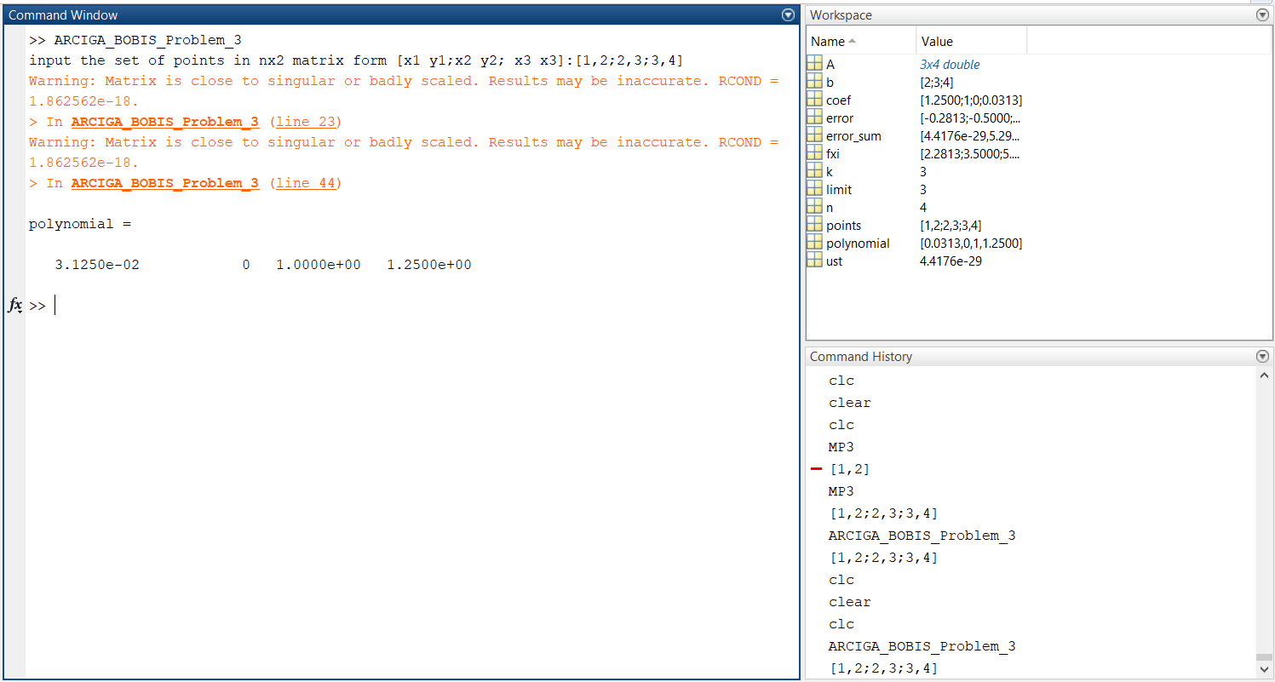

Given 10 Sets of Points [x1, y1; x2, y2;xn, yn]: [3, 4; 1, -2; 8, 7; 1, 4; 5,6; 8, 9; 9, 3;0,1; 1, 5; 7,7]

