Users Manual

All Purpose Radar Development System (APRD)

Version 17


5551 Ekwill Street, Suite A Santa Barbara CA 93111
(805) 683-6414 FAX (805) 683-4076

TABLE OF CONTENTS

INTRODUCTION 2
HARDWARE SETUP 3
SOFTWARE INSTALLATION 6
BASIC APRD NAVIGATION 7
Starting APRD 7
Menu Bar 8
File 8
Hardware 9
Analysis 12
View 16
Data 16
Tools 19
Remote 22
Lua 22
Window 23
Help 23
Status Bar 24
DATA ACQUISITION 25
Radar System Configuration 25
Gate Parameters 26
Scan Parameters 27
Collecting Data 27
Saving Data 28
DATA ANALYSIS 29
Opening a Data File 29
View Windows 29
Window Types 29
Panel 35
Tools 36
Keyboard Commands 37
General 37
Analysis Window 38
Frequency, Time and Distance Windows 38
Mouse Commands 39
Analysis Window 39
Image Window 39
Analysis Tools 39
Summary 39
Lua Analysis 40
APPENDIX 41
Exploring APRD Functionality 41
System Configuration and Data Acquisition 41
Data Analysis 43
Lua Reference 47
Additional Notes on Gate Parameters 48
Additional Notes on LNA and TDD 49
Additional Specifications and Notes 49

INTRODUCTION

The All Purpose Radar Development System (APRD) is a software tool designed by AKELA, Inc. that enables users to digitally control the operating parameters of AKELA's radars, to acquire data from a user-specified configuration of sensors, and display this information in various formats in real time, as well as to replay data files and perform additional data and image analysis.

APRD acts as the command center of a flexible network of radar sensors, allowing users the ability to customize both radar operation and processing algorithms to fulfill a broad range of sensing requirements.

The system has several built-in signal processing and motion detection algorithms, and offers powerful imaging capabilities; furthermore, users have the freedom of creating their own Lua scripts to perform more advanced operations with the data acquired by AKELA's radars.

HARDWARE SETUP

Step 1: Unpack the components.

The system should consist of AKELA's Wide Band Radar, a power supply, and a power cord. The IP address of the radar is labeled on the casing.

The On/Off button, LED status indicators, and Ethernet and power connectors are located on the front panel of the radar.

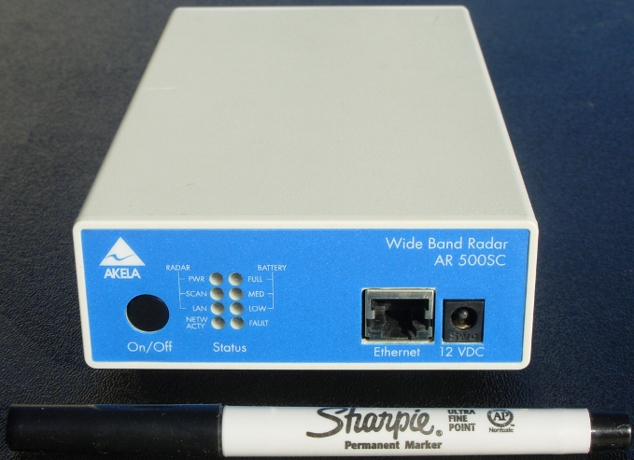

Figure 1 - AKELA Wide Band Radar Unit

The RF connector ports are located on the back.

Step 2: Set up the network

Connect the radar to your network via the Ethernet port.

The IP Address for the unit is labeled on the casing and is a fixed IP address. If the unit is connected directly to a desktop or laptop Ethernet connection, the hosting system (computer) will need to be set to a fixed IP Address in the range of 192.168.1.1 to 192.168.1.254 excluding the unit’s IP address; with a subnet mask of 255.255.255.0.

Step 3: Connect the power supply.

1. Connect the 12 volt DC output connector of the switching AC adaptor to the mini power jack labeled "12 VDC" on the Wide Band Radar.

2. Connect the AC input of the power supply to the AC mains supply (100 to 240 VAC 50/60 Hz) with the standard IEC AC power cord that is provided.

Step 4: Turning the radar On/Off.

AKELA's Wide Band Radar has a momentary Press On and Press Off function. To turn the radar power On, depress the On / Off button and hold it for approximately 1 second, or until the PWR status indicator is illuminated.

Turn the radar power Off by depressing and holding the same button for approximately 3 seconds, or until the PWR status indicator shuts off. When the radar has been turned off, all status indicators will be extinguished.

Step 5: Understanding the Status Indicators.

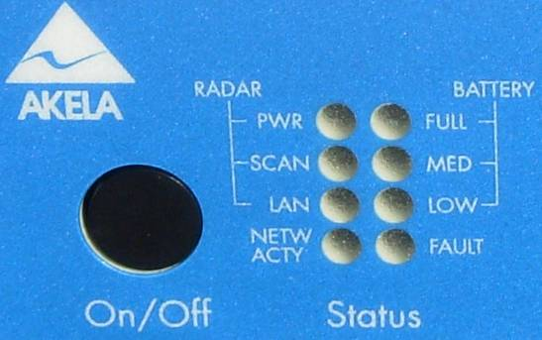

Figure 2 - Status Indicators

PWR | Indicates whether radar is on or off.
SCAN | Is illuminated every time APRD scans for data.
LAN | Is illuminated if radar is connected to a local area network.
NETW ACTY | Blinks when there is network activity (e.g. while scanning).
FULL | Battery is full. The status should always be full when using the AC power supply provided.
MED | Battery level is medium.
LOW | Battery level is low.
FAULT | Check the power supply for problems.

Step 6: Connect antennas, or an attenuator between RF connector ports.

The recommended method for testing the radar is to first connect a minimum of 30 dB of attenuation between two RF connector ports and take a data trace using APRD.

Check that the RF connectors have been tightened and adjust the gain setting in APRD to prevent the signal from clipping.

If the frequency response appears normal, connect antennas to the RF connector ports. Adjust the gain setting in APRD so that the peak magnitude of your signal is between 80 and 85 dB. Stay below 90 dB, at which point signals may be clipped.

Note on Hardware Maintenance

- Periodically inspect the radar antenna connectors for damage. Do not attempt to mate damaged connectors together.

SOFTWARE INSTALLATION

APRD may be installed on the host system from the provided CD ROM. Navigate to the root folder of the CD, double click on the APRD installation executable file, and follow the on screen instructions. The default installation folder is C:\Program Files\AKELA\APRD, you may change this at installation. The installation will, by default, add an icon to the Start menu as well as the desktop.

After APRD is installed on your computer you may start the program and connect the unit to the power supply provided and the network connection to your host computer. Sample radar data, various configuration files, sample Lua scripts, and demo and help files can be found in their respective sub-folders of the directory APRD is installed. For a more detailed description on setting up APRD to begin collecting data with the unit, refer to the DATA ACQUISITION and Exploring APRD Functionality sections

Note on Operating Systems

- The APRD Software Program is designed to be used under Microsoft Windows XP. It works with Windows ME, 2000, Vista and Windows 7 as well but has not been extensively tested under these operating systems. For best stability, Windows XP is recommended.

BASIC APRD NAVIGATION

Starting APRD

Upon opening APRD, a default group of windows will be opened. A number of the windows may be resized and moved in order to best display the active windows. The windows that are opened when APRD starts up can be configured under Tools >> Window Activation. The user is allowed to customize the interface to an environment that may be most suited for a specific purpose (e.g. data acquisition).

For more advanced environment control, a Startup Lua file can command the actual window activation process and, if desired, the tiling of windows. The Startup Lua file is specified in Startup tab under Tools >> System Parameters.

The main console displays the version number of APRD, the status of the program, and any error messages. The various Lua help files, available under Help, are also displayed in the console window.

The image below shows an example of a window setup to display the frequency information for the data that is being collected and replayed. The windows will be explained in more detail later in this section.

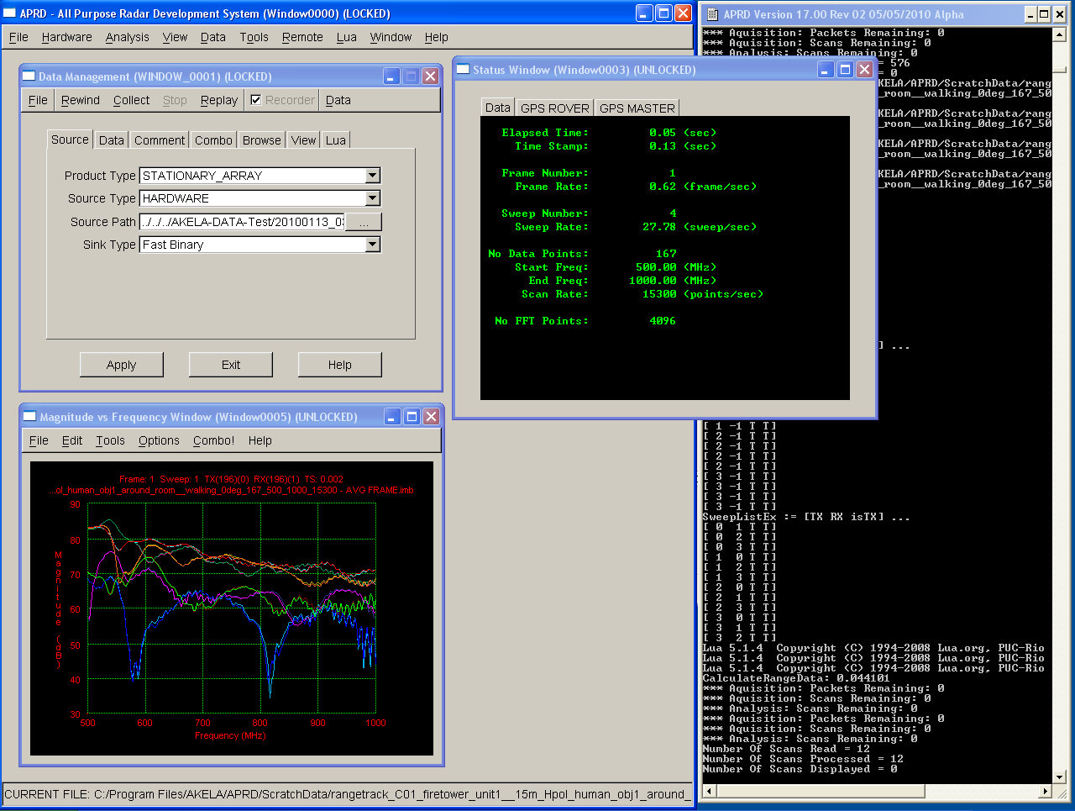
Console
Window
Data Management
Window
Frequency
Window
Status
Window

Figure 3 - Sample APRD Window Configuration

Menu Bar

The various functions and displays of APRD are organized under the menu bar. The available menus are File, Hardware, Analysis, View, Data, Tools, Remote, Lua, Window, and Help.

File
New. This clears the current data as well as resets the fields of any open data or image windows. The system configurations are restored to those of the startup configuration file, if one is specified, thus returning the system to the startup state.

Open/Save/Save As Data. Allows the user to open, or save a data file for playback and analysis within APRD.

Open Config. Allows the user to open a configuration file different from the APRD startup configuration specified in the Startup tab under Tools >> System Parameters. Several configuration files are included to demonstrate the flexible architecture of AKELA's radar system. Different sensor array configurations can be assembled to fulfill different operational requirements, and setting up configuration files in advance provides a quick way to explore these possibilities.

Save Config. Writes any changes made to System Parameters, Analysis Filters, or Hardware Parameters (found under the Tools, Analysis, and Hardware menus, respectively) to the current configuration file.

Save Config As. Writes any changes made to System Parameters, Analysis Filters, or Hardware Parameters (found under the Tools, Analysis, and Hardware menus, respectively) to a new configuration file, or an existing configuration file of your choice.

Open Analysis. Opens a previously saved Analysis file (*.ana) that preserves the characteristics of the display.

Open Chart. Opens a previously saved Chart file (*.cha) that preserves the current display.

Open Surface Window. Opens a previously saved surface file (*.sfc) that preserves the characteristics of the display including the axis limits, zoom, and color map.

Open Texture Window. Opens a previously saved surface file (*.sfc) that preserves the characteristics of the display including the axis limits, zoom, and color map.

Exit Application. Closes APRD.

Hardware

Hardware Parameters. Configures radar sensors for data acquisition.

Sensors

Under the Sensors tab, the user adds a sensor to the network by right clicking in the field and selecting "New" in the context menu. Standard keyboard commands may also be used: Ctrl+N to add a new sensor, Ctrl+X to cut, Ctrl+C to copy, Ctrl+V to paste, and Del to delete.

- The Sensor Switch checkbox should be enabled for a switched sensor system operation.

- The port number is only relevant if Sensor Switch is checked under the Sensors tab.

- The IP address of the sensor, the operating gain, the TX and RX delays (TDel, RDel) should all be entered accordingly.

- The TX, RX, and Mono checkboxes determine whether to use the specified sensor to transmit and/or to receive, and whether to operate in monostatic mode for the specific unit.

- K, Theta are used for when active nulling is implemented.

- The X, Y, and Z location of the sensor are used in image reconstruction.

- The sensor types are:

GENERIC
Use this sensor type for a standard stand-alone radar system.

ARRAY_MASTER and ARRAY_SLAVE
ARRAY systems are configured with multiple slave sensors and a single controlling master unit.

- If a specific sensor won't be used in data acquisition, it is recommended that the user uncheck the Enable box instead of deleting a row from the sensor list, in order to maintain consistency in programming the sensors.

Scan

The user specifies the number of data points to take per scan, the start and stop frequency in MHz, and the sample rate for data acquisition. Additionally, the user may specify the number of FFT points to be used for data analysis. The number of FFT points may also be specified under the FFT tab in the Analysis >> Analysis (Filter) Options menu.

Global

The Global tab overrides the specified parameters for all sensors.

- Check the box for Nulling Circuit to enable active nulling and specify the nulling file, if the nulling option is available.

- If Auto Gain Adjust is selected, the radar gain is automatically changed to keep the peak value of radar returns between 80 and 85 dB for maximum dynamic range.

- If Normalize Scan is selected, radar returns are adjusted to a 0 gain setting. This gives equal weight to different antenna pairings during image reconstruction.

- Check the box for Global Gain and enter its value below to override the specified gain for all sensors.

Bands

Specific frequency bands for inclusion and exclusion can be specified in the fields. If nothing is entered, it is assumed that no bands need to be excluded.

Gate

The Gate tab determines the length of time in nanoseconds for each of the gating parameters for pulse modulation.

- The Gate TX1 specifies the duration of the transmit pulse.

- The Gate TX1-RX1 specifies the duration of the dead time between the transmit pulse and when the receiver begins receiving.

- The Gate RX1 specifies the duration that the receiver is receiving.

- The Gate RX2-TX1 is the dead time before the next pulse begins to transmit.

Additional Notes on Gate Parameters

    - Gate RX1-RX2 and Gate RX2 are not used and should be set to 0.

    - For more detail on setting the gate parameters, please read the Gate Parameters portion of the DATA ACQUISITION section.

Program

The Program tab determines the programming of the radar sensors.

- If the Enable Transmitters box is unchecked, the TX will be turned off.

- Checking Enable Stitch Point applies a correction to the data received from the radar system to compensate for the “step” in the frequency response across frequency band boundaries for different divisions of the frequency divider bands.

- Enable Power Amp enables the power amp if a power amp is available in the current hardware configuration.

- Checking Enable Lua allows the advanced user the flexibility of programming radars via Lua scripts. The location of the Lua files should be specified under Lua path.

Converter

Specifies the time delay and frequency boundary for systems with block converters. Also specifies the frequency boundaries for the radar’s frequency divider.

PLL

The PLL Divider value sets divisor used for the radar PLL.

A PLL table can be used to change the PLL value as a function of frequency.

GPS

Specifies the IP addresses for up to 2 GPS units. The GPS offset specifies the relative distance of the Rover sensor from the (0, 0, 0) origin of the sensors.

Ports

Label the ports and create aliases for switched systems.

Lua

Specifies a Lua file to run during data collection.

User

The user can insert comments that will be stored in the data file for notes on the system configuration and/or further processing. This is separate from the comment field in the Data Management Window.

Sensor Status Window. Lists all sensor settings.

Status Window. Displays important information about the data file being processed including current frame number, sweep number, and time stamp, as well as overall parameters such as the number of data points and frequency range.

Dashboard. Displays the current velocity, declination and tilt of the system based off the shaft encoder readings.

Analysis

Analysis (Filter) Options. Settings for the analysis of acquired data.

Background

When activated, the filter performs a background subtraction on every scan using either a running average or a background file. For the running average, the user specifies the number of scans to average.

Exclusion

User specifies bands to exclude during data analysis.

Encoder

Shaft encoder settings only apply to image reconstruction for mobile arrays.

- Specify the IP address of the sensor that is providing shaft encoder data.

- Rev is the number of shaft encoder counts per revolution.

- Shaft is the relative number of counts the shaft encoder outputs before the number rolls over.

- Base is the distance between the wheels, in meters.

- Circ is the circumference of the wheel, in meters.

- Type is the dimensions to track for the specified shaft encoder

- X and Y specifies the location of the shaft encoder measuring tilt in the case that the encoder is measuring the tilt of the system.

- Ratio specifies a wheel calibration factor to account for difference in wheel sizes. A value of 1 is used for equal sized wheels, whereas a value of 0.990 would specify that one wheel is ~1% smaller than the other wheel.

FFT

The specified number of FFT points is used in analysis. The user can also choose to apply a Hann window and/or pad the data points with leading zeroes.

UDP

If UDP is activated, the computer can act as a UDP source. (The receiving station needs to set the source as "UDP_DATA_SOURCE" under Tools >> System Parameters).

Lua

Specifies a Lua script that is to be run during data analysis.

User1 - 3

When enabled a user defined DLL can be specified for further analysis of the data.

Image Control Panel. The panel control is accessible from and pertinent to the Image Window and Texture Window. This allows the user to control the color scale, the type of image reconstruction, image boundaries and cell size. In addition, the Texture Window allows the user to adjust the position of the viewing angle and the zoom distance.

Image

The user can choose the maximum and minimum color intensity values, as well as the maximum and minimum signal threshold, can also be adjusted. Additionally, the user can choose to blend the static objects into the background of the image by enabling Background Blend, and the thresholds can be dynamically adjusted using Auto Threshold.

Scale

The user can specify a minimum and maximum intensity scale for the images.

Field

The user can adjust the definition of the analysis field, adjusting the maximum and minimum range and cross-range distances, in meters, for the current system setup.
Enable Beam option toggles an overlaid beam to provide the user with information on the orientation of the radiation pattern for the specified system setup. Additionally, for a moving platform, Enable Track will plot the track of the platform as it moves within the field.

Recon

There are multiple types of images that can be displayed with basic raw images or images with filters applied, which show the results of various analyses on the data. The cell size, cell factor, and distance correction, if any, are also specified in this tab.

XY

Allows the user to define the Z-value and the boundaries of the XY plane in meters.

XZ

Allows the user to define the Y-value and the boundaries of the XZ plane in meters.

YZ

Allows the user to define the X-value and the boundaries of the YZ plane in meters.

Analysis

Enable Peak Analysis toggles a chart window that plots the location of the peak signal in the image window for the peaks from the last n seconds, as specified in the Peak History (s) dialog field.

Enabling the Queue sets the queue length for processing sweeps within an image when the Product Type is “MOBILE_ARRAY_RELATIVE”.

L1 & L2 Statistics sliders are used to determine the weighting for the formation of images of type “Statistical”.

Ground

Ground Truth and Markers specify text files that have stored GPS coordinates in UTM for the ground truth or markers for targets. The locations will be overlaid in the image window with a circle drawn around the ground truth points, and a cross for the marker points.

Lua

Specifies a Lua script that will perform additional processing on the reconstructed images.

Field Viewer. Constructs a 2D image showing an overhead view of the sensor positions and analysis area orientation.

Image Window. Constructs a 2D image where color represents signal intensity.

Texture Window. Constructs a 3D image where signal intensity is represented by both color and height. Allows the user to adjust the tilt angle, compass angle, zoom distance, and image height of the 3D view.

View

Freq Window. Displays the magnitude of the data (in dB) versus frequency.

Time Window. Displays the range profile.

Distance Window. Similar to the Time Window, but with distance as the x-axis.

Phase vs Freq Window. Plots phase (in radians) as a function of frequency.

Phase vs Time Window. Plots phase as a function of time.

Unwrapped Phase vs Freq Window. Plots unwrapped phase versus frequency.

Unwrapped Phase vs Time Window. Plots unwrapped phase versus time.

Re vs Freq Window. Plots I data versus frequency.

Im vs Freq Window. Plots Q data versus frequency.

Re vs Time Window. Plots I data versus time.

Im vs Time Window. Plots Q data versus time.

Data

Erase. Clears the data from memory.

Rewind. Moves current position to the beginning of the data.

Collect. Starts data acquisition.

Stop. Stops data acquisition.

Replay. Plays the data from the current position.

Recorder. During data acquisition toggles the storing of the current data.

Data Management Window. In addition to easy access to the commands mentioned above, the Data Management Window controls how APRD handles and saves data:

Source

Under the Source tab, the user can specify whether the system is a stationary array, a mobile array, or a distributed array. The source type should be set to "hardware" for data acquisition, or "data file" for data playback. Setting the source type to "UDP data source" allows the user to access and process the files being acquired by another computer on the network. The source path, if the source type is a data file, can also be specified in the Source tab in the Tool >> System Parameters menu. To simply open a data file the user may go directly to File >> Open Data.

Data

- The "Sweep Type" can be set to Single Combination to acquire or display data from one TX and one RX, Single Sweep for data from one TX and any number of RX, Single Frame for data from any number of TX and any number of RX, or Multi Frame.

- Recorder should be checked in order to save all data obtained. The fields below will not appear unless Recorder is checked.

- If Repeat is checked, the data replays automatically.

- If a Max Time (in seconds) is specified, the file acquired will contain N seconds of radar data, unless manually stopped prior to max time being reached. If a Max Time is specified and the Repeat box is checked, data continues to be acquired after the specified Max Time is reached, but only the last N seconds of data are saved to file.

- If Auto Save is checked, the file is automatically saved with the specified filename at the end of data collection. If a file with the same name already exists, the user will be prompted to choose between writing over the file, saving to a new file, or canceling.

- Filename specifies the directory and name of the file to be saved.

- The Auto Increment checkbox appears if Auto Save is checked. This appends a suffix (for example, 0000) to the filename and automatically increments the number each time a file is saved.

Comment

View or edit comments associated with a data file. The data will need to be saved after comments have been added. This Comment tab is synchronized with the Comment tab of the Data Editor Window.

Combo

The Combo tab allows the user to specify a command which will determine the combinations of transmit and receive pairs from the data that will be displayed.

Examples -
“*”: specifies all combinations.
“>”: all combinations off
“0>1”: specifies data for the combination of transmit from sensor 0, receive on sensor 1.
“*>1”: all transmitters, receive by sensor 1.
“1,2>*”: transmit by sensor 1 and 2, receive by all sensors.
“1,2”: equivalent to “1,2>1,2”.

Browse

The Browse tab displays the current position in the data and the corresponding combo number, frame number, and sweep number. The TX, RX, and time stamp are also shown.

View

The View tab only applies when Single Combination is selected for "Sweep Type." The checkboxes correspond to the list of windows available under the View menu. The selected plots will appear when Single Combination data is acquired, or when other data files are replayed in the Single Combination mode.

Lua

Checking Enable Lua and entering a Lua path will execute the specified script files upon data acquisition or stopping for the following sweep types: Single Combination, Single Sweep, and Single Frame.

Data Editor Window. The Data Editor Window provides an easy way to truncate or keep portions of the data, to further filter out certain combinations, and to save the edited data.

Marker

To edit the data, move the left and right marker positions to the desired beginning and end points of your new data. Select Save or Save As to store the truncated data.

Comment

View or edit comments associated with a data. The data will need to be saved after comments have been added. This Comment tab is synchronized with the Comment tab of the Data Management Window.

Combo

The Combo tab has the same functionality as the one found in the Data Management Window and allows the user to specify a command which will determine the combinations of transmit and receive pairs from the data that will be displayed.

Examples -
“*”: specifies all combinations.
“>”: all combinations off
“0>1”: specifies data for the combination of transmit from sensor 0, receive on sensor 1.
“*>1”: all transmitters, receive by sensor 1.
“1,2>*”: transmit by sensor 1 and 2, receive by all sensors.
“1,2”: equivalent to “1,2>1,2”.

Lua

Checking Enable Lua and entering a Lua path will execute the specified script files upon data acquisition or stopping for the following sweep types: Single Combination, Single Sweep, and Single Frame.

Data Monitor Window. Displays the current trace with frame number, sweep number, and TX-RX combination corresponding to the current position in the data. The user is able to specify the view type (e.g. frequency, time, phase vs. freq, etc.) under the View menu item and may specify the current displayed position in the data by using the position slider under the Browse tab in the Data Management Window.

Tools

Summary. The Summary tool prompts the user for a directory path and lists all the data files in that folder, along with relevant information extracted from the files' headers.

Editor. Opens a blank Editor Window for writing new configuration files.

K, Theta Calibration. Used with the active nulling circuit when nulling is implemented.

Generate Nulling File. Generates a nulling file for use with when nulling is implemented.

System Parameters. Controls overall APRD settings.

Startup

The user specifies APRD's working directory as well as what configuration and/or Lua files to use on startup.

Source

Under the Source tab, the user can specify whether the system is a stationary array or a mobile array.

The multiple mobile array times are used for imaging purposes. Image reconstruction for Mobile Array Absolute reconstructs the area specified for the image slice with respect to the initial absolute position of the system. Mobile Array Relative reconstructs the images relative to system and does not take into account the absolute position of the system. Mobile Array Montage reconstructs the images relative to the system, but overlays subsequent images on their absolute position.

The Source Type should be set to "HARDWARE" for data acquisition, or "DATA_FILE" for data playback. Setting the source type to "UDP_DATA_SOURCE" allows the user to access and process the files being acquired by another computer on the network. The source path, if the source type is a data file, can also be specified in the Source tab, or the user may go directly to File >> Open Data.
The Sink Type specifies the format of the saved files.

System

- The “Enable Virtual Memory Management” puts APRD into a memory management mode which reads and writes files directly to and from the disk instead of loading and storing data in physical memory. This should be enabled when working with large files; however it may cause degradation in performance when running analyses on smaller files.

- When data contents have been modified, APRD usually prompts the user to either save or discard the current data before collecting new data. Selecting the "Delete Data Recorder Without Asking" option will turn off this reminder and overwrite the data directly.

- The "Real-time Data Playback" checkbox determines the frame rate of display windows when data files are replayed. If selected, the image plays back within the same time frame as was required for data acquisition.

- The "Enable Remote Operation at Startup" checkbox allows remote operation of APRD at startup.

- The "Enable Asynchronous Data Collection" checkbox causes the radar system to run in asynchronous mode, as opposed to synchronous mode, during data collection. This option is recommended for operating environments where communication with the radar may be periodically interrupted, such as with long-range wireless communication.

- “Allow Data File to Override Configuration” causes the configuration of the system to be replaced by the configuration that was used for the collection of data when a data file is loaded into APRD.

- The “Remove Stitch Points” causes a correction to be applied to the data received from the radar system to compensate for the “step” in the frequency response across frequency band boundaries for different divisions of the frequency divider bands.

Window

Provides various controls for the functionality and behavior of windows within APRD.

Thread

The checkboxes allow users with multiple processing cores the benefit of smoother window movements and enhanced processing.

Communications

Specify the input and output ports as well as the broadcast and server addresses.

System Menus. Controls the menu items for APRD, allowing for customization of the items that are displayed and their labels. Under the various tabs, the user may customize APRD by selecting which Lua functions to include under the various analysis menus, and the names they should appear as. Checking the "--" box inserts a divider line in the dropdown menu after the selected item.

Window Activation. Selects the windows that are opened when APRD collects or plays data. (Or, go to Window >> Activate to open them immediately.) Different windows may be opened depending on whether the application is set for Multi Frame, Single Frame, Single Sweep, or Single Combination operation.

Remote

Initialize. Initializes a remote connection for remote operation.

Terminate. Terminates a remote connection that has been previously established.

Lua

New Script File. Opens a blank Script Window for creating new Lua scripts.

Open Script File. Opens an existing Lua script for editing.

Open Startup File. Opens the Startup file specified under System Parameters.

Run Script File. Runs an existing Lua script.

Run Startup File. Runs the Startup file specified under System Parameters.

Trace Execution. If selected, prints lines of executed Lua code in the console.

The menu items below Trace Execution will launch Lua scripts. The functionality of the scripts vary, however they typically perform analysis or editing functions on the data. The menu items can be customized under the Application tab in Tools >> System Menus.

Window
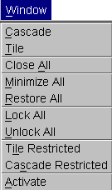

Cascade. Cascades all APRD windows.

Tile. Tiles all APRD windows.

Close All. Closes all unlocked windows. Cross-plots, dialogs, and editor windows come up locked by default.

Minimize All. Minimizes all APRD windows.

Restore All. Restores all APRD windows.

Lock All. Locks all APRD windows.

Unlock All. Unlocks all APRD windows.

Tile Restricted. Tiles only the resizable, non-dialog windows.

Cascade Restricted. Cascades only the resizable, non-dialog windows.

Activate. Opens those windows selected under Tools >> Window Activation.

Help

Open Help File. Opens the browser to specify an APRD help file.

Lua – [type]. Prints help for the various Lua function libraries, which have been built into APRD, to the main console.

About. Displays APRD version number and release date.

Status Bar

The status bar appears at the bottom of the APRD window and shows the current system configuration type, the current configuration file, and the data source type.

DATA ACQUISITION

The process of data acquisition involves configuring APRD's system and hardware settings to communicate with the radar sensor(s), specifying the sweep parameters, collecting the desired length of data, and saving the data to a file.

Radar System Configuration

APRD comes with a number of preset configuration files for different systems, and for additional features such as active nulling and block converter. These provide examples and good starting points for customizing a configuration file to suit your application.

1. Go to File >> Open Config if you wish to start with one of the existing configurations, otherwise you may select File >> New to reset the configuration settings to their default state before editing the configuration.

2. Under the Source tab in the Tools >> System Parameters window, make sure that the array type corresponds to your system setup. Data Acquisition requires the selected Source Type to be Hardware.

3. Add unit(s) to the sensors list under the Sensors tab in Hardware >> Hardware Parameters window.

After adding each sensor, edit their entries and make sure that the IP address, port number (if running a switched system), gain, TX and RX delays, and sensor location (if applicable) are entered correctly.

Refer to the section on Hardware under BASIC APRD NAVIGATION for an explanation of the tabs and fields.

Additional Notes on Radar System Configuration

- Determining the Optimal Gain Value:

The gain value should be carefully chosen such that the radar is not operating in saturation and the returns aren't clipped.

It is recommended that the frequency data be kept below 90 dB as shown in the Frequency Window. Therefore, it is best to start with a low gain value upon first collecting data, and then increase the sensor gain so that the maximum peak of the frequency response is in the 80 – 85 dB range. Each incremental gain step will increase the magnitude of the frequency response by 3 dB.

- Setting the Converter and PLL Values

The values for the fields under the Converter and PLL tabs will need to be checked to ensure they are correct for the hardware. Below is a table for the values that should be used for the corresponding radar model.

Radar Model | Frequency Range | Converter Boundary | Converter Type | Frequency Boundary 1 | Frequency Boundary 2 | PLL Div.
Standard | 250 – 2000 MHz | 250 | HIGH | 500 | 1024 | 50
Decade | 200 – 2000 MHz | 200 | HIGH | 450 | 950 | 50
3 GHZ | 380 – 3000 MHz | 380 | HIGH | 775 | 1550 | 80

- Using a Pulse Modulator/TDD

For detailed instructions on setting the Gate parameters for pulse modulation, go to the Gate Parameters section below.

Gate Parameters

The gate parameters are specified under the Gate tab in the Hardware >> Hardware Parameters window. When the Gate, Enable box is unchecked the unit operates in continuous wave (CW) mode. When the gating is enabled, the unit operates in the gated mode using the parameters specified. At power up the gating function is off. The state of the Gate function, as well as all other hardware parameters do not take effect in the hardware until the units has been stopped and the collect function from the Data tab in the main APRD window or the Data tab in the Data Management window has been invoked by the user.

The gate times are specified in nanoseconds. The resolution of the gate periods are 6.1035 ns. APRD will round the user inputs to the nearest valid gate time and will warn the user of gate times that are to short or to long. The user input will be displayed even if these values are not exact. The unit will be setup with only the valid values determined by APRD.

The effect of the gate time parameters is cumulative. First the Tx Pulse will occur for the period specified by the Gate TX1 (ns) parameter then the Transmitter will be off and the receiver input will be off for the period specified by the Gate TX1-RX1 (ns) parameter. Following the Gate TX1-RX1 the Tx will be off and the receiver will be on for the period specified by the Gate RX1 (ns) parameter, a second set of receive gate parameters may be specified by the user in the same manner as above. After the period equal to the sum specified by the first 5 gate parameters the transmitter will be off and the receiver will input will be off for the period specified by the Gate RX2-TX1 (ns) parameter. This cycle then repeats until the data collection is stopped. Only one Tx pulse per gate cycle is permitted.

The valid ranges of gate times are:

Field Name | Valid Range of Values
Gate TX1 (ns) | 24 – 1556
Gate TX1-RX1 (ns) | 18 – 1556
Gate RX1 (ns) | 18 – 1556
Gate RX1-RX2 (ns) | 24 – 1556 or 0
Gate RX2 (ns) | 24 – 1556 or 0
Gate RX2-TX1 (ns) | 18 – 1556

For additional information on setting the gate values, please read the Additional Notes on Gate Parameters section of the APPENDIX.

Scan Parameters

APRD programs the radar sensors with the start and stop frequencies of a scan, the number of data points per scan, and the data sampling rate.

1. Under Hardware >> Hardware Parameters, click on the Scan tab to specify the number of data points, the frequency range, and the sample rate.

2. If there are any frequency bands you wish to exclude, use the Bands tab to establish and enable/disable these bands.

3. You may want to save these changes to the configuration file of your choice under File >> Save Config As.

Collecting Data

1. Ensure that the sensors have been configured correctly under the Sensors of Hardware >> Hardware Parameters.

2. Go to Data >> Data Management Window to bring up the Data Management window.

3. Under the Source tab of the Data Management Window, ensure that the Product Type and Source Type of correct.

4. Under the Data tab, select the desired sweep type. Choose Single Combination to acquire data from one TX and one RX, Single Sweep to acquire data from one TX and any number of RX, Single Frame for data from any number of TX and any number of RX, or Multi Frame for a sequence of Single Frames.

5. If Recorder and Auto Save are enabled, specify a directory and filename for saving data.

6. To collect only N seconds of data in the Multi Frame mode, enter the time in seconds in the Max Time field. When used in conjunction with the Auto Save and Auto Increment filename functions, this feature is particularly useful for collecting a series of data files of roughly the same size, for comparison and analysis.

Refer to the section on Data >> Data Management Window under BASIC APRD NAVIGATION for an explanation of the features.

7. APRD will start collecting data when the user clicks Collect in the Data Management Window, or Data >> Collect in APRD's main menu.

8. Data collection will stop automatically in the Single Combination, Single Sweep, and Single Frame modes. In the Multi Frame sweep mode, data collection will stop if (1) the user presses Stop in the Data Management window or under the Data menu, OR (2) the maximum time has been reached. If Repeat is enabled, however, data continues to be collected, but only the last N seconds will be preserved in the available data.

9. The data collected will be shown in real time in the Data Monitor Window, or any of the other display windows under the View menu. These windows may also be configured to open automatically upon the collection of data by going to Tools >> Window Activation.

Saving Data

1. In the Data tab of the Data Management Window, the Recorder needs to be turned on in order to save all acquired data. If Recorder is turned off, APRD only retains data from the most recently scanned combination; this may be useful for setting up hardware and verifying that everything is functioning.

2. If the Auto Save option is not enabled, the user will be prompted to either save or discard the current data before collecting new data; if Auto Save is enabled, the data contents are automatically written to a file with the specified filename.

The Auto Increment checkbox appears when Auto Save is enabled. This appends a numerical suffix (for example, 0000) to the filename and automatically increments the number each time a file is saved.

DATA ANALYSIS

Radar data acquired with APRD can be opened for replaying and processing on any system with APRD installed.

Opening a Data File

1. From either the main menu or the Data Management Window select File >> Open Data.

2. The Sweep Type in the Data tab of the Data Management window may be adjusted. For example, a Multi Frame data file may be replayed in the Single Combination mode to produce single-shot displays.

If continuous replaying is desired, check the box for Repeat.

The "Real-time Data Playback" checkbox under Tools >> System Parameters may also be selected to adjust the frame rate so that playback appears as if in real time.

3. Click Data >> Replay from the main menu or from the Data Management Window.

View Windows

The default windows that are opened upon file playback can be configured under Tools >> Window Activation. In addition, the user may choose to view the data in the form of any of the displays listed under the View menu.

Window Types

Freq. Window. Displays the magnitude of the data (in dB) versus frequency.

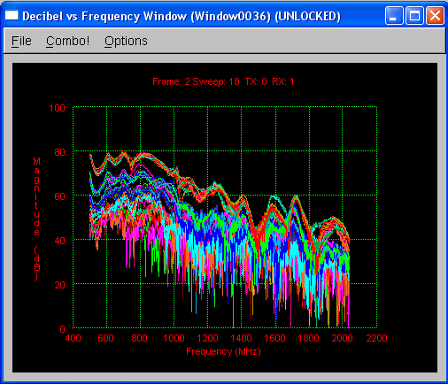

Time Window. Displays the range profile.

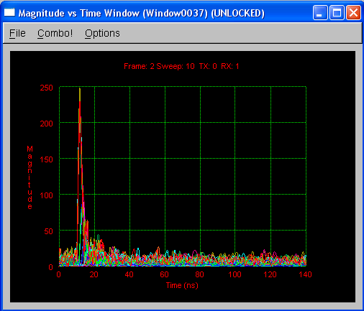

Distance Window. Similar to the Time Window, but uses distance as the x-axis.

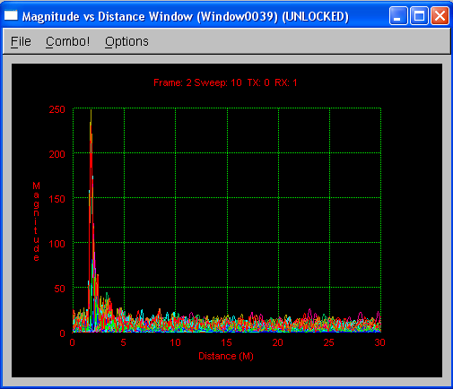

Phase vs Freq. Window. Plots phase (in radians) as a function of frequency.

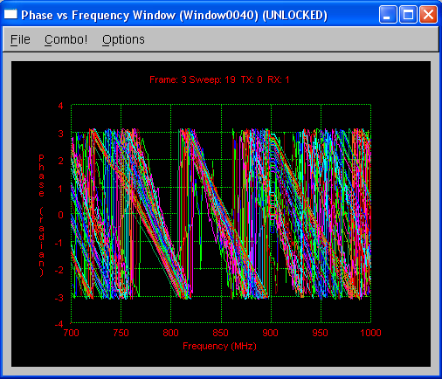

Phase vs Time Window. Plots phase as a function of time.

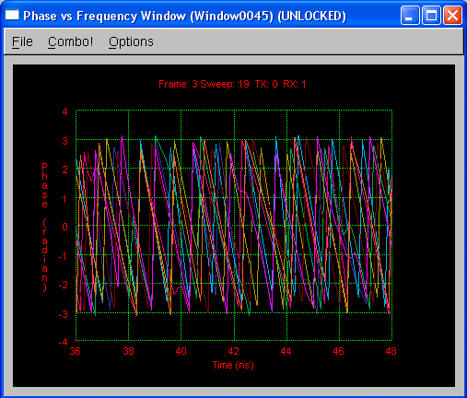

Unwrapped Phase vs Freq Window. Plots unwrapped phase versus frequency.

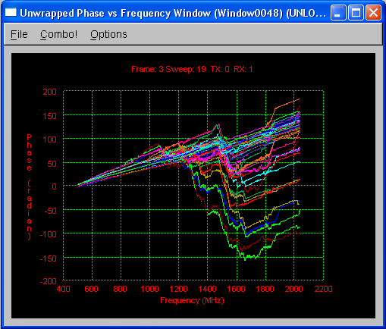

Unwrapped Phase vs Time Window. Plots unwrapped phase versus time.

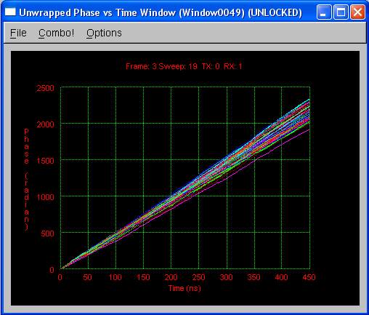

Re vs Freq Window. Plots I data versus frequency.

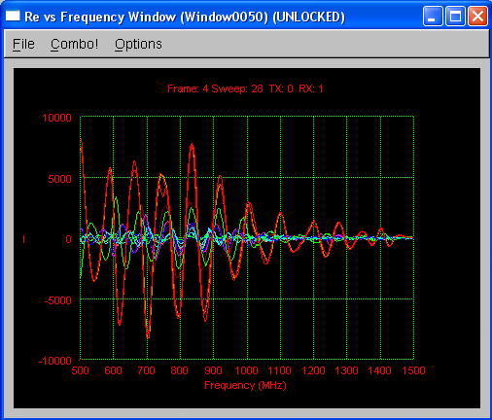

Im vs Freq Window. Plots Q data versus frequency.

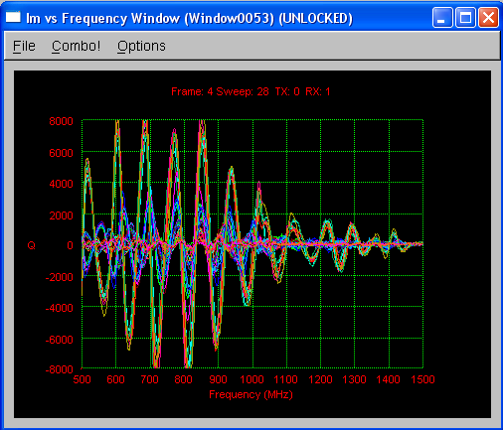

Re vs Time Window. Plots I data versus time.

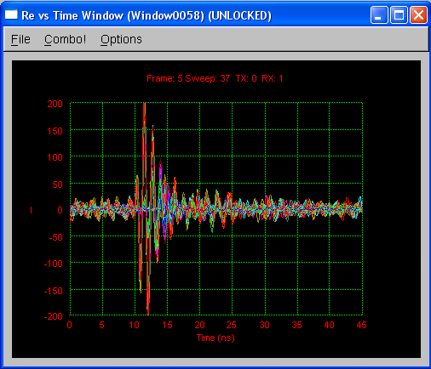

Im vs Time Window. Plots Q data versus time.

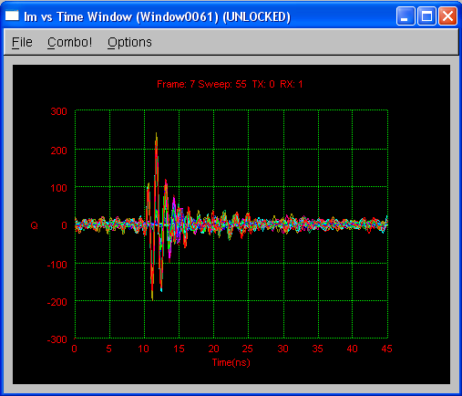

Image Window. Constructs a 2D image where color represents signal intensity.

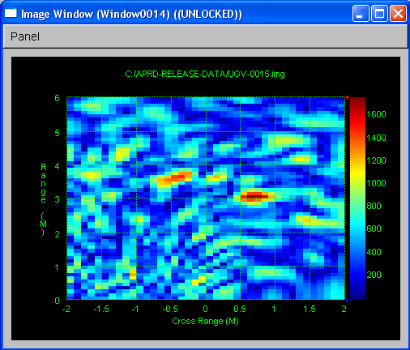

Texture Window. Constructs a 3D image where signal intensity is represented by both color and height. Allows the user to adjust the tilt angle, compass angle, zoom distance, and image height of the 3D view.

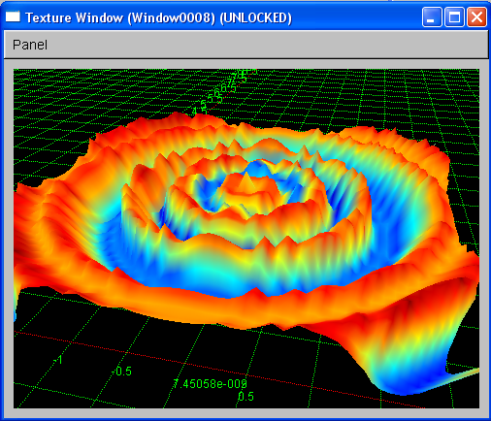

Field Viewer. Displays an iconic view of the user-defined field. A movable and re-scalable box is overlaid on the field view to define the area that is reconstructed by the Image and Texture windows. A beam pattern is overlaid to orient the user to the location and radiation pattern of the system.

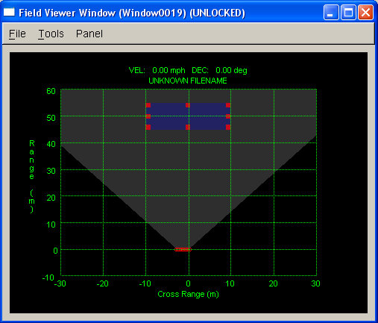

Sensor Status Window. Lists all sensor settings.

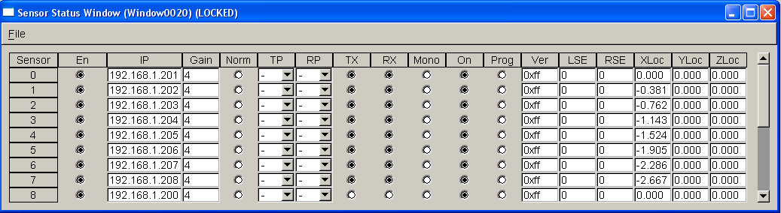

System Status Window. Displays important information about the data being processed including current frame number, sweep number, and time stamp, as well as overall parameters such as the number of data points and frequency range.

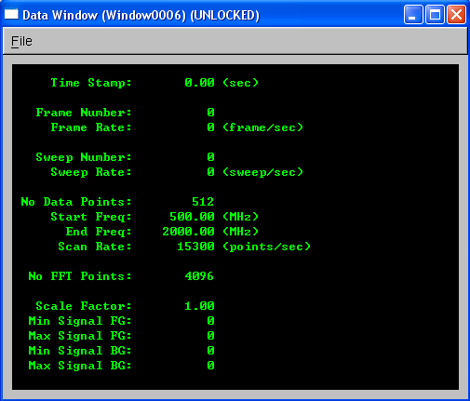

Data Monitor. Displays the current trace with frame number, sweep number, and TX-RX combination corresponding to the current position in the data.

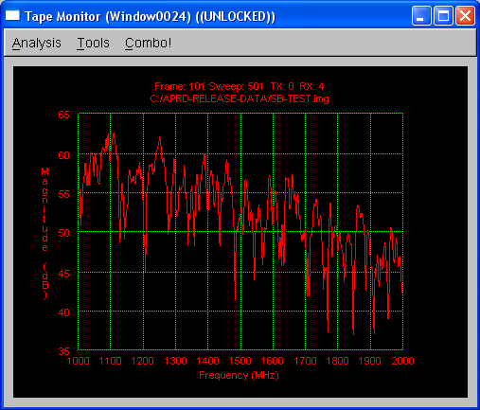

Panel

The panel control is accessible from and applies to the Image Window and Texture Window. This allows the user to control the color scale, the type of image reconstruction, image boundaries and cell size. In addition, the Texture Window allows the user to adjust the position or the viewing angle and the zoom distance.

Image

The user can choose the maximum and minimum color intensity values, as well as the factor to scale the intensity by, an option to gray out stationary data as a background for the image, and specify whether the threshold for the color gradient should be adjusted automatically.

Field

The user can adjust the definition of the analysis field, adjusting the maximum and minimum range and cross-range distances, in meters, for the current system setup. An option for an overlaid beam can be chosen to provide the user with information on the orientation and radiation pattern for the specified system setup.

Recon

The update parameter allows the user to specify between updating the image on every frame, sweep or combination. The image type specifies if the displayed image will be of the raw data, or with additional filters or analysis performed on the data. Image Slice specifies the plane in which the images should be constructed. The cell size and factor determine the resolution of the image. Distance correction, if specified, compensates for the additional path loss for objects in range by increasing the intensity of the of image pixels as a function of distance based off of the factor specified in the Distance Correction field.

XY

Allows the user to define the Z-value and the boundaries of the XY plane in meters.

XZ

Allows the user to define the Y-value and the boundaries of the XZ plane in meters.

YZ

Allows the user to define the X-value and the boundaries of the YZ plane in meters.

Analysis

Various additional image analyses may be enabled under this tab.

Lua

Specifies a Lua script that will perform additional processing on the reconstructed images.

Tools

The tools list is accessible from the menu of the Data Monitor Window, any Analysis Window under the View main menu, or by right-clicking the mouse outside of the plot region within these windows.

Line. Displays a line plot. This is the default.

Scatter. Displays a scatter plot.

Scatter + Line. Displays a scatter and line plot.

Linear Scale. Plots using a linear scale. This is the default.

Log Scale. Plots using a logarithmic scale.

Map Scale. Applies the scaling of the current window to windows of the same type.

Map Type. Applies the map type (e.g. Magnitude vs. Time) of the current window to spawned plots and cross plots.

Map Selection. Applies the selection of the combinations of the current window to other windows of the same type.

Spawn Analysis. Creates a duplicate of current window in an analysis window, preserving the settings and parameters of the current window.

Spawn Chart. Creates a duplicate of current window, preserving only the data and scale of the current window.

Cross Plot. Automatically cross plots all windows similar to current window.

Reset Scale. Resets scale to the default.

Lock. Locks the window.

Unlock. Unlocks the window.

Keyboard Commands

The following is a summary of the keyboard options that are not otherwise visible in menus. In general, adding a SHIFT modifies the behavior of the command. Except for function keys, a CONTROL reverses the command.

General

CTRL+TAB:
Selects the next window.
CTRL+F4:
Closes current window.
ALT+F4:
Closes the application.
CTRL+F1:
Selects a green background and black background for current window.
CTRL+F2:
Selects a black foreground and white background for current window.
SHIFT+CTRL+Fn:
Selects color scheme for all applicable open windows.

Analysis Window

INSERT, HOME, PAGE UP:
Shows all lines and resets selection to first line.
DELETE, END, PAGE DOWN:
Hides all lines.
ALPHA-NUMERIC:
Shows individual traces, numbered from 0 through 9 and then A through Z.
CTRL+ALPHA-NUMERIC:
Hides individual traces, numbered from 0 through 9 and then A through Z.
LEFT-ARROW:
Moves cross-hairs to previous data point.
SHIFT+LEFT-ARROW:
Moves 4 points at a time.
RIGHT-ARROW:
Moves cross-hairs to next data point.
SHIFT+RIGHT-ARROW:
Moves 4 points at a time.
UP-ARROW:
Selects next line.
ALT+UP-ARROW:
Displays only the next line.
DOWN-ARROW:
Selects previous line.
ALT+DOWN-ARROW:
Displays only the previous line.

Frequency, Time and Distance Windows

INSERT, HOME, PAGE UP:
Shows all combinations.
DELETE, END, PAGE DOWN:
Hides all combinations.
ALPHA-NUMERIC:
Activates a sensor and its combinations.
CTRL+ALPHA-NUMERIC:
Deactivates a sensor and its combinations.
SHIFT+TX:
Activates a TX and any RX combination.
CTRL+SHIFT+TX:
Deactivates a TX and any RX combination.

Mouse Commands

The following is a summary of the mouse options. In general, adding a SHIFT modifies the behavior of the command, whereas adding a CONTROL reverses the operation.

Analysis Window

LEFT-MOUSE-DRAG:
Defines a new region of interest.
LEFT-MOUSE-DOUBLE-CLICK:
Returns to the previous region of interest.
CTRL+LEFT-MOUSE-DOUBLE-CLICK:
Resets plot scales.
RIGHT-MOUSE-INSIDE-PLOT-REGION:
Places a cross-hair cursor at the location of the mouse.
RIGHT-MOUSE-INSIDE-PLOT-REGION-DOUBLE-CLICK:
Removes the cross-hair cursor.
RIGHT-MOUSE-OUTSIDE-PLOT-REGION:
Activates tool pop-up menu.

Image Window

SHIFT+LEFT-MOUSE-DOUBLE-CLICK:
Makes the current scale settings permanent.

Analysis Tools

APRD has a few tools to assist in the analysis of data files. These can be found under the Tools and Lua menus of the main window.

Summary

The Summary tool first brings up the Editor Window. Selecting File >> New within the Editor Window prompts the user for a directory path. After a path is selected, the Editor Window displays all data files in that folder along with relevant information extracted from the files' headers.

This tool helps the APRD user organize and keep track of data files, particularly if a large number of data files have been acquired.

Lua Analysis

AKELA has implemented and integrated a collection of Lua scripts in APRD to assist users in the analysis of data files. These can be added or removed from the Lua menu of the main window by going to the Lua Application tab in Tools >> System parameters.

Users are encouraged to explore these Lua files and to try saving and opening Surface files in the Image Window. They will be able to make the most of APRD's versatility by creating their own Lua scripts. The scripting ability is what transforms advanced data analysis methods into efficient processes within APRD.

Noise Analysis

This Lua script calculates the noise of the data file from both magnitude and phase information. The results are displayed in either a chart or 2D Image Window depending on the analysis type specified by the user.

Within the Image Window, the File menu allows the user to save the present figure as a Surface file (*.sfc), or to open a different Surface file. Clicking Panel allows the user to change the image color properties as well as the title and axes labels.

Additional Lua scripts are available by default under the Lua menu; however there is no documentation for the individual scripts at this time.

APPENDIX

Exploring APRD Functionality

System Configuration and Data Acquisition

A quick way to start exploring APRD's functionality is to open the sample configuration file "SWITCHED_EXAMPLE.cfg" from the SampleConfigurations folder in the directory APRD was installed. Specify the configuration by clicking on the File >> Open Config menu item and browsing to the file location. The configuration file will load a set of parameters into APRD to see the basic setup of an example system for data acquisition and analysis.

The “SWITCHED_EXAMPLE.cfg" configuration is for a fixed switched sensor system which transmits and receives on 4 antennas. To view the hardware setup in APRD system, open up the Hardware Parameters window it from the Config menu. Below is a picture of the system.

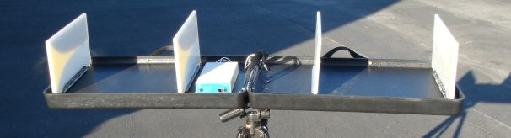
Antennas
Radar Unit
Antennas

Figure 4 - Example Radar System

Under the Sensors tab of the Hardware Parameters window, the system that was set up is a switched system with 4 antennas. Since this is a single unit with 4 RF connector ports, the antennas share a single IP address with each antenna having a unique port. The sensor entries describe the RF connector port the antenna is connected to, the relative location of each antenna, the desired gain step, and the cable delay correction times. The system is configured to transmit and receive (TX and RX) on all sensors. The gains have been set to 2 in order to provide the greatest dynamic range when collecting data with the system. The signal delays for the transmission and receive paths (TDel and RDel) have been specified at 6.912 ns to correct for the time offset caused by the signal delays from traveling through the radar circuitry and cables to and from the antennas. Additionally, the relative location of the sensors has been specified in meters (XLoc). The current configuration describes a set of sensors that are fixed inline with each other in the X-dimension; however it is possible to describe the relative location of sensors in all three dimensions (XLoc, YLoc, ZLoc). The parameters K and Theta have been left as 0.000 since this system does not support active nulling.

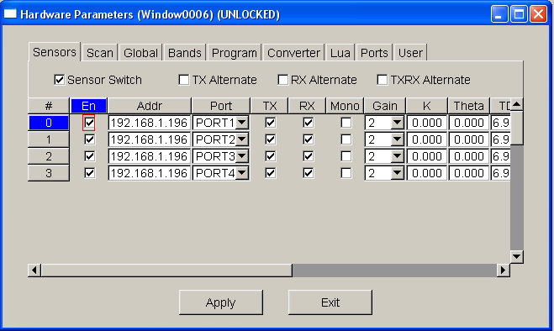

Figure 5 - Hardware Parameters Window, Sensors

A set of optimal scan parameters was determined based on factors such as the desired detection range, system setup, and characteristics of the environment where the data was collected. For this example, data was collected of an individual walking around the inside of a building. The system was approximately 15 meters away from the front of the building, and the building was 7 meters deep. For this scenario, under the Scan tab, the frequency range, number of points, and sample rate were specified to provide a frame rate of approximately 7 frames per second (sufficient for detecting the motion of a walking individual), and a maximum detection range of 50 meters to ensure the whole building and the region behind the building were within the detection range. The frequency range was chosen due to capabilities of the radar system and the frequency response of the walls’ material.

The frequency step size that would provide the desired maximum detection range was calculated by dividing the speed of light by 2 times the maximum range. Therefore, with a maximum desired detection range of 50 meters, the frequency step size needed to be approximately 3E⁸ / (2 x 50) = 3 MHz. The number of points needed therefore was 500 MHz / 3 MHz ~ 167 points.

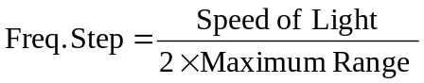

Equation 1 – Frequency Step
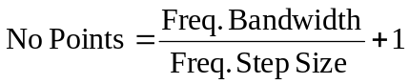

Equation 2 - Number of Points

To determine the necessary scan rate to obtain the desired frame rate, the scan rate was calculated as a function of frame rate by dividing the number of transmit and receive combination by the frame rate. In this case there were 12 combinations (each transmitting sensor has 3 sensors receiving, therefore there are 4 transmissions x 3 receives = 12) and the desired frame rate of 7 frames per second. This yields scan rate of approximately 15,300 Hz.

Equation 3 – Scan Rate

For analysis, the number of FFT points should be a power of 2, and be at least 2 times the number of points. However, for increased resolution in the time domain the number of FFT points can be increased, therefore the number of points chosen for this analysis was 4096.

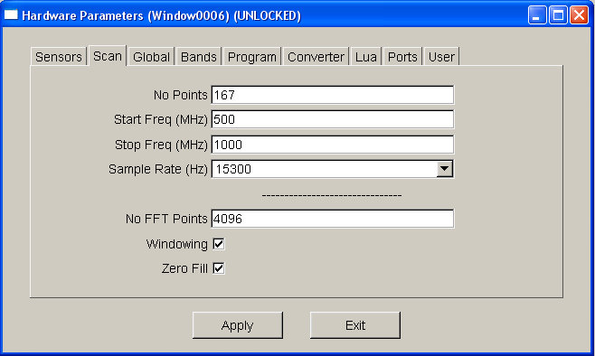

Figure 6 - Hardware Parameters Window, Scan

For this example, the configuration has specified a sample data file to be used for data collection, as opposed to acquiring data directly from hardware. This has been done to mimic the collection of data without the need to set up a physical system to explore APRD’s functionality. To begin collecting data, select Data >> Data Management Window, and go to the Data tab. Ensure that the sweep type is MULTI_FRAME, the Recorder option is checked, the Repeat option is not checked, and that the Max Time is at least 20 seconds. Once these settings have been verified, click Collect at the top of the Data Management window.

Data Analysis

Once the data has begun collecting, you may begin analyzing the data. If the Frequency Window is not open, go to View >> Frequency Window to open the window. In the Frequency Window, a number of traces will be displayed showing the frequency responses between the sets of transmit and receive pair combinations. The user will often want to concentrate only on a single response, or a small set of responses. In order to see only a subset of the traces the user can select the Combo! menu item and a specific subset of transmit and receive combinations can be specified in the command line of the Combo! dialog window. The expression syntax to specify which combinations the user wants to display is described in the dialog window. For this example, let’s display only the signals received by Sensor 0. To do this, in the command line field, enter “*>0”, where “*” indicates all sensors, “>” indicates “transmitting to”, and “0” specifies sensor 0. After entering in the expression into the command line and hitting OK, only 3 frequency response traces should be shown. The Frequency Window with all of the scan traces and the traces for the subset of scans are shown in Figure 7.

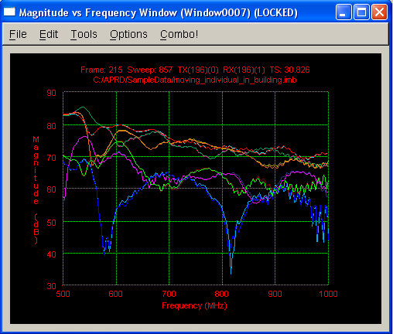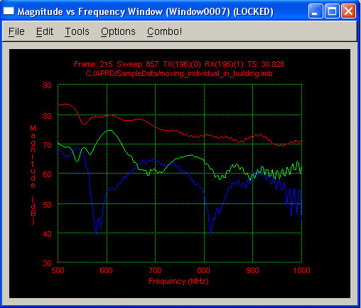
Full Set of Scans
Scans Received by Sensor 0 Only

Figure 7 - Frequency Window, All Scans vs. Subset of Scans

The data for this example was taken in front of a building, with the front wall of a building approximately 15 meters from the system. To see the specific return signals of the wall and its distance from the system, open the Distance Window from the View menu. If the window is blank, click on the Data >> Replay menu item to replay the data. The Distance Window will show a large peak on the far left-hand side at 0 meters. This is the direct path signal between the antennas and should be ignored for this example. At around 15 meters there is another, smaller peak. To zoom in on this peak, click and hold the left mouse button while you drag the cursor to draw a box around the area of the peak. The full view and the zoomed in view are shown in Figure 8. Once zoomed in, to zoom back out to the previous view, simply double click the left mouse button anywhere inside the grid.

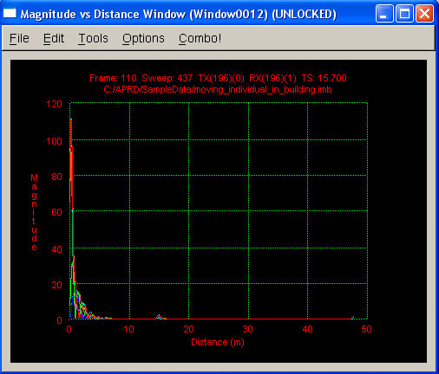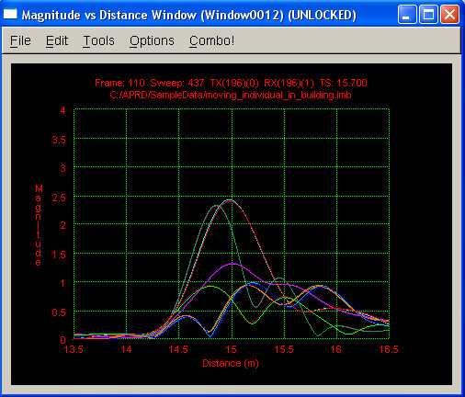
Peak at
15 meters
Full View
Zoomed View of Peak at 15 Meters

Figure 8 - Distance Window, Full View vs. Zoomed View

To browse to a specific point in the data, go to the Browse tab in the Data Management Window. A specific point in the data can be shown by entering values into Frame, Sweep, or Time text fields and hitting the Apply button at the bottom of the dialog window. Alternatively the Combo slider can be dragged to move through the data using the mouse, or, if the tab is selected, using the keyboard’s arrow keys. Specifying a point in the data using the Browse tab will activate a Data Monitor window if one is not already open. The form in which the data is viewed (e.g. frequency, time, distance, etc…) can be changed by selecting alternative forms under the View menu of the Data Monitor window.

To display an image showing the intensity of movement and location of the individual, open up an Image Window under the View menu. The area of reconstruction for the displayed image is shown with range and cross-range along the vertical and horizontal axis’, respectively. To change the area of reconstruction, click on the Panel menu in the Image Window to bring up the Image Control Panel window. For this example data we are looking at the location in the X and Y dimension. The range and cross-range boundaries will therefore be redefined under the XY tab. Given the location and dimensions of the building relative to the system, for this example the values shown in Figure 9 will reconstruct an image containing the front wall, and the movement inside the building. To adjust the boundaries, simply change the min and max values for X and Y and then hit Apply. Alternatively, the image reconstruction area can be altered by opening the Field Viewer Window under the View menu, and changing the location and/or dimensions of the overlaid box, which is drawn to match the defined reconstruction area.

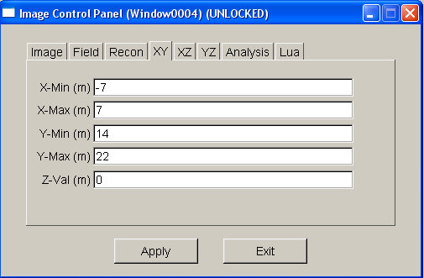

Figure 9 - Image Reconstruction Area Settings

Once the image reconstruction area has been defined, go to the Image tab in the Image Control Panel. Since we know that the wall is a large stationary signal in the data, make sure that Background Blend is selected. This will cause the wall, and any other large stationary object, be shown as a gray area in the background of the image. Additionally, since the response of a moving object can vary greatly between frames, it is best to have Auto Threshold enabled when looking at data with moving objects. You can also adjust the min/max color intensity and scale factor if you wish, but their default values should be ok for this example. Hit Apply before moving away from the window or to other tabs.

Next, we will want to make sure that the right image construction algorithm is used for the detection of moving objects. This can be done by going to the Recon tab and selecting First Order for the Image Type. First Order creates an image by taking two consecutive images and subtracting the first image from the second. This will remove the responses for stationary objects from the image and leave only responses for objects that have changed position between frames. For the motion of humans with a collection rate of approximately 7 frames per second this algorithm is sufficient. To adjust the resolution of the image, the Cell Factor can be adjusted; however for the highest resolution, enter “0” for the Cell Factor. The distance correction does not need to be used for this example. To ensure that any new settings take effect, hit Apply.

Move back to the Image Window. If the data has stopped collecting, select the Data >> Replay menu item and the displayed images should look similar to the one in Figure 10. You can zoom in and out in the same way as with an analysis window, as was shown earlier in this section with the example of zooming in on a peak in the Distance Window. To quickly change a number of the settings for the image window, right clicking anywhere in the black border around the grid will cause a drop-down menu to appear with setting options.
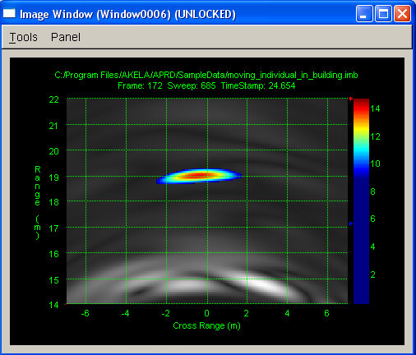

Figure 10 - Image of Motion Intensity with Background Blending

Lua Reference

Demonstration Files

To demonstrate the capabilities of Lua and provide examples of the functionality and implementation of the built-in Lua functions, demonstration Lua scripts have been included in the APRD installation. The files are located in the LuaHelp sub-folder in the directory APRD is in installed and are of the format Demo-XXX.lua. To open the files go to the Lua >> Open Script File. Once a Lua script has been opened, the script may be run by clicking Go from the Debug menu in the editor window. To directly run the script, simply go to Lua >> Run Script File, and the script will run automatically without opening an editor window.

Reference Manual

The reference manual for Lua 5.1 is available online:

http://www.lua.org/manual/5.1/

The Lua website has current releases and additional information including links to a Lua users community.

http://www.lua.org

Book

The book Programming in Lua complements the reference manual and explains in detail the constructs of the language. Examples are presented in the book.

The first edition of the book was aimed at Lua 5.0, and has been made available online:

http://www.lua.org/pil/

The second edition of the book updates the text to Lua 5.1 and includes new material. It can be purchased through the Lua website to help support the Lua project.

Additional Notes on Gate Parameters

Frequency and time domain noise induced by gate parameters.

Care must be taken in the selection of the gate time parameters to avoid inducing noise in the time and frequency domains. Total gate periods that are a sub harmonic of 10.7 MHz will induce noise in the receiver.

The reciprocal of the sum of the gate times must not equal 10.7 MHz +/- 0.5 MHz or any integer sub multiple of 10.7 MHz +/- 0.5 MHz.

With the values of the gate times rounded to the nearest increment of 6.1035 ns the fundamental frequency produced by the resultant period would be:

For an example we can assume the following values for the gate parameter fields:

Field | Field Value (ns) | Actual Value (ns)
Gate TX1 | 36 | 36.62
Gate TX1-RX1 | 60 | 61.04
Gate RX1 | 100 | 97.66
Gate RX1-RX2 | 0 | 0
Gate RX2 | 0 | 0
Gate RX2-TX1 | 24 | 24.41

Plugging in the numbers for this example produces gives us the fundamental frequency of the reciprocal of the total gate times:

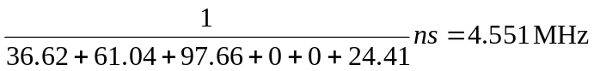

The harmonics of the resultant fundamental frequency would be:

Second harmonic 9.102 MHz
Third harmonic 13.6534 MHz
Fourth harmonic 18.2045 MHz
Fifth harmonic 22.7556 MHz

The gate values in the example thus satisfy the requirement to avoid a sub harmonic of 10.7MHz +/- 0.5 MHz.

Additional Notes on LNA and TDD

The Receive input power limitations are as follows:

When the unit is equipped with a TDD assembly, if the Enable LNA box is unchecked in the APRD Hardware Parameters >> Program tab, maximum input power to a receive RF port is +13dBm peak power to avoid permanent damage to the unit and -5dBm peak power to assure operation within specifications. The minimum attenuation between any two ports must be 7 dB to avoid permanent damage to the unit and 25 dB to assure operation within specifications.

When the unit is equipped with a TDD assembly, if the Enable LNA box is checked in the APRD hardware Parameters Window, Program Tab maximum input power to a receive RF port is -7dBm peak power to avoid permanent damage to the unit and -25dBm peak power to assure operation within specifications.

The minimum attenuation between any two ports must be 27 dB to avoid permanent damage to the unit and 45 dB to assure operation within specifications.

LNA Configuration:

The Hardware Parameters tab may be accessed in APRD by selecting Hardware >> Hardware Parameters from the main APRD window.

The state of the LNA Enable, as well as all other hardware parameters do not take effect in the hardware until the units has been stopped and the collect function from the Data tab in the main APRD window or the Data tab in the Data Management window has been invoked by the user.

Additional Specifications and Notes

The following abbreviated specifications apply to units with serial numbers of the form R5B###TC### composed of an Akela AR500 Rev B and a TDD Rev C Module.

RF Frequency Range: 250 to 2000 MHz

RF Output Power with TDD Module 250MHz: 16dBm Minimum, 17dBm typical, 20dBm Maximum

RF Output Power with TDD Module 2000MHz: 13dBm Minimum, 14dBm typical, 17dBm Maximum

RF Output Power Slope versus frequency: 3 dB from 250 to 2000 MHz typical

RF Input 1 db Compression Level LNA not Enabled: +3 dBm Typical

RF Input damage Level LNA not Enabled: +13dBm

RF Input 1 db Compression Level LNA Enabled: -17dBm Typical

RF Input damage Level LNA Enabled: -7dBm

DC Power supply Voltage Range 10 to 15 VDC with under and over voltage detection and lockout.

Reverse polarity protection, Fuse and shunt diode, subjection to a reverse voltage condition with blow the input protection fuse. The fuse is not replaceable by the end user.

Power supply over voltage protection, Fuse and shunt zener diode, subjection to an over voltage condition with blow the input protection fuse. The fuse is not replaceable by the end user.

The unit is capable of operating from a DC power source other than the supplied power supply. If the user desires to operate the Radar from a power source other than the provided power supply please contact Akela, Inc. for assistance.

The system may be connected to a network that uses DHCP, but an address conflict may result if the DHCP server has assigned the unit’s IP address to another user.
Make sure to use an attenuator with 30 dB or more of attenuation! Otherwise the mixers may be driven into compression and the hardware damaged.
Refer to the DATA ACQUISITION section for help with taking a data trace.
For machines running Windows Vista and 7, it is suggested that you do not install APRD in the Program Files folder and instead install it in a folder that does not require administrative privileges (e.g C:\).
A value of 50 should be used for radars with the upper frequency limit of 2000 MHz, and a value of 80 for radars that go about 2000 MHz
Actual frame rate will be slightly less due to communication and processing overhead
Besides analyzing at collection time, saved data files can be loaded for analysis under File >> Open
Windows can be made to automatically open upon collection under Tools >> Window Activation
The valid value ranges for the text fields for this example file are: Frame 100 - 220, Sweep 397 - 877, Time 14.3 - 31.5
If you do not hit Apply after making changes to settings the new settings may not be applied or preserved when you move to another window or to other tabs.
If the data replays too quickly, enable Real-time Data Playback under the System tab of the Tools >> System Parameters Menu
Due to the resolution of the clock used to control the gating, the actual values for the gate parameters will be the nearest integer multiple of 6.1035.

