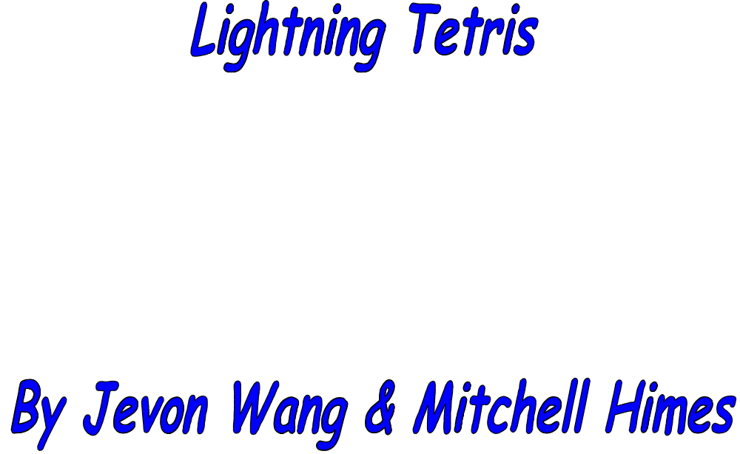



Table of Contents

1 History of Tetris
2 Introductions
3 Objects
4 How to play
5 Shapes
6 Disclaimers

1: History of Tetris:
Tetris is a popular game developed in 1985-86 by Alexey Pajitnov, Dmitry Pavlovsky, Vadim Gerasimov. These three men worked on this game together on IBM computers. It may look different now, but it is still the same idea and rules.

2: Introduction:
Thank you for purchasing Lightning Tetris. We are positive that you will enjoy this game and hours of play. If you like our game, please send your thanks (MONEY) to 485 Stinson Road, Allen, Texas.

3: Object:
The object of Tetris is to manipulate the falling shapes to form a solid row of blocks horizontally across. Once a solid row is formed, the row will disappear, adding points to your total. The game is over once blocks can fall no more because of a build up of non-solid rows.

4: How to Play:
Once you are in the main menu, you are given three options: 1. Start Game, 2. High Score, and Exit. To start game simply press the number 1, to view the high score press 2, and to exit press any other button.

Once in the game the shapes start dropping. To move the shape to the left press the left arrow key. To move right press the right arrow key. To rotate the shapes press the up arrow. To drop the shape fast press the down arrow key. To replay the game, simply rerun the game. Press the Esc key at any time to exit the game.

5: Shapes





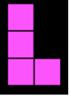



6: Disclaimer:
The programmers of this game spent many long hours slaving over their keyboards to complete this game. PLEASE DO NOT COPY OR STEAL THIS GAME!!! OR YOU WILL RECIEVE MASS AMOUNTS OF PAIN!!!

(c)Nerds Company, inc.

