

* Add Unigram to map
* Add Bigram to map
* Show Code



Task

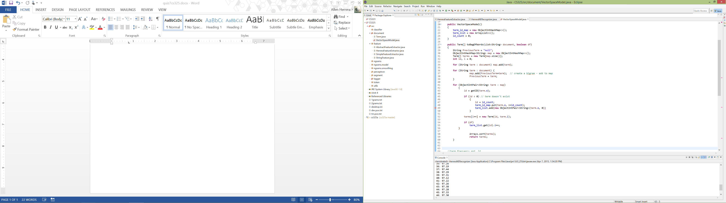The Java file can be found in my quiz7 folder

I’m sure you could combine both For-Loops together to be more efficient but for the sake of distinctly seeing both unigrams and bigrams separately, I didn’t combine both loops.

Honor Code: I worked with Mourya and Henry.