Functionality
The NCT data science project includes many internal and external modules to achieve the required computations like reading the one-star data, store, select, retrieve, distribute and display the results in many different charts. The charts will be the visual representation of the stated questions like:
- Which is the best reliable car model that most likely will pass the NCT test.
- Which is the worst car model that will fail on the NCT test.
- Which car make, or make and model is the best future investment to suggest to the customers.
- What is the most likely problem with the given car model on the NCT test.
- And many possible question and output.
The power of the NCT test is, there is no limit on the stated questions, because the product use SQL database to store tabular data, and can retrieve any variant of the data by the SQL queries. The following diagram is the visual representation of the final product connected the internal and external components/interfaces. Figure 1

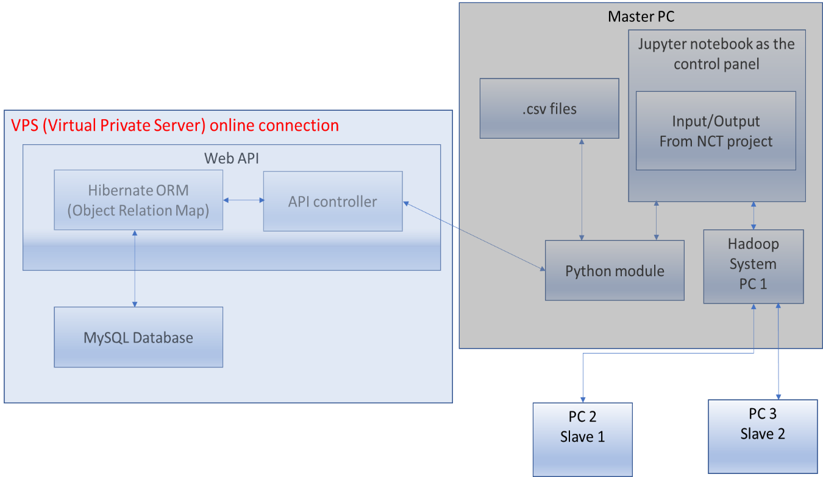
Figure 1: NCT data science project system representation.
The main scenario of the system functionality should happen in sequences. First the user must access the main module to operate the product, what will be IPython Jupyter kernel module. This interface can access the Python code, to carry out function calls, to connect the internal and external parts to work together as a single unit. The user able to read tabular files from the operating system and send the row values to the database. Able to send SQL queries to the web API to retrieve selected rows and column to calculate and display charts. To distribute the processing jobs between network connected computer, in the project the Hadoop system will be used. The charts will be displayed with the IPython Jupyter kernel in the web browser.

Functionality description.
The NCT project will use IPython Jupyter notebook through the web browser as a main user interface to interact and operate the product. The Jupyter notebook can connect to the Python files and able to execute the functions within the files.
After the Jupyter notebook started, the user needs to start a new kernel in the notebook, to use the built-in command line. In the command line must to import the modules to intend to use in the process. Figure 2
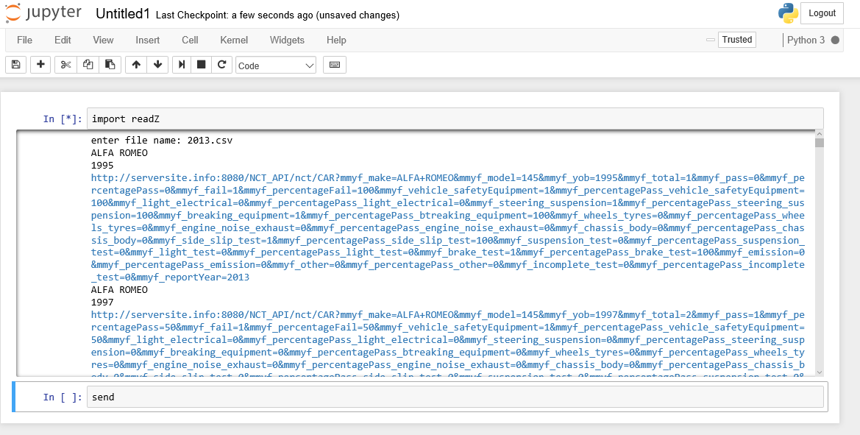

Figure 2: Jupyter notebook in action

As the picture show above the “send” method called by the IPython Jupyter notebook, and the python scripts start reading the 2013.csv file line by line. In the same time, it is building up the URL call requests and executes it and sending to the web API. In this way the project can be controlled by the Jupyter kernel, such as reading the NCT related csv files, sending to the web API, receiving a HTML status code or a specific respond from the API.
The API built in Java Spring MVC (Model View Controller) design pattern, with transactional data access objects (DAO), that are mapped with Hibernate ORM (Object Relation Mapping) technology. In this way the web API make sure there is no partial transactions can happen, because if any part of the registering process fails, then the database access will not happen and refuse the transaction. In this way the Python module can keep track of any single API call happen, or fail. When the API call fail the module should try to repeat the row injection to the database as it is resending the values. The API implements few listeners methods in the controller. The first method responsible to listen for the API calls to save the sent values of car make and model details. The other method listens for NCT test centres result. Booth method is connected to the corresponding mapped data access object and save the details to the database. To operate the NCT project through the web interface, the API must implement at least one method in the controller to listen for the SQL requests from the Python modules, and sends back the collected data from the database in JSON format. To make selection of the database, this method will be responsible to broke down the request and build the equivalent Hibernate ORM database calls.
The Hibernate ORM mentioned above is the key to the database mapping process. It is framework to mapping object oriented model to a relation database. So, it is very tight programmed to the data set, since every single column value want to save in the database, must implemented in the Java model. The model attributes name, database table, column names must match. The project use two different model, one for the make and model mapping, and the another to the NCT test centres model mapping. This technology can create a database table if the database exists, but the table in the database not exist.
Figure 3, Figure 4 – 4.1

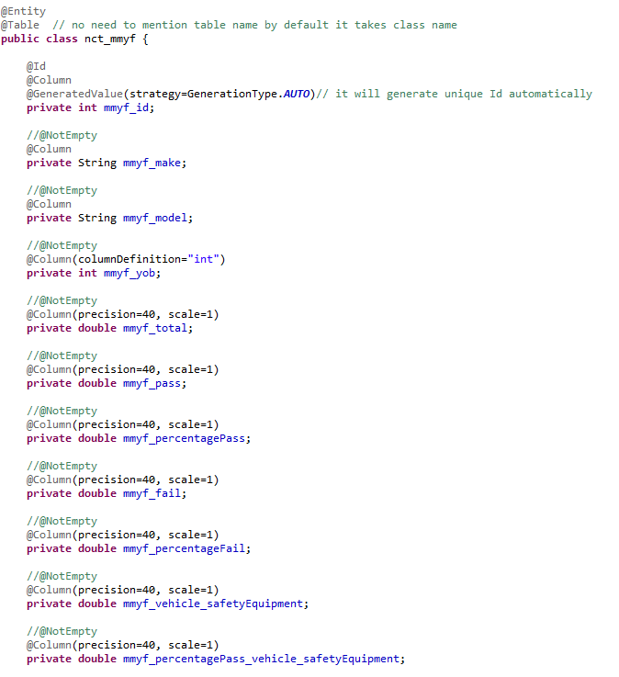
Figure 3: Java DAO object

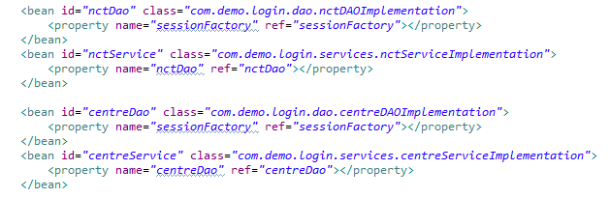
Figure 4: Hibernate ORM session factory mapping to Java objects

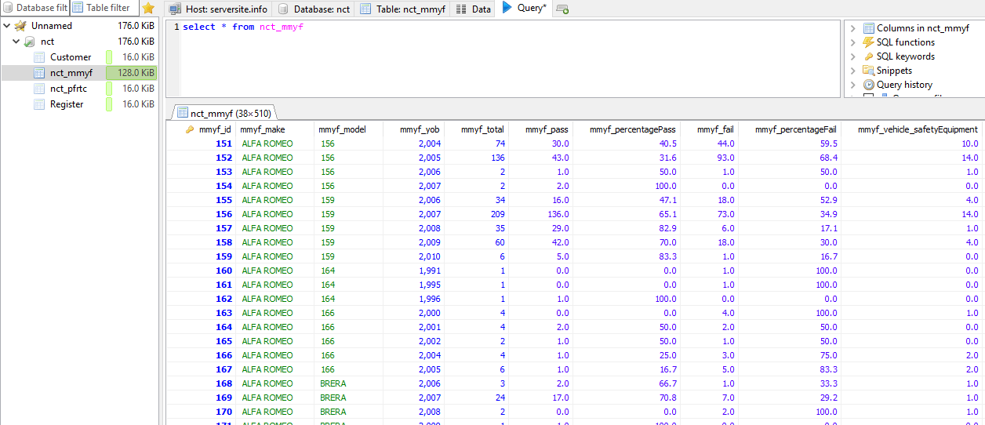
Figure 4.1: Make and model values stored in database

As the part of the system, need to mention the application server that runs the Spring MVC web API. It can be important since the Java API does not use direct database connection, it is connected to the application server connection pool. The application server is a Payara (Glassfish) J2EE container with a direct connection pool to the MySQL database, that can handle the communication between the Java API and the database itself. The default pool size is 8 to 32 connections, that can be extended if the requests cannot be executed in fast manner. Figure 5
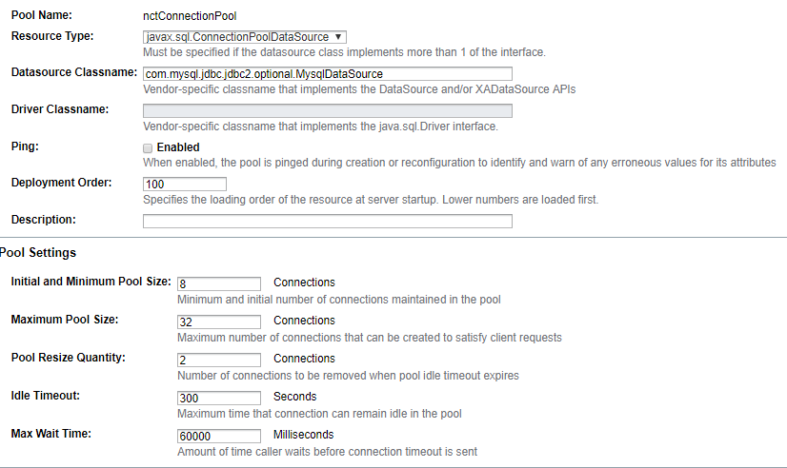
Figure 5: Payara application server connection pool to NCT database
So, the API when receive the request from the Python module with a SQL queries, then it will be delegated to the Hibernate Object Mapping framework. The ORM is connected to the application server, and through it is connection pool sends the request to the database. When the selected respond arrives to the Hibernate ROM, the it is returning the result to the API. The API turn the result data set to JSON file and sends back to the Python module.
At this stage of the process the system saved the data set to the database, received the SQL requests from Python module and returned the result data set in JSON format. The Python stores all the data received from the API and starts communicating with the Hadoop file system.
As it was mentioned before, the NCT project will use Hadoop framework to distribute stored data and work process between network connected computers. Hadoop is a great environment for data transformation, but as a data science environment it poses challenges. The system use Map reduce technology that splits the data set into independent chunks which are processed by the map task in a parallel manner between the computers in the Hadoop networked system. Then the framework sorts the outputs of the maps, which are then input to the reduce tasks. The input and output of the job are stored in the file system. The Hadoop framework takes care of scheduling, monitoring and re-executes the failed tasks. (Hadoop, 2013) When Hadoop finish with the process of the data set, then return the processed value to the program function that requested the distributed data process.

In this point need to mention the usage of the Hadoop framework with Python programming language. Python has several interfaces to use the HDFS (Hadoop File System). The NCt project probably will use one of the following two libraries. (McKinney, 2017)

hdfs3 - is a lightweight Python wrapper for libhdfs3, a native C/C++ library to interact with the Hadoop File System (HDFS).
- PyArrow - Apache Arrow is an in-memory transport layer for data that is being read or written with Parquet files. PyArrow includes Python bindings to this code, (pyarrow, 2017)
Usage of hdfs3: Figure 6
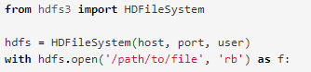
Figure 6: Usage of hdfs3 pythonlibrary

Usage of pyarrow: Figure 7
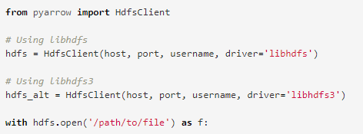
Figure 7: Usage of pyarrow
As a last step in the process, the Jupyter notebook should represent the processed data by the Hadoop and the python modules in a visual representative format. To achieve tis functionality with Jupiter must use some sort of Python library that can display data in charts. As one example of Python library to display result sets in chart, can use the Ploty’s python API. (ploty, 2015)
Usage of Ploty’s API: Figure 8 - 9
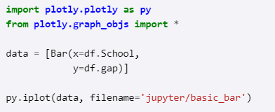
Figure 8: Ploty’s API import and simple usage

Figure 9: Sample output of chart with Ploty’s API

User Interface description.
The user interface, that allows to interact with the NCT project, is an open-source application that allows to create and share documents that contains live code, equations, visualization and it is called Jupyter notebook. Figure 10
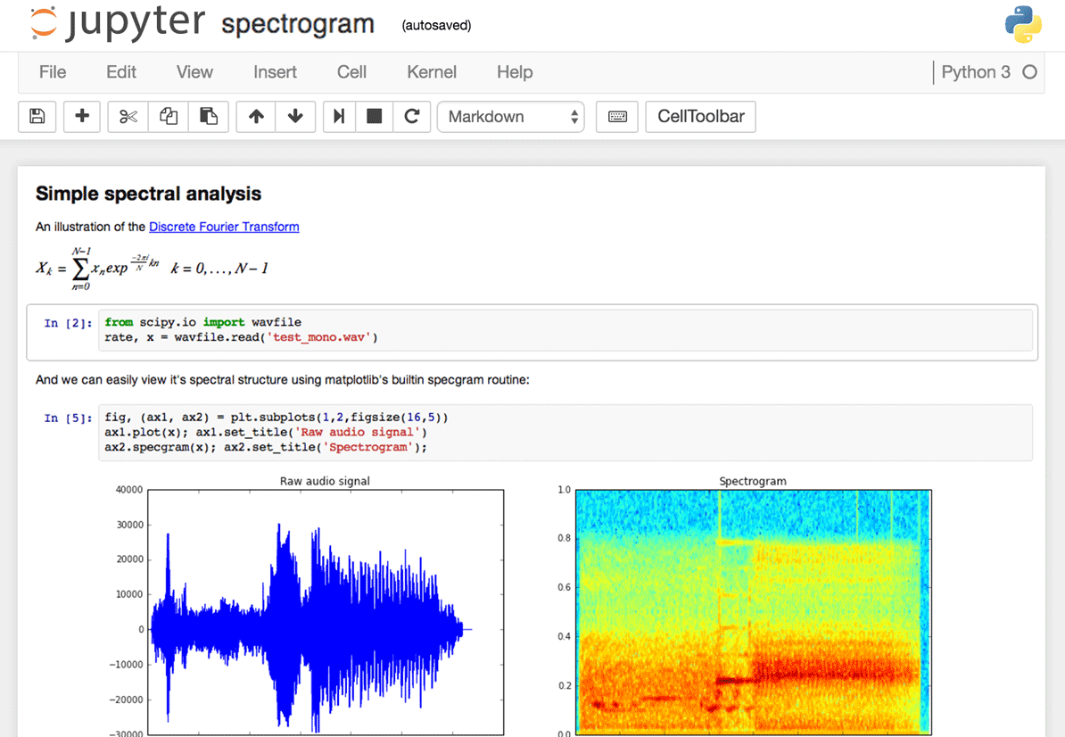
Figure 10: User interface (Devlin, 2016)

Jupyter notebook, known as the IPython notebook, is a flexible tool that can create analyses, can keep code, images, comments and plots together. Jupyter is very flexible and extensible, supports many programming languages and easy to install and start on a computer on a server.
To display tables, charts or any kind of visual representation, simply need to import a library and use the library interface to play around with the data and display it. The most important feature in Jupyter is the plotting features. There are many libraries are available to creating visual representation.
So, Jupyter is a good choice to use as the user interface in the project, since easy to install, support many libraries to create visual representation of digital data, and able to interact with external modules such as python or Hadoop system.

Few option to use in the NCT project for visualization of processed data:
- Matplotlib - (the de-facto standard)
- Seaborn - is built over Matplotlib and makes building more attractive plots easier
- Mpld3 - alternative renderer (using d3) for matplotlib code
- Bokeh - building interactive plots
- Plot.ly - generate nice plots
- Altair - new declarative visualization library

External Interfaces.
The one of the most important/complex and the less noticed external interface is the Virtual Private Server(VPS). It stores the database, keep up running the web API and the J2EE application server. Complex, because it needs to set up by the terminal, it must be secured and should be fast enough the network connectivity to serve the NCT data science project, when the big data sets will be send and stored in the database.
The other external interfaces are the networked slave computers, connected to the master computer in the Hadoop distributed file system to support the computation process. Those computers needs to be set up as well, but then they are waiting to the master computer instructions.

Bibliography
Devlin, J., 2016. 28 Jupyter Notebook tips, tricks and shortcuts. [Online]
Available at: https://www.dataquest.io/blog/jupyter-notebook-tips-tricks-shortcuts/
[Accessed 12 11 2017].
Hadoop, 2013. Hadoop. [Online]
Available at: https://hadoop.apache.org/docs/r1.2.1/mapred_tutorial.html
[Accessed 12 11 2017].
McKinney, W., 2017. Native Hadoop file system (HDFS) connectivity in Python. [Online]
Available at: http://wesmckinney.com/blog/python-hdfs-interfaces/
[Accessed 12 11 2017].
ploty, 2015. Jupyter Notebook Tutorial in Python. [Online]
Available at: https://plot.ly/python/ipython-notebook-tutorial/
[Accessed 12 11 2017].
pyarrow, 2017. Reading and Writing the Apache Parquet Format. [Online]
Available at: https://arrow.apache.org/docs/python/parquet.html
[Accessed 12 11 2017].

