Architecture
Architecture application in software is a structured solution, that defines any technical and operational requirements within that project. The requirement needs to optimize the common quality of its attributes, for example performance, security, and manageability. The decision made here can impact the quality, performance, maintainability, and overall success of the application.
Philippe Kruchten, Grady Booch, Kurt Bittner, and Rich Reitman derived and refined a definition of architecture based on work by Mary Shaw and David Garlan (Shaw and Garlan 1996). Their definition is:
“Software architecture encompasses the set of significant decisions about the organization of a software system including the selection of the structural elements and their interfaces by which the system is composed; behaviour as specified in collaboration among those elements; composition of these structural and behavioural elements into larger subsystems; and an architectural style that guides this organization. Software architecture also involves functionality, usability, resilience, performance, reuse, comprehensibility, economic and technology constraints, trade-offs and aesthetic concerns.”

API
It is imperative that modern Web applications provide desktop-like rich browser interfaces using Asynchronous JavaScript and XML (Ajax) or the Google Web Toolkit (GWT) as well as RESTful Web services to external client applications.
What is REST?
REST, or REpresentational State Transfer, is an architectural style for providing standards between computer systems on the web, making it easier for systems to communicate with each other. REST-compliant systems, often called RESTful systems, are characterized by how they are stateless and separate the concerns of client and server. We will go into what these terms mean and why they are beneficial characteristics for services on the Web.
Guiding Principles of REST
- Client–server – By separating the user interface concerns from the data storage concerns, we improve the portability of the user interface across multiple platforms and improve scalability by simplifying the server components.
- Stateless – Each request from client to server must contain all of the information necessary to understand the request, and cannot take advantage of any stored context on the server. Session state is therefore kept entirely on the client.
- Cacheable – Cache constraints require that the data within a response to a request be implicitly or explicitly labelled as cacheable or non-cacheable. If a response is cacheable, then a client cache is given the right to reuse that response data for later, equivalent requests.
- Uniform interface – By applying the software engineering principle of generality to the component interface, the overall system architecture is simplified and the visibility of interactions is improved. In order to obtain a uniform interface, multiple architectural constraints are needed to guide the behaviour of components. REST is defined by four interface constraints: identification of resources; manipulation of resources through representations; self-descriptive messages; and, hypermedia as the engine of application state.
- Layered system – The layered system style allows an architecture to be composed of hierarchical layers by constraining component behaviour such that each component cannot “see” beyond the immediate layer with which they are interacting.
- Code on demand (optional) – REST allows client functionality to be extended by downloading and executing code in the form of applets or scripts. This simplifies clients by reducing the number of features required to be pre-implemented.
On the server side, the application state and functionality are divided into resources. A resource is an item of interest, a conceptual identity that is exposed to the clients. Example resources include application objects, database records, algorithms, and so on. Every resource is uniquely addressable using a URI (Universal Resource Identifier). All resources share a uniform interface for the transfer of state between client and server. Standard HTTP methods such as GET, PUT, POST, and DELETE are used. Hypermedia is the engine of the application state, and resource representations are interconnected by hyperlinks.
Another important REST principle is the layered system, which means a component cannot see beyond the immediate layer with which it is interacting. By restricting knowledge of the system to a single layer, a boundary is placed on the overall system complexity, promoting substrate independence.
REST architectural constraints, when applied as a whole, generate an application that scales well to a large number of clients. It also reduces interaction latency between clients and servers. The uniform interface simplifies the overall system architecture and improves the visibility of the interactions between subsystems. REST simplifies implementation for both the client and server.
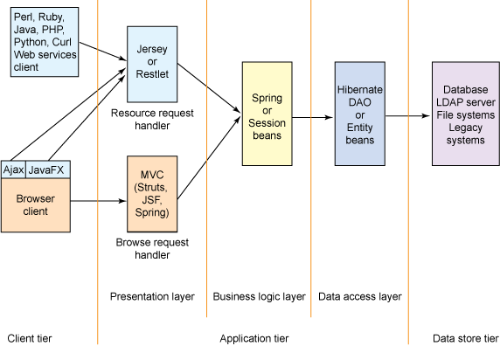
Figure 1. Diagram of a multi-tiered Web application
Hadoop
Hadoop is an open source software built by Apache. The software is a framework for storage and large-scale processing, it does this on large data-set, by clustering the data on commodity hardware. There are mainly five building blocks inside this runtime environment (from bottom to top):
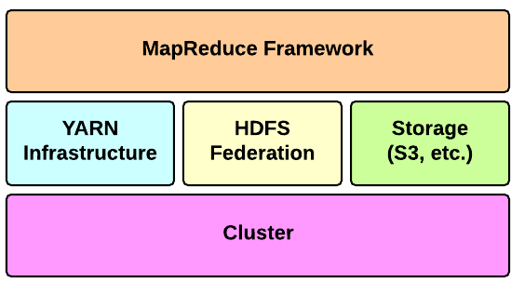
Figure 2: Hadoop Runtime Environment
Apache Hadoop offers a scalable, flexible and reliable distributed computing big data framework for a cluster of systems with storage capacity and local computing power by leveraging commodity hardware. Hadoop follows a Master Slave architecture for the transformation and analysis of large datasets using Hadoop MapReduce paradigm. The 3 important Hadoop components that play a vital role in the Hadoop architecture are -
- Hadoop Distributed File System (HDFS) – Patterned after the UNIX file system
- Hadoop MapReduce
- Yet Another Resource Negotiator (YARN)
Hadoop follows a master slave architecture design for data storage and distributed data processing using HDFS and MapReduce respectively. The master node for data storage is Hadoop HDFS is the NameNode and the master node for parallel processing of data using Hadoop MapReduce is the Job Tracker. The slave nodes in the Hadoop architecture are the other machines in the Hadoop cluster which store data and perform complex computations. Every slave node has a Task Tracker daemon and a DataNode that synchronizes the processes with the Job Tracker and NameNode respectively. In Hadoop architectural implementation the master or slave systems can be setup in the cloud or on premise.
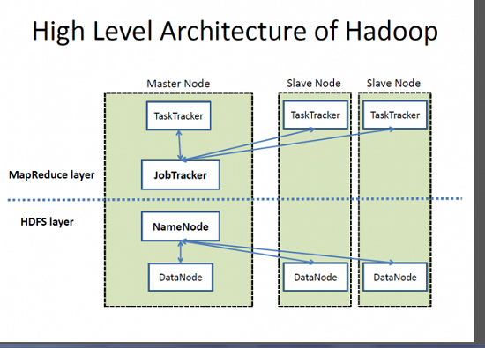
Figure 3: High level Architecture of Hadoop
The heart of the distributed computation platform Hadoop is its java-based programming paradigm Hadoop MapReduce. Map or Reduce is a special type of directed acyclic graph that can be applied to a wide range of business use cases. Map function transforms the piece of data into key-value pairs and then the keys are sorted where a reduce function is applied to merge the values based on the key into a single output.

Project layout
For the current project, the Hadoop structure will consist of three nodes, one will be set as the master, while the order two will be the slave. Figure 4 will show the basic layout:

Master
slave
slave

Figure 4: Current layout of Hadoop Structure.
There may be a fourth node add later in the project, to improve productive, speed and time to do the task.

Databases
A Database is a collection of records. Database management systems are designed as the means of managing all the records. Database Management is a software system that uses a standard method and running queries with some of them designed for the oversight and proper control of databases.
There are many different types of databases in use these days, the following is a few examples of these different types:
- Relational Databases
- Document-Oriented Database
- Real-Time Database
- Hypermedia Database
There are a lot more, but for this project, the type of database that will be used is Document-Oriented Database. There are also many different versions of this type of database, for this project the version called MariaDB will be used.
MariaDB Column Store is a columnar storage engine designed for distributed massively parallel processing (MPP). It consists of a number of different components, working together.
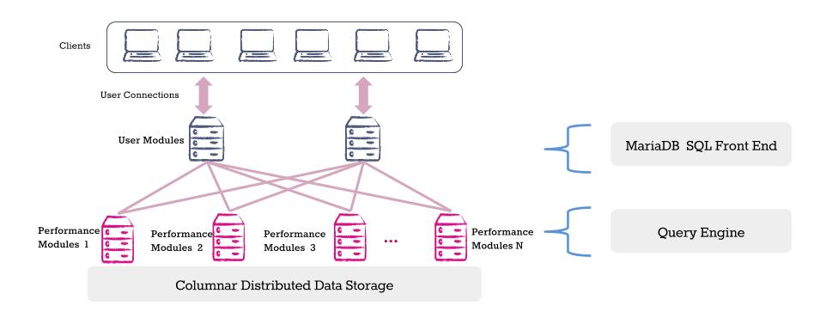
Figure 5: Columnar Distributed Data Storage.
These components include:
- User Module:
The User Module is made up of the front end MariaDB Server instance and a number of processes specific to MariaDB Column Store that handle concurrency scaling. The storage engine plugin for MariaDB Column Store hands over the query to one of these processes which then further break down SQL requests, distributing the various parts to one or more Performance Modules to process the query. Finally, the User Module assembles all the query results from the various participating Performance Modules to form the complete query result set that is returned to the user.
- Performance Module:
The Performance Module is responsible for storing, retrieving, and managing data, processing block requests for query operations, and passing it back to the User Module(s) to finalize the query requests. The Performance Module selects data from disk and caches it in a shared nothing data cache that is part of the server on which the Performance Module resides. MPP is accomplished by allowing the user to configure as many Performance Modules as they would like; each additional Performance Module adds more cache to the overall database as well as more processing power.
- Storage:
MariaDB Column Store is extremely flexible with respect to the storage system. When running on premise, it can use either local storage or shared storage (e.g. SAN) to store data. In the Amazon EC2 environment, it can use ephemeral or Elastic Block Store (EBS) volumes. When data redundancy is required for a shared-nothing deployment, it is built to integrate with GlusterFS and the Apache Hadoop Distributed File System (HDFS). In the first alpha release only local storage, shared storage and EBS configuration have been tested. HDFS and GlusterFS testing will be done in future alpha releases.
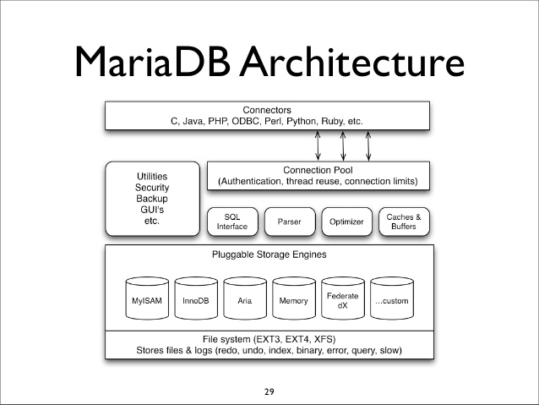
Figure 6: MariaDB Architecture.

