Active Intelligence
Building the Continuous Agentic Learning Loop
Semantic context layers, cross-layer inferencing, and a hybrid engine where ML decides in real time and the LLM strategizes
Prepared by Allen Hoem · Principal PM candidate, Context Intelligence & Marketing Reasoningv4 · June 2026

Executive summary
Active Intelligence already ships agentic AI that acts, not just answers — monitoring billions of signals, flagging why a campaign is over- or under-indexing against its sector, and recommending action automatically, compressing first-campaign time from 2.6 hours to ~18 minutes (8x). This blueprint defines the foundational layer beneath that experience: a structured context substrate of three semantic layers, a cross-layer inferencing engine that reasons across them, and a hybrid engine in which machine-learning models make the real-time decisions and the frontier LLM turns the scores into strategy and content.
The thesis sharpens here. An LLM left alone reaches for web “best practices” and hallucinated confidence. We invert that: scoring models ground the LLM. Predictive impact and success scores — trained per tenant, rolled up to industry and global tiers — constrain the agent’s reasoning to each customer’s real telemetry. The result is marketing-grade intelligence: explanations and recommendations anchored to measured outcomes, not internet lore. Deeper context produces grounded reasoning, which drives engagement, which deepens context — the Flywheel.

1. The strategic inflection
Marketing AI began as prompt-and-respond. Active Intelligence moved to agent-to-user — the system initiates. The next step is agent-to-outcome: the marketer declares a top-level goal (“Increase Q3 retention by 15%”) plus brand guardrails, and a multi-agent ecosystem pursues it continuously. For a base of 180,000+ businesses — mostly small teams without a data-science function — that is the difference between software you operate and intelligence that operates for you. The moat is not the model (a commodity input); it is the structured context only we hold and the grounding discipline that makes reasoning over it trustworthy.
What this unlocks for the marketer: they set objectives instead of babysitting automations, and they receive recommendations they can trust because each one is tied to their own performance data, not a generic playbook.

2. The two problem spaces

2.1 The Context Intelligence Layer (structured intelligence)
The Context Layer gives the system a deep, current understanding of each customer’s business. In v2 it is explicitly composed of three semantic context layers — Content, Campaign, and Individual — each continuously revised, markdown-summarized for fast retrieval, and scored. Together they form the grounded memory every agent reasons over: not a passive data lake, but a living, per-tenant context object.

2.2 The Deep Reasoning Agent (deep reasoning over dashboarding)
The Deep Reasoning Agent turns that context into insight — why engagement shifted, what top segments share, where the next campaign should focus. Its output is never a bare metric; it is an explanation plus a recommended action plus the evidence trail. Crucially, its reasoning is grounded by scoring models so the “why” is anchored to measured performance, not asserted from training priors.

3. Architecture
The diagram below revises the working block diagram into a single grounded system. Marketer surfaces sit on top; a cross-layer inferencing engine reasons across the three semantic layers; a hybrid engine splits the work — ML makes the real-time decisions while the LLM strategizes and generates; and a tenant→industry→global modeling hierarchy supplies the scores. Channels, creative briefs, and declarative goals feed the stack; post-campaign learning re-grounds the next loop.
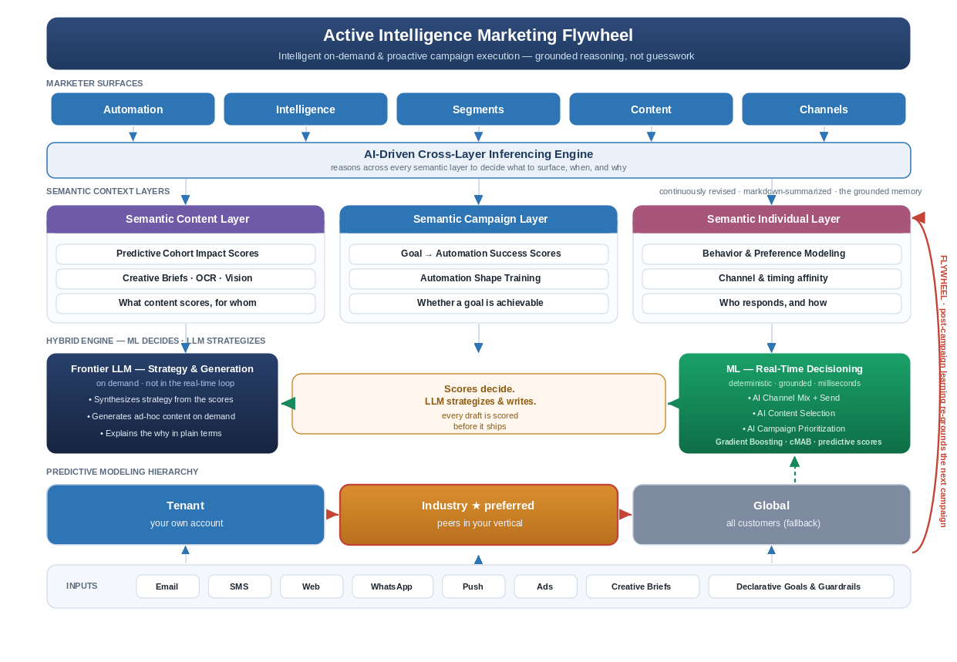
Figure 1 — Revised Active Intelligence architecture: grounded reasoning across semantic layers.

3.1 Marketer surfaces and the cross-layer inferencing engine
Active Intelligence presents across the surfaces marketers already use — Automation, Intelligence, Segments, Content, and Channels. Behind them, the cross-layer inferencing engine is the conductor: it reasons across all three semantic layers at once to decide what to surface, when, and why. A retention risk, for example, is only legible when Content scores, Campaign success scores, and Individual behavior are read together — no single layer sees it.

3.2 The three semantic context layers
Each layer owns a distinct question and a distinct set of scores. Each is continuously revised as campaigns execute and learning is captured.
Layer | Owns the question | Signals & scoring
Semantic Content Layer | Which content scores, and for whom? | Predictive Cohort Impact Scores; creative briefs ingested via OCR + Vision; per-cohort content performance.
Semantic Campaign Layer | Is this goal achievable, and how? | Goal→Automation Success Scores; Automation Shape Training; what automation structures convert.
Semantic Individual Layer | Who responds, and how? | Behavior & preference modeling; channel and timing affinity at the individual_id level.  Content and conversion preferences scored and matched.
“Semantic” is deliberate: each layer is summarized into language the agent can reason over and a vector the models can score, so the same context serves both the LLM and the ML stack.

3.3 The division of labor: ML decides, the LLM strategizes
This is the heart of the architecture — and the most common place teams get it wrong. The instinct is to put a frontier LLM in the real-time decision loop. We do not. Real-time decisioning is a machine-learning job; the LLM’s job is strategy, generation, and explanation.
- ML — the decisioning engine, in real time. Gradient Boosting, Contextual Multi-Armed Bandits, and predictive impact/success scores make the high-frequency calls — channel mix, send-time, content selection, and campaign prioritization — deterministically, in milliseconds, from numbers earned on real outcomes. This is where optimization actually happens.
- Frontier LLM — the strategist, on demand. The LLM never decides what to send in real time. It reads the scores to synthesize a marketing strategy, generates ad-hoc content when asked, and explains the why in plain marketing terms. Its output is language and creative — not routing weights.
Why the split matters in practice: frontier LLMs are too slow, too costly, and too non-deterministic to sit in a per-message decision loop at 180k-tenant scale — and putting them there is precisely how you get confident-sounding, ungrounded recommendations. ML keeps the decisions fast, cheap, and grounded; the LLM makes the strategy legible and the content fresh. And every LLM-generated asset is scored by the same ML models before it ships, so generation never escapes the grounding. Scores decide; the LLM strategizes and writes.

3.4 The predictive modeling hierarchy: tenant → industry → global
Scores come from a three-tier hierarchy, queried in order of specificity:
- Tenant model — the customer’s own account; most specific, but sparse for smaller businesses. Note: This may be difficult to achieve due to lower volume of SMB, thus, the need for the next tiers.
- Industry model (preferred) — peers in the same vertical, learned across tenants through the semantic abstraction / trust boundary. This is the sweet spot: dense enough to be reliable, similar enough to be relevant. Most SMBs lack the data volume to train a strong tenant model alone, so the industry tier is where grounding becomes trustworthy.
- Global model — all customers; the fallback for cold starts when neither tenant nor industry data is sufficient.
Because industry and global models are trained only on generalized semantic intent matrices — never raw copy or PII — cross-tenant learning compounds without anyone’s proprietary strategy crossing a tenant line.

3.5 Declarative Goals for Active Intelligence
The Declarative Goal framework functions as the formal contract between marketer intent and agentic execution. By surfacing these parameters as high-level configuration points rather than granular workflow steps, we ensure agents remain tethered to the user's specific business objectives, regulatory requirements, and brand guardrails.

3.6 Building Trust with multi-tentant semantic scoring
Raw input “I need to return this red XL sweater ASAP — it arrived torn” becomes [Urgency: High] [Category: Apparel] [Issue: Defect] before it informs any cross-tenant model. The customer’s words, identity, and our customer’s strategy stay behind the boundary; only generalized meaning crosses to train the industry and global tiers.

4. Eval-driven quality: the production bar
“Marketing-grade” must be measurable. Every AI feature is gated by an eval harness before promotion:
- Golden sets — versioned datasets of real campaign scenarios with known-good reasoning and recommendations.
- Quality rubrics — factual grounding in the scores, actionability, brand-voice adherence, and — critically — zero hallucinated or unsupported metrics.
- Automated grading — LLM-as-judge calibrated to human raters, running in CI so every prompt or model change is scored before release.
Grounding is itself an eval dimension: a recommendation that cannot be traced to a score fails the rubric. This is also how we safely adopt new frontier models — a candidate promotes only when it beats the incumbent on the golden set.

5. Tenancy, trust, and scale
The architecture serves 180k+ businesses on a logical multi-tenant baseline, with isolated single-tenancy for HIPAA/FINRA customers via the regulated_industry flag. The semantic layers maintain strict data partitioning; identity resolution stitches Email, SMS, Web, and WhatsApp touchpoints to one authoritative individual_id — holistic journeys without leaking PII across the trust boundary.

6. Strategic Roadmap

The following roadmap visualizes the progressive rollout of the Active Intelligence flywheel, moving from foundational content grounding to full-funnel, individual-level orchestration.
[Diagram Suggestion: A three-tiered arrow graphic progressing from left to right.
Phase 1 (Foundation): Content-Level Intelligence (Content Layer, Predictive Cohort Scoring).
Phase 2 (Orchestration): Campaign-Level Automation (Campaign Layer, Proactive Recommendations).
Phase 3 (Activation): Individual-Level Personalization (Individual Layer, Predictive Simulation). Flow below the arrows: Data -> Context -> Reasoning -> Action -> Feedback Loop.]

Phase 1: Content Scoring & Semantic Content Layer
- Focus: Establishing the semantic foundation by grounding content performance in data.
- Key Deliverables: Implementation of the Semantic Content Layer; deployment of Predictive Cohort Impact Scoring; integration of OCR/Vision for AI tagging to be eventually scored.
- Exit Criteria: Model-validated correlation between cohort scores and content engagement; successful "LLM-as-judge" calibration against content-scoring golden sets.

Phase 2: Proactive Campaign Recommendations & Semantic Campaign Layer
- Focus: Moving from descriptive scoring to prescriptive campaign automation.
- Key Deliverables: Deployment of the Semantic Campaign Layer; engine logic for goal-to-automation success scoring; automated surfacing of high-propensity "Plays" in the marketer dashboard.
- Exit Criteria: >10% uplift in campaign success rates compared to baseline; zero hallucination rate on metric reporting as verified by the CI eval harness.

Phase 3: Individual Semantic Layer & Campaign Activation Simulation
- Focus: Closing the loop with individual-level identity resolution and predictive simulation.
- Key Deliverables: Integration of the Semantic Individual Layer (channel/timing affinity); unified Identity Resolution (Email, SMS, Web, WhatsApp); pre-launch "impact simulation" for campaigns.
- Exit Criteria: Successful cross-channel journey stitching with verified PII protection; "simulation accuracy" metrics aligning with live test-group performance.

7. Business impact — what the Flywheel compounds
- For the marketer: set a goal, not a flowchart, and trust the output — every recommendation is grounded in their own performance data, extending the 8x lifecycle compression into ongoing optimization.
- For ActiveCampaign: a structural data moat. Tenant→industry→global scoring means reasoning improves with scale; a new entrant with the same LLM starts at zero grounded context.

8. Key risks and mitigations
Risk | Mitigation
LLM hallucinates ungrounded advice | Scoring models gate every recommendation; “traceable to a score” is an eval-rubric requirement enforced in CI.
Sparse tenant data weakens scores | Industry-tier model is the default; tenant scores blend in only as volume and confidence grow.
Agent autonomy erodes trust | Evidence-attached recommendations, exploration caps, and human-in-the-loop approval for high-impact actions early on.
Semantic abstraction leaks PII/strategy | Trust-boundary red-teaming in the golden set; abstraction audit is a Phase 2 exit gate.
Frontier-model regressions ship | No model promotes without beating the incumbent on the golden set.

9. The prototype
This memo ships with an interactive, ActiveCampaign-skinned prototype — a live, multi-page web app — that surfaces the architecture inside the product. It demonstrates what a dashboard cannot:
- Proactive campaign creation from telemetry — the agent surfaces ready-to-launch campaigns triggered by signal shifts, each card showing the semantic layers and scores that grounded it and the predicted lift.
- From insight to launch, grounded — opening a play carries its reasoning into a campaign builder: predicted lift, model tier, and the scores it is built on, beside the campaign about to ship.
- Grounded drill-down reporting — a freeform Active Intelligence overview that drills into the Content, Campaign, and Individual layers, exposing the evidence behind every number.
A first-run guided tour walks a new marketer through each surface. Explore it live at allenhoem.github.io/active-intelligence-flywheel/prototype/.

9.1 Prototype in action
Four screens carry the argument, captured from the live prototype:

Figure 2 — Proactive campaigns: plays surfaced from telemetry, each grounded by semantic-layer scores, model tier, and predicted lift.
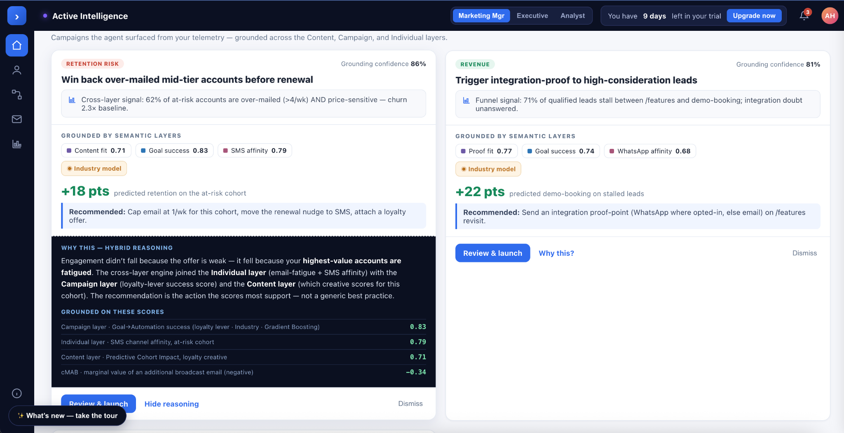
Figure 3 — “Why this?” expands the hybrid reasoning and the exact scores behind the recommendation, including the negative score for the tactic being suppressed.
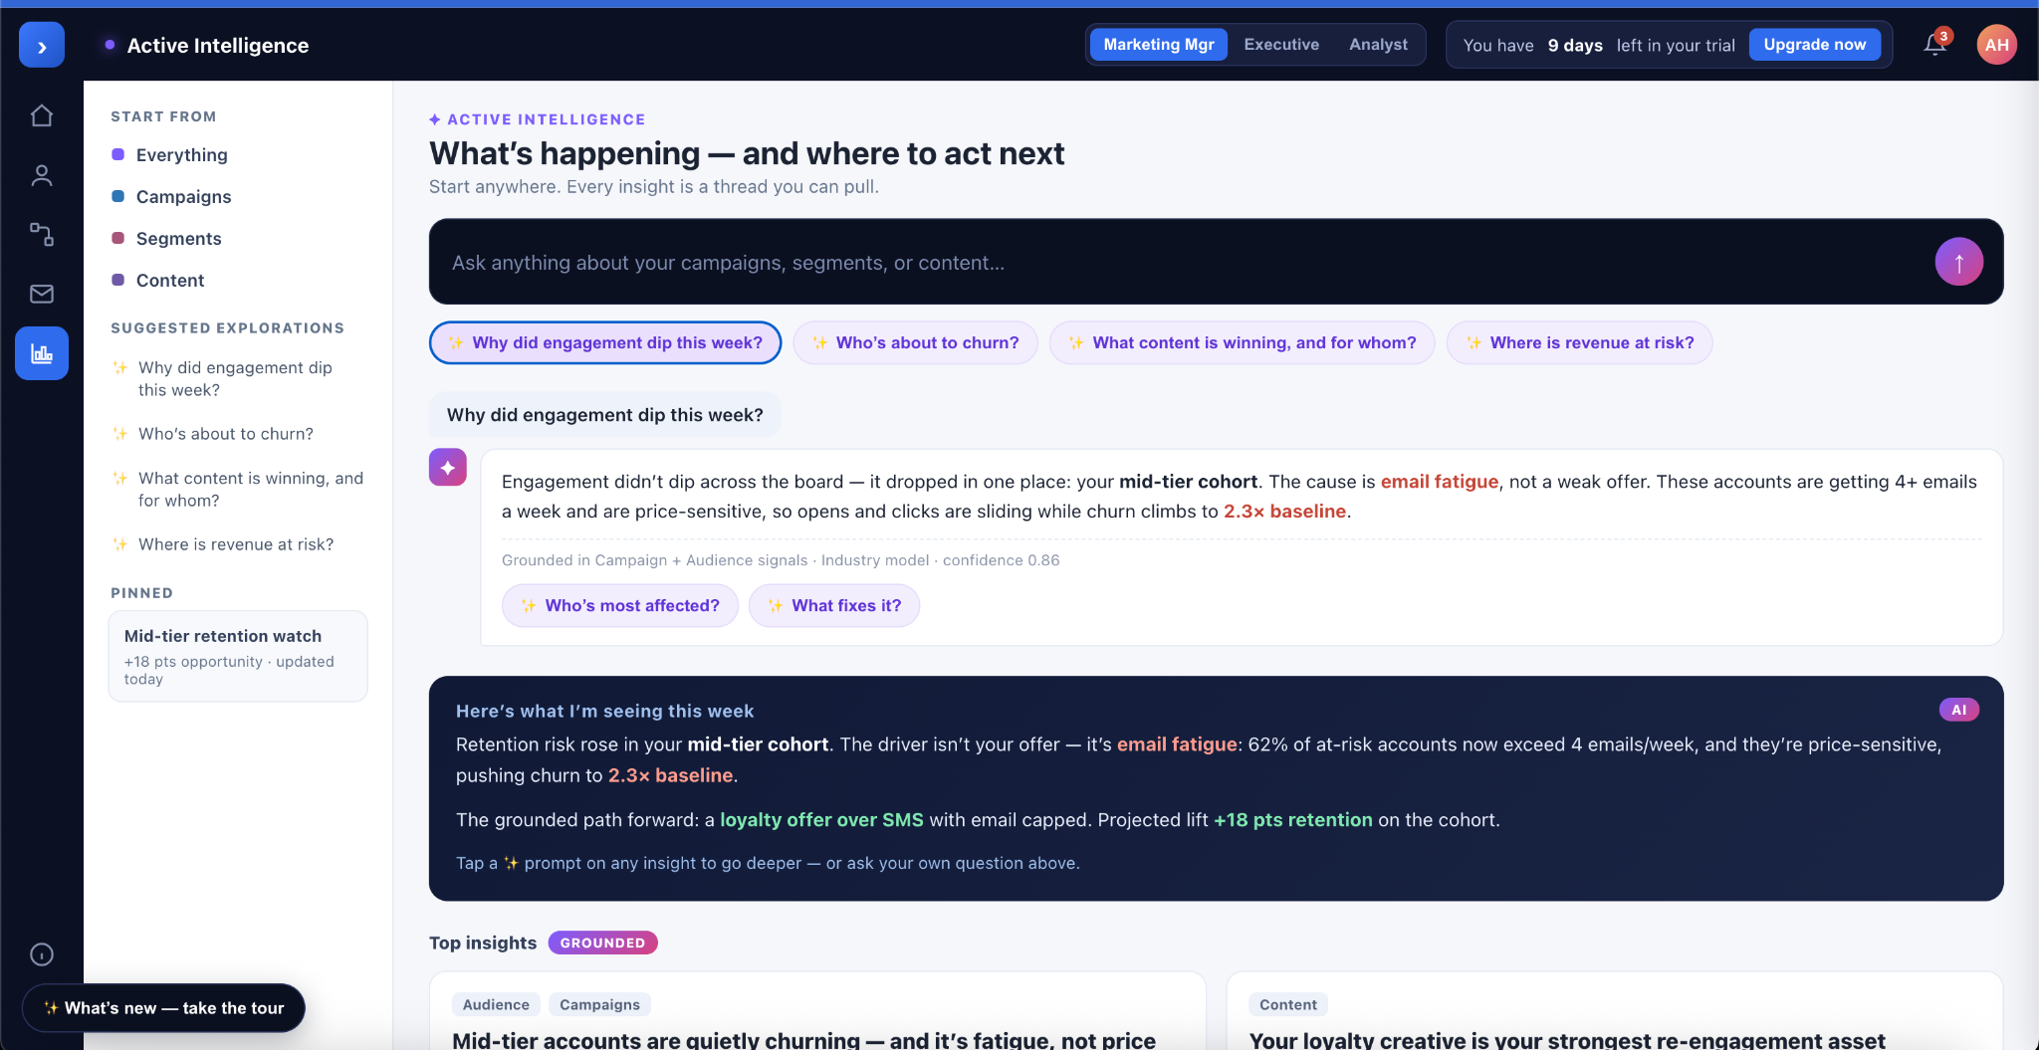
Figure 4 — Active Intelligence · Explore: plain-language insights, sparkle prompts, and a Claude-style ask box that turns any finding into a thread.
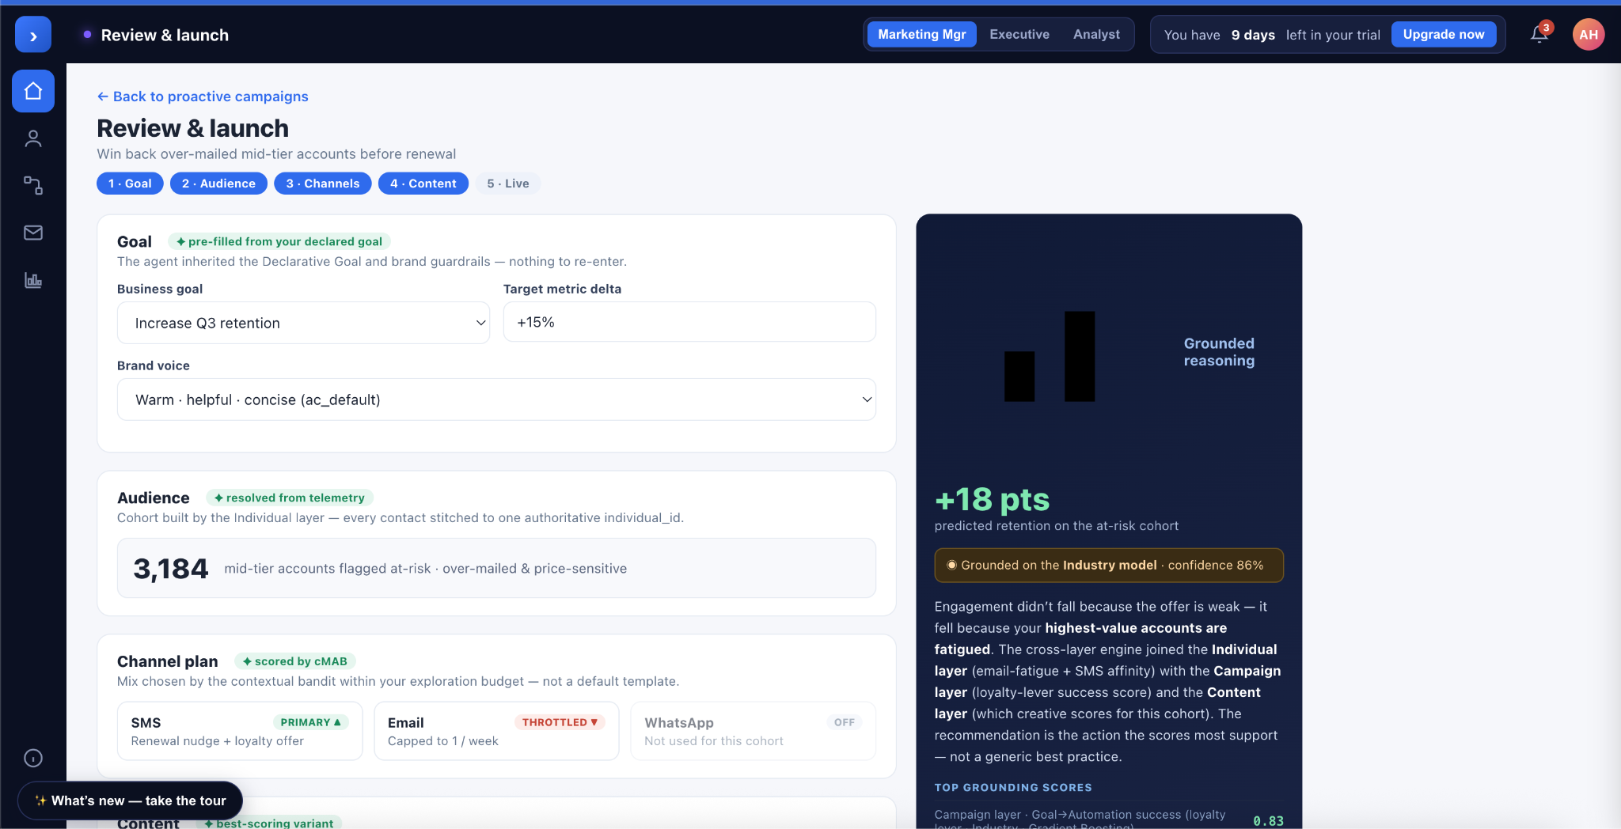
Figure 5 — Review & launch: the grounded play pre-filled, with the reasoning panel beside the campaign about to ship.

10. Future strategic bets
Beyond shipping the core flywheel, here is where Active Intelligence should place its next bets. Each extends the same grounded engine into new surface area, respects the trust boundary and the eval bar, and several deepen the moat in ways a competitor buying the same models cannot copy.

10.1 The Active Intelligence Skills Marketplace
A marketplace where customers and partners build and sell Active Intelligence Skills — packaged capabilities such as a vertical scoring model, a creative-generation recipe, or an analysis playbook — that plug into the ML and LLM layers model-agnostically. Skills are eval-certified before listing (they must clear the same golden-set bar we hold ourselves to), distributed through an SDK, and integrate behind the trust boundary against scores and semantic intents rather than raw data. Creators monetize their expertise; ActiveCampaign earns a commission on every sale.
Strategically this turns the flywheel into a platform: every new Skill deepens the context and sharpens the reasoning for everyone, the marketplace compounds the moat the way an app store does — network effects we own — and it adds a revenue line that scales with the ecosystem rather than with our headcount.

10.2 Paid-social automation on the Flywheel — Meta & X
Extend the agentic loop beyond owned channels (email, SMS, web, WhatsApp) into paid social — Facebook/Instagram and X. The same Declarative Goal and cMAB decisioning that route owned messages would allocate ad budget, sync semantic segments as custom and lookalike audiences, generate and pre-score creative, and close the loop on paid-conversion signals. The payoff: Active Intelligence becomes full-funnel — grounding paid spend in the same scores that ground retention — and the flywheel begins learning from acquisition signals, not just engagement. It also brings real ad budget under management, a materially larger value pool than owned-channel optimization alone.

10.3 Model Context Protocol (MCP) access
Delivered! Nice work Active Campaign team! https://www.activecampaign.com/platform/ai-mcp.

Make Active Intelligence speak MCP in both directions. As an MCP server, expose the Context Layer and Deep Reasoning Agent so a customer’s own agents — and the broader assistant ecosystem — can query grounded marketing context and trigger actions, governed by the trust boundary and the Declarative Goal. As an MCP client, let the agent pull external context (CRM, data warehouse, ad platforms, support) into its reasoning. The bet: Active Intelligence becomes the grounded marketing-context layer for the agent ecosystem — interoperable, and sticky precisely because it is the source of truth others build on.

10.4 Agent-to-UI (A2UI) for Claude, ChatGPT & Gemini
Render and drive Active Intelligence experiences — the proactive plays, the explore surface, the campaign builder — directly inside the leading assistants via agent-to-UI / generative-UI surfaces. Marketers increasingly start their day in Claude, ChatGPT, or Gemini; A2UI meets them there, with grounded, actionable intelligence rendered in line rather than as a link out. This is a distribution bet, and we stay deliberately model-agnostic across all three — capturing the surface without taking on single-channel dependency, the same agnosticism that defines the engine.

10.5 Vertical Industry Packs.

Pre-trained industry models bundled with curated Skills for specific verticals — healthcare, financial services, ecommerce. This leans directly on the industry-model preference and the regulated-tenancy capability, turning the architecture’s strengths into a go-to-market wedge and a deeper moat.
ML decides. The LLM strategizes and writes. Evals are the bar. The Flywheel is the moat.

