Active Intelligence
Building the Continuous Agentic Learning Loop
Semantic context layers, cross-layer inferencing, and a hybrid LLM×ML engine where scoring models ground the reasoning
Prepared by Allen Hoem · Principal PM candidate, Context Intelligence & Marketing Reasoning v2 · June 2026

Executive summary
Active Intelligence already ships agentic AI that acts, not just answers — monitoring billions of signals, flagging why a campaign is over- or under-indexing against its sector, and recommending action automatically, compressing first-campaign time from 2.6 hours to ~18 minutes (8x). This v2 blueprint defines the foundational layer beneath that experience: a structured context substrate of three semantic layers, a cross-layer inferencing engine that reasons across them, and a hybrid LLM×ML execution stack in which machine-learning scoring models keep the frontier LLM grounded in what actually performs.
The thesis sharpens here. An LLM left alone reaches for web “best practices” and hallucinated confidence. We invert that: scoring models ground the LLM. Predictive impact and success scores — trained per tenant, rolled up to industry and global tiers — constrain the agent’s reasoning to each customer’s real telemetry. The result is marketing-grade intelligence: explanations and recommendations anchored to measured outcomes, not internet lore. Deeper context produces grounded reasoning, which drives engagement, which deepens context — the Flywheel.
We ship in three phases (Prototype → Beta + Security Audit → GA), each gated by an eval harness. This memo embeds a revised architecture diagram and ships with an interactive, ActiveCampaign-skinned prototype of the experience.

1. The strategic inflection
Marketing AI began as prompt-and-respond. Active Intelligence moved to agent-to-user — the system initiates. The next step is agent-to-outcome: the marketer declares a top-level goal (“Increase Q3 retention by 15%”) plus brand guardrails, and a multi-agent ecosystem pursues it continuously. For a base of 180,000+ businesses — mostly small teams without a data-science function — that is the difference between software you operate and intelligence that operates for you. The moat is not the model (a commodity input); it is the structured context only we hold and the grounding discipline that makes reasoning over it trustworthy.
What this unlocks for the marketer: they set objectives instead of babysitting automations, and they receive recommendations they can trust because each one is tied to their own performance data, not a generic playbook.

2. The two problem spaces

2.1 The Context Intelligence Layer (structured intelligence)
The Context Layer gives the system a deep, current understanding of each customer’s business. In v2 it is explicitly composed of three semantic context layers — Content, Campaign, and Individual — each continuously revised, markdown-summarized for fast retrieval, and scored. Together they form the grounded memory every agent reasons over: not a passive data lake, but a living, per-tenant context object.

2.2 The Deep Reasoning Agent (deep reasoning over dashboarding)
The Deep Reasoning Agent turns that context into insight — why engagement shifted, what top segments share, where the next campaign should focus. Its output is never a bare metric; it is an explanation plus a recommended action plus the evidence trail. Crucially, its reasoning is grounded by scoring models so the “why” is anchored to measured performance, not asserted from training priors.

3. Architecture
The diagram below revises the working block diagram into a single grounded system. Marketer surfaces sit on top; a cross-layer inferencing engine reasons across the three semantic layers; a hybrid engine pairs frontier-LLM reasoning with ML scoring models; and a tenant→industry→global modeling hierarchy supplies the scores. Channels, creative briefs, and declarative goals feed the stack; post-campaign learning re-grounds the next loop.
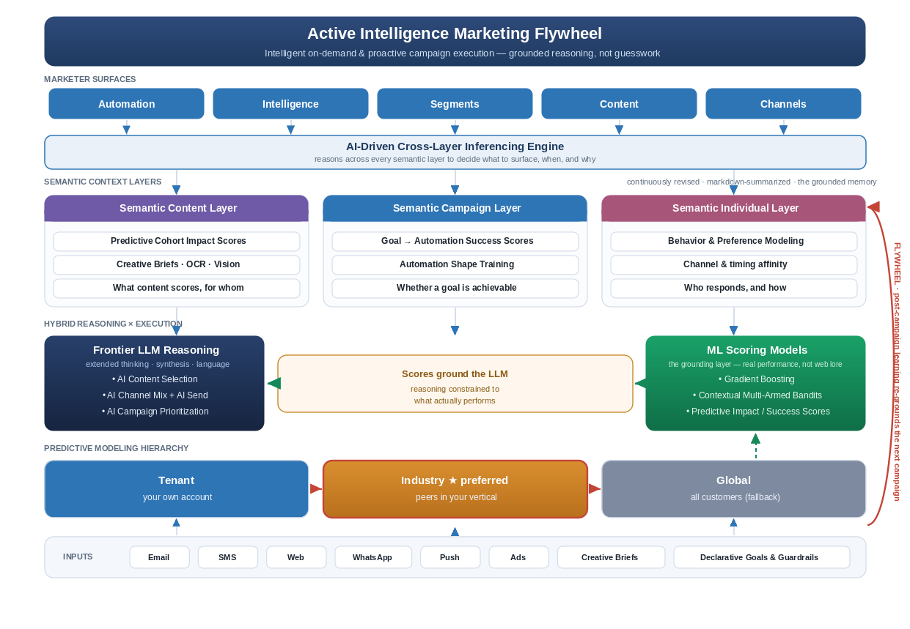
Figure 1 — Revised Active Intelligence architecture: grounded reasoning across semantic layers.

3.1 Marketer surfaces and the cross-layer inferencing engine
Active Intelligence presents across the surfaces marketers already use — Automation, Intelligence, Segments, Content, and Channels. Behind them, the cross-layer inferencing engine is the conductor: it reasons across all three semantic layers at once to decide what to surface, when, and why. A retention risk, for example, is only legible when Content scores, Campaign success scores, and Individual behavior are read together — no single layer sees it.

3.2 The three semantic context layers
Each layer owns a distinct question and a distinct set of scores. Each is continuously revised as campaigns execute and learning is captured.
Layer | Owns the question | Signals & scoring
Semantic Content Layer | Which content scores, and for whom? | Predictive Cohort Impact Scores; creative briefs ingested via OCR + Vision; per-cohort content performance.
Semantic Campaign Layer | Is this goal achievable, and how? | Goal→Automation Success Scores; Automation Shape Training; what automation structures convert.
Semantic Individual Layer | Who responds, and how? | Behavior & preference modeling; channel and timing affinity at the individual_id level.
“Semantic” is deliberate: each layer is summarized into language the agent can reason over and a vector the models can score, so the same context serves both the LLM and the ML stack.

3.3 Hybrid reasoning: scoring models ground the LLM
This is the heart of the architecture and the answer to LLM hallucination. Two engines work in concert:
- Frontier LLM reasoning — extended thinking, cross-source synthesis, and language. It decides AI Content Selection, AI Channel Mix + Send, and AI Campaign Prioritization, and it explains the why in plain marketing terms.
- ML scoring models — Gradient Boosting, Contextual Multi-Armed Bandits, and predictive impact/success scores. These are the grounding layer: numbers earned from real outcomes.
The LLM does not invent a recommendation and hope; it reasons within the envelope the scores define. A tactic the models score poorly for this tenant cannot be confidently recommended, regardless of how often the open web calls it a best practice. Language makes the insight legible; the scores make it true. That handshake — scores ground the LLM — is what separates marketing-grade intelligence from a clever chatbot.

3.4 The predictive modeling hierarchy: tenant → industry → global
Scores come from a three-tier hierarchy, queried in order of specificity:
- Tenant model — the customer’s own account; most specific, but sparse for smaller businesses.
- Industry model (preferred) — peers in the same vertical, learned across tenants through the semantic abstraction / trust boundary. This is the sweet spot: dense enough to be reliable, similar enough to be relevant. Most SMBs lack the data volume to train a strong tenant model alone, so the industry tier is where grounding becomes trustworthy.
- Global model — all customers; the fallback for cold starts when neither tenant nor industry data is sufficient.
Because industry and global models are trained only on generalized semantic intent matrices — never raw copy or PII — cross-tenant learning compounds without anyone’s proprietary strategy crossing a tenant line.

3.5 The Declarative Goal: a machine-readable contract
Strategic boundaries are enforced through a machine-readable goal configuration via the Declarative Goal API — the precise edges within which agents may operate.
Field | Type | Purpose
campaign_id | UUID | Scopes the goal to a campaign and tenant.
business_goal_type | Enum | Retention, acquisition, reactivation, revenue, etc.
target_metric_delta | Float | The declared outcome, e.g. +15% retention.
brand_voice_id | String | Binds generation to the tenant’s brand guardrails.
model_tier_pref | Enum | tenant | industry | global — defaults to industry.
exploration_budget | Float | How much the cMAB may explore vs. exploit.
regulated_industry | Boolean | Routes to isolated single-tenancy when true.

3.6 The trust boundary in one example
Raw input “I need to return this red XL sweater ASAP — it arrived torn” becomes [Urgency: High] [Category: Apparel] [Issue: Defect] before it informs any cross-tenant model. The customer’s words, identity, and our customer’s strategy stay behind the boundary; only generalized meaning crosses to train the industry and global tiers.

4. Eval-driven quality: the production bar
“Marketing-grade” must be measurable. Every AI feature is gated by an eval harness before promotion:
- Golden sets — versioned datasets of real campaign scenarios with known-good reasoning and recommendations.
- Quality rubrics — factual grounding in the scores, actionability, brand-voice adherence, and — critically — zero hallucinated or unsupported metrics.
- Automated grading — LLM-as-judge calibrated to human raters, running in CI so every prompt or model change is scored before release.
Grounding is itself an eval dimension: a recommendation that cannot be traced to a score fails the rubric. This is also how we safely adopt new frontier models — a candidate promotes only when it beats the incumbent on the golden set.

5. Tenancy, trust, and scale
The architecture serves 180k+ businesses on a logical multi-tenant baseline, with isolated single-tenancy for HIPAA/FINRA customers via the regulated_industry flag. The semantic layers maintain strict data partitioning; identity resolution stitches Email, SMS, Web, and WhatsApp touchpoints to one authoritative individual_id — holistic journeys without leaking PII across the trust boundary.

6. Phased rollout
Phase | Window | Scope | Exit gate
Phase 1  Prototype | ~30 days | Declarative Goal API; semantic layers v0 (Content + Campaign + Individual summaries & scores); grounding handshake on one goal type; offline cMAB; AC-skinned UI demo. | Grounded reasoning ≥ human baseline on the v1 golden set; live multi-view prototype.
Phase 2  Beta + Security Audit | ~Q3 2026 | Closed beta; online cMAB with exploration caps; industry-tier models live behind the trust boundary; PII/red-team audit; single-tenant isolation validated. | Pass security audit; design-partner lift on the declared metric; zero PII-boundary violations.
Phase 3  GA | ~Q4 2026 | GA across goal types and channels; tenant/industry/global hierarchy in production; full eval + grounding harness in CI; role-based reporting & notifications. | Adoption/retention targets across the base; grounding-pass-rate held above threshold release-over-release.

7. Business impact — what the Flywheel compounds
- For the marketer: set a goal, not a flowchart, and trust the output — every recommendation is grounded in their own performance data, extending the 8x lifecycle compression into ongoing optimization.
- For ActiveCampaign: a structural data moat. Tenant→industry→global scoring means reasoning improves with scale; a new entrant with the same LLM starts at zero grounded context.
- For regulated segments: single-tenant isolation unlocks healthcare and financial-services accounts — new TAM, not just better retention.

8. Key risks and mitigations
Risk | Mitigation
LLM hallucinates ungrounded advice | Scoring models gate every recommendation; “traceable to a score” is an eval-rubric requirement enforced in CI.
Sparse tenant data weakens scores | Industry-tier model is the default; tenant scores blend in only as volume and confidence grow.
Agent autonomy erodes trust | Evidence-attached recommendations, exploration caps, and human-in-the-loop approval for high-impact actions early on.
Semantic abstraction leaks PII/strategy | Trust-boundary red-teaming in the golden set; abstraction audit is a Phase 2 exit gate.
Frontier-model regressions ship | No model promotes without beating the incumbent on the golden set.

9. The prototype
This memo ships with an interactive, ActiveCampaign-skinned prototype that surfaces the architecture inside the product. It demonstrates three things a dashboard cannot:
- Proactive campaign creation from telemetry — the agent surfaces ready-to-launch campaigns triggered by signal shifts, each card showing the semantic layers and scores that grounded it and the predicted lift.
- Grounded drill-down reporting — a freeform Active Intelligence overview that drills into the Content, Campaign, and Individual layers, exposing the ML/LLM evidence behind every number.
- Role-based views and notifications — the same intelligence re-framed for Executive, Marketing Manager, and Analyst, with proactive alerts tailored to each role.
Open “active_intelligence_ac_ui.html” in any browser to explore all three.
Scores ground the reasoning. Evals are the bar. The semantic layers are the memory. The Flywheel is the moat.

