Answer Sheet for Midterm Exam

1. (a) (b)
3
3
r
d
r
d
r
n
d
r
n
d
r
n
d
r
n
d
r
n
d
r
n
0
1
r
d
2
0
0
r
d
1
2
1
r
d
3
a
H0
H1
H2
H0
H1
H2
 | row | col | Val
a[0] | 3 | 3 | 3
[1] | 0 | 0 | 1
[2] | 0 | 1 | 2
[3] | 2 | 1 | 3

2.
100
-3
-1
30
20
0
-100
p

3. (a) C (b) D

- [1] n-3 [2] n [3] ⎣n/2⎦+1 [4] n-4

- (a) The tree is empty or is skewed to the left
(b) The tree is empty or has a single node only
(c) The tree is empty or is skewed to the right
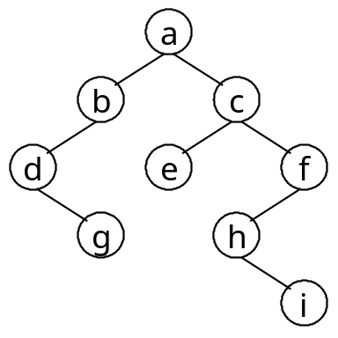
6. (a) (b)
c
e
f
h
i
b
d
g
a

(c) No. has a right child.
a

8
6
35
102
26
56
70
42
2
88
99
7.

8. (a) child ++ child/2 list[child/2]
- 92, 86, 56, 70, 35, 33, 48, 65, 12, 24
0
a
/
0
b
1
0
c
0
d
/
0
e
t
9. Reverse p, and t is the new head pointer.

10. Sample program:

Boolean delete_BST(tree_pointer *tree, int x)
{ /* delete all the nodes with key < x from BST tree */
/* return a signal of failure or success after deletion */
tree_pointer root = *tree;

if (x<1 || x>100) { /* handle illegal function call */
printf("ERROR: illegal input: x must be in [1, 100].\n"); return FALSE;
}
if (!root) return TRUE; /* if tree is empty, do nothing */
if (root->key <= x) { /* the left subtree (and the root if < x) must be deleted */
free_tree(root->left_child); /* delete the left subtree */
if (root->key < x) {
*tree = root->right_child; /* the current root is root of right subtree */
free(root); /* delete the root */
delete_BST(tree, x); /* check the right subtree */
}
else /* if x == root->key */
(*tree)->left_child = NULL; /* re-define the left child of root */
}
else /* if x < root->key */
delete_BST(&(root->left_child), x); /* check the left subtree */
return TRUE;
}

void free_tree(tree_pointer tree)
{ /* recursive postorder traversal to free each node of tree */
if (!tree) return;
free_tree(tree->left_child); free_tree(tree->right_child); free(tree);
}

