Version 0.0
Tuesday, April 16, 2019
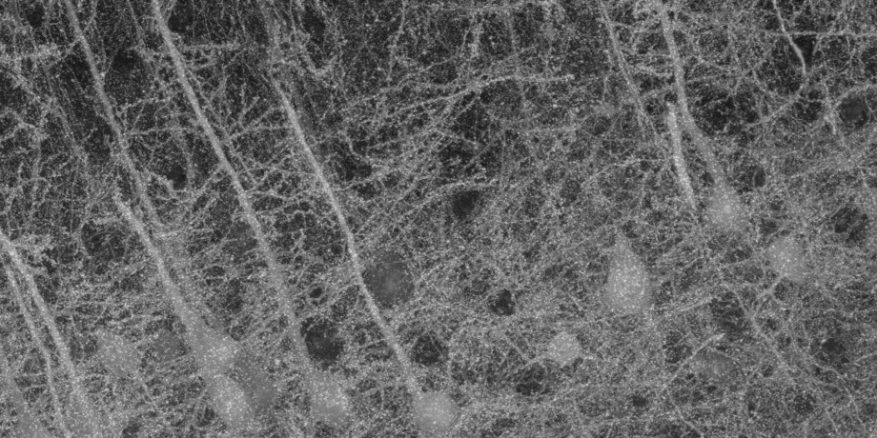
Smith Lab, The Allen Institute for Brain Science

Preface
AT introduction here..
The ATExplorer application integrates a workflow, as well as a number of software components
that are useful in the context of Array Tomography.
The following software components are the main building blocks that ATExplorer is built on
top of:
- RENDER PYTHON by F Collman et al. RenderPython is a thin Python wrapper for Render.
- RENDER by ??? et.al
- FIJI by et. al....
- DOCKER et. al.
In addition to the above, semi specialized software packages, a number of open source, C++,
libraries are employed by the ATExplorer application:
- VTK by
- POCO by ??? et.al
- LIBCURL by et. al....
- TINYXML2 et. al.
- DUNE SCIENTIFIC LIBRARY (DSL) et. al.
The ATExplorer application was designed and implemented in the lab. of Stephen J Smith and
Forrest Collman, at the Allen Institute of Brain Science by Totte Karlsson.

The following people has been contributing to the effort; ....

Overview of the ATExplorer UI’s and underlying software

Introduction
This chapter gives an overview of the software application that is named ATExplorer.
The ATExplorer application was designed and implemented due to an emerging need to allow non-programmers to process, manage and explore Array Tomography data on a routine basis.
Depending on the actual protocols, an Array Tomography data set can range in size from a few hundred megabytes, to very large, like several Terra bytes. Depending on the number of stains and sessions, the complexity of the data-sets range from trivial to complex.
One of the main challenges in Array Tomography is the precise digital reconstruction of an original volume, i.e. from individually cut and imaged slices of tissue.
However, before volume reconstruction can begin, various pre data processing algorithms needto be applied, such as median filtering, flat-field correction and de-convolution. These processing algorithms are all, to some extent, complex. ATExplorer provides the non-programmer user with intuitive and easy to use UI components to guide through this process, in order to quickly get to data that is useful for scientific discovery and exploration.

A manual Array Tomography workflow
In order to get from raw acquired data to fine aligned 3D volumes, a number of processing steps,
i.e. a pipeline, is required. (Create a pipeline figure)
_ FLATFIELD CORRECTION
_ DECONVOLUTION
_ STITCHING
_ REGISTRATION
_ ROUGH ALIGNING
_ FINE ALIGNING
_ OTHER
The pipeline is integrated into the ATExplorer UI. However, in certain situations it may be
necessary to push data through the pipeline manually. ATExplorer provides a set of Python scripts
that can be used for this purpose. The scripts are to be found in the folder /atPipeline/source
and /atPipeline. These pipeline scripts can be executed on their own, or from within the UI.
Each pipeline script is discussed in terms of their purpose, input and output data, in the sections below.

Creation of Renderstacks from raw image data
The first step in order to get easy and useful access to raw data is to create stacks in Render. A
stack, in this context, can be thought of as an object in the Render backend that that keep positional and orientational information about a set of imaged section tiles.
However, before this data can be populated, a set of files, statetables, need to be created using
the python script createStateTables.py. A statetable file contain meta data for individual section, by
session.
- create_state_tables
- create_rawdata_render_multi_stacks
- Creation of median files
- Create_flatfield_corrected_data.py

The Render Service

The ATExplorer UI
Figure 1: ATExplorer UI. The circled numbers in the figure indicate relevant elements of the UI; 1 Project(s) TreeView. 2 Tabbed Project Item View. 3 Information and Application Log Messages.

1.4.1 Importing Data
_ IMPORTING PROCESS Give an overview on what happens when data is being imported to ATExplorer
.
_ DATA FORMATS Describe the Allen Institute format, and Kristinas format.

1.4.2 Connect to a a Remote (or local) RenderHost

1.4.3 Create of RenderStacks

1.4.4 Manage Stacks in Render

1.4.5 Explore Data

Appendices

Setup a RenderHost and RenderPython

Software Design and Software Components

ATExplorer UI
ATExplorer UI
The ATExplorer UI is a Microsoft Windows desktop application implemented using Embarcadero’s
C++ Builder tools. The C++ Builder environment provide a programmer with hundreds of components
for efficient and rapid development of Windows applications. In addition, thousands of third
party components are available as well.
This appendix discusses some of the software designs and software components employed
when implementing the ATExplorer
C.1.1 Observers and subjects
The Tree view and PageControl .
C.1.2 The TreeView
The items in the Treeview stores data objects as (void*) pointers. Any object registered with the
tree (as a node) need to be a descendant of the class ExplorerObject. Typical scenario:
ExplorerObject* eo = (ExplorerObject*) node->Data
if(dynamic_cast<...>(eo))
{}
Populating an ATData object
ATExplorer Software API’s
atCore
C.2.2 atData
C.2.3 atVCLCore
C.3 ThirdParty libraries
C.3.1 Poco
C.3.2 libCurl
C.3.3 SQLite 3
C.3.4 TinyXML2
C.3.5 Dune Scientific libraries: dslFoundation

ThirdParty libraries

How to Build ATExplorer and its API’s
Public Software Repository: git@github:com : TotteKarlsson=ATExplorer:git

Data formats . . . . . . . . . . . . . . . . . . . . . . . . 29
Allen institute stat format
Kristina format

Arraybot and ArrayCam . . . . . . . . . . . . . 31

atDB

ATClassifier

