Draft schema for common E-Phys and O-Phys file format, Allen Institute (October 2014)

The schema described here is based on HDF5 and it includes both data and analysis components. Data is organized based on whether it is being recorded from the system (acquisition) or being pushed into the system (stimulus). Analysis is organized based on whether it is common analysis techniques, such as spike sorting (processing) or end-user and lab-specific analysis (analysis). The file represents one experimental session for a single animal.

Data sequence
The file format is designed around a data structure called a 'sequence' which stores time-varying data. A data sequence is a superset of several INCF types, including time series, signal events, image stacks and experimental events. To account for different storage requirements and different modalities, a sequence can be extended, or subclassed.

Sequence organization
Each sequence has its own HDF5 subgroup, and all datasets of the schema are in that subgroup.
Dataset | Attribute | Type | Description | Comment
description |  | text | verbal description of sequence | Eg, what sequence represents, where data comes from, etc
ancestry |  | text array | family (subclass) hierarchy | Array describes the names of all parents, in order. Eg, [0]=”Electrical” [1]=”Patch-clamp”.
data |  | polymorphic | values in sequence. can also store binary data (eg, image frames)
sampling_rate |  | int | samples per second | Approximate value. Actual sampling rate derivable from timestamp array
num_samples |  | int | number of data samples, or image frames
filter |  | text | describes filtering that's been applied to stored data
timestamps |  | double array | Timestamps for every N'th sample | Time relative to experiment start time. Units of seconds.
t_interval |  | int | N | For event data, N=1 (ie, timestamp stored for all samples).
discontinuity_idx |  | int array | When time series is broken, mark index of each resumption | Only relevant for N>1
discontinuity_t |  | double array | When time series is broken, mark time of each resumption | Only relevant for N>1

Time representation
The format is designed to store irregularly occurring events as well as regularly sampled data, including regularly sampled data with irregular interruptions. The core of the approach is based on how Neuralynx represents time in their files, which is to either store timestamps with each sample (eg, for events) or to store timestamps at regular intervals (eg, for data series). This is configured by setting a value for 't_interval', defining the interval between time samples (eg, N=1 for events, N=512 for regularly sampled).

In a regularly sampled stream, a timestamp for every Nth sample is stored. This will help to account for clock drift, which is important for temporally aligning different sequences. To allow alignment in the event that a stream is interrupted, such as if stimulus/acquisition is temporarily disabled or interrupted, two discontinuity arrays are used. The first, discontinuity_t, stores the time when the signal resumes, and the second, discontinuity_idx, stores the index in the data array when the signal was resumed. Using discontinuity information and the sampling rate, it is possible to reconstruct the time of all samples with relatively high precision, even with many discontinuities and a large interval between storing regular timestamps, in turn allowing alignment of all samples between different sequences.

If only the start/stop time of a sequence is necessary, such as short recordings or where the sampling rate can be treated as constant, it is possible to store only the start and stop time in the timestamps array, with the timestamp interval N=(num_samples-1).

Data sequence subclasses
The data sequence is a data structure/object. It can be subclassed to represent more narrowly focused modalities (e.g., electrical versus optical physiology) as well as new modalities (eg, video tracking of whisker positions). When it a sequence is subclassed, new datasets are added to the modality, and all datasets of parent classes are preserved. An initial set of subclasses are described below.

DA extends Sequence
General class for storing digital-analog and analog-digital sequences, such as voltage, sound, resistance, etc.
Additional datasets | Type | Description | Comment
data | float array | All subclasses use data as float array (multidimensional possible) | This and all child classes use data as a float array
resolution | float | Minimum acquisition resolution | minimum acquisition resolution
max_value | float | Max value in data[] | max value in data[]
min_value | float | Min value in data-= | min value in data[]

Position extends DA
Stores spatial data about environment, such as physical position, pupil center, etc.
Additional datasets | Type | Description | Comment
lost_intervals | double array | 2D array storing intervals where position data was not determinable or was not reliable | For some scenarios, can be overloaded to include different aspects of physical environment. Eg, for pupil tracking, can store pupil center plus size (eg,, x,y,r)

Electrical extends DA
Stores acquired voltage data, from intra- and extracellular recordings
Additional datasets | Type | Description | Comment
electrode_map | int array | Indices to electrodes stored in experiment's electrode map array

Patch-clamp extends Electrical
Stores acquired voltage data from intracellular patch-clamp recordings
Additional datasets | Type | Description | Comment
holding_current | float |  | units: Volts
access_resistance | float |  | units: Ohm

Spike-event extends Electrical
Spike events are snapshots of, eg, threshold crossings. All events span the same recording channels and store snapshots of equal duration. The 't_interval' value is set to one for this and all subclasses.
Additional datasets | Type | Description | Comment
t_interval |  | set to 1
sample_length | int | number of samples per snapshot | This is technically redundant with dimensions of 'data' but is explicit to detect if 'data' is transposed versus what was expected.

Image extends Sequence
General image data
Additional datasets | Type | Description | Comment
format | text |  | eg, tiff, png, raw, external. For png/tiff, stacks are stored with in the png/tiff format. For raw, the sequence stores data from only one channel.
bits_per_pixel | int |  | only relevant for format='raw'. Bytes per image is int((bits_per_image+7)/8) – ie, not bit packing.
dimension | int array | number of pixels for on x, y and z axes | only relevant for format='raw'
frame_file | text | path or URL to external image file | only relevant for format='external'

Optical extends Image
Additional datasets | Type | Description | Comment
field_of_view | float array | width, height, depth of image | Units of meters
orientation | text | orientation of image relevant to reference frame. | Need to also describe frame of reference.

Two-photon extends Optical
Additional datasets | Type | Description | Comment
max_voltage | float |  | Units: Volts
min_voltage | float |  | Units: Volts
pmt_gain | float | photomultiplier gain
imaging_depth | float | imaging depth into tissue | ie, below surface. Units meters
scan_line_rate | float | scan lines per second | Units Hz

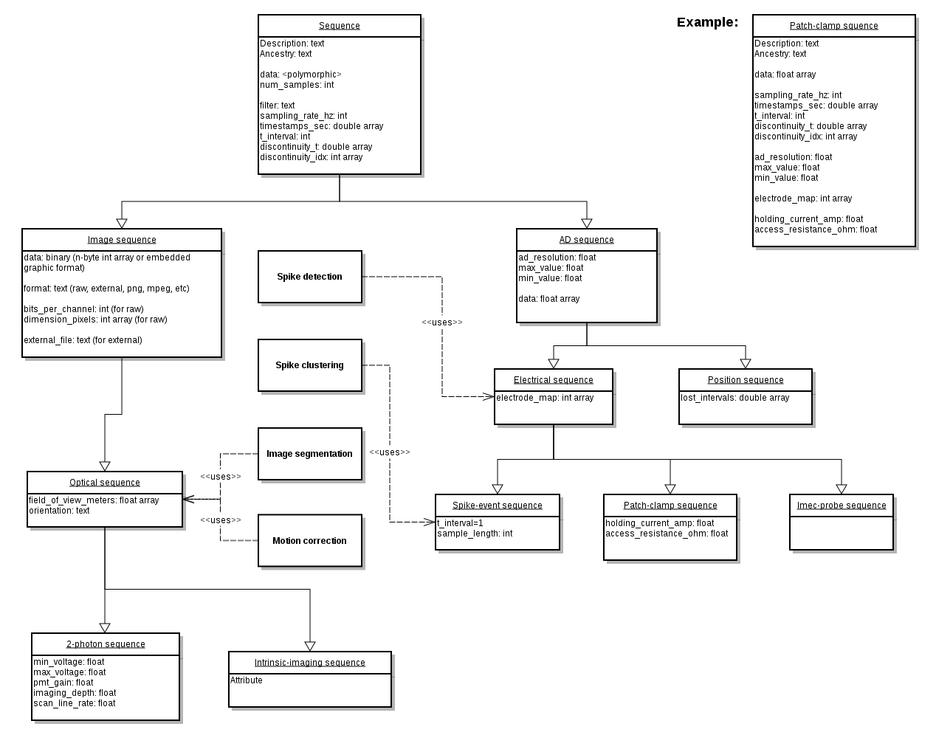

Schema description

File organization
The file is organized into several top-level groups.
Group | Description | Comment
/general | Experimental metadata, including protocol, notes and description of hardware device(s)
/acquisition | Data streams recorded from the system, including ephys, ophys, tracking, etc.
/stimulus | Data pushed into the system (eg, video stimulus, sound, current, etc)
/epochs | Experimental intervals, such as a sub-experiment | Epochs are logically distinct segments of an experiment, each often having a particular scientific goal or that requires a different mode of processing/analysis. Epoch boundaries should be definable before an experiment starts (but aren't always)
/processing | Intermediate analysis of data, including spike cluster, extracting position from tracking data, stitching together slice images | The data stored here represents the intermediate and output data using common techniques and tools (eg, klustakwik or klusters). Data (pre)processing techniques that are infrequently used or that are lab specific should be stored under 'analysis'
/analysis | Lab-specific and custom analyses | Processing and analysis done by different labs to explore different hypotheses. There is no defined schema for data in this folder. To share analysis data between labs, it should be stored in standard types (eg, INCF types) and appropriately documented.

Stylistic convention for groups and datasets is that all names are lower-case, using underscores to separate words.

Top-level datasets
Dataset | Type | Description | Comments
/ai_version | text | File version string | Eg, “AIFile.1.0.0”. Identifying string “AIFile” with major, minor and patch numbers.
/identifier | text | Unique file ID | Eg, concatenated lab name, file creation date/time and experimentalist, or a hash of these and/or other values. The goal is that the string should be unique to all other files.
/file_create_data | text | Time file was created, UTC | Date + time, Use ISO format (eg, ISO 8601). File can be created after experiment was run, so this may differ significantly from experiment start time.
/experiment_start_time | text | Time of experiment start, UTC | Date + time, Use ISO format (eg, ISO 8601). All time units stored in file use this time as reference (ie, T0)

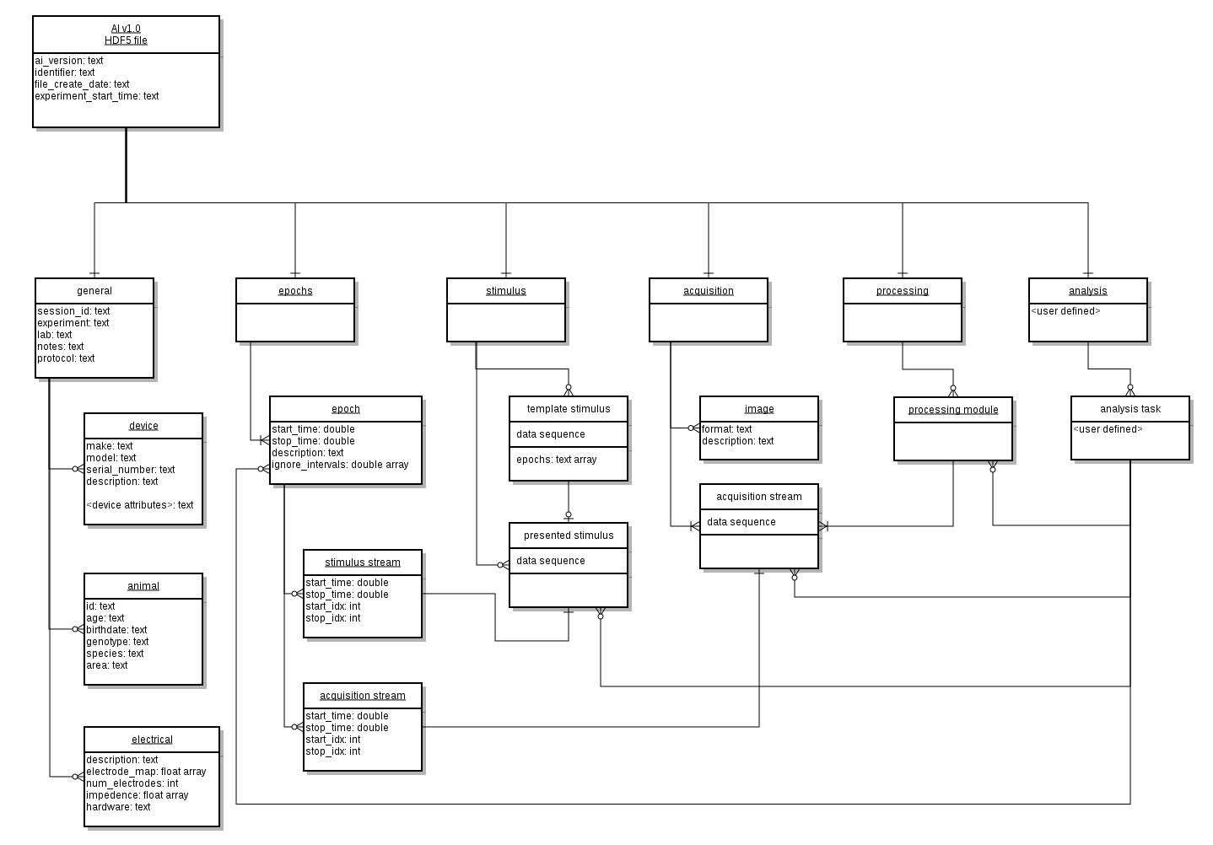

Top-level group: general
Datasets and subgroups | Type | Description | Comments
session_id | text |  | Only 1 session_id per file, with all time aligned to experiment start time.
animal | folder
id |  | ID of animal used in experiment
species |  | Species of recording | TODO Specify naming convention
genotype |  | Genetic strain | If absent, assume WT. Otherwise indicate genes knocked-in/-out. TODO Specify naming convention
age |  | Age of animal | TODO Specify naming convention
area |  | Recording site(s) | TODO Specify naming convention
experiment
lab
notes
protocol
devices | folder |  | Eg, monitors, ADC boards, microscopes, etc
NEC234WM | folder | Example device
description | text | eg, “24-inch NEC LCD monitor”
serial_number | text
resolution | text | eg, dpi for x and y
distance | text | distance of monitor from animal
electrical |  | meta-information for electrical
description | text | Information to interpret electrode position | In edge cases (eg, recording from soma + dendrite) there might not be a coordinate frame to indicate exact recording location. Data stored here should is human-readable and should give enough data to interpret non-standard reference frames. This information might be stored externally (eg, a website, doc file, etc).
num_electrodes | int
electrode_map | x,y,z float array | Physical location of electrodes | Location of electrodes relative to one another. This records the point in space. If an electrode is moved, it needs a new entry in the electrode map for its new location. Otherwise format doesn't support using the same electrode in a new location, or processing spikes pre/post drift.
impedance | float array |  | Units: Ohms
hardware | text | Ephys acquisition devices and types of electrodes used | The name of one or more entries /general/devices should be described here. If different electrodes are acquired using different hardware, a human parsable mapping between electrode numbers and devices should be provided here.
optical |  | meta-information for electrical

Top-level group: acquisition
Acquired data includes tracking and experimental data streams (ie, everything measured from the system)
Datasets and subgroups | Type | Description | Comments
sequences | folder | Acquired sequences | When importing acquisition data to neurodata file, all acquisition/tracking/stimulus data must already be aligned to a common time frame. It is assumed that this task has already been performed.
acquisition_sequence_x | generic sequence |  | Name is arbitrary
images | folder
image_x | binary | Photograph of experiment or experimental setup (video also OK) | Name is arbitrary
format (attr) | text | format of image | eg, jpg, png, mpeg
description (attr) | text | human description of image

Top-level group: stimulus
Stimuli are here defined as any signal that is pushed into the system as part of the experiment (eg, sound, video, voltage, etc). Many different experiments can use the same stimuli, and stimuli can be re-used during an experiment. The stimulus group is organized so that one version of template stimuli can be stored and these be used multiple times. These templates can exist in the present file or can be HDF5-linked to a remote file.
Datasets and subgroups | Type | Description | Comments
templates | folder | Template stimuli | Times stored in templates are all relative to the beginning of that stimulus. When templates are used, the stimulus instances must convert these times to the experiment's time reference frame.
template_stimulus_x | generic sequence |  | Name is arbitrary
epochs (attr) | text array | Epochs where this template was used | names in array correspond to those in /epochs
presentation | folder | Stimuli presented during the experiment
stimulus_sequence_x | generic sequence |  | Name is arbitrary

Top-level group: epochs
An experiment can be separated into one or many logical intervals, with the order and duration of these intervals often definable before the experiment starts. In this document, and in the context of the HDF5 file, these intervals are called 'epochs'. Epochs have acquisition and stimulus data associated with them, and different epochs can overlap. Examples of epochs are the time when a rat runs around an enclosure or maze as well as intervening sleep sessions; the presentation of a set of visual stimuli to a mouse running on a wheel; or the uninterrupted presentation of current to a patch-clamped cell. Epochs can be limited to the interval of a particular stimulus, or they can span multiple stimuli.
Datasets and subgroups | Type | Description | Comments
epoch_x |  | Different experimental epoch | Name is arbitrary but must be unique within the experiment.
description | text
start_time | double
stop_time | double
ignore_intervals | 2D double array
acquisition_series_x |  | input stream recorded during epoch | Name is arbitrary and does not have to match the sequence that it refers to
t_start | double | Starting time of sequence in epoch | Start and stop time are technically redundant, as this information is available within the series, but computing it from an arbitrary point in the time[] and discontinuity[] arrays is not necessarily trivial
t_stop | double | Endting time of sequence in epoch
idx_start | int | Epoch's start index in sequences data[] field
idx_stop | int | Epoch's stop index in sequences data[] field
sequence |  | link to sequence under /acquisition
stimulus_series_x |  | Output stream presented during epoch | Name is arbitrary and does not have to match the sequence that it refers to
t_start | double | Starting time of sequence in epoch | Start and stop time are technically redundant, as this information is available within the series, but computing it from an arbitrary point in the time[] and discontinuity[] arrays is not necessarily trivial
t_stop | double | Endting time of sequence in epoch
idx_start | int | Epoch's start index in sequences data[] field
idx_stop | int | Epoch's stop index in sequences data[] field
sequence |  | link to sequence under /stimulus/presentation

Top-level group: processing
'Processing' refers to intermediate analysis of the acquired data to make it more amenable to scientific analysis. Examples of intermediate analyses include spike sorting; image segmentation, normalization, and/or stitching; and extracting position data from tracking videos. Common tools that are used for data processing (eg, klustakwik or klusters) would be expected to write their data here. Custom analysis, as well as uncommonly and/or rarely used forms of intermediate analysis, and any analysis not clearly supported by this format, should be stored in the 'analysis' group.

Processing is broken down into modules. Presently, there are 3 module types, one for extracellular ephys, one for ophys, and one for tracking. Different software tools are expected to access and store data in these processing modules, with all software for a given modality (eg, spike clustering) using the same modality folder. Each application or tool that does processing of the data has its own data subfolder, “app_data_<X>”, and all application-specific data should be stored there. There are no data formatting requirements in any app_data folder, and the responsibility for defining and maintaining application data is the responsibility of the application designer.

Extracellular e-phys processing is done under folders having the name “electrical_N”, where “N” is a distinct number. Typically each electrode shank (or virtual shank) will have its own electrical_N folder. O-phys processing is done under folders named “optical_N”. Analysis of tracking data is stored under the “tracking” folder. No naming conventions have been defined for tracking yet.

Datasets and subgroups | Type | Description | Comments
electrical_0 | folder | Analysis of ephys data to extract the times and sources of individual spikes. | Name represents a specific processing round, for example for a particular shank or electrode group. The convention is for each shank to have an “electrode_N” entry for different N. If multiple processing rounds are performed on the same shank, append a letter to denote the different passes, eg, “Electrode_0b”
app_data_X | folder | Folder to store application-specific data for software tool “X” | Format of data in folder is arbitrary and is up to app developer to decide
electrode_map | int array | Indices to electrodes in /general/electrical/electrode_map | The indices are only for the electrodes being processed in this electrode group (eg, shank, tetrode, etc)
num_electrodes | int
features | 2D float array | List of features of each tracked event, used for clustering and/or cluster-cutting. | For example, peak, energy, PC1, PC2, PC3, for each event
description (attr) | text | Description of stored features
waveforms | Electrical sequence, N=1 | Snapshot of all electrodes during an event | This can be either a new sequence, derived from data under /acquisition, or a link to spike events stored in /acquisition, for example if the acquisition system only stored spikes, not a continuous signal
cluster | int array | Cluster number for each event in './waveforms' | for klustakwik, this corresponds to data in .clu.N file
notes | text | Description of method used to perform this processing round | A human-readable field describing, eg, parameters passed to the clustering algorithm, the cluster-cutting software used, what prior processing was done, etc.
template | 2D float array | Mean signal on all electrodes for each clustered event
template_sd | 2D float array | Standard deviation of signal on all electrodes
unit_0 | folder | First of many possible units | “_<n>” suffix for different clusters N
position | float array | x,y,z position of unit, if known | Units: meters
spikes | double array | Event times for unit, sorted | Units: seconds
optical_0 | folder | Analysis of ophys data | Name represents a specific processing round of o-phys data
app_data_X | folder | Folder to store application-specific data for software tool “X” | Format of data in folder is arbitrary and is up to app developer to decide
working_image_0 | Optical sequence | One or more intermediate images created during processing | Processing steps may include normalization, downsampling, motion correction, etc
image_x | Optical sequence | Reconstructed or processed image to use for analysis | Name is arbitrary. This represents the (a) final processed image from all of the working images.
unit_0 | folder | First of many possible units | “_<n>” suffix for different N
signal | float array | d<signal>/<signal> signal of object | dF/F for 2-photon, dR/R for intrinsic imaging. Sequence stores 1D data (ie, in data[], not image_data[])
spikes | double array | Sorted list of estimated spike times for unit | Time in seconds, relative to experiment start
name | text
mask | folder | pixels that compose object
mask_0 | int array | array of pixels this object consists of, at specified point in time | Name should include number and number should increment with each successive mask
timestamp (attr) | double |  | mask can change with time so need to store the start time of when this mask was used
tracking | folder | Processed tracking data | Lab-specific data can go here if it's stored as a sequence. If not, it should be put in /analysis
app_data_X | folder | folder to store application-specific data for software tool “X” | Format of data in folder is arbitrary and is up to app developer to decide
tracking_x | generic sequence | Data from a particular tracking stream | eg, rat position, lick direction, pupil size/direction. Necessary meta data for sequence is stored in sequence's 'meta' folder

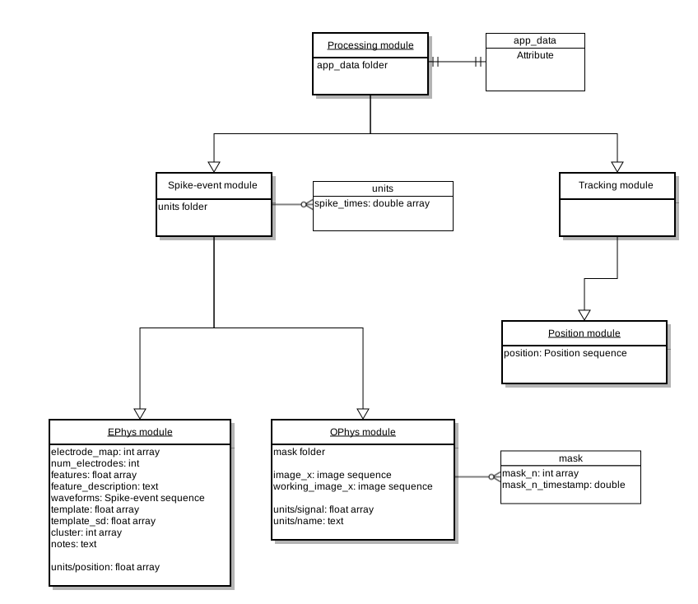
Top-level group: analysis

The file can store lab-specific and custom data analysis without restriction on its form or schema. Such data should be place in the analysis group. This analysis data should be documented and stored in a standard way, using INCF data types, so that it is sharable with other labs.

