OpenScope project workflow

# PROJECT NAME/NUMBER: OpenScope 2022 Illusion

# LIMS PROJECT CODE NAME: OpenScopeIllusion

# Goal of work:

Imagine being out in the open sea on a boat. Suddenly, you notice a dark shape passing by underwater. Even though the shape is distorted by the wave and the color is a mere shade different from the water, you mind automatically infers the outline of a shark.

Perception is inference rather than faithful reconstruction. However, sensory neuroscience has traditionally focused on the question of how faithfully/accurately the brain can represent sensory information. Moreover, sensory stimuli typically used in neurophysiology experiments make it difficult to dissociate between a neural representation that is faithful vs inferred. Illusions arise due to rational mistakes in perceptual inference, exemplifying the dichotomy between faithful representation and inferred representation. Here, we propose to utilize **illusory contours (ICs)** to study the neural mechanisms of perceptual inference.

**The binding problem** is a fundamental steppingstone towards cracking the neural code1,2. It concerns the question of “how are neural signals representing the same perceptual object bound?” The binding problem has two components, the spatial component (“which neurons need to bind?”) and the temporal component (“at what timescale do the neurons need to coordinate?”). These two problems are intricately linked, such that it is not possible to solve one without solving the other.

We propose to utilize the *OpenScope Neuropixels platform* to test the hypothesis that the binding required for encoding ICs is mediated by synchronous spiking of IC-encoding excitatory neurons (**Aim 1**). The binding-by- synchrony further posits that gamma oscillations (~40Hz) create time slots for synchrony. Accordingly, prior studies have shown IC-specific increases in gamma power15. Recently, there has been a debate about which inhibitory interneurons, parvalbumin (PV) vs somatostatin (SST) expressing neurons, mediate gamma oscillations necessary for binding16–19. We predict that the interneuron type that mediates binding will increase their synchronization during IC-encoding (**Aim 2**).

# WORKFLOW STEPS:

|  |
| --- |
| Steps: |
| Surgery  ISI  Passive Habituation/Behavior  Two photon imaging (Multiscope)  Neuropixel recording  Perfusion  Brain Clearing  Tissuecyte  Brain OPT imaging  Post-Tissuecyte Analysis  Probe annotation  Vasculature Drawing  Registration to CCF  Mouse Closing |

# DATACUBE:

# EXPERIMENTAL DESIGN – Behavior/Habituation:

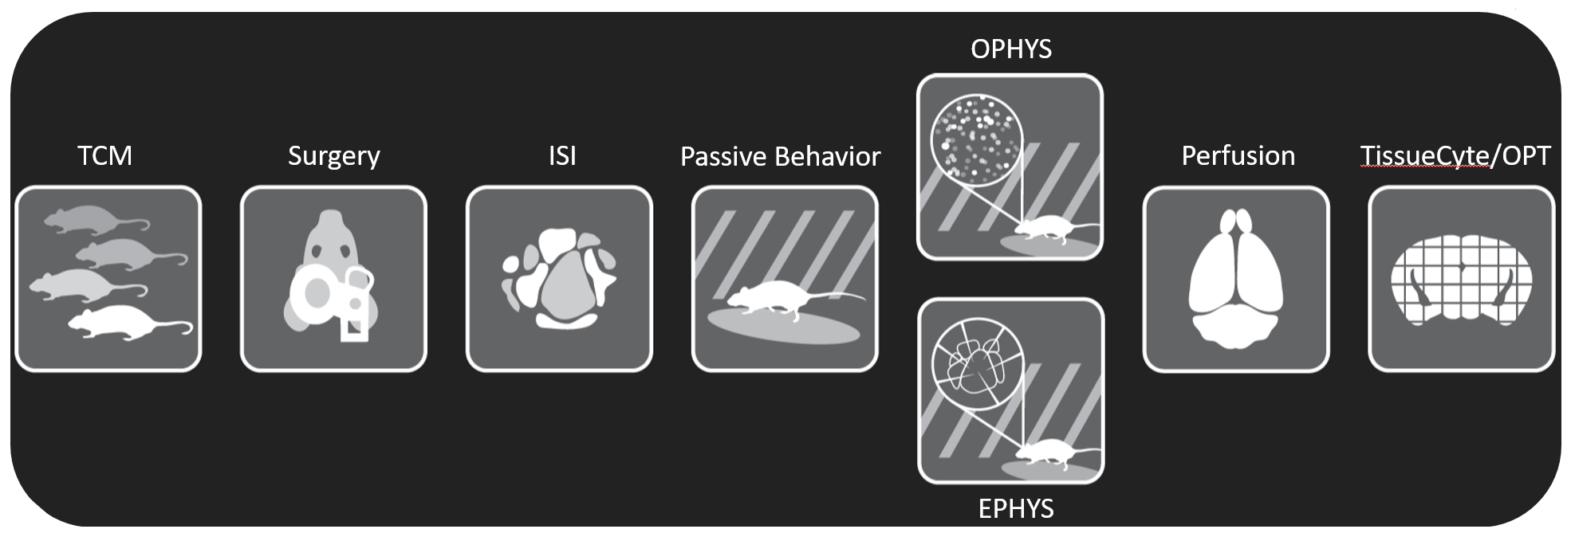

## 2 WEEK HABITUATION

### Week 1 Handling

|  |  |  |
| --- | --- | --- |
| DAY | DESCRIPTION | DURATION |
| 1 | Handling | 5 min |
| 2 | Handling | 5 min |
| 3 | Handling + Head Fixation | 5 min |
| 4 | Handling + Head Fixation | 10 min |
| 5 | Handling + Head Fixation | 10 min |

### Week 2: Operant Conditioning

|  |  |  |
| --- | --- | --- |
| DAY | SESSION DURATION | DESCRIPTION/CONDITIONS |
| note | *run illusion_stimulus_pilot.py* | *Nrep must be edited in Nrep.csv*  *illusion_stimulus_pilot.py calls ICwcfg1_1rep.stim, ICwcfg0_1rep.stim, ICkcfg1_1rep.stim, ICkcfg0_1rep.stim, RFCI_1rep.stim, sizeCI_1rep.stim,* |
| 6 | 10 min | *Nrep=2* |
| 7 | 20 min | *Nrep=5* |
| 8 | 30 min | *Nrep=8* |
| 9 | 40 min | *Nrep=10* |
| 10 | 50 min | *Nrep=14* |

# EXPERIMENTAL DESIGN – Data Collection:



## Session on Neuropixel rigs (Habituation and Recording Sessions)

### Habituation (modifications to scripts permitted)

|  |  |  |
| --- | --- | --- |
| **Day** | **Session duration** | **Description** |
|  |  | *illusion_stimulus_ habit.py calls ICwcfg1_ habit.stim, ICwcfg0_ habit.stim, ICkcfg1_ habit.stim, ICkcfg0_ habit.stim, RFCI_ habit.stim, sizeCI_ habit.stim,**DURFAC must be edited in DURFAC.csv* |
| Day 1 | 1h | *Set DURFAC=2, run illusion_stimulus_habit.py* |
| Day 2 | 1h | *Set DURFAC=2, run illusion_stimulus_habit.py* |
| Day 3 | 1h30 | *Set DURFAC=3, run illusion_stimulus_habit.py* |
| Day 4 | 1h30 | *Set DURFAC=3, run illusion_stimulus_habit.py* |
| Day 5 | 2h | *run illusion_stimulus_fullpipe.py* |

### Recording Sessions:

|  |  |  |
| --- | --- | --- |
| DAY | SESSION DURATION | DESCRIPTION/CONDITIONS |
| 1 | *2h (longer stim will cause more stress)* | *run illusion_stimulus_fullpipe.py* |

# EXPERIMENTAL DESIGN – Comments:

**Visual Stimulation:** Each visual stimulation session will consist of 3 blocks. The order of trials will be randomized within each block.

**Block A. Illusory Contour Block (~104 min, referred to as ICwcfg1, ICwcfg0, ICkcfg1, ICkcfg0 in the script):** The first block will be the illusory contour (IC) block (Figure 2A). IC stimuli contained illusory contours. Rotated control (RC) stimuli were designed such that the RC stimulus pair (RC1 & RC2) would match the IC stimulus pair (IC1 & IC2) in their component parts, but not evoke an illusory percept. T-type real edges (named after the T-shape within the image, denoted REt) were designed to dissociate between inferred vs faithful representation (for details, see Figure 3 and preliminary data section below): REt1 (REt2) was designed to have the same amount of overlap with IC1 (IC2) as with RC1 (RC2). X-type real edges (named after the X-shape within the image, denoted REx) were also designed to test for the presence of the inferred edge in IC evoked neural activity pattern (Figure 3 and preliminary data section): Each IC had equivalent overlap with either REx. For synchrony, noise correlation, and covariance analyses, trial repetition will be maximized in this block (400 repeats, ~80 min, **ICwcfg1**). Each stimulus will be presented for 0.4 sec, with 0.4 sec inter-stimulus interval. In addition, to examine horizontal and vertically oriented ICs, we will present another set of images by rotating each image in Figure 2A by 45 degrees; this set will be presented with lower trial counts (20 repeats, ~8 min, **ICwcfg0**). In addition, the same stimuli with black-white inverted will be presented (20 repeats each, ~8 min each, **ICkcfg1, ICkcfg0**)

**Block B. Receptive Field Mapping Block (~3.5 min, referred to as RFCI in the script):** We will use circular patches of drifting gratings to map receptive fields (Figure 2B). The diameter of the circular patch will be 16 visual degrees, matching the size of the illusory region in Block A (i.e., the gap distance between two diagonal white circles in Figure 2A *Blank* stimulus is 16 degrees). These circular patches will be presented in 9 different positions. The center location is at the center of the monitor, and hence matches the center of images in Block A. The other 8 positions will be located 16 degrees away from the center of the monitor. The drifting gratings will be presented in 4 directions (0°, 45°, 90°, 135°). The spatial (0.04 cycles/degree) and temporal (2 cycles/second) frequencies will be fixed to the mode of V1 neurons25,26. The drifting gratings will have 100% contrast and will be presented on a gray background. In addition, to examine feedback receptive fields, inverse gratings will be presented (full screen drifting gratings with gray circular patches27), with otherwise same features (positions, directions, spatial and temporal frequency, contrast). Each stimulus will be presented for 0.25 sec with zero inter-stimulus interval and repeated 10 times.

**Block C. Size Tuning Block (~13 min, referred to as sizeCI in the script):** This block is similar to Block B, but with the circular patches varying in size rather than position (Figure 2C). The circular patches will be concentric at the center of the monitor, and the diameter of the circular patches will vary between 0, 4, 8, 16, 32, 64 visual degrees. (Note that a classic grating with 0 degree size is a blank gray screen, whereas an inverse grating with 0 degree size is a full screen drifting grating). The drifting gratings will be presented in 8 directions (0°, 45°, 90°, 135°, 180°, 225°, 270°, 315°). Each stimulus will be presented for 0.25 sec with 0.5 sec inter-stimulus interval and repeated 8 times.



**Figure.** Visual Stimuli.

1. Illusory contour block (ICwcfg1). The illusory gap region is 16 visual degrees. This stimulus set will be presented as the images above (ICwcfg1), rotated 45 degrees (ICwcfg0), black-white inverted (ICkcfg1) and 45 degree rotated + black-white inverted (ICkcfg0).
2. Receptive field mapping block (RFCI). Circular patches are 16 visual degrees in diameter, 8 directions (45° intervals) and 9 different locations.
3. Size tunning mapping block (sizeCI). Concentric circular patches in different sizes (0, 4, 8, 16, 32, 64 visual degrees) will be presented in 8 directions.

# Tentative yearly schedule

|  |  |  |  |  |
| --- | --- | --- | --- | --- |
| **Illusion** | surgery | Stimulus delivery | Production run 1 | Production run 2 |
| Mar |  | We make new software workflows for the project with final stimuli |  |  |
| Apr | Ask for 1st surgeries | Validate workflow on NP0 and NP2 | 1 integration test mouse |  |
| May |  |  | 2 QC mice  *SST opto-tagging |  |
| Jun |  |  | External team evaluates | 1 QC mouse  *SST opto-tagging |
| Jul |  |  | External team re-evaluates opto-tagging plan (see below) | 2 QC mice  *SST opto-tagging |
| Aug |  |  |  | 2 QC mice  *opto-tagging tbd between SST vs PV |
| Sept |  |  |  | 2 QC mice  *opto-tagging tbd between SST vs PV |
| Oct |  |  |  | 1 QC mouse  *opto-tagging tbd between SST vs PV |
| Nov |  |  |  |  |
| Dec |  |  |  |  |

* Note, the original plan is to do opto-tagging in 7 SST and 3 PV mice, but depending on yield, we may re-evaluate and switch to 10 SST mice instead.