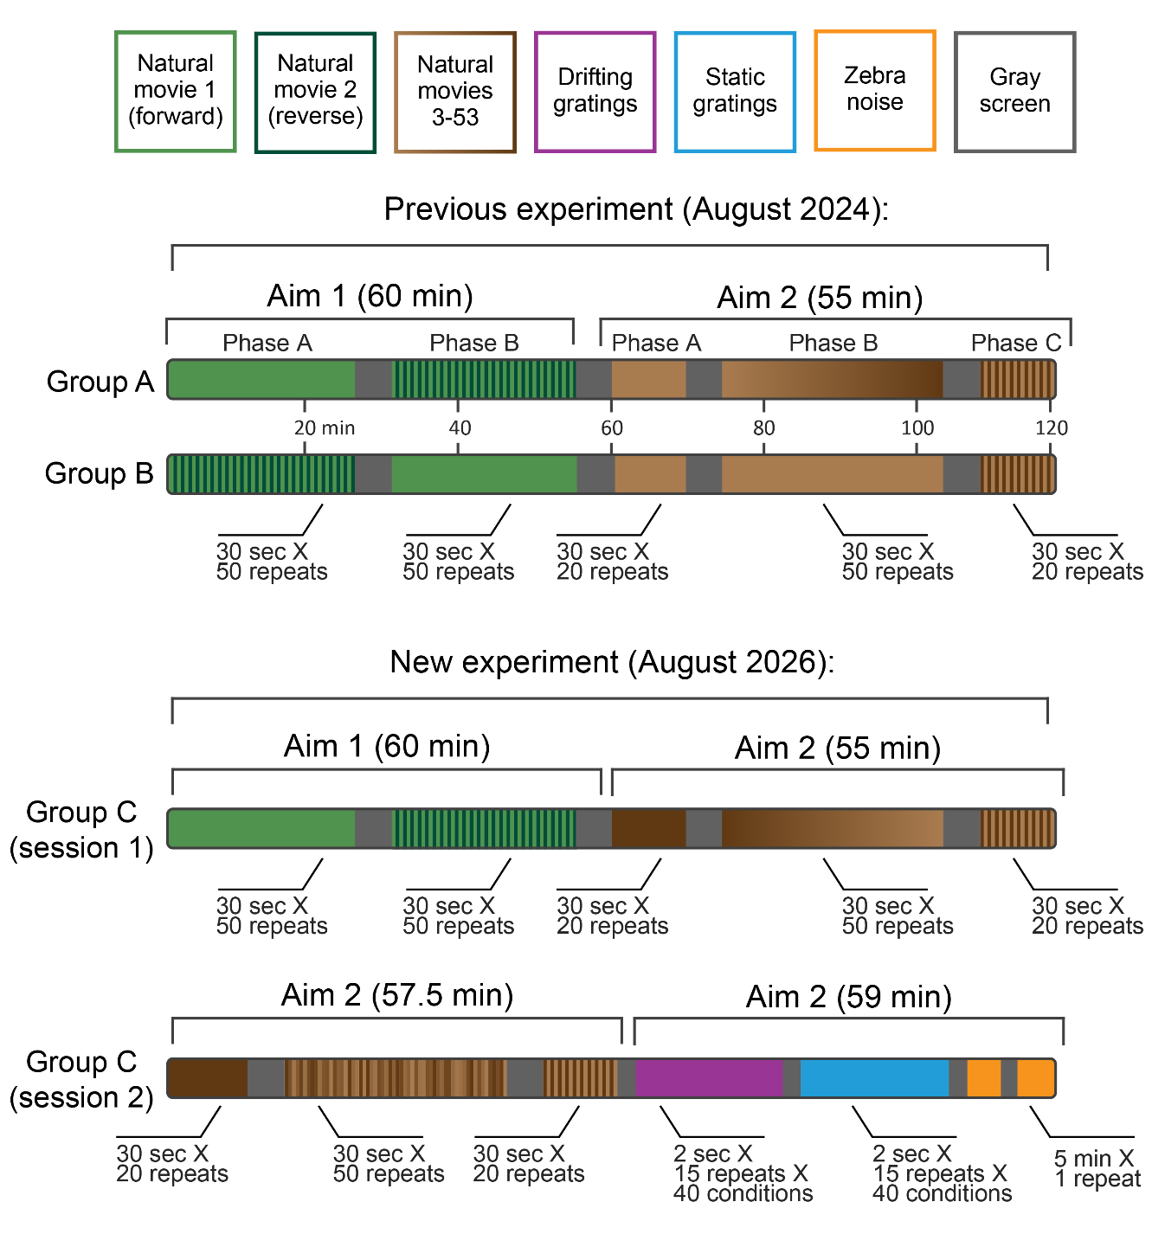
The previous experiment (August 2024) consisted of two phases in which different sets of 30 sec long natural movies will be presented:
- Phase 1 consists of two natural movies (i.e., movie01 and movie02) and a constant gray screen (i.e., movie00).
- Phase 2 consists of 50 natural movies (i.e., movie03-movie52) and a constant gray screen (i.e., movie00).
Animals were assigned into two groups (A and B), each presented with the movies in different order.
In both groups, a total of 230 movies were presented for a total time of 115 min:
- For group A:
  - Phase 1:
    - 50 presentations of movie01 (25 min)
    - 10 presentations of movie00 (5 min)
    - 50 alterations between movie01 and movie02 (25 min)
    - 10 presentations of movie00 (5 min)
  - Phase 2:
    - 20 presentations of movie03 (10 min)
    - 10 presentations of movie00 (5 min)
    - 50 sequential presentations from movie03 to movie52 (25 min)
    - 10 presentations of movie00 (5 min)
    - 20 alterations between movie03 and movie52 (10 min)
- For group B:
  - Phase 1:
    - 50 alterations between movie01 and movie02 (25 min)
    - 10 presentations of movie00 (5 min)
    - 50 presentations of movie01 (25 min)
    - 10 presentations of movie00 (5 min)
  - Phase 2:
    - 20 presentations of movie03 (10 min)
    - 10 presentations of movie00 (5 min)
    - 50 presentations of movie52 (25 min)
    - 10 presentations of movie00 (5 min)
    - 20 alterations between movie03 and movie52 (10 min)
The new experiment (August 2026) will consist of a single group of mice (Group C) which will undergo two recording sessions occurring on two consecutive days.
The first session will have a similar experimental design as in Group A (i.e., two phases for a total of 230 movie presentations over 115 min) however with different stimulus ordering in the second phase of the experiment.
The second session serves as a control experiment for Aim 2 in our proposal and will have a unique design where in the first hour movies will be presented In a pseudo-random order and in the second hour synthetic stimuli (e.g., drifting gratings, static gratings and zebra noise) will be presented.

For group C (new experiment august 2026):
  - Session 1 (day 1;115 min)
    - Phase 1 (60 min):
      - 50 presentations of movie01 (25 min)
      - 10 presentations of movie00 (5 min)
      - 50 alterations between movie01 and movie02 (25 min)
      - 10 presentations of movie00 (5 min)
    - Phase 2 (55 min):
      - 20 presentations of movie52 (10 min)
      - 10 presentations of movie00 (5 min)
      - 50 sequential presentations from movie52 to movie03 (25 min)
      - 10 presentations of movie00 (5 min)
      - 20 alterations between movie52 and movie03 (10 min)
  - Session 2 (day 2; 116.5 min)
    - Phase 1 (57.5 min):
      - 20 presentations of movie52 (10 min)
      - 10 presentations of movie00 (5 min)
      - 50 presentations of movies 03-52 in pseudo random order (25 min)
      - 10 presentations of movie00 (5 min)
      - 20 alterations between movie52 and movie03 (10 min)
      - 5 presentations of movie00 (2.5 min)
    - Phase 2 (24 min):
      - Drifting gratings with a spatial frequency of 0.04 cycles/deg, 80% contrast, 8 directions (0º, 45º, 90º, 135º, 180º, 225º, 270º, 315º, clockwise from 0º = right-to-left) and 5 temporal frequencies (1, 2, 4, 8, and 15 Hz), with 16 repeats per condition; presented in random order for 2 seconds each.
      - 2.5 min gray screen
    - Phase 3 (22.5 min):
      - Static gratings at 6 different orientations (0º, 30º, 60º, 90º, 120º, 150º, clockwise from 0º = vertical), 5 spatial frequencies (0.02, 0.04, 0.08, 0.16, 0.32 cycles/degree), and 4 phases (0, 0.25, 0.5, 0.75) with 40 repeats per condition; presented in random order for 0.25 seconds, with no intervening gray period.
      - 2.5 min gray screen
    - Phase 4 (12.5 min):
      - Zebra noise – two blocks (5 min each) of the same movie sequence with 2.5 min gray screen in between blocks

