Guided Capstone Project Report

Big Mountain is a ski resort in Montana that has historically priced its tickets at a premium relative to comparable resorts. However, this approach does not account for how individual resort features contribute to pricing and does not support strategic investment decisions. The following problem statement was written as a starting point for the pricing analysis:

Problem Statement: What opportunities exist to increase revenue for Big Mountain by 10% by the end of the upcoming winter season based on increasing the night skiing acreage and/or conducting a marketing campaign for the newest chair lift and the famous Hellfire run?

Data Wrangling and Exploratory Data Analysis
The original dataset that was given to the team was reduced from 330 rows and 27 columns to 277 rows and 25 columns after removing features with excessive missing values and excluding incomplete or unreliable records. Adult Weekend ticket price was selected as the target variable. Big Mountain currently charges $81 for the same.

Although additional engineered features were explored (e.g., resorts_per_100kcapita, resorts_per_100ksq_mile, resort_skiable_area_ac_state_ratio, etc.), the modeling ultimately emphasized operational characteristics most directly tied to skier experience. Scatterplots of features versus ticket price (graph shown below) showed positive correlation for the following key features from the original dataset: vertical drop, snowmaking area, number of runs, total chairs, fast quads, and longest run. During principal component analysis, there was no obvious pattern from the PC1-PC2 scatterplot that was constructed for the average ticket price for each state, and no other outstanding relationships between state and ticket price were uncovered during exploratory analysis. As such, I used the data from all states to build my pricing model. At the end of this phase, the following target features were short-listed for my modelling of the ticket price: NightSkiing_ac, Snow Making_ac, vertical_drop, fastQuads, Runs, and total_chairs.

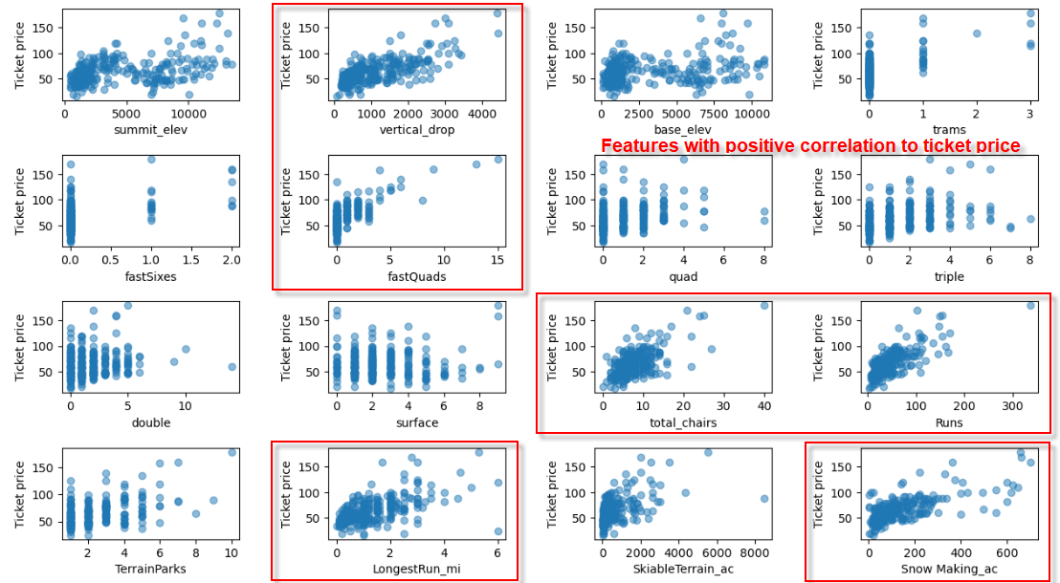

Preprocessing and Training
The dataset was split into training and testing sets using 32 numerical features. A baseline model using the average ticket price produced a mean absolute error (MAE) of approximately $19, which left room for much improvement. A linear regression model was tried next. Median imputation was used to address missing values and produced better results than mean imputation. The linear model using median imputation explained 81% of variance in the training set and 72% in the test set, reducing MAE to approximately $9. Cross-validation confirmed stable performance of the model. Feature selection from cross validation of this model identified the most important variables as vertical drop, snowmaking area, total chairs, fast quads, number of runs, trams, and skiable terrain.
Feature | Regression Coefficient
vertical_drop | 10.767857
Snow Making_ac | 6.290074
total_chairs | 5.794156
fastQuads | 5.745626
Runs | 5.370555
LongestRun_mi | 0.181814
trams | -4.142024
SkiableTerrain_ac | -5.24978

Vertical drop and snowmaking were the strongest positive contributors, while trams and skiable terrain showed a negative relationship. The negative correlation for skiable terrain suggests that larger resorts may rely more on volume-based pricing. A random forest model was then tried, and this improved both accuracy and consistency. Feature scaling on the model did not improve results, and median imputation remained optimal. The model identified four primary estimators: fast quads, runs, snowmaking area, and vertical drop.
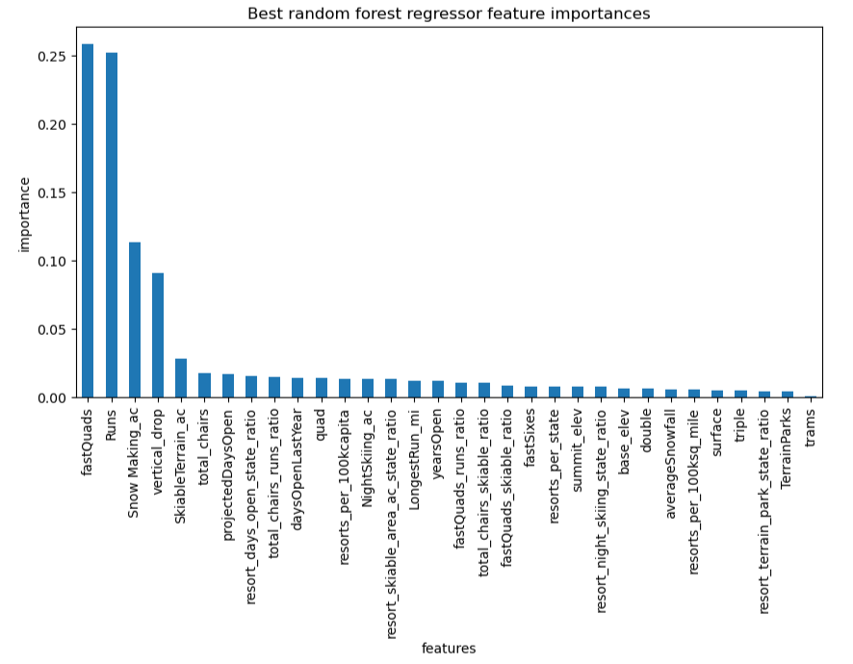

The decision was made to ultimately use the random forest model for the Modeling Phase as this model had a lower cross-validation mean absolute error by almost 1 dollar (9.64 for random forest versus 10.50 for linear). It also exhibited less variability during cross validation (1.35 for random forest versus 1.62 for linear). At this stage it is important to note that night skiing acreage, as mentioned in the Problem Statement, is no longer a factor worth considering in the final model. Finally, a learning curve analysis confirmed that the size of the cleaned dataset was sufficient, and no further data collection was required.

Modeling
The $81 that Big Mountain charges for an adult weekend ticket is among the highest in Montana and is above the national average. The random forest model predicted an optimal price of $95.87, indicating that the resort was vastly underpricing relative to its features. At the very least, this shows that the cost of a recently installed chairlift can be covered with a minimal price increase ($0.88 per ticket). However, a nearly $15 increase in ticket price by itself may be perceived as onerous by customers. Any pricing adjustment should therefore be implemented carefully and supported by clearly communicated improvements in high-value features. Options from leadership for the enhancement of facilities now appear easily viable.

Several strategic scenarios were evaluated:
- Closing underutilized runs: Eliminating the least-used run has no impact on ticket price. The model predicts a $0.41 drop in ticket price for the next run, and a further $0.16 drop will allow an additional three runs to be shut down. This suggests an opportunity to reduce operating costs with minimal pricing impact.
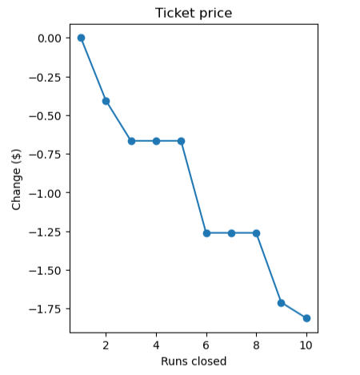

- Increasing vertical drop by 150 feet with additional lift: This scenario provides the greatest benefit. The model supports a ticket price increase of $8.61, generating approximately $15 million in additional seasonal revenue (based on 350,000 visitors skiing an average of 5 days). This aligns with the strong influence of vertical drop on pricing.
- Same as previous option but with 2 acres of snow making: The model supports a ticket price increase of $9.90, generating approximately $17.3 million in additional seasonal revenue (based on 350,000 visitors skiing an average of 5 days). It is worthy to note that both this and the previous option are dependent on the added expense for setting up new runs, chairlifts, and operating the snowmaking machines, none of which the data team has been privy to.
- Increasing the Hellfire run by 0.2 miles with 4 acres of snow making: This option yielded no price change according to the model.

Pricing Recommendation
The first recommendation would be to immediately raise the adult weekend ticket price by $0.88 in order to cover the seasonal operating cost of the newly installed chair lift. My preference would be to raise by an even $1.00. The next recommendation would be to shut down the least used run at Big Mountain as this will have no impact on the ticket price. Please note that it must be determined that the recently installed chair lift was not assigned to this run. It would also be prudent to undertake option #2 above since there are many other resorts that have greater vertical drops versus Big Mountain. Of course, care would need to be taken to determine the total cost for increasing the drop and installing the additional lift so that the additional expected revenue is not completely nullified by the cost and the targeted 10% increase in revenue can be achieved.

Conclusion and Future Scope of Work
Since the model shows evidence of ticket underpricing, it will need to be determined what percentage premium was used to calculate Big Mountain's current weekend ticket price over the market segment and how this percentage premium was arrived at. The features that were included in the market segment at the time of calculation would also need to be outlined. Future scope of work would include a detailed run-down of the individual operating expenses for Big Mountain (e.g., one-time cost for adding a new chair lift, seasonal operating costs of the snow making machines, etc.) to allow for more defined price estimates from the model.

