WFM MIND MAP

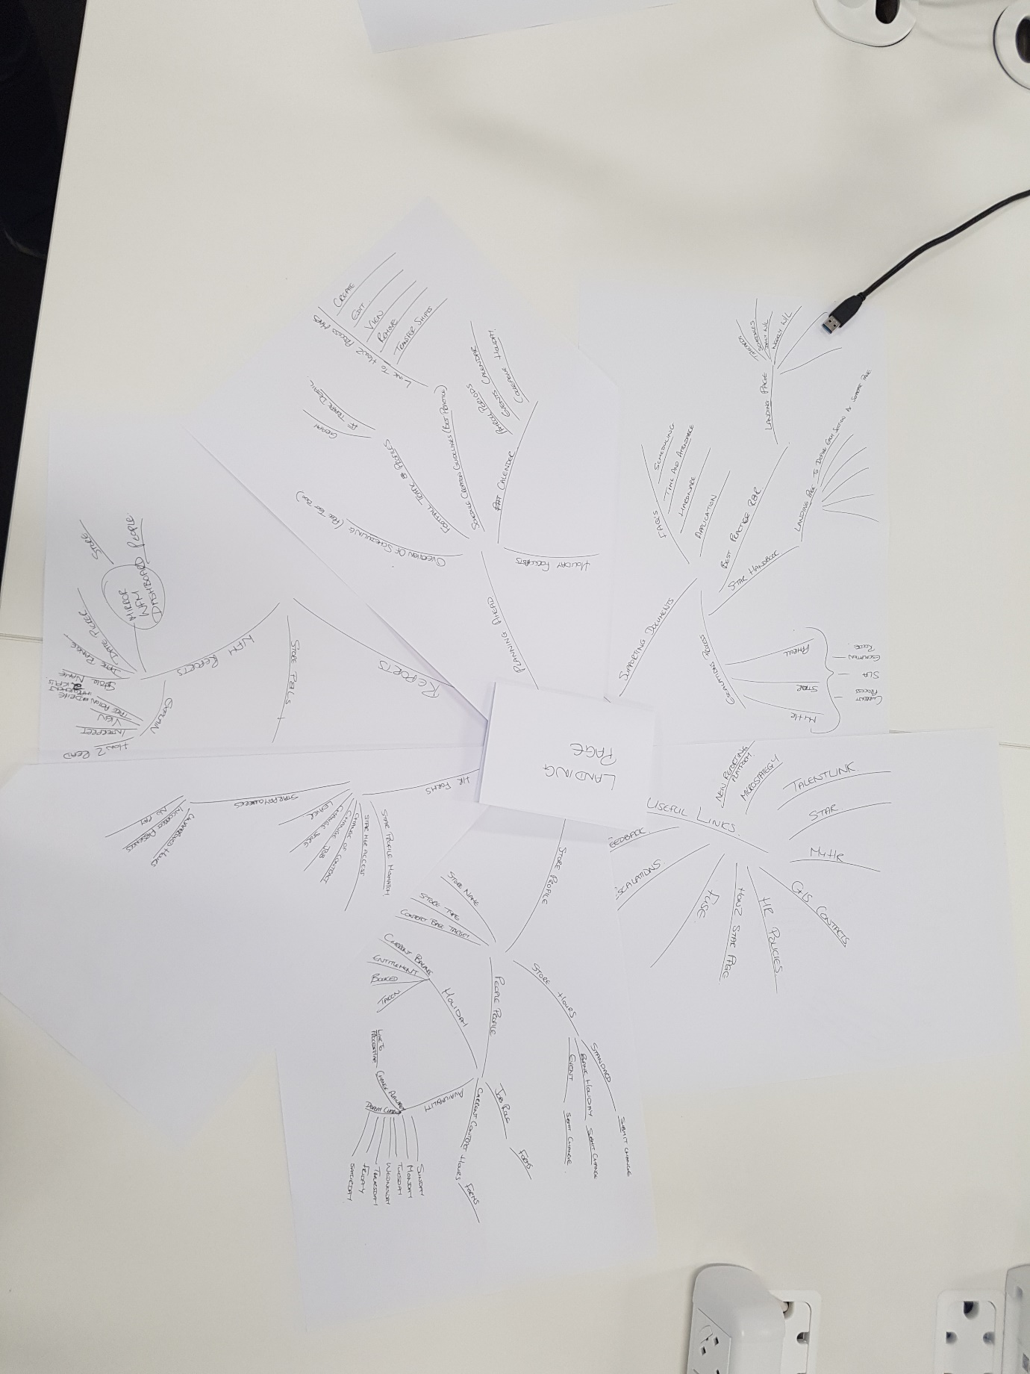

**Landing Page**

* Reports
  + Store P&Ls
  + Wfm Reports – (Dashboard - Date Picker, Date range, Store Name, How to read, interpret, Take Actions)
* Planning Ahead
  + Holiday Forecasts
  + Overview of scheduling
  + Footfall Traffic Profiles
    - General
    - Traffic Detail
  + Schedule Creation Guidelines (Process Maps -> Create, edit, View, Remove, Transfer)
  + Calendar (Payroll Periods, Event Calendar, Colleague Holiday)
  + Holiday Forecasts
* Store Profile (Dashboard – Store Name, Contract Base Target)
  + Store Hours
    - Standard (Submit Change)
    - Bank Holiday (Submit Change)
    - Event (Submit Change)
  + People Profile
    - Job Role (Forms),
    - Current contract hours (Forms),
    - Availability (in days) – Display Current, Change (Link to processing)
    - Holiday - Current Balance, Entitlement, Booked, Taken

**Footer**

* Supporting Docs
  + FAQs (Scheduling, Time & Attendance, Hardware, Application)
  + Best Practice (Timecards, Schedules, Daily W/L, Weekly W/L)
  + Star Handbook
  + Escalations Process (My HR, STAR, Payroll)
* Useful Links
  + Feedback
  + Escalations
  + Fuse
  + How to Star Page
  + HR Policies
  + GIS Contacts
  + My HR
  + STAR
  + Talent Link
  + Micro Strategy
  + New Reporting Platform
* HR Forms
  + Star Profile Mismatch
  + Star MGR Access
  + Change of Contract
  + Change Job
  + Change Store
  + Leaver
* Star Pay
  + Unapproved Hours
  + Incorrect Absences
  + No Pay