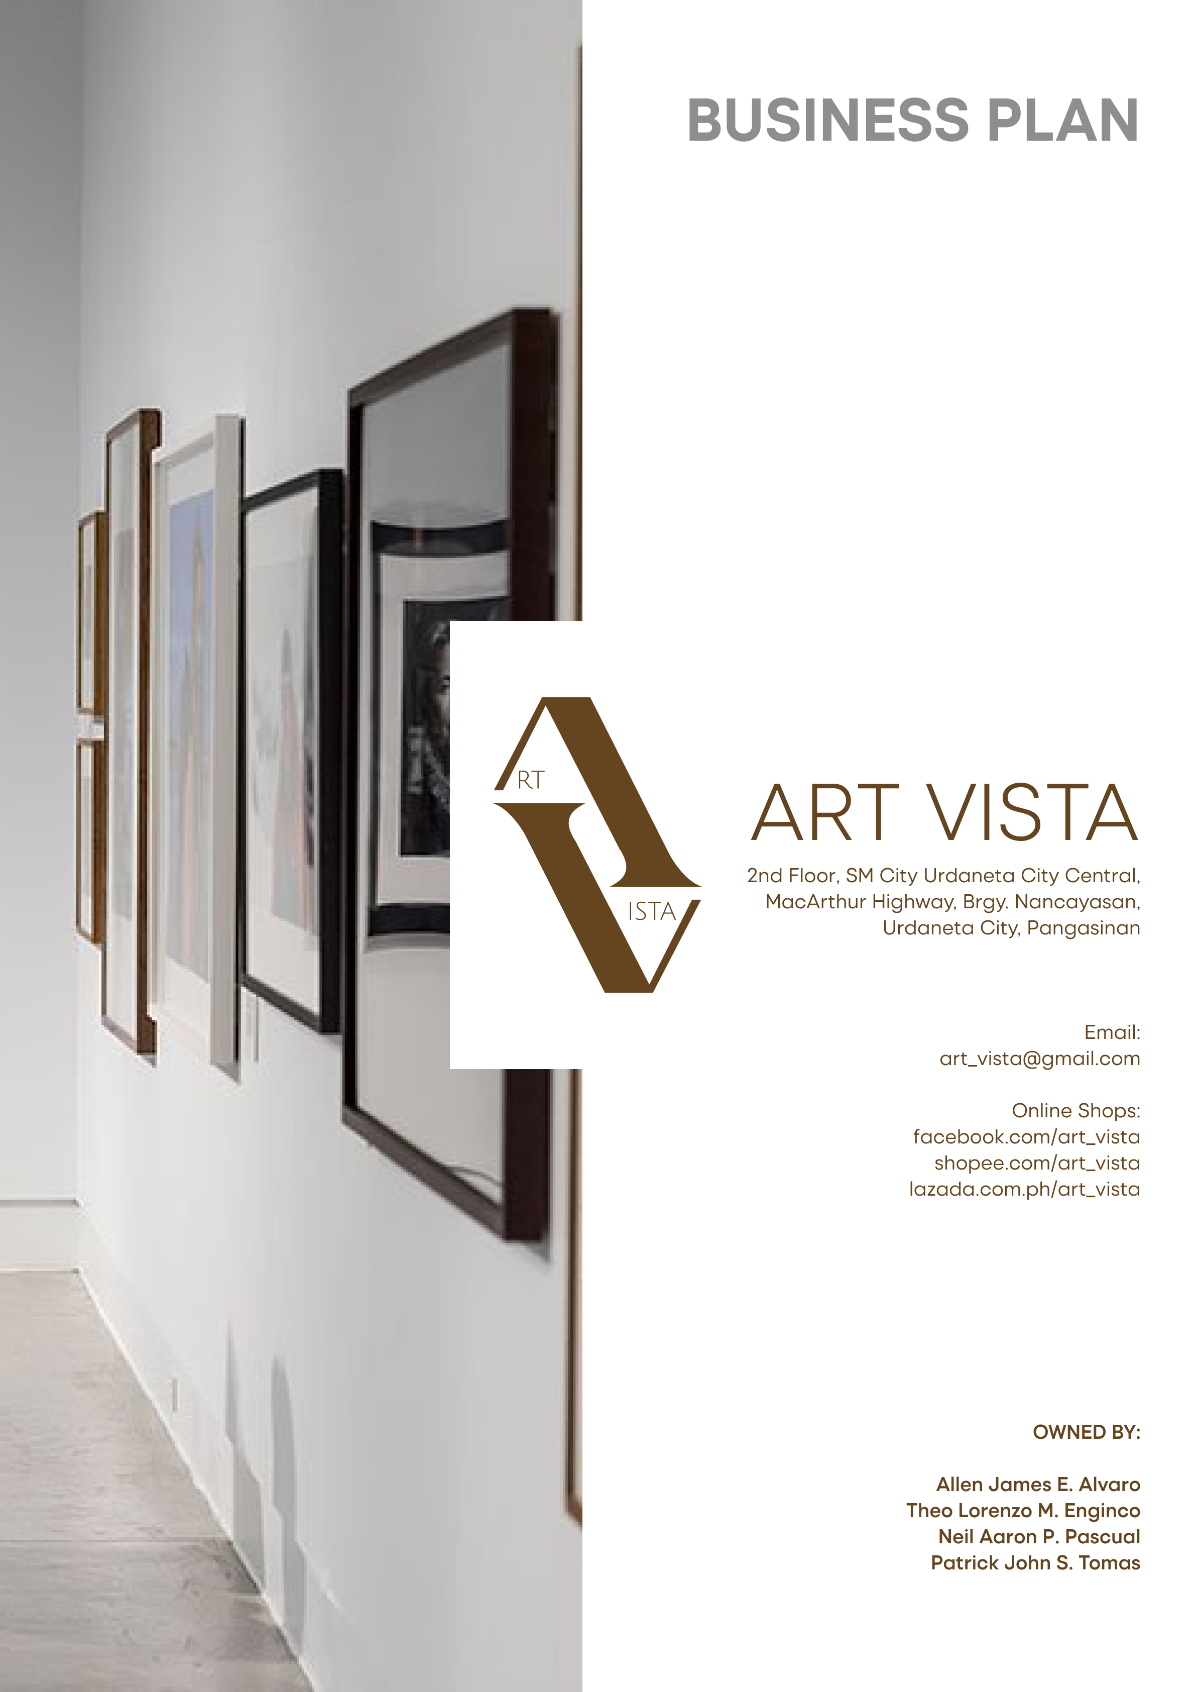

Table of Contents

INTRODUCTION 1

Environmental Analysis 3

BUSINESS DESCRIPTION 4

Organizational Plan 6

Production Plan 10

Operation Plan 15

MARKETING PLAN 17

# INTRODUCTION

This section of the business plan outlines the business description of Art Vista, its geographical location, and the total funding requirements, including potential funding sources.

**Description of the Business**

Art Vista is an art gallery founded by a group of passionate artists, each specializing in various mediums such as oil, acrylic, mixed-media, watercolor, and charcoal. This physical art studio serves as a platform for showcasing and selling original artworks crafted by the talented team of artists. The collection features a diverse range of pieces, allowing art enthusiasts to explore and appreciate the beauty of different artistic expressions.

In addition to the curated selection of original artworks, Art Vista offers a unique and personalized service—art commissions. Clients have the opportunity to collaborate with the skilled artists to bring their artistic visions to life. This personalized service is perfect for people who seek customized pieces that align with their preferences, ensuring a one-of-a-kind art experience.

Art Vista is more than just a typical art gallery. It is a friendly space where artists and art lovers come together. The gallery is all about encouraging creativity and connecting people through diverse artistic forms. Through the combination of original masterpieces and the option for personalized commissions, Art Vista endeavors to make art more accessible and meaningful to everyone.

**Location of the Business**

Art Vista has picked its spot with care to connect easily with its customers. Located on the 2nd Floor of SM City Urdaneta City Central, along MacArthur Highway in Brgy. Nancayasan, Urdaneta City, Pangasinan, the art gallery sits in the heart of the city's shopping and business area. This central location makes it easy for art enthusiasts and potential buyers to visit and enjoy the diverse artworks created by the artists.

For the art-making process, Art Vista operates in the residence of one of the artists in Brgy. Nancamaliran West, Urdaneta City, approximately 4 kilometers from the art gallery. The deliberate separation between the gallery and the production space is designed to foster a quiet and focused atmosphere, enabling artists to freely express their creative minds while passionately creating their masterpieces. This home-based setup not only contributes to a conducive and uninterrupted artistic environment but also helps in minimizing additional rental expenses.

These locations were chosen not just because they're close to customers but also considering things like safety, transportation, and having no direct competitors within SM City Urdaneta City Central. With the art gallery in a busy commercial area and the production space in a peaceful residential spot, Art Vista aims to balance both the art experience for customers and the creative process for the artists.

**Funding Requirement and Source of Funds**

Art Vista estimates a total startup cost of PHP [total cost] to establish and operate the art gallery business and is broken down as follows:

|  |  |
| --- | --- |
| EXPENSE | AMOUNT IN PHP |
| SM Mall Space Rental | Php 8,000 per month |
| Interior Setup (Fixtures) | Php 20,000 |
| Art Supplies | Php |
| Working Capital | Php 100, 000 |

**SM Mall Space Rental:** The expense encompasses the lease of a space at SM City Urdaneta City Central, securing a prominent location for the gallery. The initial cost covers the first month's rent for the SM Mall space, amounting to PHP 8,000. It's important to note that future monthly rents are categorized as continuous operational costs and are not included in the startup expenditure.

**Interior Setup (Fixtures):** This covers the creation of an inviting and aesthetically pleasing space within the gallery, ensuring a conducive environment for art appreciation.

**Art Supplies:** This budget is allocated for the acquisition of necessary art supplies, tools, and materials essential for the art-making process.

**Working Capital:** This portion is designated to cover day-to-day operational expenses and ensure a smooth start during the initial phase of the business.

**Source of Funds**

The initial investment for Art Vista will be collectively provided by the owners as a general partnership, ensuring an equal share in financing the entire estimated cost of PHP [total cost] to initiate and establish the business. This collaborative funding approach reflects the commitment of all partners to the vision and success of Art Vista. By opting for this owner-funded strategy, the general partnership fosters a flexible and hands-on approach to business management, guaranteeing that each owner has a direct and equal vested interest in the success of the art gallery venture.

# Environmental Analysis

# BUSINESS DESCRIPTION

This section provides a concise overview of the business, encompassing product description, required equipment and materials, business size, and personnel requirements.

**Product Description**

Art Vista offers a diverse range of unique artworks, including paintings and portraits, crafted with precision from various materials such as oil, acrylic, mixed-media, watercolor, and charcoal. The collection, representing the individual artistic styles of the four founders, establishes not only visual appeal but also a direct connection between artists and art enthusiasts.

The artworks come in various sizes, each available with optional frames to suit personal preferences. The styles range from abstract to realism, with each piece carefully crafted to evoke different emotions. The standard pricing is designed to be accessible, ranging from as low as Php 5,000 to Php 20,000, depending on factors like size, medium, and the complexity of the artwork concepts.

For those seeking a truly personalized experience, Art Vista’s art commissions offer a unique opportunity. Each commissioned artwork is completed within at least 3 days up to 1 week, considering the pending list and the intricacies of details and size. Every finished artwork, especially paintings, undergoes a protective fixative spray to prevent fading over time.

To ensure the safe delivery of artworks, each piece is meticulously bubble-wrapped and entrusted to a reliable delivery company. This attention to detail extends Art Vista’s commitment to providing a seamless and secure experience for valued customers. Art Vista envisions standing as Urdaneta’s central destination, where art becomes a personalized, tangible, and enriching experience for every art enthusiast.

**Equipment/Materials Needed**

To bring Art Vista's artistic vision to life, the following equipment and materials are essential for the creation and presentation of the unique artworks:

1. **Art Supplies:** A comprehensive assortment of high-quality art supplies, including canvases, brushes, palettes, paints (oil, acrylic, watercolor), charcoals, and other necessary materials for various artistic techniques.
2. **Easels:** Sturdy and adjustable easels provide a proper support system for artists to work on their canvases comfortably.
3. **Frames:** Optional frames in various sizes and styles to accommodate the diverse preferences of customers and enhance the presentation of artworks.
4. **Protective Fixative Spray:** A reliable fixative spray used to protect finished artworks, especially paintings, from fading over time.
5. **Aprons and Protective Clothing:** To protect artists' clothing from paint and other art materials.
6. **Delivery Packaging Materials:** Additional packaging materials, including bubble wrap and protective layers, to secure artworks during transportation.
7. **Lighting Fixtures:** Adjustable and focused lighting to highlight each artwork and create an aesthetically pleasing display.
8. **Printed Brochures or Catalogs:** Professionally designed brochures or catalogs providing additional information about Art Vista and its artists.

**Size of the Business**

In defining the size of Art Vista, various indicators are considered, taking into account the nature of the business as a starting venture in the art industry. The key metrics for determining the size of a business include assets, revenue, production, number of employees, and capital invested.

For Art Vista, being a new enterprise, the classification aligns with the Department of Trade and Industry's criteria for Micro, Small, and Medium Enterprises (MSMEs). As of its establishment, Art Vista falls within the micro-enterprise category, characterized by PHP 3,000,000 or less in assets and one to nine employees.

Given its small-scale operations, Art Vista focuses on agile and personalized services, leveraging the unique skills and artistic styles of its four founders. The emphasis is on quality and customization, creating a distinct niche in the market. While the business may evolve over time, the current micro-enterprise classification reflects the initial stage of Art Vista's journey, highlighting its dedication to artistry and its valued customers.

**Personnel Requirement**

Art Vista, in its initial phase, is led by its four founders, each a skilled artist specializing in various mediums such as oil, acrylic, mixed-media, watercolor, and charcoal. As a micro-enterprise, Art Vista currently operates with a lean structure, where the founders actively manage and oversee all aspects of the business.

The current team consists of:

[List here – from Task 5]

# Organizational Plan

In this section of the business plan, we outline our organizational structure, liability considerations for the owner, key roles, and proposed salaries. It provides a succinct overview of how our business is organized for optimal efficiency and growth.

**Form of Business Organization**

In the pursuit of a collaborative and synergistic operational model, our chosen form of business organization is a General Partnership. This deliberate selection is rooted in the belief that a General Partnership structure best aligns with our strategic vision and organizational objectives. The partnership framework is characterized by shared decision-making, collective responsibility, and a pooling of diverse skills and resources. This model not only facilitates agility and adaptability but also underscores our commitment to fostering a culture of cooperation and joint ownership. As partners, we anticipate that this organizational structure will contribute to the overall resilience and success of our venture by harnessing the collective strengths of each partner.

**Liability of the Owner**

[Business name natin di ko kasi alam palagay dito haha], in pursuit of its strategic expansion, has secured an unlimited business loan of $100,000 from [Imaginary Bank baka may nalagay na kayo lagay niyo na lang para same haha]. This substantial financial commitment will be allocated towards augmenting the art inventory, intensifying marketing initiatives, and renovating the gallery space. The nature of this liability is characterized by its unlimited scope, signifying that the owners assumes personal responsibility for the entire debt amount. [Imaginary Bank], as the creditors, extends this loan with specified terms, encompassing an interest rate and a structured repayment plan over a defined period. This financial arrangement underscores the commitment of [business name] to its growth objectives, acknowledging the personal financial responsibility of the owners in the event of any unforeseen challenges or liabilities incurred by the business.

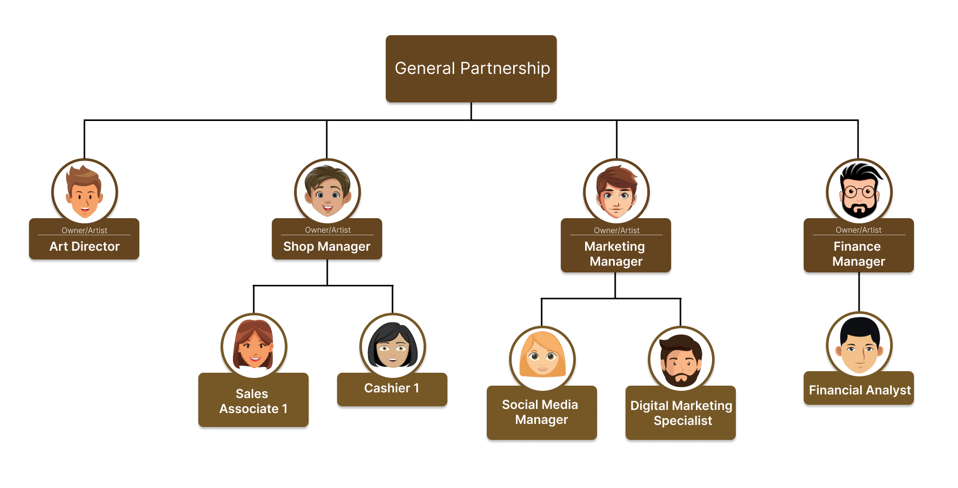**Organizational Structure**

**Role of the Owner**

**Art Director:** Overseeing the artistic aspects of projects, ensuring creative vision aligns with business goals.

Tasks:

* Collaborating with co-artists to develop creative concepts.
* Providing artistic direction for projects and ensuring a cohesive visual identity.
* Ensuring the quality and uniqueness of artistic content.

**Art Gallery Manager:** Managing the physical store and overall operations of the art gallery.

Tasks:

* Supervising day-to-day gallery activities and staff.
* Curating and organizing art exhibitions and events.
* Handling customer interactions and maintaining a positive gallery atmosphere.

**Marketing Manager:** Developing and implementing marketing strategies to promote the gallery.

Tasks:

* Creating and executing marketing campaigns to drive foot traffic and online engagement.
* Analyzing market trends and customer feedback to refine marketing strategies.

**Finance Manager:** Responsibilities: Handling the financial aspects of the business, including budgeting and expense management.

Tasks:

* Overseeing financial transactions, including invoicing and payments.
* Managing budgets and financial planning.
* Collaborating with the co-owners and stakeholders to ensure financial stability.

**Collaboration and Decision-Making:** The owners will collaborate regularly to align individual functions with overall business objectives. Major decisions, such as budget allocation, marketing strategies, and artistic direction, will involve collective input and agreement. Regular communication and synergy among the owners will be crucial for the success of the business.

**Key Performance Indicators (KPIs)**

Each owner will be assessed based on specific KPIs related to their roles:

* Art Director: Creative impact, artistic quality, and alignment with business goals.
* Art Gallery Manager: Store performance, customer satisfaction, and successful event execution.
* Marketing Manager: Effectiveness of marketing campaigns, audience engagement, and brand visibility.
* Finance Manager: Financial health, expense control, and adherence to budgetary goals.

This collaborative and specialized approach ensures that each owner contributes their expertise to different facets of the business, fostering a well-rounded and successful art gallery.

**Proposed Salary**

**Sales Staff:**

* Monthly Salary per Sales Staff: ₱300 X
* Social Security System (SSS) Contribution: $X
* Pag-Ibig Contribution: $X
* Philhealth Contribution: $X
* Total Monthly Compensation per Sales Staff: $X
* Annual Compensation per Sales Staff: $X (12 months)

**Cashier:**

* Monthly Salary for Cashier: ₱300 Y
* SSS Contribution: $Y
* Pag-Ibig Contribution: $Y
* Philhealth Contribution: $Y
* Total Monthly Compensation for Cashier: $Y
* Annual Compensation for Cashier: $Y (12 months)

**Social Media Manager:**

* Monthly Salary for Social Media Manager: ₱300 Z
* SSS Contribution: $Z
* Pag-Ibig Contribution: $Z
* Philhealth Contribution: $Z
* Total Monthly Compensation for Social Media Manager: $Z
* Annual Compensation for Social Media Manager: $Z (12 months)

**Digital Marketing Specialist:**

* Monthly Salary for Digital Marketing Specialist: ₱300 V
* SSS Contribution: $V
* Pag-Ibig Contribution: $V
* Philhealth Contribution: $V
* Total Monthly Compensation for Digital Marketing Specialist: $V
* Annual Compensation for Digital Marketing Specialist: $V (12 months)

**Financial Analyst:**

* Monthly Salary for Financial Analyst: ₱300 U
* SSS Contribution: $U
* Pag-Ibig Contribution: $U
* Philhealth Contribution: $U
* Total Monthly Compensation for Financial Analyst: $U
* Annual Compensation for Financial Analyst: $U (12 months)

**Estimated Monthly Salary Expenses for the Business:**

TotalMonthlySalaryExpenses = X + Y + Z + V + U

**Estimated Annual Salary Expenses for the Business:**

TotalAnnualSalaryExpenses = 12 ∗ X + 12 ∗ Y + 12 ∗ Z + 12 ∗ V + 12 ∗ U

# Production Plan

This section of the production plan presents the production schedule, production process, equipment required, sources of materials and estimated production cost.

**Production Schedule**

The Acrylic Artist can produce an acrylic painting within a range of 2 days to a week, considering variations based on the artwork's size (excluding drying time). The Oil Painting Artist typically completes an oil painting within 1-2 days, not including the necessary drying period. The Portrait Artist is capable of crafting a small portrait in approximately 6 hours, while larger portraits may require a day or more, considering the intricacies of the artwork. Assuming an average production time of 4 days, the weekly output of acrylic painting is approximately 1.75 paintings per week and 7 paintings per month. With an average production time of 1.5 days, the weekly output for oil paintings is around 4.67 paintings per week and 18.67 paintings per month. Considering an alternating approach between small and larger portraits, the weekly drawing production is approximately 4.67 drawings per week and 18.67 drawings per month. Do note that these are estimates since artist have their own pace and workflow.

**Production Process**

Acrylic Painting Production Process:

1. Conceptualization and Planning:

Processing Procedure: Develop a concept and plan the composition.

Materials: Sketchpad, pencils, erasers.

Expected Time: Varies (days to weeks)

1. Surface Preparation

Processing Procedure: Select canvas, apply gesso.

Materials: Canvas, gesso, brushes.

Expected Time: Varies (hours).

1. Sketching:

Processing Procedure: Create an initial sketch.

Materials: Pencil, sketchpad.

Expected Time: Varies (hours).

1. Base Layers and Layering:

Processing Procedure: Apply acrylic paint layers.

Materials: Acrylic paints, brushes, palette.

Expected Time: Days to weeks (including drying time).

1. Final Touches:

Processing Procedure: Add details and refine.

Materials: Fine brushes, additional colors.

Expected Time: Varies (hours to days).

1. Drying Time:

Processing Procedure: Allow the painting to dry.

Materials: None.

Expected Time: Varies (hours to days).

Oil Painting Production Process:

1. Conceptualization and Planning:

Processing Procedure: Develop a concept and plan the composition.

Materials: Sketchpad, pencils, erasers.

Expected Time: Variable based on complexity (days to weeks).

1. Surface Preparation:

Processing Procedure: Select canvas, apply gesso, and potentially an underpainting.

Materials: Canvas, gesso, brushes.

Expected Time: Varies (hours).

1. Blocking in and Layering:

Processing Procedure: Apply initial layers, build up details.

Materials: Oil paints, brushes, palette.

Expected Time: Days to weeks (including drying time).

1. Final Details and Glazing:

Processing Procedure: Add final details and optional glazes.

Materials: Fine brushes, glazing medium (if used).

Expected Time: Varies (hours to days).

1. Drying Time:

Processing Procedure: Allow the painting to dry.

Materials: None

Expected Time: Longer duration (weeks to months).

Portrait Drawing Production Process:

1. Reference Gathering:

Processing Procedure: Collect reference materials (photographs, live sittings).

Materials: Photographs or live subjects.

Expected Time: Variable.

1. Surface Preparation:

Processing Procedure: Select and prepare drawing paper.

Materials: Drawing paper, pencils.

Expected Time: Varies (minutes to hours).

1. Sketching and Detailing:

Processing Procedure: Create an initial sketch and add details.

Materials: Pencils, erasers.

Expected Time: Hours.

1. Background (Optional):

Processing Procedure: Decide and add a background if necessary.

Materials: Additional drawing tools.

Expected Time: Varies (minutes to hours).

1. Final Touches and Protective Measures:

Processing Procedure: Make final adjustments, add protective coatings if needed.

Materials: Fixatives or protective coatings can also use frame.

Expected Time: Varies (minutes to hours).

**Processing Plant and Equipment**

Facilities used to make our products is in our home. Equipment used are Easels, tables, brushes, palette knives, palette, acrylic paints, canvas, gesso and primer, oil paints, drawing pencils, sketchpads and drawing paper, erasers and sharpeners, fixatives, drying racks, storage facilities, finishing tools, protective gear, shipping and packaging supplies.

|  |  |
| --- | --- |
| Equipment | Cost |
| HOKKA Branded Original Easel Wooden Painting/Display Stand 1.6meters x3 | Php 1,500.00 |
| DIO107 Metal Drafting Table x3 | Php 8,997.00 |
| Versatile Paintbrush Set x2 | Php 2,658.00 |
| PALETTE KNIFE SET x2 | Php 700.00 |
| 25 Grid Watercolor Palette x2 | Php 278.00 |
| // Art Ranger Acrylic paint set x2 | Php 740.00 |
| Canvas Board | Php 42.00 – Php 150.00 per pieces |
| // WINSOR & NEWTON GESSO 946ml x2 | Php 1,350.00 |
| // HiRo paint primer 100ml x2 | Php 380.00 |
| // WINSOR&NEWTON Professional Color Oil Paint | Php 675.00 |
| Sketch Pencil Set Artist Craft Professional Drawing Kit x3 | Php 1,095.00 |
| 12x18 Sketchpad x3 | Php 750.00 |
| // Artist Paint Spray Fixative 320ml | Php 467.00 |
| Drying Rack/Table | Php 1,000.00 |
| Frame | Php 68.00 – Php 200.00 |
| Anti-Fouling Gloves x3 | Php 300.00 |
| Artist Apron x3 | Php 600.00 |
| Bubble Wrap and Boxes | Php 100.00 |

**Sources of Materials**

For the art supplies while online store operates in a wide scale and not close to our home/studio. Their efficient shipping network ensures that our orders arrive in a given timeline. Standard payment term is 30 days net after the receipt of goods and since it is online we can use credit card or use other way to provide secure payment gateways.

Significant discounts are offered for bulk purchases, encouraging cost savings for larger orders. In case of damage in the product, the supplier has a straight forward process for reporting and replacing the damaged supplies.

In terms of shipment, Shipments are typically handled through reputable carriers, ensuring safe and reliable delivery. Shipping costs are factored into the overall order.

Lastly, all suppliers selected to buy supplies from have a reputable reputation and have a tested and proven quality of materials, proven to be reliable and have positive review from other customers. They can also be communicated with in case an issue with the order is present, ensuring a smooth transaction that can help in maintaining a strong and reliable supply chain.

**Production Cost**

The labor cost is 300 per hour of making the product (not including the drying time). The cost for materials in average is Php 2,032.00 for acrylic painting, Php 2,337.00 for oil painting and Php 1,162.00 for charcoal drawing. Since we are not using a factory or equipment that uses electricity we do not have a factory overhead. Do note that the cost of materials assume that we are using all materials like the paint in one go so in reality the cost of materials is less than or equal to the given average price. So, adding that together if we assume the average length of acrylic painting is 4 hours the total cost labor included is Php 3,232.00 for an acrylic painting, for oil painting if done with the same calculation as the acrylic is Php 3,537.00 and for charcoal drawing if we assume the time of drawing is 2 hours then the production cost is Php 1,762.00.

# Operation Plan

This section of the business plan presents the evaluation of the suppliers, materials requisition and receiving procedures, storage and inventory control system, shipment system and control and functions of supported services.

**Evaluation of Suppliers**

Evaluating suppliers is needed to ensure that the supplier is reliable and is a good source/s of materials. In order to evaluate suppliers, we must conduct critical evaluation starting with performance metrics. Performance metrics should list the product quality, consistency, delivery time and customer service.

**Materials Requisition and Receiving Procedures**

In our material requisition and receiving procedures, our designated Quality Control Inspector plays a pivotal role in ensuring the accuracy and quality of received materials. Upon receiving advance notification from suppliers, we meticulously inspect incoming shipments, verifying packing lists, comparing quantities against purchase orders, and assessing the condition of materials. We lead the Quality Control Team in implementing sampling plans and conducting tests according to predetermined standards, maintaining detailed records of the entire process. Additionally, we are responsible for handling non-conforming materials, including documentation and necessary actions. Our expertise and attention to detail contribute significantly to our commitment to high-quality raw materials in the production process.

**Storage and Inventory Control System**

In designing our storage and inventory control system, crucial considerations encompass the decision to own or rent a warehouse, efficient warehouse management practices, streamlined transfer procedures, and meticulous control of inventory. We assess factors such as storage capacity, location, and cost-effectiveness to determine the optimal ownership or rental approach. Experienced personnel oversee daily operations, focusing on space optimization and safety protocols. Well-defined processes govern the transfer of goods, emphasizing speed, accuracy, and real-time tracking. Our inventory control relies on sophisticated software, conducting regular audits to align digital records with physical stock and implementing security measures to prevent losses. Through these integrated strategies, we aim to establish a responsive, secure, and efficient logistics framework.

**Shipment System and Control**

Our shipment system and control mechanisms are designed to ensure a smooth and reliable process. The approval of shipping and sales documents is a meticulous step, guaranteeing accuracy and compliance. Terms of shipment are clearly defined, specifying responsibilities and mitigating risks. The manner of shipping the product is carefully selected based on factors like product nature and destination, balancing efficiency and cost-effectiveness. Additional terms and conditions, as outlined in the sales contract, are thoroughly addressed, providing a comprehensive framework that contributes to the integrity and efficiency of our shipment processes.

**Functions of Support Services**

In our small business with a team of four artists, support services are streamlined across finance, marketing, operations, and human resources. The finance function is dedicated to maintaining financial health and making informed decisions, ensuring stability in our artistic endeavors. Marketing services focus on creating a digital presence, leveraging social media, and implementing cost-effective strategies to attract a targeted audience. Operations support optimizes day-to-day processes, emphasizing efficient inventory management and timely production workflows. Human resources services concentrate on managing our small team effectively, fostering a positive work environment, and addressing the unique needs of our artists. Together, these integrated support functions contribute to the overall success and sustainability of our artistic venture.

# MARKETING PLAN

This section details how Art Vista will sell its unique artworks by utilizing the 7Ps of Marketing namely Product, Place, Price, Promotion, Packaging, and Positioning.

**Product**

Art Vista offers a wide variety of original artworks, including paintings and portraits, that are expertly produced from materials such as oil, acrylic, mixed-media, watercolor, and charcoal. The collection, which represents the four founders' individual artistic approaches, builds an instant connection between artists and art enthusiasts. The product's uniqueness stems from its customization choices, which include various sizes, extra frames, and styles ranging from abstract to realism.

**Place**

Art Vista is located in high-traffic locations, with its physical gallery situated on the 2nd Floor of SM City Urdaneta City Central, MacArthur Highway. This prime location ensures accessibility for art enthusiasts and potential customers, creating a centralized hub for artistic exploration. Additionally, recognizing the importance of wider reach and convenience, Art Vista extends its accessibility through online shops, ensuring a comfortable and seamless experience for customers beyond the physical gallery space.

**Price**

The pricing strategy is designed to be reasonably priced, ranging from as low as Php 5,000 to Php 20,000, depending on factors like size, medium, and the complexity of the artwork concepts. The competitive pricing aims to attract a diverse customer base while reflecting the value of the unique, handcrafted artworks.

**Promotion**

To create awareness and drive traffic, Art Vista employs a multi-faceted promotional approach. This includes digital marketing through its online shop and social media platforms, showcasing the artists' creative process and finished pieces. Collaborations with local art events, workshops, and partnerships with influencers in the art community contribute to a dynamic promotional strategy.

**Packaging**

Art Vista places emphasis on the careful packaging of artworks, using bubble wrap, foam boards, secure containers, and reliable delivery services to ensure safe transportation. This attention to detail extends the brand's commitment to providing a seamless and secure experience for valued customers.

**Positioning**

Art Vista strategically positions itself as the premier destination for unique and valuable artworks in Urdaneta City, emphasizing a personalized and enriching art experience. The brand focuses on providing competitively priced, high-quality, and handcrafted pieces that stand out in the market. With an emphasis on customization options, diverse styles, and a direct connection between artists and art enthusiasts, Art Vista aims to be synonymous with artistic expression and creativity. The brand's positioning seeks to create a lasting impression as a dynamic hub within the local art community, offering a meaningful and personalized art experience for customers.