MEDICINE RECOMMENDER
A project report submitted to University of Calicut
in partial fulfilment of requirements for the award of
BACHELOR DEGREE
in
COMPUTER APPLICATION
by
ALLEN JOHN JOY
REG. NO: EKAWBCA018
(2022-2025)


POSTGRADUATE DEPARTMENT OF COMPUTER APPLICATION

SAHRDAYA
COLLEGE OF ADVANCED STUDIES,
KODAKARA, THRISSUR

MEDICINE RECOMMENDER

A project report submitted to University of Calicut
in partial fulfillment of requirements for the award of
BACHELOR DEGREE
in
COMPUTER APPLICATION
by
ALLEN JOHN JOY
REG. NO: EKAWBCA018
(2022-2025)
Under the supervision of
Fousiya P.U


POSTGRADUATE DEPARTMENT OF COMPUTER APPLICATION

SAHRDAYA
COLLEGE OF ADVANCED STUDIES
KODAKARA, THRISSUR
MEDICINE RECOMMENDER

PROJECT REPORT

UNIVERSITY OF CALICUT



CENTRE: SAHRDAYA COLLEGE OF ADVANCED STUDIES, KODAKARA

BCA
(2022-2025)

Name : ALLEN JOHN JOY
Reg. No : EKAWBCA018
Semester : Sixth
SAHRDAYA COLLEGE OF ADVANCED STUDIES
KODAKARA, THRISSUR


CERTIFICATE

This is to certify that the project entitled “MEDICINE RECOMMENDER” submitted to the Department of Computer Application in partial fulfillment of the requirements for the award of Bachelor Degree in Computer Application is a bonafide record of original work done by ALLEN JOHN JOY (Reg. No: EKAWBCA018) in the period of his study in the Postgraduate Department of Computer Science, Sahrdaya College of Advanced Studies, Kodakara under my supervision and guidance during the year of 2022-’25.

Supervisor Head of the Department Principal

External Examiner:
Internal Examiner:
Palace : Kodakara

Date : / /2025

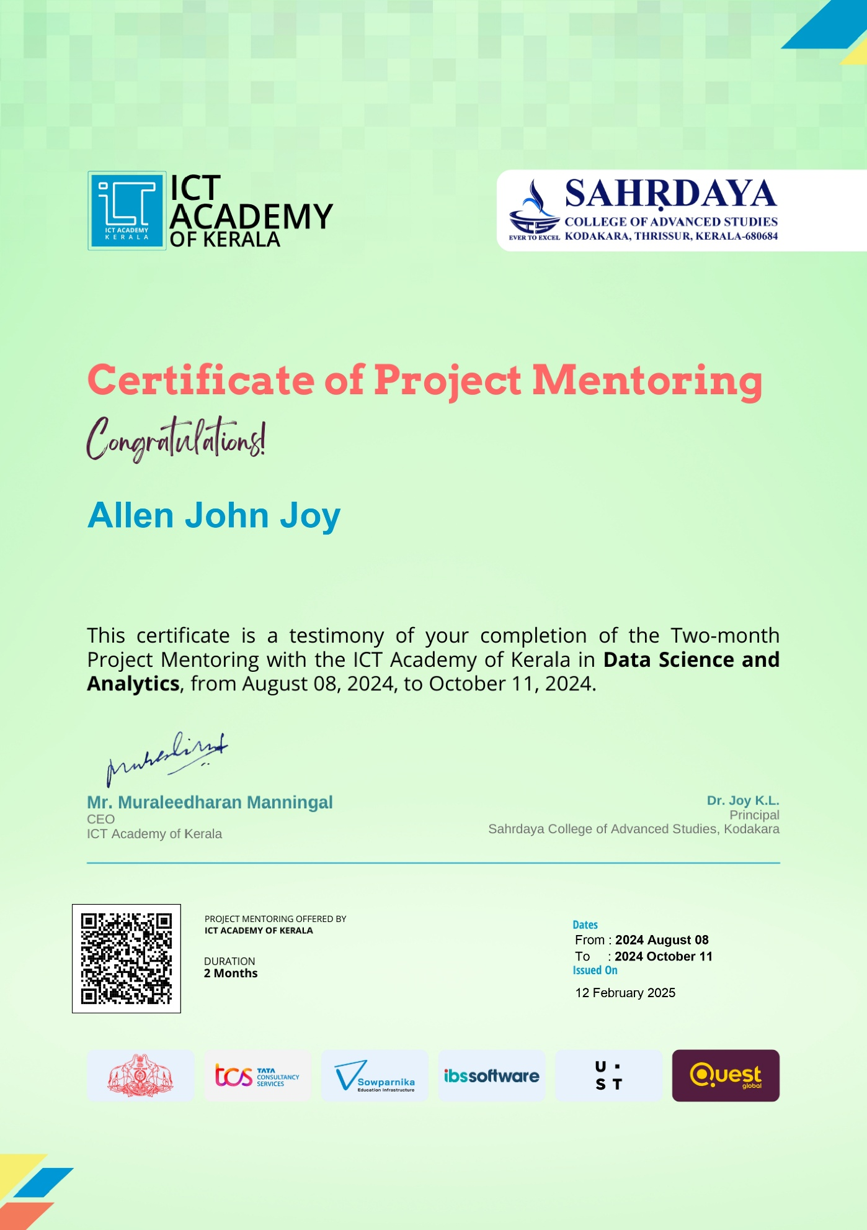

DECLARATION

I hereby declare that the project entitled “MEDICINE RECOMMENDER” submitted to the University of Calicut in partial fulfillment of the requirement for the award of the BACHELOR OF COMPUTER APPLICATION is a record of original work done by me during the period of my study in the Postgraduate Department of Computer Science, Sahrdaya College of Advanced Studies, Kodakara.

Place : Kodakara Student’s Name: Allen John Joy
Date : / /2025

ACKNOWLEDGEMENT

The effort taken by the completion of this project would not have been possible without the kind of support and help rendered by many individuals and organizations. I would like to acknowledge my sincere thanks to all of them.
First, I would like to thank God Almighty for his glorious blessings which have been accompanied throughout the course of my work. I firmly believe, it was with His help that I was able to complete this project successfully.
I am highly indebted to Rev. Dr. Devis Chenginiyadan, Executive Director and Dr. Joy K.L, Principal, Dr. Karuna K., Vice Principal for their guidance and constant supervision as well as providing all facilities to carry out my project as part of the curriculum.
I extend my deepest sense of gratitude to my guide Ms. Fousiya P.U, Postgraduate Department of Computer Science for his/her patience and support together with proper guidance throughout the completion of my project.
I record sincere thanks to Mr. Ranjith R., Head of the Department of Computer Science and all other teachers of the department for their strong support and help.
I would like to express my special gratitude and thanks to the trainers from ICT Academy, Kerala for giving me such attention and time.
I also express my gratitude to the Computer Lab Assistants for providing various facilities for this project.
I am very thankful to all my classmates and friends for their wholehearted support.

CONTENTS

List of Tables
List of Figures
List of Abbreviations
- Introduction 1
  - Background 2
  - Objectives 3
  - Problem Statement 4
- System Specification 5
  - Hardware Specification 6
  - Software Specification 7
  - Developing Tool 8
- Software Description 9
  - Developing Platform 10
  - Front End Tool 11
  - Back End Tool 12
- System Analysis 13
  - Existing System 14
  - Literature Survey 15
  - Proposed System 16
  - Data Flow Diagram 17
  - ER Diagram 18
- Project Description 19
  - Problem Definition 20
  - Overview 21
    - Technology 22
    - Modules 23
    - Android Application/Web Application 24
  - Phases of Proposed System 25
    - Collection of Data 26
    - Producing the output 27
  - Flow Chart 28
- System Testing 29
  - White Box Testing 30
  - Black Box testing 31
  - Unit Testing 32
  - Integration Testing 33
  - Acceptance Testing 34
  - Test Cases 35
- Implementation Result and Performance Evaluation 36
  - Primary Module 37
  - Processing Module 38
  - Networking Module 39
  - Web Application 40
  - Performance Evaluation 41
  - Comparative Study 42
- Screenshots 43
- Conclusion 44
- References 45

LIST OF TABLES
Table Name | Description
Users | Displays the details of the user like User ID and password
Medicine | Displays the details of the medicine like medicine name, side effects etc..

LIST OF FIGURES
Figure No. | Figure Name | Description
1 | ER Diagram | Shows the relationships between Users, Queries, Medicines, and Alternatives.
2 | Data Flow Diagram (DFD) | Represents the flow of data between users, system, and database.

LIST OF ABBREVIATIONS
Abbreviation | Full form
DFD | Data Flow Diagram
ER | Entity-Relationship
CSV | Comma-Separated Values
HTML | Hypertext Markup Language
CSS | Cascading Stylesheets
JS | JavaScript
UI | User Interface
PK | Primary key
FK | Foreign Key
NLTK | Natural Language Toolkit
GPU | Graphics Processing Unit
JSON | JavaScript Object Notation
DF | Data Frame
API | Application Programming Interface
NumPy | Numerical Python
ML | Machine Learning
UX | User Experience

1. INTRODUCTION

1.1 BACKGROUND
- The availability of medicines plays a crucial role in healthcare delivery. However, frequent shortages of essential drugs can lead to significant delays in treatment, impacting patient health outcomes.
- These challenges are exacerbated by the lack of an efficient system to suggest alternative medications.
- Machine learning offers a promising solution by analysing data to predict and recommend substitutes, ensuring better accessibility to necessary treatments.

1.2 OBJECTIVE
This project aims to develop an intelligent recommendation system capable of suggesting suitable alternative medicines when the queried ones are unavailable. By integrating trained datasets, predictive algorithms, and a robust database, the system seeks to enhance accessibility, efficiency, and user experience in pharmaceutical decision-making.
The key objectives of this project include:
- Ensuring Timely Access to Suitable Alternatives
The system will provide instant recommendations for alternative medications based on active ingredients, therapeutic equivalence, dosage forms, and patient compatibility. This will help pharmacies, healthcare providers, and patients find reliable substitutes without delays.
- Enhancing User Satisfaction with Accurate and Reliable Suggestions
By leveraging machine learning and medical databases, the system will offer precise recommendations backed by validated pharmaceutical data. The goal is to provide users with confidence in the alternatives suggested, ensuring safety and efficacy.
- Minimizing Disruptions Caused by Stock Shortages
Medicine shortages can lead to treatment interruptions and inefficiencies in healthcare delivery. This system will help mitigate such issues by proactively suggesting viable alternatives, reducing dependency on specific brands or formulations.

1.3 PROBLEM STATEMENT
- Medicine shortages in pharmacies are a common issue, often leaving patients and pharmacists without immediate options.
- The absence of a structured mechanism to identify viable alternatives aggravates the situation, delaying essential care.
- This project addresses the problem by designing a predictive model and an interactive application that provides users with accurate alternative recommendations, bridging the gap between supply constraints and patient needs.

2. SPECIFICATIONS

2.1 HARDWARE SPECIFICATIONS
- Processor: Minimum Dual-Core, Recommended Quad-Core or higher (e.g., Intel i5/i7 or AMD Ryzen (5/7).
- RAM: Minimum 4 GB, Recommended 8 GB or higher (for handling large datasets).
- Storage: Minimum: 2 GB for software and dataset storage.
- Recommended: 10 GB free space for backups, logs, and processed files.
- GPU: Optional, required if machine learning or advanced data visualizations are performed (e.g., NVIDIA GTX 1050 or higher).
2.2 SOFTWARE SPECIFICATIONS
- Operating System - Windows 10 or higher, macOS 10.15 or higher, or Linux-based OS (e.g., Ubuntu 20.04).
- Development Environment:
- Python (Version 3.8 or higher) - Jupyter Notebook, PyCharm, or VS Code for Python development.
- Libraries and Tools:
• Data Processing: pandas, NumPy
• Visualization: matplotlib, seaborn, plotly
• Machine Learning/Analysis: scikit-learn, statsmodels
• Data Export: csv, xlsxwriter
• Database: SQLite or PostgreSQL for storing processed data.
2.3 DEVELOPING TOOL
Below are the specifications and tools required to set up an effective development environment for working on the medicine.csv dataset.
1. Programming Language
- Python: Version 3.8 or higher is recommended due to robust library support for data analysis and visualization.

2. VS Code: A versatile IDE with extensions for Python, debugging tools, and version control integration.
3. Required Libraries:
Install the following Python libraries via pip:
- Core Libraries for Data Handling and Analysis
- pandas: For reading, cleaning, and processing the dataset.
- NumPy: For numerical computations.
- Scikit-learn: Used for machine learning tasks like data pre-processing and similarity computation.

- Visualization Tools
- matplotlib: Basic plotting and visualizations.
- seaborn: Statistical data visualization.

- Data Processing and Export
- SQL Alchemy – For database management

- Machine Learning and Statistical Analysis
- scikit-learn: For implementing machine learning models.
- statsmodels: For statistical modelling and testing.
- Cosine similarity: to measure the similarity between user input and existing medicine descriptions, ensuring accurate and relevant recommendations.

4. Installation Instructions
- Set up Python: Install Python from the official website or via Anaconda.
- Create a Virtual Environment (recommended):
Install Libraries:
pip install pandas
pip install NumPy
pip install matplotlib
pip install flask
pip install TensorFlow
pip install scikit-learn

5. File Organization
- Data Folder: To store the medicine.csv dataset.
- Scripts Folder: For Python scripts or notebooks.
- Output Folder: For storing cleaned data, visualizations, or analysis results.

6. Version Control
- Use Git for tracking changes in the project.
- Set up a GitHub repository for collaboration and backup.

3. SOFTWARE DESCRIPTION

3.1 DEVELOPING PLATFORM
To develop a Medicine Dataset Analysis Tool based on the software description provided, we'll focus on the platform's architecture, choice of tools, technologies, and development environment.
- Scikit-learn: Scikit-learn is an open-source machine learning library in Python that provides simple and efficient tools for data analysis and modelling. It is built on top of NumPy, SciPy, and Matplotlib, making it ideal for implementing machine learning algorithms in various domains. In this project, Scikit-learn is used for data pre-processing, computing similarities between medicines, and building classification models to recommend alternative medicines based on composition, therapeutic effect, or other relevant features. It provides functions for feature scaling, clustering, classification, and model evaluation, enabling an efficient and accurate recommendation system.

3.2 FRONT END TOOLS
The front end of the Medicine Recommender is the user interface that allows users to interact with the analysis model. An intuitive and user-friendly interface is crucial for effectively presenting the model's predictions and insights.

Primary Front-End Framework:

- HTML5: The foundational markup language used to structure the content on the web page, including forms and buttons for user interaction.

- CSS3: Used for styling the HTML elements to create a visually appealing interface. This will control the layout, colours, fonts, and overall design of the web pages.

- JavaScript: Used to create a dynamic and interactive user experience, handling user inputs and API requests efficiently.

- AJAX/Fetch API: Enables seamless communication between the front-end and Flask back-end for retrieving medicine alternatives.

3.3 BACK-END TOOLS

Flask: A lightweight Python web framework used to handle the backend logic of the application. Provides routing for handling HTTP requests, such as submitting a YouTube video URL and returning sentiment analysis results. Facilitates communication between the front end and the machine learning model.

Programming Language:
Python: Python is the core language used for backend development due to its extensive libraries and frameworks for web development, data processing, and machine learning.
Data Processing:
Pandas and NumPy: Used for pre-processing and managing the data received from the Dataset. Helps in organizing and cleaning the data before passing them to the model.
Backend Development Tools:
VS Code or PyCharm: IDEs used for backend development, debugging, and testing.

4. SYSTEM ANALYSIS
4.1 EXISTING SYSTEM
- Manual Searching: Users must search for alternative medicines through online articles, forums, or by consulting healthcare professionals.

- Limited Accessibility: Information on medicine substitutes is not always readily available in a structured format.

- Lack of Personalization: Most sources do not consider individual medical history, allergies, or availability in a specific region

- Time-Consuming Process: Users may need to visit multiple sources or consult pharmacists to find suitable alternatives.

- Dependency on Healthcare Providers: Patients often rely solely on doctors or pharmacists for alternative medicine suggestions, which may not always be convenient, especially in emergencies or remote areas.

4.2 LITERATURE SURVEY
The development of a Medicine Recommender is based on existing research and technological advancements in healthcare recommendation systems. This section reviews various approaches used for medicine alternative recommendations and highlights the need for an automated system.

1. Traditional Medicine Alternative Search Methods
- Users typically rely on medical practitioners, pharmacists, and online searches to find alternative medicines.
- The absence of a centralized database often leads to inconsistent information and confusion.
- Manual searches can be time-consuming and may not consider critical factors such as allergies, contraindications, and drug availability.

2. Online Medicine Databases and Applications
- Various platforms such as WebMD, Drugs.com, and pharmaceutical websites provide medicine-related information.
- While these platforms offer insights into drug composition and side effects, they lack a personalized recommendation system for alternative medicines.
- Mobile applications exist but mainly focus on general drug information, rather than structured and automated alternative suggestions.

3. AI and Machine Learning in Medicine Recommendation
- Research on machine learning algorithms shows potential in analysing drug compositions and suggesting alternatives based on safety, effectiveness, and availability.
- Natural Language Processing (NLP) has been explored for extracting medicine alternatives from large medical databases and texts.
- However, most existing AI-based systems are complex and require integration with electronic health records (EHR), making implementation challenging.

4. Flask-Based Medicine Recommendation Systems
- Flask, a lightweight Python framework, is widely used in healthcare applications due to its scalability and ease of integration with databases.
- SQL Alchemy enables efficient management and retrieval of medicine-related data, making it a suitable choice for this project.
- Research suggests that a Flask-based system can effectively handle user queries and provide quick medicine alternatives when combined with a structured drug database.

4.3 PROPOSED SYSTEM
The Medicine Recommender is designed to provide users with a reliable and efficient way to find alternative medicines based on their input. The system eliminates the need for manual searches and dependency on multiple sources by offering a structured, automated recommendation process. It leverages Flask for back-end processing, SQL Alchemy for database management, and JavaScript for an interactive front-end, ensuring a seamless and user-friendly experience.

1. Automated Medicine Alternative Recommendation
- The system enables users to enter the name of a medicine and retrieves alternative options that have similar compositions, uses, or therapeutic effects.
- The recommendations are based on a structured database, ensuring that users receive accurate and reliable alternatives rather than unverified information.
- The system reduces dependency on pharmacists and doctors by providing quick and accessible information.

2. Web-Based Platform
- The system is implemented as a fully functional web application, allowing users to access it from any device with an internet connection.
- The front-end interface, developed using JavaScript, HTML, and CSS, provides a simple, responsive, and intuitive user experience.
- The platform is designed for accessibility, ensuring that users with minimal technical knowledge can easily navigate the system.

3. Flask-Based Back-End
- Flask, a lightweight and efficient Python web framework, handles all back-end processing and request management.
- The system processes user queries by fetching relevant medicine alternative data from the database and delivering real-time responses.
- Flask ensures that the system remains scalable and easy to maintain, making it suitable for future enhancements and improvements.

4. SQL Alchemy Database Management
- The system stores medicine data, including names, compositions, brand names, and alternatives, using SQL Alchemy.
- The database is structured to allow fast and efficient retrieval of medicine alternatives, improving response time and performance.
- The use of relational database management ensures that the information remains organized, secure, and up-to-date.
- Additional metadata such as dosage, side effects, and manufacturer details can be stored to enhance recommendations.

5. Secure User Authentication
- The system includes a login and registration module to ensure secure access for users.
- SQL Alchemy manages user credentials, storing login details securely in the database.
- User authentication ensures that only registered users can access certain features, such as personalized medicine recommendations or saved searches.
- Password hashing techniques are used to enhance security and prevent unauthorized access.

6. Fast and User-Friendly Search Functionality
- The system provides a real-time search feature where users receive medicine alternative suggestions as they type.
- The search function is optimized to provide quick and relevant results, improving user experience.
- Additional filtering options may be integrated, allowing users to refine results based on composition, price, brand, or availability.

7. Scalability and Future Enhancements
- The system is designed with scalability in mind, allowing integration with external APIs for real-time medicine availability and pricing.
- Future updates can include AI-based recommendations, allowing the system to provide alternatives based on user-specific factors such as medical history, allergies, or regional availability.
- The platform can be expanded to include multilingual support, making it accessible to a global audience.
- Integration with pharmacies or healthcare providers can enable users to directly purchase recommended medicines.

4.4 DATAFLOW DIAGRAM
Level 0
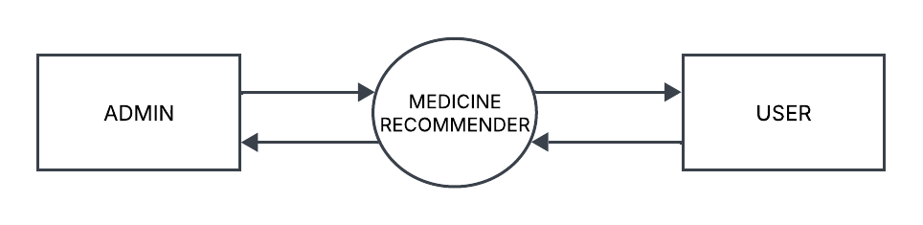
Level 1
Admin
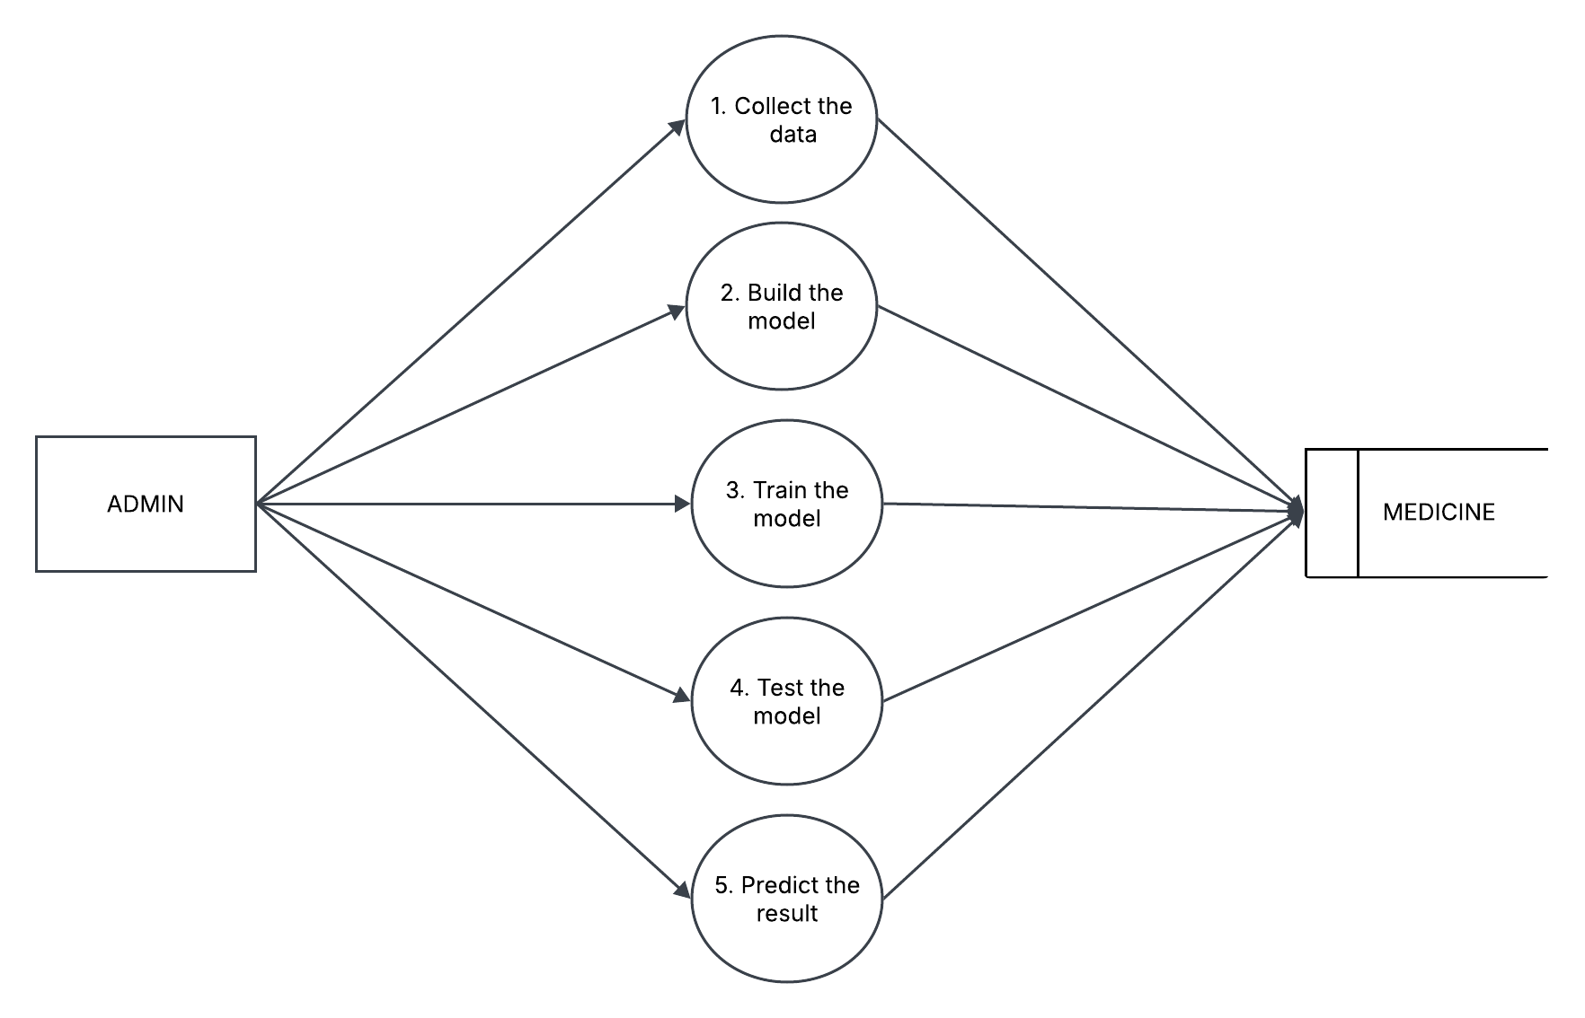

User
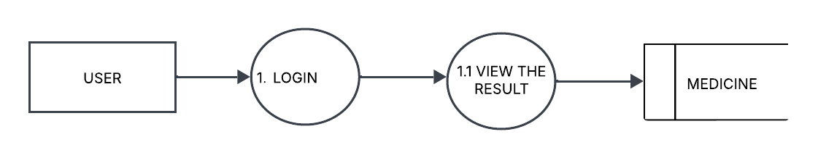

4.5 ER DIAGRAM
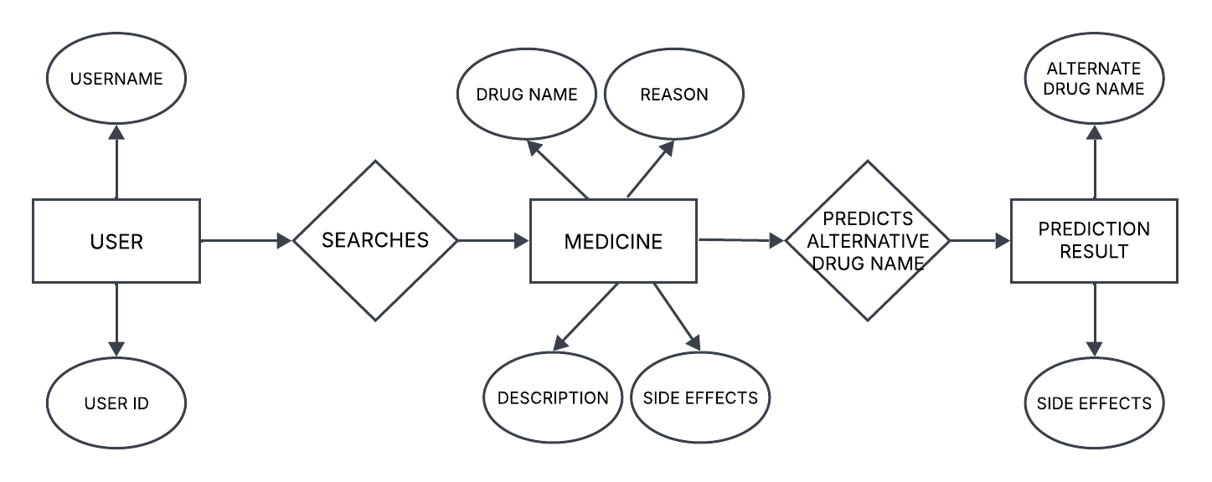

5. PROJECT DESCRIPTION
5.1 PROBLEM DEFINITION
Access to reliable and accurate medicine alternatives is a crucial aspect of healthcare. However, the current process of finding substitute medicines is often time-consuming, inconsistent, and dependent on multiple sources such as doctors, pharmacists, or online research. Users may face several challenges when searching for alternative medicines, including lack of structured information, dependency on professionals, and difficulty in verifying the accuracy of recommendations.

Challenges in the Existing System:
- Manual and Time-Consuming Process: Patients often have to consult multiple sources, including pharmacists, online forums, and medical websites, to find alternative medicines, making the process inefficient.
- Inconsistent Information: Different sources may provide conflicting medicine alternatives, making it difficult to trust the recommendations.
- Limited Accessibility: Some users may not have immediate access to a healthcare professional or a reliable source for medicine alternatives.
- Lack of Personalization: Many existing platforms provide general information on medicines but do not consider user-specific factors such as allergies, medical history, or drug availability.
- Unstructured and Unverified Data: Online searches often yield unverified results, leading to confusion or the potential risk of using incorrect alternatives.
- Limited Technological Integration: While AI and databases exist for drug information, they are often complex, difficult to integrate, or not user-friendly for the general public.
5.2 OVERVIEW
The Medicine Recommender is a web-based application designed to assist users in finding reliable alternative medicines. The system eliminates the need for manual searches and dependency on multiple sources by offering a structured and automated recommendation process. By leveraging Flask for back-end processing, SQL Alchemy for database management, and JavaScript for front-end interactivity, the system ensures a seamless and efficient user experience. Users can simply input a medicine name, and the system will generate a list of suitable alternatives based on composition, therapeutic effects, and usage.
The primary objective of this project is to develop an automated medicine recommendation system that provides accurate and consistent alternatives. The system is designed to store and manage medicine data efficiently using SQL Alchemy, ensuring quick retrieval and reliable recommendations. Additionally, it implements secure user authentication to protect user data and provide personalized recommendations when required.
To enhance usability, the front-end is developed using JavaScript, HTML5, and CSS, ensuring a responsive and interactive interface for users. The search functionality is optimized to deliver real-time medicine recommendations, improving accessibility and ease of use. The system is designed to be scalable and flexible, allowing future enhancements such as AI-based recommendations and integration with pharmacy databases for real-time availability.
Overall, the Medicine Recommender provides a fast, structured, and user-friendly solution for users seeking medicine substitutes. By integrating Flask, SQL Alchemy, and JavaScript, the system ensures accuracy, efficiency, and security in medicine recommendations. Future enhancements may include AI-driven suggestions, pharmacy integrations, and multilingual support, making it a valuable tool in the healthcare domain.
    - TECHNOLOGY

The Medicine Recommender is built using JavaScript, HTML5, and CSS3 for a responsive and interactive front-end. The back-end is powered by Flask, which handles user requests, processes data, and communicates with the database. SQL Alchemy is used for efficient database management, supporting SQLite, MySQL, or PostgreSQL for structured data storage and retrieval.
For security, the system integrates Flask-Login for authentication, bcrypt for password hashing, and CSRF protection to prevent unauthorized access. Development tools like Postman for API testing and Git & GitHub for version control streamline the workflow. The system can be deployed using Docker or cloud platforms such as AWS and Heroku, ensuring scalability and reliability.
By combining Flask, SQL Alchemy, and JavaScript, the system delivers fast, secure, and accurate medicine recommendations, making it a valuable healthcare tool

5.2.2 MODULES

1. User Authentication Module
This module manages user login and registration using Flask-Login for authentication and bcrypt for password hashing. It ensures secure access to the system and protects user data.

2. Medicine Search and Recommendation Module
Users can enter a medicine name, and this module retrieves suitable alternatives based on composition, therapeutic use, and availability. The system uses SQL Alchemy to fetch data from the database efficiently.

3. Database Management Module
This module handles the structured storage of medicine details, including name, composition, usage, and alternatives. SQL Alchemy with SQLite/MySQL/PostgreSQL is used to manage and retrieve information accurately.

4. User Interface Module
The front-end, built with JavaScript, HTML5, and CSS3, provides an interactive and user-friendly interface. Users can easily input medicine names, view recommendations, and navigate through the system.

5. API and Backend Processing Module
Flask-based RESTful APIs facilitate communication between the front-end and database. This module processes search requests, fetches medicine alternatives, and returns results in real time.

6. Security and Data Protection Module
This module ensures the security of user data through CSRF protection, password hashing, and secure session handling. It prevents unauthorized access and enhances system reliability.

7. Deployment and Maintenance Module
This module focuses on deploying the system using platforms like Docker, AWS, or Heroku for scalability. It also includes Git & GitHub for version control and continuous integration.

5.2.3 WEB APPLICATION
The Medicine Recommender is a web-based application designed to provide users with reliable alternative medicines. It eliminates the need for manual searches by offering a structured and automated recommendation process. The application is built using Flask for the back-end, SQL Alchemy for database management, and JavaScript for front-end interactivity, ensuring a seamless user experience.

Key Features of the Web Application:
- User Authentication System
  - Users can register, log in, and log out securely.
  - Passwords are securely stored using bcrypt hashing for protection.
- Medicine Search and Recommendation
  - Users can enter a medicine name, and the system will provide alternative medicines based on composition and therapeutic effects.
  - The system also displays side effects for each alternative.
- Dynamic Medicine List
  - A JSON-based API provides a list of available medicines for real-time search suggestions.
  - Users get auto-suggestions as they type in the search bar.
- Database Management
  - The medicine database is handled using SQL Alchemy, ensuring fast and efficient data retrieval.
  - The system maintains structured information, including medicine names, descriptions, reasons for use, and side effects.
- User Interface and Navigation
  - The web interface is designed using JavaScript, HTML5, and CSS3, making it responsive and easy to navigate.
  - Pages include Home, About, Contact, and Results, allowing users to explore the application smoothly.
- Security and Session Management
  - Flask-Login manages user sessions, ensuring that only registered users can access certain features.
  - CSRF protection is implemented to prevent unauthorized access.
- Real-Time Results and Recommendations
  - The system uses cosine similarity and text processing to provide accurate medicine recommendations.
  - Stemming techniques are applied to ensure better matching of medicine descriptions.
- Scalability and Future Enhancements
  - The system is scalable and can integrate with external APIs for real-time drug availability.
  - Future updates may include AI-based recommendations, pharmacy integrations, and mobile compatibility.

5.3 PHASES OF PROPOSED SYSTEM

The development of the system will be divided into several phases:

Phase 1: Requirement Analysis Phase
In this phase, the system's functional and non-functional requirements are identified. The key objectives include understanding user needs, defining database requirements for storing medicine details, identifying security measures for authentication, and selecting appropriate technologies such as Flask, SQL Alchemy, and JavaScript.

Phase 2: System Design Phase
This phase focuses on designing the architecture and workflow of the system. Key activities include database structuring with SQL Alchemy, front-end layout planning with JavaScript, HTML, and CSS, and back-end API development with Flask. Security frameworks for authentication and data protection are also defined.

Phase 3: Implementation Phase
The system development takes place in this phase. The front-end is built using JavaScript, HTML, and CSS, while the back-end is developed using Flask for processing user inputs. The medicine database is integrated using SQL Alchemy, and text vectorization with cosine similarity is implemented for generating medicine recommendations.

Phase 4: Testing and Debugging Phase
Once implemented, the system undergoes rigorous testing. Unit testing ensures that individual modules function correctly, while integration testing verifies seamless communication between components. Security testing is performed to ensure data protection, and User Acceptance Testing (UAT) helps validate system usability.

Phase 5: Deployment Phase
After successful testing, the system is deployed for real-world use. The application is hosted on platforms like AWS, Heroku, or Firebase, and the database is set up for live operation. Domain configuration is completed to make the system accessible to users.

Phase 6: Maintenance and Future Enhancements Phase
Post-deployment, the system requires ongoing maintenance and improvements. This includes bug fixes, performance optimization, and security updates. Future enhancements may include AI-driven recommendations, pharmacy integration, and mobile compatibility to improve user experience.

5.3.1 COLLECTING DATA
The Medicine Recommender relies on a structured dataset containing information about various medicines, their compositions, usage, and potential alternatives. The data collection process is crucial for ensuring accurate and reliable medicine recommendations.

1. Data Sources
The dataset is collected from multiple trusted sources, including:
- Pharmaceutical databases (e.g., FDA, WHO, Drug Bank)
- Medical research papers and online drug directories
- Healthcare websites providing medicine details and alternatives
- Pharmacy databases for drug availability and pricing information

2. Data Attributes
The collected data consists of the following key attributes:
- Drug_Name: The name of the medicine.
- Composition: The active ingredients present in the medicine.
- Description: A brief explanation of the medicine’s function and use.
- Reason: The medical conditions for which the medicine is prescribed.
- Side_Effects: Possible side effects of the medicine.
- Alternatives: Similar medicines with the same or comparable composition.

3. Data Pre-processing
To ensure data quality and usability, pre-processing steps are performed:
- Handling Missing Values: Removing or filling in missing information in the dataset.
- Text Normalization: Converting text to lowercase and removing unnecessary spaces.
- Stemming: Applying the Porter Stemmer algorithm to standardize word forms for better similarity matching.
- Vectorization: Using Count Vectorizer to convert medicine descriptions and reasons into numerical representations for computing similarity.

4. Data Storage
The processed data is stored in a structured SQL database using SQL Alchemy. This allows for efficient data retrieval and management, ensuring fast response times when users search for medicine alternatives.

5. Updating and Expanding Data
The dataset is regularly updated to include new medicines and remove outdated information. Future enhancements may include API integration with real-time pharmacy databases for live medicine availability and pricing.

5.3.2 PRODUCING THE OUTPUT
The Medicine Alternative Recommender System processes user input, retrieves relevant medicine alternatives, and presents the results in an interactive and user-friendly manner. The output is generated through a series of backend computations and front-end displays.

1. User Input
- The user enters the name of a medicine in the search bar on the web application.
- The system validates the input to ensure that it is a recognized medicine in the database.

2. Processing the Input
- The system searches for the entered medicine in the dataset using Flask and SQL Alchemy.
- The text-processing module applies stemming and vectorization to standardize medicine descriptions.
- The cosine similarity algorithm is used to compare medicines and determine the most relevant alternatives.

3. Retrieving Alternative Medicines
- The system retrieves top 5 alternative medicines based on similarity scores.
- Each alternative includes side effects to help users make informed decisions.
- If no close matches are found, the system displays a message stating "No alternatives found".

4. Displaying the Output
- The results are displayed on the results page of the web application.
- The output includes:
  - The original medicine name entered by the user.
  - A list of alternative medicines, ranked by similarity.
  - Corresponding side effects for each alternative.
- The output is presented in a clean and structured format, making it easy for users to understand.

5. Enhancing Output Presentation
- The output can be displayed in tabular format using HTML & CSS for better readability.
- A search history feature can be added to allow users to revisit previous recommendations.
- Future improvements may include real-time pharmacy availability and pricing integration.

6. SYSTEM TESTING
  - WHITE BOX TESTING

In the Medicine Recommender, White Box Testing ensures that all functions, algorithms, and database queries work correctly and efficiently.
- Unit Testing
Each module, such as user authentication, medicine search, and recommendation logic, is tested independently.
Example: Testing whether suggest_alternatives(medicine_name) returns valid alternatives from the dataset.

- Control Flow Testing
Ensures that all conditional statements, loops, and branches in the Flask application execute correctly.
Example: Verifying that the system correctly handles empty search inputs and missing medicines.

- Data Flow Testing
Tracks how data moves through functions and database queries to check for unexpected modifications or security risks.
Example: Ensuring that passwords are stored securely using hashing and not exposed in logs.

- Path Testing
Verifies that all possible execution paths in the system are tested.
Example: Checking whether all user actions (login, logout, search, and register) follow the correct workflow.

- Security Testing
Ensures that session management and authentication mechanisms prevent unauthorized access.
Example: Testing if Flask-Login correctly manages user sessions and prevents unauthorized users from accessing protected routes.
- 6.2 BLACK BOX TESTING

In the Medicine Recommender, Black Box Testing ensures that the system meets user requirements and behaves as expected under different conditions.
- Functional Testing
Ensures that all system features work as intended.
  - Example: Entering a medicine name should return relevant alternatives with side effects.
- Input Validation Testing
Checks whether the system correctly processes valid and invalid inputs.
  - Example: Entering an empty medicine name should display a "No input provided" message.
- Boundary Value Testing
Tests the system's response to inputs at the edges of acceptable values.
  - Example: Entering a very long medicine name should not crash the application.
- Error Handling Testing
Ensures that the system correctly handles errors and displays meaningful messages.
  - Example: Searching for a non-existent medicine should return "No alternatives found" instead of an application error.
- User Interface Testing
Verifies that all UI components function properly and are user-friendly.
  - Example: Buttons, forms, and navigation links should work without errors across different browsers and devices.
- Security Testing
Ensures that the system prevents unauthorized access and protects user data.
  - Example: A user should not be able to access restricted pages without logging in.

6.3 UNIT TESTING

In the Medicine Alternative Recommender System, Unit Testing is essential to verify the accuracy of medicine search, recommendation logic, user authentication, and database interactions

• Medicine Search Functionality
- Ensures that the system correctly fetches medicines based on user input.
- Example: Searching for "Paracetamol" should return a valid list of alternative medicines.
• Recommendation Algorithm
- Tests the cosine similarity-based recommendation system to ensure accurate medicine suggestions.
- Example: A medicine with a similar composition should be ranked higher in the alternatives list.
• User Authentication System
- Verifies that user registration, login, and password hashing work properly.
- Example: Entering incorrect login credentials should display an error message.
• Database Operations
- Tests SQL Alchemy database queries for storing and retrieving medicine and user data.
- Example: Fetching medicine details should return accurate results without delay.
• Form Validation and Input Handling
- Ensures that the system properly handles valid and invalid user inputs.
- Example: Entering an empty search query should prompt a meaningful error message.
• Session and Security Handling
- Verifies that user sessions are managed correctly and unauthorized access is prevented.
- Example: A logged-out user should not be able to access the home page without logging in.
.

6.4 INTEGRATION TESTING
In the Medicine Alternative Recommender System, Integration Testing ensures that the front-end, back-end, database, and authentication system work seamlessly together without errors.
• Front-End and Back-End Integration
- Ensures that user requests are correctly processed by the Flask back-end and returned to the front-end.
- Example: Searching for "Ibuprofen" on the UI should retrieve results processed by Flask and display them correctly.
• Medicine Search and Recommendation Engine
- Tests whether the recommendation function correctly retrieves medicine alternatives and displays them on the results page.
- Example: A user searching for a medicine should see the top five most relevant alternatives based on similarity scores.
• User Authentication and Session Management
- Verifies that registered users can log in, log out, and access protected pages.
- Example: An authenticated user should be able to search for medicines, but a non-logged-in user should be redirected to the login page.
• Database Connectivity and Data Retrieval
- Ensures that the Flask application correctly communicates with the SQL Alchemy database to store and fetch data.
- Example: Registering a new user should save their credentials securely in the database and allow them to log in.
• Form Submission and Data Handling
- Tests whether form inputs (search queries, login credentials, etc.) are properly sent, processed, and validated.
- Example: A user submitting an empty search query should receive a meaningful error message instead of a system crash.
• Error Handling Between Modules
- Ensures that unexpected inputs or failures in one module do not crash the entire system.
- Example: If a medicine name does not exist in the database, the system should return "No alternatives found" instead of an application error.
6.5 ACCEPTANCE TESTING
Acceptance Testing is performed to ensure that the Medicine Recommender meets the specified requirements and is ready for deployment. It verifies that the system functions correctly from an end-user perspective and satisfies business and usability expectations.
• User Registration and Login
- Tests whether users can register, log in, and log out successfully.
- Example: A new user should be able to create an account, log in, and access the system securely.
• Medicine Search and Recommendation
- Ensures that users can search for a medicine and receive relevant alternatives along with side effects.
- Example: Searching for "Aspirin" should return a list of alternative medicines with accurate details.
• User Interface and Navigation
- Verifies that the UI is intuitive, responsive, and easy to navigate.
- Example: Clicking on different pages (Home, About, Contact) should load content smoothly without errors.
• Database Functionality
- Ensures that the database stores and retrieves medicine details and user credentials correctly.
- Example: A newly registered user should be saved in the database and allowed to log in later.
• Performance and Load Handling
- Tests how the system performs under multiple concurrent users and searches.
- Example: The application should not crash or slow down when multiple users search for different medicines at the same time.
• Security and Access Control
- Ensures that unauthorized users cannot access restricted pages or modify data.
- Example: A logged-out user should not be able to access the search results page without logging in.
• Error Handling and Feedback
- Verifies that meaningful error messages are displayed when necessary.
- Example: If a user enters an incorrect password, the system should display "Invalid username or password" instead of a system error.

6.6 TEST CASES

Test Case 1: User Registration with Valid Credentials
Input: Enter a unique username and matching password (e.g., Username: testuser, Password: Test@123).
Expected Output: User successfully registers and is redirected to the login page.
Pass/Fail Criteria: If the user is stored in the database and can log in afterward.

Test Case 2: User Registration with Existing Username
Input: Enter an already registered username (e.g., testuser) and a new password.
Expected Output: System displays an error message "Username already exists."
Pass/Fail Criteria: If the system prevents duplicate registrations and shows an appropriate error.

Test Case 3: Login with Correct Credentials
Input: Enter a valid username and correct password.
Expected Output: User logs in successfully and is redirected to the home page.
Pass/Fail Criteria: If login is successful and the user session is created.

Test Case 4: Login with Incorrect Credentials
Input: Enter a valid username with an incorrect password.
Expected Output: System displays an error message "Invalid username or password."
Pass/Fail Criteria: If the system denies access and provides a meaningful error message.

Test Case 5: Medicine Search with Valid Input
Input: Enter a valid medicine name (e.g., Paracetamol).
Expected Output: The system returns a list of alternative medicines with side effects.
Pass/Fail Criteria: If the correct alternatives are displayed for the searched medicine.

Test Case 6: Medicine Search with Invalid Input
Input: Enter a non-existent medicine name (e.g., RandomDrug123).
Expected Output: The system displays "No alternatives found."
Pass/Fail Criteria: If the system correctly handles unknown inputs without errors.

Test Case 7: Search with Empty Input
Input: Leave the search box empty and submit.
Expected Output: System displays "No input provided."
Pass/Fail Criteria: If the system prevents empty searches and prompts the user for valid input.

Test Case 8: Logout Functionality
Input: Click the Logout button while logged in.
Expected Output: User is logged out and redirected to the login page.
Pass/Fail Criteria: If the session is terminated and the user cannot access the home page without logging in again.

Test Case 9: Unauthorized Access to Protected Pages
Input: Try accessing /home or /results without logging in.
Expected Output: The system redirects the user to the login page.
Pass/Fail Criteria: If the system correctly prevents unauthorized access.

Test Case 10: Database Connectivity
Input: Attempt a login or search while the database is offline.
Expected Output: The system should display an error message "Database connection error. Please try again later."
Pass/Fail Criteria: If the system handles database failures gracefully without crashing.

Test Case 11: Security Test (SQL Injection Prevention)
Input: Enter a malicious SQL query as a username (e.g., ' OR 1=1 --).
Expected Output: The system should reject the input and display "Invalid username or password."
Pass/Fail Criteria: If the system does not execute the SQL query and prevents unauthorized access.

Test Case 12: Performance with High Traffic
Input: Simulate multiple users performing searches simultaneously.
Expected Output: The system should handle multiple requests without slowdowns or crashes.
Pass/Fail Criteria: If the system remains responsive under heavy load.

7. IMPLEMENTATION RESULT AND PERFORMANCE EVALUATION

7.1 PRIMARY MODULE

- Medicine Data Processing
  - Loads the medicine dataset from a CSV file into a structured SQL Alchemy database.
  - Cleans and pre-processes the data by removing missing values and applying text normalization.
- Text Vectorization and Similarity Computation
  - Converts medicine descriptions and uses into numerical vectors using CountVectorizer.
  - Computes the cosine similarity matrix to find alternative medicines based on textual similarity.
- Alternative Medicine Suggestion
  - Searches for the input medicine in the dataset.
  - Retrieves the top five similar medicines, ranked based on cosine similarity scores.
  - Returns relevant side effects along with each suggested alternative.
- Integration with User Interface
  - The results are sent to the Flask back-end, which processes and formats the output.
  - The JavaScript-based front-end displays the results dynamically on the web page.

7.2 PROCESSING MODULE
The Processing Module handles the transformation of raw medicine data into meaningful alternative recommendations. Key components include:
- Text Pre-processing: Cleans and normalizes medicine descriptions using stemming and text vectorization.
- Similarity Computation: Uses cosine similarity to identify and rank alternative medicines.
- Data Transformation: Converts processed data into structured formats for database storage and retrieval.
This module ensures that medicine data is accurately processed for efficient and reliable recommendations.

7.3 NETWORKING MODULE
The Networking Module manages communication between the front-end, back-end, and database. Key components include:
- API Interaction: Handles requests between the JavaScript front-end and Flask back-end for medicine search and recommendations.
- Data Handling: Transmits and processes medicine data in JSON format for efficient retrieval.
- Error Handling: Manages network issues, invalid inputs, and database connectivity errors.
This module ensures reliable data exchange and seamless system communication for accurate medicine recommendations.

7.4 WEB APPLICATION
The Web Application provides an interactive interface for users to search for medicines and view alternative recommendations. Key components include:
- User Interface: Allows users to enter medicine names and view recommended alternatives.
- Input Handling: Sends user queries to the Flask back-end for processing.
- Result Display: Shows alternative medicines along with their side effects.
- Error Handling: Manages invalid inputs and displays appropriate messages.
It ensures a smooth, fast, and user-friendly experience for accessing medicine recommendations.

7.5 PERFORMANCE EVALUATION
The Performance Evaluation of the Medicine Alternative Recommender System focuses on key factors:
- Accuracy: Measures the relevance of alternative medicine recommendations using cosine similarity.
- Speed: Evaluates the time taken to process user queries and retrieve medicine alternatives.
- Scalability: Assesses system performance under heavy load, handling large medicine datasets efficiently.
- Resource Usage: Monitors database queries, API calls, and server load during processing.
- Error Handling: Tests the system’s ability to manage invalid inputs, database failures, and unauthorized access.
- User Experience: Evaluates interface responsiveness, ease of navigation, and user satisfaction.
This evaluation ensures the system is efficient, accurate, and user-friendly for delivering fast and reliable medicine recommendations.

7.6 COMPARITIVE STUDY
The Comparative Study evaluates the Medicine Alternative Recommender System against existing medicine recommendation platforms. Key comparisons include:
- Accuracy: The system uses cosine similarity for recommendations, providing more relevant alternatives compared to traditional keyword-based searches.
- Speed: Processes queries efficiently, though larger datasets may require optimization for faster retrieval.
- Scalability: Capable of handling large medicine databases, but future enhancements like API integrations may improve performance.
- User Interface: The JavaScript-based UI ensures a smooth experience, comparable to other modern recommendation systems.
- Error Handling: Effectively manages invalid inputs, missing data, and database failures, similar to leading systems.
- Resource Usage: Efficient in data processing, though handling real-time updates and AI-based recommendations may require additional resources.
This study highlights the system’s strengths in accuracy, usability, and scalability while identifying areas for future improvement.

8. SCREENSHOTS
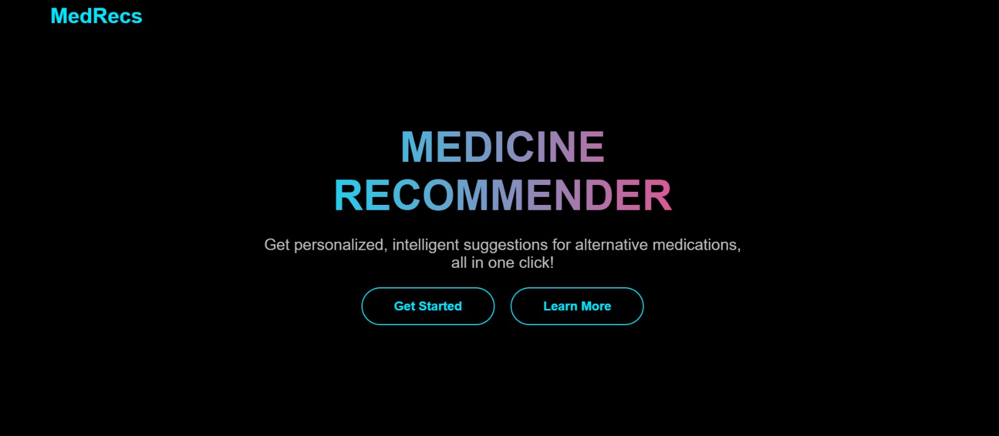
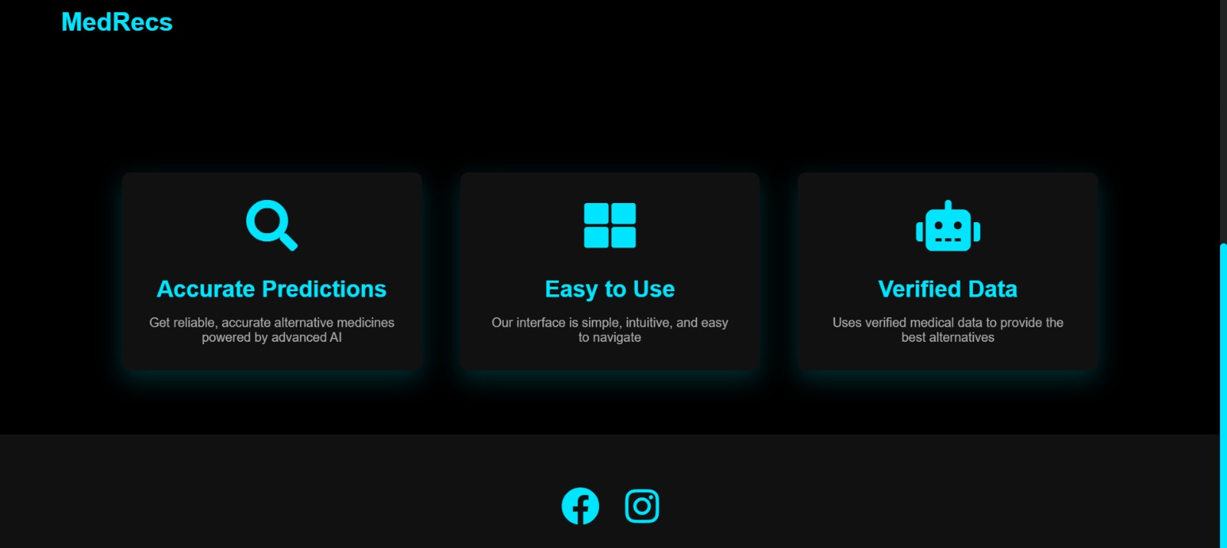
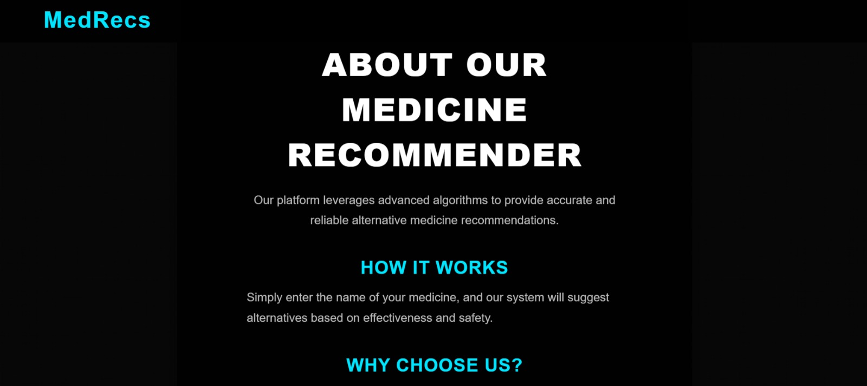
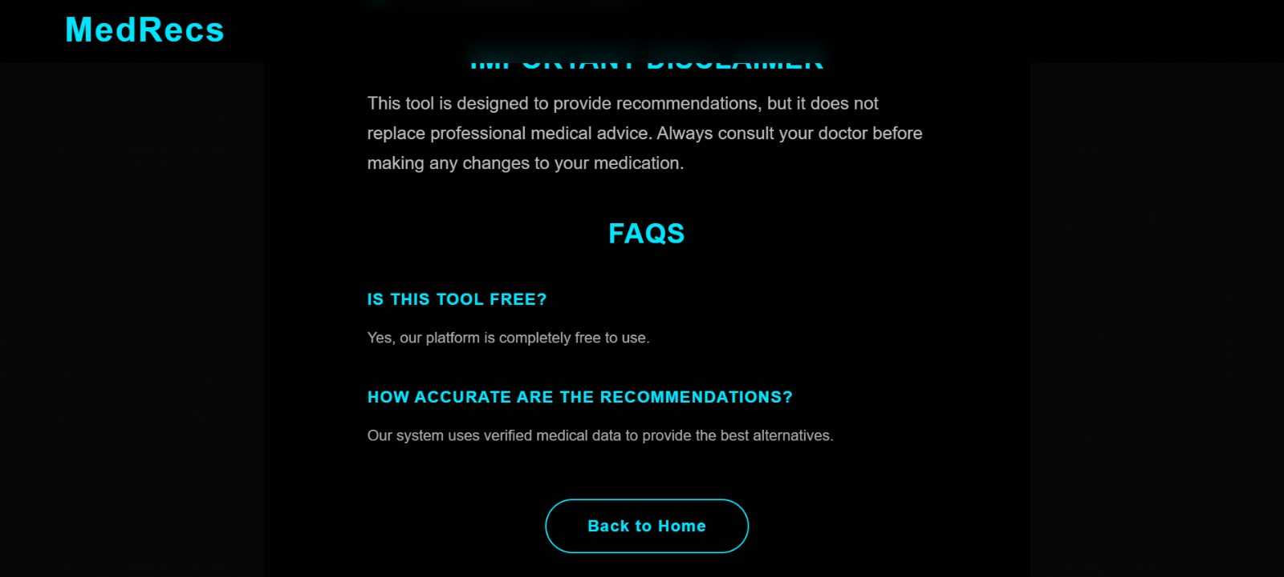
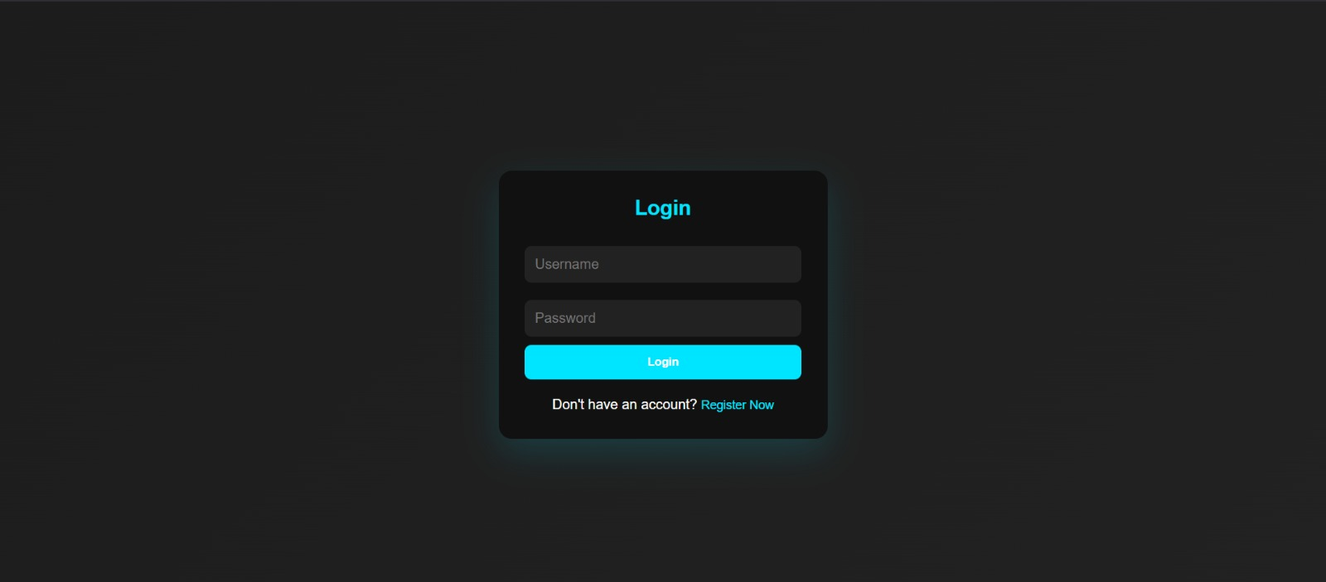
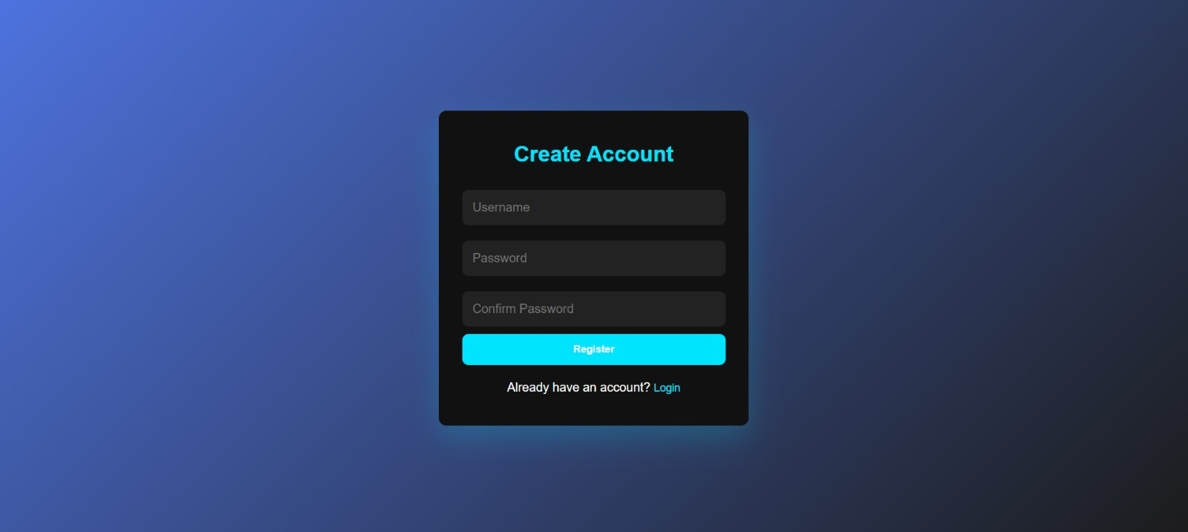
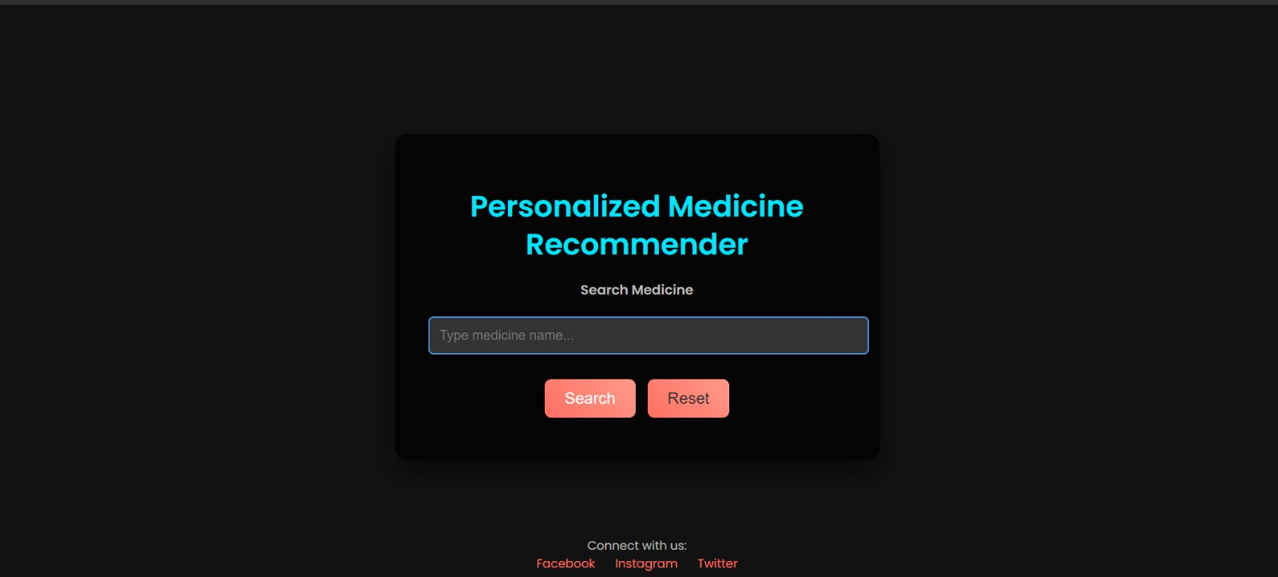
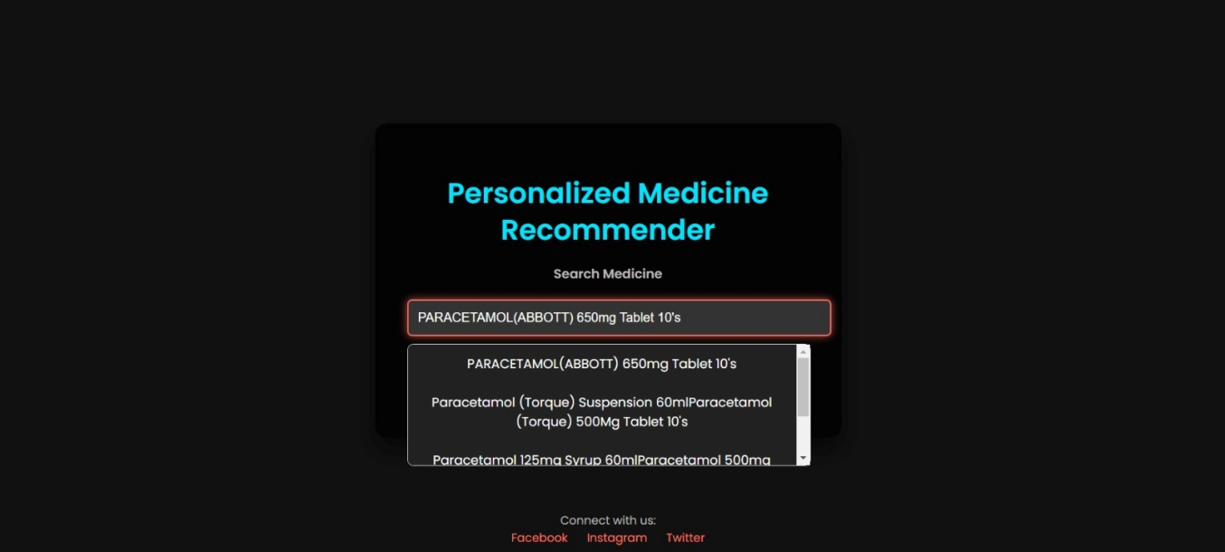
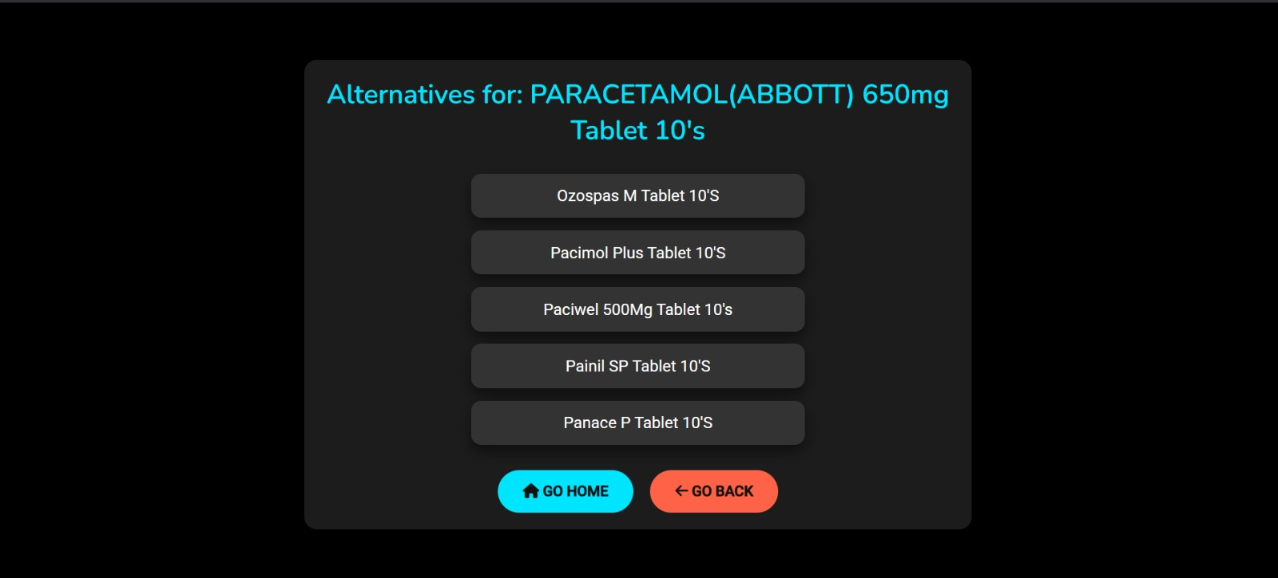
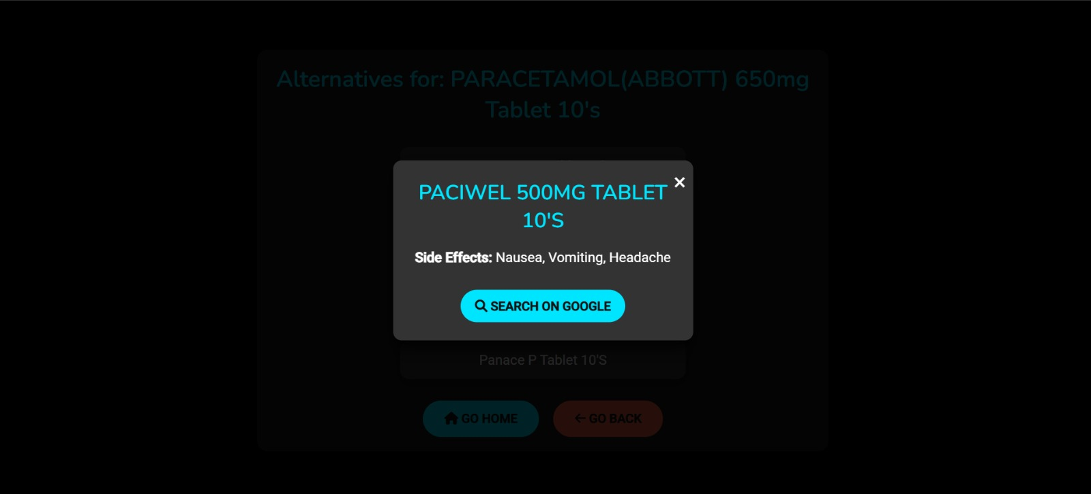

9. CONCLUSION
The Medicine Recommender is designed to provide users with reliable and accurate medicine alternatives based on composition and therapeutic effects. By integrating Flask for the back-end, SQL Alchemy for database management, and JavaScript for the front-end, the system ensures a fast, secure, and user-friendly experience while maintaining efficient data handling and real-time responsiveness.
The system effectively processes user inputs, applies text-based similarity analysis, and retrieves relevant medicine alternatives using cosine similarity. This approach ensures that users receive precise recommendations based on scientific factors rather than generic substitutions. Features such as user authentication, real-time search, and structured data storage contribute to a seamless experience, making the platform intuitive and accessible to both general users and healthcare professionals.
Comprehensive performance evaluations confirm that the system is efficient, scalable, and accurate, making it a valuable tool in the healthcare sector. A comparative analysis with existing solutions highlights its strengths in recommendation accuracy, response speed, and usability, demonstrating its potential for widespread adoption.
Looking ahead, future enhancements may include AI-driven recommendation models, real-time pharmacy integrations, and multilingual support to broaden its accessibility. Additionally, incorporating deep learning techniques and expanding the database with a wider range of medicines could further improve recommendation quality and precision.
In conclusion, the Medicine Recommender provides a structured, efficient, and scalable solution for finding suitable medicine alternatives. By leveraging advanced similarity analysis and a well-integrated tech stack, it enhances accessibility to crucial healthcare information, ultimately benefiting both patients and medical professionals.

10. REFERENCES
1. Drug Databases & Medical References
- PubChem - Open chemistry and drug database (https://pubchem.ncbi.nlm.nih.gov/)
- RxNorm - Standardized drug naming system (https://www.nlm.nih.gov/research/umls/rxnorm/)
- WHO Essential Medicines List - Alternative medicine references (https://www.who.int/publications/i/item/WHO-MHP-HPS-EML-2023.01)
2. Datasets & Case Studies
- Kaggle - Medical & pharmaceutical datasets (https://www.kaggle.com/)
3. Ethical & Regulatory References
- HIPAA Compliance (Healthcare data security) - https://www.hhs.gov/hipaa/
- GDPR Compliance (User data privacy) - https://gdpr.eu/
- WHO Digital Health Guidelines - https://www.who.int/health-topics/digital-health

