**Talkbox**

**Group 14**

**EECS 2311 | Lassonde School Of Engineering**

User-Manual

# Table of Contents

Table of Contents: 1

Installation: 2

Getting Started: 2 - 4

COMMON USAGE SCENARIOS: 5

# Installation:

The product can be installed on any device that can use the Java Virtual Machine (JVM) through running the Java Applet. The app will allow for an interface with hardware components as specified through the libraries provided. Furthermore, the applet is created to configure a Raspberry Pi and it’s relevant GPIO ports.

To install the TalkBox Prototype, begin by downloading the Github repository from <https://github.com/AllenKaplan/TalkBox> as a ZIP and extract the “Prototype” directory to your desired location. To launch either the Configurator or Simulator applications double click their respective .jar files.

# Getting Started:

## Configurator:

The TalkBox can be configured through use of a Configurator app. Here users are given the option to select a dictionary containing words used in generating custom speech. Furthermore, the Configuration app allows the user to select a directory of custom pre-recorded audio. Finally, the user can launch the Simulator app to see their changes in effect.

1. Launch Configurator

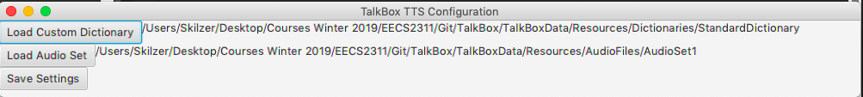

1. Select Dictionary

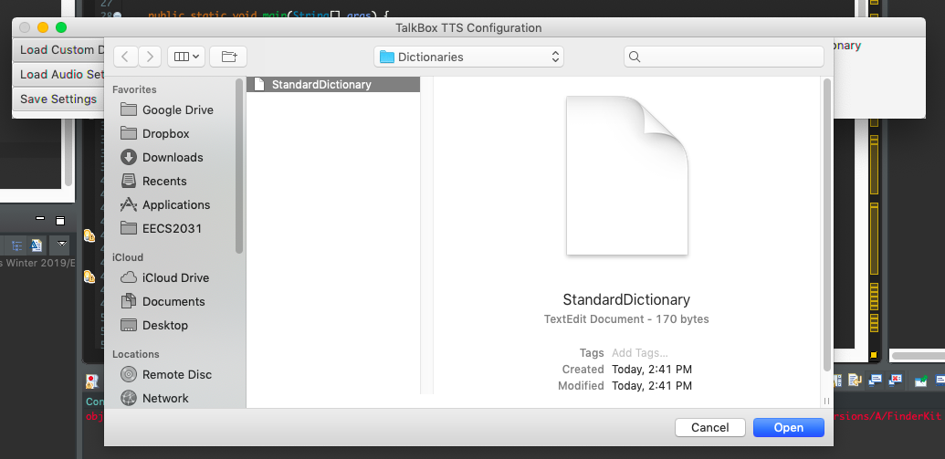

1. Select AudioSet

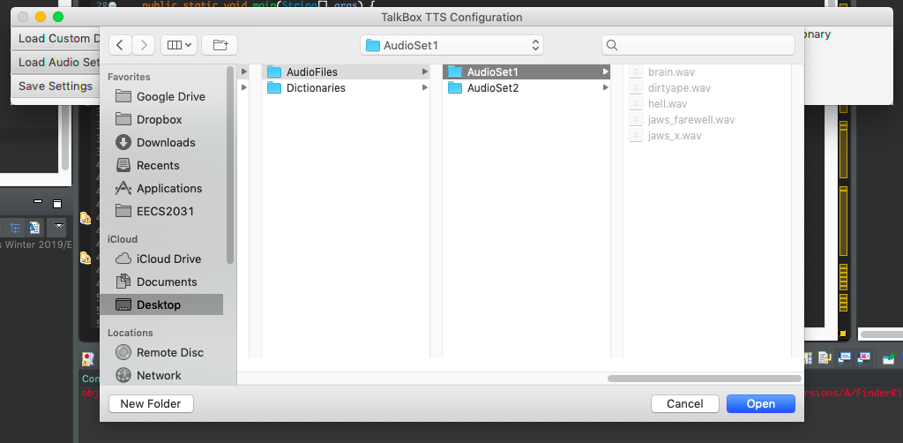

Finally, the user may choose to launch the Simulator app directly from the configurator or exit the application and launch it separately.

## Simulator:

The Simulator app simulates what the TalkBox hardware interface might look like when fully implemented. It provides utilities for generating speech from a set of input words as well audio playback buttons for prerecorded audio both of which can be configured through the Configurator app.

1. Initial launch conditions (using AudioSet1 and StandardDictionary)

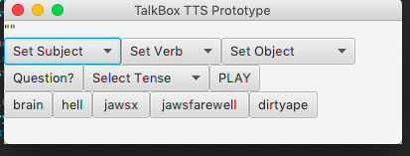

1. Generate sentence using drop down selections

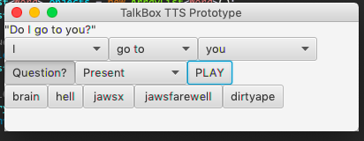

## Modifying the Standard Dictionary:

Modifying the Standard Dictionary is a great way to allow the user to customize their TalkBox experience through enabling them to use language that suits their personality. To achieve this, first navigate to the directory containing the Dictionaries:

1. Navigate to the appropriate directory

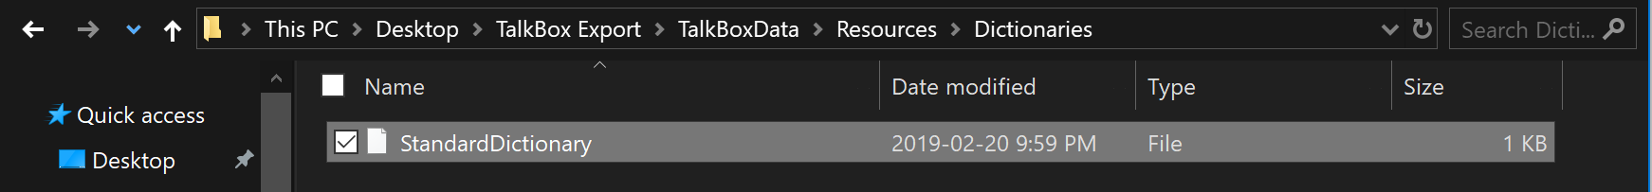

Following this, open the StandardDictionary.txt file with your favorite text editor or create a new text file.

1. Open StandardDictionary.txt

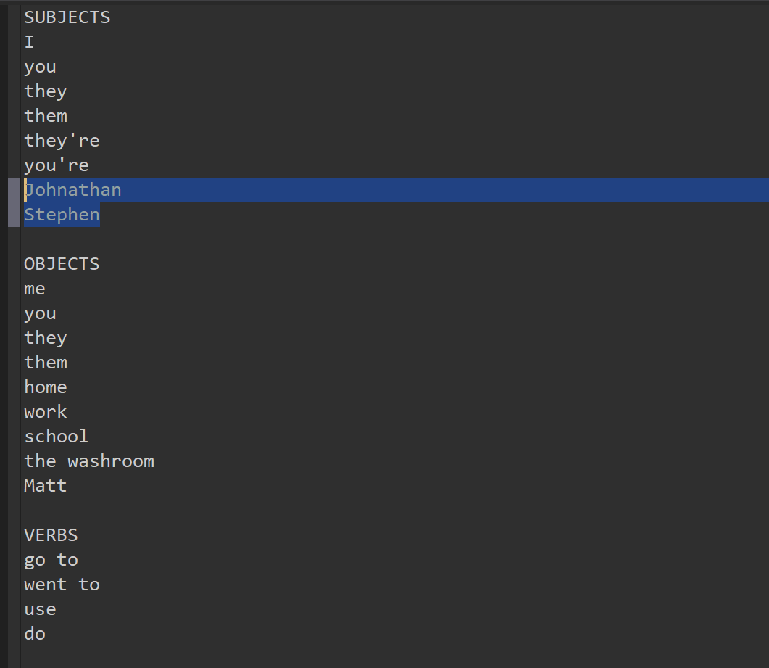

Finally, to add a word simply type it on a new line underneath the respective heading (SUBJECTS, OBJECTS, VERBS).

# Audio Record:

Please press the “Record Audio” button in the configurator app if you would like to record and save your voice file in the TalkBoxdata resources folder. You can then select the audio file through the simulator app window and play the file for the user.

# Edit Audio Set Name:

Through the configurator app window press “Edit AudioSet” Button then select the audio file’s name you would like to edit.

# Common Usage Scenarios:

### Scenario 1: (Guardian/Caretaker)

* Client records desired audio and places it inside a directory
* Client launches TalkBox Configurator
* Client selects directory of recorded audio files
* Client saves their choices and closes the application

### Scenario 2: (Guardian/Caretaker)

* Client creates their own dictionary or modifies existing StandardDictionary
* Client launches TalkBox Configurator
* Client selects their desired dictionary
* Client saves their choices and closes the application

### Scenario 3: (TalkBox user)

* Client launches TalkBox Simulator (whether by themselves or through the aid of a guardian/caretaker)
* Client may select from possible verbs, subjects, objects, tense and whether their phrase is a question
* Sentence is generated and displayed for the user to see
* Sentence gets converted from text to audio when client presses “play” button

### Scenario 4: (TalkBox user)

* Client launches TalkBox Simulator (whether by themselves or through the aid of a guardian/caretaker)
* Client may select any custom audio button configured from an audio set chosen in the Configurator app to play
* Audio plays immediately proceeding the button press