1. hash函数：<https://blog.csdn.net/u012834750/article/details/80005162>
2. 一致性hash算法：

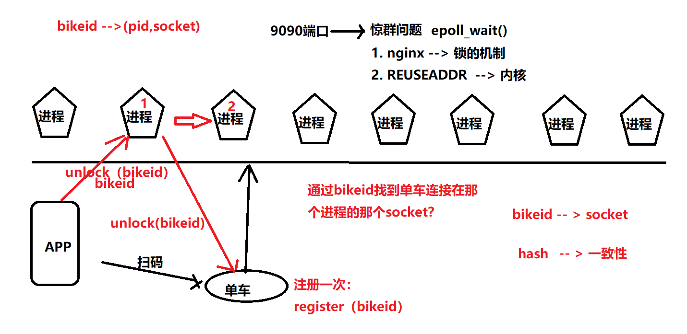

一致性hash算法通过bikeid找对应的文件描述符。

如何移动文件描述符号：

ssize_t sendmsg(int sockfd, const struct msghdr *msg, int flags);

sockfd ： unix_socket = socket(AF_UNIX, type, 0);

error = socketpair(AF_UNIX, type, 0, int *sv);

msg ： msghdr：

struct msghdr {

void *msg_name; /* optional address */ , NULL

socklen_t msg_namelen; /* size of address */, 0

struct iovec *msg_iov; /* scatter/gather array */ IO VECTOR

size_t msg_iovlen; /* # elements in msg_iov */

void *msg_control; /* ancillary data, see below */ 额外的数据。

size_t msg_controllen; /* ancillary data buffer len */

int msg_flags; /* flags (unused) */

};

struct iovec {

void *iov_base; /* Starting address */ ： buf

size_t iov_len; /* Number of bytes to transfer */

};

struct cmsghdr {

socklen_t cmsg_len; /* data byte count, including header */

int cmsg_level; /* originating protocol */

int cmsg_type; /* protocol-specific type */

/* followed by unsigned char cmsg_data[]; */

};

cmsghdr;

char cm[Len];

struct msghdr msg = {0};

struct cmsghdr *cmsg;

int myfds[NUM_FD]; /* Contains the file descriptors to pass. */

union {

/* ancillary data buffer, wrapped in a union in order to ensure

it is suitably aligned */

char buf[CMSG_SPACE(sizeof myfds)];

struct cmsghdr align;

} u;

int *fdptr;

msg.msg_control = u.buf;

msg.msg_controllen = sizeof u.buf;

cmsg = CMSG_FIRSTHDR(&msg);

cmsg->cmsg_level = SOL_SOCKET;

cmsg->cmsg_type = **SCM_RIGHTS**;

cmsg->cmsg_len = CMSG_LEN(sizeof(int) * NUM_FD);

/* Initialize the payload: */

fdptr = (int *) CMSG_DATA(cmsg);

memcpy(fdptr, myfds, NUM_FD * sizeof(int));

server:

1. socket （AF_UNIX）
2. bind （sockaddr_un）
3. listen
4. accept
5. recvmsg (msghdr, cmsghdr + control_data<file description is set, type SCM_RIGHTS>).

client:

1. socket (AF_UNIX)
2. connect (socketaddr_un)
3. sendmsg (msghdr, cmsghdr + control_data<file description is set, type SCM_RIGHTS>).

启动时序图：

产品开发的时候： 框架arch startup

uml ： rose astah viso