Original created on Paint and saved with extension .bmp

Saved As .png using paint.net (Magic Wand with Tolerance equal to 72)

Converted to .EPS and .PDF using <http://www.autotracer.org/> with the next parameters:

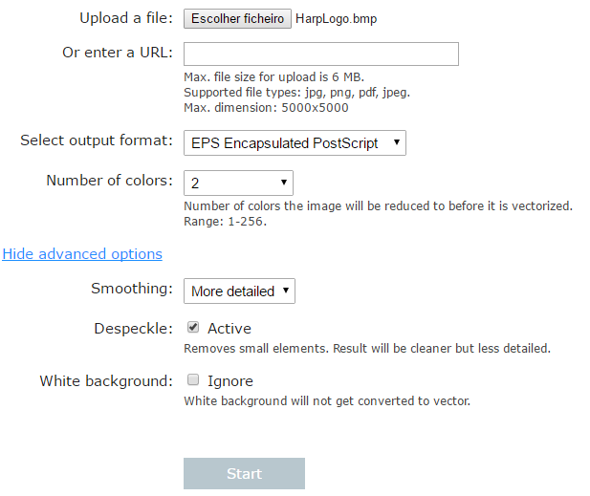

Use <http://epsviewer.org> to view the .EPS file.

Resized to 128 x 128 pixels using <http://imagesplitter.net/> with the next configurations:

