Allen Nguyen

MECE 5397 (Scientific Computing for Mechanical Engineering)

Assignment 7

Problem 2:



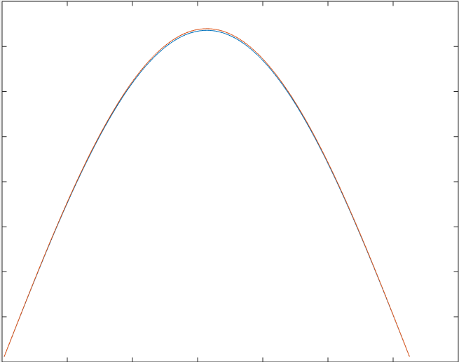

Figure 1: Graph comparing the exact solution (blue curve) and numerical solution (red curve) at T=10.

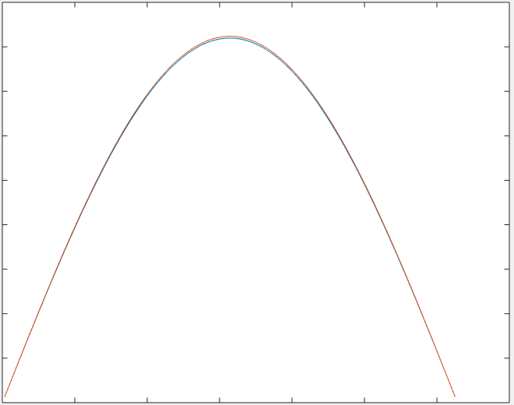

Figure 2: Graph comparing the exact solution (blue curve) and numerical solution (red curve) at T=2.

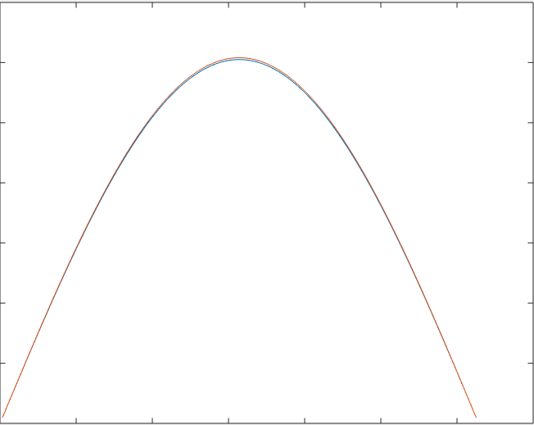

Figure 3: Graph comparing exact solution (blue curve) and numerical solution (red curve) at T=5.

The numerical solutions shown in the three graphs above were obtained from Crank-Nicolson method with k=1 and 200 internal points for both time and space. As the number of internal points for time and space increases, the average error becomes smaller.

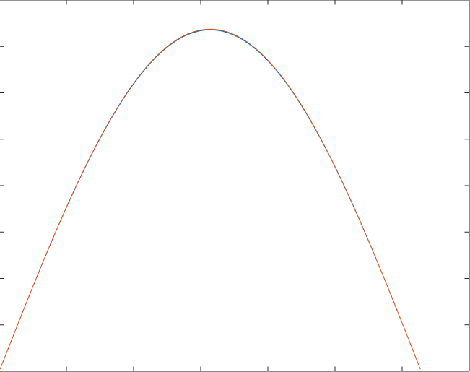

Figure 4: Graph comparing exact solution (blue curve) and numerical solution (red curve) at T=10

Figure 4 was obtained with 500 internal points for space and time. As seen in the graph, the average error is so small that both curves are on top of each other. This proves that the numerical solution has grid covergence