**地物确定**

探索所下载区域OSM数据，初步确立区域内所包含地物种类，并进行分类提取。

以苏州市湖西社区为例：

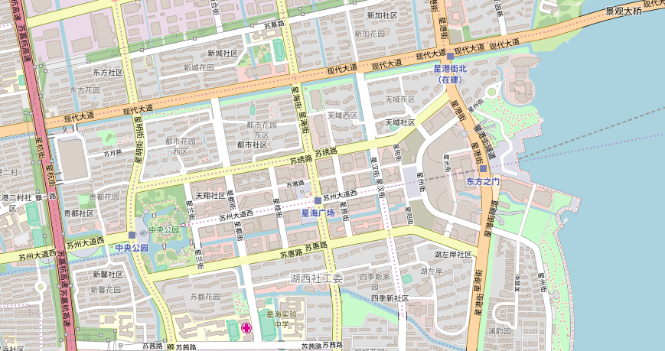

图1 研究区

1，通过OpenStreetMap查看研究区地物信息

浏览<https://www.openstreetmap.org/#map=15/31.3181/120.6683> 进入OpenStreetMap主页，如图2：

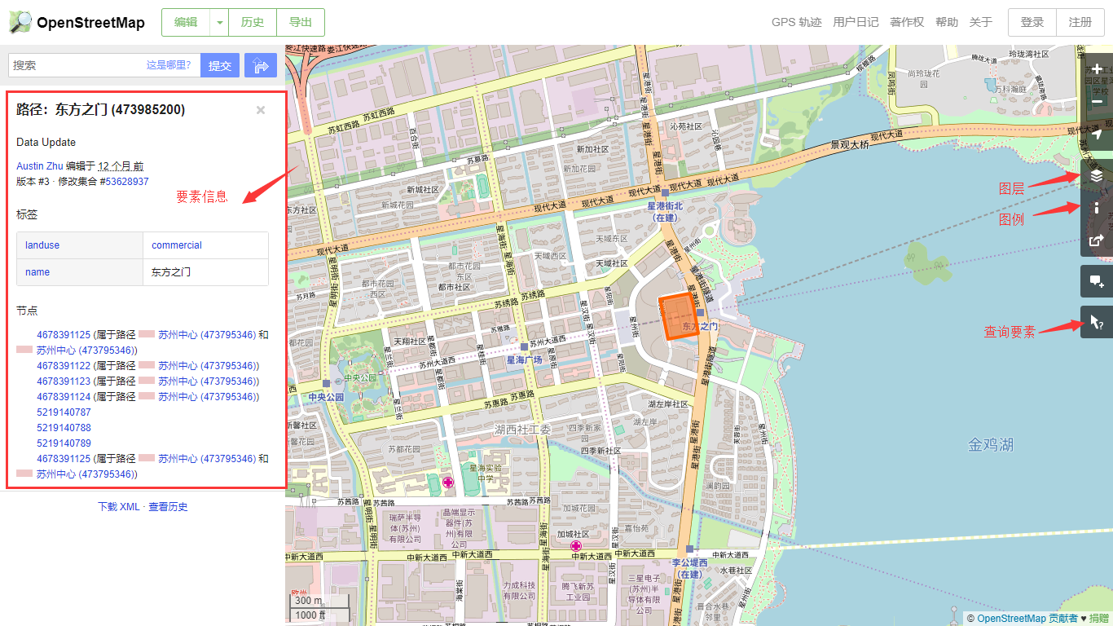

图2 OpenStreetMap主页

对OSM数据的形象化理解可通过使用“查询要素”按钮，选中要素即可获得该要素的全部osm信息。

2，使用Symbolize OSM Data工具符号化研究区osm数据，得到OSM Downloaded Points、OSM Download Lines、OSM Downloaded Polygons，初步获得要素分类结果，如图3-5。所得数据以工具默认分类标准进行分类，利用此数据可进一步进行地物提取。

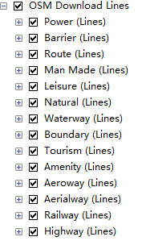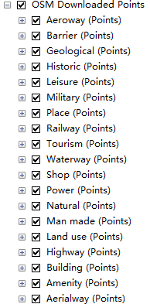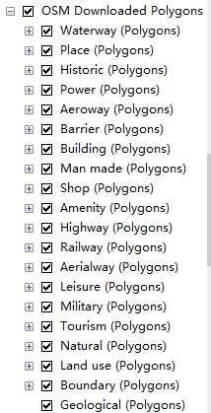

图3-5 符号化后的分类结果

使用Symbolize OSM Data工具得到的分类结果中，部分在研究区内并不存在，因此需要逐类进行属性检查，排除不存在的要素类。排除后的结果集通过“导出”保存为单独图层，，进一步提取地物信息，即可作为制图原始数据。

基于以上两种方法，确定研究区地物类类别（如下表所示），并确定详细的地物，据此作为主题图层的依据：

|  |  |  |
| --- | --- | --- |
| **面** | **线** | **点** |
| 设施  电力  休闲  水体  交通  建筑物  自然景观  人工景观  用地类型 | 铁路  公路  隧道  缆线  障碍物 | 设施  公路  休闲  电力  商店  旅行  自然景观 |

研究区详细地物及其属性字段：

**公共属性字段：**

|  |  |  |
| --- | --- | --- |
| **公共字段** | **数据类型** | **解释** |
| osm_id | Integer | osmID。OSM元素ID |
| osmuid | Integer | 用户ID。数据贡献者ID |
| osmchanges | Integer | 变更集ID。变更数据集ID |
| osmtimesta | W3C Date and Time Formats | 时间戳。 |
| osmversion | Integer | 版本。 |
| osm_name | String | osm元素代表实际名称。 |

下面以湖西片区为例介绍包含地物的属性字段：

**用地类型：**

|  |  |  |
| --- | --- | --- |
| **补充字段** | **值** | **解释** |
| **landuse** |  |  |

居住区

|  |  |  |
| --- | --- | --- |
| **补充字段** | **值** | **解释** |
| landuse | residential |  |

商业区

|  |  |  |
| --- | --- | --- |
| **补充字段** | **值** | **解释** |
| landuse | commercial+retail |  |

工业区

|  |  |  |
| --- | --- | --- |
| **补充字段** | **值** | **解释** |
| landuse | industrial |  |

**植被用地：**

|  |  |  |
| --- | --- | --- |
| **补充字段** | **值** | **解释** |
| **landuse** |  |  |
| **leisure** |  |  |
| **natural** |  |  |

草地

|  |  |  |
| --- | --- | --- |
| **补充字段** | **值** | **解释** |
| landuse | grass | 排除公园类草地 |

公园草地

|  |  |  |
| --- | --- | --- |
| **补充字段** | **值** | **解释** |
| landuse | grass |  |
| leisure | park |  |

公园

|  |  |  |
| --- | --- | --- |
| **补充字段** | **值** | **解释** |
| Leisure | park |  |

树林

|  |  |  |
| --- | --- | --- |
| **补充字段** | **值** | **解释** |
| natural | wood |  |

灌木林

|  |  |  |
| --- | --- | --- |
| **补充字段** | **值** | **解释** |
| natural | scrub |  |

水体

|  |  |  |
| --- | --- | --- |
| **补充字段** | **值** | **解释** |
| natural | water |  |
| waterway | riverbank |  |

**城市设施：**

|  |  |  |
| --- | --- | --- |
| **补充字段** | **值** | **解释** |
| **amenity** |  |  |
| **leisure** |  |  |

医院

|  |  |  |
| --- | --- | --- |
| **补充字段** | **值** | **解释** |
| amenity | hospital |  |

学校

|  |  |  |
| --- | --- | --- |
| **补充字段** | **值** | **解释** |
| amenity | school |  |

幼儿园

|  |  |  |
| --- | --- | --- |
| **补充字段** | **值** | **解释** |
| amenity | kindergarden |  |

运动中心

|  |  |  |
| --- | --- | --- |
| **补充字段** | **值** | **解释** |
| leisure | sports_centre |  |

操场跑道

|  |  |  |
| --- | --- | --- |
| **补充字段** | **值** | **解释** |
| leisure | pitch+track |  |

**建筑物：**

|  |  |  |
| --- | --- | --- |
| **补充字段** | **值** | **解释** |
| building | ALL | 提取building中所有值 |

**公路：**

|  |  |  |
| --- | --- | --- |
| **补充字段** | **值** | **解释** |
| **highway** |  | **确定公路的等级** |
| **osm_bridge** | **no** | **排除桥的可能性** |
| **osm_tunnel** | **no** | **排除隧道的可能性** |
| **osm_lanes** |  | **车道数** |
| **osm_oneway** |  | **确定能否为单向行驶** |
| **osm_layer** |  | **表示地物相对于地表的位置** |

一级公路

|  |  |  |
| --- | --- | --- |
| **补充字段** | **值** | **解释** |
| highway | primary |  |

二、三级公路

|  |  |  |
| --- | --- | --- |
| **补充字段** | **值** | **解释** |
| highway | secondary+ tertiary |  |

服务路

|  |  |  |
| --- | --- | --- |
| **补充字段** | **值** | **解释** |
| highway | Residential  +service  +unclassified |  |

小路

|  |  |  |
| --- | --- | --- |
| **补充字段** | **值** | **解释** |
| highway | footway+ path+ steps |  |
| SHAPE_Leng |  |  |

**桥：**

|  |  |  |
| --- | --- | --- |
| **补充字段** | **值** | **解释** |
| **highway** |  | **确定公路的等级** |
| **osm_bridge** | **yes** |  |
| **osm_tunnel** | **no** | **排除桥的可能性** |
| **osm_lanes** |  | **车道数** |
| **osm_oneway** |  | **确定能否为单向行驶** |
| **osm_layer** |  | **表示地物相对于地表的位置** |

高速公路桥

|  |  |  |
| --- | --- | --- |
| **补充字段** | **值** | **解释** |
| highway | motorway |  |

一级公路桥

|  |  |  |
| --- | --- | --- |
| **补充字段** | **值** | **解释** |
| highway | primary |  |

二、三级公路桥

|  |  |  |
| --- | --- | --- |
| **补充字段** | **值** | **解释** |
| highway | primary |  |

小桥

|  |  |  |
| --- | --- | --- |
| **补充字段** | **值** | **解释** |
| highway | Footway  + service  + unclassified |  |

**隧道：**

|  |  |  |
| --- | --- | --- |
| **补充字段** | **值** | **解释** |
| **highway** |  | **确定公路的等级** |
| **osm_bridge** | **no** | **排除桥的可能性** |
| **osm_tunnel** | **yes** |  |
| **osm_lanes** |  | **车道数** |
| **osm_oneway** |  | **确定能否为单向行驶** |
| **osm_layer** |  | **表示地物相对于地表的位置** |

一级公路隧道：

|  |  |  |
| --- | --- | --- |
| **补充字段** | **值** | **解释** |
| highway | primary |  |

三级公路隧道：

|  |  |  |
| --- | --- | --- |
| **补充字段** | **值** | **解释** |
| highway | tertiary |  |

未分级公路隧道：

|  |  |  |
| --- | --- | --- |
| **补充字段** | **值** | **解释** |
| highway | unclassified |  |

服务公路隧道：

|  |  |  |
| --- | --- | --- |
| **补充字段** | **值** | **解释** |
| highway | service |  |

**地铁：**

|  |  |  |
| --- | --- | --- |
| **补充字段** | **值** | **解释** |
| **railway** | **subway** |  |
| **osm_bridge** |  |  |
| **osm_tunnel** | **yes** |  |
| **osm_layer** |  | **表示地物相对于地表的位置** |

**线缆：**

|  |  |  |
| --- | --- | --- |
| **补充字段** | **值** | **解释** |
| **power** | **line** |  |
| **osm_cables** |  | **供电线缆** |
| **osm_circui** |  | **电缆回路，一般单回路和双回路较普遍** |

**公交站：**

|  |  |  |
| --- | --- | --- |
| **补充字段** | **值** | **解释** |
| **highway** |  |  |

**地铁站：**

|  |  |  |
| --- | --- | --- |
| **补充字段** | **值** | **解释** |
| **railway** | **station** |  |

**兴趣点：**

兴趣点可按照制图分级策略进行动态提取为单独图层。

**公共服务点：**

|  |  |  |
| --- | --- | --- |
| **补充字段** | **值** | **解释** |
| **amenity** | **atm、bank、hospital、post_office、toilets、**  **community_centre等** |  |

**商业休闲点：**

|  |  |  |
| --- | --- | --- |
| **补充字段** | **值** | **解释** |
| **amenity** | **bar、cafe、restaurant、parking、fast_food等** |  |

**商店：**

|  |  |  |
| --- | --- | --- |
| **补充字段** | **值** | **解释** |
| **shop** | **bakery、supermarket clothes、hairdresser等** |  |