Cancer Personalized Drug Recommendation (CPDR)

Ruzhen Chen

2022-04-17

Table of Contents

Package overview 1

Workflow 2

1. Data download 2

2. Identification of individual disease signals 3

3. Screening of candidate agents by reversing signals 6

4. Assessment of drug efficacy 7

Session information 8

### Ruzhen Chen

# Package overview

Due to cancer heterogeneity, only some patients can benefit from drug therapy. The personalized drug use is important for improving the treatment response rate of cancer patients. Patient transcriptome has recently demonstrated its value in guiding personalized drug use, and Connectivity map (CMAP) is a reliable computational approach for drug recommendation. However, there is still no personalized drug recommendation tool based on patient transcriptomic profiles and CMAP. To fill this gap, here we proposed such a feasible workflow and a user-friendly R package - Cancer Personalized Drug Recommendation (CPDR).

CPDR has three features. 1) It identifies the individual disease signature by using the patient subgroup with transcriptomic profiles similar to that of the input patient. 2) Transcriptomic profile purification is supported for the subgroup with high infiltration of non-cancerous cells. 3) It supports in silico drug efficacy assessment using drug sensitivity data of cancer cell lines.

# Workflow

We demonstrated the pipeline of CPDR with the aid of a dataset from GEO (GSE164541), containing gene expression profiles of 5 patients with colorectal cancer.

## 1. Data download

### 1.1 Clinical patients’ RNA-seq count data (GSE164541)

library(CPDR)  
library(GEOquery)  
library(org.Hs.eg.db)  
  
getGEOSuppFiles('GSE164541', makeDirectory = TRUE, fetch_files = TRUE)  
clinical <- read.csv("./GSE164541/GSE164541_ANT_count.csv.gz")  
clinical <- inner_join(clinical,   
 bitr(clinical$ENSEMBL,   
 fromType = "ENSEMBL",  
 toType = "SYMBOL",   
 OrgDb = org.Hs.eg.db),by = "ENSEMBL")  
clinical <- clinical[!duplicated(clinical$SYMBOL),]  
row.names(clinical) <- clinical$SYMBOL  
clinical_profile_set <- clinical[,grep("PT",colnames(clinical))]  
  
head(clinical_profile_set)

Table1: Clinical patients’ RNA-seq count data

|  |  |  |  |  |  |
| --- | --- | --- | --- | --- | --- |
|  | PT1 | PT2 | PT3 | PT4 | PT5 |
| DDX11L2 | 0 | 0 | 0 | 0 | 0 |
| DDX11L16 | 0 | 0 | 0 | 0 | 0 |
| DDX11L1 | 0 | 0 | 0 | 0 | 0 |
| DDX11L5 | 0 | 0 | 0 | 0 | 0 |
| DDX11L17 | 0 | 0 | 0 | 0 | 0 |
| WASH7P | 45 | 47 | 14 | 22 | 3 |

### 1.2 Background data

download_db(pset = c('CCLE','PRISM'), # pharmacogenetic data  
 tset = 'coadread', # TCGA data. View(CPDR::TCGA_sets) for available cancer type  
 nset = 'GTEX', # GTEX data  
 saveDir = '.',  
 verbose = T)  
  
# read downloaded TCGA dataset  
exdir <- cBioPortalData::untarStudy("./CPDR_db/TCGA/  
 25dc53d4417_coadread_tcga_pan_can_atlas_2018.tar.gz")  
coadread <- cBioPortalData::loadStudy(exdir)

## 2. Identification of individual disease signals

### 2.1 Preprocessing

pmat = select_db(Assay = coadread,   
 cmat = clinical_profile_set,  
 removeBatchEffect = TRUE,   
 OrgDb = org.Hs.eg.db,  
 minSampleSize = 10,  
 MSI_status = NULL,  
 driver_gene = NULL,  
 MUT_status = NULL,  
 CNA_status = NULL)  
gc()

### 2.2 Subtyping

result = get_NMF(mat = pmat$mat,  
 method = 'MAD',  
 clusterNum = 4,   
 seed = 3211232,  
 nrun = 10,  
 doPlot = T)

Figure1: NMF subtyping result

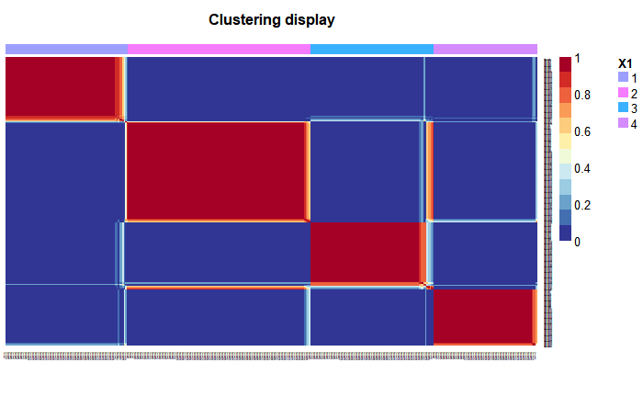

### 2.3 Identification of subgroups

subgroup = get_subgroup(cmat = pmat$cmat,   
 mat = pmat$mat,   
 subtype = result,   
 k = 10,  
 biopsy = "COLON",  
 adjacent = F,  
 doplot = T,  
 db.path = '.',  
 OrgDB = org.Hs.eg.db)

Figure2: The heatmap of Spearman correlation coefficients between query samples and subtypes

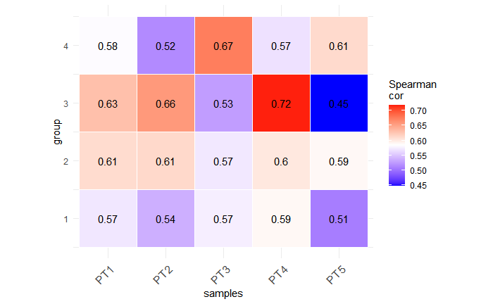

### 2.4 Estimation of non-cancerous infiltration

es = get_estimateScore(mat = pmat$mat, subtype=result, doplot = T)

*Figure3: The non-cancerous cell infiltration heatmap of colorectal cancer subtypes*

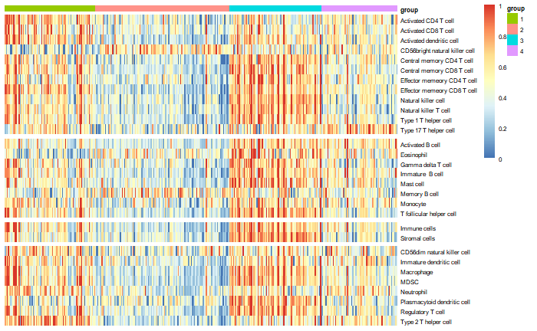

### 2.5 Purification of subgroups

# subgroup simple version  
subgroup_simple = lapply(subgroup, function(x){  
 lapply(x, function(y){  
 gene = intersect(row.names(y),row.names(octad.db::lincs_signatures))  
 return(y[gene,])  
 })  
})  
purify_data = get_puretumor(subgroup = subgroup_simple)  
head(subgroup_simple[[1]]$case)

Table2: Subgroup of PT1

|  |  |  |  |  |  |  |  |  |  |  |
| --- | --- | --- | --- | --- | --- | --- | --- | --- | --- | --- |
|  | TCGA-WS-AB45-01 | TCGA-F4-6704-01 | TCGA-AZ-4323-01 | TCGA-AY-6196-01 | TCGA-AZ-6607-01 | TCGA-EI-7004-01 | TCGA-G4-6302-01 | TCGA-A6-6651-01 | TCGA-AF-2687-01 | TCGA-AF-2690-01 |
| TSPAN6 | 1348 | 2626 | 1559 | 1151 | 2211 | 1589 | 1746 | 7967 | 9139 | 6969 |
| SCYL3 | 728 | 875 | 713 | 1033 | 384 | 791 | 481 | 631 | 969 | 743 |
| BAD | 1317 | 3698 | 1095 | 1148 | 1674 | 1544 | 1278 | 1535 | 1023 | 1732 |
| LAP3 | 6746 | 5744 | 4743 | 7648 | 2617 | 4296 | 5296 | 6653 | 6979 | 8694 |
| SNX11 | 1200 | 1220 | 1162 | 884 | 1043 | 1484 | 888 | 1280 | 1302 | 1301 |
| CASP10 | 1028 | 2176 | 1032 | 1587 | 878 | 1662 | 1596 | 871 | 887 | 1268 |

### 2.6 Differential expression analysis

signature = get_diff(data = purify_data,   
 DE_method = 'limma',   
 normalize_samples = TRUE,   
 threshold_log2foldchange = 2,   
 threshold_pval = 1,   
 threshold_adjpval = 0.05)  
head(signature[[1]])[,1:7]

Table3: Inidividual disease signature of PT1

|  |  |  |  |  |  |  |
| --- | --- | --- | --- | --- | --- | --- |
| log2FoldChange | AveExpr | t | pvalue | padj | identifier | ensembl |
| -7.338973 | 6.909496 | -9.480442 | 0e+00 | 3.00e-07 | GSTM2 | ENSG00000213366 |
| -4.772934 | 8.663945 | -6.606637 | 5e-07 | 3.24e-05 | CEBPD | ENSG00000221869 |
| -4.759664 | 13.018551 | -9.010200 | 0e+00 | 6.00e-07 | MYL9 | ENSG00000101335 |
| -4.700296 | 5.481505 | -9.399755 | 0e+00 | 3.00e-07 | HOXA5 | ENSG00000106004 |
| -4.254804 | 12.538385 | -7.867757 | 0e+00 | 3.70e-06 | CSRP1 | ENSG00000159176 |
| -4.215757 | 8.172159 | -9.360803 | 0e+00 | 3.00e-07 | SLC25A4 | ENSG00000151729 |

## 3. Screening of candidate agents by reversing signals

sRGES = lapply(signature, function(x, LINCS){  
 return(get_reverse_score(dz_signature = x,  
 max_gene_size=500,  
 permutations = 10000,  
 LINCS_data = LINCS))   
 },LINCS = NULL)  
  
gc()  
head(sRGES[[1]])

Table4: Candidate agents for PT1

|  |  |  |  |  |  |  |  |
| --- | --- | --- | --- | --- | --- | --- | --- |
| pert_iname | mean | min | max | n | median | sd | sRGES |
| BRD-K91899208 | -0.7450238 | -0.7450238 | -0.7450238 | 1 | -0.7450238 | NA | -0.7450238 |
| BRD-K83757561 | -0.7007165 | -0.7007165 | -0.7007165 | 1 | -0.7007165 | NA | -0.7007165 |
| BRD-K12230293 | -0.6912223 | -0.6912223 | -0.6912223 | 1 | -0.6912223 | NA | -0.6912223 |
| BRD-K20347745 | -0.6892153 | -0.6892153 | -0.6892153 | 1 | -0.6892153 | NA | -0.6892153 |
| BRD-K31593084 | -0.6856379 | -0.6856379 | -0.6856379 | 1 | -0.6856379 | NA | -0.6856379 |
| BRD-K97217923 | -0.6448751 | -0.6448751 | -0.6448751 | 1 | -0.6448751 | NA | -0.6448751 |

## 4. Assessment of drug efficacy

### 4.1 Calculation of inidividual-related cell lines

cell_info = get_cell(cmat = pmat$cmat,  
 db.path = './CPDR_db/Pharmacogenomic',  
 removeBatchEffect = FALSE,  
 orgDB = org.Hs.eg.db)

### 4.2 Evaluattion of drug effectiveness at cell-line level

cor = drugcorTest(mysRGES=sRGES, topline = topline, cell_info = cell_info)  
draw_cor_map(sRGES[[1]],topline[1], cell_info = cell_info)

*Figure4: The predicted drugs efficacy test in PT1*

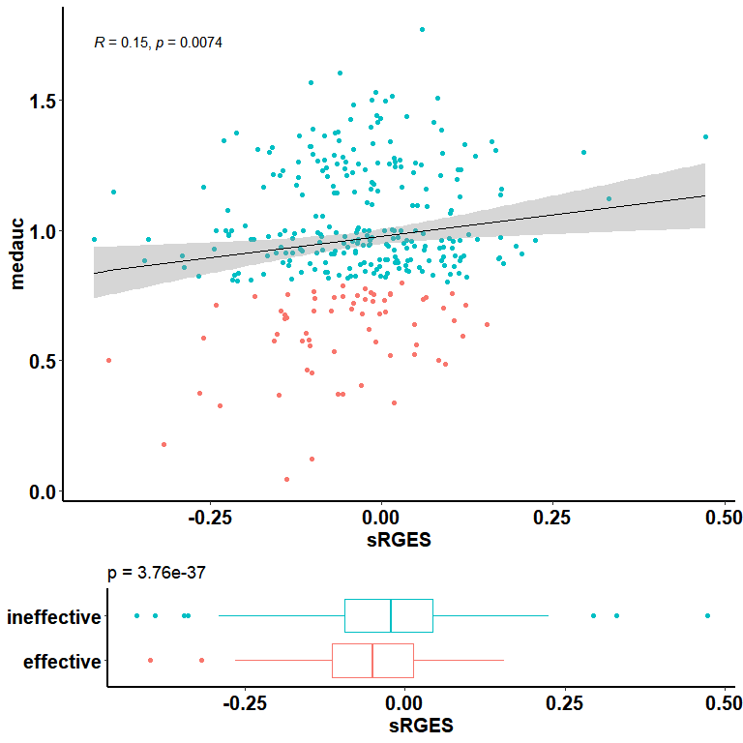

# Session information

Here is the output of sessionInfo on the system where this document was compiled:

sessionInfo()

## R version 4.1.1 (2021-08-10)  
## Platform: x86_64-w64-mingw32/x64 (64-bit)  
## Running under: Windows 10 x64 (build 19044)  
##   
## Matrix products: default  
##   
## locale:  
## [1] LC_COLLATE=Chinese (Simplified)_China.936   
## [2] LC_CTYPE=Chinese (Simplified)_China.936   
## [3] LC_MONETARY=Chinese (Simplified)_China.936  
## [4] LC_NUMERIC=C   
## [5] LC_TIME=Chinese (Simplified)_China.936   
##   
## attached base packages:  
## [1] stats graphics grDevices utils datasets methods base   
##   
## loaded via a namespace (and not attached):  
## [1] compiler_4.1.1 magrittr_2.0.1 fastmap_1.1.0 tools_4.1.1   
## [5] htmltools_0.5.2 yaml_2.2.1 stringi_1.7.4 rmarkdown_2.11   
## [9] highr_0.9 knitr_1.36 stringr_1.4.0 xfun_0.25   
## [13] digest_0.6.27 rlang_0.4.11 evaluate_0.14