Hypothesis Representation

Our new form uses the "Sigmoid Function," also called the "Logistic Function":

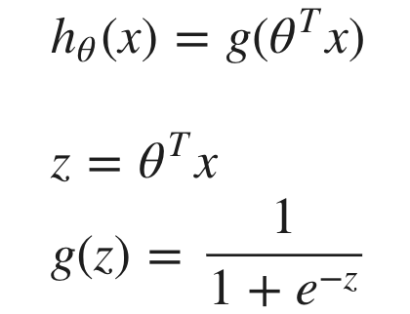

The following image shows us what the sigmoid function looks like:

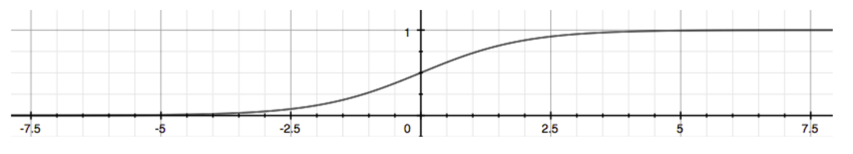

Decision Boundary

In order to get our discrete 0 or 1 classification, we can translate the output of the hypothesis function as follows:

The way our logistic function g behaves is that when its input is greater than or equal to zero, its output is greater than or equal to 0.5:

So if our input to g is *θTX*, then that means:

From these statements we can now say:

In this case, our decision boundary is a straight vertical line placed on the graph where x1 ​=5, and everything to the left of that denotes y = 1, while everything to the right denotes y = 0.

Cost Function

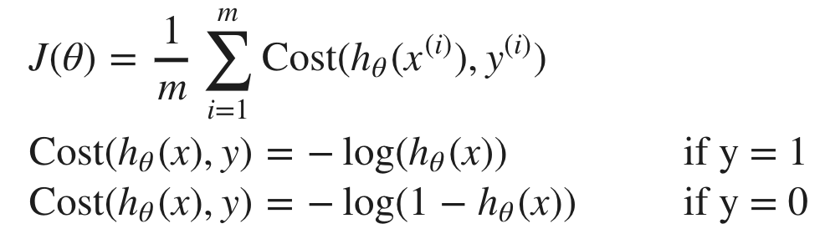

When y = 1, we get the following plot for *J*(*θ*) vs *hθ*​(*x*):

Similarly, when y = 0, we get the following plot for *J*(*θ*) vs *hθ*​(*x*):

If our correct answer 'y' is 0, then the cost function will be 0 if our hypothesis function also outputs 0. If our hypothesis approaches 1, then the cost function will approach infinity.

If our correct answer 'y' is 1, then the cost function will be 0 if our hypothesis function outputs 1. If our hypothesis approaches 0, then the cost function will approach infinity.

Note that writing the cost function in this way guarantees that J(θ) is convex for logistic regression.

# Simplified Cost Function and Gradient Descent

We can fully write out our entire cost function as follows:

A vectorized implementation is:

### **Gradient Descent**

A vectorized implementation is:

# Advanced Optimization

**"Conjugate gradient", "BFGS", and "L-BFGS"** are more sophisticated, faster ways to optimize θ that can be used instead of gradient descent. We suggest that you should not write these more sophisticated algorithms yourself (unless you are an expert in numerical computing) but use the libraries instead, as they're already tested and highly optimized. Octave provides them.

**regularization**

**Gradient Descent**

The term  performs our regularization. With some manipulation our update rule can also be represented as:

The first term in the above equation,  will always be less than 1. by some amount on every update. Notice that the second term is now exactly the same as it was before.

### **Normal Equation**

Now let's approach regularization using the alternate method of the non-iterative normal equation.

To add in regularization, the equation is the same as our original, except that we add another term inside the parentheses:

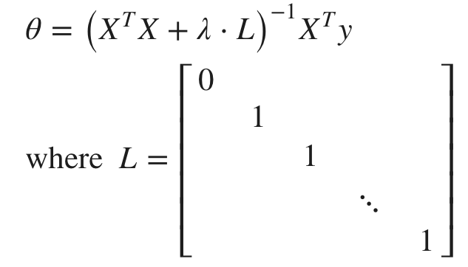

# Regularized Logistic Regression

Recall that our cost function for logistic regression was:

We can regularize this equation by adding a term to the end:



Thus, when computing the equation, we should continuously update the two following equations:

