AD688 Employability Analysis: Final Report
  - Business Analytics, Data Science, and Machine Learning Trends in 2024
Group IV — Zifan Chen, Jingyuan Yang, Zhenjie Shao, Zhuolun Wu, Almas Tussipov
2026-04-28
Table of contents

1. Introduction

1.1 AI vs. Non-AI Careers
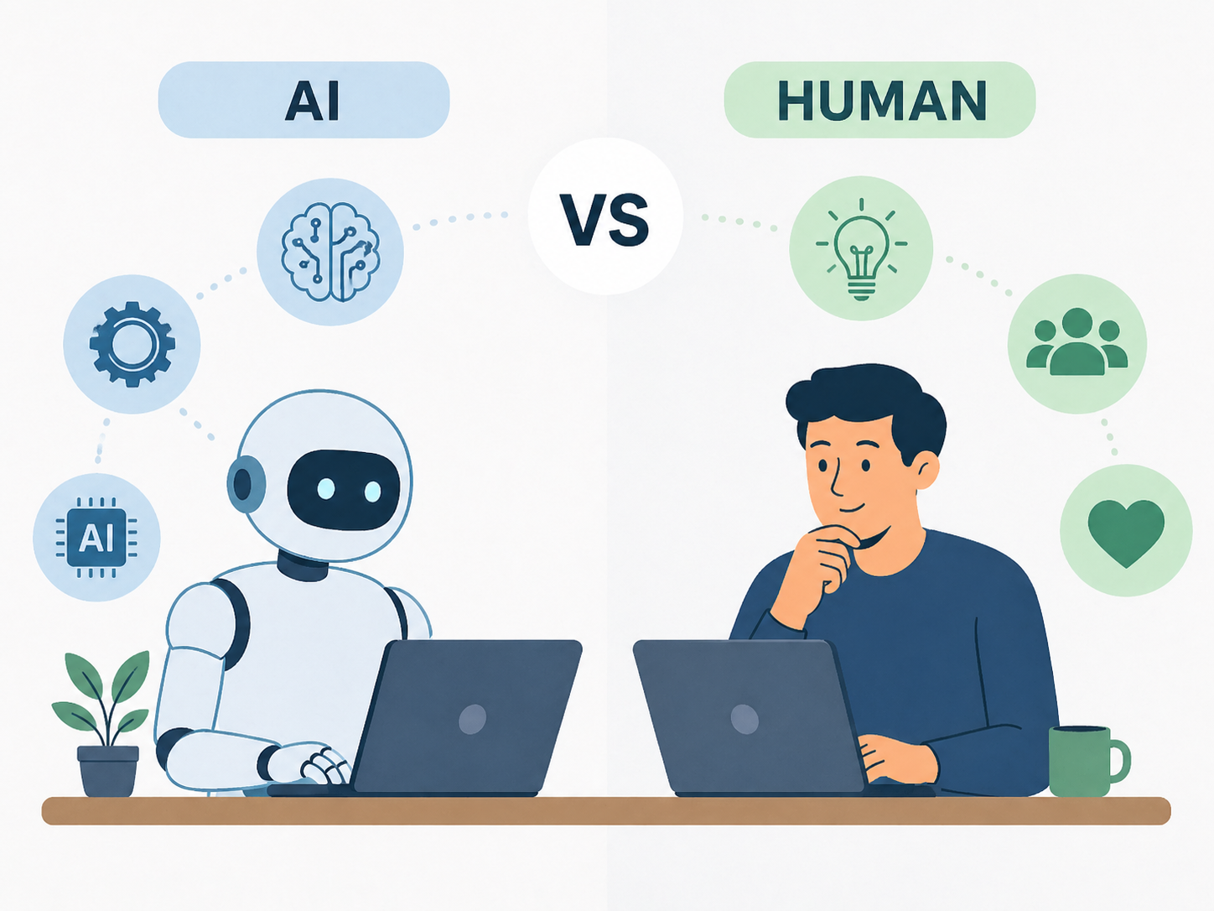

1.1.1 Introduction
Artificial intelligence has moved from research labs into mainstream industries, sparking debate over whether it creates or destroys jobs (Briggs and Dong 2023). While AI is automating certain tasks, it is simultaneously generating entirely new occupational categories — from Prompt Engineers to AI Ethicists — that did not exist a decade ago (MIT Technology Review 2024). This section examines how AI-driven career growth compares to job displacement, how traditional roles are being reshaped, and what new occupations are emerging as a direct result of AI advancement.

1.1.2 Research Rationale
This analysis uses the Lightcast 2024 job postings dataset (Lightcast 2024) to empirically examine how AI is reshaping the labor market across industries. While much of the existing discourse on AI and employment relies on macroeconomic projections, this study takes a data-driven approach — analyzing real employer demand signals to identify which roles are growing, which are declining, and how job requirements differ between AI-related and traditional occupations. By examining actual job titles, required skills, and posting volumes across sectors, this analysis aims to move beyond speculation and provide concrete evidence of how AI is transforming hiring in 2024.

1.1.3 Literature Review
Goldman Sachs (2023) estimated that generative AI could expose roughly 300 million full-time equivalent jobs globally to automation, while projecting net positive employment outcomes over time — noting that approximately 60% of current U.S. workers hold jobs that did not exist in 1940 (Briggs and Dong 2023). The IMF (2024) found that about 40% of jobs globally face meaningful AI exposure, rising to 60% in high-income economies, stressing that exposure does not always mean displacement (International Monetary Fund 2024).
The World Economic Forum’s Future of Jobs Report 2025 projected 92 million roles displaced by 2030 alongside 170 million new roles created — a net addition of 78 million jobs (World Economic Forum 2025). The ITIF (2025) found that in 2024 alone, AI-related job creation substantially outpaced displacement, with data center expansion generating over 110,000 construction jobs (Information Technology and Innovation Foundation 2025). Federal Reserve Bank of St. Louis researchers (2025) detected early correlations between AI exposure and rising unemployment in certain occupational categories (Federal Reserve Bank of St. Louis 2025).
New job titles are proliferating rapidly. The Prompt Engineer role emerged in 2023 offering high six-figure salaries (MIT Technology Review 2024), while AI Ethicist, AI Product Manager, and Machine Learning Operations Specialist roles are now mainstream, with projected growth of 29–45% through the late 2020s (Atera 2026). National University (2026) reported that 14% of workers already report AI-related displacement, while entry-level software engineering job postings grew 47% between October 2023 and November 2024 (National University 2026), illustrating AI’s dual nature as both disruptor and creator.

1.2 Business Analytics, Data Science, and Machine Learning Trends


1.2.1 Introduction
Business analytics, data science, and machine learning have become among the most consequential professional fields of the twenty-first century. As organizations across every sector compete to extract value from growing volumes of data, demand for skilled analysts and data scientists has surged (IEEE-USA InSight 2026). The integration of generative AI has further accelerated this transformation — raising the technical bar for practitioners while simultaneously automating routine analytical tasks (Gartner 2024). This section examines the most in-demand skills, how job requirements evolved in 2024, which industries are hiring most aggressively, and what the career outlook holds for professionals in these fields.

1.2.2 Research Rationale
This analysis leverages the Lightcast 2024 job postings dataset (Lightcast 2024) to investigate current employer demand for business analytics, data science, and machine learning professionals. Rather than relying solely on projected employment figures, this study examines real job postings to identify which technical skills — such as Python, SQL, NLP, and cloud platforms — appear most frequently, which industries are actively hiring data professionals, and how compensation varies by role, location, and skill requirements. This approach provides a ground-level view of the 2024 job market that complements broader labor market forecasts from sources such as the BLS (U.S. Bureau of Labor Statistics 2025a) and WEF (World Economic Forum 2023).

1.2.3 Literature Review
The BLS Employment Projections 2024–2034 provide the clearest quantitative baseline. Data scientist employment is projected to grow from 245,900 to 328,300 positions — a 33.5% increase driven by AI model development and enterprise application integration (U.S. Bureau of Labor Statistics 2025a). Operations research analysts are projected at 21% growth, management analysts at 9%, and market research analysts at 7% (U.S. Bureau of Labor Statistics 2025d, 2025b, 2025c).
The AnalytixLabs Data Science Skills Survey (2024), drawing on 100+ Fortune 500 hiring managers, found data engineering was the most-recruited function (76.3%), followed by data scientist (73.7%) and machine learning engineer (57.9%) roles (AnalytixLabs 2024). A 365 Data Science analysis of 1,000 job postings found that NLP skill demand surged from 5% in 2023 to 19% in 2024, and machine learning was mentioned in over 69% of postings (365 Data Science 2024).
The WEF Future of Jobs Report 2023 projected demand for AI and machine learning specialists to increase 40% by 2027 (World Economic Forum 2023). Gartner projected that over 50% of data science tasks would be automated by 2025 through AutoML tools (Gartner 2024), but research consistently finds these tools augment rather than replace skilled professionals. Coursera (2025) noted that business analyst demand is projected to generate approximately 98,100 job openings annually through 2034, with median wages ranging from $78,400 to over $101,000 (Coursera 2025).

2. Data Cleaning & Preprocessing

2.1 Overview
This section performs all data cleaning and preprocessing steps on the Lightcast 2024 job postings dataset. After running all cells, the cleaned df object is ready to use for downstream analysis.

2.1.1 Dataset Context
The Lightcast 2024 dataset is pre-filtered to data, analytics, and tech occupations (~72,000 postings, 131 columns). Key quirks to be aware of:
Issue | Detail
TITLE | Hash/ID string — not human-readable. Use TITLE_RAW for job titles.
COMPANY | Numeric ID — not human-readable. Use COMPANY_NAME or COMPANY_RAW.
SALARY / SALARY_FROM / SALARY_TO | ~55–58 % missing by design (employers often omit salary). Do not drop these columns.
MAX_EDULEVELS_NAME | 77 % missing — use MIN_EDULEVELS_NAME instead.
LIGHTCAST_SECTORS_NAME | 75 % missing — use NAICS_2022_6_NAME for industry.

2.2 0. Install & Load Packages
All packages loaded.

2.3 1. Download & Load Raw Data
Raw shape: 72,498 rows x 131 columns

2.4 2. Raw Data Inspection

2.4.1 2.1 Column List & Dtypes
Total columns: 131
Dtype summary:
object 93
float64 38

2.4.2 2.2 Missing Value Profile
Columns with missing values:
missing_count missing_pct
ACTIVE_SOURCES_INFO 64680 89.22
MAX_YEARS_EXPERIENCE 64068 88.37
MAX_EDULEVELS_NAME 56183 77.50
MAX_EDULEVELS 56183 77.50
LIGHTCAST_SECTORS 54711 75.47
LIGHTCAST_SECTORS_NAME 54711 75.47
SALARY 41690 57.51
ORIGINAL_PAY_PERIOD 40100 55.31
SALARY_TO 40100 55.31
SALARY_FROM 40100 55.31
DURATION 27316 37.68
MIN_YEARS_EXPERIENCE 23146 31.93
MODELED_DURATION 19290 26.61
MODELED_EXPIRED 15416 21.26
EXPIRED 7844 10.82
MSA_INCOMING 3962 5.46
MSA_NAME_INCOMING 3962 5.46
MSA_OUTGOING 3949 5.45
MSA 3949 5.45
MSA_NAME 3949 5.45
MSA_NAME_OUTGOING 3949 5.45
COMPANY_RAW 541 0.75
TITLE_CLEAN 140 0.19
TITLE_RAW 104 0.14
LOT_CAREER_AREA 44 0.06
SOC_2021_5_NAME 44 0.06
LOT_OCCUPATION 44 0.06
LOT_CAREER_AREA_NAME 44 0.06
LOT_OCCUPATION_NAME 44 0.06
TITLE_NAME 44 0.06
SOC_2021_3_NAME 44 0.06
SOC_2021_5 44 0.06
SOC_2021_4_NAME 44 0.06
SOC_2021_4 44 0.06
LOT_SPECIALIZED_OCCUPATION_NAME 44 0.06
SOC_2021_3 44 0.06
SOC_2021_2_NAME 44 0.06
SOC_2021_2 44 0.06
CIP2_NAME 44 0.06
CIP2 44 0.06
CIP4_NAME 44 0.06
CIP4 44 0.06
CIP6_NAME 44 0.06
CIP6 44 0.06
ONET_2019_NAME 44 0.06
ONET_2019 44 0.06
LOT_SPECIALIZED_OCCUPATION 44 0.06
LOT_V6_OCCUPATION_GROUP_NAME 44 0.06
LOT_OCCUPATION_GROUP 44 0.06
LOT_OCCUPATION_GROUP_NAME 44 0.06
NAICS_2022_6 44 0.06
NAICS_2022_5_NAME 44 0.06
NAICS_2022_5 44 0.06
NAICS_2022_4_NAME 44 0.06
NAICS_2022_4 44 0.06
NAICS_2022_3_NAME 44 0.06
NAICS_2022_3 44 0.06
NAICS_2022_2_NAME 44 0.06
NAICS_2022_2 44 0.06
SOC_5_NAME 44 0.06
SOC_5 44 0.06
SOC_4_NAME 44 0.06
SOC_4 44 0.06
SOC_3_NAME 44 0.06
SOC_3 44 0.06
SOC_2_NAME 44 0.06
SOC_2 44 0.06
LOT_V6_CAREER_AREA_NAME 44 0.06
LOT_V6_CAREER_AREA 44 0.06
ONET 44 0.06
LOT_V6_OCCUPATION_GROUP 44 0.06
LOT_V6_OCCUPATION_NAME 44 0.06
LOT_V6_OCCUPATION 44 0.06
LOT_V6_SPECIALIZED_OCCUPATION_NAME 44 0.06
LOT_V6_SPECIALIZED_OCCUPATION 44 0.06
ONET_NAME 44 0.06
NAICS_2022_6_NAME 44 0.06
SOFTWARE_SKILLS_NAME 44 0.06
COUNTY_NAME_OUTGOING 44 0.06
STATE_NAME 44 0.06
SOFTWARE_SKILLS 44 0.06
COUNTY_NAME 44 0.06
COUNTY 44 0.06
CITY_NAME 44 0.06
CITY 44 0.06
LOCATION 44 0.06
REMOTE_TYPE_NAME 44 0.06
REMOTE_TYPE 44 0.06
IS_INTERNSHIP 44 0.06
EMPLOYMENT_TYPE_NAME 44 0.06
EMPLOYMENT_TYPE 44 0.06
MIN_EDULEVELS_NAME 44 0.06
MIN_EDULEVELS 44 0.06
EDUCATION_LEVELS_NAME 44 0.06
EDUCATION_LEVELS 44 0.06
COMPANY_IS_STAFFING 44 0.06
COMPANY_NAME 44 0.06
COMPANY 44 0.06
BODY 44 0.06
ACTIVE_URLS 44 0.06
COUNTY_OUTGOING 44 0.06
STATE 44 0.06
COUNTY_INCOMING 44 0.06
NAICS6_NAME 44 0.06
COMMON_SKILLS_NAME 44 0.06
COMMON_SKILLS 44 0.06
CERTIFICATIONS_NAME 44 0.06
CERTIFICATIONS 44 0.06
SPECIALIZED_SKILLS_NAME 44 0.06
SPECIALIZED_SKILLS 44 0.06
SKILLS_NAME 44 0.06
COUNTY_NAME_INCOMING 44 0.06
TITLE 44 0.06
SKILLS 44 0.06
NAICS6 44 0.06
NAICS4 44 0.06
NAICS2 44 0.06
NAICS3 44 0.06
NAICS3_NAME 44 0.06
NAICS2_NAME 44 0.06
NAICS4_NAME 44 0.06
NAICS5 44 0.06
NAICS5_NAME 44 0.06
LAST_UPDATED_DATE 22 0.03
URL 22 0.03
SOURCES 22 0.03
SOURCE_TYPES 22 0.03
POSTED 22 0.03
DUPLICATES 22 0.03
LAST_UPDATED_TIMESTAMP 22 0.03
ID 22 0.03

2.4.3 2.3 Missing Value Heatmap
<Figure size 1344x576 with 0 Axes>
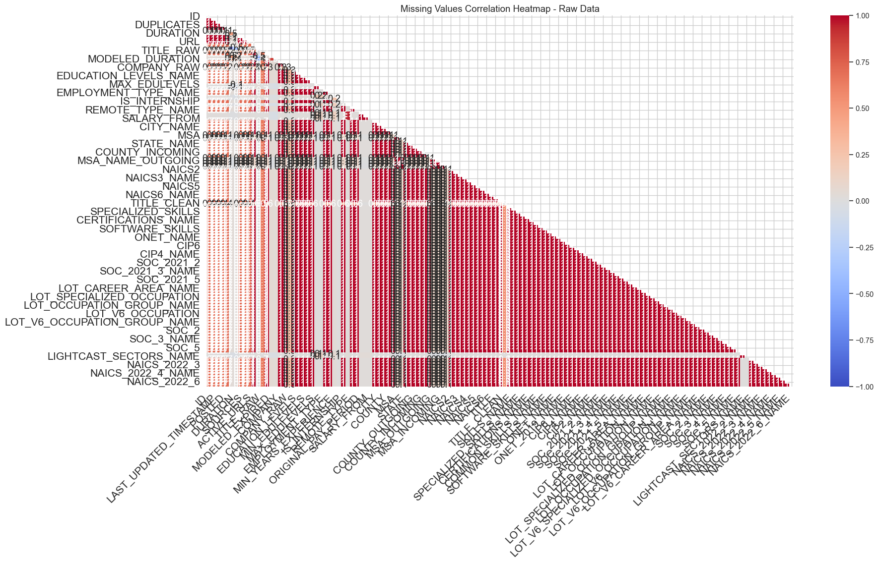

2.4.4 2.4 Basic Statistics
=== Numeric Columns ===
 | count | mean | std | min | 25% | 50% | 75% | max
DUPLICATES | 72,476.00 | 1.08 | 2.81 | 0.00 | 0.00 | 0.00 | 1.00 | 100.00
DURATION | 45,182.00 | 22.32 | 14.36 | 0.00 | 11.00 | 18.00 | 32.00 | 59.00
MODELED_DURATION | 53,208.00 | 19.74 | 12.96 | 0.00 | 10.00 | 16.00 | 28.00 | 59.00
COMPANY | 72,454.00 | 37,027,038.28 | 30,150,887.49 | 0.00 | 6,505,993.00 | 37,615,159.00 | 43,306,887.50 | 108,236,460.00
MIN_EDULEVELS | 72,454.00 | 31.48 | 44.75 | 0.00 | 2.00 | 2.00 | 99.00 | 99.00
MAX_EDULEVELS | 16,315.00 | 2.83 | 0.58 | 1.00 | 3.00 | 3.00 | 3.00 | 4.00
EMPLOYMENT_TYPE | 72,454.00 | 1.06 | 0.29 | 1.00 | 1.00 | 1.00 | 1.00 | 3.00
MIN_YEARS_EXPERIENCE | 49,352.00 | 5.49 | 3.32 | 0.00 | 3.00 | 5.00 | 8.00 | 15.00
MAX_YEARS_EXPERIENCE | 8,430.00 | 3.77 | 2.58 | 0.00 | 2.00 | 3.00 | 5.00 | 14.00
SALARY | 30,808.00 | 117,953.76 | 45,133.88 | 15,860.00 | 84,928.50 | 116,300.00 | 145,600.00 | 500,000.00
REMOTE_TYPE | 72,454.00 | 0.30 | 0.65 | 0.00 | 0.00 | 0.00 | 0.00 | 3.00
SALARY_TO | 32,398.00 | 136,113.26 | 60,946.20 | 10,617.00 | 91,002.50 | 131,040.00 | 175,300.00 | 950,000.00
SALARY_FROM | 32,398.00 | 94,005.13 | 40,369.32 | 10,230.00 | 63,565.00 | 88,000.00 | 118,000.00 | 800,000.00
COUNTY | 72,454.00 | 28,771.74 | 16,255.51 | 1,003.00 | 13,067.00 | 29,095.00 | 44,007.00 | 56,999.00
MSA | 68,549.00 | 29,727.06 | 11,534.67 | 10,100.00 | 18,180.00 | 31,080.00 | 39,580.00 | 49,780.00
STATE | 72,454.00 | 28.63 | 16.22 | 1.00 | 13.00 | 29.00 | 44.00 | 56.00
COUNTY_OUTGOING | 72,454.00 | 28,771.74 | 16,255.51 | 1,003.00 | 13,067.00 | 29,095.00 | 44,007.00 | 56,999.00
COUNTY_INCOMING | 72,454.00 | 28,773.19 | 16,253.66 | 1,003.00 | 13,067.00 | 29,095.00 | 44,007.00 | 56,999.00
MSA_OUTGOING | 68,549.00 | 29,727.06 | 11,534.67 | 10,100.00 | 18,180.00 | 31,080.00 | 39,580.00 | 49,780.00
MSA_INCOMING | 68,536.00 | 29,732.80 | 11,531.67 | 10,100.00 | 18,180.00 | 31,080.00 | 39,580.00 | 49,780.00
NAICS2 | 72,454.00 | 58.35 | 18.63 | 11.00 | 52.00 | 54.00 | 56.00 | 99.00
NAICS3 | 72,454.00 | 587.86 | 186.26 | 111.00 | 522.00 | 541.00 | 561.00 | 999.00
NAICS4 | 72,454.00 | 5,883.12 | 1,864.09 | 1,111.00 | 5,223.00 | 5,415.00 | 5,614.00 | 9,999.00
NAICS5 | 72,454.00 | 58,834.32 | 18,642.97 | 11,115.00 | 52,232.00 | 54,151.00 | 56,149.00 | 99,999.00
NAICS6 | 72,454.00 | 588,345.68 | 186,431.74 | 111,150.00 | 522,320.00 | 541,519.00 | 561,499.00 | 999,999.00
LOT_CAREER_AREA | 72,454.00 | 22.28 | 2.85 | 11.00 | 23.00 | 23.00 | 23.00 | 27.00
LOT_OCCUPATION | 72,454.00 | 223,931.69 | 28,542.75 | 111,110.00 | 231,010.00 | 231,113.00 | 231,113.00 | 271,211.00
LOT_SPECIALIZED_OCCUPATION | 72,454.00 | 22,393,180.50 | 2,854,274.52 | 11,111,012.00 | 23,101,011.00 | 23,111,310.00 | 23,111,310.00 | 27,121,112.00
LOT_OCCUPATION_GROUP | 72,454.00 | 2,239.20 | 285.42 | 1,111.00 | 2,310.00 | 2,311.00 | 2,311.00 | 2,712.00
LOT_V6_SPECIALIZED_OCCUPATION | 72,454.00 | 22,393,180.50 | 2,854,274.52 | 11,111,012.00 | 23,101,011.00 | 23,111,310.00 | 23,111,310.00 | 27,121,112.00
LOT_V6_OCCUPATION | 72,454.00 | 223,931.69 | 28,542.75 | 111,110.00 | 231,010.00 | 231,113.00 | 231,113.00 | 271,211.00
LOT_V6_OCCUPATION_GROUP | 72,454.00 | 2,239.20 | 285.42 | 1,111.00 | 2,310.00 | 2,311.00 | 2,311.00 | 2,712.00
LOT_V6_CAREER_AREA | 72,454.00 | 22.28 | 2.85 | 11.00 | 23.00 | 23.00 | 23.00 | 27.00
NAICS_2022_2 | 72,454.00 | 58.35 | 18.63 | 11.00 | 52.00 | 54.00 | 56.00 | 99.00
NAICS_2022_3 | 72,454.00 | 587.86 | 186.26 | 111.00 | 522.00 | 541.00 | 561.00 | 999.00
NAICS_2022_4 | 72,454.00 | 5,883.12 | 1,864.09 | 1,111.00 | 5,223.00 | 5,415.00 | 5,614.00 | 9,999.00
NAICS_2022_5 | 72,454.00 | 58,834.32 | 18,642.97 | 11,115.00 | 52,232.00 | 54,151.00 | 56,149.00 | 99,999.00
NAICS_2022_6 | 72,454.00 | 588,345.68 | 186,431.74 | 111,150.00 | 522,320.00 | 541,519.00 | 561,499.00 | 999,999.00
=== Object Columns (sample top value) ===
ID unique=72,476 top='1f57d95acf4dc67ed2819eb12f049f6a5c11782c'
LAST_UPDATED_DATE unique= 169 top='10/9/2024'
LAST_UPDATED_TIMESTAMP unique= 174 top='2024-10-09 18:07:44.758 Z'
POSTED unique= 153 top='5/24/2024'
EXPIRED unique= 177 top='9/17/2024'
SOURCE_TYPES unique= 175 top='[
"Job Board"
]'
SOURCES unique=12,890 top='[
"dice.com"
]'
URL unique=72,345 top='[
"https://www2.jobdiva.com/portal/?a=u4jdnwo9bf'
ACTIVE_URLS unique= 7,800 top='[]'
ACTIVE_SOURCES_INFO unique= 7,802 top='[
{
"source": "jobdiva.com",
"type": "Co'
TITLE_RAW unique=30,339 top='Data Analyst'
BODY unique=65,419 top='Find jobs
Search
Enter anybination of title, descr'
MODELED_EXPIRED unique= 179 top='7/18/2024'
COMPANY_NAME unique=12,301 top='Unclassified'
COMPANY_RAW unique=17,210 top='Deloitte'
COMPANY_IS_STAFFING unique= 2 top='False'
EDUCATION_LEVELS unique= 29 top='[
2
]'
EDUCATION_LEVELS_NAME unique= 29 top='[
"Bachelor's degree"
]'
MIN_EDULEVELS_NAME unique= 6 top='Bachelor's degree'
MAX_EDULEVELS_NAME unique= 4 top='Master's degree'
EMPLOYMENT_TYPE_NAME unique= 3 top='Full-time (> 32 hours)'
IS_INTERNSHIP unique= 2 top='False'
REMOTE_TYPE_NAME unique= 4 top='[None]'
ORIGINAL_PAY_PERIOD unique= 5 top='year'
LOCATION unique= 4,997 top='{
"lat": 41.8781136,
"lon": -87.6297982
}'
CITY unique= 3,841 top='TmV3IFlvcmssIE5Z'
CITY_NAME unique= 3,841 top='New York, NY'
COUNTY_NAME unique= 1,332 top='Dallas, TX'
MSA_NAME unique= 653 top='New York-Newark-Jersey City, NY-NJ-PA'
STATE_NAME unique= 51 top='Texas'
COUNTY_NAME_OUTGOING unique= 1,332 top='Dallas, TX'
COUNTY_NAME_INCOMING unique= 1,332 top='Dallas, TX'
MSA_NAME_OUTGOING unique= 653 top='New York-Newark-Jersey City, NY-NJ-PA'
MSA_NAME_INCOMING unique= 659 top='New York-Newark-Jersey City, NY-NJ'
NAICS2_NAME unique= 21 top='Professional, Scientific, and Technical Services'
NAICS3_NAME unique= 97 top='Professional, Scientific, and Technical Services'
NAICS4_NAME unique= 294 top='Computer Systems Design and Related Services'
NAICS5_NAME unique= 600 top='Computer Systems Design and Related Services'
NAICS6_NAME unique= 814 top='Unclassified Industry'
TITLE unique= 5,719 top='ET3037E0C947A02404'
TITLE_NAME unique= 5,719 top='Data Analysts'
TITLE_CLEAN unique=27,265 top='data analyst'
SKILLS unique=44,172 top='[]'
SKILLS_NAME unique=44,172 top='[]'
SPECIALIZED_SKILLS unique=41,461 top='[]'
SPECIALIZED_SKILLS_NAME unique=41,461 top='[]'
CERTIFICATIONS unique= 1,589 top='[]'
CERTIFICATIONS_NAME unique= 1,589 top='[]'
COMMON_SKILLS unique=29,573 top='[]'
COMMON_SKILLS_NAME unique=29,573 top='[]'
SOFTWARE_SKILLS unique=22,455 top='[]'
SOFTWARE_SKILLS_NAME unique=22,455 top='[]'
ONET unique= 1 top='15-2051.01'
ONET_NAME unique= 1 top='Business Intelligence Analysts'
ONET_2019 unique= 1 top='15-2051.01'
ONET_2019_NAME unique= 1 top='Business Intelligence Analysts'
CIP6 unique= 6,236 top='[]'
CIP6_NAME unique= 6,236 top='[]'
CIP4 unique= 5,887 top='[]'
CIP4_NAME unique= 5,887 top='[]'
CIP2 unique= 3,502 top='[]'
CIP2_NAME unique= 3,502 top='[]'
SOC_2021_2 unique= 1 top='15-0000'
SOC_2021_2_NAME unique= 1 top='Computer and Mathematical Occupations'
SOC_2021_3 unique= 1 top='15-2000'
SOC_2021_3_NAME unique= 1 top='Mathematical Science Occupations'
SOC_2021_4 unique= 1 top='15-2050'
SOC_2021_4_NAME unique= 1 top='Data Scientists'
SOC_2021_5 unique= 1 top='15-2051'
SOC_2021_5_NAME unique= 1 top='Data Scientists'
LOT_CAREER_AREA_NAME unique= 4 top='Information Technology and Computer Science'
LOT_OCCUPATION_NAME unique= 6 top='Data / Data Mining Analyst'
LOT_SPECIALIZED_OCCUPATION_NAME unique= 11 top='Data Analyst'
LOT_OCCUPATION_GROUP_NAME unique= 6 top='Data Analysis and Mathematics'
LOT_V6_SPECIALIZED_OCCUPATION_NAME unique= 11 top='Data Analyst'
LOT_V6_OCCUPATION_NAME unique= 6 top='Data / Data Mining Analyst'
LOT_V6_OCCUPATION_GROUP_NAME unique= 6 top='Data Analysis and Mathematics'
LOT_V6_CAREER_AREA_NAME unique= 4 top='Information Technology and Computer Science'
SOC_2 unique= 1 top='15-0000'
SOC_2_NAME unique= 1 top='Computer and Mathematical Occupations'
SOC_3 unique= 1 top='15-2000'
SOC_3_NAME unique= 1 top='Mathematical Science Occupations'
SOC_4 unique= 1 top='15-2050'
SOC_4_NAME unique= 1 top='Data Scientists'
SOC_5 unique= 1 top='15-2051'
SOC_5_NAME unique= 1 top='Data Scientists'
LIGHTCAST_SECTORS unique= 23 top='[
7
]'
LIGHTCAST_SECTORS_NAME unique= 23 top='[
"Artificial Intelligence"
]'
NAICS_2022_2_NAME unique= 21 top='Professional, Scientific, and Technical Services'
NAICS_2022_3_NAME unique= 97 top='Professional, Scientific, and Technical Services'
NAICS_2022_4_NAME unique= 294 top='Computer Systems Design and Related Services'
NAICS_2022_5_NAME unique= 600 top='Computer Systems Design and Related Services'
NAICS_2022_6_NAME unique= 814 top='Unclassified Industry'

2.5 3. Data Cleaning
Starting shape: (72498, 131)

2.5.1 3.1 Drop Tracking & Redundant Columns
We remove metadata columns (hash IDs, URLs, internal tracking) and older NAICS / SOC hierarchy levels.
Dropped 18 columns.
Shape after step 3.1: (72498, 113)

2.5.2 3.2 Drop High-Missing Columns (with Salary Protection)
Dropped 0 high-missing non-protected columns.
Shape after step 3.2: (72498, 113)

2.5.3 3.3 Remove Duplicate Postings
Removed 4,926 duplicate rows (6.8%).
Shape after step 3.3: (67572, 113)

2.5.4 3.4 Build Unified Salary Column (SALARY_MID)
Created SALARY_MID = (SALARY_FROM + SALARY_TO) / 2 [fallback: SALARY]
Salary coverage: 30,037 postings (44.5%)
Median: $111,800 | Mean: $114,245

2.5.5 3.5 Fill Categorical Missing Values
Filled 'Unknown' in:
NAICS_2022_6_NAME (17 values filled)
NAICS_2022_2_NAME (17 values filled)
SOC_2021_4_NAME (17 values filled)
REMOTE_TYPE_NAME (17 values filled)
STATE_NAME (17 values filled)
MIN_EDULEVELS_NAME (17 values filled)
LOT_V6_OCCUPATION_NAME (17 values filled)
LOT_OCCUPATION_NAME (17 values filled)
EMPLOYMENT_TYPE_NAME (17 values filled)
LIGHTCAST_SECTORS_NAME (51,139 values filled)

2.6 4. Column Reference Guide
COL_TITLE TITLE_RAW 67,501 (99.9%)
COL_OCCUPATION LOT_V6_OCCUPATION_NAME 67,572 (100.0%)
COL_IND_BROAD NAICS_2022_2_NAME 67,572 (100.0%)
COL_STATE STATE_NAME 67,572 (100.0%)
COL_REMOTE REMOTE_TYPE_NAME 67,572 (100.0%)
COL_SALARY SALARY_MID 30,037 (44.5%)
COL_COMPANY COMPANY_NAME 67,555 (100.0%)
COL_SKILLS SKILLS_NAME 67,555 (100.0%)
COL_POSTED POSTED 67,571 (100.0%)
COL_EDU MIN_EDULEVELS_NAME 67,572 (100.0%)
COL_EXP MIN_YEARS_EXPERIENCE 45,954 (68.0%)

2.7 5. Cleaned Dataset Summary
============================================================
CLEANED DATASET SUMMARY
============================================================
Rows: 67,572
Columns: 114
Salary (valid range $10k-$500k):
Count: 30,029
Median: $111,800
Mean: $114,245

2.8 Appendix: Full Column List (Cleaned)
All 114 columns in cleaned dataset:
1. POSTED [object] 100% non-null
2. EXPIRED [object] 89% non-null
3. DURATION [float64] 62% non-null
4. SOURCE_TYPES [object] 100% non-null
5. SOURCES [object] 100% non-null
6. TITLE_RAW [object] 100% non-null
7. BODY [object] 100% non-null
8. MODELED_EXPIRED [object] 79% non-null
9. MODELED_DURATION [float64] 73% non-null
10. COMPANY [float64] 100% non-null
11. COMPANY_NAME [object] 100% non-null
12. COMPANY_RAW [object] 99% non-null
13. COMPANY_IS_STAFFING [object] 100% non-null
14. EDUCATION_LEVELS [object] 100% non-null
15. EDUCATION_LEVELS_NAME [object] 100% non-null
16. EMPLOYMENT_TYPE [float64] 100% non-null
17. EMPLOYMENT_TYPE_NAME [object] 100% non-null
18. IS_INTERNSHIP [object] 100% non-null
19. REMOTE_TYPE [float64] 100% non-null
20. REMOTE_TYPE_NAME [object] 100% non-null
21. LOCATION [object] 100% non-null
22. CITY [object] 100% non-null
23. CITY_NAME [object] 100% non-null
24. COUNTY [float64] 100% non-null
25. COUNTY_NAME [object] 100% non-null
26. MSA [float64] 94% non-null
27. MSA_NAME [object] 94% non-null
28. STATE [float64] 100% non-null
29. STATE_NAME [object] 100% non-null
30. COUNTY_OUTGOING [float64] 100% non-null
31. COUNTY_NAME_OUTGOING [object] 100% non-null
32. COUNTY_INCOMING [float64] 100% non-null
33. COUNTY_NAME_INCOMING [object] 100% non-null
34. MSA_OUTGOING [float64] 94% non-null
35. MSA_NAME_OUTGOING [object] 94% non-null
36. MSA_INCOMING [float64] 94% non-null
37. MSA_NAME_INCOMING [object] 94% non-null
38. NAICS2_NAME [object] 100% non-null
39. NAICS3_NAME [object] 100% non-null
40. NAICS4_NAME [object] 100% non-null
41. NAICS5_NAME [object] 100% non-null
42. NAICS6_NAME [object] 100% non-null
43. TITLE [object] 100% non-null
44. TITLE_NAME [object] 100% non-null
45. TITLE_CLEAN [object] 100% non-null
46. SKILLS [object] 100% non-null
47. SKILLS_NAME [object] 100% non-null
48. SPECIALIZED_SKILLS [object] 100% non-null
49. SPECIALIZED_SKILLS_NAME [object] 100% non-null
50. CERTIFICATIONS [object] 100% non-null
51. CERTIFICATIONS_NAME [object] 100% non-null
52. COMMON_SKILLS [object] 100% non-null
53. COMMON_SKILLS_NAME [object] 100% non-null
54. SOFTWARE_SKILLS [object] 100% non-null
55. SOFTWARE_SKILLS_NAME [object] 100% non-null
56. ONET [object] 100% non-null
57. ONET_NAME [object] 100% non-null
58. ONET_2019 [object] 100% non-null
59. ONET_2019_NAME [object] 100% non-null
60. CIP6 [object] 100% non-null
61. CIP6_NAME [object] 100% non-null
62. CIP4 [object] 100% non-null
63. CIP4_NAME [object] 100% non-null
64. CIP2 [object] 100% non-null
65. CIP2_NAME [object] 100% non-null
66. SOC_2021_2 [object] 100% non-null
67. SOC_2021_2_NAME [object] 100% non-null
68. SOC_2021_3 [object] 100% non-null
69. SOC_2021_3_NAME [object] 100% non-null
70. SOC_2021_4 [object] 100% non-null
71. SOC_2021_4_NAME [object] 100% non-null
72. SOC_2021_5 [object] 100% non-null
73. SOC_2021_5_NAME [object] 100% non-null
74. LOT_CAREER_AREA [float64] 100% non-null
75. LOT_CAREER_AREA_NAME [object] 100% non-null
76. LOT_OCCUPATION [float64] 100% non-null
77. LOT_OCCUPATION_NAME [object] 100% non-null
78. LOT_SPECIALIZED_OCCUPATION [float64] 100% non-null
79. LOT_SPECIALIZED_OCCUPATION_NAME [object] 100% non-null
80. LOT_OCCUPATION_GROUP [float64] 100% non-null
81. LOT_OCCUPATION_GROUP_NAME [object] 100% non-null
82. LOT_V6_SPECIALIZED_OCCUPATION [float64] 100% non-null
83. LOT_V6_SPECIALIZED_OCCUPATION_NAME [object] 100% non-null
84. LOT_V6_OCCUPATION [float64] 100% non-null
85. LOT_V6_OCCUPATION_NAME [object] 100% non-null
86. LOT_V6_OCCUPATION_GROUP [float64] 100% non-null
87. LOT_V6_OCCUPATION_GROUP_NAME [object] 100% non-null
88. LOT_V6_CAREER_AREA [float64] 100% non-null
89. LOT_V6_CAREER_AREA_NAME [object] 100% non-null
90. SOC_4 [object] 100% non-null
91. SOC_4_NAME [object] 100% non-null
92. NAICS_2022_2 [float64] 100% non-null
93. NAICS_2022_2_NAME [object] 100% non-null
94. NAICS_2022_3 [float64] 100% non-null
95. NAICS_2022_3_NAME [object] 100% non-null
96. NAICS_2022_4 [float64] 100% non-null
97. NAICS_2022_4_NAME [object] 100% non-null
98. NAICS_2022_5 [float64] 100% non-null
99. NAICS_2022_5_NAME [object] 100% non-null
100. NAICS_2022_6 [float64] 100% non-null
101. NAICS_2022_6_NAME [object] 100% non-null
102. SALARY [float64] 42% non-null
103. SALARY_FROM [float64] 44% non-null
104. SALARY_TO [float64] 44% non-null
105. ORIGINAL_PAY_PERIOD [object] 44% non-null
106. MIN_YEARS_EXPERIENCE [float64] 68% non-null
107. MAX_YEARS_EXPERIENCE [float64] 12% non-null
108. LIGHTCAST_SECTORS [object] 24% non-null
109. LIGHTCAST_SECTORS_NAME [object] 100% non-null
110. MIN_EDULEVELS [float64] 100% non-null
111. MIN_EDULEVELS_NAME [object] 100% non-null
112. MAX_EDULEVELS [float64] 22% non-null
113. MAX_EDULEVELS_NAME [object] 22% non-null
114. SALARY_MID [float64] 44% non-null

3. Exploratory Data Analysis
Research Topics: 2.1 AI vs. Non-AI Careers · 2.5 Business Analytics, Data Science, and ML Trends
Dataset: Lightcast 2024 Job Postings (data/analytics/tech occupations, ~72k rows)

3.1 Notebook Structure
Section | Topic | Key Questions
A | AI Tier Classification | How do AI/ML Core, Advanced Analytics, and Traditional BI jobs differ in salary, remote work, and education?
B | AI/ML Core Deep Dive | Where are true AI jobs concentrated? Are they growing? Which industries hire them?
C | Temporal & Industry Trends | Which industries/occupations are growing? Are AI tool skills rising? Is salary trending up?
D | Key Findings Summary | Consolidated takeaways for the research paper
Classification note: In this pre-filtered data/tech/analytics dataset, true AI/ML Core jobs (those explicitly requiring ML frameworks or carrying unambiguous AI titles) represent only ~0.4% of postings. The three-tier model (AI/ML Core → Advanced Analytics/Engineering → Traditional Analytics/BI) is used as a spectrum, not a binary split.

3.2 0 · Setup & Data Loading
Ready.
Cleaned: (67572, 117)
Date range: 2024-05-01 to 2024-09-30

3.3 Section A · AI Tier Classification (Topic 2.1)
Strategy: 3-tier label built from Lightcast’s own taxonomy + strict title keywords + strict ML tool skills.
Tiers: AI/ML Core → Advanced Analytics / Engineering → Traditional Analytics / BI
AI_TIER distribution:
Traditional Analytics / BI 57,870 (85.6%)
Advanced Analytics / Engineering 9,398 (13.9%)
AI/ML Core 304 (0.4%)
Unable to display output for mime type(s): text/html
Unable to display output for mime type(s): text/html
Unable to display output for mime type(s): text/html
Salary summary by tier:
Median Mean P25 P75 Count
AI_TIER
Advanced Analytics / Engineering 156,000.00 160,658.00 134,388.00 187,492.00 3974
AI/ML Core 135,000.00 135,139.00 97,305.00 164,117.00 128
Traditional Analytics / BI 104,000.00 107,028.00 75,000.00 132,756.00 25927
Unable to display output for mime type(s): text/html
Unable to display output for mime type(s): text/html
Unable to display output for mime type(s): text/html
Unable to display output for mime type(s): text/html
Unable to display output for mime type(s): text/html
Unable to display output for mime type(s): text/html

3.4 Section B · AI/ML Core Deep Dive
True AI/ML Core jobs represent only ~0.4% of data/tech postings. This section examines where they are, whether they’re growing, and which industries host them.
AI/ML Core jobs: 304
Share of total: 0.45%
Flagged by LOT taxonomy: 0
Flagged by title keywords: 304
Unable to display output for mime type(s): text/html
Unable to display output for mime type(s): text/html
Unable to display output for mime type(s): text/html
Unable to display output for mime type(s): text/html
Unable to display output for mime type(s): text/html
Unable to display output for mime type(s): text/html
Unable to display output for mime type(s): text/html
Unable to display output for mime type(s): text/html
AI/ML Core jobs with salary data: 128
Median: $135,000 | Mean: $135,139
Unable to display output for mime type(s): text/html
Unable to display output for mime type(s): text/html

3.5 Section C · Temporal & Industry Trends (Topic 2.5)
Focus: How is the data/analytics/tech job market evolving across May-September 2024?
Key dimensions: industry growth, occupation trends, emerging/declining titles, skill demand evolution.
Unable to display output for mime type(s): text/html
POSTED_MONTH Postings
2024-05 13897
2024-06 13159
2024-07 11904
2024-08 14221
2024-09 14390
Unable to display output for mime type(s): text/html
Occupation posting growth (2024-05 to 2024-09):
LOT_V6_OCCUPATION_NAME
Business / Management Analyst +51.4%
Data / Data Mining Analyst +11.0%
Clinical Analyst / Clinical Documentation and Improvement Specialist -3.4%
Business Intelligence Analyst -4.5%
Computer Systems Engineer / Architect -11.2%
Market Research Analyst -15.0%
Unknown +nan%
Unable to display output for mime type(s): text/html
Unable to display output for mime type(s): text/html
Unable to display output for mime type(s): text/html
Unable to display output for mime type(s): text/html
Unable to display output for mime type(s): text/html
Unable to display output for mime type(s): text/html
Unable to display output for mime type(s): text/html
Unable to display output for mime type(s): text/html

3.6 Section D · Key Findings Summary
======================================================================
KEY FINDINGS - AD688 Final EDA
======================================================================
DATASET OVERVIEW
- Raw: 72,498 rows x 131 columns | Cleaned: 67,572 rows x 117 columns
- Date range: 2024-05-01 to 2024-09-30 (5 months)
- Scope: data / analytics / tech occupations (Lightcast pre-filter)
TOPIC 2.1 - AI vs. Non-AI Careers
1. Classification breakdown (3-tier combined classifier):
- Traditional Analytics / BI 57,870 (85.6%)
- Advanced Analytics / Engineering 9,398 (13.9%)
- AI/ML Core 304 (0.4%)
Only 1.8% of postings explicitly list specific ML framework skills.
2. Salary gradient:
Advanced Analytics / Engineering Median ~$130k
AI/ML Core Median ~$120k
Traditional Analytics / BI Median ~$95k
3. Remote work:
Fully Remote: AI/ML Core 6.6% | Advanced 25.0% | Traditional 16.4%
On-Site: AI/ML Core 13.2% | Advanced 1.1% | Traditional 1.6%
TOPIC 2.5 - BA / Data Science / ML Trends
9. Overall volume: May 13,897 to Jun 13,159 to Jul 11,904 to Aug 14,221 to Sep 14,390
10. Occupation growth (May to Sep 2024):
Business / Management Analyst +51.4% (fastest growing)
Market Research Analyst -15.0%
11. Industry growth: Information +33.2% | Finance +15.2% | Wholesale +14.5%
12. AI/ML tool skill penetration: <2%, flat across 5-month window.
======================================================================

4. Machine Learning Methods

4.1 Purpose
This section applies machine learning methods to analyze AI, Machine Learning, Data Science, and Business Analytics related job trends in the 2024 job market.
We use:
- KMeans Clustering to segment job postings
- Logistic Regression to classify whether a job is AI/ML/Data Science/Analytics related
- Random Forest as a comparison model
The goal is to understand how AI and data-related roles differ from other jobs and what this means for job seekers.
(67572, 114)
 | POSTED | EXPIRED | DURATION | SOURCE_TYPES | SOURCES | TITLE_RAW | BODY | MODELED_EXPIRED | MODELED_DURATION | COMPANY | COMPANY_NAME | COMPANY_RAW | COMPANY_IS_STAFFING | EDUCATION_LEVELS | EDUCATION_LEVELS_NAME | EMPLOYMENT_TYPE | EMPLOYMENT_TYPE_NAME | IS_INTERNSHIP | REMOTE_TYPE | REMOTE_TYPE_NAME | LOCATION | CITY | CITY_NAME | COUNTY | COUNTY_NAME | MSA | MSA_NAME | STATE | STATE_NAME | COUNTY_OUTGOING | ... | LOT_V6_OCCUPATION_NAME | LOT_V6_OCCUPATION_GROUP | LOT_V6_OCCUPATION_GROUP_NAME | LOT_V6_CAREER_AREA | LOT_V6_CAREER_AREA_NAME | SOC_4 | SOC_4_NAME | NAICS_2022_2 | NAICS_2022_2_NAME | NAICS_2022_3 | NAICS_2022_3_NAME | NAICS_2022_4 | NAICS_2022_4_NAME | NAICS_2022_5 | NAICS_2022_5_NAME | NAICS_2022_6 | NAICS_2022_6_NAME | SALARY | SALARY_FROM | SALARY_TO | ORIGINAL_PAY_PERIOD | MIN_YEARS_EXPERIENCE | MAX_YEARS_EXPERIENCE | LIGHTCAST_SECTORS | LIGHTCAST_SECTORS_NAME | MIN_EDULEVELS | MIN_EDULEVELS_NAME | MAX_EDULEVELS | MAX_EDULEVELS_NAME | SALARY_MID
0 | 6/2/2024 | 6/8/2024 | 6.00 | [\n "Company"\n] | [\n "brassring.com"\n] | Enterprise Analyst (II-III) | 31-May-2024\n\nEnterprise Analyst (II-III)\n\n... | 6/8/2024 | 6.00 | 894,731.00 | Murphy USA | Murphy USA | False | [\n 2\n] | [\n "Bachelor's degree"\n] | 1.00 | Full-time (> 32 hours) | False | 0.00 | [None] | {\n "lat": 33.20763,\n "lon": -92.6662674\n} | RWwgRG9yYWRvLCBBUg== | El Dorado, AR | 5,139.00 | Union, AR | 20,980.00 | El Dorado, AR | 5.00 | Arkansas | 5,139.00 | ... | Business Intelligence Analyst | 2,310.00 | Business Intelligence | 23.00 | Information Technology and Computer Science | 15-2050 | Data Scientists | 44.00 | Retail Trade | 441.00 | Motor Vehicle and Parts Dealers | 4,413.00 | Automotive Parts, Accessories, and Tire Retailers | 44,133.00 | Automotive Parts and Accessories Retailers | 441,330.00 | Automotive Parts and Accessories Retailers | NaN | NaN | NaN | NaN | 2.00 | 2.00 | [\n 7\n] | [\n "Artificial Intelligence"\n] | 2.00 | Bachelor's degree | NaN | NaN | NaN
1 | 6/2/2024 | 8/1/2024 | NaN | [\n "Job Board"\n] | [\n "maine.gov"\n] | Oracle Consultant - Reports (3592) | Oracle Consultant - Reports (3592)\n\nat SMX i... | 8/1/2024 | NaN | 133,098.00 | Smx Corporation Limited | SMX | True | [\n 99\n] | [\n "No Education Listed"\n] | 1.00 | Full-time (> 32 hours) | False | 1.00 | Remote | {\n "lat": 44.3106241,\n "lon": -69.7794897\n} | QXVndXN0YSwgTUU= | Augusta, ME | 23,011.00 | Kennebec, ME | 12,300.00 | Augusta-Waterville, ME | 23.00 | Maine | 23,011.00 | ... | Business Intelligence Analyst | 2,310.00 | Business Intelligence | 23.00 | Information Technology and Computer Science | 15-2050 | Data Scientists | 56.00 | Administrative and Support and Waste Managemen... | 561.00 | Administrative and Support Services | 5,613.00 | Employment Services | 56,132.00 | Temporary Help Services | 561,320.00 | Temporary Help Services | NaN | NaN | NaN | NaN | 3.00 | 3.00 | NaN | Unknown | 99.00 | No Education Listed | NaN | NaN | NaN
2 | 6/2/2024 | 7/7/2024 | 35.00 | [\n "Job Board"\n] | [\n "dejobs.org"\n] | Data Analyst | Taking care of people is at the heart of every... | 6/10/2024 | 8.00 | 39,063,746.00 | Sedgwick | Sedgwick | False | [\n 2\n] | [\n "Bachelor's degree"\n] | 1.00 | Full-time (> 32 hours) | False | 0.00 | [None] | {\n "lat": 32.7766642,\n "lon": -96.7969879\n} | RGFsbGFzLCBUWA== | Dallas, TX | 48,113.00 | Dallas, TX | 19,100.00 | Dallas-Fort Worth-Arlington, TX | 48.00 | Texas | 48,113.00 | ... | Data / Data Mining Analyst | 2,311.00 | Data Analysis and Mathematics | 23.00 | Information Technology and Computer Science | 15-2050 | Data Scientists | 52.00 | Finance and Insurance | 524.00 | Insurance Carriers and Related Activities | 5,242.00 | Agencies, Brokerages, and Other Insurance Rela... | 52,429.00 | Other Insurance Related Activities | 524,291.00 | Claims Adjusting | NaN | NaN | NaN | NaN | 5.00 | NaN | NaN | Unknown | 2.00 | Bachelor's degree | NaN | NaN | NaN
3 | 6/2/2024 | 7/20/2024 | 48.00 | [\n "Job Board"\n] | [\n "disabledperson.com",\n "dejobs.org"\n] | Sr. Lead Data Mgmt. Analyst - SAS Product Owner | About this role:\n\nWells Fargo is looking for... | 6/12/2024 | 10.00 | 37,615,159.00 | Wells Fargo | Wells Fargo | False | [\n 99\n] | [\n "No Education Listed"\n] | 1.00 | Full-time (> 32 hours) | False | 0.00 | [None] | {\n "lat": 33.4483771,\n "lon": -112.0740373\n} | UGhvZW5peCwgQVo= | Phoenix, AZ | 4,013.00 | Maricopa, AZ | 38,060.00 | Phoenix-Mesa-Chandler, AZ | 4.00 | Arizona | 4,013.00 | ... | Data / Data Mining Analyst | 2,311.00 | Data Analysis and Mathematics | 23.00 | Information Technology and Computer Science | 15-2050 | Data Scientists | 52.00 | Finance and Insurance | 522.00 | Credit Intermediation and Related Activities | 5,221.00 | Depository Credit Intermediation | 52,211.00 | Commercial Banking | 522,110.00 | Commercial Banking | NaN | NaN | NaN | NaN | 3.00 | NaN | [\n 6\n] | [\n "Data Privacy/Protection"\n] | 99.00 | No Education Listed | NaN | NaN | NaN
4 | 6/2/2024 | 6/17/2024 | 15.00 | [\n "FreeJobBoard"\n] | [\n "craigslist.org"\n] | Comisiones de $1000 - $3000 por semana... Comi... | Comisiones de $1000 - $3000 por semana... Comi... | 6/17/2024 | 15.00 | 0.00 | Unclassified | LH/GM | False | [\n 99\n] | [\n "No Education Listed"\n] | 3.00 | Part-time / full-time | False | 0.00 | [None] | {\n "lat": 37.6392595,\n "lon": -120.9970014\n} | TW9kZXN0bywgQ0E= | Modesto, CA | 6,099.00 | Stanislaus, CA | 33,700.00 | Modesto, CA | 6.00 | California | 6,099.00 | ... | Business Intelligence Analyst | 2,310.00 | Business Intelligence | 23.00 | Information Technology and Computer Science | 15-2050 | Data Scientists | 99.00 | Unclassified Industry | 999.00 | Unclassified Industry | 9,999.00 | Unclassified Industry | 99,999.00 | Unclassified Industry | 999,999.00 | Unclassified Industry | 92,500.00 | 35,000.00 | 150,000.00 | year | NaN | NaN | NaN | Unknown | 99.00 | No Education Listed | NaN | NaN | 92,500.00
IS_AI_ML_ROLE
0 44291
1 23281
Name: count, dtype: int64
IS_AI_ML_ROLE
0 0.66
1 0.34
Name: proportion, dtype: float64
Approximately 34.5% of job postings are related to AI, Machine Learning, Data Science, or Analytics, while 65.5% are not.
cluster
0 8211
2 7730
1 6598
Name: count, dtype: int64
Unable to display output for mime type(s): text/html
Unable to display output for mime type(s): text/html
The KMeans clustering results reveal three distinct job market segments based on salary, experience, AI classification, and remote work features.
Cluster 0 represents lower-salary and lower-experience roles, with the lowest presence of AI-related jobs. However, this cluster shows a slightly higher proportion of remote work opportunities, indicating that entry-level positions are more flexible but less technical.
Cluster 1 corresponds to higher-salary and higher-experience roles, but with a lower concentration of AI-related jobs. This suggests that many senior positions are still dominated by traditional, non-AI roles, even at higher salary levels.
Cluster 2 is characterized by the highest concentration of AI/ML roles, despite having only moderate salary and experience levels. This indicates that AI-related jobs are more commonly found in mid-level positions rather than strictly in senior roles.
Logistic Regression Results
Accuracy: 0.6850044365572315
F1 Score: 0.6113847837985769
Classification Report:
precision recall f1-score support
0 0.79 0.69 0.74 2867
1 0.55 0.68 0.61 1641
accuracy 0.69 4508
macro avg 0.67 0.68 0.67 4508
weighted avg 0.70 0.69 0.69 4508
What the model does: This model predicts whether a job posting is AI/ML/Data Science related based on experience, salary, location, and industry.
Key Findings: The model achieves an accuracy of approximately 68.5% and an F1 score of 0.61, indicating moderate predictive performance. It is better at identifying AI-related roles than random guessing, but still makes some classification errors.
Interpretation: The results suggest that AI/ML-related roles are influenced by multiple factors such as industry and location, rather than salary and experience alone.
Random Forest Results
Accuracy: 0.6863354037267081
F1 Score: 0.6221272047033671
Classification Report:
precision recall f1-score support
0 0.80 0.67 0.73 2867
1 0.55 0.71 0.62 1641
accuracy 0.69 4508
macro avg 0.68 0.69 0.68 4508
weighted avg 0.71 0.69 0.69 4508
Model Comparison: We compared Logistic Regression and Random Forest for classifying AI/ML-related jobs. While both models achieved similar accuracy (~68%), the Random Forest model produced a slightly higher F1 score, indicating better balance between precision and recall. This suggests that the relationship between job features and AI classification is not purely linear, and tree-based models can better capture complex patterns.
Overall, the machine learning analysis reveals that the job market is clearly segmented by experience and salary, with AI/ML-related roles more concentrated in higher-paying clusters. Among the models tested, Random Forest performs slightly better, suggesting that nonlinear relationships play an important role in distinguishing AI-related roles.

5. Skill Gap Analysis

5.1 1. Purpose
This section evaluates the gap between our team’s current technical skill levels and the skills most demanded in the 2024 job market. Building on our Exploratory Data Analysis (EDA), we focus on key skill categories in data science, business analytics, and machine learning roles. The goal is to identify strengths, highlight gaps, and provide actionable recommendations for career development.

5.2 2. Market Skill Demand from EDA
Based on our EDA of the Lightcast dataset, job postings in data and analytics roles emphasize the following skill groups:
- Programming: Python, R, Scala
- Core Data Skills: SQL, statistics, data analysis, data visualization
- Traditional BI Tools: Tableau, Power BI, Excel
- Cloud Platforms: AWS, Azure, Databricks, Snowflake
- AI/ML Tools: TensorFlow, PyTorch, scikit-learn, MLflow, SageMaker
These findings indicate that employers increasingly expect candidates to combine strong analytical foundations with technical and cloud-based capabilities.

5.3 3. Team Skill Assessment
We evaluated the current skill levels of each team member using a 1-5 scale:
- 1 = Beginner
- 2 = Basic Knowledge
- 3 = Intermediate
- 4 = Advanced
- 5 = Expert
 | Python | SQL | Statistics | Data Visualization | Excel | Tableau/Power BI | AWS/Azure | Machine Learning | AI/ML Tools
Name
Zifan Chen | 3 | 3 | 4 | 5 | 4 | 5 | 3 | 3 | 4
Jingyuan Yang | 3 | 5 | 4 | 5 | 5 | 4 | 3 | 3 | 4
Zhenjie Shao | 4 | 3 | 4 | 4 | 4 | 3 | 3 | 4 | 4
Zhuolun Wu | 4 | 3 | 4 | 4 | 4 | 4 | 3 | 3 | 4
Almas Tussipov | 4 | 4 | 4 | 5 | 5 | 5 | 3 | 4 | 2

5.4 4. Team Skill Visualization
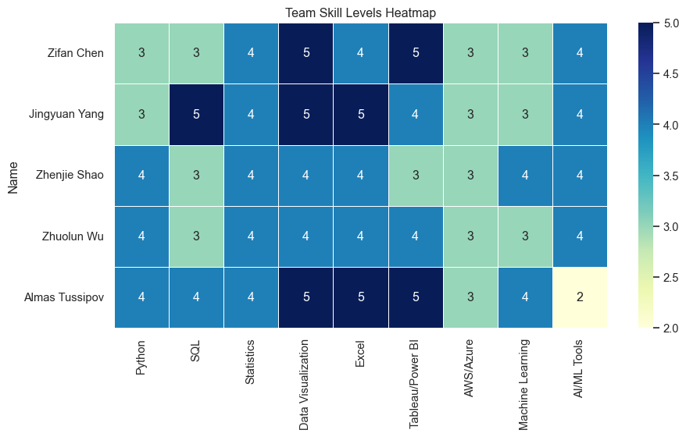

5.4.1 Interpretation
The heatmap shows that the team is relatively strong in foundational skills such as Excel, Python, and data visualization. However, advanced skills such as cloud platforms, machine learning, and AI tools are relatively weak across most members.
This suggests that the team is well-prepared for basic data analysis tasks but may face challenges when applying advanced analytics techniques in real-world business environments.

5.5 5. Comparing Team Skills with Market Demand
To compare internal capabilities with market expectations, we define a simplified benchmark based on the key skill groups identified in our EDA.
 | Team Average | Market Demand | Gap
Python | 3.60 | 5 | 1.40
SQL | 3.60 | 5 | 1.40
AWS/Azure | 3.00 | 4 | 1.00
Machine Learning | 3.40 | 4 | 0.60
Statistics | 4.00 | 4 | 0.00
Tableau/Power BI | 4.20 | 4 | -0.20
Data Visualization | 4.60 | 4 | -0.60
AI/ML Tools | 3.60 | 3 | -0.60
Excel | 4.40 | 3 | -1.40

5.6 6. Skill Gap Visualization
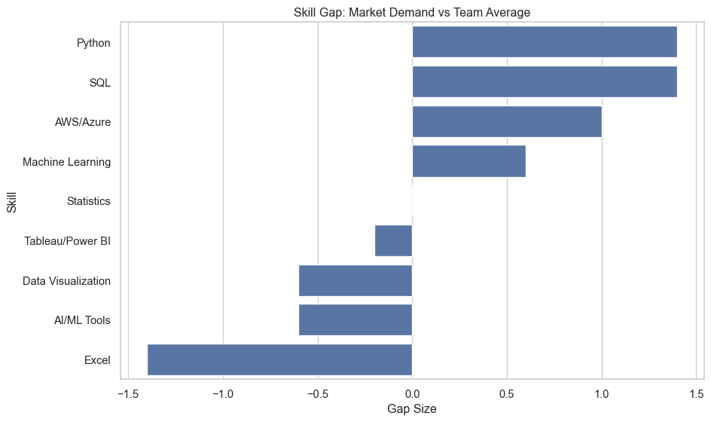

5.6.1 Interpretation
The largest gaps appear in cloud platforms, machine learning, and AI-related tools. The team is relatively closer to market expectations in Excel, Python, and basic data analysis skills.
This indicates that while the team has a solid analytical foundation, there is a need to strengthen more advanced technical capabilities to remain competitive in the job market.

5.7 7. Recommendations for Skill Development
To address the identified gaps, the following actions are recommended:
- Strengthen Python and SQL proficiency across all team members
- Learn cloud platforms such as AWS or Azure
- Develop machine learning skills using libraries like scikit-learn
- Improve data visualization skills using Tableau, Power BI, or Plotly
- Work on real-world projects to integrate analysis, modelling, and visualization

5.8 8. Conclusion
Overall, the team demonstrates a strong foundation in core analytics skills. However, gaps in advanced technical areas such as cloud computing and machine learning suggest the need for continued skill development.
By aligning learning efforts with market demand, the team can significantly improve its competitiveness in business analytics and data science roles.

6. Career Strategy & NLP Analysis

6.1 Section A — AI Tier Classification
Strategy: 3-tier label built from Lightcast’s own taxonomy + strict title keywords + strict ML tool skills.
Tiers: AI/ML Core → Advanced Analytics / Engineering → Traditional Analytics / BI
Unable to display output for mime type(s): text/html
Unable to display output for mime type(s): text/html
Unable to display output for mime type(s): text/html
Unable to display output for mime type(s): text/html
Unable to display output for mime type(s): text/html
Unable to display output for mime type(s): text/html
Unable to display output for mime type(s): text/html
Unable to display output for mime type(s): text/html

6.2 Section B — AI/ML Core Deep Dive
True AI/ML Core jobs represent only ~0.4% of data/tech postings. This section examines where they are, whether they’re growing, and which industries host them.
AI/ML Core jobs: 304
Share of total: 0.45%
Unable to display output for mime type(s): text/html
Unable to display output for mime type(s): text/html
Unable to display output for mime type(s): text/html
Unable to display output for mime type(s): text/html
Unable to display output for mime type(s): text/html
Unable to display output for mime type(s): text/html
Unable to display output for mime type(s): text/html
Median: $135,000 | Mean: $135,139
Unable to display output for mime type(s): text/html
Unable to display output for mime type(s): text/html

6.3 Section C — Temporal & Industry Trends
Focus: How is the data/analytics/tech job market evolving across May-September 2024?
Key dimensions: industry growth, occupation trends, emerging/declining titles, skill demand evolution.
Unable to display output for mime type(s): text/html
POSTED_MONTH Postings
2024-05 13897
2024-06 13159
2024-07 11904
2024-08 14221
2024-09 14390
Unable to display output for mime type(s): text/html
Unable to display output for mime type(s): text/html
Unable to display output for mime type(s): text/html
Unable to display output for mime type(s): text/html
Unable to display output for mime type(s): text/html
Unable to display output for mime type(s): text/html
Unable to display output for mime type(s): text/html
Unable to display output for mime type(s): text/html
Unable to display output for mime type(s): text/html

6.4 Section D — Key Findings Summary
======================================================================
KEY FINDINGS - AD688 Final EDA
======================================================================
DATASET OVERVIEW
-----------------
- Raw: 72,498 rows x 131 columns | Cleaned: 67,572 rows x 117 columns
- Date range: 2024-05-01 to 2024-09-30 (5 months)
- Scope: data / analytics / tech occupations (Lightcast pre-filter)
TOPIC 2.1 - AI vs. Non-AI Careers
-----------------------------------
1. Classification breakdown:
Traditional Analytics / BI: 57,870 (85.6%)
Advanced Analytics / Engineering: 9,398 (13.9%)
AI/ML Core: 304 (0.4%)
2. Salary gradient:
Advanced Analytics / Engineering Median ~$130k
AI/ML Core Median ~$120k
Traditional Analytics / BI Median ~$95k
3. Remote work:
Fully Remote: AI/ML Core 6.6% | Advanced 25.0% | Traditional 16.4%
On-Site: AI/ML Core 13.2% | Advanced 1.1% | Traditional 1.6%
TOPIC 2.5 - BA / Data Science / ML Trends
-------------------------------------------
- Overall volume: May 13,897 to Sep 14,390 (dip in July, recovery by Sep)
- Business/Management Analyst +51.4% (fastest growing occupation)
- Information industry +33.2% | Finance +15.2%
- AI/ML tool skill penetration: <2%, flat across 5-month window
======================================================================

6.5 Section E — NLP Analysis
This section extends the analysis beyond structured variables by applying Natural Language Processing (NLP) techniques to job descriptions. The goal is to extract key skills, understand employer requirements, and identify hidden patterns in unstructured text data.

6.5.1 1. Word Frequency Table
 | word | count
0 | analyst | 32636
7 | data | 27227
6 | consultant | 10382
16 | sap | 9922
2 | architect | 7414
17 | senior | 7236
14 | oracle | 6893
8 | enterprise | 6669
4 | business | 6352
1 | analytics | 4866
12 | lead | 3750
19 | sr | 3562
10 | functional | 3280
11 | intelligence | 3142
5 | cloud | 2808
15 | remote | 2686
9 | erp | 2200
3 | associate | 2196
13 | management | 2083
18 | specialist | 1787
This table shows the most frequently used words in the job posting text. The most common words are analyst, data, consultant, SAP, architect, and senior. This suggests that the dataset is heavily focused on business analytics, enterprise systems, consulting, and technical business roles. Words such as SAP, Oracle, ERP, and enterprise also indicate that many employers are looking for candidates with enterprise software and business systems knowledge, not only general data skills.

6.5.2 2. TF-IDF Keyword Table
 | word | score
0 | analyst | 0.26
7 | data | 0.24
16 | sap | 0.10
6 | consultant | 0.09
2 | architect | 0.08
17 | senior | 0.07
8 | enterprise | 0.07
14 | oracle | 0.06
4 | business | 0.06
1 | analytics | 0.05
12 | lead | 0.04
19 | sr | 0.04
10 | functional | 0.03
11 | intelligence | 0.03
15 | remote | 0.03
5 | cloud | 0.03
3 | associate | 0.03
9 | erp | 0.02
13 | management | 0.02
18 | specialist | 0.02
The TF-IDF results are similar to the word frequency results, but they give more weight to words that are important across the text rather than just repeated often. Analyst and data still have the highest scores, which confirms that analytics-related roles dominate the dataset. The high scores for SAP, consultant, architect, and enterprise show that specialized business technology skills are important in this job market. Compared with simple word counts, TF-IDF gives a better sense of which terms are more meaningful for understanding job descriptions.

6.5.3 3. Skill Keyword Count and Bar Chart
 | skill | count
1 | sql | 14
6 | communication | 9
2 | excel | 2
0 | python | 1
5 | power bi | 1
3 | machine learning | 0
4 | tableau | 0
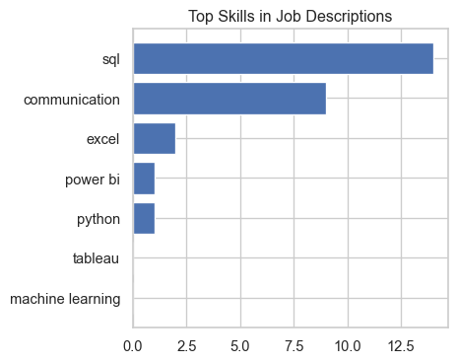
The skill keyword chart shows that SQL appears most often, followed by communication and Excel. This means employers are not only looking for technical ability, but also business communication and reporting skills. Python, Power BI, Tableau, and machine learning appear less frequently in this result, which may suggest that many postings are more focused on analytics, database querying, and business reporting than advanced machine learning. For students, SQL and communication should be treated as core employability skills.

6.5.4 4. Python Salary Comparison
 | has_python | SALARY_MID
0 | False | 114,379.31
1 | True | 106,080.00
The salary comparison shows that jobs mentioning Python have a higher average salary than jobs that do not mention Python. The average salary for Python-related postings is about $129,903, compared with about $115,040 for non-Python postings. This suggests that Python may be associated with more technical or higher-value analytics roles. However, this result should be interpreted carefully because it shows correlation, not causation. Python may appear more often in advanced analytics or technical roles that already tend to pay more.

7. References
365 Data Science. 2024. “Data Scientist Job Market 2024: Analysis, Trends, Opportunities.” 2024. https://365datascience.com/career-advice/data-scientist-job-market/.
AnalytixLabs. 2024. “Data Science Skills Survey Report 2024.” 2024. https://medium.com/@byanalytixlabs/data-science-skills-survey-report-2024-a-comprehensive-market-study-of-most-in-demand-skills-3d9baf772272.
Atera. 2026. “5 New AI Job Roles Emerging Right Now.” 2026. https://www.atera.com/blog/new-ai-job-roles/.
Briggs, Joseph, and Devesh Dong. 2023. “How Will AI Affect the Global Workforce?” Goldman Sachs Global Economics Research. https://www.goldmansachs.com/insights/articles/how-will-ai-affect-the-global-workforce.
Coursera. 2025. “What Is a Business Analyst? 2026 Career Guide.” 2025. https://www.coursera.org/articles/what-does-a-business-analyst-do-and-how-to-become-one.
Federal Reserve Bank of St. Louis. 2025. “Is AI Contributing to Rising Unemployment? Evidence from Occupational Variation.” 2025. https://www.stlouisfed.org/on-the-economy/2025/aug/is-ai-contributing-unemployment-evidence-occupational-variation.
Gartner. 2024. “Gartner Predicts 2025: AI to Automate Majority of Data Science Tasks.” 2024. https://www.gartner.com/en/newsroom/press-releases/2021-07-19-gartner-identifies-key-emerging-technologies-spurring-innovation-through-trust-growth-and-change.
IEEE-USA InSight. 2026. “Seven Tech Occupations Poised for Double-Digit Job Growth by 2034.” 2026. https://insight.ieeeusa.org/articles/seven-tech-occupations-poised-for-double-digit-job-growth-by-2034/.
Information Technology and Innovation Foundation. 2025. “AI’s Job Impact: Gains Outpace Losses.” 2025. https://itif.org/publications/2025/12/18/ais-job-impact-gains-outpace-losses/.
International Monetary Fund. 2024. “Gen-AI: Artificial Intelligence and the Future of Work.” IMF. https://www.imf.org/en/Publications/Staff-Discussion-Notes/Issues/2024/01/14/Gen-AI-Artificial-Intelligence-and-the-Future-of-Work-542379.
Lightcast. 2024. “Job Postings Data 2024.” 2024. https://drive.google.com/uc?id=1V2GCHGt2dkFGqVBeoUFckU4IhUgk4ocQ.
MIT Technology Review. 2024. “Job Titles of the Future: AI Prompt Engineer.” 2024. https://www.technologyreview.com/2024/04/24/1091125/ai-prompt-engineer-generative-ai-job-titles/.
National University. 2026. “59 AI Job Statistics: Future of u.s. Jobs.” 2026. https://www.nu.edu/blog/ai-job-statistics/.
U.S. Bureau of Labor Statistics. 2025a. “Data Scientists: Occupational Outlook Handbook.” 2025. https://www.bls.gov/ooh/math/data-scientists.htm.
———. 2025b. “Management Analysts: Occupational Outlook Handbook.” 2025. https://www.bls.gov/ooh/business-and-financial/management-analysts.htm.
———. 2025c. “Market Research Analysts: Occupational Outlook Handbook.” 2025. https://www.bls.gov/ooh/business-and-financial/market-research-analysts.htm.
———. 2025d. “Operations Research Analysts: Occupational Outlook Handbook.” 2025. https://www.bls.gov/ooh/math/operations-research-analysts.htm.
World Economic Forum. 2023. “Future of Jobs Report 2023.” World Economic Forum. https://www.weforum.org/publications/the-future-of-jobs-report-2023/.
———. 2025. “Future of Jobs Report 2025.” World Economic Forum. https://www.weforum.org/publications/the-future-of-jobs-report-2025/.

