### Assignment: Implementing Block-wise Discrete Fourier Transform (DFT) and Inverse Discrete Fourier Transform (IDFT)

#### Objective:

In this assignment, you will implement the **Discrete Fourier Transform (DFT)** and **Inverse Discrete Fourier Transform (IDFT)** from scratch, without relying on any external libraries like NumPy. The goal is to understand how DFT works by dividing an image into blocks, applying the DFT to each block, displaying the amplitude and phase of each block, and reconstructing the image using the IDFT.

You will use **Matplotlib** to display the images and the results.

### Assignment Tasks:

· **Load an image:**

The image must be loaded as a grayscale image.

· **Divide the image into blocks:**

Divide the image into blocks of size 8x8 (or any other size you prefer).

· **Implement the DFT from scratch:**

You need to write a function that performs a 2D DFT using its mathematical definition: 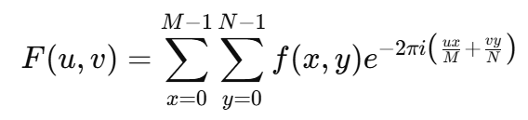

where f(x,y)f(x, y)f(x,y) is the input image block, and F(u,v)F(u, v)F(u,v) is the DFT result.

· **Implement the IDFT from scratch:**

Write a function that performs the 2D Inverse DFT: 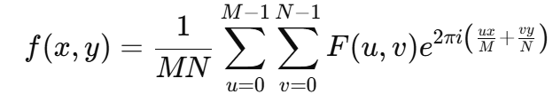

where F(u,v)F(u, v)F(u,v) is the DFT result, and f(x,y)f(x, y)f(x,y) is the reconstructed block.

· **Compute amplitude and phase:**

After applying DFT, compute the amplitude and phase of each block: 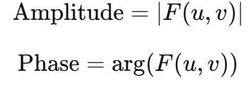

· **Reconstruct the image:**

After applying IDFT to all blocks, reconstruct the entire image.

· **Display the results:**

Use Matplotlib to display:

* 1. The original image.
  2. The reconstructed image (after applying IDFT).
  3. The amplitude of the frequency domain of a selected block.
  4. The phase of the frequency domain of the same selected block.

### Code Requirements:

* **Do not use NumPy or any external libraries for DFT/IDFT computation.**
* Use Matplotlib for displaying images.
* Write clear and concise comments for each part of the code, explaining what each step does.

### Submission:

* Submit the Python code with proper comments and structure.
* Ensure the code is formatted and structured logically.
* Include test cases using at least two different images.

### Additional Guidelines:

* **Code structure**: Ensure the code is well-structured and commented, especially for complex operations like DFT.
* **Block size**: Default block size is 8x8, but this can be adjusted.
* **Testing**: Test the code with different images and ensure that the reconstructed image closely resembles the original image.