7CCSMPNN Pattern Recognition
Coursework Assignment 3
Student ID: 1415506 Name: Yongjuan Zhang
The Iris flower data set consists the date of 3 species of Iris (setosa, virginica and versicolor) characterised by 4 features: the length and the width of the sepals and petals in centimetres. The Iris data set (in Matlab format) with file name “iris class1 2 3 4D.mat” is available on KEATS. A multi-class SVM-based classifier formed by multiple SVMs is employed to handle the classification problem. Two 3 ^{r d} - party Matlab SVM toolboxes are recommended to implement the multi-class SVM-based classifier. You can use either one of them for this assignment. Details can be found in Appendix 1.
a) Write down your 7-digit student ID denoted as s₁s₂s₃s₄s₅s₆s₇.
My student ID: 1415506

b) Find R₁ which is the remainder of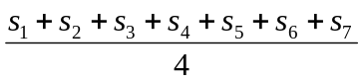. Table 1 shows the multi- class methods to be used corresponding to the value of R1obtained.
R₁ | Method
0 | One against one
1 | One against all
2 | Binary decision tree
3 | Binary coded

Table 1: R₁ and its corresponding multi-class method.
R₁=2 Binary decision tree
c) Use the Matlab code “PR_SVM subdata.m” available on KEATS to randomly partition the Iris data into 5 equal size sub-data sets referred to as D1 to D5, which will be used for 5-fold cross validation. Note that the notations D1 to D5 here are used to present the concept. Refer to Appendix 2 for details of datasets and sub-datasets generated by the provided Matlab code.

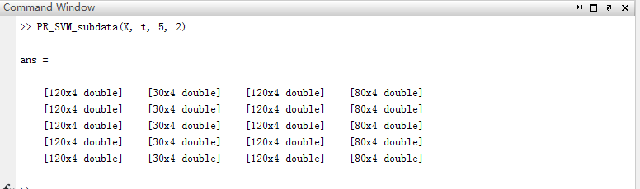

D1: [120x4 double] [30x4 double] [120x4 double] [80x4 double]
D2: [120x4 double] [30x4 double] [120x4 double] [80x4 double]
D3: [120x4 double] [30x4 double] [120x4 double] [80x4 double]
D4: [120x4 double] [30x4 double] [120x4 double] [80x4 double]
D5: [120x4 double] [30x4 double] [120x4 double] [80x4 double]
d) Write a Matlab script to implement the multi-class SVM-based classifier using the R₁th method(Binary decision tree). Train and test multi-class SVM-based classifier using 5-fold cross validation. The cross-validation process will repeat the training-testing process 5 times. In the i^{th} time, D_{i} sub-data set is used for testing and the rest sub-data sets (forming a single data set) are used for training. For example, in the 1 st time, D1 is used for testing and D₂, D₃, D₄ and D₅ forming a single data set is used for training.
用二元判定树的方法写出matlab的脚本文件去运行基于SVM的多类分类器

e)Summarise the classification accuracy (in %) in the form of Table 2 for different kernels (linear, polynomial and RBF kernels) and values of C. Comment on the results.
– Consider the values of C as 1, 10, and 100.
– Pick the coefficients of polynomial and RBF kernels of your choice. Use the same coefficients for all values of C.

In total, you will have 3 tables in the form of Table 2. Each for a value of C.
 | Linear Kernel |  | Polynomial Kernel |  | RBF Kernel
Fold | Training  Accuracy  (%) | Testing  Accuracy  (%) | Training  Accuracy  (%) | Testing  Accuracy  (%) | Training  Accuracy  (%) | Testing  Accuracy  (%)
1
2
3
4
5
Average
Accuracy
Table 2: Summary accuracy table for linear kernel, polynomial kernel and RBF kernel with a chosen value of C.
The training/testing accuracy is the classification accuracy that the input samples from the training/test dataset are correctly recognised. For example, considering a training dataset of 50 samples, 40 of them are correctly recognised, the training accuracy is 40/50 = 80%. The average accuracy is the average accuracy of the five results.
C=1
 | Linear Kernel |  | Polynomial Kernel |  | RBF Kernel
Fold | Training  Accuracy  (%) | Testing  Accuracy  (%) | Training  Accuracy  (%) | Testing  Accuracy  (%) | Training  Accuracy  (%) | Testing  Accuracy  (%)
1 | 100 | 90 | 100 | 90 | 100 | 90
2 | 98.33 | 100 | 99.17 | 93.33 | 99.17 | 100
3 | 98.33 | 100 | 99.17 | 100 | 98.33 | 96.67
4 | 99.17 | 96.67 | 100 | 90.00 | 97.50 | 96.67
5 | 98.33 | 100 | 100 | 93.33 | 99.17 | 93.33
Average  Accuracy | 98.33 | 97.33 | 99.67 | 93.33 | 98.33 | 95.33

C=10
 | Linear Kernel |  | Polynomial Kernel |  | RBF Kernel
Fold | Training  Accuracy  (%) | Testing  Accuracy  (%) | Training  Accuracy  (%) | Testing  Accuracy  (%) | Training  Accuracy  (%) | Testing  Accuracy  (%)
1 | 99.17 | 90 | 100 | 90 | 100 | 90
2 | 98.33 | 100 | 100 | 100 | 99.17 | 100
3 | 98.33 | 96.67 | 100 | 100 | 99.17 | 96.67
4 | 98.33 | 93.33 | 100 | 90 | 100 | 93.33
5 | 96.67 | 100 | 100 | 93.33 | 99.17 | 93.33
Average  Accuracy | 98.17 | 96 | 100 | 94.67 | 99.50 | 94.67

C=100
 | Linear Kernel |  | Polynomial Kernel |  | RBF Kernel
Fold | Training  Accuracy  (%) | Testing  Accuracy  (%) | Training  Accuracy  (%) | Testing  Accuracy  (%) | Training  Accuracy  (%) | Testing  Accuracy  (%)
1 | 100 | 90 | 100 | 90 | 100 | 90
2 | 97.5 | 100 | 100 | 100 | 100 | 96.67
3 | 97.5 | 100 | 100 | 100 | 100 | 93.33
4 | 99.17 | 90 | 100 | 90 | 100 | 93.33
5 | 97.5 | 100 | 100 | 93.33 | 100 | 93.33
Average  Accuracy | 98.3 | 96 | 100 | 94.67 | 100 | 93.33

