# Background

Openpay is looking for quality Javascript frontend and full-stack engineers to join our team and help deliver payment and cash flow solutions for our customers.

# The Task

One of the final steps for a customer to complete a purchase with Openpay is to choose a plan. Plans with Openpay can vary by payment interval (weekly, fortnightly or monthly) and by number of payments.

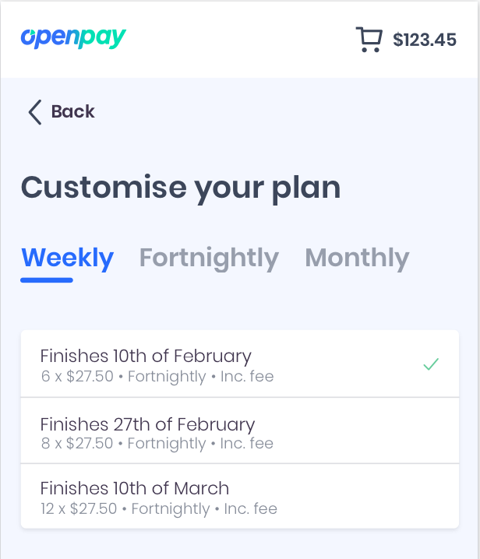Create a React solution that enables a customer to choose the correct Openpay plan for them. They should be able to select from plan organized by interval and ordered by number of payments.

Use the design provided as a guide.

The purchase price is already set $123.45

The available plans will be fetched from an API.

Sample API Response:

[

{

"interval": "weekly",

"paymentCount": 6

},

{

"interval": "weekly",

"paymentCount": 8

},

{

"interval": "weekly",

"paymentCount": 12

},

{

"interval": "monthly",

"paymentCount": 2

},

{

"interval": "monthly",

"paymentCount": 3

}

]

# Notes

* We are looking for a sample of how you break down a problem and validate your solution.
* Use the design as a guide to the user experience, we are not looking for a pixel perfect result.
* If you have any questions, feel free to reach out.

# Submission

Send an email with your solution (or link to) back to the your Openpay contact.