# 3WEB_Project_SupTrac

Table of Contents

3WEB_Project_SupTrac 1

Team members 1

Project Introduction 1

Login page 2

Index page 3

All Ticket Page 4

New Tickets page 4

Ticket Detail and comments Display 5

Add a Comment 6

Add a Ticket 7

Edit and Delet Ticket 7

Report to work on a Ticekt 9

My tickets listing 10

Send an asynchronous e-mail 10

Documents I use in this project 10

Code Introduction: 12

Finish goals 14

# Team members

Name: Zhang Xiao long ID: 201107

Name: Zhang Tian jian ID: 201106

Name: Zhang Ye Zhou ID: 201108

Name: Guo Yong ID: 201092

# Project Introduction

This project we create a SupTrac like SupTodo ( our last year Java project).

To start the project :

**First : at cmd start the mongodb use mongod.**



**We use test :**

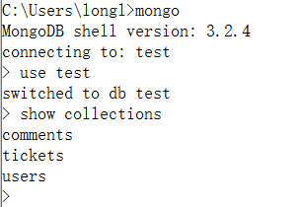

**Second : At another cmd , in the project path**



Then the project starts.

Here I will introduce our project use page and introduction.

## Login page

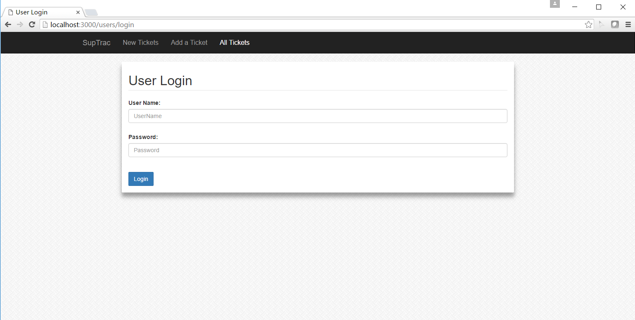

This page is our login page.

We create a ProductOwner User : UserName : LiMing

Password : 123

And user can not go to other pages without login. They will return to login page.

## Index page

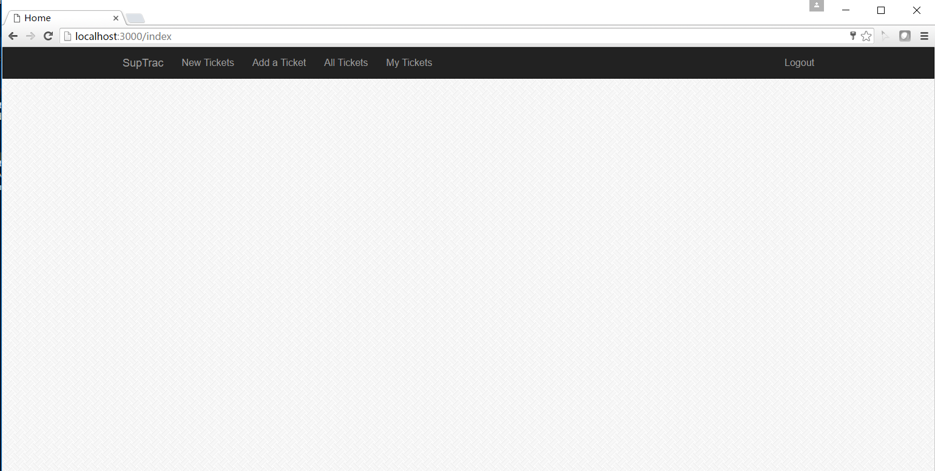

This is the Index page nothing in it but the Navigation Bar , user can use Navigation Bar to choose which page wo show .

## All Ticket Page

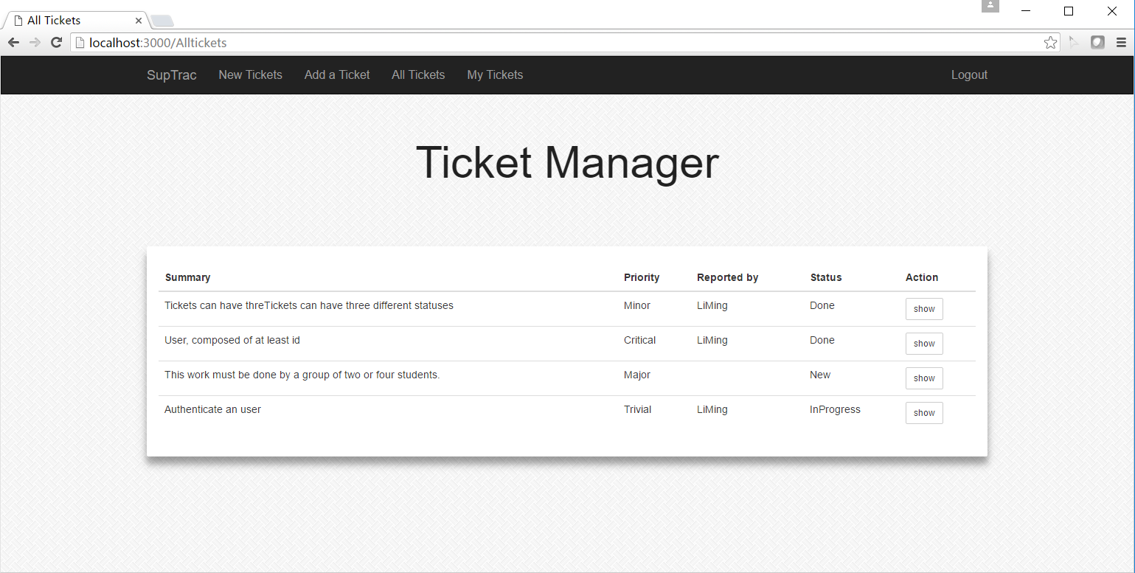

There you can see the All tickets page, this page will show the tickets (no matter what status is ) . you can see the status can be :

Done , New and Inprogress. New ticket’s developer is nobody so is blank ,and when user start working , the status changes to Inprogress.

## New Tickets page

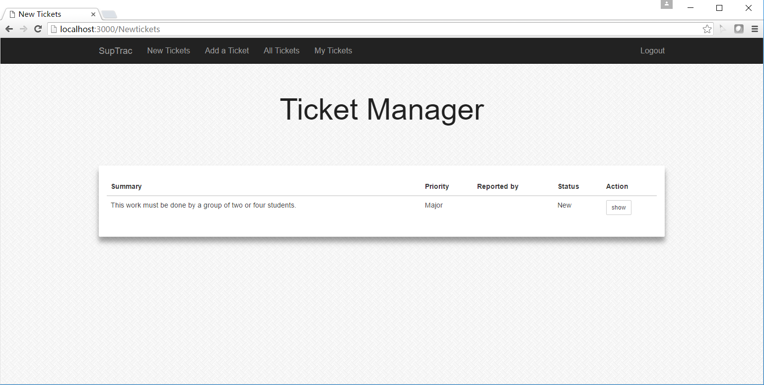

The New Tickets page will only show the tickets which status is New. And every ticket has a button to show.

## Ticket Detail and comments Display

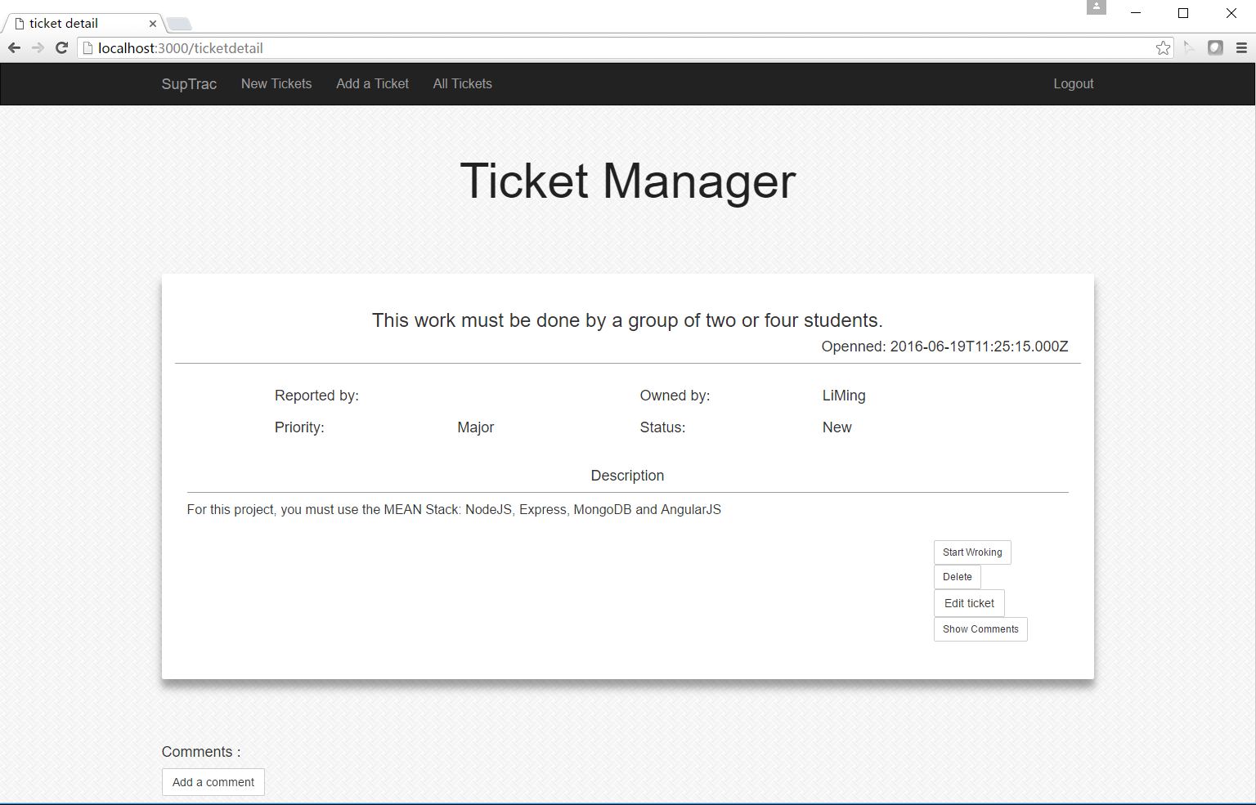

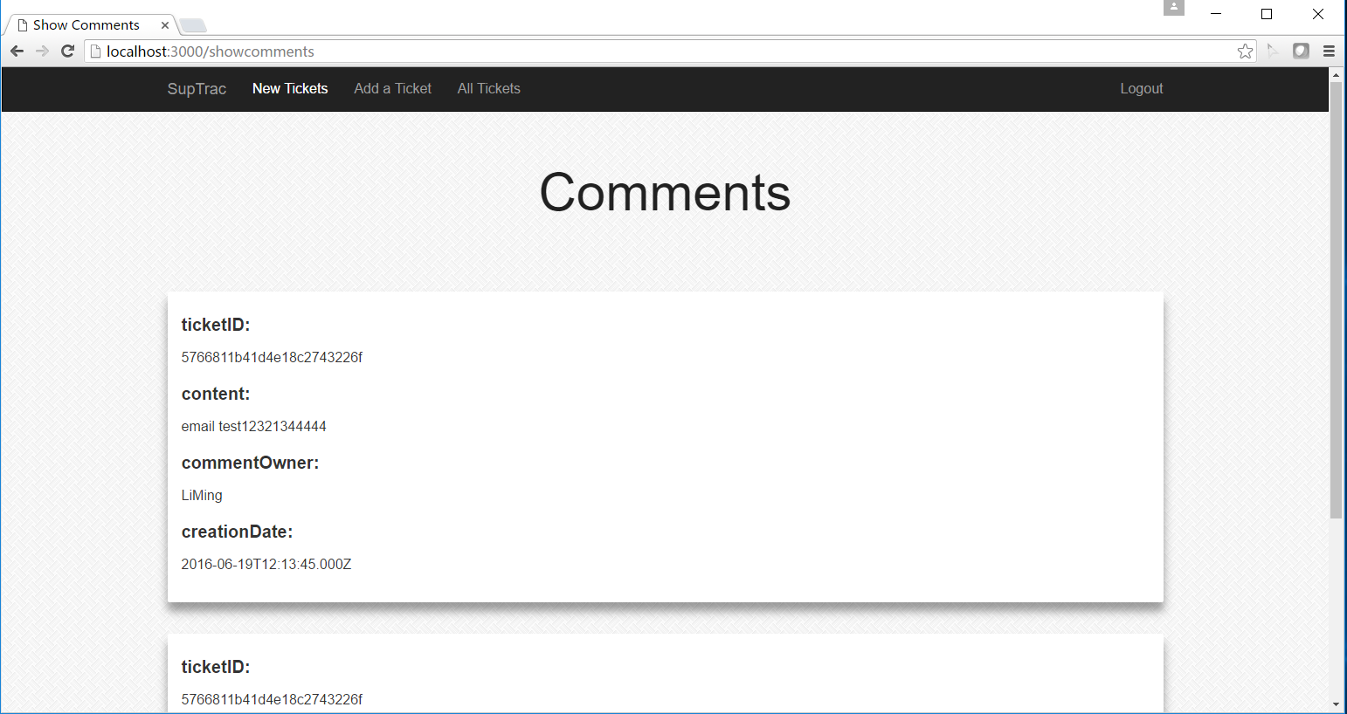

This is the Ticket Detail and comments page, I meet some problem there, later the coding part I will talk about it clearly. And the end is I can not show the comments and ticket detail in the same page, because the data transport. At the .ejs file I use $http.get(jsonUrl), to get the data , I meet a problem is that I can’t get two Urls data at the same time . I know I show use code like the this , but it doesn’t work. So I choose that way , I know it is not a good way ☹ .

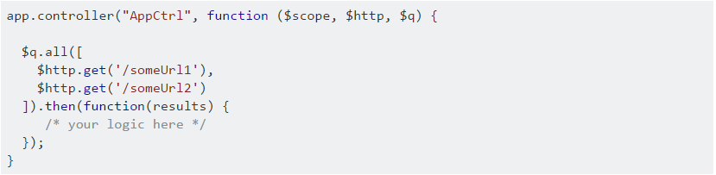

## Add a Comment

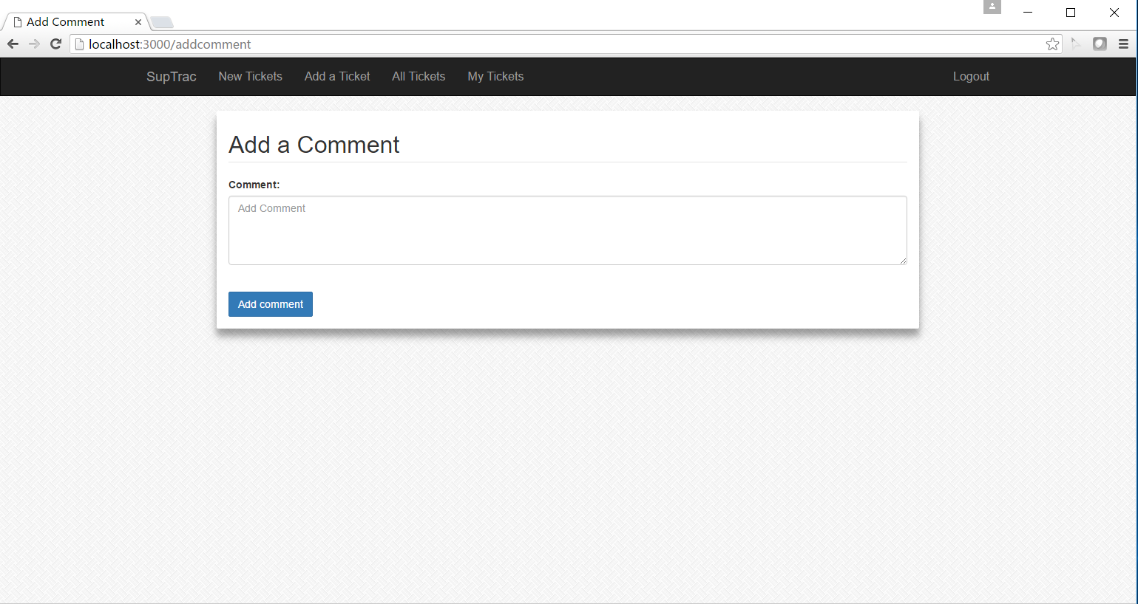

Every Ticket Detail page has a button to add comment . After user click it , will turn to Add comment page. After add comment page will turn to the ticket detail page .

## Add a Ticket

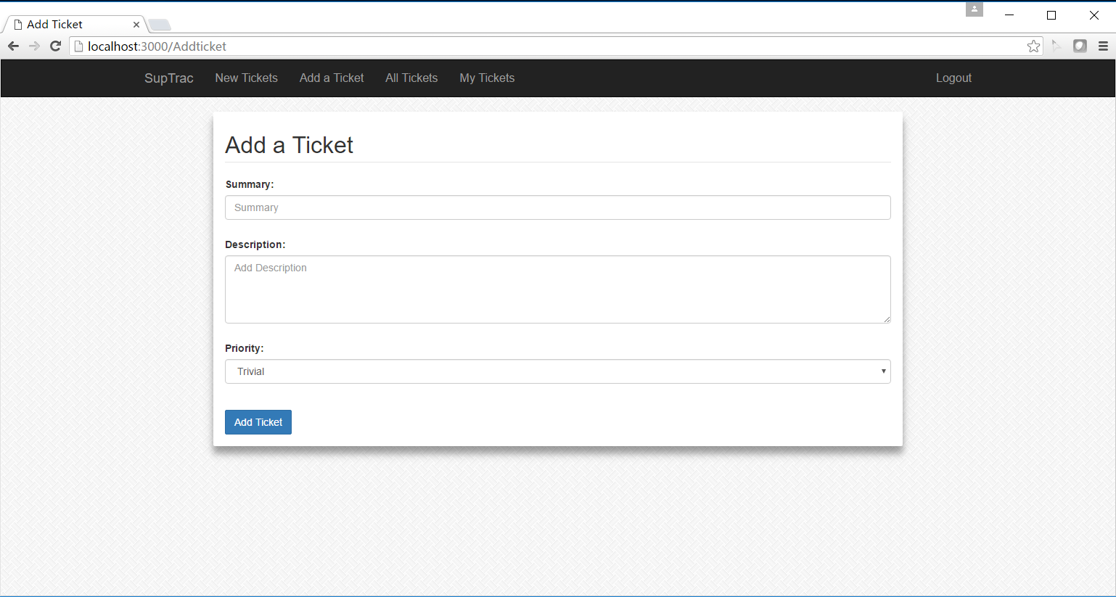

At the Navigation Bar , user can choose add a Ticket ,

At the Add Ticket page, user can set the summary , description ,priority , and the Stauts will be New automaticly.

## Edit and Delet Ticket

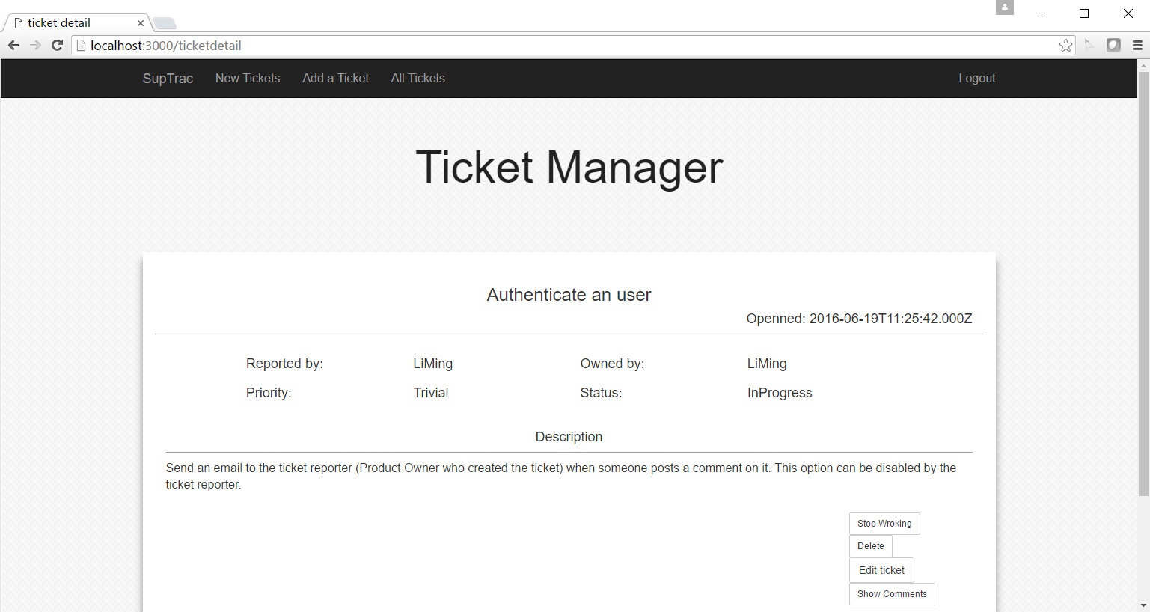

At the Ticekt Detail page , ProductOwner can choose edit or delete the Ticekt, and There we meet another problem , I try to use session.user.position to control the button show , ( productOwner will show edit and delete button ) and ( Developer will show the start working and stopworking buttons) , But I can not get the session data at the EJS page , so I can not control the buttons . Which means No matter what kind of user , can choose Edit and Delete , start or stop working .

And I search the solution is that : use code like res.render(‘url’ , parameters) at the router.js and use <% some %> or {{some }} at page , but it didn't work ☹.

But The Edit and Delete Function can work!!

After Delete :

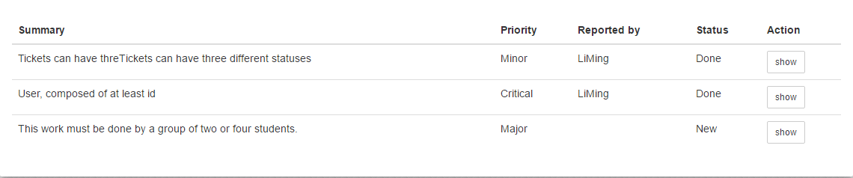

Edit the Ticket page:

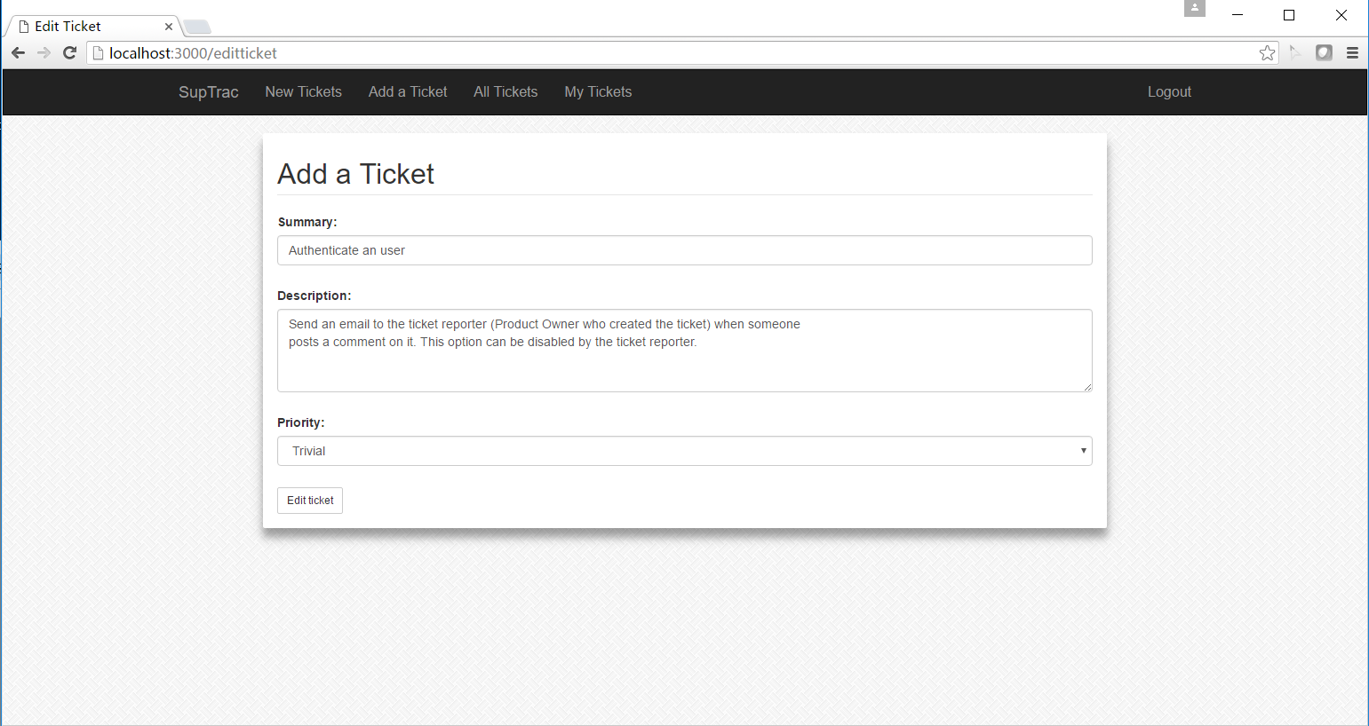

## Report to work on a Ticekt

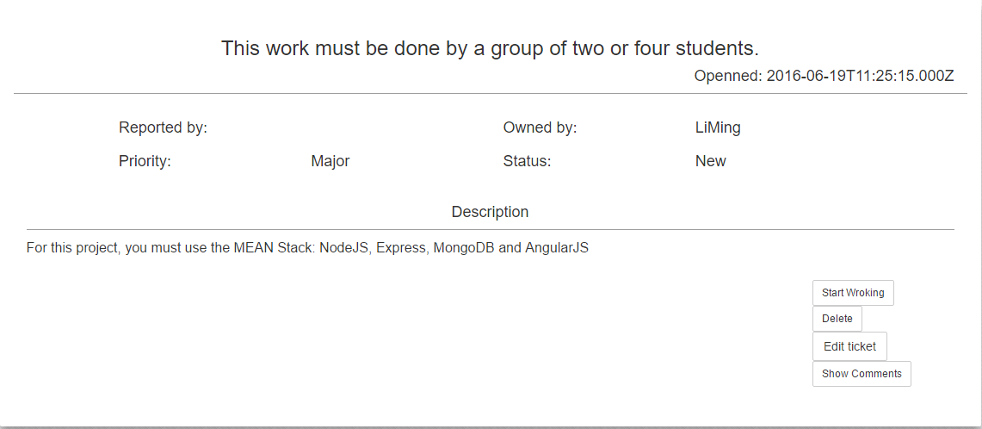

At the Ticket Detail page, developer can choose StartWorking or StopWorking button depend on the Ticket’s status( New will be StartWorking , Inprogress will be Done).

## My tickets listing

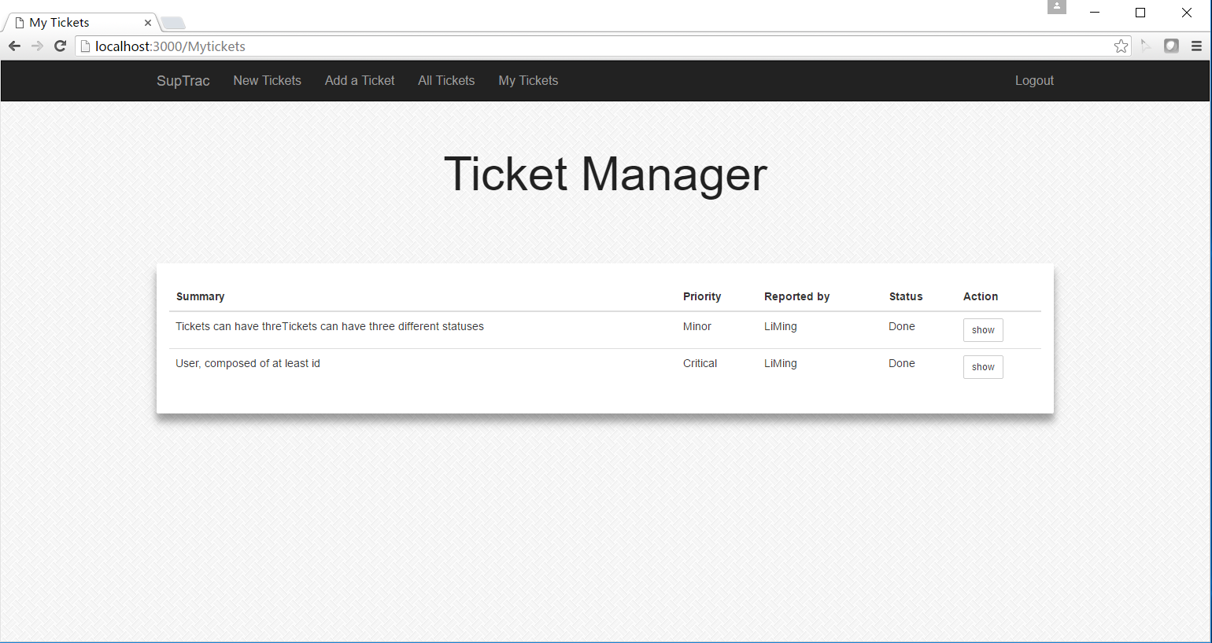

The user is Li Ming , so the My Tickets’ will show the Tickets that the developer is Li Ming.

## Send an asynchronous e-mail

Every time, user add a comment , the productOwner will get a Email from ([2817743523@qq.com](mailto:2817743523@qq.com)) tell him that a comment added. The Li Ming’s email I set is my Supinfo email is [201107@supinfo.com](mailto:201107@supinfo.com) and I get the email successfully.

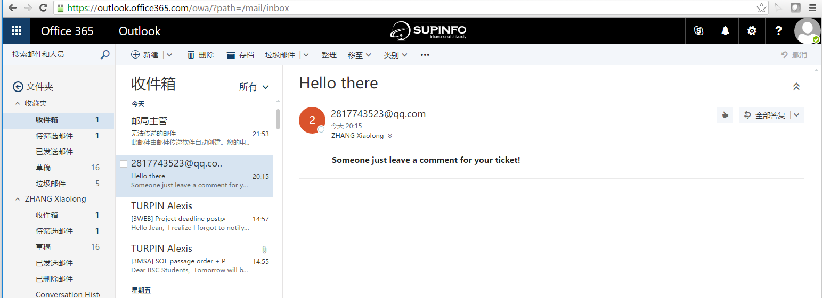

## Documents I use in this project

Node.jsDocument : <http://www.runoob.com/nodejs/nodejs-tutorial.html>

Create Sample Static Website Using Node.js – YouTube :

<https://www.youtube.com/watch?v=TLuijugSBUc>

MongoDB Tutorial for Beginners:

<https://www.youtube.com/watch?v=1NP5lLwH9F8&list=PL6gx4Cwl9DGDQ5DrbIl20Zu9hx1IjeVhO&index=2>

NodeJS MongoDB Tutorial – YouTube :

<https://www.youtube.com/watch?v=Do_Hsb_Hs3c>

"Simple login using Mongoose / MongoDB - Node.js Tutorial 17 – YouTube:

<https://www.youtube.com/watch?v=pzGQMwGmCnc>

Node.js Part 2 - Install MongoDB in Windows – YouTube:

ttps://www.youtube.com/watch?v=1yZj_9VWMdE

MongoDB Tutorials for nodeJS Developers – YouTube:

<https://www.youtube.com/watch?v=uvcUO8DPWfs&list=PLRQuJcU2aZG-aMedJxa7p7ylYmOn5iMlS>

Inserting Data Into MongoDB: Node.js – YouTube:

<https://www.youtube.com/watch?v=uZqwHfNIf8M>

Node.js MongoDB Tutorial using Mongoose – YouTube:

<https://www.youtube.com/watch?v=5e1NEdfs4is>

MongoDB Tutorial for Beginners:

<https://www.youtube.com/watch?v=ynPAkZyH3R8&list=PL6gx4Cwl9DGDQ5DrbIl20Zu9hx1IjeVhO&index=3>"

Building a Website from Scratch with ExpressJS and Bootstrap | Codementor:

<https://www.codementor.io/nodejs/tutorial/build-website-from-scratch-using-expressjs-and-bootstrap>

Node.js Tutorial: Using MongoDB:

<http://blog.modulus.io/mongodb-tutorial>

## Code Introduction:

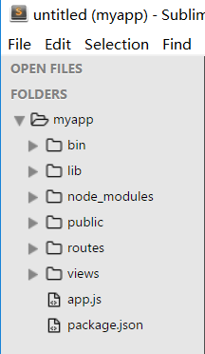

This is my app Folder ( created by exprss) .

The Lib folder contains the modules I create

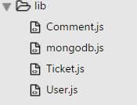

And the router , get , post function in

Index.js contains the Ticket and Comments Post, get, functions

Users contains the user get,post ,functions

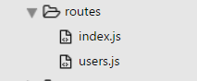

The Pages in Views

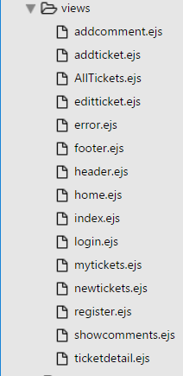

The Public folder :

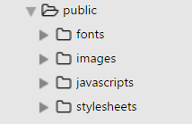

Contains the some css, javascripts file we use.

## Finish goals

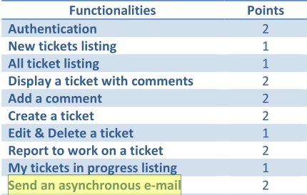

Finish these goals , but the button control ( depend on the user’s position to show the button) .

The buttons functions can work good.

That’s all, Thank you for Reading☺!