**CS 410000 Computer Architecture**

**Homework 1**

**(Due: 2023-10-2 23:59)**

110020037 李承翰

Please evaluate your computer performance by executing the following benchmarks, and fill the blanks of table. In addition, basic hardware information of your computer has to be reported too. You can download the benchmark source code from eeclass, and re-compile them for your Linux system.

|  |
| --- |
| **Compile Instructions**  1) Change directories to “src” of benchmarks. (eq. SPEC2000_SS/CINT2000/164.gzip/src)  2) Make sure your gcc location in *Makefile.defaults* (eq. cc=gcc), and type "make",  3) Execute the “./run” script, and report your program elapsed time. |

|  |  |
| --- | --- |
| **Reference machine information** | |
| **Processor model** | Intel(R) Core(TM) i5-8400 CPU @ 2.80GHz |
| **Memory size** | 32 GB |
| **Operating system (OS)** | Ubuntu 18.04.5 LTS |

|  |  |  |  |
| --- | --- | --- | --- |
| **Benchmark** | **Execution time of your machine (second)** | **Execution time of reference machine (second)** | **Speedup of your machine w.r.t. reference machine** |
| **164.gzip** | 0.653 | 0.564 | 86.4% |
| **175.vpr** | 0.502 | 0.482 | 96.0% |
| **181.mcf** | 0.114 | 0.072 | 63.2% |
| **Arithmetic mean** | 0.423 | 0.373 | 88.2% |

|  |  |
| --- | --- |
| **Work station machine information** | |
| **Processor model** | AMD EPYC 7282 16-Core Processo |
| **Memory** | 263623900 kB |
| **Operating system (OS)** | CentOS Linux release 7.9.2009 |

Snapshots of compilation results.

164.gzip

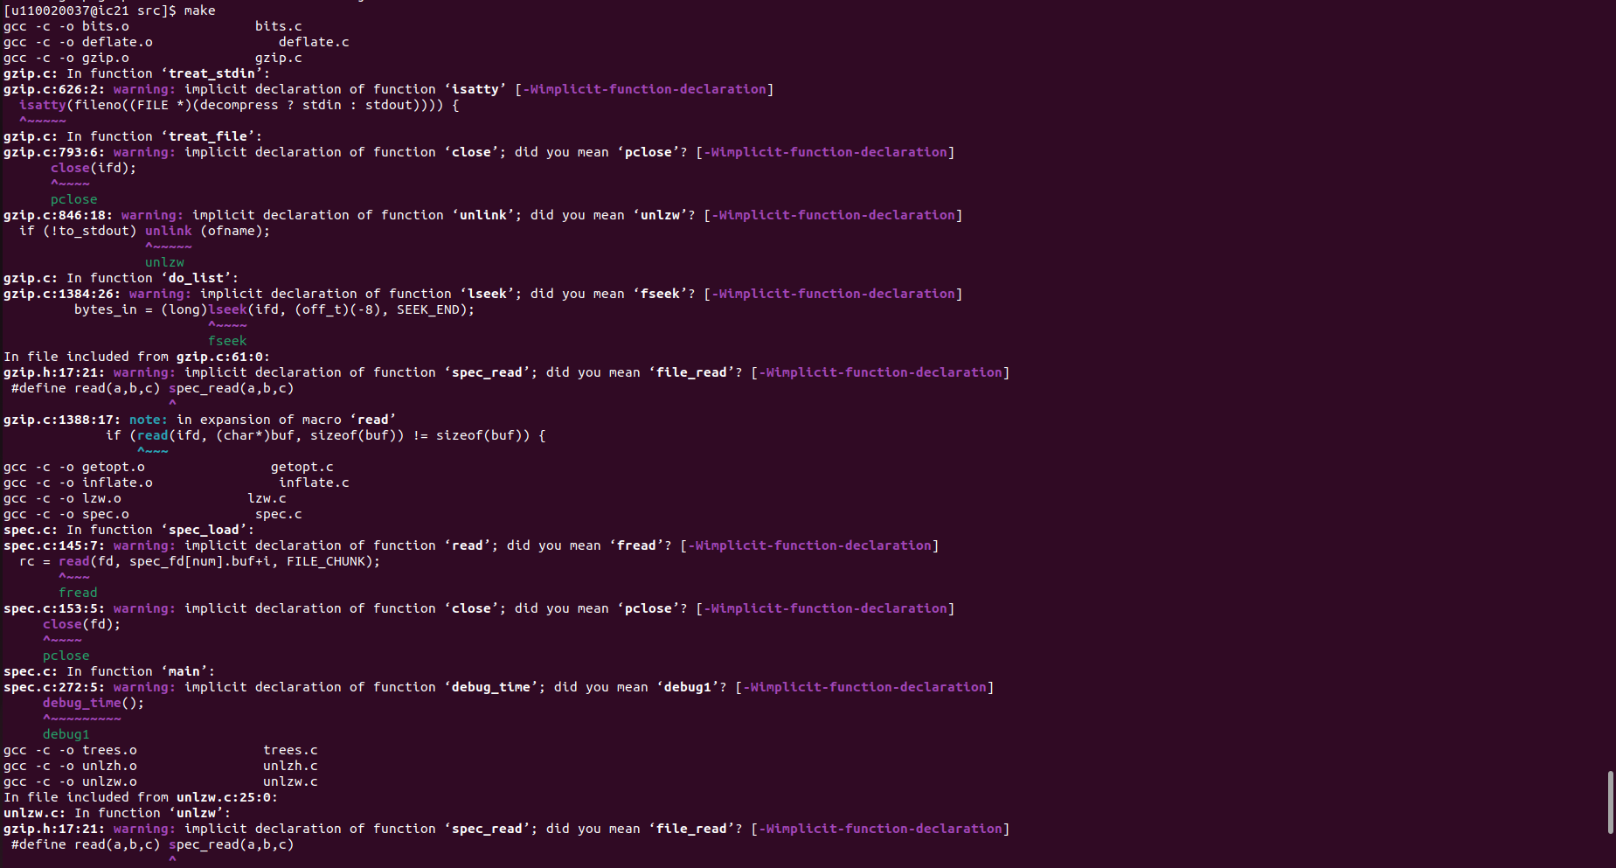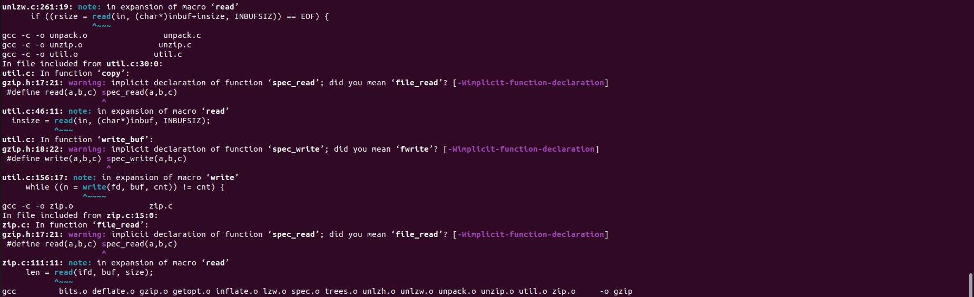175.vpr

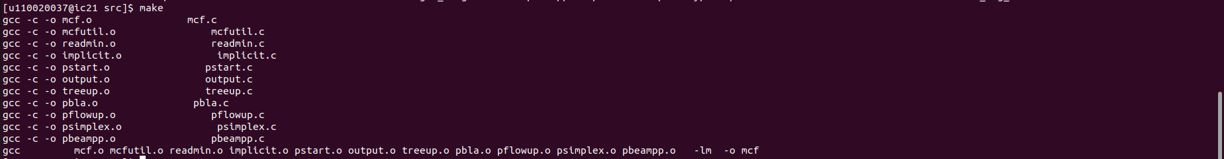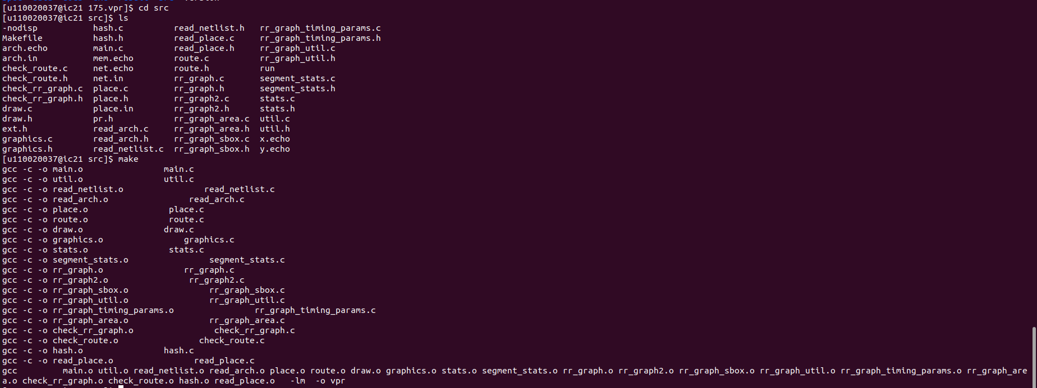181.mcf

Snapshots of execution results

164.gzip

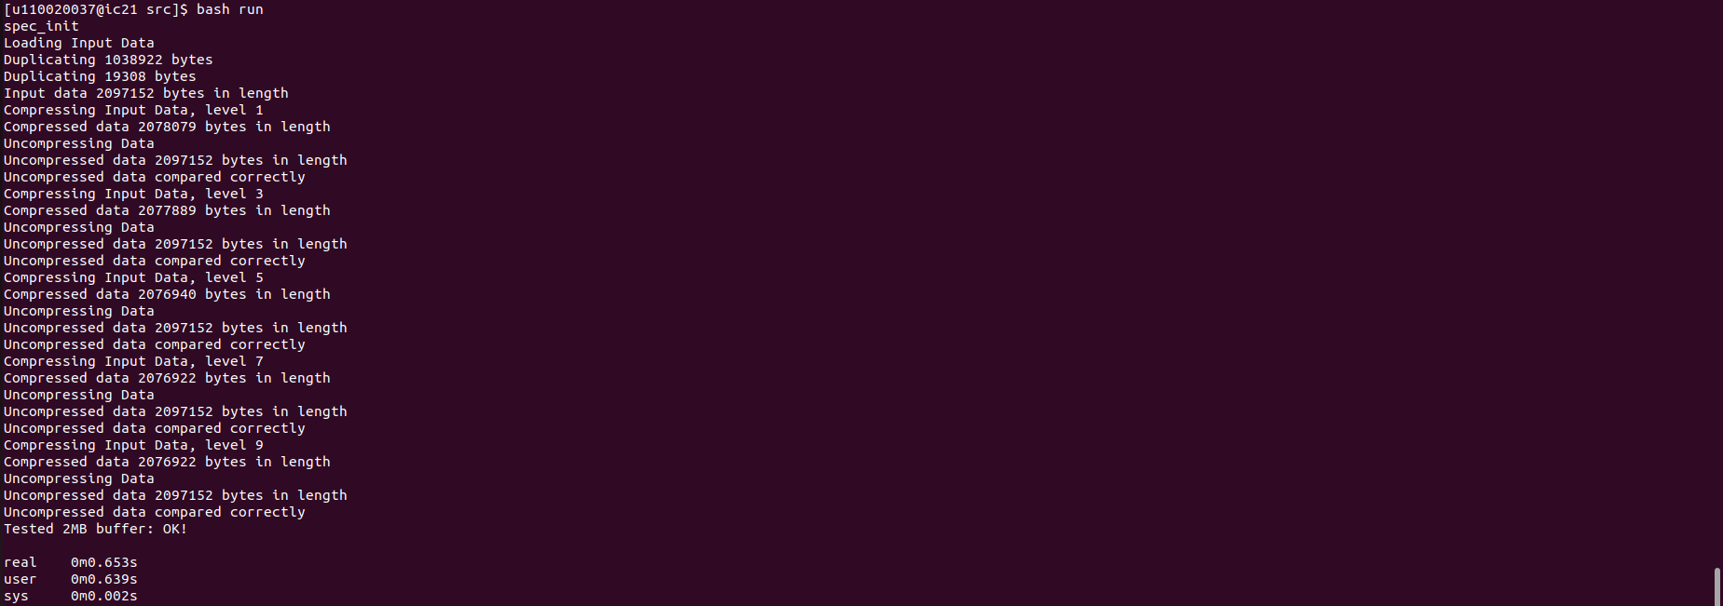

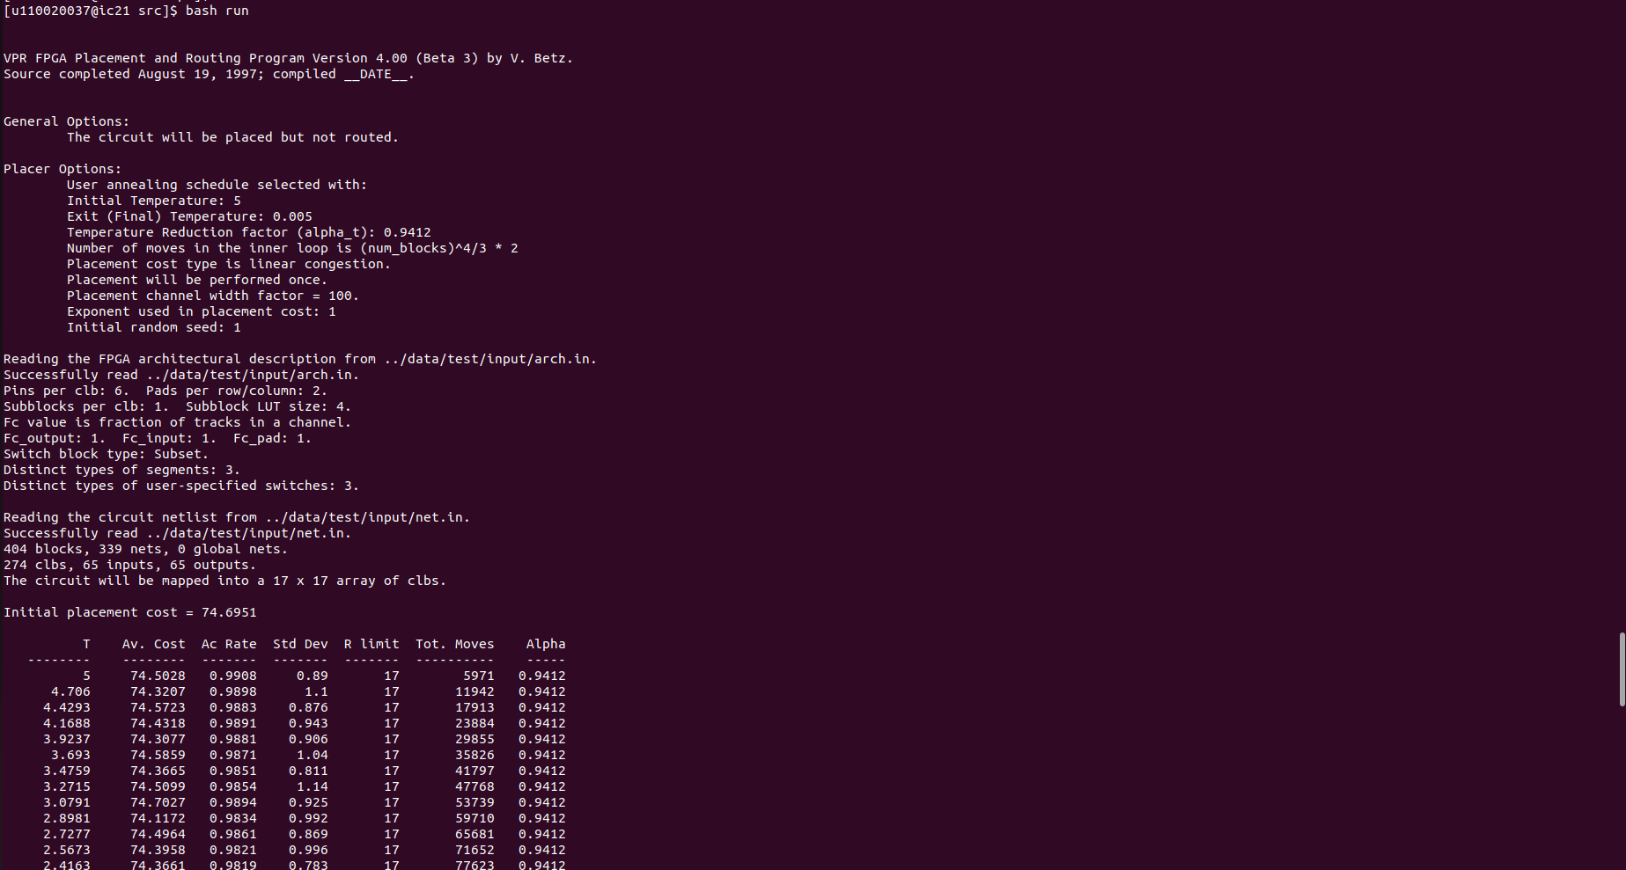175.vpr

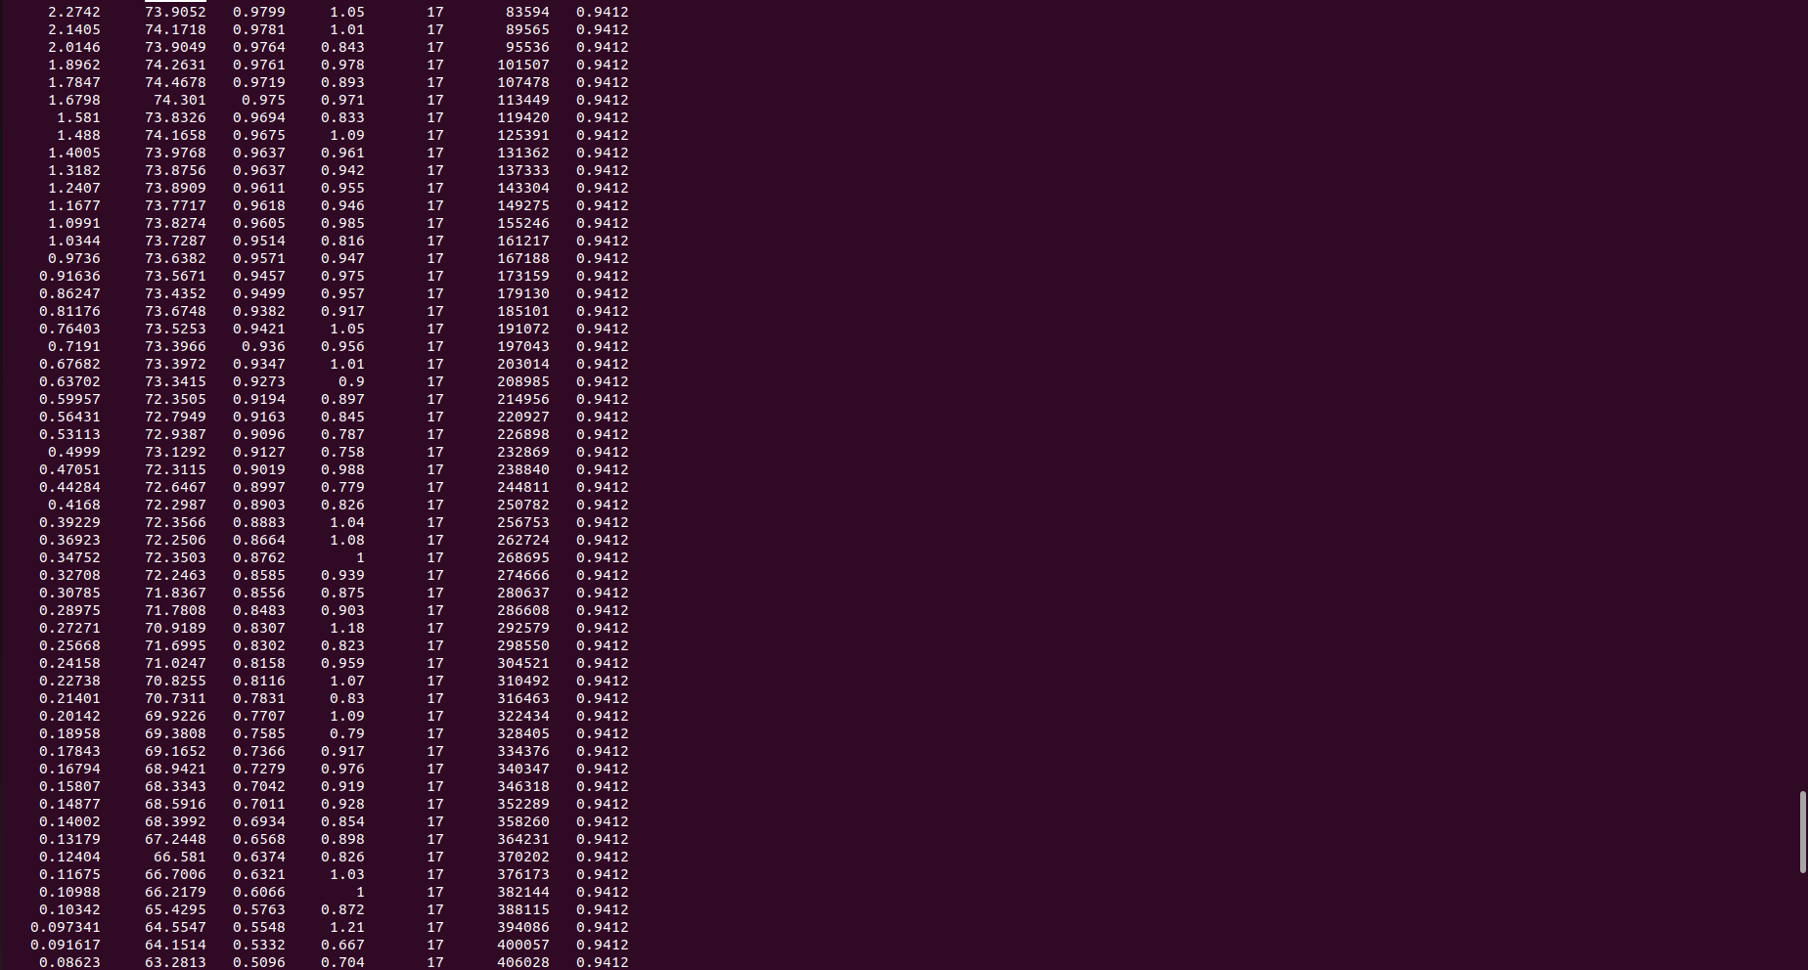

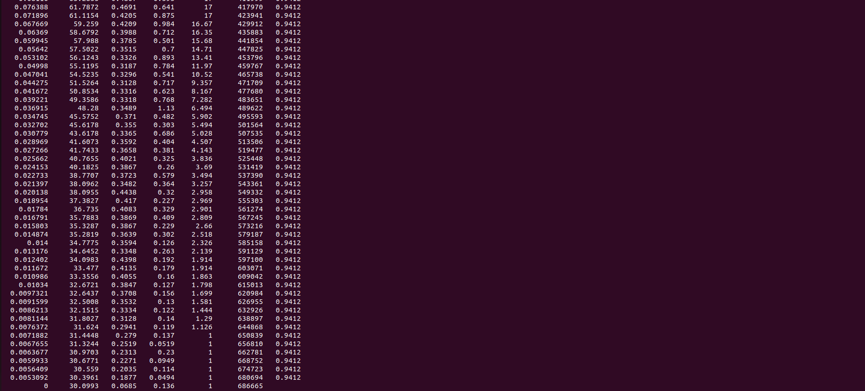

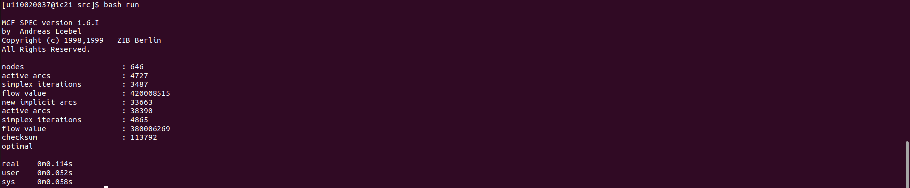181.mcf