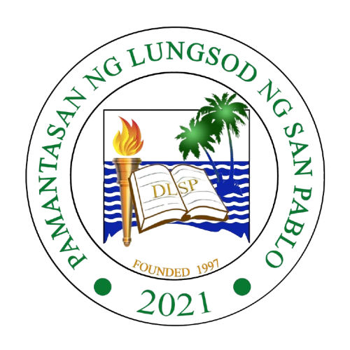 | PAMANTASAN NG LUNGSOD NG SAN PABLO  PLSP Economics Society – EcoS  "Empowered and committed organization of service." | 

asdsda
(Membership Form)
Generated on: March 12, 2026

Full Name:
GUERRA, JOHN ALLEN A.

Email Address:
johnallenguerra@gmail.com

Phone Number:
1231231231

Course and Year:
BSIT 4X

Date Joined:
2026-03-12

Membership Role:
President

Skills/Expertise:
dsdasdas

Availability for Activities:
efere

"Primed to Lead and Serve for Progress"

