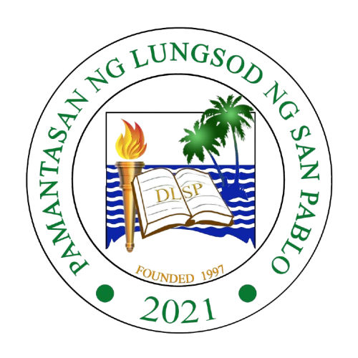 | PAMANTASAN NG LUNGSOD NG SAN PABLO  PLSP Economics Society – EcoS  "Empowered and committed organization of service." | 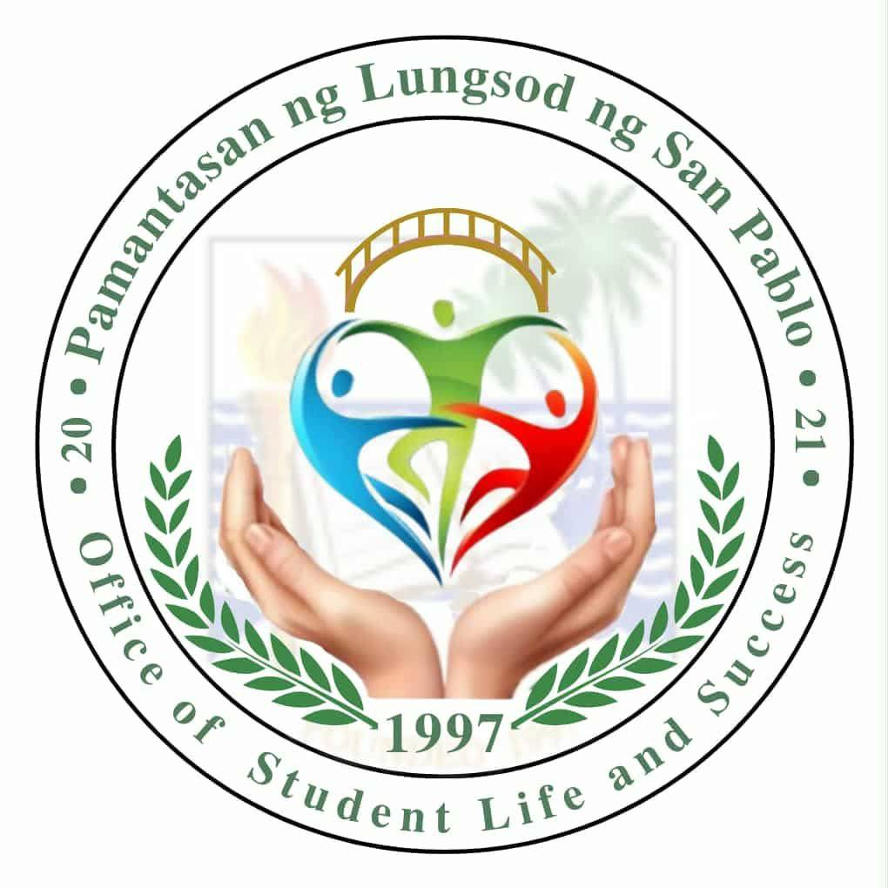

fasfhaskjfashfk
(Membership Form)
Generated on: March 04, 2026

Full Name:
dkahdsaj

Email Address:
saldjasldkj

Phone Number:
1112121

Course and Year:
maldsdal

Date Joined:
2026-03-04

Membership Role:
dlasdjsal

Skills/Expertise:
lkashdkajs

Availability for Activities:
laskdjsakdhas

"Primed to Lead and Serve for Progress"

