A典型 | B跳转 | C经典js | 4.1时间戳与时间转换4.2.时间小于10 添加0  new Date().valueOf() | 5.$.trim(); replace  去除两边空格
6去除表单enter时间 | join(',')  切割字符串去“” | 8.更改标题title | 9.replace(/\D/g,'') | 10.屏幕宽高
11. 去除空格 | 12 限制非法字符 | 13 提交按钮颜色变化 | 14.JQ,DOM获取data-id | 15获取后台PHP传到前端的数组
16.//unshift()前面加  pop()删除最后面一个  Push()后面加  shift()删除最前面一个  match(/\d+/g)检索指定值match("world")  indexOf() | 17.提交按钮颜色变化 | 18.1.alert三种弹框样式  2.h5拨打电话  ziliaoku/资料 | 19.h5中ios系统时间得加格式“2019-1-1T00:00:00”  判断是否为IOS浏览器 | 20.时间筛选ziliaoku/资料
21内容筛选ziliaoku/资料 | 22.H5的localStorage简单存储删除 | 23.获取当前滚动的高度 | 24.1.文本域的字数控制 、textarea自适应高度 | 25.1.onpaste事件在用户向元素中粘贴文本时触发。
25.2.oncontextmenu 当用户在 <div> 元素 上右击鼠标时执行 JavaScript | 26.hasClass()  removeClass()  addClass()  find() attr() css()  fadeIn() fadeOut() | 27.主要的用意就是当主函数完成后再去执行回调函数 callback() | 28.原生js 获取路由参数 | 29.1获取后端数据转换  JSON.stringify() 方法将 JavaScript 对象转换为字符串  29.2JSON.parse() 方法将数据转换为 JavaScript 对象
30.forEach() | 31 1.获取线上两点间距离 2.鼠标点击屏幕两点间距离 | 32.给span添加自定义属性 | 33添加属性setAttribute

1.典型<li class="clickSM">
<img class="tishiyu" style="position: absolute;top:80px;right:100%;z-index: 999999;" src="images/gugao/tishiyu.png"/>
<img class="thisSM" style="display: none;position: absolute;top:80px;left:-120px;z-index: 999999;" src="images/qrcode/qrcode.png">
<p><img src="images/icon/scan.png"></p>
<p class="fsize18">扫码</p>
</li>
$(function(){
/*头部导航*/
$('.header-2-l>ul li').click(function(){
$(this).addClass('active').siblings().removeClass('active');
})
// 点击回到顶部
$('.gototop').click(function () {
$('body,html').animate({scrollTop: 0}, 1000);
})
$('.clickSM').click(function(){
if ($('.thisSM').css('display') == 'none') {
$('.tishiyu').fadeOut();
$('.thisSM').fadeIn(500);
} else{
$('.thisSM').fadeOut(500);
}
});
$('.header-2-r .select_bt').click(function(){
if ($('.header-2-r .select_info').css('display') == 'none') {
$('.header-2-r .select_info').slideDown();
}else{
$('.header-2-r .select_info').slideUp();
}
});
B.跳转
1.window.history.go(-1);window.history.go(0);
2（php）.onclick="location.href='phone_Property2.html'"
3.window.location.href = "/settled/status";

2.<!--已登录-->
<div class="logged" style="position: relative; cursor: pointer;">
<div style="display: flex;">
<p class="hours">
<span>早上好，</span>
<span>中午好，</span>
<span>下午好，</span>
<span>晚上好，</span>
李先生
</p>
<img src="images/logo/qiyeLogo.png" width="20px" height="20px" style="margin: 0 5px; position: relative; top: 8px;"/>
<i class="iconfont icon-Group-" style="color: #979797;"></i>
</div>

<div class="isLogin" style="display: none;">
<div class="head-img">
<img src="images/icon/logo_1.png"/>
</div>
<p class="hours1" style="text-align: center;">
<span>早上好</span>
<span>中午好</span>
<span>下午好</span>
<span>晚上好</span>
&nbsp;&nbsp;李先生
</p>

/*上，中，下午好，晚上好*/
function timess(){
var mydate = new Date();
var thisTime = mydate.getHours();
if (thisTime>=3 && thisTime<=11) {
$('.hours span').eq(0).show().siblings().hide();
$('.hours1 span').eq(0).show().siblings().hide();
} else if (thisTime>=12 && thisTime<14) {
$('.hours span').eq(1).show().siblings().hide();
$('.hours1 span').eq(1).show().siblings().hide();
} else if(thisTime>=14 && thisTime<18){
$('.hours span').eq(2).show().siblings().hide();
$('.hours1 span').eq(2).show().siblings().hide();
}else{
$('.hours span').eq(3).show().siblings().hide();
$('.hours1 span').eq(3).show().siblings().hide();
}
}
timess();
setInterval(function () {
timess();
},60000);

$('.popout_msg ul li:eq(' + I + ')').addClass('popout_msg_active').siblings().removeClass('popout_msg_active').hide();

//3.A. //监控回车键，搜索框
$('.srarch').keydown(function(e) {
var e = e || window.event, ec = e.keyCode || e.which;
var nulls = /^[\s]*$/;
if (!e.ctrlKey && 13 == ec) {
$('.srarch_btn').click();
return false;
}
});
//B. 回车键事件确定
$(document).keypress(function (e) {
if (e.which == 13) {
$('.btn_true').click();
}
});

//4.A.
<span id="user_id" style="display:none;">{{$select_id}}</span>
//js文件接收var user_id=$('#user_id').text();//用户id
//4.B.{{$select_id}} 当页直接调用

- //第一页面localStorage页面间传值，保存于浏览器端
$('.pad li').click(function(){
let i = $(this).index();
if (i == 0) {
localStorage.lastname = "lu0";
} else if(i == 1){
localStorage.lastname = "lu1";
}else{
localStorage.lastname = "lu2";
}
});
//第二页面localStorage页面间传值，保存于浏览器端
var lastname = localStorage.lastname;
if (lastname == 'lu0') {
$('.main_r_1 ul li').eq(1).click();
} else if(lastname == 'lu1'){
$('.main_r_1 ul li').eq(2).click();
}else if(lastname == 'lu2'){
$('.main_r_1 ul li').eq(3).click();
}
localStorage.lastname = 'lu';

1.fadeOut() | fadeIn(500); | slideDown() | slideUp() | hide() | .show() | attr('data-id')
addClass('active') | siblings() | eq(0) | Str.substr(3,7) | Str.substr(3) | find(".collection_id").text()
removeClass('active') | Focus（） | Blur（） | $.trim |  | time:new Date().toLocaleTimeString()
//6. var url = window.location
// // console.log(url.pathname)
// if(url == '/modifyCompany'){
// url ='/modifyCompany';
// }else {
// url ='/saveAuditingLogo';
// }

C经典js

1.$(obj).parent('.tmp_follow').find('.love').show();
2.layer.msg('收藏成功');
layer.closeAll('loading');

<div data-id="1"></div>
console.log($(this).data('id'))
console.log($(this).attr('data-id'))
3.let fileID = $('.del_pdf').attr('data-id');
4.clickli = (userid) => { //通过唯一的userid值来判断是否要选中
let ii = $('.Molist li').length;
for (let i = 0; i < ii; i++) {
let j = $('.Molist li').eq(i).attr('data-user-id');
if (j == userid) {
$('.Molist li').eq(i).click();
}}}
5.$('.yjc').click(function () {
if ($(this).find('.icon-danxuan').css('display') == 'none') {
$(this).find('.icon-danxuan').show().siblings().hide();
$('.wjc').find('.icon-danxuan').hide().siblings().show();
yjc_sel = true;
wjc_sel = false;
yjcOrWjc = "已解除租约";
} else {
$(this).find('.icon-danxuan').hide().siblings().show();
yjc_sel = false;
}
});
6.if (yjc_sel == false && wjc_sel == false) {
$('.error_outZome').css('opacity', '1');
} else {
$('.error_outZome').css('opacity', '0');
$('.outZome_pop,.temp').fadeOut(500);
7.$('.EFlist').on('click', 'li', function () { //控制多选框点击事件 新增
let i = $(this).index();
if ($(this).children('i').hasClass('icon-icon-')) {
$(this).children('i').removeClass('icon-icon-');
$(this).children('i').addClass('icon-duoxuankuang1');
$('.nodebox input[type=checkbox]:eq(' + i + ')').click();
checkboxfun('.nodebox');
} else {
$(this).children('i').removeClass('icon-duoxuankuang1');
$(this).children('i').addClass('icon-icon-');
$('.nodebox input[type=checkbox]:eq(' + i + ')').click();
checkboxfun('.nodebox');
}
})
8.time:new Date().toLocaleTimeString()
9.从小到大排列a-b
<script type="text/javascript">
function sortNumber(a,b)
{
return a - b
}

var arr = new Array(6)
arr[0] = "10"
arr[1] = "5"
arr[2] = "40"
arr[3] = "25"
arr[4] = "1000"
arr[5] = "1"
document.write(arr + "<br />")
document.write(arr.sort(sortNumber))
</script>

4.时间戳与时间转换
4.1A1 时间戳=>时间转换
var dec =new Date(parseInt(1555668578*1000) )
console.log(dec.toLocaleDateString().replace(/\//g, "-") )
formatDayTime(lease_agreement.manage_fee_free_time * 1000)
时间=>时间戳转换
- A2 start_time = Date.parse(start_time)/1000;
A3 new Date(star).getTime()/1000
B1. //获取当前时间
//var nowtime =new Date().toLocaleDateString();
//获取当前时间再转为时间戳
- Date.parse(new Date().toLocaleDateString())/1000;

与当前时间的天数差
Math.floor((Date.parse(new Date())-1556418600*1000)/1000/60/60/24)
//4.2.时间小于10 添加0
function num(s) {
return s < 10 ? '0' + s: s;
}
function _GetDateStr(sj_str) {
var dd =[];
dd =new Date(sj_str*1000).toLocaleDateString().split('/');
var y = dd[0];
var m = dd[1];//获取当前月份的日期
var d = dd[2];
return y+"."+num(m)+"."+num(d);
}
// console.log(_GetDateStr(1548604800));
4.3 valueOf() 方法可返回 Boolean 对象的原始值。
new Date().valueOf() 1574078080723

4.4带中横线的日期格式在iOS手机系统上 转换时间戳NaN问题
var str = '2019-04-01-14:13:00';
alert(new Date(str.replace(/-/g,'/')).getTime())//1554099180000
alert(new Date(str).getTime())//NaN苹果手机不适用
或者改为’/’ 2019/04/01
Date.parse(new Date(result.replace(/-/g,'/')).toLocaleDateString())/1000;

formatDayTime(val) {
if(val) {
let date = new Date(val)
let Y = date.getFullYear();
let M = date.getMonth() + 1;
let D = date.getDate();

if(M < 10) {
M = '0' + M;
}
if(D < 10) {
D = '0' + D;
}
return Y + '-' + M + '-' + D ;
} else {
return '';
}
},
- var sDate=DateStr.replace(/(^\s+|\s+$)/g,''); //去两边空格;
//去除空格
removeSpace: function (str, type) {
// type 1-所有空格 2-前后空格 3-前空格 4-后空格
switch (type) {
case 1:
return str.replace(/\s+/g, "");
case 2:
return str.replace(/(^\s*)|(\s*$)/g, "");
case 3:
return str.replace(/(^\s*)/g, "");
case 4:
return str.replace(/(\s*$)/g, "");
default:
return str;
}
//return this;
},

6.<form onsubmit="return false;">
<input id="park_name" style="width:80%" type="text" style="display:none" placeholder="请输入园区名称">
</form>

7.confirm_photos= jsontext.join(',')
["repair_7622ce0d-6960-4d87-823a-23d34bd4a133.jpg", "repair_c7a490f1-ea06-489e-8f29-ac7c80e5a5a8.jpg"]->
repair_7622ce0d-6960-4d87-823a-23d34bd4a133.jpg,repair_c7a490f1-ea06-489e-8f29-ac7c80e5a5a8.jpg
- // 标题title
1.$(document).attr("title","公司设置");
2.
if(_type == 2){
document.title = "带出租";
}else if(_type == 3){
document.title = "即将到期";
}else if(_type == 4){
document.title = "已到期";
}

9.// /\D/g
onkeyup="this.value=this.value.replace(/\D/g,''),
首先这是个正则式验证,用来验证输入值的规则；
当输入值的键盘抬起时触发这个事件.this.value表示此输入框的值,/\D/g为正则表达式,用来匹配所有非数字字符；
此句功能为：将输入值为非数字的字符替换为空；
这个只要你新建个页面测试下就能理解的；
10.var _widht = document.documentElement.clientWidth; //屏幕宽
var _height = document.documentElement.clientHeight;//屏幕高
//11. 去除空格start
$(document).ready(function() {
$('.addParkName-box input').keyup(trimkeyup);
});
function trimkeyup(e) {
lucene_objInput = $(this);
if (e.keyCode != 38 && e.keyCode != 40 && e.keyCode != 13) {
var im = lucene_objInput.val().replace(/\s+/g, "");
// var im = $.trim(lucene_objInput.val());
lucene_objInput.val(im);
}}
// php去除空格end
$.trim(document.getElementById("company_name").value);

//12 限制非法字符
$("#company_name").on('keyup input propertychange',function(){
var value = $(this).val();
var lastV = value.substring(value.length-1,value.length);
var pattern = /[`~!@#$%^&*()_\-+=<>?:"{}|,.\/;'\\[\]·~！@#￥%&*（）\-+={}|《》？：“”【】、；‘’，。、]/im;
var pattern1 = /[……——]/im;
if(pattern.test(lastV)){
$(this).val(value.slice(0,value.length-1));
}
if(pattern1.test(lastV)){
$(this).val(value.slice(0,value.length-2));
}
});
//13 提交按钮颜色变化
function checkParkBtn() {
if($("#company_name").val() != '' && $("#phone_num").val() != '' && $("#phone-roomNum").val() != '' && $("#park_contacts").val() != ''){
document.querySelector('.addParkName-btn').style.background='linear-gradient(180deg, rgba(24, 189, 247, 1) 0%, rgba(10, 136, 236, 1) 100%)';
}else{
document.querySelector('.addParkName-btn').style.background='rgba(0,0,0,0.25)';
}
}

checkParkBtn();

$("#company_name,#phone_num,#park_contacts").on("input",function(){
checkParkBtn();
});
14.JQ,DOM获取data-id
1.<body data-value="{{$park_id}}">
JQ var park_id = $('body').attr("data-value");
DOM document.body.dataset.value
document.body.dataset.value
1.2 $.trim(document.getElementById("company_name").value);
1.3document.querySelector('.addParkName-btn').dataset.value
2.<body data-orderid="{{$lease_order->id}}">
JQ var park_id = $('body').attr("data-orderid");
DOM document.body.dataset.orderid

15 获取后台PHP传到前端的数组
var room_name = @json($room_name);
16.//前面后面添加删除
var datas = [10,20,30];
datas.unshift(40,50);//前面加
console.log(datas.toString())//40,50,10,20,30

datas.pop();//删除最后面一个
console.log(datas.toString())// 40,50,10,20

datas.push(60,70);//后面加
console.log(datas.toString())//40,50,10,20,60,70

datas.shift();//删除最前面一个
console.log(datas.toString())//50,10,20,60,70

1.var str="1 plus 2 equal 3"
document.write(str.match(/\d+/g))
//1,2,3
2.var str="Hello world!"
document.write(str.match("world") + "<br />")
document.write(str.match("World") + "<br />")
document.write(str.match("worlld") + "<br />")
document.write(str.match("world!"))
//world
//null
//null
//world!
3.indexOf() 方法可返回某个指定的字符串值在字符串中首次出现的位置。
var str="Hello world!"
document.write(str.indexOf("Hello") + "<br />") //0
document.write(str.indexOf("World") + "<br />") //-1
document.write(str.indexOf("world")) //6
4.str="老师说：请用小红，我的，朋友造句。小李说：小红，是我的朋友"
var arr=str.match(/小[\u4e00-\u9fa5]/ig);
console.log(arr);// ["小红", "小李", "小红"]

17.提交按钮颜色变化 .display_btn
1.单个input框
<div class="addParkName-box" style="margin-top:0px;margin-bottom:0px;">
<div class="search addParkName-bar">
<span>公司联系人</span>
<input id='company_contacts' type="text" name="contacts" value="{{ $res_info['contacts'] }}"
style="width: calc(100% - 60px);color: rgba(0,0,0,0.45);" placeholder="请输入公司联系人姓名" maxlength="4"
onchange="this.value=this.value.replace(/[^\u4e00-\u9fa5]/g,'')"
onkeyup="if(this.value != ''){document.querySelector('.display_btn').style.background='linear-gradient(180deg, rgba(24, 189, 247, 1) 0%, rgba(10, 136, 236, 1) 100%)'}else{document.querySelector('.display_btn').style.background='rgba(0,0,0,0.25)'}">
</div>
<div id="companyContacts_submit" class="display_btn">确认</div>
</div>
2.多个状态一起
var submitArry = [".register_input9","#nwe_phone_num",".or-bank",".or-bankName",".or-bankAccount","#park_contacts","#phone_num","#or-waterRent","#or-electricity","#or_lossRate","#TheLeaseBtn"];
submitArrySet();
submitArry.forEach(function(index){
$(index).on("input",function(){
submitArrySet()
})
})
function submitArrySet(){
var _status = true;
submitArry.forEach(function(ele){
if($(ele).val() == ""){
_status = false;
}
})
@if($type == 2)//手机
if(_status){
document.querySelector('.change_phone_submit').style.background = 'linear-gradient(180deg, rgba(24, 189, 247, 1) 0%, rgba(10, 136, 236, 1) 100%)';
} else {
document.querySelector('.change_phone_submit').style.background = 'rgba(0,0,0,0.25)';
}
@elseif($type == 3)//银行卡
if(_status){
document.querySelector('.bank_submit').style.background ='linear-gradient(180deg, rgba(24, 189, 247, 1) 0%, rgba(10, 136, 236, 1) 100%)';
} else {
document.querySelector('.bank_submit').style.background = 'rgba(0,0,0,0.25)';
}
@elseif($type == 4)//园区设置
if(_status){
document.querySelector('.set_addParkName-btn').style.background='linear-gradient(180deg, rgba(24, 189, 247, 1) 0%, rgba(10, 136, 236, 1) 100%)';
}else{
document.querySelector('.set_addParkName-btn').style.background='rgba(0,0,0,0.25)';
}
@endif
}
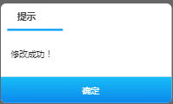
- 弹框
1.alerts._show("已提交 等待审核！",function(){
window.location.href= '/settled/status';
})
2./*
* 用法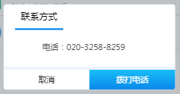
*/
// function rentPay(_this,state,order_id){
// var recor = alertObj.oAlert({
// style:'wap',
// title:(state == 0 ? '付款' : '收款' ),
// content : (state == 0 ? '是否确认已付款？' : "是否确认收款？" ),
// buttons :{
// '取消' : function(){
// recor.close();
// },
// '确定' : function(){
// // $loading.init({
// // next: function (e) {
// // var _that = e;
// $.ajax({
// })
// // }
// // })
// }
// }
// })
// }
18.h5拨打电话
<a class='telPhone' href="tel:020-3258-8259">电话：020-3258-8259</a>
19.判断是否为IOS浏览器
// 时间筛选
yizuSide({ele:".select",width:"287"},function(startime,endtime,fn){
_start_time = startime.split(".");
_endtime = endtime.split(".");
var star, end;
var u = navigator.userAgent, app = navigator.appVersion;
var isiOS = !!u.match(/\(i[^;]+;( U;)? CPU.+Mac OS X/); //ios终端
if (isiOS) {
star = (new Date(_start_time[0]+"-"+_start_time[1]+"-"+_start_time[2]+"T00:00:00")).getTime() / 1000 ; //开始时间
end = (new Date( _endtime[0]+"-"+ _endtime[1]+"-"+ _endtime[2]+"T00:00:00")).getTime() / 1000 ; //结束开始时间

}else{
star = new Date(startime).getTime() / 1000 ; //开始时间
end = new Date(endtime).getTime() / 1000 ; //结束开始时间
}
if(star > end){
alerts._show("开始时间不能大于结束时间",function(){
$("#ending-time").val();
})
return;
}
fn();
});
20.时间筛选
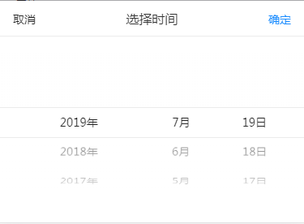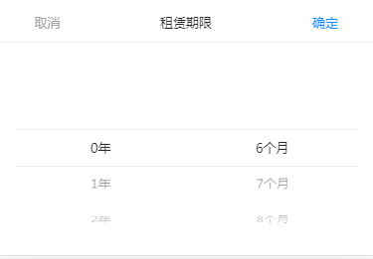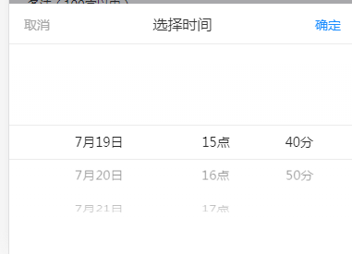
21.内容筛选
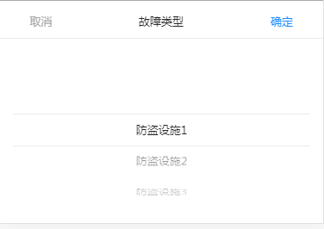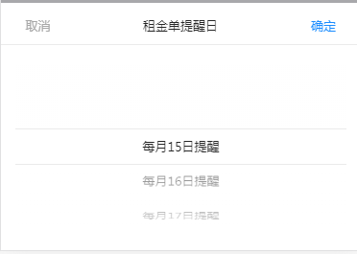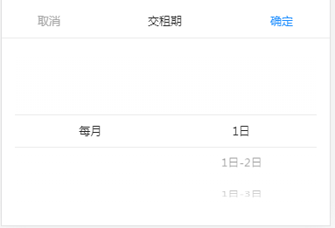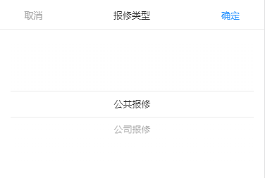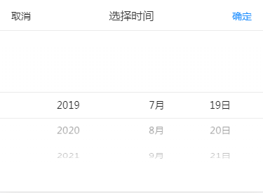
21.2时间弹框筛选
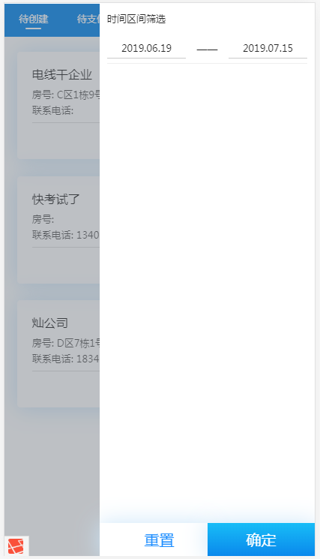

22.H5的localStorage简单存储删除

<!DOCTYPE html><html><head lang="en">
<meta charset="UTF-8">
<meta name="viewport" content="width=device-width, initial-scale=1.0">
<title>H5的storage</title></head><body>
<input type='button' onclick='setItems()' value='存值' />
<input type='button' onclick='getItems()' value='取值' />
<input type='button' onclick='deleteItem()' value='删除' /></body><script src="js/jquery.min.js"></script><script>
//localStorage存值永久有效
function setItems(){
var user = {};
user.name = 'Adam Li';
user.age = 25;
user.home = 'China';
localStorage.setItem('userinfo',JSON.stringify(user));
}
//localStorage取值
function getItems(){
var data = JSON.parse(localStorage.getItem('userinfo'));
console.log("name:"+data.name+'\r age:'+data.age+"\r home:"+data.home);
}

//localStorage删除指定键对应的值
function deleteItem(){
localStorage.removeItem('userinfo');
console.log(localStorage.getItem('userinfo'));
}</script></html>
延伸：
// console.log(this.$route.path)
// this.$router.push("/moreRoomStateData/68/"+id)
// var id = this.$route.params.id;
//localStorage.parkId = "lu0";//设置
// var parkId = localStorage.parkId;//引用
23.获取当前滚动的高度
/*JS的入口函数 */
window.onload = function () {
search();
};
let search = function () {/*监听滚动事件 */
window.onscroll = function () {/*获取当前滚动的高度*/
let scrollHeightOne = document.body.scrollTop;
let scrollHeightTwo = document.documentElement.scrollTop;
let scrollHeightThree = window.pageYOffset;
console.log("scrollHeightOne:"+scrollHeightOne);
console.log("scrollHeightTwo:"+scrollHeightTwo);
console.log("scrollHeightThree:"+scrollHeightThree);
}
};
24.input不为空时，提交按钮更改颜色
1.单个input
1. <input class=" phone-tel" oninput="javascript:value=this.value.replace(/[^\d]/g,'');if(this.value.length>11) this.value=this.value.substring(0,11);" autocomplete="off" type="tel" placeholder="请输入"
onkeyup="if(this.value != ''){document.querySelector('.display_btn').style.background='linear-gradient(180deg, rgba(24, 189, 247, 1) 0%, rgba(10, 136, 236, 1) 100%)'}else{document.querySelector('.display_btn').style.background='rgba(0,0,0,0.25)'}">
2.多个input
var submitArry = ["#company_contacts",".phone_num1"];
submitArrySet();
submitArry.forEach(function(index){
$(index).on("input",function(){
submitArrySet()
})
})
function submitArrySet(){
var _status = true;
submitArry.forEach(function(ele){
if($(ele).val() == ""){
_status = false;
}
})
if(_status){
document.querySelector('.companyContacts_submit').style.background = 'linear-gradient(180deg, rgba(24, 189, 247, 1) 0%, rgba(10, 136, 236, 1) 100%)';
} else {
document.querySelector('.companyContacts_submit').style.background = 'rgba(0,0,0,0.25)';
}
}

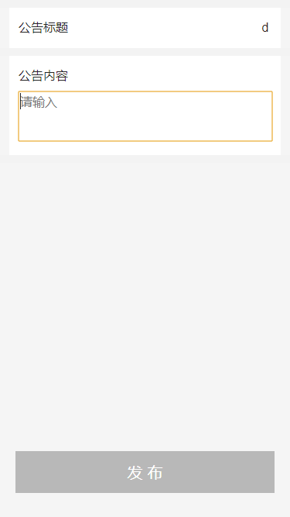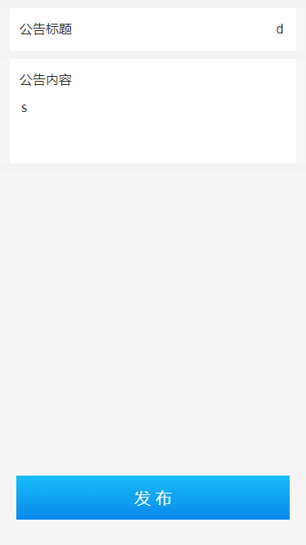

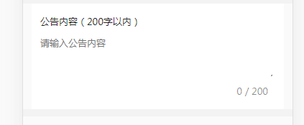
24.1.文本域的字数控制 、textarea自适应高度
C:/Users/Administrator/Desktop/phone/通知公告D2-b1.html#
<p style="margin-bottom:10px;">公告内容（200字以内）</p>
<textarea class="textArea" id="content-input" datatype="required" isheightauto="true" placeholder="请输入公告内容" msg="必填项" name="grxygzjh" onfocus='autoTextarea(this)'
style="font-family: PingFang-SC-Medium;width:99%; font-size: 13px; border-style: none ;height: 56px; background: transparent;text-align:left; color:rgba(0,0,0,0.85);"
type="text" ></textarea>
<p style="float:right;padding-top: 5px;color: rgba(0,0,0,0.45);"> <span class="textNum" style="padding-right:0px;color: rgba(0,0,0,0.45);" >0</span><span style="color: rgba(0,0,0,0.45);"> / 200</span><p>
24.1.文本域的字数控制
$('.textArea').on("keyup", function () {
$('.textNum').text($('.textArea').val().length);//这句是在键盘按下时，实时的显示字数
if ($('.textArea').val().length > 200) {
$('.textNum').text(200);//长度大于100时0处显示的也只是100
$('.textArea').val($('.textArea').val().substring(0, 200));//长度大于100时截取钱100个字符
}
});
24.2.textarea自适应高度
var autoTextarea = function (elem, extra, maxHeight) {
extra = extra || 0;
var isFirefox = !!document.getBoxObjectFor || 'mozInnerScreenX' in window,
isOpera = !!window.opera && !!window.opera.toString().indexOf('Opera'),
addEvent = function (type, callback) {
elem.addEventListener ?
elem.addEventListener(type, callback, false) :
elem.attachEvent('on' + type, callback);
},
getStyle = elem.currentStyle ? function (name) {
var val = elem.currentStyle[name];

if (name === 'height' && val.search(/px/i) !== 1) {
var rect = elem.getBoundingClientRect();
return rect.bottom - rect.top -
parseFloat(getStyle('paddingTop')) -
parseFloat(getStyle('paddingBottom')) + 'px';
};
return val;
} : function (name) {
return getComputedStyle(elem, null)[name];
},
minHeight = parseFloat(getStyle('height'));
elem.style.resize = 'none';
var change = function () {
var scrollTop, height,
padding = 0,
style = elem.style;
if (elem._length === elem.value.length) return;
elem._length = elem.value.length;
if (!isFirefox && !isOpera) {
padding = parseInt(getStyle('paddingTop')) + parseInt(getStyle('paddingBottom'));
};
scrollTop = document.body.scrollTop || document.documentElement.scrollTop;
elem.style.height = minHeight + 'px';
if (elem.scrollHeight > minHeight) {
if (maxHeight && elem.scrollHeight > maxHeight) {
height = maxHeight;
style.overflowY = 'auto';
} else {
height = elem.scrollHeight;
style.overflowY = 'hidden';
};
style.height = height + extra + 'px';
// scrollTop += parseInt(style.height) - elem.currHeight;
// document.body.scrollTop = scrollTop;
// document.documentElement.scrollTop = scrollTop;
elem.currHeight = parseInt(style.height);
};
};
addEvent('propertychange', change);
addEvent('input', change);
addEvent('focus', change);
change();
};
$(document).ready(function() {
$("table tbody td").each(function() {
if ($(this).find("[datatype='required']").length > 0||$(this).find("[datatype='number']").length > 0) {
$(this).css("position", "relative");
}
})
})

25.1.onpaste事件在用户向元素中粘贴文本时触发。
25.2.oncontextmenu 当用户在 <div> 元素 上右击鼠标时执行 JavaScript
<el-input id="park_contacts" type="text" v-model="setContactForm.contacts" autocomplete="off" maxlength="15" placeholder="请输入联系人姓名"
onkeyup="value=value.replace(/[^\a-\z\A-\Z\u4E00-\u9FA5\ ]/g,'')" onpaste="value=value.replace(/[^\a-\z\A-\Z\u4E00-\u9FA5\ ]/g,'')" oncontextmenu = "value=value.replace(/[^\a-\z\A-\Z\u4E00-\u9FA5\ ]/g,'')"></el-input>
12位中英文 /[^\a-\z\A-\Z\u4E00-\u9FA5\ ]/g
12位中英文加数字 /[^\a-\z\A-\Z0-9\u4E00-\u9FA5\ ]/g
- 1 hassClass()、2.addClass()、3.removeClass()、4.find()5.attr()6.css()
if($(this).find('i:first').hasClass('yz-info-Showicon')){
$(this).find('i:first').removeClass('yz-info-Showicon').addClass('yz-info-Hideicon')
}

$("input").focus(function(){
$(this).css({'border':'1px solid #198dff'});
$(this).parent().find('i').eq(0).addClass('color_blue');
});
$('.pwd_close,.pwd_show').click(function(){//密码小眼睛
$(this).siblings('input').attr("type");
if($(this).siblings('input').attr("type") == 'password'){
$(this).siblings('input').attr("type","text");
$('.pwd_show').fadeIn();
}else{
$(this).siblings('input').attr("type","password");
$('.pwd_close').show();
}});
5.attr()
// $('.logged').hover(function(){
// $('.isLogin').stop();
// $(this).find('.isLogin').slideDown();
// },function(){
// $('.isLogin').stop();
// $(this).find('.isLogin').slideUp();
// });
6.css()
$('.yjc').click(function(){
if ($(this).find('.icon-danxuan').css('display') == 'none') {
$(this).find('.icon-danxuan').show().siblings().hide();
$('.wjc').find('.icon-danxuan').hide().siblings().show();
} else{
$(this).find('.icon-danxuan').hide().siblings().show();
}
});

27.主要的用意就是当主函数完成后再去执行回调函数 callback()

$("p").hide(1000,function(){
alert("The paragraph is now hidden");
});
28.原生js 获取路由参数
方法一
//获取url参数
function getQueryString(name) {
var reg = new RegExp("(^|&)" + name + "=([^&]*)(&|$)", "i");
var r = window.location.search.substr(1).match(reg);
if (r != null) return decodeURI(r[2]);
return null;
}
var idCode = getQueryString('id');
var title = getQueryString('title');
$(".nav h3").text(title);
方法二
//获取url参数
var idArray = window.location.search.split("=");
var id = idArray[1];
29.获取后端数据转换
var idArray = window.location.search.split("=");
var id = idArray[1];
console.log(id)

// var route_list = @json($route_list);
29.1JSON.stringify() 方法将 JavaScript 对象转换为字符串
var obj = { "name":"runoob", "alexa":10000, "site":"www.runoob.com"};
var myJSON = JSON.stringify(obj);
document.getElementById("demo").innerHTML = myJSON;

将 JavaScript 对象转换为 JSON 字符串
{"name":"runoob","alexa":10000,"site":"www.runoob.com"}

29.2JSON.parse() 方法将数据转换为 JavaScript 对象

var text = '{ "name":"Runoob", "alexa":"function () {return 10000;}", "site":"www.runoob.com"}';
var obj = JSON.parse(text);
obj.alexa = eval("(" + obj.alexa + ")");
document.getElementById("demo").innerHTML = obj.name + " Alexa 排名：" + obj.alexa();

将字符串转换为 Date 对象。
Runoob创建日期: Sat Dec 14 2013 08:00:00 GMT+0800 (中国标准时间)
var _teamData = ([{time: "11月07日 05:11", geohash: "ws0s4m47dgfr"},{time: "", geohash: "ws0s4m47dgfr"},{time: "11月05日 05:11", geohash: "ws0s4m4rzhx7"},{time: "11月07日 05:11", geohash: "ws0s4m4zqr8f"}]),_teamDataArry = [];
_teamData.forEach(function(team){
// 1.
// _teamDataArry[team.time] = function(){
// var mapBox = document.createElement("div");
// mapBox.className = "map-controller";
// mapBox.innerHTML = '<div id="map"></div>'
// document.body.appendChild(mapBox);
// this.doCancel=function(){
// document.body.removeChild(mapBox);
// }
// var url = '/manager/patrolDetail/'+team.route_id+'/'+team.user_id;
// var url = '/manager/patrolDetail/'+2+'/'+3;
// setLine(this,url);
// };
// 2.
if(team.time)
_teamDataArry.push(team.time)
})
console.log(_teamDataArry)
- forEach()

31 1.获取线上两点间距离 2.鼠标点击屏幕两点间距离

//1.获取线上两点间距离
// [23.231213, 113.305213]. [23.231945, 113.305402], [23.231876, 113.306047]

//coord 判断点
//coords 组成线的点的集合
//结合了openlayers计算线的长度，可以数据计算 (x2-x1)*(x2-x1)+(y2-y1)*(y2-y1)开平方
// var geoHashArry = ["ws0s4m47dgfr","ws0s4m4rzhx7","ws0s4m4zqr8f","ws0s4m5520d7","ws0s4m48nqk5"];
function Range(rangeArry){
var range='';
for(let i=0;i<rangeArry.length-1;i++){
let ii = i+1;
range = Number(range) + Number( GetDistance(rangeArry[i][0],rangeArry[i][1],rangeArry[ii][0],rangeArry[ii][1]));
}
return range.toPrecision(3);
}
// 方法定义 lat,lng
function GetDistance( lat1, lng1, lat2, lng2){
var radLat1 = lat1*Math.PI / 180.0;
var radLat2 = lat2*Math.PI / 180.0;
var a = radLat1 - radLat2;
var b = lng1*Math.PI / 180.0 - lng2*Math.PI / 180.0;
var s = 2 * Math.asin(Math.sqrt(Math.pow(Math.sin(a/2),2) +
Math.cos(radLat1)*Math.cos(radLat2)*Math.pow(Math.sin(b/2),2)));
s = s * 6378.137 ;// EARTH_RADIUS;
s = Math.round(s * 10000) / 10000;
return s;
}
// 调用 return的距离单位为km
// GetDistance(23.231213,113.305213,23.231945, 113.305402)

// 2.鼠标点击屏幕两点间距离
// 23.231876, 113.306047
// var p1,p2;
// document.addEventListener("mousedown",function(e){
// //思路:为了实现计算两点之间的间距，首先需要设置两个变量p1和p2用于接收
// //两次按下鼠标时所产生的事件参数对象，为网页文档对象Document注册鼠标按下事件
// //通过:Math.abs()获取两点之间横纵坐标差的绝对值
// //通过Math.sqrt()函数计算出两点间的直线距离
// if(!p1){
// p1 = e;
// return;
// }
// p2 = e;
// dx = Math.abs(p2.clientX - p1.clientX);
// dy = Math.abs(p2.clientY - p1.clientY);
// var dis = Math.sqrt(Math.pow(dx,2)+Math.pow(dy,2));
// //去除小数点后的数字，这样看起来舒服
// console.log("这两点之间的直线距离为:"+parseInt(dis)+"px");
//
// },false);

32.给span添加自定义属性

<span id='sid' ></span><span id='sid2' data-cate="444"></span><button id="js">JSClick</button><button id="jq">JQClick</button><script src="js/jquery-3.1.1.min.js"></script><script>
var spanObj = document.getElementById("sid");
spanObj.setAttribute("data-cate", 'lowRate'); // js设置属性，相对于jq
$("#js").click(function () {
alert(spanObj.dataset.cate); // js获取属性，相对于jq
})
$("#jq").click(function () {
$("#sid2").attr('data-cate','555'); // jq设置属性
alert($("#sid2").data('cate')); // jq获取属性
alert($("#sid2").attr('data-cate')); // jq获取属性
})
</script>

- 添加属性setAttribute
33.1原生
document.getElementById("date").setAttribute("route_id", route_id)
document.getElementsByTagName('svg')[0].setAttribute('viewBox',' -10 -10 120 120');
document.getElementsByClassName('el-progress__text')[0].innerHTML='225%';

33.2Jq设置
<p title="你最喜欢的明星是？">你最喜欢的明星是？</p> <ul> <li title="刘亦菲">刘亦菲</li> <li title="李易峰" value="123">李易峰</li> <li title="杨洋">杨洋</li> </ul>

1、使用attr(属性名)获取属性的值。
alert($("ul li").attr("title"));//结果刘亦菲
alert($("ul li：eq(0)").attr("title"));//结果：刘亦菲
alert($("ul li:eq(1)").attr("title"));//结果：李易峰（吾里峰峰）
alert($("ul li").attr("value"));//结果：undefined
alert($("ul li:eq(1)").attr("value"));//结果：123
2、attr(name,value) //设置属性的值
$("ul li:eq(2)").attr("title","胡歌");
alert($("ul li:eq(2)").attr("title"));//结果：胡歌

3.题外话：删除属性：removeAttr();
$("ul li:eq(1)").removeAttr ("title");

