Experiment 10: Test security of UPI applications on Desktop sharing applications.

Step 1:
Download and install UPI application on your phone
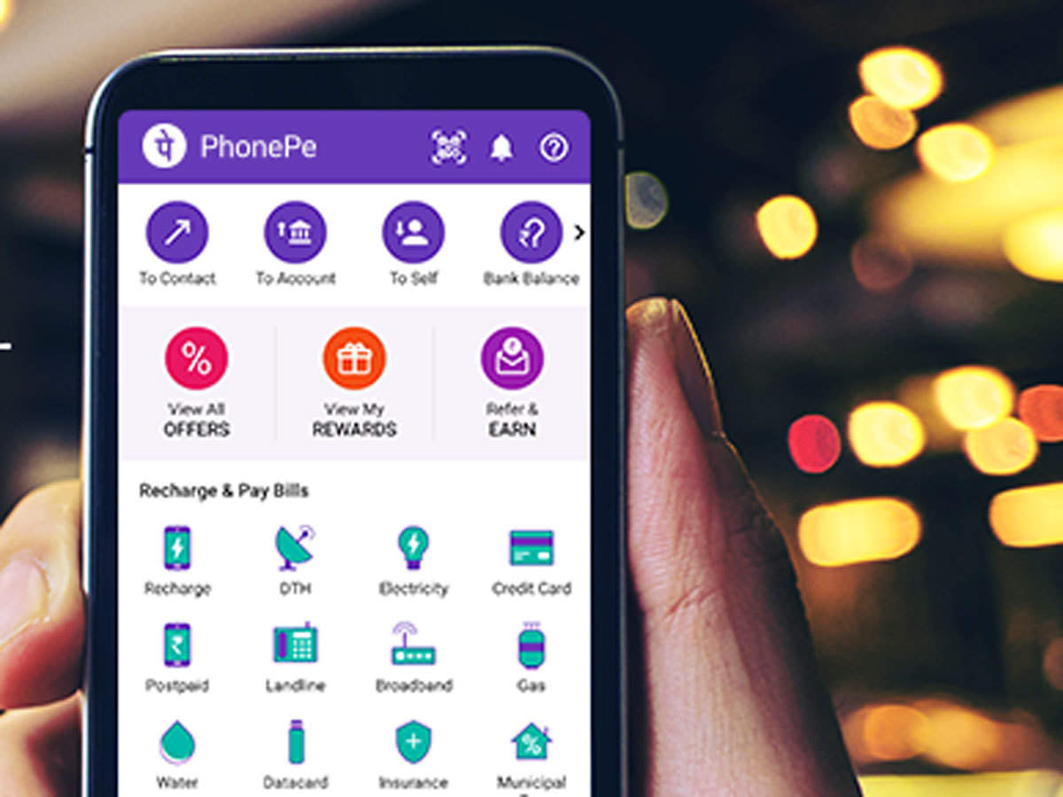
Download and install Team Viewer on your phone and computer
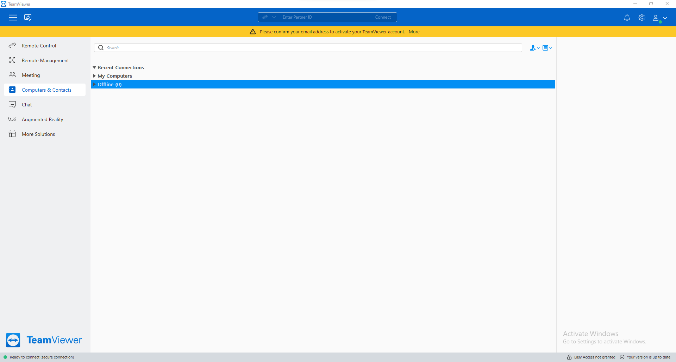
Download and install Anydesk on your phone and computer
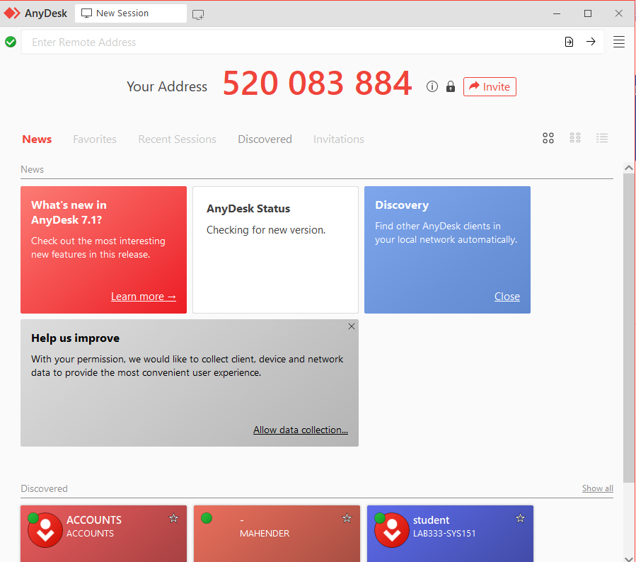
Step 2:
Test the security of the application and fill the table (keep adding more applications as you test)
Connecting mobile and computer.
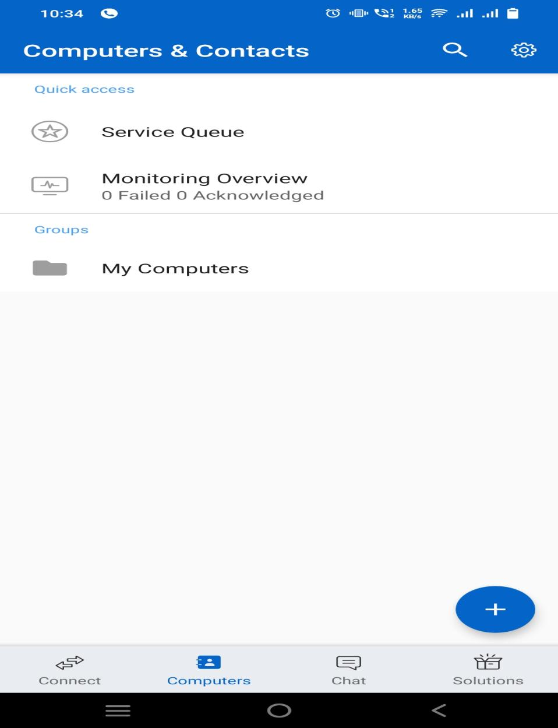

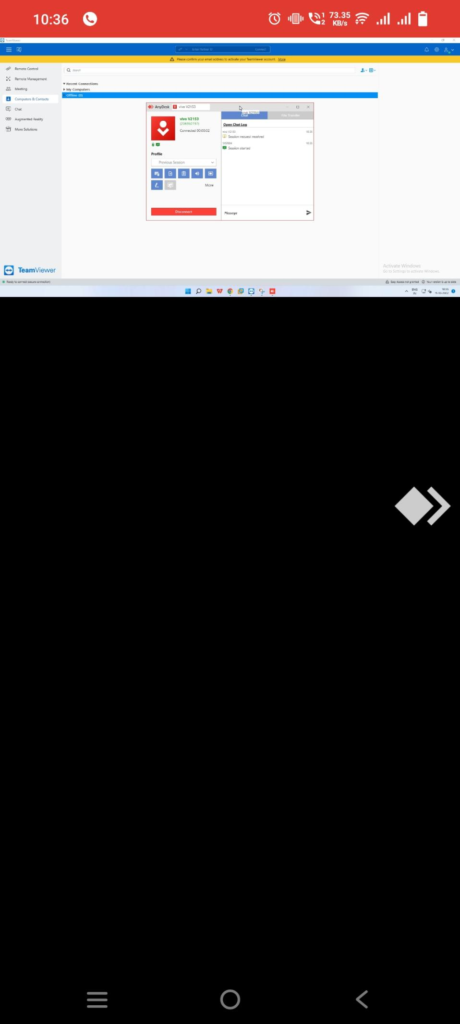
UPI Apps | Team Viewer | Any Desk
BHIM
Google Pay
Phonepe

If we try to perform any transactions using any UPI applications it won’t allow performing transactions.
UPI applications will display an alert to ensure security while performing the any transactions.
