Step 1: Connect PC to your Router using a cable
Step2: Run IP address of router in any of the browser
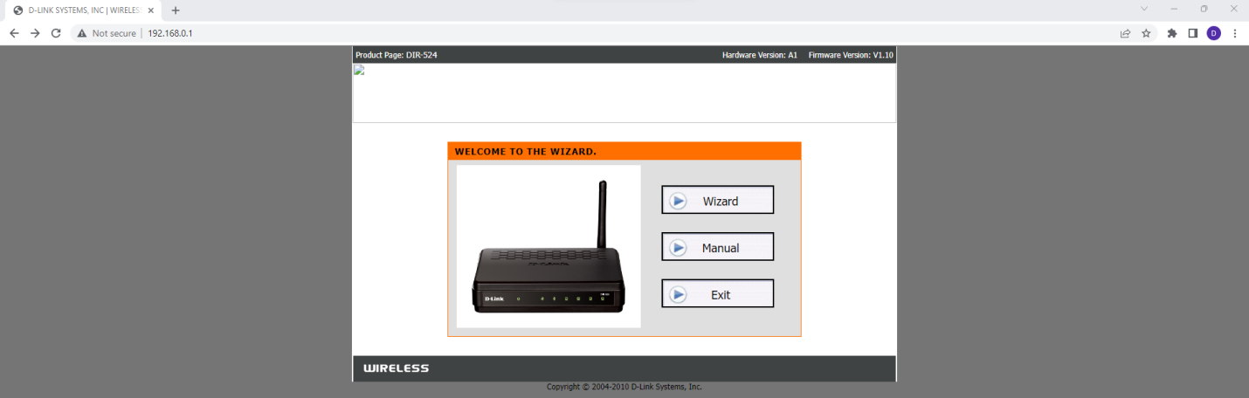
Step3: click Wizard
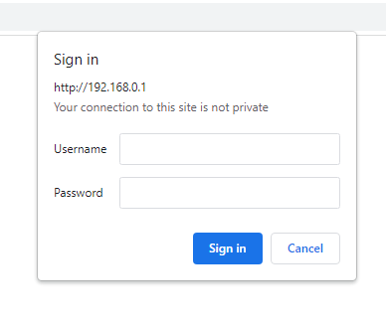
Step4: Login with the credentials which are available on the router
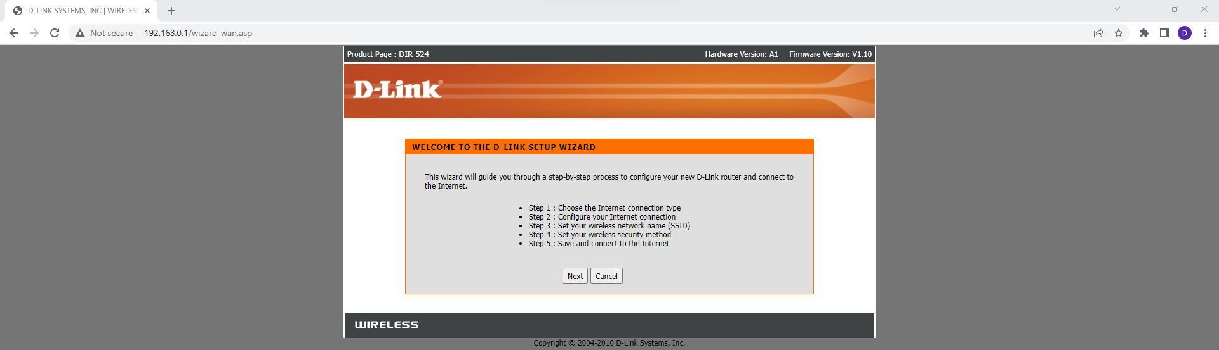
Step 5: click Next
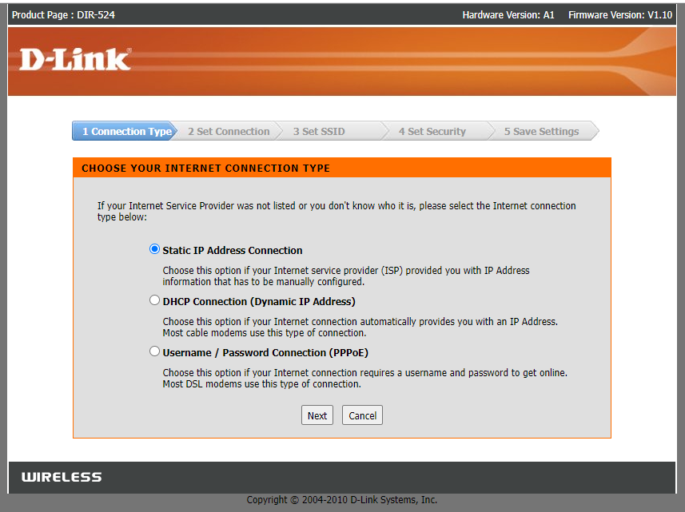
Click Next and Enter IP address provided by service provider
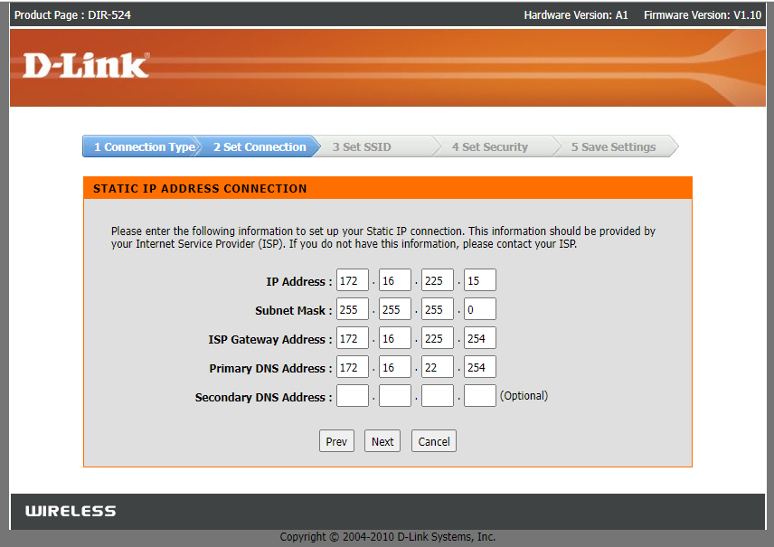
Click Next and enter the name of the wireless network
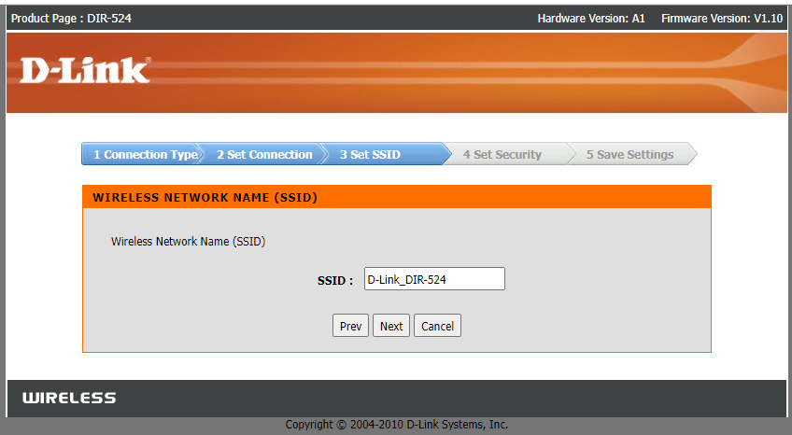
Click Next and set the security mode
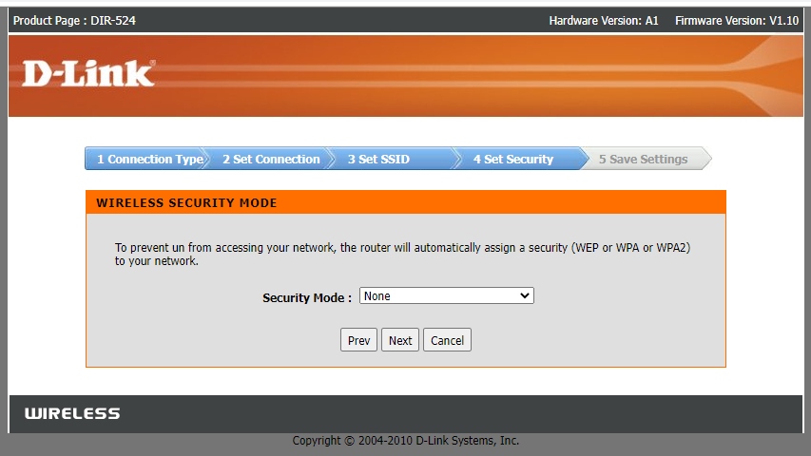
click Next save continue
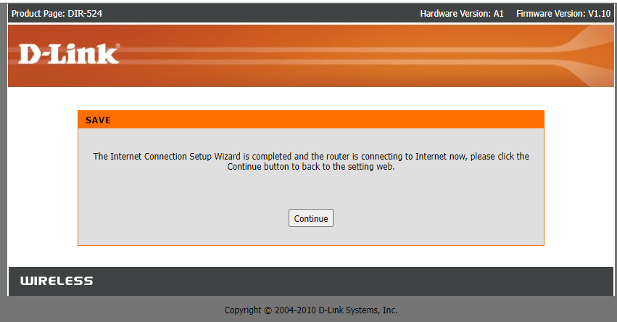
click continue
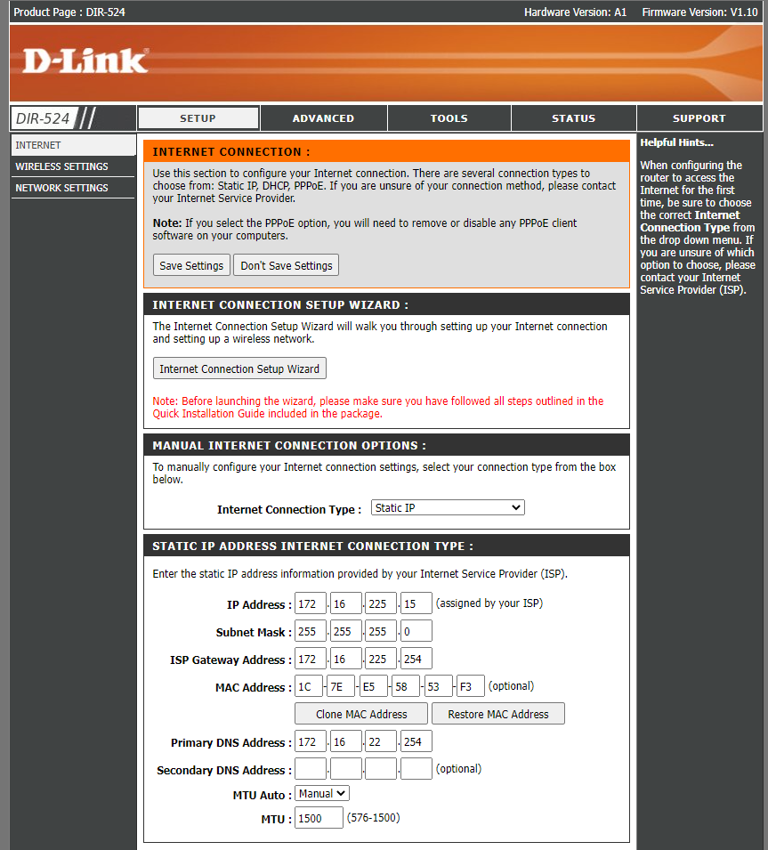
Step 6: In manual internet connection setup wizard
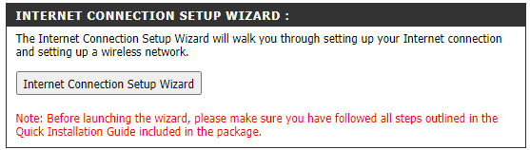
Step 7: Click Next
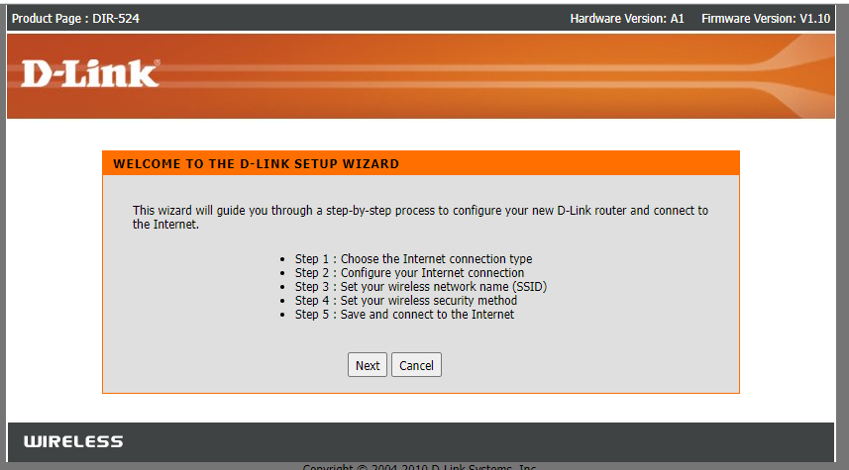
Click next
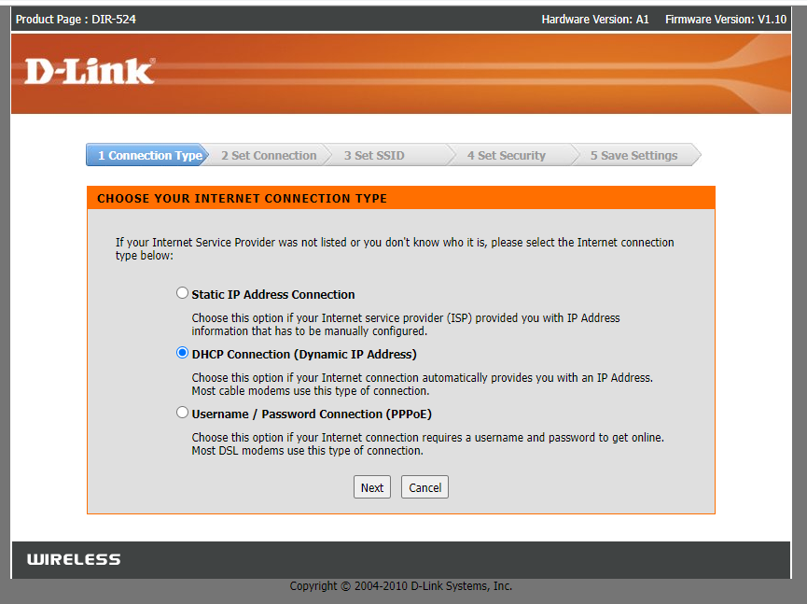
Click Next
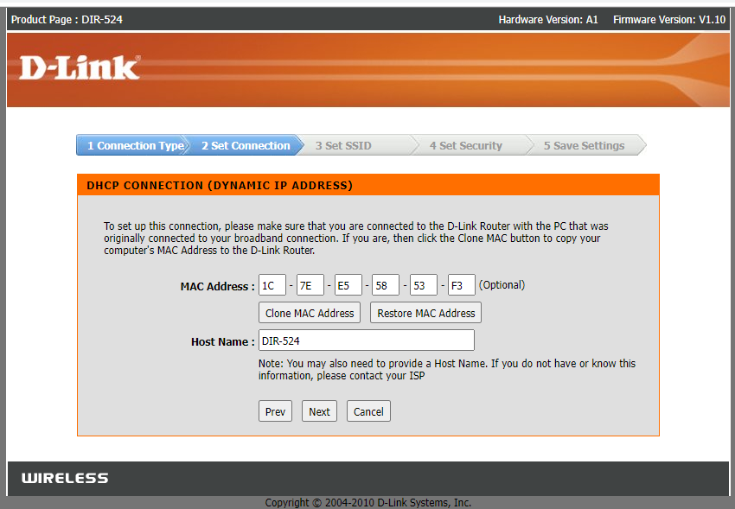
Click Next
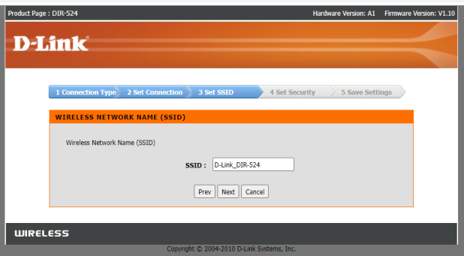
Click Next
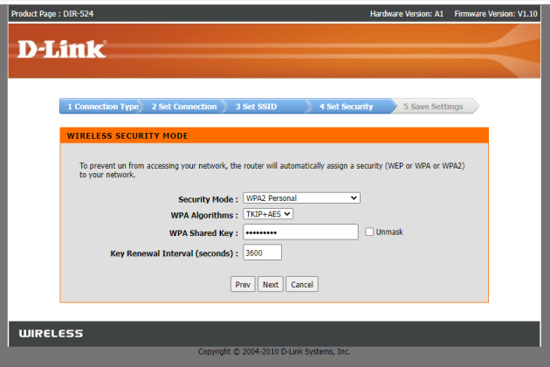
Click Next
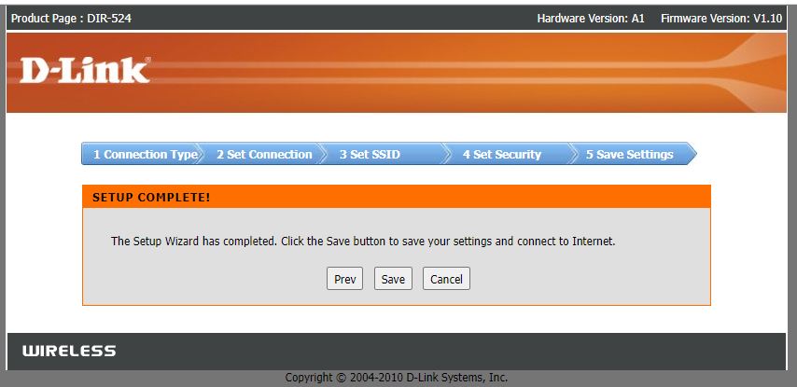
Click Continue
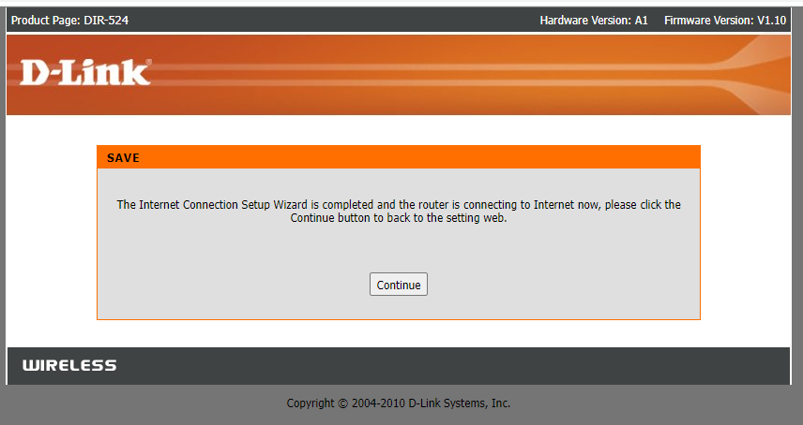
Step: 8 Click wireless Settings
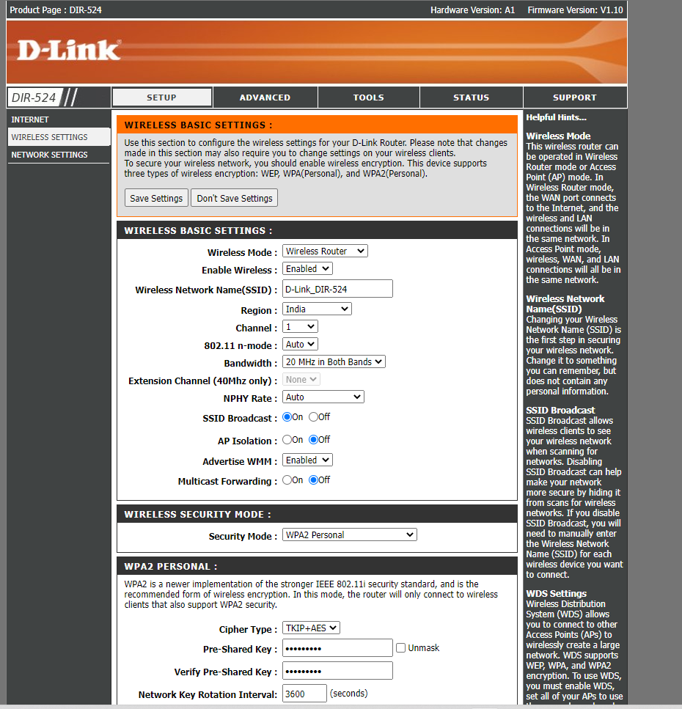
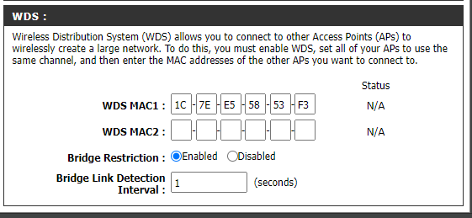
Step 9: Click Save.
Step 10: Goto Network and Internet and connect to the wifi-DLink_DIR-524
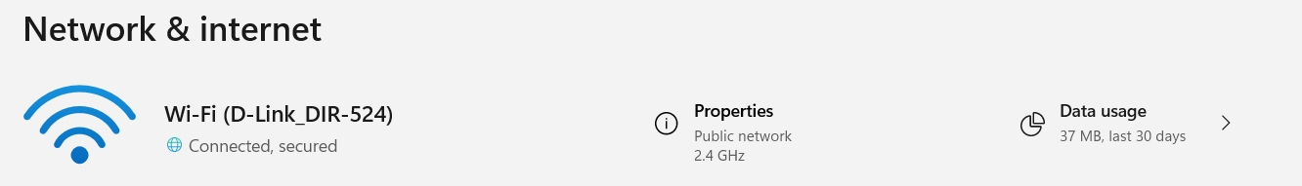
Step 11: run google.com in the browser to check the availability of Wifi
