**THE REVOLUTIONARY GOVERNMENT OF ZANZIBAR**

**Zanzibar e-Government Agency**



**Digital Project Records Management System (DPRMS)**

**SYSTEM DESIGN DOCUMENT**

**September 2023**

# Table of Contents

Table of Contents ii

1 Introduction 4

1.1 Purpose 4

1.2 Document Conventions 4

1.3 Intended Audience and Reading Suggestions 4

1.4 Product Scope 4

1.5 References 4

2 External Interface Requirements 4

2.1 User Interfaces 5

2.2 Hardware Interfaces 5

2.3 Software Interfeces 5

2.4 Communications Interfaces 5

3 System Design Features 5

3.1 User Management 5

3.2 System Architecture 6

3.3 ERD 7

3.3.1 ERD Diagram 7

3.4 Use Case 8

3.4.1 Use case Diagram 8

3.5 Class Diagram 9

3.5.1 Class Diagram 9

3.6 User Processes 10

3.6.1 State Diagram for User 10

3.6.2 Sequence Diagram for user 11

3.7 IT Staff Processes 11

3.7.1 State Diagram for IT Staff 11

3.7.2 Sequence Diagram for IT Staff 12

3.8 Admin Processes 12

3.8.1 State Diagram for Admin 12

3.8.2 Sequence diagram for Admin 13

3.9 Data Dictionary 13

3.9.1 Document Table 13

3.9.2 Project Table 14

3.9.3 User Table 14

3.9.4 Roles table 14

3.9.5 Notification Table 14

# Introduction

## Purpose

Zanzibar e-Government Agency has a role to identify and acknowledge all the ICT-related projects in the revolutionary government of Zanzibar. However, the challenges facing Zanzibar e-Government Agency is that the information systems are not registered/known and there is a need for a streamlined approval process for new systems development, we propose the creation of the Digital Projects Records Management System (DPRMS). The DPRMS will serve as a comprehensive solution to address the lack of visibility into existing government information systems and facilitate a standardized process for proposing, approving, registering and managing new and old system projects across various government offices.

## 

## Intended Audience and Reading Suggestions

In the realm of the Digital Projects Records Management System (DPRMS), our narrative extends a warm embrace to a diverse array of distinguished stakeholders. From the esteemed government officials steering the ship of ICT initiatives through Zanzibar e-Government Agency, to the astute project managers orchestrating innovations to all those who partake in the intricate ballet of government technology. The document intends to provide the members of the DPRMS project a unified view of the technical details of the system design to be followed during the development of the respective application.

## Product Scope

The DPRMS is a sophisticated software solution meticulously crafted to empower users with the essential algorithms and data required for automating the multifaceted process of project approval, registration, storage, and real-time monitoring within the Zanzibar e-government agency. Upon its successful implementation, the system will not only register information institutions undergoing specific projects but also oversee project information corrections, proactively notifying users for swift approvals.

Moreover, the system boasts a user-friendly interface, allowing seamless document uploads for various project stages, including planning, design, and development. DPRMS is poised to efficiently manage and optimize the full spectrum of processes and operations outlined above, ushering in a new era of efficiency and accountability within the organization.

## References

# External Interface Requirements

## User Interfaces

The system shall have the friendly interfaces for various users, each user shall access the system based on his roles in the system, Users will face with some options that related with his roles such as registering project details, approving project proposal, uploading required documents such as TOR and concept note etc.…

## Hardware Interfaces

The System will work with both computers and mobile devices.

## Software Interfeces

The system shall have the interface that shall enable DPRMS to exchange information with other system through application programming interface (API).

## Communications Interfaces

The system shall have the communication interface, which will enable to exchange information with other system.

# System Design Features

## User Management

DPRMS has three main users; these users have different roles in the system. The table below summarizes these users with their roles in the system.

|  |  |  |
| --- | --- | --- |
| **User Group** | **Feature** | **Functionalities** |
| Admin | Manage Other Users accounts | Create, View, Edit, Activate, Deactivate |
| Manage Approval Process | Approve, Disapprove |
| Obtain report | View |
| Institute User | Register Project | Create, View, Edit, |
| Submit required documents | Create, View, Edit, Delete |
| Fill checklist | Edit, Delete |
| Staff user | Provide comments | Create, View |
| View Project list | View, edit, |
|  | Provide comments | Create, Edit, View, Delete |

## System Architecture

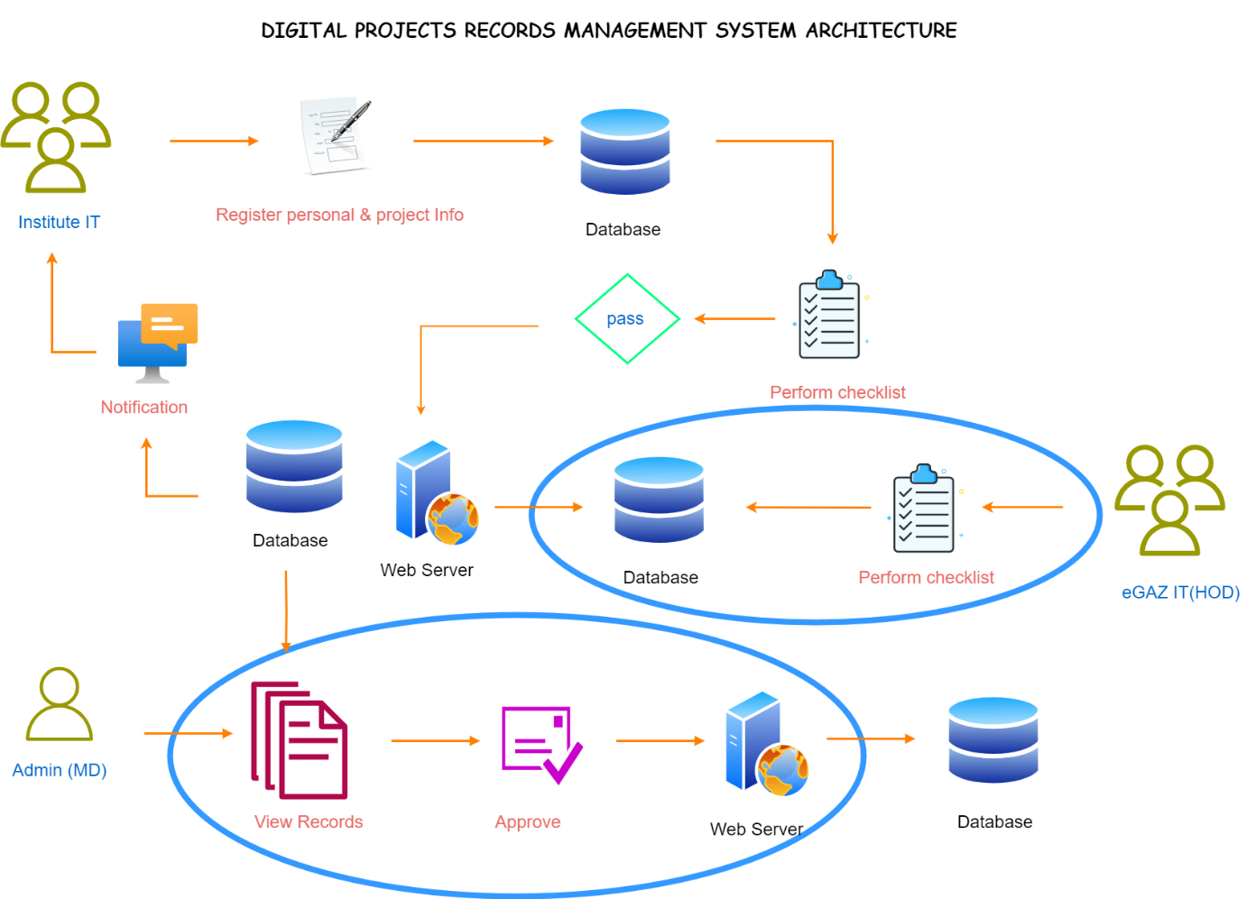

Figure DPRMS System Architecture

## ERD

### ERD Diagram

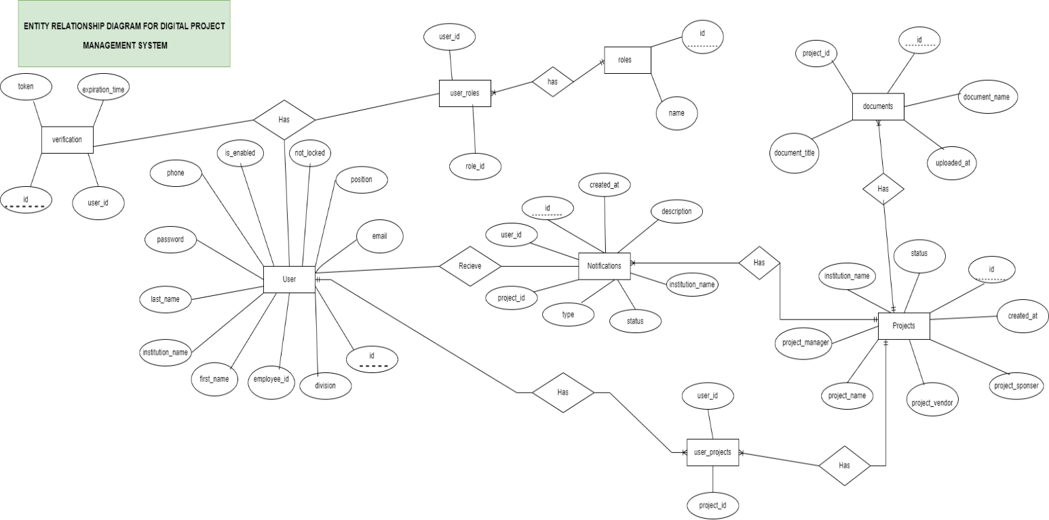

Figure ERD Diagram

## Use Case

### Use case Diagram

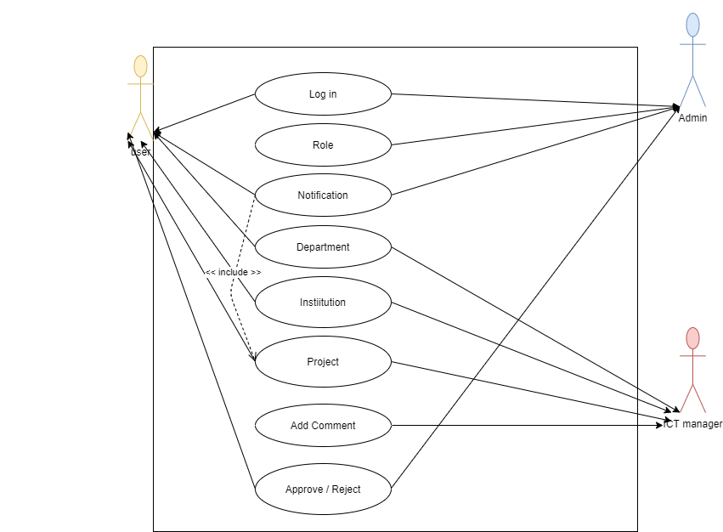

Figure DPRMS Use Case

## Class Diagram

### Class Diagram

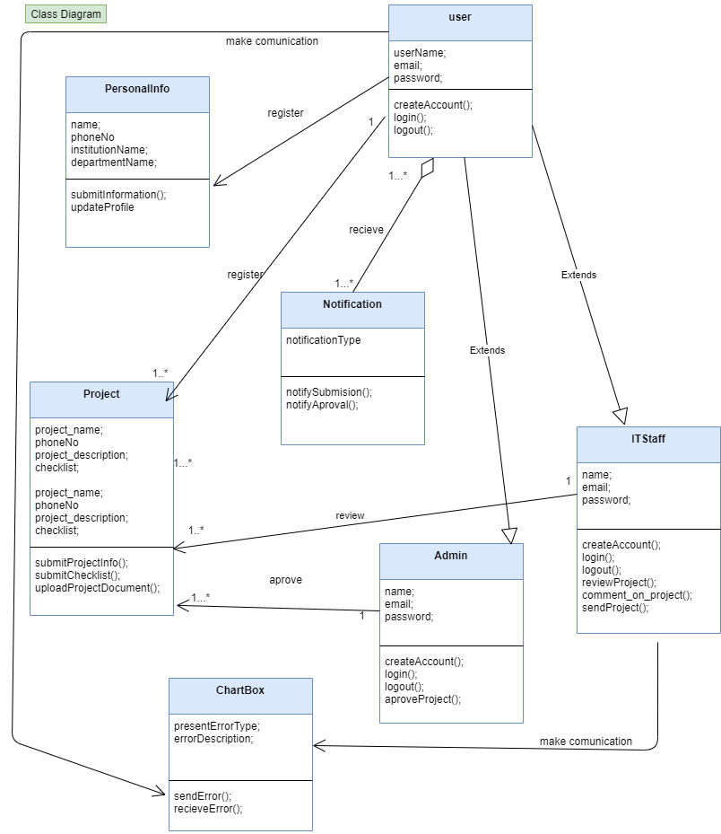

Figure DPRMS Class Diagram

## User Processes

### State Diagram for User

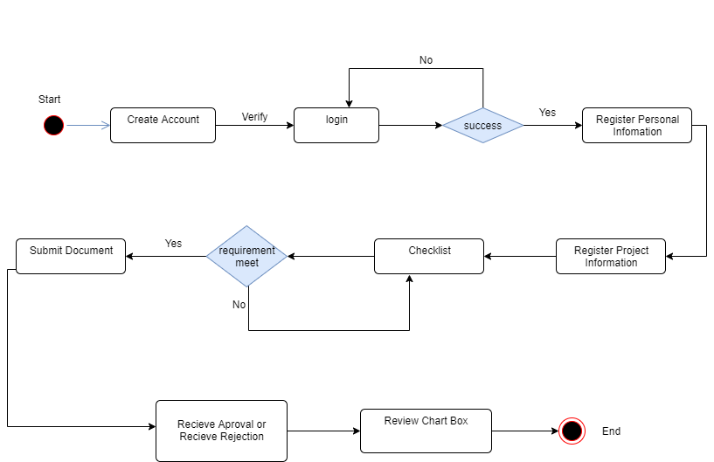

Figure User State Diagram

### Sequence Diagram for user

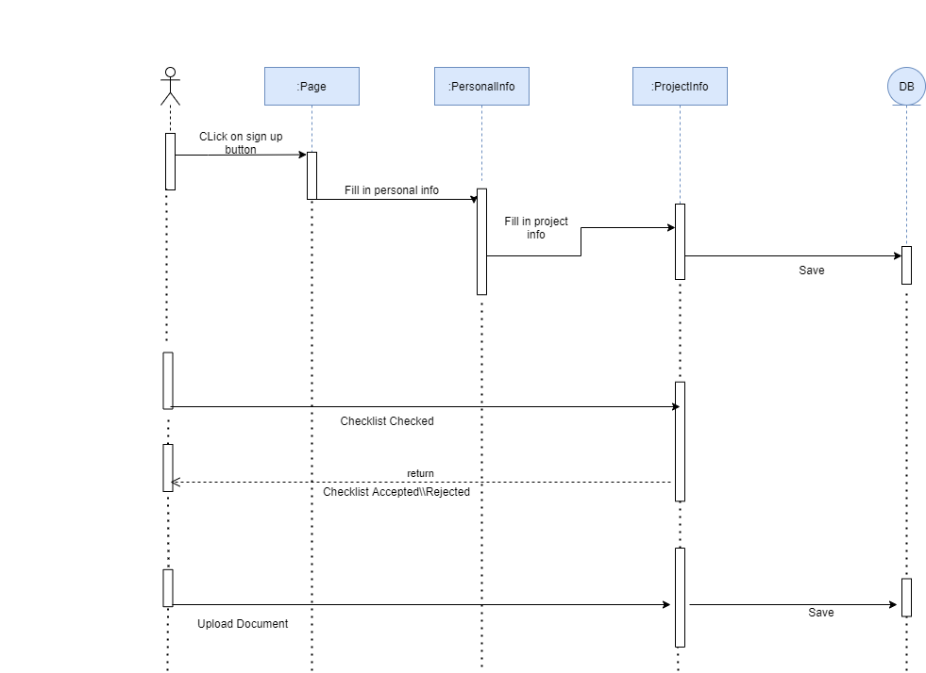

Figure User Sequence Diagram

## IT Staff Processes

### State Diagram for IT Staff

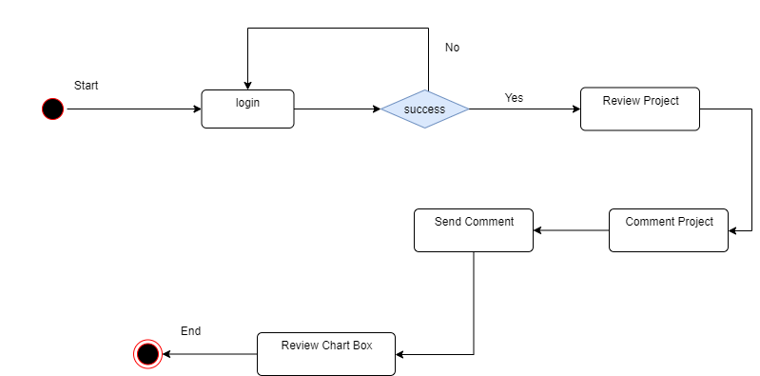

Figure IT Staff State Diagram

### Sequence Diagram for IT Staff

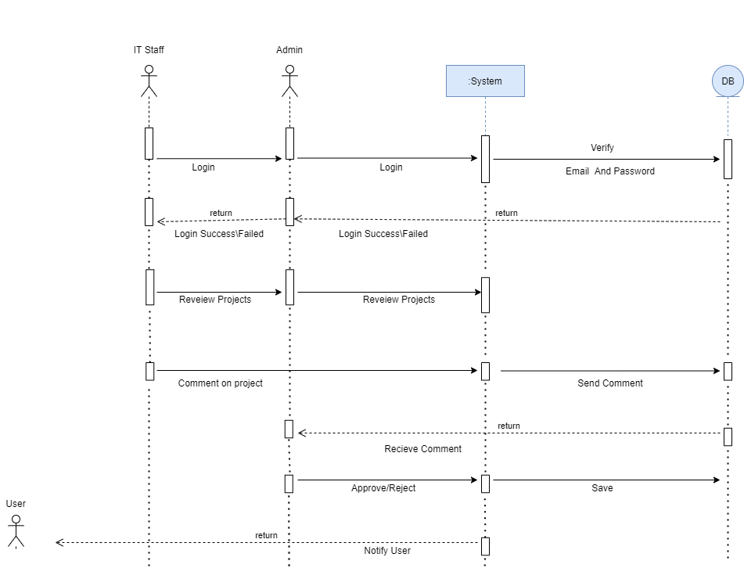

Figure IT Staff Sequence Diagram

## Admin Processes

### State Diagram for Admin

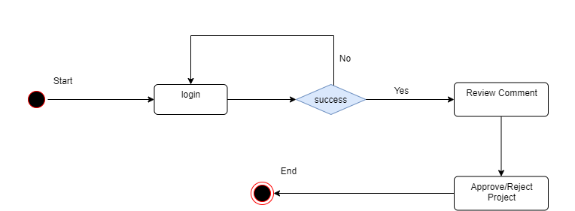

Figure Admin State Diagram

### Sequence diagram for Admin



Figure Admin Sequence Diagram

## Data Dictionary

### Document Table

|  |  |  |  |  |
| --- | --- | --- | --- | --- |
| Field Name | Data type | Field Length | Constraint | Description |
| id | BIGINT | 20 | Primary key | Auto generated |
| document name | VARCHAR | 255 | Not null | Name of the document |
| uploaded_at | DATETIME |  | Not null | Time of uploading |
| Project_id | BIGINT | 20 | Not null | Unique id of project |
| Document title | VARCHAR | 255 | Not null | Title of the project |

### Project Table

|  |  |  |  |  |
| --- | --- | --- | --- | --- |
| Field name | Data type | Field length | Constraint | Description |
| id | BIGINT | 20 | Primary key | Auto generated |
| created_at | DATETIME |  | Not null | Time |
| institution_name | VARCHAR | 255 | Not null | Name of institute |
| project_manager | VARCHAR | 255 | Not null | Project manager name |
| project_name | VARCHAR | 255 | Not null | Name of the project |
| project_sponsor | VARCHAR | 255 | Not null | Sponsor of project |
| project_vendor | VARCHAR | 255 | Not null | Vendor of project |
| status | VARCHAR | 255 | Not null | Status of Project |

### User Table

|  |  |  |  |  |
| --- | --- | --- | --- | --- |
| Field name | Data type | Field length | Constraint | Description |
| id | BIGINT | 20 | Primary key | Auto generated |
| division | VARCHAR | 255 | Not null | Division name |
| email | VARCHAR | 255 | Not null | User email |
| employee_id | VARCHAR | 255 | Not null | Employeed |
| first_name | VARCHAR | 255 | Not null | User name |
| institution_name | VARCHAR | 255 | Not null | Name of the institute |
| is_enabled | BIT | 1 | Not null | enabled |
| last_name | VARCHAR | 255 | Not null | User last name |
| Password | VARCHAR | 255 | Not null | Login password for user |
| phone_number | VARCHAR | 255 | Not null | Mobile number |
| Position | VARCHAR | 255 | Not null | Position |
| not_locked | BIT | 1 | Not null | Not locked |

### Roles table

|  |  |  |  |  |
| --- | --- | --- | --- | --- |
| Field name | Data type | Field name | Constraint | Description |
| id | BIGINT | 20 | Primary key | Auto generated |
| name | VARCHAR | 255 | Not null | Name of user |

### Notification Table

|  |  |  |  |  |
| --- | --- | --- | --- | --- |
| Field name | Data type | Field length | Constraint | Description |
| id | BIGINT | 20 | Primary key | Auto generated |
| created_at | DATETIME |  | Not null | created |
| description | VARCHAR | 255 | Not null | description |
| institution_name | VARCHAR | 255 | Not null | Institute name |
| status | VARCHAR | 255 | Not null | status |
| type | VARCHAR | 255 | Not null | Notification type |
| project_id | BIGINT | 20 | Not null | Id assigned to a project |
| user_id | BIGINT | 20 | Not null | User id |